IEEE P802.15
Wireless Personal Area Networks

Project | IEEE P802.15 Working Group for Wireless Personal Area Networks (WPANs)
Title | Draft of TG7r1 Technical Considerations Document Structure Discussion
Date Submitted | [15 April, 2015]
Source | [Yu Zeng]  [China Telecom]  [zengyu@ctbri.com.cn]
Re: | [TG7r1 CFA responses]
Abstract | [Draft of OCC part of technical considerations for TG7r1.]
Purpose | [To assist to prepare TG7r1 TCD]
Notice | This document has been prepared to assist the IEEE P802.15. It is offered as a basis for discussion and is not binding on the contributing individual(s) or organization(s). The material in this document is subject to change in form and content after further study. The contributor(s) reserve(s) the right to add, amend or withdraw material contained herein.
Release | The contributor acknowledges and accepts that this contribution becomes the property of IEEE and may be made publicly available by P802.15.

Option 1 Parallel (Current)
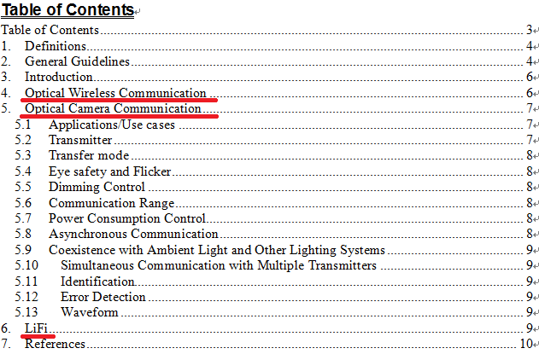

Option 2 Tree

