IEEE P802.15
Wireless Personal Area Networks

Project | IEEE P802.15 Working Group for Wireless Personal Area Networks (WPANs)
Title | Draft of TG7r1 Technical Considerations Document
Date Submitted | [3 May, 2015]
Source | [Hideki Aoyama]  [Panasonic]  [aoyama.hideki@jp.panasonic.com] | Rick Robert, Intel, richard.d.roberts@intel.com
Re: | [TG7r1 CFA responses]
Abstract | [Draft of OCC part of technical considerations for TG7r1.]
Purpose | [To assist to prepare TG7r1 TCD]
Notice | This document has been prepared to assist the IEEE P802.15. It is offered as a basis for discussion and is not binding on the contributing individual(s) or organization(s). The material in this document is subject to change in form and content after further study. The contributor(s) reserve(s) the right to add, amend or withdraw material contained herein.
Release | The contributor acknowledges and accepts that this contribution becomes the property of IEEE and may be made publicly available by P802.15.

List of contributors
Hideki Aoyama | Panasonic
Mitsuaki Oshima | Panasonic
Rojan Chitrakar | Panasonic
Nikola Serafimovski | pureLiFi
Murat Uysal | Ozyegin University
Yu Zeng | China Telecom
Richard Roberts | Intel
Yeong Min Jang | Kookmin University

Table of Contents
Table of Contents 3
1. Definitions 4
2. General Guidelines 4
3. Introduction 6
4. Optical Wireless Communication 6
4.1 Optical Camera Communication 7
4.1.1 Applications/Use cases 7
4.1.2 Transmitter 7
4.1.3 Transfer mode 8
4.1.4 Eye safety and Flicker 8
4.1.5 Dimming Control 8
4.1.6 Communication Range 8
4.1.7 Power Consumption Control 8
4.1.8 Asynchronous Communication 8
4.1.9 Coexistence with Ambient Light and Other Lighting Systems 9
4.1.10 Simultaneous Communication with Multiple Transmitters 9
4.1.11 Identification 9
4.1.12 Error Detection 9
4.1.13 Waveform 9
4.2 LiFi 10
4.2.1 Applications/Use cases 10
4.2.2 Transmitter 10
4.2.3 Transfer mode 10
4.2.4 Eye safety and Flicker 11
4.2.5 Dimming Control 11
4.2.6 Communication Range 11
4.2.7 Multiple User Support 11
4.2.8 Asynchronous Communication 11
4.2.9 Handover and Interference Coordination 11
4.2.10 Localization 12
4.2.11 Coexistence with Ambient Light and Other Lighting Systems 12
4.2.12 Simultaneous Communication with Multiple Transmitters 12
4.2.13 Error Detection 12
4.2.14 Waveform 12
4.3 LED-ID 12
5. References 12

Definitions

OCC | Optical Camera Communication
OWC | Optical Wireless Communication
LiFi | High speed, bidirectional, networked and mobile wireless communications using light
MIMO | Multiple Input/Multiple Output

General Guidelines

This technical considerations document (TCD) describes the technical aspects that TG7r1 standard must fulfill, such as performance-related issues, reliability issues and availability issues. These types of requirements are often called quality of service (QoS) requirements; other requirements are usually maintenance-level requirements or external constraints, sometimes called compliance. Technical requirements are summarized as any other specifications; they have a name and a unique identifier. Technical requirements are documented in the same manner as any specifications, including a description, an example, a source or references to related technical requirements and a revision history. TG7r1 needs to effectively define and manage requirements to ensure they are meeting needs of the OWC (Optical Wireless Communications) users, while proving compliance.

Ideally, considerations should be:

• Correct technically and legally,
• Complete by expressing a whole idea or statement,
• Clear (i.e., unambiguous and not confusing),
• Consistent (not in conflict with other requirements),
• Verifiable, so that it can be determined that the system meets the requirements,
• Traceable (i.e., uniquely identified and track-able),
• Feasible, so that they can be accomplished within given cost and schedule limits,
• Modular, so that they can be changed without excessive impact to other requirements, and
• Design-independent, not to pose a specific solution on design.

Each consideration must first form a complete sentence, containing a subject and a predicate. These sentences must consistently use the verb “shall”, “will” or “must” to show the requirement's mandatory nature, and “should” or “may” to show that the requirement is optional. The whole requirement specifies a desired end goal or result and contains a success criterion or other measurable indication of the quality.

TCD needs to capture these levels of user requirements, maintaining intelligent traceability and change impact analysis between them.

Typical constraint considerations can specify:

• Performance,
• Interfaces,
- Coexistence,
• Security,
• Safety,
• Reliability,
• Availability, and
• Maintainability.

An efficient way of writing better requirements is to ensure they are clearly mapped to test cases. When specifying considerations or requirements, test cases must be considered to provide directions to help to verify requirements or considerations in the document. This can be provided by specifying a packet error rate and packet size for comparing contributions, for example. Making sure each requirement is clearly verifiable from the start, which not only helps to prepare later phases of the project, but it also puts the developer in the correct state of mind. Requirements and their associated tests must also indicate what the system should not do, and what happens at the limits (i.e., degraded mode). This rule also applies for compliance requirements: indicating how they shall be tested is a good way to write better requirements.

TCD needs to implement a reliable and repeatable change control process that helps turn this challenge into an opportunity.

By providing examples and counter-examples of good requirements and documents, IEEE can enhance the quality, consistency, and completeness of the requirements. These can originally be templates, industry standards and rules inside a repository, such as the IEEE server.

Requirements for Typical Sentence Construction

Defects to be avoided are:

- Vagueness,
- Weakness,
- Over specification,
- Subjectivity,
- Multiplicity,
- Unclear meaning, and
- Implicit meaning.

Some words listed below should be used with caution:

“adequate”, “applicable”, “appropriate”, “approximate”, “bad”, “best practice”, “between”, “clearly”, “compatible”, “completely”, “consider”, “could”, “down to”, “easy/easily”, “effective”, “efficient”, “equivalent”, “excellent”, “good”, “his/her”, “however”, “ideal”, “etc”, “in order to”, “include but shall not be limited to”, “least”, “like”, “low”, “maximise”, “may”, “most”, “minimum/minimal”, “must”, “nearly”, “necessary”, “needed”, “normal”, “or”, “possible/possibly”, “practicable”, “provide”, “quality”, “readily”, “relevant”, “safe/safely“, “same”, “should”, “significant”, “similar”, “so as”, “subject to”, “substantial”, “sufficient”, “suitable”, “support”, “target”, “typical”, “up to”, “user friendly”, “whether”, “will”, “with”, and “worse”.

Difference between Considerations and Requirements (TCD vs. TRD)

The TG7r1 group decided to use the term “considerations” instead of “requirements” in order to adopt a less rigid and formal process with the intention to be able to develop the standard quickly. This document serves to provide guidance for development of technical contributions for the IEEE 802.15.7r1 standard. The contents of the document are expected to be similar to a technical requirements document.

Introduction

This document provides the technical contents of the project to develop PHY and MAC protocols for Optical Wireless Communications. This document will provide guidance on how to respond to a call for contributions.

This document serves two purposes:
- It summarizes the applications presented in response to TG7r1 Call for Applications and questions and answers.
- It describes and defines the fundamental requirements implied by the applications but not necessarily stated explicitly.

Optical Wireless Communication

Optical Wireless Communication (OWC) is a wireless communication method using optical wavelength radio wave as the carrier wave.
OWC can be classified into:
Optical Camera Communications which enables optical wireless communications using an image sensor as a receiver.
LiFi which is high-speed, bidirectional, networked and mobile wireless communications using light.
LED-ID which is wireless light ID system using various LEDs.

Optical Camera Communication

Applications/Use cases

The following OCC applications/use cases were presented in response to TG7r1 Call for Applications.

A1 Offline to Online Marketing/Public Information System [2, 3, 5, 6, 7]
A2 IoT (M2M/D2D/ Internet of Light (IoL)) [2, 3, 9, 10, 11]
A3 Indoor Positioning [2, 5, 10]
A4 Vehicular Communication [2, 7]
A5 Underwater Communication [8]
A6 Power Consumption Control [4]
A7 Vehicular Positioning [2]
A8 Seaside Communication [?]

The standard will consist of multiple PHY/MAC modes to meet the following variety of requirements.

Transmitter

The standard should support the following devices as transmitters for each application.

Device | Applications/Use cases
Ceiling light | A2, A3
Flash light | A5, A2
Car light | A4, A7
Indirect light | A1, A4
Illuminated signage with diffused light such as LCD screen backlighting | A1, A2
Illuminated signage with discrete LEDs | A1, A2
Digital signage (such as LCD display) | A1, A2
Traffic light and Intelligent Traffic System (ITS) | A1, A2, A4, A7
Lighthouse | A1, A8

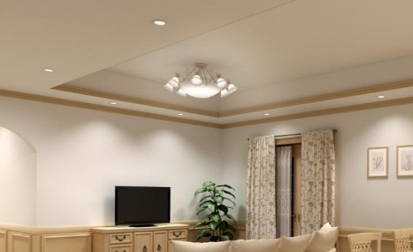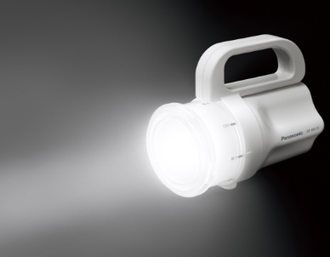
Ceiling light Flash light

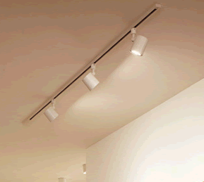
Car light Indirect light

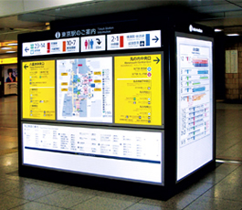
Illuminated signage Illuminated signage
with front panel without front panel

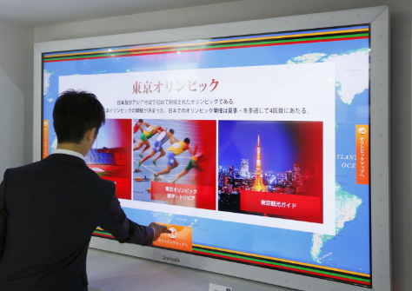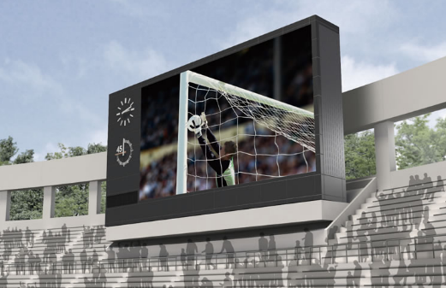
Digital signage

Traffic light Lighthouse

Receiver

The standard will support optical camera, which has 2-dimentional array of photo sensors that measure intensity of visible light, IR and/or UV, as receiver. The standard will support image sensors of global/sequential shutter (rolling shutter) with multiple PHY/MAC modes.

Carrier Frequency

Carrier frequency will be limited in visible light, IR and UV frequency band.

Transfer mode

A PHY/MAC mode of the standard will support at least one of the following transfer mode:
ID broadcast mode which repetitively broadcast less than or equal to 128 bits of ID in a second with small overhead of MAC frame for application A1, A2, A3, A4 and A5.
Unidirectional data transfer mode which transmit longer data stream for application A2 and A4.
Bidirectional data transfer mode which enables efficient communication for application A2.

Eye safety and Flicker

The modulated light that can be seen by the human I shall be safe for human eye in the aspects of frequency and intensity of light. And the modulated light will not stimulate sickness such as photosensitive epilepsy.
The standard will support at least one flicker free PHY mode, in which the modulation is imperceptible for human eye, for application A1, A3, A4, A7 and A8. The standard may allow flicker PHY mode for application A1, A2, A3 and A5.

Dimming Control

The standard will support dimming control for application A1, A2, A3, A4 and A7.

OCC Communication Range

Communication range depends on the size and the brightness of a transmitter in conjunction with some protocols. The range performance criteria will be determined by the committee at the time the need arises.

Power Consumption Control

The standard should support power consumption control for application A6.

Coexistence with Ambient Light

The standard will co-exist with ambient light that may be reflected on a surface of a transmitter. In addition, coexistence shall be shown with the existing IEEE802.15.7-2011 operating modes.

Coexistence with Other Lighting Systems

The standard will co-exist with other lighting systems. It will enable a receiver to receive a signal from a transmitter even if other lighting systems are captured in the same image frame, which are optically separable from the transmitter.

Simultaneous Communication with Multiple Transmitters

The standard will support simultaneous communication with multiple coordinated/uncoordinated transmitters, which are separated on a captured image. Simultaneous communication with coordinated transmitters is called Multiple Input/Multiple Output (MIMO) and a MIMO MAC protocol shall be incorporated into the standard so the camera enabled receiving device knows how to process the received data.

Identification of Transmitter

The standard will support identifying the source of transmitted data by observation of the transmitting source in the image; that is, there must be association between an observed objection that is transmitting data and the location of the object in the image.

Performance Data

TBD - The committee shall determine performance data at a future time.

Nearly point image data source

The standard will support at least one OCC PHY mode that works when the LED light source appears as nearly a point source; that is, the LED illuminates only a small number of image pixels.

Simultaneous low frame rate and high frame rate transmission

The standard will support at least one OCC PHY mode that simultaneously allows OCC modulated LED light sources to be identified at a low camera frame rate and then demodulated at a high camera frame rate using region-of-interest sub-sampling.

Low overhead repetitive transmission

The standard will support at least one OCC MAC mode that supports repetitive informational broadcast at very low data rate; that is, the frame format has very little overhead and is optimized for short payloads sent in a repetitive manner.

LiFi

Applications/Use cases

The following LiFi applications/use cases were presented in response to TG7r1 Call for Applications.

- Indoor Office/Home Applications: (Conference Rooms, General Offices, Shopping Centres, Airports, Railways, Hospitals, Museums, Aircraft Cabins, Libraries etc.)
- Data Center / Industrial Establishments (Personalized Manufacturing Cells, Factories, Hangers, etc.)
- Vehicular Communications (Vehicle-to-vehicle, Vehicle-to-Infrastructure)
- Wireless Backhaul (Small Cell Backhaul, Surveillance Backhaul, Lan Bridging)

These have been summarized in document number 15-15-0302-01-007a.

Transmitter

The standard should support the following devices as transmitters for each application.

Device | Applications/Use cases
Ceiling light | B1 – B3
Indirect light | B1
Car light | B3
Directed lights | B2, B4

Transfer mode

The standard will support continuous data streaming for all applications with bidirectional functionality. The standard must provide a PHY mode that allows the optimal use of the available optical bandwidth on a given luminaire for B1 – B4.

The standard must define a range of data rates from minimum supported connectivity or at least 10 Mbps to peak data rates of 10 Gbps.

The standard must define a range of latencies from maximum supported of at most 20 ms to minimum latency of 1 ms.

Eye safety and Flicker

The modulated light will be safe for human eyes and will not stimulate photosensitive epilepsy. The standard should support flicker free PHY mode, in which the modulation is imperceptible for the human eye, for application B1 and B3.

Dimming Control

The standard will support dimming control for application B1 – B3.

Communication Range

The communication range depends on multiple external factors (signal magnification, signal collimation, source power, etc.). These are implementation aspects and these numbers are provided as guidelines only. The committee will agree to use the same channel model to assess the performance capabilities of the proposed schemes.

Multiple User Support

The standard must provide mechanisms to support multiple users receiving different data streams from the same light source (multiple access).

Asymmetric Communication

The standard will support asymmetric communication between transmitters and receivers to allow higher data rates in one direction.

Handover and Interference Coordination

The standard must provide mechanisms to support handover between light sources, allowing users to maintain a continuous network connection.

The standard must provide mechanisms that can be used to develop and deliver interference coordination techniques by higher layers.

Localization

The standard must provide mechanism to support precise indoor positioning algorithms with less than 10 cm diameter precision.

Coexistence with Ambient Light and Other Lighting Systems

The standard will co-exist with ambient light whose reflected brightness is less than xx % of brightness of a transmitter.
The standard will co-exist with other lighting systems. This will enable a receiver communicate with a supported transmitter even in the presence of other modulated lights.
In addition, coexistence shall be shown with the existing IEEE802.15.7-2011 operating modes.

Simultaneous Communication with Multiple Transmitters

The standard will support interference coordination techniques to deal with simultaneous communication with multiple coordinated/uncoordinated transmitters.

It will support cooperative signal processing among multiple transmitters with negligible impact on latency.

Waveform

The standard will employ at least one PHY mode that uses variable current modulation.

LED-ID

References

- The IEEE P802.15.7r1 Short-Range Optical Wireless Communications Task Group Project Authorization Request (PAR): https://mentor.ieee.org/802.15/dcn/15/15-15-0064-00-0007-p802-15-7-revision-par-approved-2014-12-10.pdf
- Intel Response to 15.7r1 CFA: IEEE802.15-15-0146-00-007a
- CASIO Response to 15.7r1 CFA: IEEE802.15-15-0173-01-007a
- China Telecom CFA Response for Optical Camera Communications: IEEE802.15-15-0180-00-007a
- Introduction of LED-ID and Smart Device Camera based Applications: IEEE802.15-15-0196-00-007a
- Panasonic Response to 15.7r1 CFA: IEEE802.15-15-0197-00-007a
- NTU Response to 15.7r1 CFA: IEEE802.15-15-0203-00-007a
- LED Tag Applications for OWC: IEEE802.15-15-0211-00-007a
- D2D/P2P applications using Flash light and Camera of Smart Device: IEEE802.15-15-0212-00-007a
- Kookmin University Response to 15.7r1 CFA: Application of OWC: IEEE802.15-15-0242-00-007a
- Kookmin University Response to 15.7r1 CFA: Applications of OCC: IEEE802.15-15-0243-00-007a
- Fraunhofer HHI Response to 15.7r1 CFA: IEEE802.15-15-0248-01-007a
- pureLiFi_CFA_response: IEEE802.15-15-0192-00-007a

