IEEE P802.15
Wireless Personal Area Networks

Project | IEEE P802.15 Working Group for Wireless Personal Area Networks (WPANs)
Title | Analysis of TG4q (ULP) Use Cases and ULP-PHYs
Date Submitted | March 10, 2015
Source | [Kiran Bynam]  [Henk de Ruijter]  [Chandrashekhar Thejaswi PS]  [Jinesh Nair]  [Chunhui Allan Zhu]  [Youngsoo Kim]  [Chiu Ngo] | Voice: [ - ]  Fax: [ - ]  E-mail: [chiu.ngo@samsung.com]
Re: | Analysis of TG4q (ULP) Use Cases and ULP-PHYs
Abstract | [This document presents several target applications of 15.4q. It describes the benefits of the two ULP-PHYs and how they can address those applications.]
Purpose | [To provide an analysis of the current TG4q PAR against its applications.]
Notice | This document has been prepared to assist the IEEE P802.15. It is offered as a basis for discussion and is not binding on the contributing individual(s) or organization(s). The material in this document is subject to change in form and content after further study. The contributor(s) reserve(s) the right to add, amend or withdraw material contained herein.
Release | The contributor acknowledges and accepts that this contribution becomes the property of IEEE and may be made publicly available by P802.15.

Table of Contents
1 Motivations and applications of ULP PHYs 3
2 ULP-TASK PHY 4
2.1 Characteristics 4
2.2 Comparison of ULP-TASK PHY with 802.15.4 (DSSS) 5
2.2.1 Modulation and spreading 5
2.2.2 Error control mechanism 5
2.2.3 Comparison of system parameters 5
3 ULP-GFSK PHY 6
3.1 Characteristics 6
3.2 Comparison of ULP-GFSK PHY with existing PHYs 8
3.2.1 Power consumption 9
3.2.2 Energy efficiency 9
4 Addressing use case scenarios 10
4.1 Mobile healthcare 10
4.2 Telecom services 11
4.3 Inventory management 12
4.1 Shelf labeling 13
5 IEEE 802.15.4q vs. Bluetooth Smart 14
References 14

Motivations and applications of ULP PHYs

For over a decade, the IEEE 802.15 working group successfully developed wireless PAN standards (802.15.4) with low energy consumption in mind. However, further reduction in energy consumption is desired to address emerging markets like wearable devices, electronic shelf labeling and building automation where the energy sources, driven by size and cost constrains, are limited to coin cell batteries or energy harvesting devices. These energy sources have substantial less capacity and peak power ratings than traditional batteries (e.g. AA or AAA size). This calls for an amendment which aims for further reduction in energy consumption and peak power. It is expected that this amendement could benefit the traditional markets, which have already been successfully addressed by IEEE802.15.4, by getting a prolonged battery life.
The current draft of the IEEE 802.15.4q amendment specifies two alternate PHYs: ULP-TASK and ULP-GFSK, in addition to those of IEEE Std 802.15.4-2011.
Our early “Wireless Sensor Market Analysis” (DCN: 15-13-0478r0) showed that a few application scenarios will be beneficial by deploying these ULP-PHYs. These include (a) mobile healthcare, (b) telecom service, and (c) shelf labeling/inventory tracking as shown in Figure 1. Their application requirements are shown in Figure 2.
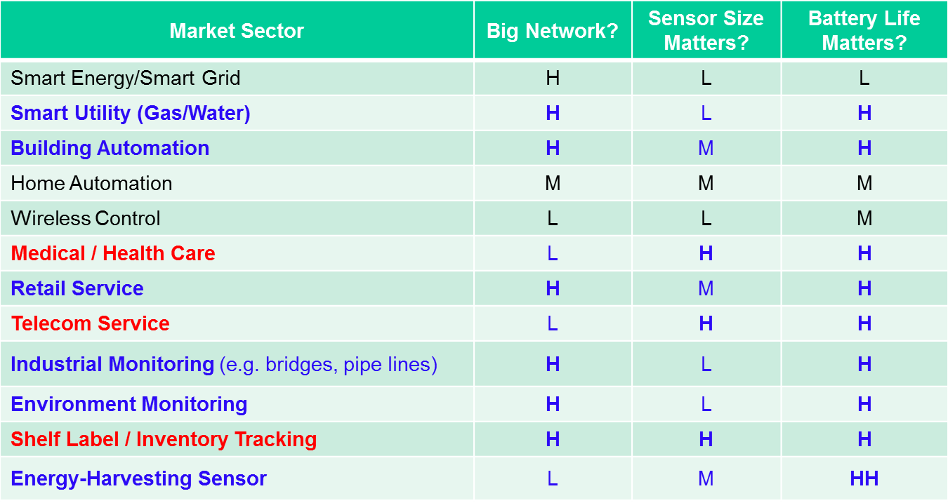
Figure 1—Wireless sensors market analysis

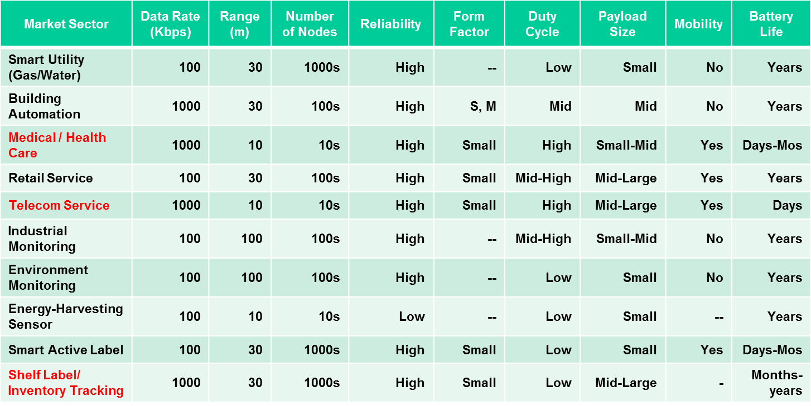
Figure 2—Application requirements

ULP-TASK PHY

Characteristics
- Best suited for non-coherent mode of operation
  - enables low power implementation at the receivers.
  - decodable simultaneously at the coherent receiver also.
- Spreading to enable robustness, data rate scalability and low-complex designs.
- Spreading sequences with good correlation properties
  - sequences with good correlation properties both in coherent (with ternary alphabet) and non-coherent (unipolar binary) modes.
  - performance similar to the best-known sequences in the respective domains. ( W-H codes in coherent mode and OOC in non-coherent mode)
Benefits at the transmitter:
- Low power consumption due to duty-cycling
- Low complexity implementation.
Benefits at the receiver:
- Non-coherent receiver
  - based on Super-regenerative reception (SRR) principle
- eliminates need of mixers, and the demodulation is based on simple envelope detection.
- Reduction in power consumption due to duty-cycling

Comparison of ULP-TASK PHY with 802.15.4 (DSSS)
In this section, the features in ULP-TASK PHY are compared with those in standard 802.15.4 (DSSS) PHY.

Modulation and spreading

In the PHY of 802.15.4 (DSSS), the data-symbols are spread using binary spreading sequences whose chips are drawn from a bipolar alphabet$\{-1, 1\}$. The resultant chip-stream is modulated using OQPSK modulation. Therefore, the receiver needs to perform quadrature processing and coherent demodulation.
In ULP-TASK PHY, the data-symbols are modulated using TASK (ternary on-off keying) whose features and benefits are discussed in the information annex (DCN 15-15-0120-00).

Error control mechanism

There is no error control mechanism used in the PHY of 802.15.4 (DSSS), whereas ULP-TASK PHY employs
- Shortened BCH (63, 51, 2) codes with bit-level interleaving
- Non-binary single parity check codes (SPC)
Use of FEC mechanism in ULP-TASKPHY contributes to approximately an SNR gain of 3 dB in the link margin. Simpler encoding and decoding algorithms have been explored which support low-complexity implementation. It should be specifically noted that, for a BCH code with an error correcting capability of 2, many variants of low-complexity implementations are available in the literature.

Comparison of system parameters

Comparison of power consumption figures of 802.15.4 (DSSS) with ULP-TASKPHY is given in the Table 1.
Table 1—Comparison of power consumptions of 802.15.4 (DSSS) and TASK PHY

System parameters | 802.15.4(DSSS) | ULP-TASKPHY
Transmitter power consumption | 12 mW | 6.3 mW
Receiver power consumption | 15 mW | 3.1 mW
Data rate | 250 kbps | 126 kbps-1 Mbps

Comparison of energy consumption between 802.15.4 (DSSS) and ULP-TASK is given in Table 2. A single super-frame was considered that consists of one beacon interval and one PPDU with a given data rate, followed by the ACK. For this super-frame, total energy consumption is evaluated for ULP-TASK PHY as well as for other existing PHYs. The following are the assumptions made in carrying out the analysis:
- Sleep current =$1 μA.$
- Data rate of the beacon frame = 126.25 Kbps.
- Beacon size = $30$ bytes.
- Transmitted packet size = 10 bytes.
- ACK size = 5 bytes.

Table 2—Comparison energy consumption of 802.15.4 (DSSS) and TASK-PHY
PHYs | Datarate (in Kbps) | Beacon Order | Beacon Interval (in milliseconds) | Energy required/ beacon interval (in micro joules)
OQPSK-DSSS | 250 | 0 | 15.36 | 44.2
ULP-TASK | 126.25 | 0 | 15.36 | 16.9
ULP-TASK | 1000 | 0 | 15.36 | 10.4
OQPSK-DSSS | 250 | 8 | 3932.160 | 56.04
ULP-TASK | 126.25 | 8 | 3932.160 | 28.67
ULP-TASK | 1000 | 8 | 3932.160 | 22.28

ULP-GFSK PHY

Characteristics
The ULP-GFSK PHY in this amendment achieves the power and energy saving by several means:
- Transmit Power Control
- Supporting the formation of Asymmetric Link Networks
- Increased data rate to minimize on-time
- Rate Switching
- Overhead reduction
- Wide band digital modulation

Transmit Power Control
The ULP-GFSK PHY introduces Transmit Power Control (TPC). For example, when device-A receives a first data frame from device-B it may inform device-B to adjust its transmit power by including a ULP-GFSK TPC IE in its enhanced acknowledgement. When device-B receives the ULP-GFSK TPC IE, it may reduce its transmit power during transmission of a second data frame to device-A. This will reduce the transmit power consumption in device-B.
To avoid lock-up the transmit power may be increased in cases where the acknowledgement is not received.
TPC is an optional feature in the ULP-GFSK PHY. The power control algorithm is not part of the ULP-GFSK PHY.
TPC will not break CSMA/CA as long as the power control is reduced as appropriate. E.g. a close-by device may blast the receiver with -40dBm. With TPC that may be reduced to -43dBm which will not break CSMA/CA but it may save energy. As an example: ~4mW power reduction would be obtained when the RF power is reduced from +5dBm to +2dBm assuming a PA efficiency of 40%. With a 15mW budget in mind, as mentioned in the PAR, this is a significant saving.
Additional advantage of TPC: Nodes that are able to reduce their output power will also reduce the probability of destructive interference resulting in fewer collisions and retransmissions.

Asymmetric Link Networks
The ULP-GFSK PHY introduces the Asymmetric Link Networks (ALN) which has great potential to save energy in all end nodes of a star network by alleviating their transmit and receive requirements.
An Asymmetric Link Network (ALN) may be formed in a star network. A device being part of an ALN will have a different MCS for transmit compared to its receive MCS. The formation of an ALN may be particularly useful when the central coordinator device employs a higher receive sensitive and transmit power compared to the end node devices in the network. In an ALN the coordinator is preferably a high performance mains powered device which may leverage its excess in sensitivity and transmit power to alleviate these requirements in the end node devices. Lowering the end node requirements for transmit power and receive sensitivity helps to prolong their battery life. In addition, the slightly higher cost of the coordinator allows all the end node devices to be low cost which helps to reduce the overall cost of the network.
As an example the coordinator device may use a coherent receiver optimized for MCS-6 (500 kbps at modulation index 0.5) with FEC capability. Given a proper receiver design and using FEC combined with differential pre-coding and GMSK may improve the receive sensitivity by up to 8 dB (see document 15-14-0072-00-004q-Joint ULP-GFSK PHY layer proposal). The improved sensitivity in the coordinator allows the end nodes to operate with a lower transmit power.
To continue the example, the end node devices may be equipped with a non-coherent FSK receiver optimized for MCS-4 (500 kbps at modulation index 0.72) without FEC decoding capability but with FEC encoding capability. The higher transmit power of the coordinator permits the end devices to operate with less sensitivity which allows for a current reduction in their receiver components such as LNA and demodulator and absence of FEC decoding. The FEC encoding involves low complexity and its power consumption is insignificant.

Notice that in link budget calculation below how the noise figure and transmit power are relaxed in the end nodes while maintaining a balanced link budget.

Table 3—Link budget example of Asymmetric Link Network

 |  | uplink | downlink
TX | Over-the-air data rate [kSymbols/s] | 1000 | 500
 | Distance [m] | 30 | 30
 | TX antenna gain [dBi] | -5 | 0
 | Center frequency [MHz] | 868 | 868
 | Transmit power [dBm] | -5 | +5
Channel | Path loss [dB] (PL exponent 2.7) | 71 | 71
RX | RX antenna gain [dBi] | 0 | -5
 | Received signal strength [dBm] | -86 | -71
 | Receiver noise figure [dB] | 5 | 10
 | Min. Eb/N0 @1% PER [dB] | 3.2 | 12.1
 | Implementation loss [dB] | 2 | 2
 | RX sensitivity [dBm] | -103.8 | -92.9
 | Link margin [dB] | 22.8 | 21.9

The transmit power in uplink direction can be reduced, as differential encoding and FEC reduce the signal energy necessary for successful decoding. In downlink direction the concentrator device makes up for the missing differential encoding and FEC in the end node by an increased transmit power.
In an ALN the link budget in the uplink direction is characterized by a relatively low transmit power and high receive sensitivity while in downlink direction that is reversed so that the link budget in both directions is balanced.

Options for higher data rate
Higher data rate capabilities in IEEE 802.15.4q can reduce the active time in both transmit and receive which saves energy. The highest rate specified in the 4q draft is 1 Mbps which is 2.5 times higher than available in the SUN-FSK PHY. The added advantage is a lower interference footprint resulting in fewer collisions and retransmissions.

Rate Switch
The Rate Switch is signaled in the PHR by the Rate Switch bit. When enabled the Rate Switch is seamless between PHR in 2GFSK and PSDU in 4GFSK. The modulation indices of the 2GFSK and 4GFSK modulation types are specified such that the outer deviation is identical and hence the modulation bandwidth is close to identical. The seamlessness, simplicity and ease of implementation make the Rate Switch feature unique. Nodes communicating with sufficient link budget can use the Rate Switch to reduce the active time in both transmitting node as well as the receiving node and save energy on both sides of the link.

Overhead Reduction
IEEE 802.15.4q is energy efficient as it utilizes shorter preambles and PHY header. Consequently, 15.4q is more energy efficient than PHY 802.15.4f, 802.15.4g and 802.15.4k. As an example: transmission of 4 data Bytes, followed by a short ack. In MR-FSK this will take 23 Bytes (PANID and short addresses) for the data transfer and 13 Bytes for the short ack. Using the ULP-GFSK PHY both data transfer and short ACK are reduced by 3 Bytes = 20% saving.

Wideband Digital Modulation
MCS-4 may be used for wideband digital modulation according to FCC part 15.247 which allows for transmit power in excess of -1.23 dBm without requiring frequency hopping. The elimination of the overhead related to frequency hopping saves energy. In addition the data rate of MCS-4 is relatively high which allows for short on-air time which saves energy as well.

Comparison of ULP-GFSK PHY with existing PHYs

While IEEE 802.15.4 already has some FSK based PHYs in several amendments, this combination of features is unique to 4q and cannot be found in any other amendment. A comparison between different amendments is provided by Table 4.
Table 4—Comparing ULP-GFSK to other 802.15.4 PHYs
 | 802.15.4-2011 DSSS | 802.15.4g MR-FSK | 802.15.4f  MSK | 802.15.4k  FSK | 802.15.4q ULP-GFSK
Min. Preamble Length | 4 octets | 4 octets | 4 octets | 4 octets | 2 octets
Min PHR Length | 1 octet | 2 octets | 1 octet | 2 octets | 1 octets
Max. Datarate | 250 kbps | 200 kbps | 250 kbps | 37.5 kbps | 1000 kbps
Datarate doubling | No | Between frames with mode switch  Adds overhead | No | No | Seamless within one frame using just a single signaling bit
FEC Support | No | Yes, K=4 | No | Yes, K=7 | Yes, K=7
TX Power control | No | No | No | No | Optional

Power consumption
FSK is widely adopted. The PAR requirement of 15mW is not an issue. There are several deveopments that shows that the power consumption in continuous receive mode can be less than 5mW [1][2].

Energy efficiency

Energy efficiency is a major concern in an ULP centered approach. The mechanisms in ULP-GFSK address this issue with a high maximum data rate which helps to reduce the on-time during transmitting and receiving. In addition, overhead in the SHR and PHR is reduced considerably. These improvements result in a very short on-time that greatly reduces consumed energy.
In a comparison of the PSDU efficiency and on-time is shown. The PPDU efficiency is calculated as follows:
$$η_{PSDU}=\frac{T_{PSDU}}{T_{SHR}+T_{PHR}+T_{PSDU}}$$

As an example a PSDU of 5 octets, i.e. one ACK frame, has been chosen. Additionally the relative energy consumption is calculated by the following equation:
$$r_{EC}=\frac{on-time}{on-time_{4q}}$$

The comparison in Table 5 shows that the ULP-GFSK PHY has the highest PPDU efficiency. If the data rate is taken into account the relative energy consumption shows the advantage of the ULP-GFSK PHY compared to the other amendments. The MSK PHY from the 4f amendment is closest in terms of relative energy consumption. However it still consumes 4.4 times more energy than the ULP-GFSK PHY. This clearly shows the potential of the ULP-GFSK PHY contributed to its dual strategy to reduce overhead and increase data rate.
Table 5—Comparison on energy efficiency

PHY | min preamble  [octets] | SFD  [octets] | PHR  [octets] | PSDU  [octets] | PPDU efficiency  $$η_{PSDU}$$ | data rate  [kpbs] | on-time  [µs] | relative energy consumption  $$r_{EC}$$
4  (DSSS) | 4 | 1 | 1 | 5 | 0.45 | 250 | 352 | 4.4
4f
(MSK)
4g  (MR-FSK) | 4 | 2 | 2 | 5 | 0.38 | 200 | 520 | 6.5
4k  (FSK) | 4 | 3 | 2 | 5 | 0.36 | 37.5 | 2987 | 37.3
4q  (ULP-GFSK) | 2 | 2 | 1 | 5 | 0.50 | 1000 | 80 | 1.00

Addressing use case scenarios

Mobile healthcare

Mobile healthcare broadly involves the use of sensor networks in medical care. In mobile healthcare, a person/patient is attached with tiny, wearable wireless sensors. Traditionally, most sensor networks have been designed with intent to support data flows with homogeneous traffic with no variations in QoS of different flows. Further, sensor networks are designed to support communication at relatively low data rates. However, deviating from the traditional view, mobile healthcare brings up the necessity to design sensor networks with following requirements:
- Design of ultra low power transceivers with low complexity.
- Communication protocols with high reliability.
- Support for various data flows with variable traffic characteristics.
- Support for simultaneous transmissions to receivers of different modes.

With the above factors in mind, IEEE 802.15.4q ULP-TASK is deisgned with an objective to support mobile healthcare applications. It involves PHY protocols supporting ULP and low-complexity implementations, variable datarates and support transmissions to receivers of different modes.

Comparison of energy consumption
In what follows, we illustrate the benefit of IEEE 802.15.4q ULP-TASK over legacy IEEE 802.15.4 through an example particular to medical healthcare. Based on the range of datarate requirements, we consider two medical sensor devices: ECG monitor and the temperature/humidity sensor. The typical traffic characteristics of these functionalities are as given in Table 7.

Table 7—Traffic characteristics of data for mobile healthcare
Node | Apps | Packet Size  (Byte) | Packets  per sec | Data Rate  (Kbps) | Mode
1 | ECG | 127 | 4 | 4.064 | CFP
2 | Humidity, Temperature, Battery | 16 | 2 | 0.256 | CAP

The following table gives the comparison of 15.4q ULP-TASK with 15.4 legacy protocol.

Table 8—Comparison of energy consumtion between ULP-TASK and 802.15.4 legacy network

Parameter | 15.4q Mobile Heathcare  (net datarate of 500Kbps) |  | 15.4 Legacy
 | Humidity, Temperature, Battery | ECG | Humidity, Temperature, Battery | ECG
Tx Power (mW) | 7 | 7 | 7 | 7
Rx Power (mW) | 4 | 4 | 15 | 15
Beacon Length(for 30 Bytes) ($μs$) | 2368 | 2368 | 1392 | 1392
Packet Length ($μs$) | 704 | 2480 | 704 | 4256
Number of packets | 2 | 4 | 2 | 4
ACK Length ($μs$) | 765 | 765 | 352 | 352
APNode  Rx energy consumption  ($μJ$) | 16 | 22 | 42 | 42
APNode  Tx energy consumption  ($μJ$) | 27 | 38 | 19.6 | 19.6
NodeAP  Rx energy consumption  ($μJ$) | 6 | 40 | 21 | 255
NodeAP  Tx energy consumption  ($μJ$) | 10 | 69 | 10 | 120
Energy comsumption in sleep mode ($μJ$) | 3 | 3 | 3 | 3
Total energy consumed in one sec ($μJ$) | 62 | 172 | 96 | 437

Telecom services
Telecom service application enables the applications of mobile phones interacting with personal equipment, data exchange between mobile phones, payments etc. The typical data rate requirements of telecom service can go upto 100kbps to 1 Mbps aggregate. However, the single node may have data rate requirements upto 10 kbps. In this example, we have considered the data rate of 5 kbps for demonstrating the energy efficiency improvement of 4q.

Table 10—Traffic characterstics of telecom services application

Packet size | Number of packets/s | Upload traffic | Download traffic
127 bytes | 5 uplink, 5 downlink | 5 kbps | 5 kbps

Table 11--Comparison for energy consumption
Parameter | 15.4q (net data rate of 500 kbps) | 15.4 Legacy
Transmitter power (5 dBm) (mw) | 7 | 7
Rx Power (4q) (mW) | 4 | 15
Beacon Length(30 Bytes) ($μsec$) | 2368 | 1152
Packet Length (127 bytes including MAC overhead) ($μsec$) | 2448 | 4292
Ack Lenth ($μsec$) | 528 | 352
Energy consumed in Rx ($μJ$) | 86.24 | 369
Energy consumed in Tx ($μJ$) | 104 | 164
Sleep energy (1 uA current) ($μJ$) | 3 | 3
Total energy consumed in one sec ($μJ$) | 193.24 | 546

Inventory management
In a typical case of inventory management application, the central server will be requesting the data from the zigbee routers placed appropriately in the building/shop. The zigbee router in turn might be communicating through the intermediate coordinator or directly with the active labels attached to the different products in the shop. The direct communication between the central coordinator and the end devices would be prohibitive in terms of the power consumption due to huge transmit power requirements. With this architecture, typically, each node shall have a capability to communicate 10 bytes of data once in a minute or more for a range of 10m. However, the node shall have capability to get synchronized with network and check for any requests coming from the central coordinator periodically for every second.

With an Rx sensitivity of -85 dBm, path loss of 70 dBm with path loss exponent of 2, the transmit power requirement for an end node shall stand at -15 dBm for lowest data rate. For the highest rate, the transmit power requirement would be -7 dBm. The overall system power requirement for the transmitter for EIRP of upto -3 dBm is 7 mW. This is because the transmitter power requirement is mainly dominated by RF circuit rather than the EIRP required. With these assumptions, the energy required for the node for a sec is calculated as shown in table below. The energy required for 1 sec is 20 nJ for 15.4q PHY as against 32 nJ for the 15.4 PHY.

Table 9—Energy consumption comparison

Parameter | 15.4q (net data rate of 800 kbps) | 15.4q (net data rate of 500 kbps) | 15.4 Legacy
Transmitter power (mW) | 7 | 7 | 7
Rx Power (4q) (mW) | 4 | 4 | 15
Beacon Length(30 Bytes) | 2368 | 2368 | 1152
Packet Length (25 bytes including MAC overhead) (usec) | 698 | 848 | 992
Ack Lenth (usec) | 498 | 528 | 352
Energy consumed in Rx ($μJ$) | 11.464 | 11.584 | 22.56
Energy consumed in Tx ($μJ$) | 4.886 | 5.936 | 6.94
Sleep energy ($μJ$) | 3 | 3 | 3
Total energy consumed in one sec ($μJ$) | 19.35 | 20.52 | 32.5

Shelf labeling

To illustrate the energy saving potential of the ULP-GFSK PHY, an exemplary calculation has been conducted to estimate battery lifetime of a shelf labeling system. For comparison, the same calculations have been done for a 15.4f (MSK PHY), a 15.4g (SUN-FSK) and a OQPSK DSSS system.

The communication scenario used for the calculation can be described as follows: A star topology network is assumed for a shelf label system. The central coordinator builds a beacon-enabled network and updates the shelf labels with information announced in the beacons. Each shelf label end node receives information every n-th hour and requests the data. Communication schedule from the perspective of an end-device is as follows:

- Receive Beacon from central node (PSDU = 30 Octets)
- If there is data announced, the shelf label sends data request command frame to central node (PSDU = 11 Octets)
- Central node responds with ACK (PSDU = 5 Octets)
- Central node sends secured data frame with new pricing. (PSDU = 30 Octets)
- Shelf label responds with ACK (PSDU = 5 Octets)
- Set device to sleep state

For the battery life estimation the following values have been assumed:

- A 240 mAh CR2032 coin cell battery with approx. 100 nA self-discharge current
- ULP-GFSK end devices using ALN: NF = 12dB, I_RX = 4 mA, P_TX = -5 dBm, I_TX = 6 mA
- Other 15.4 end devices: NF = 8dB, I_RX = 6 mA, P_TX = 0 dBm, I_TX = 7 mA
- 0.7 µA current consumption in sleep state

Table 9—Comparison on battery lifetime
Amendment | Beacon interval  [s] | Data rate  [kpbs] | Data interval  [s] | Battery lifetime [years]
15.4  (DSSS) | 0.5 | 250 | 3600 | 1.9
15.4f  (MSK) | 0.5 | 250 | 3600 | 1.8
15.4g  (MR-FSK) | 0.5 | 200 | 3600 | 1.4
15.4q  (ULP-GFSK) | 0.5 | 1000 | 3600 | 8.0

The low energy aspects of the ULP-GFSK become clear when looking atTable 9. Using the ULP-GFSK PHY results in more than four times longer battery lifetime than the other PHYs.

IEEE 802.15.4q vs. Bluetooth Smart

IEEE 802.15.4q has the following advantages, comparing to Bluetooth Smart™:
- A wireless communication device operating in sub-GHz bands requires far less power compared to devices operating in 2.4 GHz. Power efficiency is equivalent to longer battery life. Bluetooth Smart, also known as Bluetooth LE, only operates in 2.4 GHz. In contrast, IEEE 802.15.4q PHY operates in both 2.4 GHz as well as sub-GHz bands. In fact, IEEE 802.15.4q could operate in a frequency band as low as 169 MHz. As such, IEEE 802.15.4q enables longer battery life compared to Bluetooth Smart when operating in Sub-GHz bands.
- IEEE 802.15.4q introduces support to asymmetric links. This feature is extremely helpful in a point to multi-point communication. In these applications the sensor nodes would have to operate with extremely low-power. However, the concentrator (PAN Coordinator) may not have this restriction. This new feature eliviate the complexity of the end nodes. Unlike IEEE 802.15.4q, Bluetooth Smart does not have such a feature to enable extremely low power operation of sensor nodes.
- IEEE 802.15.4q utilizes 802.15.4 MAC with some minor modifications to accommodate new PHYs. As such, mesh networking is fully supported. Bluetooth Smart on the other hand does not support mesh networking in a native way.

References

- Paper 25.8, ISSCC-2010 describes an 863-928MHz RF transceiver in 018MOS. The chip consumes 3.5mW in continuous reception.
- Paper 13.2, ISSCC-2015 describes a 3.7mW-RX 4.4mW-TX Fully Integrated Bluetooth Low-Energy/IEEE802.15.4/Proprietary SoC with an ADPLL-Based Fast Frequency Offset Compensation in 40nm CMOS.

