IEEE P802.15
Wireless Personal Area Networks

Project | Dependability Interest Group
Title | Meeting Minutes for March 2015
Date Submitted | March 10, 2015
Source | [Jussi Haapola]  [Centre for Wireless Communications / University of Oulu] | Voice: +358 40 8363 018  E-mail: jhaapola@ee.oulu.fi
Re: | Meeting Minutes
Abstract
Purpose | Minutes of Dependability Interest Group sessions
Notice | This document has been prepared to assist the IEEE P802.15. It is offered as a basis for discussion and is not binding on the contributing individual(s) or organization(s). The material in this document is subject to change in form and content after further study. The contributor(s) reserve(s) the right to add, amend or withdraw material contained herein.
Release | The contributor acknowledges and accepts that this contribution becomes the property of IEEE and may be made publicly available by P802.15.

Tuesday, March 10, 2015, PM1, 13:30

  - Meeting called to order 13:32
By Chair Ryuji Kohno (YNU / CWC-Nippon)
Secretary Jussi Haapola (Centre for Wireless Communication / University of Oulu)

No essential intellectual property in the scope of IG DEP was declared.

  - Roll Call
Notepad for Attendance circulated.

Chair showed IEEE Patent policy.

Chair issued Call for Potentially Essential Patents
No essential intellectual property in the scope of IG DEP was declared.

Ryuji Kohno presented Opening report Doc #204r1

  - Approval of previous meeting minutes
Doc #0047 Minutes were approved.

  - Recall of CFI
Doc #14-449r6 presented by Ryuji Kohno

  - Review received responses to CFI

Doc #0221 was presented by Hiroshi Kobayashi (Nissan)

Real-time definition in Doc #221, some delay acceptable. Desire to capture all data continuously without delay. Secondary target is to do a sample-by-sample monitoring.

In alarm and critical events, millisecond-order delays are the maximum allowed.

Monitoring ranges from once per day to real-time measurements.
Hundreds of sensors per line, communications range at least 20 meters.

How much wireless devices are you using?
- 2.4 GHZ and 5.46 GHz WiFI for automated guided vehicles.
- Quality assurance person checklist with wireless confirmation.

Not enough experience in wireless to say what is missing.

Doc #217 was presented by Ryuji Kohno

Nanotron: simple but efficient UWB solution
What does not work on current UWB?
- Customer wanted small and lightweight solution.
- Receivers currently consume a lot of power.
- Simple, reliable data radio with localization capability does not exist.

Jussi Haapola presented University of Oulu part of the document.

  - Recess at 15:30.

  - Attendees

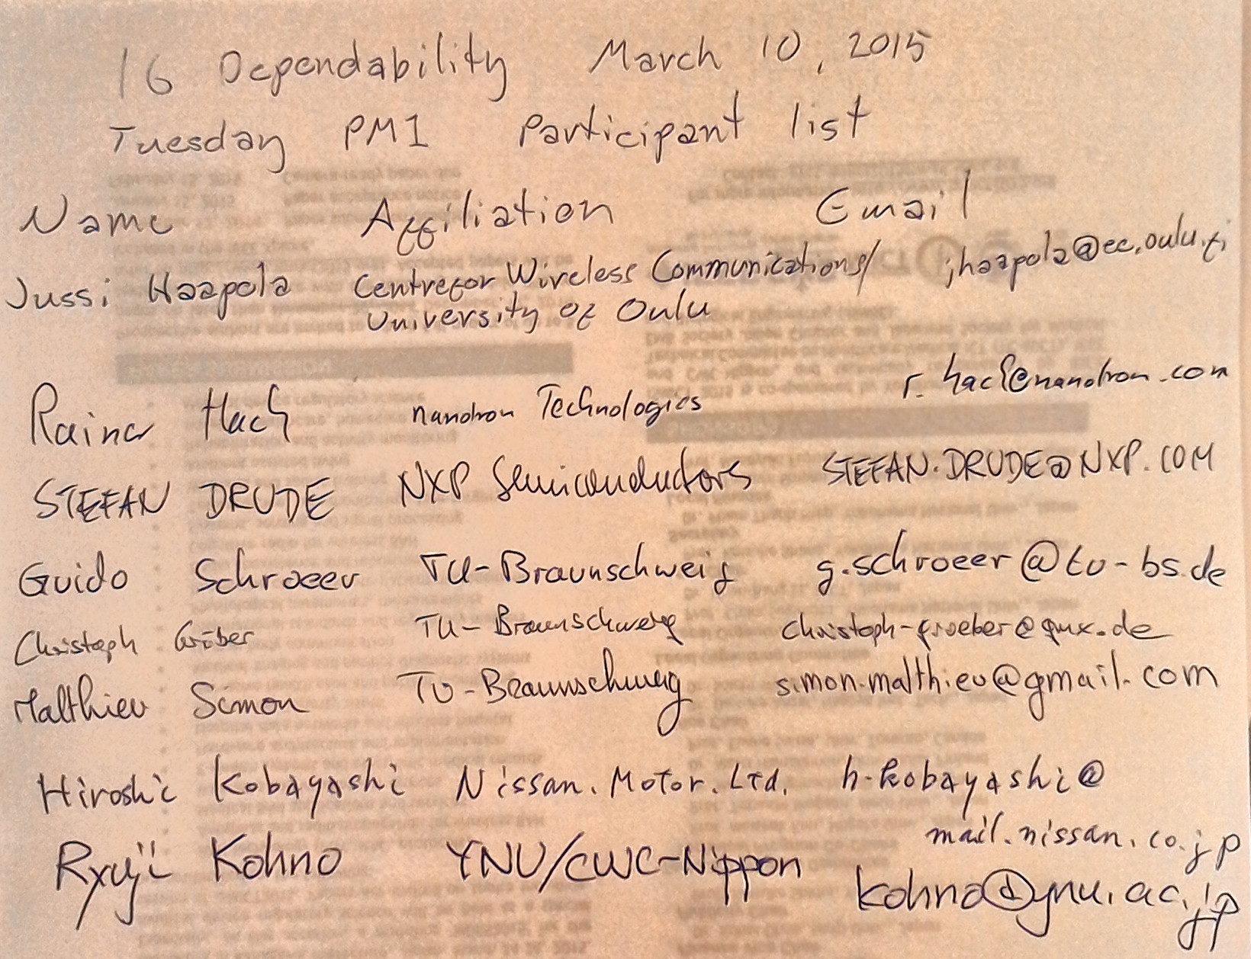

Tuesday, March 10, 2015, PM2, 16:00

  - Meeting called to order at 16:06
By Chair Ryuji Kohno (YNU / CWC-Nippon)
Secretary Jussi Haapola (Centre for Wireless Communication / University of Oulu)

  - Roll Call
Notepad for Attendance circulated

  - Review received responses to CFI
Produces summary of requirements at the end of Doc #217.

Decision to circulate summary of requirements to parties that responded to CFI for further clarifications.

  - Meetings
Telco scheduled Tue 21st PDT 15:00, Wed 22nd April EET 01:00, JST 07:00.
  - Adjourn 18:08.

  - Attendees
