**IEEE P802.15**

**Wireless Personal Area Networks**

|  |  |  |
| --- | --- | --- |
| Project | IEEE P802.15 Working Group for Wireless Personal Area Networks (WPANs) | |
| Title | Contributuion to section 7 in ARD | |
| Date Submitted | [March 9, 2015] | |
| Source | Thomas Kürner | E-mail: t.kuerner@tu-bs.de |
| Re: |  | |
| Abstract | This contribution contains a decription on the backhauling use case for TG3d's Applicaton Requirements Document | |
| Purpose | Supporting document for the development of the amendment 3d of IEEE 802.15.3 | |
| Notice | This document has been prepared to assist the IEEE P802.15. It is offered as a basis for discussion and is not binding on the contributing individual(s) or organization(s). The material in this document is subject to change in form and content after further study. The contributor(s) reserve(s) the right to add, amend or withdraw material contained herein. | |
| Release | The contributor acknowledges and accepts that this contribution becomes the property of IEEE and may be made publicly available by P802.15. | |

# Backhauling

## Description of the operational environment

A backhaul link in a cellular network is a connection between the base station and a more centralized network element, see Fig. 7.1. Backhauling in todays cellular networks is done either by fibre or microwave links. Various drivers exist, which require high-capacity backhaul links. One driver is the enourmous increase of traffic in cellular networks, which may be adressed by the deployment of ultra-dense networks. Another driver is the introdcution of so-called cooperative multi-point trasnmission (CoMP). Both aspects are described in section 7.1.1 and 7.1.2, respectively.

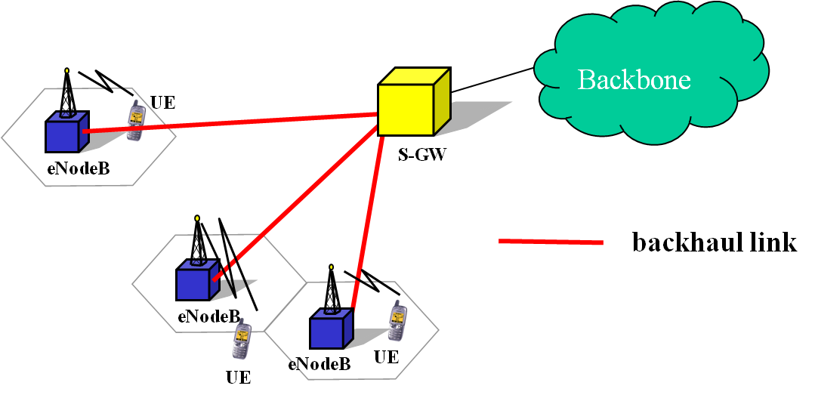

Fig. 7.1 Backhaul links in a cellular network [1]

### Backhauling for ultra-dense Network Deployments

With the foreseen implementation of indoor ultra-high broadband access in fifth generation (5G) systems the backhauling capacity may become critical. For example [3] mentions that traditional backhaul that utilzes narrow bandwidth is regarded as a potential bottelneck for the overall cellulra network. This view is also supported by figures reported in the recently published NGMN 5G White Paper [2], which forecasts an aggregated traffic density of 15 Tbps/km2 for the downlink and 2 Tbps/km2 in the Uplink for indoor ultra-high broadband access. Another application with similar aggregated traffic is broadband access in crowd (e. g. in a stadium), where the NGMN White Paper predicts 0,75 Tbps/stadium in the DL and 1.5 Tbps/stadium in the UL. Such high demand of traffic at local hot spots may require aggregated backhauling, see Fig. 7.2 [1].

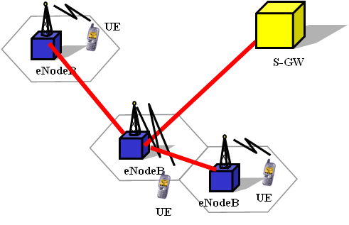

Fig. 7.2 Aggegration of Backhaul links [1]

Since not all network operators have access to fibre networks, wireless backhauling is an obviuos alternative. Since also backhaul networking flexibility is critical to successful deployments [4], wireless backhaul may be advantageous over fibre-based backhauling.

### Backhauling for the Deployment of Cooperative Multipoint Transmission

The tight coordination of transmitted signals by several base stations will reduce interference, which in turn will increase the capacity of the network. Such concepts have been subject to standardistaion in 3GPP [5]. In order to apply this concept each base station requires information about the transmission of all other base stations received within a cell, see Fig. 7.3. This requires high-capacity backhaul connections betweeen all involved cells. The requirement for high backhaul capacity currently restricts deployment of CoMP. Providing sufficient backhauling capacity will be a key enabler for the introdcution of CoMP.

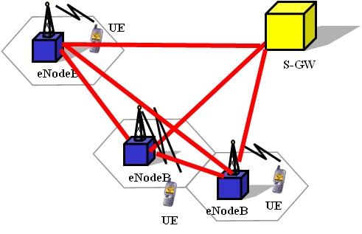

Fig. 7.3 Backhauling between base stations when CoMP is applied [1]

## Definition of a typical transmission range

The typical range for this application is in the order of a few hundred meters up to several kilometers.

## Description of the conditions to achieve the Target data rate

Due to the high attenuation caused by diffraction a line-of-sight condition is required. In addition to the high free-space loss the atmpspheric attenuation [9] becomes important. The attenuation of electromagnetic waves in the atmosphere occurs due to interactions and resonances with the molecules of the atmosphere[9,10]. Especially the water vapour has an important influence on THz-waves. The specific attenuation can be calculated with the ITU-R [11] and *am* [12] models. However, fog and especially rain can lead to a scattering of the THz-waves at the water droplets, which reduces the power at the receiver [13,14]. In most cases the atmospheric attenuation adds to the attenuation of either the fog or the rain, but not both together. If it is assumed that the maximum allowed attenuation for a given application amounts to 100 dB/km, 5 different transmission windows can be allocated in the frequency range between 300 and 900 GHz. The center frequencies and bandwidths of these transmission windows are given in Table 7.1 [9,10].



Table 7.1 Bandwidths and center frequencies of the transmission windows in the frequency range of 330 GHz and 900 GHz with an overall attenuation below 100 dB/km in the worst case

Due to the very high path loss accompanied with THz transmission, for outdoor applications high antenna gains are required. The antenna gain depends on the distance, transmitted data rate, carrier frequency and application. However, an example for a fixed wireless link with a distance of 1 km under worst environmental conditions of a rain rate of 50 mm/h is given in Figure 7. For shorter distances, or better atmospheric conditions, antennas with lower gain can be used. If a transmit power of 10 dBm, a noise figure of 10 dB, and an ambient temperature of 300 K is assumed, the maximum transmittable data rates per GHz bandwidth in a 1 km link are shown in Figure 7.4 [10].



Fig. 7.4 Maximum data rate per GHz as a function of antenna gains and carrier frequency

From Figure 7.4, very high data rates can only be transmitted if the antenna gains are respectively high. For an antenna gain of 50 dBi for the transmitter and receiver antennas a maximum data rate of 25 Gbps can be transmitted in the 76 GHz bandwidth available in the first window. However, if the antenna gain is increased to 70 dBi, the maximum data rate can be increased to about 860 Gbps in the first transmission window.

For 70 dBi antenna gain the angle for loss of connectivity due to fluctuation of the pole and the pole twist is just 0.13°. The requirement for adaptive antenna alignments or control mechanisms to compensate for pole sway/twist depends on the grade of sway/twist impairments, given by the antenna installations, e.g. type of pole or building.

## Specific issues with respect to regulations

Due to he operation in outdoor environments measures to avoid interference of passive services operating in the same band has to be avoided. Results on investigations of potential interference for fixed wireless links are reported in [15,16].

## Specific requirements with respect to the MAC

The application highly-directed antennas used in fixed point-to-point links yields to low interference and low porbability of collision. This may yield in simplified solutions for the MAC.

## Other issues

There is a trend that IP/Ethernet gets more importance as a transport technology for backhauling in mobile networks [4,6,7,8]. The standard shpuld foresee the Capability to carry carrier Etherent packets as paylaod.

## References

[1] T. Kürner, "Requirements on Wireless Backhauling/Fronthauling ", IEEE 802.15-13- 0636-01-0thz, Dallas, November 2013.

[2] NGMN Alliance: "NGMN 5G White Paper" , www.ngmn.org, 17.2.2015

[3] P.Wang, Y. Li, L. Song, B. Vucetic, "Multi-Gigabit Millimeter Wave Wireless Communictions for 5G: From Fixed Wireless Fixed Access to Cellular Networks, IEEE Communcations Magazine, pp. 168-178, Vol. 53, No. 1, January 2015

[4] Alcatel Lucent Application Note; A New Era of Mobile Backhaul; http://resources.alcatel-lucent.com/?cid=163517

[5] Quelle für CoMP

[6] http://www.ericsson.com/ourportfolio/telecom-operators/mobile-backhaul

[7] Transmode Application Note; Ethernet mobile backhaul delivers new services with higher performance and lower costs; http://www.transmode.com/en/resource/application- notes?task=document.download&id=15

[8] Alcatel Lucent Application Note; IP/MPLS Mobile Backhauls for Heterogenous Networks; http://resources.alcatel-lucent.com/?cid=162070

[9] M. Grigat, T. Schneider, S. Preußler, R. P. Braun: Link Budget Considerations for THz Fixed Wireless Links, IEEE 802.15-12-0582-01-0thz, San Antonio, November 2012

[10] T. Schneider, A. Wiatrek, S. Preußler, M. Grigat, R. P. Braun: Link Budget Analysis for Terahertz Fixed Wireless Links, IEEE Transactions on THz Science and Technology 2, 250 – 256 (2012)

[11] Attenuation by Atmospheric Gases, ITU Rec. ITU-R P.676-8, ITU, Oct. 2009

[12] “The *am* atmospheric model, submillimeter array,” Tech. Memo #152 <https://www.cfa.harvard.edu/~spaine/am/>

[13] “Attenuation due to clouds and fog”, ITU Rec. ITU-R P.840-4, ITU, Oct. 2009

[14] “Specific attenuation model for rain, for use in prediction methods”, ITU Rec. ITU-R P.838-3, ITU, 2005

[15] S. Priebe, D. M. Britz, M. Jacob, S. Sarkozy, K. M. K. H. Leong, J. E. Logan, B. S. Gorospe, T. Kürner: Interference Investigations of Active Communications and Passive Earth Exploration Services in the THz Frequency Range“, accepted for publication in IEEE Transactions on THz Science and Technology, 14 pages, 2012

[16] S. Priebe: Interference between THz Communications and Spaceborne Earth Exploration Services, IEEE 802.15-12-0324-00-0thz, San Diego, July 2012