IEEE P802.15
Wireless Personal Area Networks

Project | IEEE P802.15 Working Group for Wireless Personal Area Networks (WPANs)
Title | IG HRRC (High Rate Rail Communications) Call for Participation (CFP)
Date Submitted | 10 March, 2015
Source | [Bing Hui; Junhyeong Kim]  [ETRI]  [218 Gajeong-ro, Yuseong-gu, Daejeon, 305-700, KOREA] | Voice: [+82-42-860-5324]  Fax: [+82-42-860-6732]  E-mail: [huibing@etri.re.kr]
Re: | [IEEE P802.15 IG HRRC is chaptered for driving on the standardization activities of high-rate mobile hotspot communications.]
Abstract | [This is a Call for Participation for IEEE P802.15 IG HRRC.]
Purpose | [Request for participation to IEEE P802.15 IG HRRC.]
Notice | This document has been prepared to assist the IEEE P802.15. It is offered as a basis for discussion and is not binding on the contributing individual(s) or organization(s). The material in this document is subject to change in form and content after further study. The contributor(s) reserve(s) the right to add, amend or withdraw material contained herein.
Release | The contributor acknowledges and accepts that this contribution becomes the property of IEEE and may be made publicly available by P802.15.

IG HRRC Call for Participation

The IEEE P802.15 Interest Group “High Rate Rail Communications” is issuing a Call for Participation to invite your participation to the IG HRRC meeting. IEEE P802.15 IG HRRC is chartered to study the high-mobility wideband hotspot communications with interest in transitioning to a Study Group in anticipation of creating a Project Authorization Request (PAR) and Five Criteria (5C). Your participation will help the Interest Group better gauge the level of interest for driving on the standardization activities of high-rate mobile hotspot communications.

- BACKGROUND

Due to the proliferation of smart devices (e.g. smartphones, tablets, televisions, etc.) and a wide range of applications requiring a large amount of data traffic anytime, anywhere, providing high quality service at high speed emerges as one of new potential use cases for the future IMT system [1]. Higher and higher data rate has been requested by the mobile subscribers recently. Figure 1 shows the Internet usage in different environments in Korea. Obviously, the proportion of demand on vehicles is quite high, and it is required to provide a similar user experience for end-users on the move as when they are static (e.g. at home or in the office). Therefore, a promising communication system will be necessary for maintaining high quality at high speed which enables successful deployment of applications on user equipment (UEs) located within a moving platform such as buses, subways or high-speed trains which are being deployed in several countries.

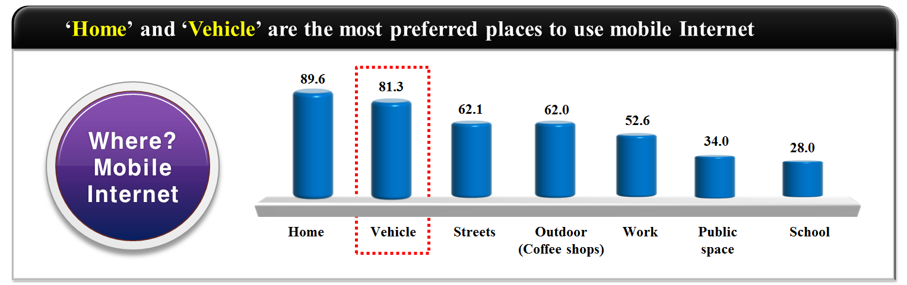
Figure 1 Survey 2012 for Mobile Internet Usage by Korea Internet & Security Agency

- CONCERNS OF IG HRRC

The IEEE P802.15 IG HRRC concerns with the mobile wireless backhauling for the high-mobility hotspot user groups. Both mmWave frequency band and sub 6GHz frequency band, shown as Figure 2, are considered to be occupied to establish the broadband wireless backhauling links for the outside of the fast moving vehicles, when the sub 6GHz frequency band is employed for the wireless access links for the inside of the vehicles. WiFi or femtocell technologies can be deployed to support the intra-vehicle services.

- Backhauling links (outside of the vehicles): supporting Gbps data rate
- Access links (inside of the vehicles): sub 6 GHz band employing WLAN or femtocell technologies

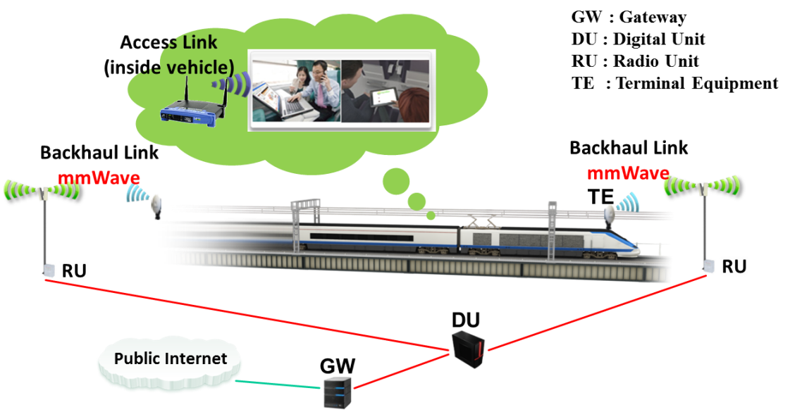
Figure 2 The Concept of High Rate Rail Communications

Finally, user groups using common UEs inside of the fast-moving vehicles should be able to achieve the Gbps data rate with high performance. The application scenarios are given as below:

- Scenario 1: subway
- Scenario 2: high-speed train (including normal-speed train)
- Scenario 3: high-speed bus (high way environment)
- Scenario 4: normal vehicles (general environment)

- CHALLENGES AND OPEN PROBLEMS

The IEEE P802.15 Interest Group HRRC greatly appreciates your opinion and response to the challenges below. Your input will help us to support the industry’s standardization efforts.

- Coverage Improvement
  - Path loss and atmospheric attenuation especially in the case of employing millimeter-wave

- Synchronization
  - Accurate Freq. & time sync.

- Doppler Effect
  - Large amount of Doppler shift

- High-speed Handover
  - Massive HO
  - Frequent HO
  - Outage/failure rate

- Tunnel Environment
  - Dedicated channel environment
  - Block of LoS link

- Etc.

- REFERENCES

- IMT Vision – “Framework and overall objectives of the future development of IMT for 2020 and beyond

