IEEE P802.15
Wireless Personal Area Networks

Project | IEEE P802.15 Working Group for Wireless Personal Area Networks (WPANs)
Title | Data Center Text for ARD
Date Submitted | 13 Jan 2015
Source | Rick Roberts  Intel  [address] | Voice: [ ]  Fax: [ ]  E-mail: Richard.d.roberts@intel.com
Re: | [If this is a proposed revision, cite the original document.]  [If this is a response to a Call for Contributions, cite the name and date of the Call for Contributions to which this document responds, as well as the relevant item number in the Call for Contributions.]  [Note: Contributions that are not responsive to this section of the template, and contributions which do not address the topic under which they are submitted, may be refused or consigned to the “General Contributions” area.]
Abstract | [Description of document contents.]
Purpose | [Description of what the author wants P802.15 to do with the information in the document.]
Notice | This document has been prepared to assist the IEEE P802.15. It is offered as a basis for discussion and is not binding on the contributing individual(s) or organization(s). The material in this document is subject to change in form and content after further study. The contributor(s) reserve(s) the right to add, amend or withdraw material contained herein.
Release | The contributor acknowledges and accepts that this contribution becomes the property of IEEE and may be made publicly available by P802.15.

Data Center

Description of the operational environment
The following information is taken from [2].

In order to apply wireless links in data centers beamforming capabilities are required, as shown in Fig. 6-1, and includes the following features:

- Beamforming capabilities both in azimuth and elevation
- Ceiling reflectors (aluminum plates or other good reflecting materials)
- Electromagnetic absorbers on top of the racks to prevent local reflection/scattering around the antenna

ceiling
Reflector
LOS
Multi Hop
Indirect LOS
(3D Beamforming)

Fig. 8-1 LOS and Indirect LOS Paths [4,5]

Traditional DCN architectures are based on layered 2-tier (3tier-) architectures with core, (aggregation) and access layers [3] A couple of specific arrangements of the servers racks exploring the possibilities to introduce wireless links are proposed as well.

In Fig. 8-2 to 8-4 some of these proposals are presented.

Fig. 8-2 Node Arrangements – Two Parallel Rows [3]

Fig. 8-3: Node Arrangements – Hexagonal Shape [3]
Intra-Rack Links
Inter-Rack Links
Fig. 8-4: Node Arrangements in a Cayley Data Center [4]

Data center infrastructure [1]
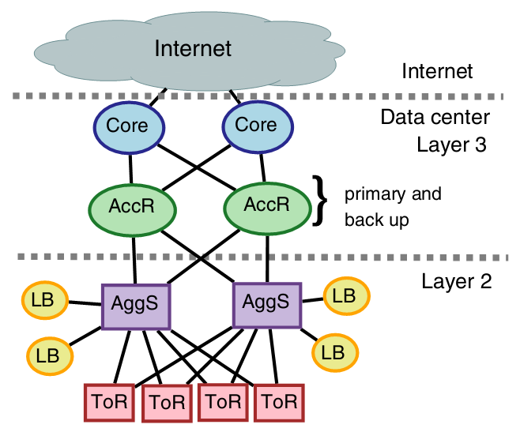

3-Tier Data center Infrastructure [1]

Core Layer
The data center core is a Layer 3 domain built with high-bandwidth links (10 GE or a bunch of 10GE)

Aggregation Layer
Supports Layer 2 and Layer 3 functionality; using 10 Gbps links.

Access Layer/ToR
A Layer 2 domain
ToR using 1Gbps links

Topology is tradeoffs
Emerging 40G Ethernet , performance bottlenecks
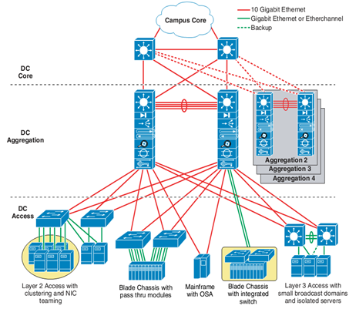

Definition of a typical transmission range
Over the last two decades, data centers have become increasingly larger. Today data centers can be the size of an indoor sports field; however, the size of the data center alone does not dictate the transmission range. The transmission range is a function of the antenna gain and the transmit power, neither of which are severely constrained in the data center environment. Depending upon the switch configuration, ranges of 10 meters to 100 meters would be in order. Keep in mind that fiber optics is still the preferred alternative to wireless switching.

Description of the conditions to achive the Target data rate
It is anticipated that the data center channel will be line-of-sight, which includes reflecting the signal off an RF mirror.

Specific issues with respect to regulation
The data center environment is an industrial environment and it is not clear at this time as to regulatory constraints. Clearly, if a human is exposed to the RF (in the line-of-sight path) then there are health concerns. But one must not assume that the data center wireless channel is easily accessible by humans. For example, the RF switch path can be an enclosed plenum area near the ceiling that would require a deliberate action by a human to be exposed to RF.

Specific requirements with respect to the MAC
The MAC should support switched beam line-of-sight.

Required BER
The wireless switch should be competitive to fiber optics in regards to bit errors. A bit error rate of 10e-12 would not be unreasonable. Obviously this will require the appropriate coding.

Multi-user Access
It is felt that the data center environment would be better served by spatial division multiplexing than by frequency division multiplexing. One reason is it is desirable to maintain as high of data as possible with the lowest Eb/No possible, which requires adequate bandwidth to accomplish. It is also conceivable that some CDMA (code division multiple access) could be utilized to improve multiple user access capability.

References
[1] Cai Yunlong: Data Center Traffic Characteristics and 100Gb/s Demand, IEEE 802.15-13-0519-00-0thz, Nanjing, September 2013

[2] T. Kürner, Literature Review on Requirements for Wireless Data Centers, IEEE 802.15-13-0411-00-0thz, Geneva, July 2013

[3] H. Vardhan, Wireless Data Center with Millimeter Wave Network, Proc. IEEE Globecom 2010

[4] Zhang W et. al, “3D beamforming for wireless data centers”, in Proceedings of the 10th ACM Workshop on Hot Topics in Networks. 2011

[5] K. Ramchadran, “60 GHz Data-Center Networking: Wireless Worryless?“, 2008

[6] “On the feasibility of Completely Wireless Data Centers“, http://www.cs.cornell.edu/courses/cs6452/2012sp/papers/cayley.pdf

