IEEE P802.15
Wireless Personal Area Networks

Project | Dependability Interest Group
Title | Meeting Minutes for November 2014
Date Submitted | November 4, 2014
Source | [Jussi Haapola]  [Centre for Wireless Communications / University of Oulu] | Voice: +358 40 8363 018  E-mail: jhaapola@ee.oulu.fi
Re: | Meeting Minutes
Abstract
Purpose | Minutes of Dependability Interest Group sessions
Notice | This document has been prepared to assist the IEEE P802.15. It is offered as a basis for discussion and is not binding on the contributing individual(s) or organization(s). The material in this document is subject to change in form and content after further study. The contributor(s) reserve(s) the right to add, amend or withdraw material contained herein.
Release | The contributor acknowledges and accepts that this contribution becomes the property of IEEE and may be made publicly available by P802.15.

Monday, November 3, 2014, PM2, 16:00

  - Meeting called to order 16:05
By Chair Ryuji Kohno
Secretary Jussi Haapola

No essential intellectual property in the scope of IG DEP was declared.

  - Roll Call
Notepad for Attendance circulated.

  - Approval of previous meeting minutes
Doc 543 Minutes were approved.

  - Revisit CFI

  - Responses to CFI
Ryuji showed two emails, one from Nissan, one from Sumitomo Chemistry that expressed interest in standardizing dependable wireless solution for a few applications.
- Bob Heile commented that the responses lack specificity on what is lacking with existing standards or what kind of technical reliability is required to fulfill the applications in the responses.
- Ryuji proposed a two-step process in CFI. First, get understanding of interest; second, get detailed information from those who expressed interest.
- Bob said that usually only one-step process is used as it saves time, but nothing prevents having such a two-step process.
- Bob: if companies do not wish to reveal the applications, they could express the technical requirements they need from wireless solutions or what is lacking in current 802 or ISA, wireless HART, etc. standards.
Security requirements were discussed on how to do it.

Discussion on the range of applications that will be included in the PAR. If there is a too diverse set, then no single amendment or standard can cover them.
- Responses to the CFI and willingness to participate in the standardization will be decisive in the set of applications that will be included in standard development.

Agenda for Tuesday:
- Revise timeline
- Look at 15.6 application matrix and IG DEP application-dependability matrix and identify what was not addressed in 15.6 standard.
- Discuss CFI second stage text.

  - Recess
Recessed at 17:52

  - Attendees
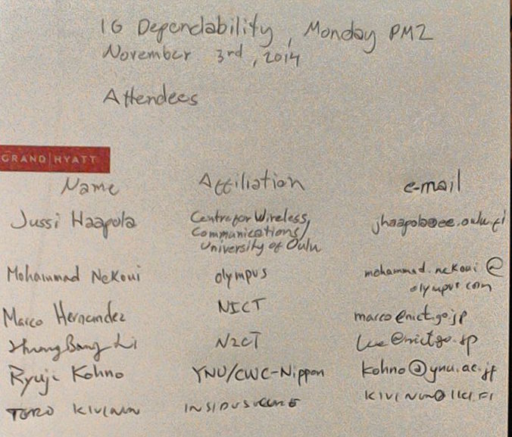

Tuesday, November 4, 2014, AM1, 08:00

  - Meeting called to order 08:03
By Chair Ryuji Kohno
Secretary Jussi Haapola

No essential intellectual property in the scope of IG DEP was declared.

  - Roll call
Notepad for Attendance circulated.

  - Revise tentative timeline
Lead by Jussi Haapola
The timeline was revised, uploaded as Doc #340r2.

  - 15.6 and IG DEP Application matrix review over 15.6 outcomes; what was not addressed in the standard
Lead by Ryuji Kohno

No feedback loop definitions in doc #15-08-0406-00-0006 & #15-08-0135-00-0006.

Feedback loop stability parameters need to be added for automotive purposes and such medical equipment as glucose sensor – insulin pump systems.

Three new parameters need to be added:
- Feedback loop stability
- Response delay
  - E.g. an airbag needs to start deploying within 15 to 30 ms after onset of crash.
- Accuracy of measurement and control
- Requirements of CAN and LIN buses

  - CFI first stage finalization
A few sentences were modified and the timeline for presenting interest was revised in the CFI.

Bob Heile will comment the CFI shortly.

  - Recess
Recessed at 9:51.

  - Attendees
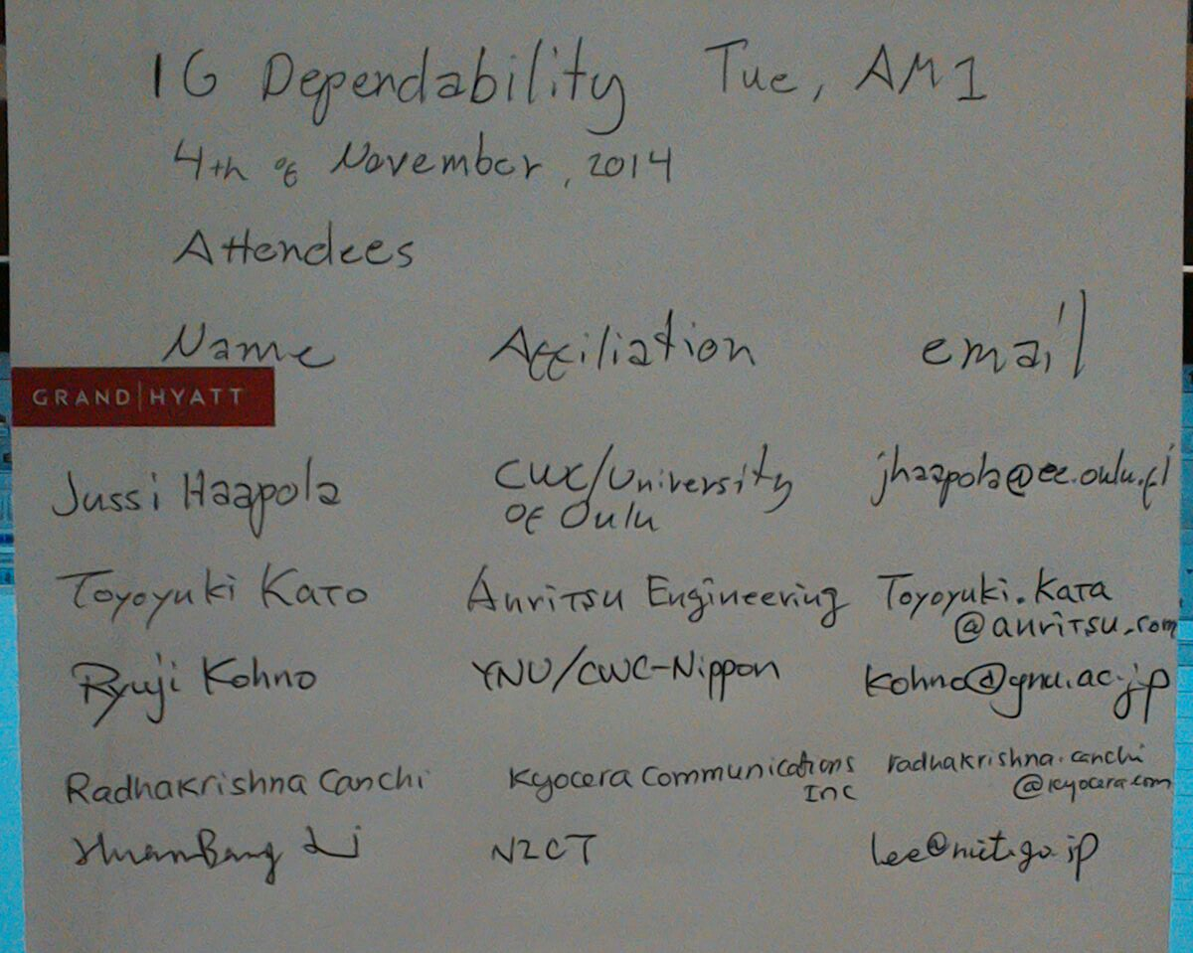

Tuesday, November 4, 2014, AM2, 10:30

  - Meeting called to order 10:37
By Chair Ryuji Kohno
Secretary Jussi Haapola

No essential intellectual property in the scope of IG DEP was declared.

  - Roll call
Notepad for Attendance circulated.

  - Discussion on second stage CFI

The first stage CFI what revised. The CFI is uploaded as Doc # 449r6. The r6 CFI has more detailed questions and submission of the second stage CFI remains open.

  - CSD development

CSD was not addressed at the meeting as CFI information is needed to formulate PAR and CSD.

  - AoB

There was no other business.

  - Adjourn
Meeting was adjourned 12:08.

  - Attendees

