**IEEE P802.15**

**Wireless Personal Area Networks**

|  |  |  |
| --- | --- | --- |
| Project | IEEE P802.15 Working Group for Wireless Personal Area Networks (WPANs) | |
| Title |  | |
| Date Submitted | [16 September, 2014] | |
| Source | [] [] [2-2-2, Hikaridai, Seika, Kyoto Japan] | Voice: [ ] Fax: [ ] E-mail: [ kitazawa@atr.jp ] |
| Re: | [ ] | |
| Abstract | [Working draft for TG4s technical guidance document] | |
| Purpose | [Summaries of technical topics discussed at TG4s] | |
| Notice | This document has been prepared to assist the IEEE P802.15. It is offered as a basis for discussion and is not binding on the contributing individual(s) or organization(s). The material in this document is subject to change in form and content after further study. The contributor(s) reserve(s) the right to add, amend or withdraw material contained herein. | |
| Release | The contributor acknowledges and accepts that this contribution becomes the property of IEEE and may be made publicly available by P802.15. | |

Document Overview

This technical document provides summary of contributions to SG SRU and TG4s regarding Spectrum Resource Measurement and Management.

|  |  |
| --- | --- |
| **List of contributors** | |
| Masayuki Ariyoshi |  |
| Shusaku Shimada |  |
| Takeshi Yamamoto |  |
|  |  |
|  |  |
|  |  |
|  |  |
|  |  |
|  |  |
|  |  |
|  |  |

Table of Contents

**1** **Overview** 4

**2** **Definitions** 4

**3** **Abbreviation and acronyms** 4

**4** **General requirements** 4

**4.1** **PAR** 4

**5** **Use Case** 5

**5.1** **Hospital/Medical/Healthcare** 5

**5.2** **Industrial Automation** 6

**5.3** **Infrastructure Monitoring** 7

**6** **Functional requirements** 8

**6.1** **Radio Resource Measurement** 8

**7** **Performance requirements** 8

**8** **Evaluation methodology** 8

**9** **Regulations** 9

**10** **References** 9

1. **Overview**

This technical guidance document provides summary of contributions to SG SRU and TG4s regarding Spectrum Resource Measurement and Management.

1. **Definitions**
2. **Abbreviation and acronyms**

RRMM Radio Resource Measurement and Management

SRU Spectrum Resource Usage

1. **General requirements**

This clause provides the basic framework of RRMM.

* 1. **PAR**

**Scope of the project:** This amendment to IEEE Std 802.15.4 defines MAC related functions to enable spectrum resource management.

It specifies

* spectrum resource measurements and network performance metrics, such as packet error ratio, delay, etc,
* information elements and data structures to capture these measurements,
* procedures for collecting and exchanging spectrum resource measurement information with higher layers or other devices.

**Need for the Project:** As various wireless systems are deployed in the shared and license exempt frequency bands including 2.4GHz and 915MHz bands, heavy interference has limited performance of the wireless systems. In order for these wireless systems to operate more effectively, a standardized set of spectrum resource measurements is needed that will facilitate management functions in these networks.

**Stakeholders for the Standard:** The stakeholders include manufacturers and users of telecom, medical, environmental, energy, and consumer electronics equipment and manufacturers and users of equipment involving the use of wireless sensor and control networks.



Figure

1. **Use Case**
   1. **Hospital/Medical/Healthcare**

Various wireless systems (WLAN, Bluetooth etc.) are deployed in medical environments.

Requirement

* + - Self-organizing wireless system
    - Spectrum sensing of whole band for searching vacant radio resources
    - Radio resource assignment and network topology management



Figure Image of medical information system in hospital

* 1. **Industrial Automation**

Requirement

* + - Quick additional deployment
    - Quick withdrawal, relocation
    - Inexpensive and reusable



Figure Industrial wireless network

* 1. **Infrastructure Monitoring**

Requirement



Figure

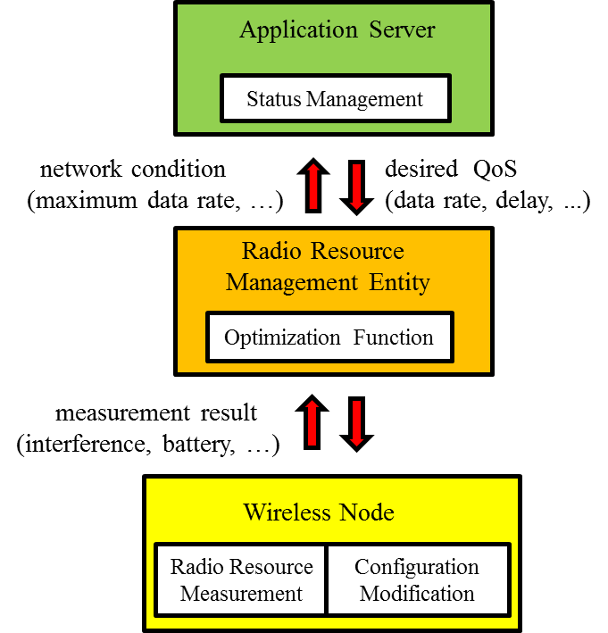

Figure

1. **Functional requirements**

This clause describes functional requirement of RRMM.

* 1. **Radio Resource Measurement**

1. **Performance requirements**
2. **Evaluation methodology**
3. **Regulations**
4. **References**
5. Kitazawa, Establishing a Study Group for a Spectrum Resource Utilization (SRU) through Radio Resource Measurement and Management for WPANs, IEEE 802.15-13-404r1
6. Kitazawa, Overview of SG SRU, IEEE 802.15-13-543r0
7. Additional use case of temporal and flexible industrial network deployment
8. Additional use case of temporal and flexible industrial network deployment, IEEE 802.15-13-654r1
9. Yamamoto et al., Simulation Methodology for SRU, IEEE 802.15-13-660r0
10. Proposal of radio resource management architecture(15-13-0285r1)
11. A Use Case of Self-Organizing Wireless Network for Medical System(15-13-306-0)
12. IG SRU Working Draft RRMM-usecases and 5C(15-13-0294r1)
13. IG SRU Usecase requirements table(15-13-0293r1)