IEEE P802.15
Wireless Personal Area Networks

Project | Dependability Interest Group
Title | Meeting Minutes for September 2014
Date Submitted | September 17, 2014
Source | [Jussi Haapola]  [Centre for Wireless Communications / University of Oulu] | Voice: +358 40 8363 018  E-mail: jhaapola@ee.oulu.fi
Re: | Meeting Minutes
Abstract
Purpose | Minutes of Dependability Interest Group sessions
Notice | This document has been prepared to assist the IEEE P802.15. It is offered as a basis for discussion and is not binding on the contributing individual(s) or organization(s). The material in this document is subject to change in form and content after further study. The contributor(s) reserve(s) the right to add, amend or withdraw material contained herein.
Release | The contributor acknowledges and accepts that this contribution becomes the property of IEEE and may be made publicly available by P802.15.

Monday, September 15, 2014, AM2, 10:30

  - Meeting called to order 10:32
By Chair Art Astrin
Secretary Jussi Haapola

No essential intellectual property in the scope of IG DEP was declared.

  - Roll Call
Notepad for Attendance circulated.

  - Approval of previous meeting minutes
Doc 436 Minutes were approved.

  - Review of tentative timeline
The tentative timeline is still feasible. Distribution of Call for Interest needs to be carried out as soon as possible

  - Review Call for Interest
Key emphasis has to be on what cannot be implemented with currently existing standards, what is the problem on current standards for adoption of wireless communications devices.

  - Recess
Recessed at 12:30

  - Attendees
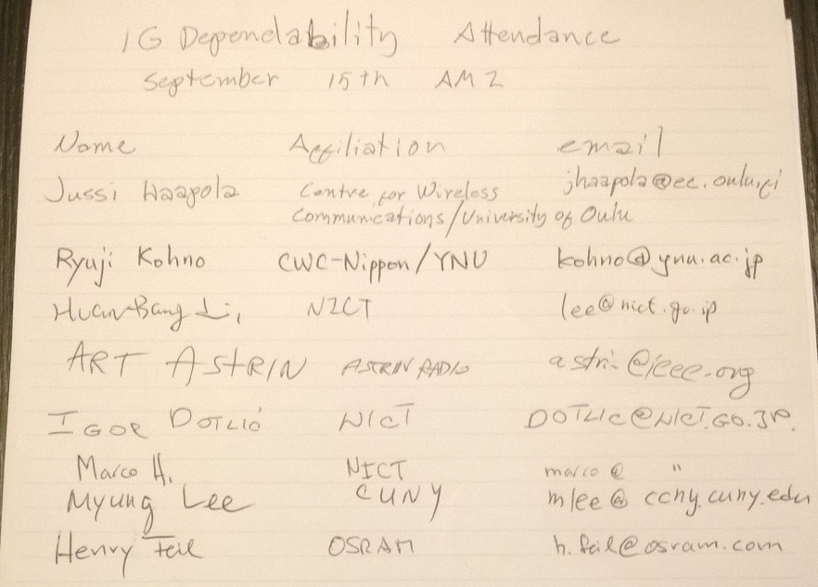

Tuesday, September 16, 2014, AM2, 10:30

  - Meeting called to order 10:32
By Chair Art Astrin
Secretary Jussi Haapola

No essential intellectual property in the scope of IG DEP was declared.

  - Roll call
Notepad for Attendance circulated.

  - Work on Call for Interest
Ryuji to work on Use case 1 picture text font sizes.
Art sent a reminder of IG DEP mailing list existence and asked people to join.
Art uploaded Call for Interest draft doc #449 rev2 for commenting.

  - PAR and 5C development
PAR and 5C development was not addressed yet.

  - Recess
Recessed at 12:15.

  - Attendees
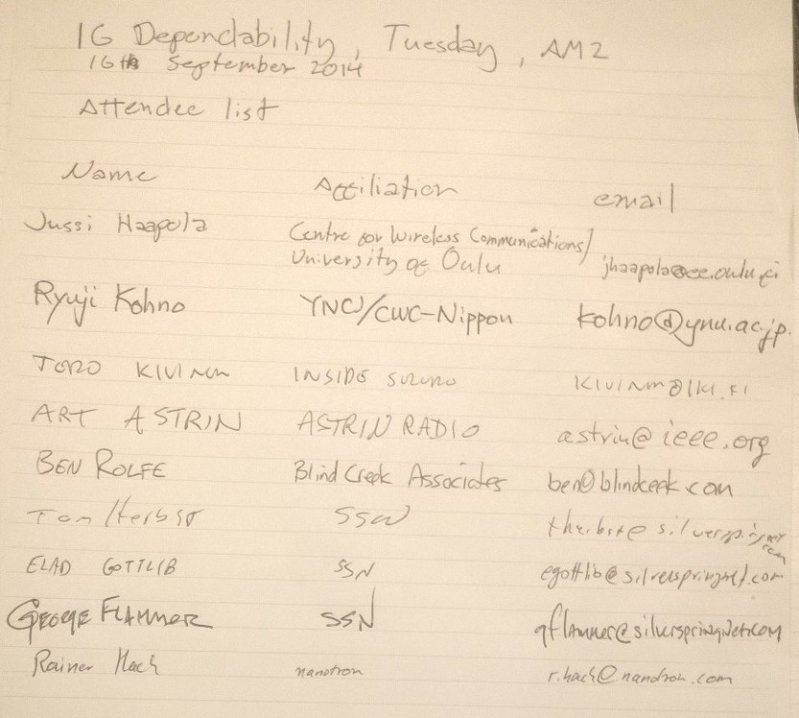

Wednesday, September 17, 2014, AM1, 08:00

  - Meeting called to order 08:10
By Chair Art Astrin
Secretary Jussi Haapola

No essential intellectual property in the scope of IG DEP was declared.

  - Roll call
Notepad for Attendance circulated.

  - Revisit on Call for Interest
Art and Ryuji finalized CFI Tuesday evening. The CFI will be disseminated shortly.

  - Criteria for Standards Development (CSD) discussion
5C criteria discussion took place.
Guido Dolmans (IMEC) pointed the group to DEWI project (European Commission Artemis section) and promised to be liaison person.
  - AoB
There was no other business
  - Adjourn
Meeting was adjourned 09:55.

  - Attendees

