IEEE P802.15
Wireless Personal Area Networks

Project | IEEE P802.15 Working Group for Wireless Personal Area Networks (WPANs)
Title | Comments on performance metrics for proposal evaluation (15-14-0489-01)
Date Submitted | 29 July, 2014
Source | Soo-Young Chang (SYCA), Sangjae Lee, Jaehwan Kim, Sangsung Choi (ETRI), and Jae-Beom Kim, Young-Bae Ko (Ajou Univ.) | Voice: [+1 530 574 2741]  E-mail: [sychang@ecs.csus.edu]
Re:
Abstract | This document presents some comments on the performance metrics to be used to compare the proposals to TG10, which was discussed during July 24 conference call and listed in 15-14-0489-01
Purpose | The proposed performance will be used for proposal comparison.
Notice | This document has been prepared to assist the IEEE P802.15. It is offered as a basis for discussion and is not binding on the contributing individual(s) or organization(s). The material in this document is subject to change in form and content after further study. The contributor(s) reserve(s) the right to add, amend or withdraw material contained herein.
Release | The contributor acknowledges and accepts that this contribution becomes the property of IEEE and may be made publicly available by P802.15.
Introduction
This document suggests a list of performance metrics to be presented in the simulation results. These metrics will be used to evaluate and compare the different proposals. Additional performance metrics may be added if agreed by the group

Performance metrics of Proposals

- Metrics Based on Proposals – need to be stated as part of results
- Accumulative or average construction overhead during whole simulation time.
  - Overhead to needed to form upward routes (Hello packets, etc.)
  - Overhead needed to form downward routes (Hello packets, etc.)
- Accumulative or average routing overhead during whole simulation time.
  - Just forward packet or is probing of next hop needed
- What else in addition to 15.4 MAC is needed to transfer packet end-to-end
  - IE’s, Header
- Recovery time (Min., Max., Avg.) for drop routes (nodes)
  - Route Updating and Re-Routing Procedure

- Metrics Based on Simulation Results/Analysis of Proposals
- End to end successful transmission ratio - Packet Delivery Ratio (PDR)
- End to end transmission delay/latency (Min., Max., Avg.) - the time elapsed from when a data packet is first sent to when it is first received at its destination
- 99.99th Percentile Latency - Computed as the 99.99th percentile of the packet delivery latency
- Number of hops (Max., Avg.)
- Battery consumption in 4 hours in duty cycling and non-duty cycling mode
  - Min., Max., Avg. for
      - PAN Coordinator

      - Router
      - End Device

Additional Items to Consider and whether they fall under 1. or 2. above
Where does AODV fit in w.r.t. overhead?
Common Scenario needs to be defined for recovery time, for simulation based purposes.
Construction time
- Computed as time to establish a route.
- The Tg10 group will decide whether association time will be included in this time.

- Simulation environment
- Traffic
  - (M:1), Source: all devices, Destination: PAN coordinator
  - (1:1), Source one node, Destination: one node.
  - (Mixed): both of them applied at the same time
- Traffic Size (data payload)
  - 100 byte per 5, 10, 15, 20, 25, 30 minutes. (6 simulation scenarios)
- Type of node deployment (positioning)
  - The number of nodes in the network (Density)
    - For some different densities considered, MAC performance affects the routing performance.
  - Location of the PAN coordinator: Center coordinates of the network
  - Grid position: 20 – 50m (distance between nodes)
  - Uniform random deployment: (min:0, max: 1,000 m size)
An example of the network density
Network size (1,000 x 1,000 meter)
Average Distance between nodes (Density) | 5m | 10m | 15m | 20m | 25m | 30m | 45m | 50m
The number of nodes in the network | 40,000 | 10,000 | 4,444 | 2,500 | 1,600 | 1,111 | 494 | 400
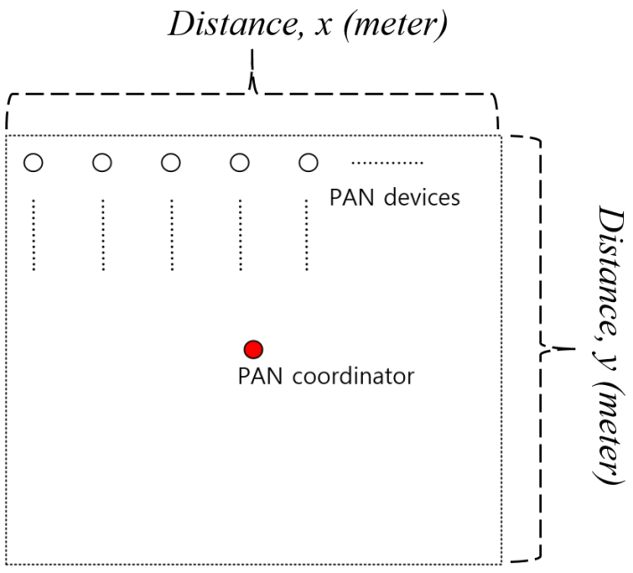
An example of the grid network topology

- MAC parameters to be additionally considered
  - Beacon Order and Superframe Order values (BO: 6, SO: 4, or vary values)
  - Data retransmission and acknowledgement enabling
  - Beacon, non-beacon enabled mode or both.
- Simulation time
  - Simulation duration: 4 hours. (it is enough, because traffic pattern of each scenario is very static)s
  - All simulation results are conducted by average 20 times simulation: to calculate min. and max. and average values with the same condition.

