IEEE P802.15
Wireless Personal Area Networks

Project | Dependable Interest Group
Title | Meeting Minutes for July 2014
Date Submitted | July 17, 2014
Source | [Jussi Haapola]  [Centre for Wireless Communications / University of Oulu] | Voice: +358 40 8363 018  E-mail: jhaapola@ee.oulu.fi
Re: | Meeting Minutes
Abstract
Purpose | Minutes of Dependability Interest Group sessions
Notice | This document has been prepared to assist the IEEE P802.15. It is offered as a basis for discussion and is not binding on the contributing individual(s) or organization(s). The material in this document is subject to change in form and content after further study. The contributor(s) reserve(s) the right to add, amend or withdraw material contained herein.
Release | The contributor acknowledges and accepts that this contribution becomes the property of IEEE and may be made publicly available by P802.15.

Tuesday, July 15, 2014, AM2, 10:30

  - Meeting called to order 10:37
By Chair Art Astrin
Secretary Jussi Haapola

No essential intellectual property in the scope of IG DEP was declared.

  - Roll Call
Notepad for Attendance circulated.

  - Approval of previous meeting minutes
Doc #305 Minutes were approved.

  - Review of tentative timeline #340
Lead by Jussi Haapola
Issuing Call for Interest would be appropriate to relevant parties and IEEE 802 community.

  - Review of current Application-Dependability matrix
Lead by Jussi Haapola
Kohno: recommendation to introduce 15.6 priority levels to automotive components.
Astrin: take 15.6. medical equipment requirements table.

  - Developing Application-Dependability matrix
Lead by Ryuji Kohno

Applications to include in the PAR
- Automotive ICT
- Medical ICT

  - Discussion of Call for Interest
Art to draft Call for Interest. To be discussed in Thursday PM1 session.

  - Recess
The chair call recess at 12:30

  - List of participants

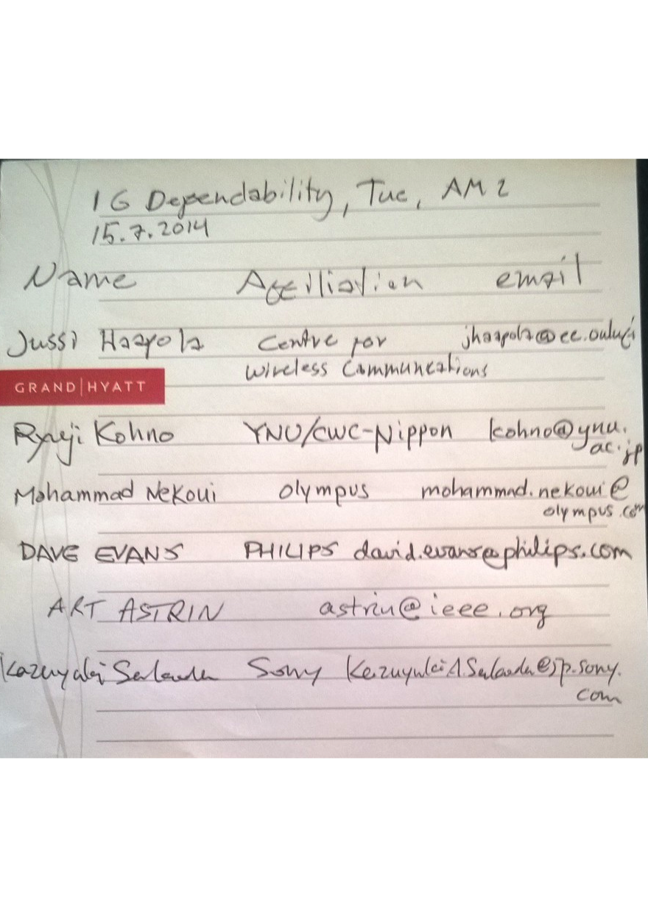

Thursday, July 17, 2014, PM1, 13:30

  - Meeting called to order 13:35
By Chair Art Astrin (Ryuji Kohno when Art left)
Secretary Jussi Haapola

  - Roll Call
Notepad for Attendance circulated.

  - Next Steps to issuing Call for Interest
Between sessions, Art Astrin prepared Call for interest.
Just before Thu session, Ryuji Kohno revised Call for Interest.
Call for Interest needs to be circulated shortly.

  - Revisit application-depandability matrix
Need to include medical applications into the matrix to determine suitability of automotive and medical ICT within same solution.

  - Any other business
Canchi, question: how can automotive and medical applications be covered by the same solution, the requirements for such applications are very different?
Kohno: From a long experience, there are a lot of similarities that can be exploited. We do not need to address all medical and automotive applications.

  - Adjourn
3:13

  - List of Attendees

