IEEE P802.15
Wireless Personal Area Networks

Project | IEEE P802.15 Working Group for Wireless Personal Area Networks (WPANs)
Title | TG9 July Document Changes
Date Submitted | 15 July 2014
Source | [Robert Moskowitz]  [Verizon] | Voice: [+1-248-928-6233]  Fax: []  E-mail: [ rgm@labs.htt-consult.com]
Re: | TG9 July Document Changes
Abstract | Proposed Changes to Predraft7-P802-15-9
Purpose | Discuss docment changes
Notice | This document has been prepared to assist the IEEE P802.15. It is offered as a basis for discussion and is not binding on the contributing individual(s) or organization(s). The material in this document is subject to change in form and content after further study. The contributor(s) reserve(s) the right to add, amend or withdraw material contained herein.
Release | The contributor acknowledges and accepts that this contribution becomes the property of IEEE and may be made publicly available by P802.15.

New section prior to 4.1

PAN View

The transport mechanism described in this document only works on a single link between two nodes in a PAN. These messages cannot be forwarded to further nodes. This limitation comes from the nature of KMP message size and the fragmentation mechanism defined herein.

It is conceivable that a specific KMP can avoid using the fragmentation mechanism by using the large MPDU supported by some PHYs. This is out of scope for this recommendation. If KMP support is needed between remote nodes, another mechanism providing large payload support via a fragmentation scheme, e.g. IP, may be used.

Replace Fig 1.1 with:

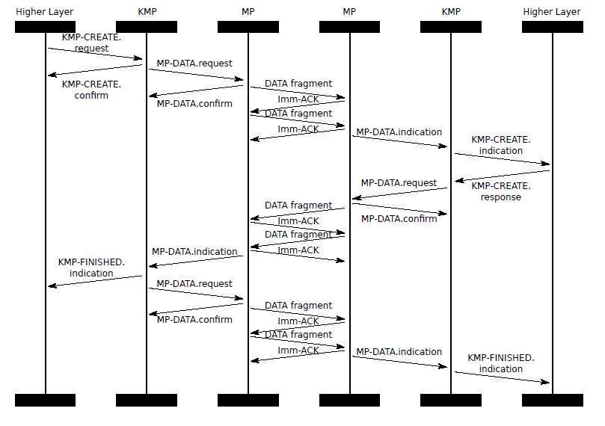

KMP MLME calls

Change MLME-KMP-START primatives to MLME-KMP-CREATE
see slide 20 for .request arguments
see slide 22 for .confirm arguments
add .indication call and see slide 24 for arguments
change .response call to be response to indication and see slide 26 for arguments

add MLME-KMP-FINISHED.indication
see slide 28 for arguments

add MLME-KMP-DELETE.* calls
slides 29 -32 for content

Need rekey discussion based on slide 33

And what else will be need to be reworked on rekey based on slide 34?

