IEEE P802.15
Wireless Personal Area Networks

Project | IEEE P802.15 Working Group for Wireless Personal Area Networks (WPANs)
Title | CAU Contribution Proposal for IEEE 802.15.8 (Doc.)
Date Submitted | June 03, 2014
Source | Jeongseok Yu  Woongsoo Na  Hyoungchul Bae  Taejin Kim  Yunseong Lee  Juho Lee  Zeynep Vatandas  Hyunsoo Kwon  Changhee Han  Sungrae Cho  Junbeom Hur  [Chung-Ang University, Korea] | E-mail:[jsyu@uclab.re.kr]  E-mail:[wsna@uclab.re.kr]  E-mail:[hcbae@uclab.re.kr]  E-mail:[tjkim@uclab.re.kr]  E-mail:[yslee@uclab.re.kr]  E-mail:[jhlee@uclab.re.kr]  E-mail:[zvatandas@uclab.re.kr]  E-mail:[khs910504@hanmail.net]  E-mail:[manjungs@gmail.com]  E-mail:[srcho@cau.ac.kr]  E-mail:[jbhur@cau.ac.kr]
Re: | This is the original document
Abstract | CAU Contribution Proposal for IEEE 802.15.8 (Doc.)
Purpose | To provide the technical guidance including functional and technical requirements to the P802.15 Working Group.
Notice | This document has been prepared to assist the IEEE P802.15.8. It is offered as a basis for discussion and is not binding on the contributing individual(s) or organization(s). The material in this document is subject to change in form and content after further study. The contributor(s) reserve(s) the right to add, amend or withdraw material contained herein.
Release | The contributor acknowledges and accepts that this contribution becomes the property of IEEE and may be made publicly available by P802.15.8.

Table of Contents
1. Overview 3
2. Definitions 3
3. Abbreviations and acronyms 3
4. General descriptions 3
4.1. Concepts and architecture 4
4.1.1 Packet Format 4
4.2. Topology 5
4.3. Reference model 5
5. MAC layer 5
5.1. MPDU structure 5
5.2. Multiple access 5
5.3. Synchronization procedure 5
5.4. Discovery procedure 5
5.5. Peering procedure 5
5.6. Scheduling 5
5.7. QoS 5
5.8. Interference management 5
5.9. Transmit power control 5
5.10. Multicast 6
5.6.2 Multicast Group Management 6
5.10.2 Multicast Data Transmission 14
5.10.3 Prevention Loopback Problem 15
5.10.4 Reliable Multicast 15
5.10.5 Multicast Protocol Using Directional Antenna 16
5.11. Broadcast 17
5.12. Multi-hop operation 17
5.12.1 Multi-hop Unicast Data Transmission 17
5.13. Relative positioning 18
5.14. Power management 18
5.15. Security 18
5.17.1 Security modes 19
5.16. Coexistence 27
5.17. Higher layer interaction 27

Overview
The 802.15.8 specification shall be developed according to the P802.15.8 Peer Aware Communication (PAC) project authorization request (PAR), document number 15-12-0063r2 and Five Criteria (5c), document number 15-12-0064r1, which were approved by the IEEE-SA in March of 2012.

Definitions

Abbreviations and acronyms
PD PAC Device
FFPD A PD which supports whole specification including routing table and it is always relay-enabled.
RFPD It has two types. These are relay-enabled PD and relay-disabled PD. Relay-enabled is a reduced-function PD which supports routing table for specific multicast group and relay-disabled is a reduced-function PD which does not support routing table.

General descriptions
This clause provides the basic framework of PDs. The framework serves as a guideline in developing the functionalities of PDs and their interactions specified in detail in the subsequent clauses.

Concepts and architecture

Topology

Reference model

MAC layer

Overview

Frame Structure

Synchronization

Discovery

Peering

Multi-hop peering
Multi-hop peering is the procedure to establish a link between a pair of PDs or links among multiple PDs with 2 or more hops.

Multi-hop peering procedure
For multi-hop peering, the peering request and response should be relayed by relay-enabled PD(s). The peering procedure is initiated by sending a peering request message including requested peering information. The relay PD should relay either request or response messages. The workflow of multi-hop peering is shown at Fig. 1.

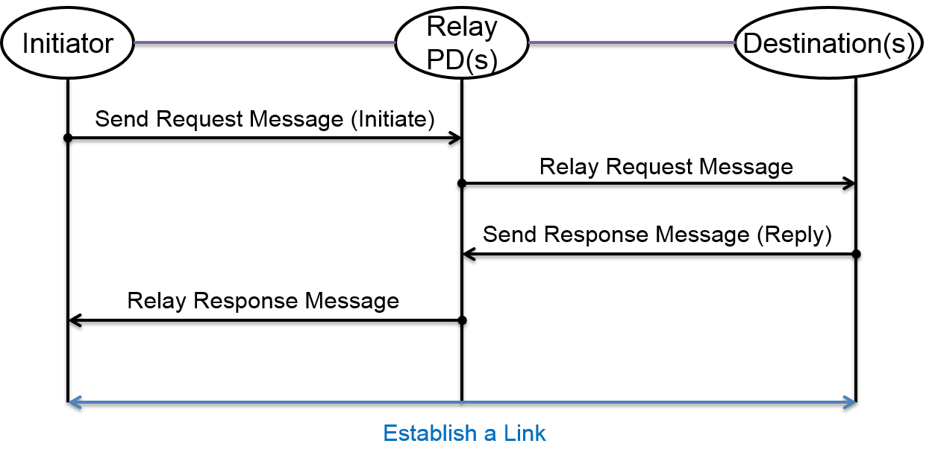
Figure 1. Multi-hop Peering Procedure

This procedure can be apply with one-to-one, one-to-many and, many-to-many peering procedures.

Multi-hop re-peering procedure
Re-peering procedure is similar to peering procedure. The main differences are: 1) some of the previous peering information may not be included in request and response messages; 2) the PD receiving the request validates peering information before making a decision to accept the re-peering request. Therefore, the procedure of multi-hop re-peering procedure is same as Fig. 1.

Multi-hop de-peering procedure
De-peering procedure starts with a de-peering request, which is replied by a de-peering response message. The procedure of de-peering is shown at Fig. 2.
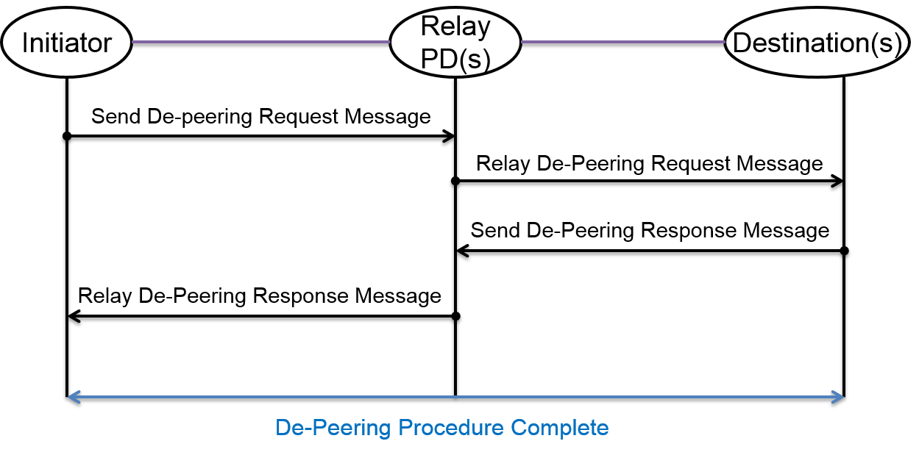
Figure 2. Multi-hop De-Peering Procedure

Communications

Unicast
Unicast is a one-to-one data communication between a pair of PDs. For reliable unicast transmission, ACK may be used for acknowledging a successful data transmission.

Multi-hop Unicast
Will be explained in section 5.14.

Multicast
Multicast is a one-to-many data communication to a group or groups of PDs which may be addressed by multicast group ID(s). To support multicast, the following features are supported:

- Multicast group creation: A PD creates a multicast group.
- Joining multicast group: A PD joins a multicast group.
- Leaving multicast group: A PD leaves a multicast group.

5.6.2.1 Finding/Joining Multicast Group
A multicast group consists of two or more PDs with the same application type ID, application specific ID, application specific group ID, and device group ID. It can be formed only if two or more PDs can recognize themselves. Before a PD joins a multicast group, it has to find the multicast group within K-hop coverage. If the PD cannot find the group, then it finds the group periodically. In order to find a multicast group, a PD broadcasts an Advertisement Command Frame (ACF) after random timer T_{j} where the maximum TTL is set to K. Range of T_{j} is [0, T_{jmax} ]. If a PD receive the ACF, it stores the ACF in order to forward it to other PDs and saves backward path in the routing table during expiration timer $T_{W}$ where $T_{W}$ is calculated by one-hop RTT and K if it is relay-enabled (Backward path is originator of the ACF, one-hop PD sending the ACF, Device Group ID & Application type ID & Application-specific ID & Application-specific group ID.) It compares the receiving frame’s Device Group ID & Application type ID & Application-specific ID & Application-specific group ID with its own. If they all are same, it replies an ARCF (Advertisement Reply Command Frame) to the PD sending the ACF (Reply of the ARCF depends upon the MGNF explained in the following pages). If any of them is not same, it decrements the TTL of the ACF and forwards the ACF.
In order to limit the duplicate ARCF, PDs replying the ARCF multicast a Multicast Group Notification Frame (MGNF) after random time. (MGNF is explained detail in later section) Then, the PD multicasting the MGNF replies source PD with an ARCF by using backward path. A PD receiving both ACF and MGNF does not reply an ARCF. A PD receiving the ARCF whose destination is not itself saves the route information of ID of the source PD sending the ARCF, ID of the one-hop PD sending the ARCF, Device Group ID, Application type ID, Application-specific ID, Application-specific group ID. Then, this PD is referred to as “FORWARDING PD.” A PD receiving the ARCF whose destination is itself saves the route information same as FORWARDING PD. Then, this PD is referred to as “JOINED MULTICAST GROUP MEMBER.”

When a PD wants to join a multicast group, it broadcasts an ACF to its neighbor PDs. When a PD which is not in the multicast group receives the ACF, it saves the route information and forwards to the others. When a multicast group member PD receives an ACF, it broadcasts an ARCF to it. If there is a duplicate ARCF, the member PD broadcasts a MGNF to the other member PD by notifying that it will send an ARCF instead of it. The node sending MGNF may send KEKs (key encryption keys) to the node which wants to join the multicast group after authentication for secure multicast if needed. It also may send rekeying messages to update an existing group key for backward secrecy. Hereby, a PD receiving the ARCF joins the multicast group.

For example, in Figure 3,
- If PD A wants to join the multicast group, it broadcasts an ACF,
- PD C is not in the multicast group. Therefore, it saves the route information and forwards to the others (e.g., F and E). PD D already received the ACF and PD F now receives the ACF. Then, there will be a duplicate ARCF from both of D and F to A. In order to limit the duplicate ARCF, PD D multicasts a MGNF notifying that D will send an ARCF instead of F.
- PD E forwards the ACF to B and G. D replies with ARCF to A. D may send KEKs to A if needed. D may send rekeying messages also. F does not transmit an ARCF to A.
- When PD A receives the ARCF, A joins D’s multicast group. Also, PD B receives the ACF from PD E. Then, B multicasts a MGNF to limit a duplicate ARCF from G.
- PD B replies with an ARCF to A through E. B may send KEKs to A if needed. B may send rekeying messages also. G does not transmit an ARCF to A since the PD G already received the MGNF from B.
- E forwards the ARCF to PD C.
- C forwards the ARCF to PD A. Then, PD A is aware of route between PD A and PD B. Now, PD A joins PD B’s multicast group. Although group of B and G are not aware of group of D and F currently, multicasting service still works by simply forwarding multicast data frames.

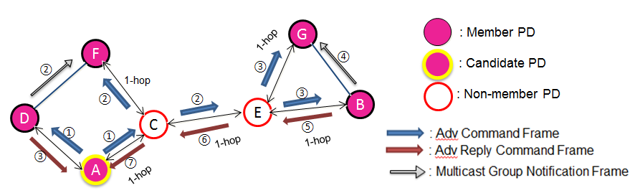
Figure 3. Finding/Joining Multicast Group

5.6.2.2 Device Group ID Creation
A multicast group is determined by application type ID, application specific ID, and application specific group ID. Therefore, it is inefficient if transmitting all IDs in a frame and managing routing table. Therefore, we propose a device group ID creation scheme. Device group ID should be unique and distributed by a PD sending the first ARCF in the group. The PD manages/updates group keys for secure and dynamic multicast group communications after authentication procedures described in security section. The PD generates device group ID based on its unicast ID. Since a PD’s unicast ID is unique, prefix concatenated by PD’s unicast ID is also unique.

Figure 4. Device Group ID

When two or more multicast groups are merged, the device group ID should be same. The PD recognizing the existence of two or more multicast groups determines the device group ID for those groups randomly. Then, the PD sends MGNF (notification type: 3 and TTL: ∞) to the group that does not have the selected group ID to update multicast group ID.
In Figure. 5, A recognizes that two device group IDs exist in networks. A determines that device group ID is 8. A sends MGNF to D and E to change device group ID. A may send rekeying messages to update an existing group key for backward secrecy.
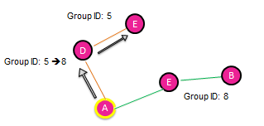
Figure 5. Device Group ID Creation

5.6.2.3 Multicast Group Notification Frame (MGNF)
The purposes of MGNF are limiting duplicate ARCF, management of routing table, notifying leaving multicast group, device group ID creation, request for unicast routing, reply for unicast routing, mobility support, local repair for relay-enabled PDs and notification of removed routing entry.

MGNF has eight notification types for above purposes. These are;

Table 1. Type of MGNF

Type | Description
0 | Limiting duplicate ARCF
1 | Management of routing table
2 | Notifying leaving multicast
3 | Device group ID creation
4 | Request for unicast routing
5 | Reply for unicast routing
6 | Mobility support
7 | Local repair
8 | Notification of removed routing entry

- Limiting duplicate ARCF(Notification Type: 0): A PD receiving an ACF multicasts MGNF with notification type set to 0 with random timer T_{j}. Range of T_{j} is [0, T_{jmax} ]. Although missing MGNF can increase duplicate ARCF, MGNFs are not retransmitted to avoid flooding. In this case, payload of MGNF contains source of the ACF.
- Management of routing table (Notification Type: 1): In order to reduce routing entries in the table, each PD maintains entries only for PDs that has exchanged ACFs and ARCFs in its routing table. Each PD in multicast group multicasts MGNFs periodically ($Tp(Period)+Tj)$with notification type set to 1. Range of random timer T_{j} is [0, T_{jmax}]. Upon receiving a MGNF, a forwarding PD updates the entries of the originator of the MGNF and one-hop PD sending the MGNF in its routing table, and forwards the MGNF. Upon receiving a MGNF, a non-forwarding PD updates the entries of the originator of the MGNF and one-hop PD sending the MGNF in its routing table, but does not forward the MGNF. Also it can be used for detection and routing table update for link breakage. When a link between two nodes is broken, the other member node in the group which is aware of the link breakage removes the entry of the node which has a broken link to its routing table. For example, in Figure 6, we suppose that the link between A and B is broken. E does not receive MGNF from A. E is aware that the link is broken, because A’s MGNF does not arrive before E’s routing table expiration timer is expired. Then, E removes the entry of A to E’s routing table.
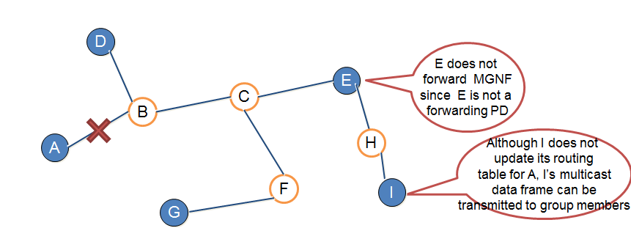
Figure 6. Detection and Routing Table Update For Link Breakage

- Notifying leaving multicast (Notification Type: 2): will be explained in 5.6.2.5 section.
- Device group ID creation (Notification Type: 3): Explained in the 5.6.2.2 section.
- Request for unicast routing (Notification Type: 4): will be explained in 5.14.1 section.
- Reply for unicast routing (Notification Type: 5): will be explained in 5.14.1 section.
- Mobility support (Notification Type: 6): will be explained in 5.6.2.6 section.
- Local repair (Notification Type: 7): will be explained in 5.6.2.6 section.
- Notification of removed routing entry (Notification Type: 8): will be explained in 5.6.2.4.2 section.

5.6.2.3.1 Reliable MGNF Transmission
We classify the level of reliable MGNF transmission in two types. These are ACK-based MGNF transmission and no ACK-based transmission. The node which transmits MGNF has to receive ACK-based MGNF from its neighbor nodes for notification types 2,3,4,5 and 8 for reliable MGNF transmission. But it does not have to receive ACK-based MGNF for notification types 0, 1, 6 and 7. Because, the notification type 0 is for limiting duplicate ARCF, thus the PD does not need to receive it. The notification type 1 is for management of routing table and MGNF is transmitted periodically. The notification type 6 is for mobility support. Due to changed route information, the node does not need to receive the ACK-based MGNF from the moving node.

5.6.2.3.2 Reliable MGNF Transmission
When a PD belongs to multiple multicast groups, it multicasts MGNF multiple times. In order to resolve the above problem, a PD may set Destination Address field of MGNF as United Multicast Address (UMA). The UMA unifies multiple different groups into a single one. The UMA can reduce the MGNF traffic as the following pages.

5.6.2.3.3 Redundant MGNF Transmission
When a PD multicast its MGNF to the other nodes, if there are nodes which are member of multiple groups simultaneously, there will be a redundant MGNF transmission.

For example, in Figure 7, we suppose that A, B, C, and D are in group 2 while B, C and E are in group 1. B and C are in groups 1 and 2 simultaneously.
- B starts to multicast its MGNF for group 1 to C and D (forwarding to E). After C and D verify device group ID field in PD B’s MGNF, PDs C and D recognize that the MGNF belongs to group 1.
- Then, D forwards the MGNF from B to E. After PD E verifies device group ID in B’s MGNF, E recognizes that the MGNF belongs to group 1.
- B starts to transmit its MGNF for group 2 to PDs A, C, and D.
- Then A, C, and D verify their device group ID in PD B’s MGNF. They recognize that the MGNF belongs to group 2. There are 3 transmissions for MGNF (B transmitted MGNF twice).
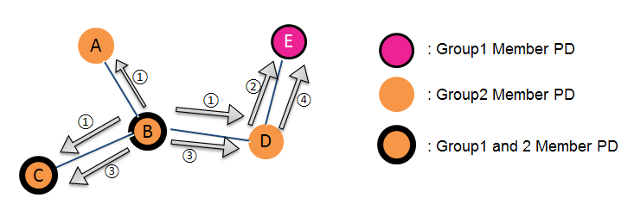
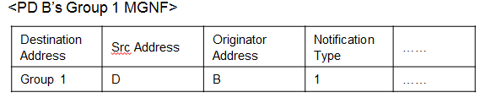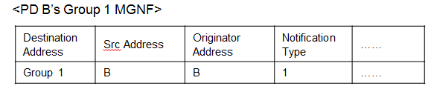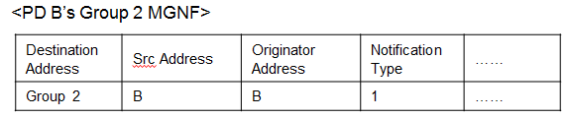
Figure 7. Redundant MGNF Transmission

5.6.2.3.4 Redundant MGNF Transmission
In order to prevent redundant MGNF transmission, we proposed a UMA-based MGNF transmission. In this proposal, we set the destination address fields to UMA for nodes which are member of two or more groups simultaneously. When a node receives MGNF, it checks its destination address and if it finds that the destination address is equal to UMA and two or more device group IDs that have the same value (forwarding PD for that group ID) and those device group ID have the same destination address with the originator of the received MGNF, then, the PD forwards the received MGNF.

For example, in Figure 8,
- PD B starts to transmit its MGNF whose destination address field set to UMA for Groups 1 and 2 to A, C, and D.
- Then A, C, and D verify the device group ID field in PD B’s MGNF, they recognize that the MGNF belongs to UMA and they forward the received MGNF. PD E receives the MGNF from D. E does not forward the MGNF. There are2 transmissions for MGNF. (B transmitted MGNF just once).

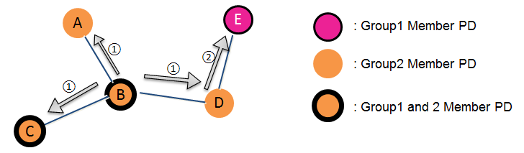
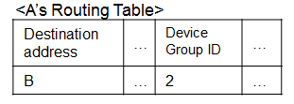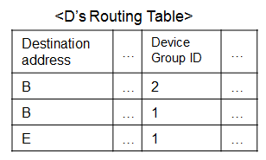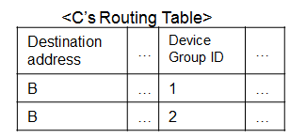
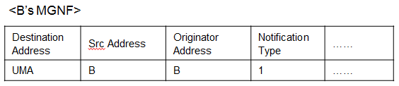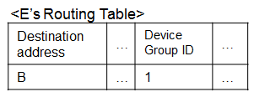
Figure 8. UMA-Based MGNF Transmission

5.6.2.4 Creation and Management of Routing Table

5.6.2.4.1 Creation of Routing Table
Whenever a relay-enabled PD receives ACF or ARCF, a routing entry is created in the routing table. Also, the routing table is updated by receiving MGNF. A routing table contains; destination address, next-hop address, expiration timer, number of hops, current_SN, device group ID, and last ACF reception time ($T_{0}$).

For example, in Figure 9,
- If A wants to join a multicast group, it broadcasts an ACF (assume K=4 hop). The initial routing table for A is as the following table (Note that originator of ACF has to save the ACF Tx time). When C receives the ACF, it creates the routing entry of A in its routing table.
- Since C is not in the multicast group, C forwards the ACF to the others (e.g., D and E). When D and E receive the ACF, they create the routing entry of A in their routing table.
- Since D is in the multicast group, D replies A with ARCF by using routing table. C creates the routing entry of D in its routing table. Suppose C forwarded an ACF at T₀. Suppose C receives an ARCF from D at T₁. Expiration timer of route entry to D in C’s routing table is updated to $T_{r}^{dst}=T_{p}+T_{jmax}+{\left(T_{1}-T_{0}\right)}/{2+(safety margin).}$ At the same time, since E is not in the multicast group, it creates the routing entry of A in its routing table and forwards to the others (e.g., B). When B receives the ACF, it creates the routing entry of A in its routing table.
- Since B is in the multicast group, B replies A with ARCF. E creates the routing entry of B in its routing table. C forwards ARCF from D to A. A updates a routing entry with expiration timer $T_{r}^{D}$.
- E forwards the ARCF received from B to C. C creates the routing entry of B in its routing table.
- PD C forwards the ARCF received from E to A. A creates a routing entry with expiration timer $T_{r}^{B}$.
- Finally, A is aware of route to B and D.
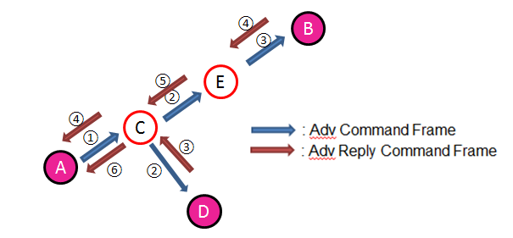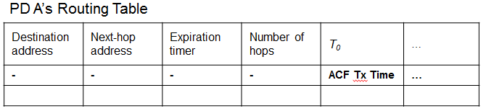
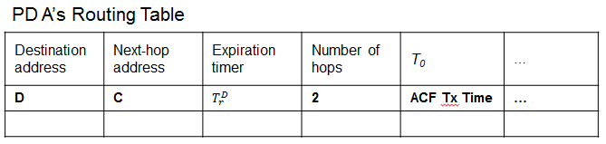
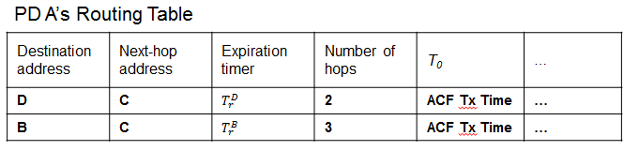
Figure 9. Creation of Routing Table

5.6.2.4.2 Management of Routing Table
When a node’s routing table is full of routing entries, it chooses a node from its routing table with shortest distance (hop-based) firstly. It sends a MGNF (type 8) to the chosen node and sets timer. When the node receives the MGNF, it breaks the link between the node and itself, and sends an ACF. The node which has timer ignores the ACF and another node which receives ACF sends ARCF to it and creates a new link between the node which sends ACF and itself.

For example, in figure 10,
- A has limited routing entry in its routing table and H wants to join the multicast group. A chooses B in its routing tree randomly. A sends MGNF to B and sets a timer.
- When B receives the MGNF, it breaks the link between A and B.
- B sends ACF. A ignores B’s ACF.
- C receives the ACF and sends ARCF to B.
- Then C creates a link between C and B. Hereby, H can join the multicast group.
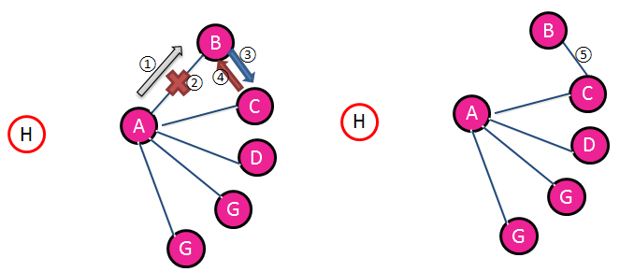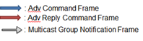
Figure 10. Management of Routing Table

Since MGNF (notification type: 1) is sent periodically, a MGNF implosion problem can occur in the network. To prevent this problem, we proposed an adaptive MGNF transmission technique based on the distance between nodes. The distance can be measured from received signal strength indicator. (RSSI) This technique is processed when the distance between nodes becomes longer or shorter. If the node moves away from the network, the MGNF transmission gets more often since there can be a link breakage. Vice versa, if the node moves within one-hop coverage (e.g mobility support), the MGNF transmission gets rarer to prevent redundant MGNF traffic.

5.6.2.5 Leaving From Multicast Group
There are several reasons for a PD to leave from the network: (i) by its intention, (ii) by mobility, (iii) by limited resources. If a PD wants to leave from a multicast group, it multicasts (within K-hop) a MGNF with notification type set to 2. A recipient of MGNF may send rekeying messages to valid group members for forward secrecy. Upon receiving the MGNF, a forwarding PD deletes the entry of the originator of the MGNF, and forward the MGNF. Upon receiving the MGNF, a non-forwarding PD deletes the entry of the originator of the MGNF, but does not forward the MGNF.

In the following figure 11,
- If PD C wants to leave from a multicast group, it multicasts a MGNF with notification type set to 2.
- B receives the MGNF from C and deletes the entry of the originator of the MGNF, and forwards the MGNF. PD D receives the MGNF and it deletes the entry of the originator of the MGNF. Finally, PD C leaves from the multicast group.

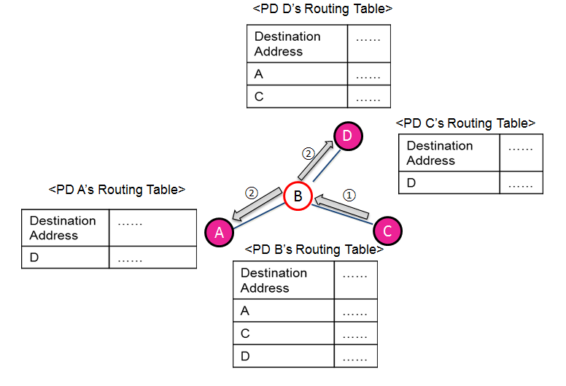
Figure 11. Leaving From Multicast Group

5.6.2.6 Mobility Support for Multicast
When a node moves within the one-hop coverage of another node, both of the nodes are aware of each other within the one-hop by MGNF’s TTL and they update their routing table. Then one of them sends a MGNF (notification type: 6) to another neighbor node. Therefore, it can be aware of that the nodes became closer. But, if the node is a multicast group member, it does not do anything. If it is a forwarding PD, it deletes routing entry whose destination field is the both of that nodes.

In figure 12, previously, B was 2-hop away from A. If B moves within the one-hop coverage of A, both of A and B are aware of each other and update their routing table. Then, A or B sends a MGNF (notification type: 6) to C. When C receives that MGNF, C is aware of that A and B became closer. Since C is a forwarding PD, it deletes routing entries whose destination field is A and B.

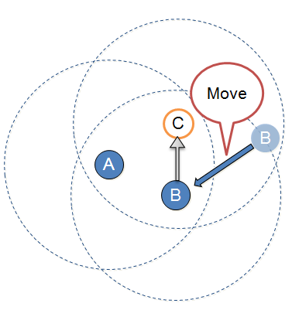
Figure 12. Mobility Support for Multicast

Since expiration timer is proportional to the number of hops from the impaired PD, the closest multicast group member detects link breakage. A PD starts local repair if it detects link breakage between multicast group members (due to expiration timer). Then, the PD multicasts MGNF (notification type: 7). If PDs receiving the MGNF create routing entry of originator of the MGNF during T_{w} , the PD performing local repair broadcasts an ACF within K-hop coverage.

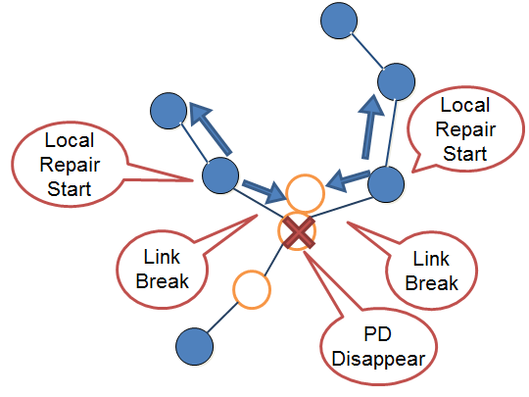
Figure 13. Local Repair Procedure for Multicast

If a PD receives the ACF, it compares the receiving frame’s Device Group ID & Application type ID & Application-specific ID & Application-specific group ID with its own. If they all are same, it finds entry the originator of the ACF in its routing table. When it finds the entry, it checks the expiration timer. If the expiration timer is less than T_{m,} then it replies the PD sending the ACF with an ARCF. (T_{m} is threshold time to decide reply) In other case, the PD receiving the ACF does not reply. If any of them is not same, it decrements the TTL of the ACF and forwards the ACF.

5.6.2.7 Merging Multicast Groups
Find/join procedure by using ACFs and ARCFs can help merging disjoint groups. If a PD in a group receives an ACF from different disjoint groups with the same Device Group ID & Application type ID & Application-specific ID & Application-specific group ID, it can initiate merging process. Then the PD replies the ACF originator with ARCF. Then, these two disjoint groups are merged by Device ID Creation Scheme. Local repair by using ACFs and ARCFs also can help merging disjoint groups. Each group member performs local repair periodically during T_{L} (long duty cycle) in order to merge disjoint groups.

5.6.2.8. Multicast Data Transmission
If a PD receives a multicast data frame, it has to decide forwarding the frame or not. The PD receiving the multicast data frame compares the source address of the data frame and next-hop address entries of its routing table. PD checks the next hop addresses in its routing table. If it finds one or more next-hop entries which are not overlapped with the source address of the received frame and those next-hop entries have same device group ID with the received frame, then, the PD forwards the incoming data frame to other PDs. Otherwise, the PD does not forward the incoming frame.
For the multicast data transmission, we have to know destination address, source address, originator address, sequence number and time to live (TTL) from multicast data frame. This information should be included in all multicast data frames. Therefore, the header in multicast data frames should contain the followings.

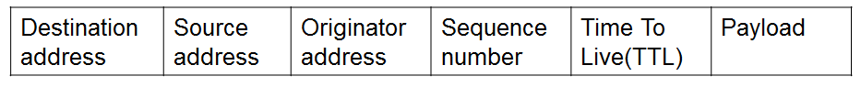
Figure 14. Multicast Data frame

For example, in Figure 15, we assume that 1) A, B, F, and G are in a same group which ID is 1, 2) A, D and H are in a same group which ID is 2, 3) A has routing information of B, D, and G, 4) B has routing information of A and F, and 5) D has routing information of A and H. A multicasts data frame to group 1.(Device Group ID: 1, Application type ID: 3, Application-specific ID: 2, Application-specific group ID: 5).
- C receiving the data frame compares the source address of the data frame and next-hop address entries in its routing table which has same group IDs from the received data frame. C finds any routing entry matching with the source address of the received frame and it searches another routing entry that has same multicast group with different next-hop address fields. Since C found, it will forward the data.
- C forwards the data. E receiving the data frame checks the condition whether forward or not. E will forward the data frame.
- E forwards the data. B and F do not forward the multicast data frame because B and F do not have next-hop address in their routing table, except E.
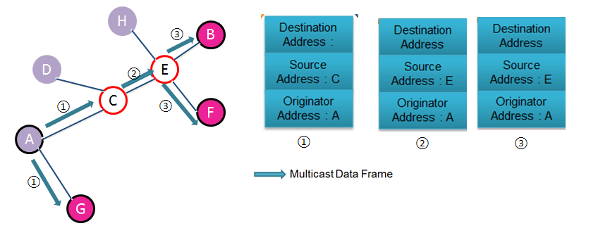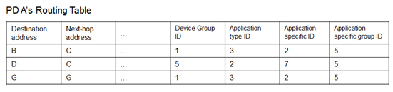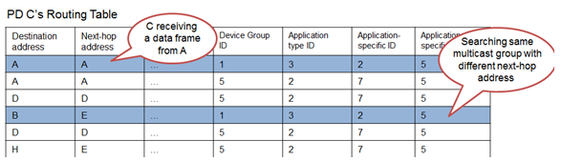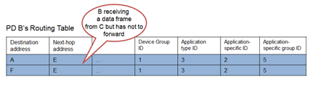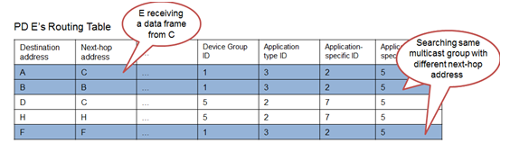
Figure 15. Multicast Data Transmission
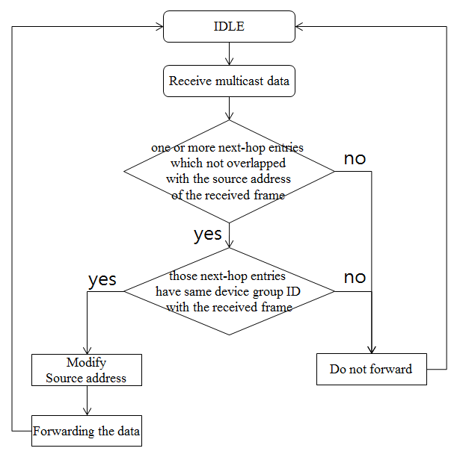
Figure 16. Multicast flowchart

5.6.2.9. Prevention Loopback Problem
PDs can prevent multicast/broadcast loopback problem by using SN (Sequence Number) of data frames. When a PD forwards data with SN = n, the PD sets current_SN field in its routing table to n. If the receiving frame’s SN is not greater than the current_SN , the PD discards the frame.

5.6.2.10. Reliable Multicast
We proposed a Block ACK technique for reliable multicast to know whether the nodes receive Multicast Data Frame fully or not. Thus, when sender PD sends Multicast Data Frame, it chooses the groups in the multicast group by depending on the order of the information of the nodes in its routing table. If the sender wants to have ‘n’ groups, it reached it by dividing the numbers of all nodes in the multicast group to n. ‘n’ is decided dynamically. Then, the sender transmits Multicast Data Frame including the information of the group which sends the block ACK.

When the nodes in the group receive all multicast data frames successfully, they transmit Block ACK to the sender by notifying that they received all frames from it. If they did not receive any data frame or they did not receive it fully, they do not transmit Block ACK to the sender. If sender does not receive Block ACK or receives a negative notification, then it retransmits the data frame to the group. These steps are processed for all groups in the multicast group respectively. If the sender does not have any data frame to transmit, it sets a timer. If the timer is expired, it transmits Request ACK to the groups respectively. The advantage of sending Block ACK is that; nodes send fewer frames than when they send implicit ACK. Thus, there is less collision.

In figure 17, sender PD S transmits Multicast Data Frame to other nodes and chooses the groups. Suppose that S decided that PDs A, B and C are in group1, D, E and F are in group2, G and H are in group3. Then A, B and C transmit Block ACK to S. If S does not have any data frame for PDs D, E and F, then it transmits Request ACK, and they reply S with a Block ACK.

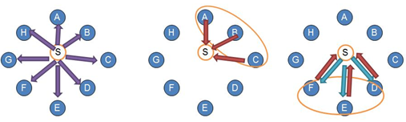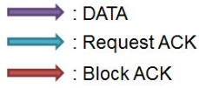
Figure 17. Reliable Multicast

5.6.2.11. Multicast Protocol Using Directional Antenna
If a PD can support directional antenna, it has to have additional routing table field which is describes its beam number forwarding to destination in order to transmit frame. That routing table contains; destination address, next-hop address, expiration timer , number of hops, current_SN, device Group ID, last ACF reception time ($T_{0}$) and beam number. If each PD wants to join a multicast group, it performs find/join procedure by using all of beams. During finding/joining procedure, PDs receiving a ACF check the SNR per beams and saves the specific beam with the highest SNR measured in order to find communication beam. If non-multicast group member receives the ACF forwards the ACF by using all of beams. If multicast group member receives the ACF, it replies ARCF by using saved specific beam with the highest SNR measured to the originator of the ACF. When PD receives ARCF, it saves the specific beam with the highest SNR measured into its routing table and forwards the ARCF by using backward path. After updating routing table, all of frames, except broadcast frame, can be transmitted directionally.

For example in Figure 18,
- If PD A wants to join a multicast, it broadcasts ACF by using all of beams.
- Then PD D and C receive the ACF. Since D is a multicast group member, it replies ARCF by using beam 3. Then, A finds the beam with the highest SNR measured and updates its routing table. C is a non-multicast group member then forwards ACF by using all of beams.
- Since F is a multicast group member, it replies ARCF by using beam 4. Then, C receives ARCF and updates its routing table. Also, E forwards its ACF by using all of beams.
- When A receives ARCF from C, it updates its routing table. Also, B replies ARCF by using beam 1. Then, E receives ARCF and updates its routing table.
- Also, E forwards ARCF by using beam 1. Then, C receives ARCF and updates its routing table.
- C forwards ARCF by using beam 1. Then, A receives ARCF and updates its routing table.
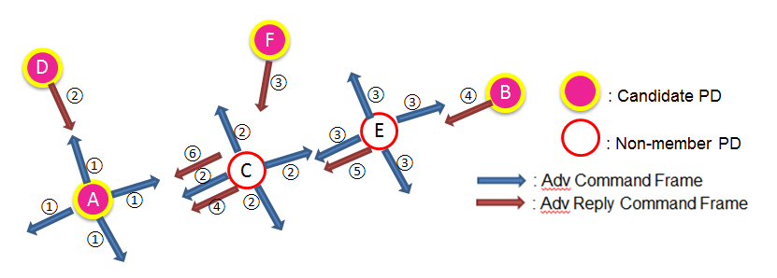
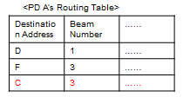
Figure 18. Multicast Protocol Using Directional Antenna

Broadcast
Broadcast is a one way data communication to any PDs within reachable range, or any PDs in a group or groups of PDs. A PD which received a broadcast message may response with acknowledgement in some service category e.g., shopping/entertaining advertisement; smart environment (office management); public safety (hazard notification and/or public emergency); etc.

Reliable Broadcast
        - Transmitter Behavior (when it has broadcast data)
When a PD has broadcasts data, the reliable broadcast will perform with following three cases.
Upstream: If the data is from its child, it does the following in its appropriate schedule:
- It broadcasts the data (piggybacked by ACK/NAK) to its children (not siblings), and sets its timer D (constant timer).
- It unicasts the data to its parent and associated neighbors, and sets its timer D.
Downstream: If the data is from its parent
- It broadcasts its data to its children (not siblings) and associated neighbors, and sets its timer D.
The other cases: If the transmitter is the originator of the data, it does the following in its appropriate schedule:
- It broadcasts the data to its children (not siblings), and sets its timer D.
- It unicasts the data to its parent and associated neighbors, and sets its timer D.
        - Receiver Behavior (after receiving broadcast data)
When a PD receives broadcast data, the PD should notify to sender PD with ACK or NAK. If the PD replies ACK instead of NAK, the transmitter cannot react the broken data. Therefore, the PD which receives a broadcast data, it delays its acknowledgement by a random timer described below:
- If the received data is erroneous, the PD activates a NAK timer.
- If the received data is OK, the PD activates an ACK timer.
If its timer expires, the PD responds (with unicast) its feedback (NAK or ACK) to its transmitter. NAK timer is generated at random in range of [0, 𝛼D] while ACK timer is generated at random in range of [𝛼D, D] which is shown at Figure 19.
- Shorter timer for NAK causes early rebroadcast of the original data to fix errors.
- Longer timer for ACK is for the case that all nodes successfully received the data.

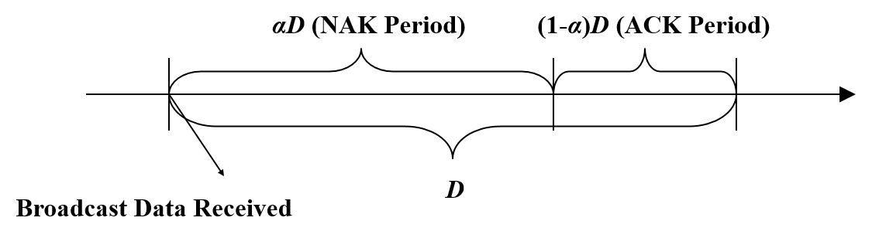
Figure 19. NAK and ACK period when a PD receives broadcast data.

        - Transmitter Behavior (after receiving feedback)
Upon the transmitter receives a NAK, it retransmits its data to fix the error, and sets its timer D.
When an ACK received, the transmitter transmits its next broadcast data if it has and sets its timer D.

        - Receiver Behavior (after receiving rebroadcast data)
- The receiver node cancels its timer (NAK or ACK).
- This will reduce unnecessary feedbacks to the transmitter.
- Based on the result of error detection/correction, the receiver uses NAK/ACK timer.
This series of procedure will continue up to predefined number of times. Overall behavior will look like as the following for and example are shown in Fig. 20.

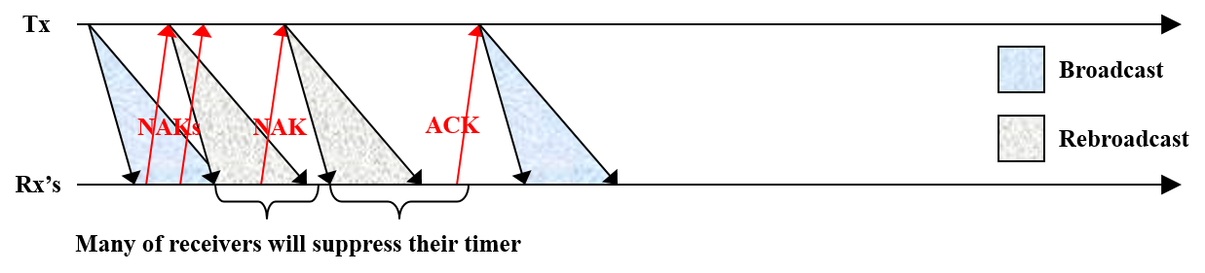
Figure 20. An outline of reliable broadcast scheme

MPDU structure
MPDU for data communication has a MPDU header and may have a variable length MPDU payload and a fixed length FCS. The MPDU payload is data information. FCS contains CRC check sequence for error detection.

MPDU structure for Multi-hop Multicast

ACF (Advertisement Command Frame)
Table 2 shows elements of ACF to find multicast group.

Table 2. ACF (Advertisement Command Frame)
Name | Type | Description
Originator Address | Integer | Originator PD’s Address
Destination Address | Integer | Destination PD’s Address
Sender Address | Integer | Sender PD’s Address
Application Type ID | Integer | Application Type ID
Application Specific ID | Integer | Application Specific ID
Application Specific Group ID | Integer | Application Specific Group ID
Device Group ID | Integer | Device Group ID
Time To Live (TTL) | Integer | Time To Live (TTL)
Sequence Number | Integer | Frame’s Sequence Number
Frame Type | Integer | Frame Type
Sub Type | Integer | Frame’s Sub Type

ARCF (Advertisement Reply Command Frame)
Table 3 shows elements of ARCF to reply ACF.

Table 3. ARCF (Advertisement Reply Command Frame)
Name | Type | Description
Originator Address | Integer | Originator PD’s Address
Destination Address | Integer | Destination PD’s Address
Sender Address | Integer | Sender PD’s Address
Receiver Address | Integer | Receiver PD’s Address
Application Type ID | Integer | Application Type ID
Application Specific ID | Integer | Application Specific ID
Application Specific Group ID | Integer | Application Specific Group ID
Device Group ID | Integer | Device Group ID
Sequence Number | Integer | Frame’s Sequence Number
Frame Type | Integer | Frame Type
Sub Type | Integer | Frame’s Sub Type

MGNF (Multicast Group Notification Frame)
Table 4 shows elements of MGNF to manage multicast group(s).

Table 4. MGNF (Multicast Group Notification Frame)
Name | Type | Description
Originator Address | Integer | Originator PD’s Address
Destination Address | Integer | Destination PD’s Address
Sender Address | Integer | Sender PD’s Address
Receiver Address | Integer | Receiver PD’s Address
Application Type ID | Integer | Application Type ID
Application Specific ID | Integer | Application Specific ID
Application Specific Group ID | Integer | Application Specific Group ID
Device Group ID | Integer | Device Group ID
Time To Live (TTL) | Integer | Time To Live (TTL)
Sequence Number | Integer | Frame’s Sequence Number
Notification Type | Integer | Notification Type (Type: 0, 1, 2, 3, 4, 5, 6, 7, 8)
Frame Type | Integer | Frame Type
Sub Type | Integer | Frame’s Sub Type

Multicast Data Frame
To perform multi-hop multicast, following elements should be included in the multicast data frame.

Table 5. Multicast Data Frame
Name | Type | Description
Originator Address | Integer | Originator PD’s Address
Destination Address | Integer | Destination PD’s Address
Sender Address | Integer | Sender PD’s Address
Receiver Address | Integer | Receiver PD’s Address
Application Type ID | Integer | Application Type ID
Application Specific ID | Integer | Application Specific ID
Application Specific Group ID | Integer | Application Specific Group ID
Device Group ID | Integer | Device Group ID
Time To Live (TTL) | Integer | Time To Live (TTL)
Sequence Number | Integer | Frame’s Sequence Number
Originator Sequence Number | Integer | Originator Sequence Number
Notification Type | Integer | Notification Type (Type: 0, 1, 2, 3, 4, 5, 6, 7, 8)
Frame Type | Integer | Frame Type
Sub Type | Integer | Frame’s Sub Type
Payload | Integer | Multicast Data
Reliability | Integer | The Number of Node which may Reply Block ACK (Optional)

Multiple access

Synchronization procedure

Discovery procedure

QoS

Interference management

Transmit power control

  - Multi-hop operation
To extend the coverage of a PD or group members, a PD or group members relay received data to the destination PD or group members.

5.14.1 Multi-hop Unicast Data Transmission
When a PD wants to unicast data frame, the PD searches routing entry of destination address in its routing table. If the PD finds the routing entry of destination address, it starts to unicast immediately. If it does not find routing entry of destination address, it multicasts a MGNF (Notification type: 4) to group. When the other PD receives the MGNF, it saves backward route information in its routing table during Tw. Then, it starts to find a routing entry of destination address in its routing table. If a PD receiving MGNF finds routing entry of destination address, it unicasts a MGNF (notification type: 5) to the PD which wants to unicast.

In the following figure,
- A wants to unicast to F within same multicast group which ID is 1, but A does not have routing information of F in A’s routing table. Then, A multicasts a MGNF (Notification type: 4) to group 1. When C receives the MGNF, it saves backward route information in the routing table during Tw. It starts to find a routing entry of F in its routing table.
- Since C did not find the routing entry, C forwards the MGNF. When E receives the MGNF, it saves backward route information in a routing table during Tw, it starts to find a routing entry of F in its routing table.
- Since E finds routing information of F, E unicasts a MGNF (notification type: 5) to A. C creates routing entry of F in its routing table.
- C forwards the MGNF to A. When A receives the MGNF, it creates a routing entry of F in its routing table. Now, A can unicast data to F.
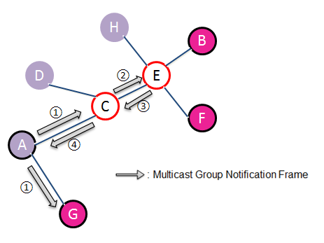
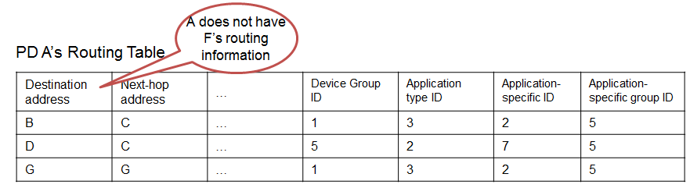
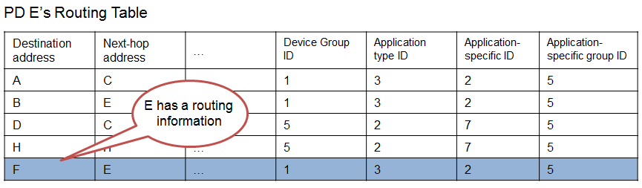
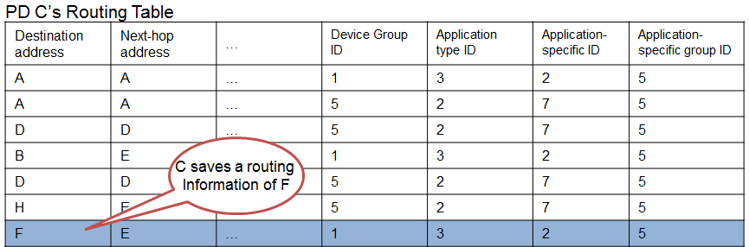
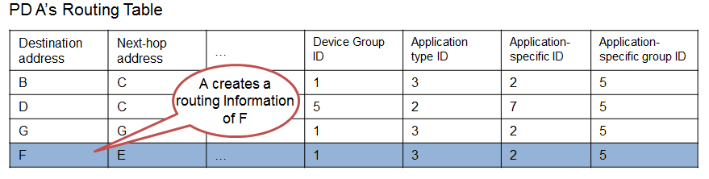
Figure 21. Unicast Data Transmission

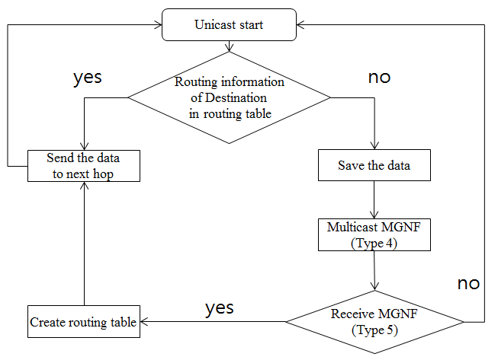
5.14.2. Multi-hop Multicast Transmission
Explained in section 5.6.2.

  - Relative positioning
  - Power management
  - Security
Security layer provides users with privacy, authentication, and authorization across the network.

5.17.1 Security modes
PAC security layer provides three different security modes on the basis of security requirements of network connections.

5.17.1.1 Security mode 1 (non-secure)
When a PAC device is in security mode 1, it shall never initiate any security procedure.

5.17.1.2 Security mode 2 (service level enforced security)
When a PAC device is in security mode 2, it shall initiate security procedures after a channel establishment request has been received or a channel establishment procedure has been initiated by itself. Whether a security procedure is initiated or not depends on the security requirements of the requested channel of service.
A PAC device in security mode 2 should classify the security requirements of its services using the following attributes.

Security requirement | Description
Authentication required | - Before connecting to the application, the remote device must be authenticated
Authorization required | - Access is only granted automatically to trusted PAC devices, or untrusted devices after an authorization procedure  - Always requires authentication to verify that the device is the right one
Encryption required | - The link must be changed to encrypted mode, before access to the service is possible

Security mode 1 can be considered as a special case of security mode 2 where no service has registered any security requirements.

5.17.1.3 Security mode 3 (link level enforced security)

When a PAC device is in security mode 3, it shall initiate security procedures before the channel is established.

5.17.2 Security parameters

PAC security layer uses the following security parameters.

Parameters | Description
PAC_ADDR | PAC device address (unique for each device)
AUTH_KEY | Authentication key used for authentication purposes
ENC_KEY | Encryption key for secure unicast
GENC_KEY | Group encryption key for secure group communication
RAND | Frequently changing random or pseudo-random number
5.17.3 Key Derivation
For secure communications between PAC devices in networks, several key materials are derived using the shared secret information between the devices.
Following figure shows the key derivation procedure between devices using PIN secretly shared during the peering phase.
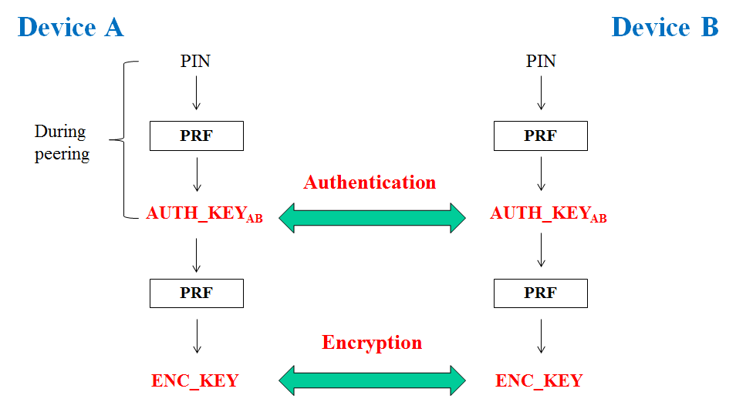
Figure 22. Key derivation

Each key material shall be derived selectively on the basis of the security mode. For example, when a PAC device is in security mode 1, it shall never initiate any security procedure. When a PAC device is in security mode 3, it shall derive all of the above key materials, such as AUTH_KEY and ENC_KEY between the devices.

5.17.4 Authentication

Authentication is the process of verifying ‘who’ is at the other end of the link. In PAC security layer, authentication is performed for devices, or services.
Technically, authentication is achieved based on the stored authentication key (AUTH_KEY) or by peering (entering a PIN).
Flowchart for authentication is shown as a follow.

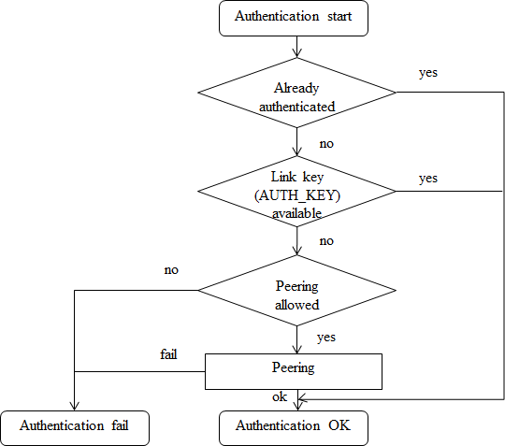
Figure 23. Flowchart for authentication

5.17.4.1 Infrastructureless authentication
In PAC networks where there is no coordinator or AAA(Authentication, authorization, accountability) server, authentication between PAC devices are done using PIN, or certificate issued by the trusted authority.
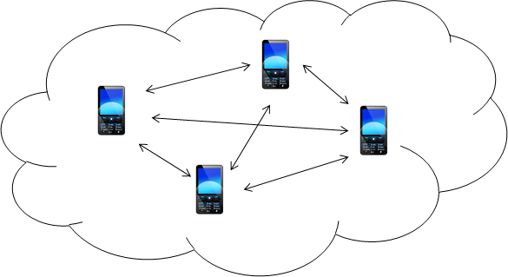
Figure 24. Infrastructureless architecture

5.17.4.1.1 PIN establishment issue
When PAC devices authenticate each other using PIN, they have to share PIN in advance. There are two ways of establishing PIN: (1) offline establishment, (2) online establishment. Because offline establishment shares PIN directly, it is secure in any environment. However, it has no scalability. On the other hand, online establishment, is not secure against the man-in-the-middle attack and replay attack in multi-hop network.

5.17.4.1.2 One-way authentication procedure
Some applications might require only one-way authentication. Following figure shows the one-way authentication procedure between PAC devices A (verifier) and B (claimant).

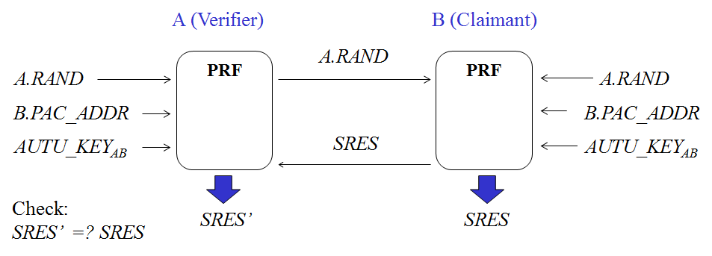
Figure 25. One-way authentication
When a verifier A requires to authenticate B, (1) A sends a random number A.RAND to B, (2) A and B computes a secret information SRES’ and SRES, respectively, using pseudo-random function (PRF) on inputs of A’s random number (A.RAND), PAC address of B (B.PAC_ADDR), and authentication key shared between them (AUTH_KEY), (3) B sends SRES, (4) A checks if SRES is equal to SRES’. If they match, authentication succeeds; if not, authentication fails.

5.17.4.1.3 Mutual authentication procedure
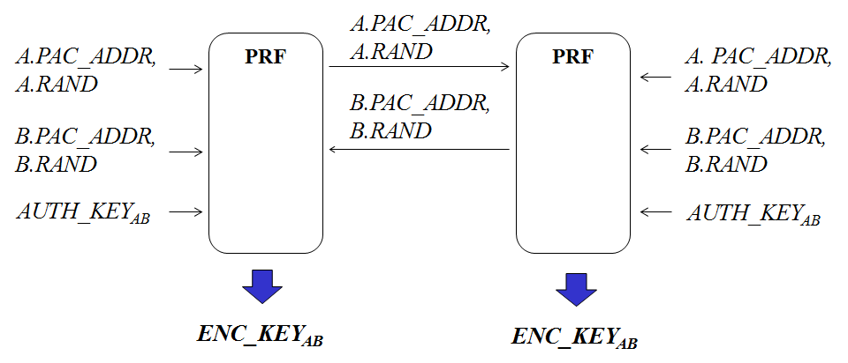
Some applications might require mutual authentication. Following figure shows the mutual authentication procedure between PAC devices A and B.
Figure 26. Mutual authentication procedure
When PAC devices A and B authenticate each other, (1) A sends its address (A.PAC_ADDR) with a random number (A.RAND) to B, (2) B also sends its address (B.PAC_ADDR) with a random number (B.RAND) to A, (3) A and B optionally computes encryption key (ENC_KEY) on the input of all of the previously exchanged information and AUTH_KEY. Then, they shall verify each other when they communicate using a secure channel protected by the shared ENC_KEY.

5.17.4.1.4 Device-to-device connection
We propose device-to-device authentication protocol without infrastructure that is secure in PAC networks. Our scheme achieves security criteria which is secure against the man-in-the-middle attack and replay attack in multi-hop network. Note that we assume PIN is distributed to each device securely before the proposed authentication protocol. Following figure shows the device-to-device authentication procedure between PAC devices A (verifier) and B (claimant).
Figure 27. device-to-device authentication procedure
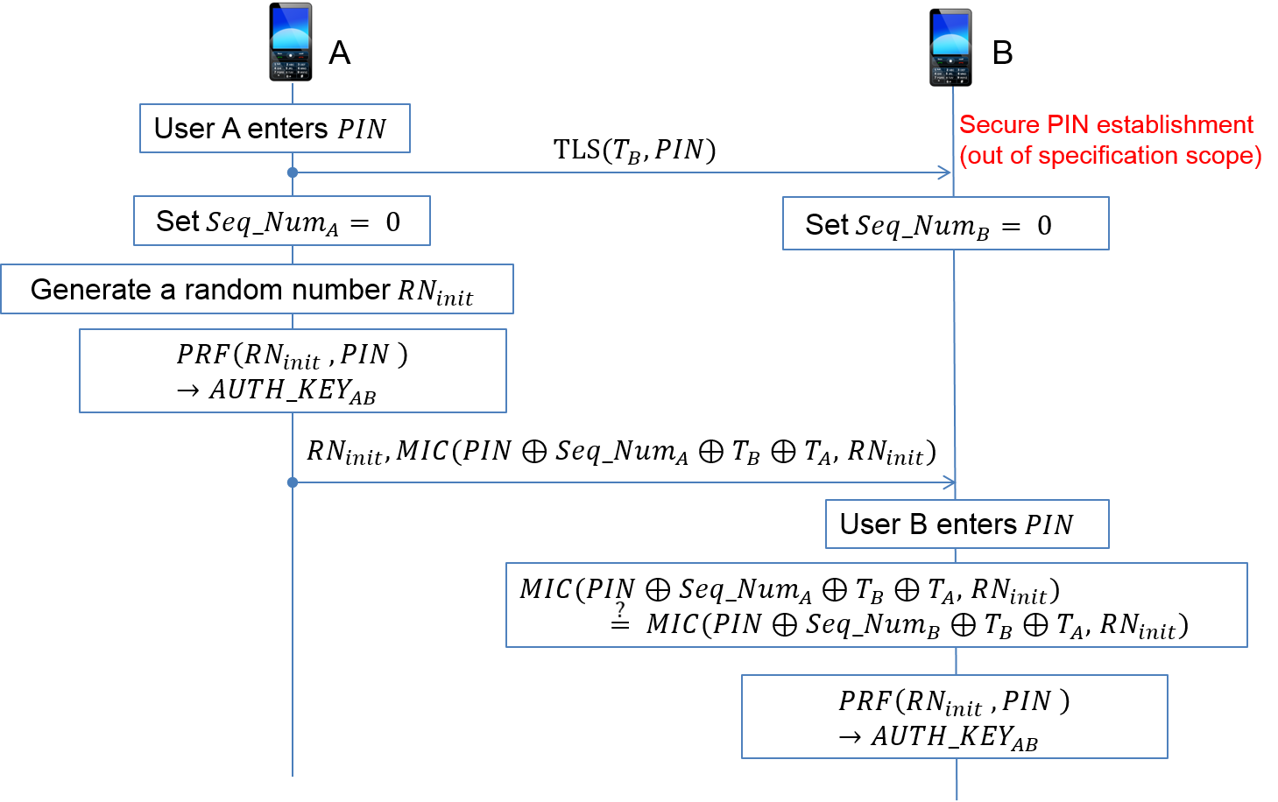
When PAC devices A and B authenticate each other, (1) A and B share PIN securely, (2) A and B reset the Seq_Num to 0. A generates random number${RN}_{init}$. Then, it generates $AUTH_{KEY}_{AB}$ using pseudo-random function PRF on inputs ${RN}_{init}$ and PIN, (3) A sends ${RN}_{init}$ in plaintext and MIN of ${RN}_{init}$ generated with a key which is XOR of A’s Seq_Num, B’s device information $T_{B}$, A’s device information $T_{A}$, and PIN to device B, (4) B enters the PIN and generates MIC of received ${RN}_{init}$ with a key, that is PIN$⊕$Seq_Num$⊕ T_{B }⊕ T_{A}$. If the MIC from B is equal to MIC from A, B can generate accurate initial key ${AUTH_KEY}_{AB}$ using pseudo-random function PRF on inputs ${RN}_{init}$ and PIN.

5.17.4.1.5 Device-to-(device in a specific group) connection
We propose device-to-(device in a specific group) authentication protocol without infrastructure that is secure in PAC networks. Our scheme achieves security criteria which is secure against the man-in-the-middle attack and replay attack in multi-hop network. Note that we assume PIN is distributed to each device securely before the proposed authentication protocol. Following figure shows the device-to-(device in a specific group) authentication procedure between PAC devices A (verifier) and B (claimant) which is in the Group G.
Figure 27. device-to-device authentication procedure
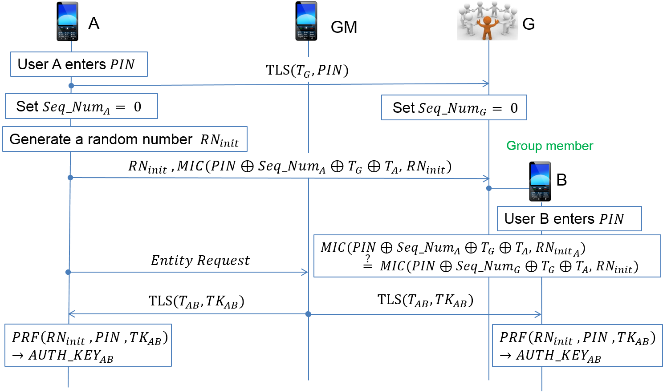
Figure 28. Device-to-(device in a specific group) authenticatino procedure

When PAC device A and PAC device group G authenticate each other, (1) A and G share PIN securely, (2) A and G reset the Seq_Num to 0. A generates random number${RN}_{init}$. Then, it generates $AUTH_{KEY}_{AB}$ using pseudo-random function PRF on inputs ${RN}_{init}$ and PIN, (3) A sends ${RN}_{init}$ in plaintext and MIN of ${RN}_{init}$ generated with a key which is XOR of A’s Seq_Num, G’s group information $T_{G}$, A’s device information $T_{A}$, and PIN to group G, (4) G enters the PIN and generates MIC of received ${RN}_{init}$ with a key, that is PIN$⊕$Seq_Num$⊕ T_{G }⊕ T_{A}$. If the MIC from G is equal to MIC from A, G can generate accurate initial key ${AUTH_KEY}_{AB}$ using pseudo-random function PRF on inputs ${RN}_{init}$ and PIN, (5) A sends the request message of connection with B to group manager GM, (6) GM distribute a temporary key ${TK}_{AB}$ to A and B securely. Then, A and B generate a new${AUTH}_{{KEY}_{AB}}=PRF({RN}_{init}, PIN, {TK}_{AB})$.

5.17.4.1.6 Security analysis
Here we sketch the proof of our proposed schemes against Man-In-The-Middle (MITH) and replay attack. Note that we assume PIN and ${TK}_{AB}$ are securely shared. After sharing PIN, ${RN}_{init}$ is transmitted with Message Integrity Code (MIC) for ${RN}_{init}$. in both protocols. Claimant can check the integrity of ${RN}_{init}$. And validity of the sender by exploiting MIC. As a result, these two proposed scheme are secure against MITM attack. In addition, exploiting sequential number, PAC devices check replayed message since they know the sequential number from MIC and receivers’ sequential number are different. Therefore device-to-device and device-to-(device in a specific group) authentication protocol are secure against MITM and replay attack.

5.17.4.2 Infrastructure authentication
In PAC networks where there is an AAA(Authentication, authorization, accountability) server and a dynamic coordinator, which is a PAC device with intermittent connection to the AAA server, authentication between PAC devices are done using symmetric master key, or certificate issued by the AAA server

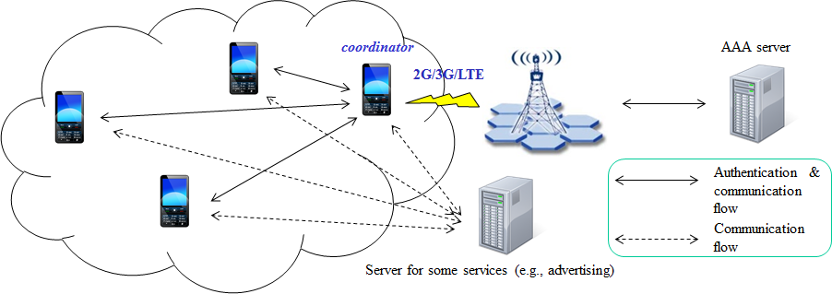
Figure 29. Infrastructure architecture

When a PAC device A and B (coordinator) authenticate each other, the mutual authentication procedure shall progress as a following figure.
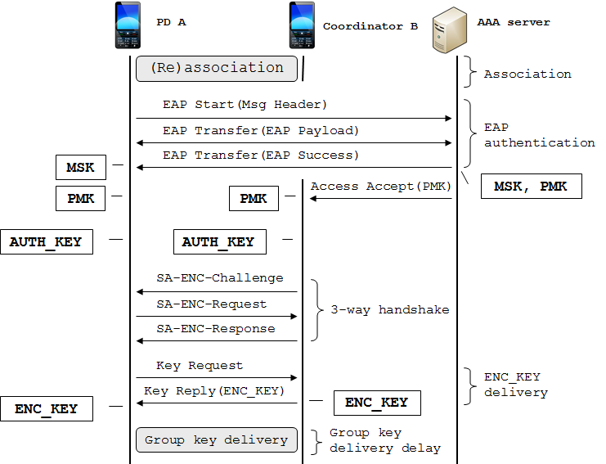
Figure 30. Infrastructure authentication

The authentication procedure consists of EAP authentication between a PAC device A and an AAA server, authentication key generation and 3-way handshake between PAC device A and B, and encryption key/group key delivery process.

5.17.4.2.1 EAP authentication
EAP (Extensible authentication protocol) authentication uses Extensible Authentication Protocol [IETF RFC 3748] in conjunction with an operator-selected EAP Method (e.g. EAP-TLS [IETF RFC 2716]). The EAP method will use a particular kind of credential – such as an X.509 certificate in the case of EAP-TLS, or a Subscriber Identity Module in the case of EAP-SIM.
The particular credentials and EAP methods that are to be used are outside of the scope of this specification. However, the EAP method selected should fulfil the following mandatory criteria listed in section 2.2 of RFC 4017: (1) mutual authentication, (2) protection against the man-in-the-middle attack. Use of an EAP method not meeting these criteria may lead to security vulnerabilities.
In the PAC authentication procedure, EAP yields the512-bit master secret key (MSK), which is delivered to a PAC device A by an AAA server.
Then the other key encryption keys (KEK) and HMAC/CMAC keys are derived from the MSK

5.17.4.2.2 Authentication key generation
After EAP authentication, the PAC device A and AAA server generate PMK using a truncation function as a follow.

PMK = Truncate(MSK, 160)

Then, the AAA server sends PMK to the coordinator B securely. On receipt of it, the coordinator B and the PAC device A generate authentication key using PMK.

AUTH_KEY = PRF(PMK, A.PAC_ADDR, B.PAC_ADDR)

Then, PD A and coordinator B derive shared KEK, HMAC/CMAC key from the AUTH_KEY.

5.17.4.2.3 SA-ENC 3-way handshake
SA-ENC 3-way handshake consists of the following messages.
(1) SA-ENC-Challenge message (A ← B): B.random, sequence number, PMK lifetime, HMAC/CMAC digest
(2) SA-ENC-Request message (A → B): A.random, B.random, sequence number, security capabilities, security negotiation parameters, HMAC/CMAC digest
(3) SA-ENC-Challenge message (A ← B): A.random, B.random, sequence number, [SA-ENC_KEY-update,] SA-descriptor, security negotiation parameters, HMAC/CMAC digest

Integrity of the above handshake messages are protected by MAC digest against forgery attack. Optional SA-ENC_KEY-update contains all the keying materials for the ENC_KEY update and distribution, which is encrypted with KEK
SA-ENC 3-way handshake provides the following security guarantees:
- Full mutual authentication,
- Message (2) indicates to the coordinator B that a PD A is alive and that A possesses the AUTH_KEY
- Message (3) indicates to the PD A that the coordinator B is alive
- The coordinator B is guaranteed that SA-ENC-Update is sent by the PD A and is fresh

5.17.4.2.4 Encryption key delivery
After a successful authorization, the PAC device A shall dynamically requests parameters for SA (security association) including ENC_KEY through KEY_Request and KEY_Reply messages. When a secure communication is required between the devices, the connections are encrypted using the ENC_KEY.

5.17.4.2.5 Group key delivery
In a network environment where the secure multicast and broadcast service (MBS) is supported, additional group key (GENC_KEY) generation and delivery process shall be performed optionally after ENC_KEY distribution procedure. Then, the group communication are encrypted using the GENC_KEY.

5.17.4.3 Authorization
Authorization is the process of deciding if device X is allowed to have access to service Y.
Authorization always includes authentication, and grants access rights to devices on the basis of their trust levels.

Device trust level | Description
Trusted device | - The device has been previously authenticated  - An authentication key is stored  - The device is marked as “trusted” in the device DB
Untrusted device | - The device has been previously authenticated  - An authentication key is stored  - But, the device is not marked as “trusted” in the device DB
Unknown device | - No security information is available for this device  - This is also an untrusted device

Trusted devices (authenticated) are allowed to services, but untrusted or unknown devices may require authorization based on interaction before access to services is granted.
Technically, key would be derived or given (established) to the authorized user during the authorization procedure.
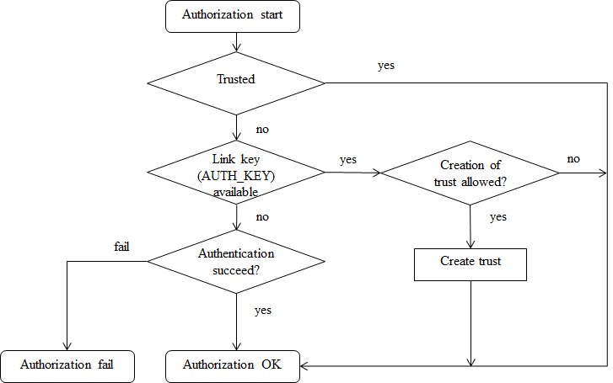
Flowchart for authorization is shown as a follow.
Figure 31. Flowchart for authorization

  - Coexistance

  - Upper layer interaction

