**IEEE P802.15**

**Wireless Personal Area Networks**

|  |  |  |
| --- | --- | --- |
| Project | IEEE P802.15 Working Group for Wireless Personal Area Networks (WPANs) | |
| Title | **Samsung-ETRI Merged Proposal to TG8 CFC (Doc.)** | |
| Date Submitted | May 5, 2014 (r0) | |
| Source | Seung-Hoon Park, Kyungkyu Kim, Anil Agiwal, Youngbin Chang, Hyunseok Ryu, Daegyun Kim and Won-il Roh (Samsung)  Byung-Jae Kwak, Kapseok Chang, Moon-Sik Lee (ETRI)  Junhyuk Kim, June-Koo Kevin Rhee (KAIST) | E-Mail:  [shannon.park@samsung.com],  [{bjkwak, kschang, moonsiklee}@etri.re.kr], [kim.jh@kaist.ac.kr, rhee.jk@kaist.edu] |
| Re: |  | |
| Abstract | Description of PAC operations and frame structure with identified features. | |
| Purpose | Corresponding to Call for Contribution | |
| Notice | This document does not represent the agreed views of the IEEE 802.15 Working Group or IEEE 802.15.8 Task Group. It represents only the views of the participants listed in the “Source(s)” field above. It is offered as a basis for discussion and is not binding on the contributing individual(s) or organization(s). The material in this document is subject to change in form and content after further study. The contributor(s) reserve(s) the right to add, amend or withdraw material contained herein. | |
| Release | The contributor acknowledges and accepts that this contribution becomes the property of IEEE and may be made publicly available by P802.15. | |
| Patent Policy | The contributor is familiar with the IEEE-SA Patent Policy and Procedures:  <http://standards.ieee.org/guides/bylaws/sect6-7.html#6> and  <http://standards.ieee.org/guides/opman/sect6.html#6.3>.  Further information is located at <http://standards.ieee.org/board/pat/pat-material.html> and  <http://standards.ieee.org/board/pat>. | |

Table of Contents

[1. Overview 3](#_Toc378250050)

[2. Definitions 3](#_Toc378250051)

[3. Abbreviations and acronyms 3](#_Toc378250052)

[4. General descriptions 5](#_Toc378250053)

[4.1. Concepts and architecture 5](#_Toc378250054)

[4.2. Topology 6](#_Toc378250055)

[4.3. Reference model 7](#_Toc378250056)

[5. MAC layer 8](#_Toc378250057)

[5.1. Overview 8](#_Toc378250058)

[5.2. Frame Structure 8](#_Toc378250059)

[5.3. Synchronization 9](#_Toc378250060)

[5.4. Discovery 10](#_Toc378250061)

[5.5. Peering 10](#_Toc378250062)

[5.6. Communications 12](#_Toc378250063)

[5.6.1. Unicast 12](#_Toc378250064)

[5.6.2. Multicast 12](#_Toc378250065)

[5.6.3. Broadcast 12](#_Toc378250066)

[5.7. MPDU structure 12](#_Toc378250067)

[5.8. Multiple access 12](#_Toc378250068)

[5.9. Synchronization procedure 13](#_Toc378250069)

[5.10. Discovery procedure 13](#_Toc378250070)

[5.11. QoS 13](#_Toc378250071)

[5.12. Interference management 13](#_Toc378250072)

[5.13. Transmit power control 13](#_Toc378250073)

[5.14. Multi-hop operation 13](#_Toc378250074)

[5.15. Relative positioning 13](#_Toc378250075)

[5.16. Power management 14](#_Toc378250076)

[5.17. Security 14](#_Toc378250077)

[5.17.1. Security modes 14](#_Toc378250078)

[5.17.2. Authentication 14](#_Toc378250079)

[5.18. Coexistence 14](#_Toc378250080)

[5.19. Upper layer interaction 15](#_Toc378250081)

[6. Physical layer 15](#_Toc378250082)

[6.1. Channelization 15](#_Toc378250083)

[6.1.1. Channelization for sub-GHz band, 2.4 GHz and 5 GHz unlicensed bands 15](#_Toc378250084)

[6.1.2. Channelization for UWB band 15](#_Toc378250086)

[6.2. Duplex schemes 16](#_Toc378250087)

[6.3. Multiplexing schemes 16](#_Toc378250088)

[6.4. PPDU structure 16](#_Toc378250089)

[6.5. Modulation and coding scheme (MCS) 16](#_Toc378250090)

[6.5.1. Modulation 16](#_Toc378250091)

[6.5.2. Coding Scheme 17](#_Toc378250092)

[6.6. Multiple antennas 17](#_Toc378250093)

[6.7. Bit interleaver 17](#_Toc378250094)

[6.8. Scrambling 17](#_Toc378250095)

[6.9. UWB Physical (PHY) layer 17](#_Toc378250099)

# Overview

The 802.15.8 specification shall be developed according to the P802.15.8 Peer Aware Communication (PAC) project authorization request (PAR), document number 15-12-0063r2 and Five Criteria (5c), document number 15-12-0064r1, which were approved by the IEEE-SA in March of 2012.

This standard defines PHY and MAC mechanism for Wireless Personal Area Networks (WPAN) Peer Aware Communications (PAC) optimized for Peer-to-Peer and infrastructure-less communications with fully distributed coordination. A peer can participate in multiple services or applications.

Key features of PAC may include the following:

* Operational in selected globally available unlicensed/licensed bands below 11 GHz capable of supporting these requirements
* Scalable data transmission rates, typically up to 10 Mbps
* Discovery for peer information without association
* Discovery signaling rate typically greater than 100 kbps
* Discovery of the number of devices in the network
* Group communications with simultaneous membership in multiple groups, typically up to 10
* Multi-hop relay
* Relative positioning
* Security

# Definitions

**Device ID**: Unique PAC device ID, e.g. MAC address

**Discovery information**: One or more of Device ID, Device Group ID, Application type ID, Application-specific ID, Application-specific user ID, and Application-specific group ID, and/or peer context and application-driven information

**Discovery**: Discovery is the procedure to detect existence and discovery information of other PDs that are within discoverable range.

**Discovering PD**: A PD which tries to discover other PD(s)

**Discovered PD**: A PD of which discovery information is received by a discovering PD.

**Peer aware communications (PAC) network**: A peer-to-peer wireless proximity network of which a device or devices communicate with other device(s) with various information such as configuration or control, location, sensing data, advertisement, multimedia contents, social contents, etc.

**Multicast group ID**: the logical identifier of a multicast group

**Payload data**: contents of a data message that is being transmitted

# Abbreviations and acronyms

|  |  |
| --- | --- |
| AAA | Authentication, Authorization, Accountability |
| AGC | Automatic Gain Control |
| BPM | Burst Position Modulation |
| BPSK | Binary Phase-Shift Keying |
| CAP | Contention Access Period |
| CCA | Clear Channel Assessment |
| CFP | Contention Free Period |
| CP | Cyclic Prefix |
| CRC | Cyclic Redundancy Check |
| CS | Channel Sampling |
| CTS | Clear To Send |
| CW | Contention Window |
| FCS | Frame Check Sequence |
| FEC | Forward Error Correction |
| GI | Guard Interval |
| IS | Interference Sensing |
| LFSR | Linear Feedback Shift Register |
| LSB | Least Significant Bit |
| LTF | Long Training Field |
| MAC | Medium Access Control |
| MLME | MAC sublayer Management Entity |
| MLSDE | MAC sublayer Service Discovery Entity |
| MSB | Most Significant Bit |
| OFDM | Orthogonal Frequency Division Multiplexing |
| PAN | Personal Area Network |
| PD | PAC Device |
| PDU | Protocol Data Unit |
| Peering-REQ | Peering-Request |
| Peering-RSP | Peering-Response |
| PHR | PHY Header |
| PHY | Physical layer |
| PID | Peering Identifier |
| PLME | PHY Layer Management Entity |
| PPDU | PHY Protocol Data Unit |
| PRBS | Pseudo-Random Binary Sequence |
| PSD | Power Spectral Density |
| PSDU | PHY Service Data Unit |
| RF | Radio Frequency |
| RTS | Request To Send |
| SC | Single Carrier |
| SDU | Service Date Unit |
| SHR | Synchronization Header |
| STF | Short Training Field |
| SYNC | Synchronization |
| ULA | Uniform Linear Array |
| UWB | Ultra Wide Band |
| ZC | Zadoff-Chu |

# General descriptions

This clause provides the basic framework of PDs. The framework serves as a guideline in developing the functionalities of PDs and their interactions specified in detail in the subsequent clauses.

## Concepts and architecture

PAC provides functionalities optimized for scalable peer to peer communications with fully distributed coordination for decentralized system composed of PDs. PAC also provides mechanisms that enable low power consumption, discovery of peer information before association, efficient resource allocation in a distributed manner, and coexistence with other 802 systems.

Some PDs may be able to connect to infrastructure on an opportunistic basis, which is out of scope for IEEE 802.15.8.

****

Figure 1. Overall PAC Architecture

A PAC system may contain the following functions at MAC and/or PHY. The block diagram is provided as information only.

**Upper Layer:** the layer above PHY/MAC, such as middleware, and application layer.

**PD Management Entity:** manages PD information across PHY/MAC and upper layer for PAC communications.

**Synchronization Function:** performs initial and/or periodic time synchronization among PDs; maintains frequency and clock phase synchronization.

**Discovery Function:** discovers peer(s) in proximity by using discovery information**.**

**Peering Function:** requests or responds to Peering (i.e. association), Peering Updates, De-peering, or Re-peering.

**Channel Management Function:** manages the radio resource including channel allocation and/or access.

**Power Control Function:** performs transmit power control and interference management based on power control information.

**Measurement and Report Function:** conducts measurements of channel information, and sends data reports from other logic functions to upper layer.

**Scheduler Function:** manages or controls the sequence of events in MAC and/or PHY layer, for example, transmission queuing, collision avoidance, etc.

**Encoder Function:** performs encoding and other data processing such as interleaving, scrambling, etc. at PHY to aid in reliable reception.

**Modulator Function:** performs modulation and other data processing such as mapping, precoding, etc. at PHY.

**Decoder Function:** performs decoding and other data processing, such as de-interleaving, de-scrambling, etc. at PHY to aid in reliable reception.

**Demodulator Function:** performs demodulation and other data processing such as equalization, de-mapping, etc. at PHY.

## Topology

Several topologies, such as mesh topology or star topology, may be used to support interactions among PDs for various services. One-to-one and one-to-many topologies shall be supported.

IEEE 802.15.8 shall support a PD having simultaneous communication sessions for same or different applications. IEEE 802.15.8 shall support a PD participation in at least two independent communication sessions with different peers at the same time.

PAC supports multi-hop relay of at least two hops.



Figure 2. An example of concurrent communication

## Reference model

All services and functions of PDs are partitioned into a physical (PHY) layer and a medium access control (MAC) sublayer of the data link layer, in accordance with the ISO/OSI-IEEE Std 802-2001 reference model. Direct communications between PDs are to transpire at the PHY layer and MAC sublayer as specified in this standard; Message security services are to occur at the MAC sublayer, and security operations are to take place inside and/or outside the MAC sublayer.

Within a PD, the MAC provides its service to the upper layer through the MAC service access point (SAP) located immediately above the MAC sublayer, while the PHY provides its service to the MAC through the PHY SAP located between them. On transmission, the upper layer passes MAC service data units (MSDUs) to the MAC sublayer via the MAC SAP, and the MAC sublayer passes MAC frames (also known as MAC protocol data units or MPDUs) to the PHY layer via the PHY SAP. On reception, the PHY layer passes MAC frames to the MAC sublayer via the PHY SAP, and the MAC sublayer passes MSDUs to the upper layer via the MAC SAP.

MAC and PHY SAPs also pass control information between the layers.



Figure 3. Reference model

There may be a logical PD management entity (PDME) that exchanges network management information with the PHY and MAC as well as with other layers.

# MAC layer

## Overview

This clause defines MAC mechanism for Wireless Personal Area Networks (WPAN) Peer Aware Communications (PAC) optimized for peer-to-peer and infrastructure-less communications with fully distributed coordination.

The MAC functions are described in this clause. The following are main functions and their brief explanation.

* Synchronization is the procedure to establish and maintain synchronization, including at least reference timing, among PDs.
* Discovery is the procedure to find existence and discovery information of other PDs that are within discoverable range.
* Peering is the procedure to establish a link between a pair of PDs or links among multiple PDs.
* Communication is the procedure to exchange data or control/management message among PDs.

## Frame Structure

PAC operates in synchronization mode, where PDs share timing reference with other PDs in proximity.

The radio resource is comprised of successive synchronization intervals with fixed time duration. The length of the synchronization interval is for further study. A synchronization interval is divided into slots as illustrated in Figure 4.



Figure 4. Synchronization interval

Timing reference signals are transmitted in the Synchronization slot. Every synchronization interval shall include a synchronization slot.

Discovery, peering, and/or data communication slot is used for discovery, peering, and/or data communication. The discovery, peering, and/or data communication slot can be further divided into smaller slots. Different combinations of the smaller slots may be used to form different types of synchronization intervals to satisfy the requirements for discovery, peering, and data communication.

Figure 5 illustrates an example configuration of a synchronization interval, where the discovery, peering, and/or data communication slot is divided into discovery slot, peering slot, and data communication slot. The configuration of synchronization interval illustrated in Figure 5 provides a power saving feature by allowing PDs in sleep mode to sleep during data communication slot while staying active during the synchronization slot, discovery slot, and the peering slot.



Figure 5. An example configuration of synchronization interval

[Proposed Frame Structure]

Data communication slot is comprised of contention access period (CAP) and contention free period CFP).



## Synchronization

In synchronized mode, PAC operates in fully distributed synchronization.

PAC currently recognizes two slightly different definitions of fully distributed synchronization.

* [Def. 1] Synchronization among PDs can be achieved by transmitting/receiving synchronization reference signal. When there is already synchronization among PDs, each PD may send synchronization reference signal independently to maintain the synchronization. When there is no synchronization already established, a PD can initiate it by transmitting synchronization reference signal.
* [Def. 2] Synchronization among PDs can be achieved by transmitting/receiving synchronization reference signal. The synchronization reference signal may be transmitted by a single PD dynamically elected by a group of PDs. When there is no synchronization already established, a PD can initiate it by transmitting synchronization reference signal.

IEEE802.15.8 PAC follows distributed synchronization procedure without any single master PD to get reference timing. The distributed synchronization is proper to flat and scalable network to be supported by PAC. Network synchronization shall be achieved prior to any other PAC procedures, such as discovery, peering (link establishment), and data communications.

*A PD shall be in synchrony state prior to peer discovery procedure and peering procedure.*

*IEEE802.15.8 PAC has two synchronization mode including Initial Synchronization mode and Maintaining Synchronization mode.*

### PAC synchronization modes and procedure

Initial Synchronization mode:

1. Start in Initial Synchronization mode.
2. PD monitors Synchronization Reference Signals (SRSs) during synchronization period.
3. If at least one SRS is detected during synchronization period, perform according to distributed synchronization mechanism.  
   Else, start PAC operations based on frame structure in Maintaining Synchronization mode.

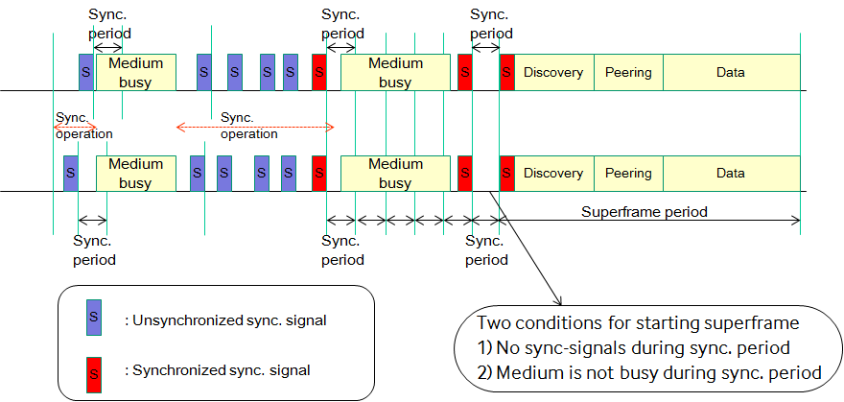

**Maintaining Synchronization mode:**

After initial synchronization is achieved, frame structure is defined and PDs switch to Maintaining Synchronization mode. In Maintaining Synchronization mode, all PDs participate in the synchronization procedure by transmitting Synchronization Reference Signal using random access in the Synchronization slot. The structure of Synchronization slot is illustrated in Fig. xxx. The Synchronization slot is 416 $μ$ sec long (‘32 backoff slot’ + ‘1 Synchronization Reference Signal’), where the backoff slot is 12 $μ$ sec long and the Synchronization Reference signal is 32 $μ$ sec long.

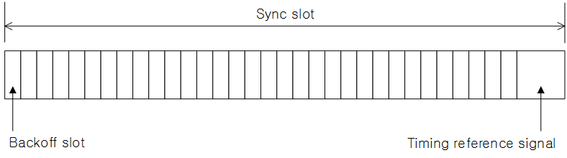

Fig. xxx: The structure of Synchronization slot.

The Synchronization procedure in Maintaining Synchronization mode is as follows:

* When a PD is initialized, the PD scans the channel to detect existing network synchronization. If it detects existing network synchronization, it adjusts its own timing to the existing network synchronization using PCO (Pulse Coupled Oscillator) synchronization algorithm described below. If no existing network synchronization is detected, it initiates Initial Synchronizatoin mode.
* A PD participating in a synchronization procedure transmits Synchronization Reference signal using CSMA/CA based random access. Synchronization Reference signal consists of preamble, timing-offset indication field (TOIF), contention-window indication field (CWIF), collision detection field (CDF), and a guard time[TBD].
* Synchronization Reference signal can be transmitted using random access anywhere in the synchronization slot as long as the transmission of the Synchronization Reference signal can be completed within the synchronization slot.
* If a PD receives a Synchronization Reference signal transmitted by a neighboring PD, the PD takes the following steps.
  + It calculates the received timing of the Synchronization Reference signal from the actual received time of the Synchronization Reference signal and offset information embedded in the Synchronization Reference signal.
  + It updates its timing using PCO synchronization algorithm applying the received timing of the Synchronization Reference signal.
  + If its own backoff counter is 1, it transmits random tones in the CDF (collision detection field).
  + If its own backoff counter is not 1, it checks the CDF to detect a collision. If a collision is detected, it increases its CW.
  + It updates CW\_other using the CW value contained in the Synchronization Reference signal as follows:

CW\_other := $β$ CW\_other + $(1-β)$ CW

* If a PD detects no transmission attempt of Synchronization Reference signal in the current sync slot, it decreases its CW.
* If the remaining time left in the current sync slot is less than the length of Synchronization Reference signal, it halts backoff procedure until the next synchronization slot.

**Random Access Scheme for Synchronization Procedure:**

The random access scheme for synchronization procedure is collision detection based CSMA/CA with EIED (Exponential Increase Exponential Decrease) backoff algorithm. The random access scheme is as follows:

* + PDs maintain CW (contention window) and CW\_other, where CW\_other is the average CW of neighboring PDs.
  + PDs select a random integer from {0, 1, 2, …, CW-1} and set their backoff counter to the selected random number.
  + PDs senses carrier, and decrease their backoff counter by 1 at the end of every elapse of backoff slot time if the channel is idle.
  + If the backoff counter becomes zero, a PD transmits Synchronization Reference signal, and choose a new random integer using the current CW and continue random backoff procedure.
  + If a PD detects a collision, it increases its CW.
  + A PD decreases its CW if no transmission attempt of Synchronization Reference signal is detected within the current synchronization slot.

**EIED Algorithm:**

The increase and decrease of CW follows EIED algorithm as follows:

* + Increase
    - If CW $≤$ 0.5 CW\_other, then CW:= CW $r_{I}^{2}$

\*
    - If 0.5 CW\_other < CW, then CW:= CW $r_{I}$

\*
  + Decrease
    - If CW < 2 CW\_other, then CW:= CW / $r_{D}$
    - If 2 CW\_other $≤$ CW, then CW:= CW / $r_{D}^{2}$

The distributed synchronization mechanism is designed based on classical PCO (Pulse Coupled Oscillator) synchronization algorithm. According to PCO algorithm, a PD assumes to have an oscillator which can fasten the own phase when receiving pulse as Figure 1. This adjustment is controlled by the predefined function  which has the own phase value as an input. If there is no other pulse detected, there is no change but normal phase increment according to time advance.

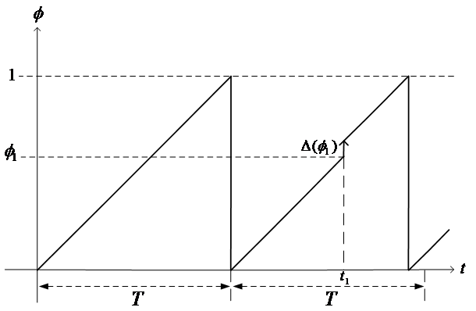

Figure 2. Oscillator Phase Transition

The overall PCO synchronization steps can be imagined from Figure 2. The phase value of each node is mapped to on the edge of circle. At first (a) phase, all nodes start randomly, so each node has a different phase value at a certain instant time. When node A increases the phase and reaches the maximum value (1 as normalized one), it fires Synchronization Signal (SS) to medium as the same role to pulse of original algorithm. Other nodes receiving the SS adjust the own oscillator to change the phase value according to predefined rule. Through these interactions with coupled oscillator, all nodes can achieve to reach the synchrony in a time as shown from Figure 2 (c).

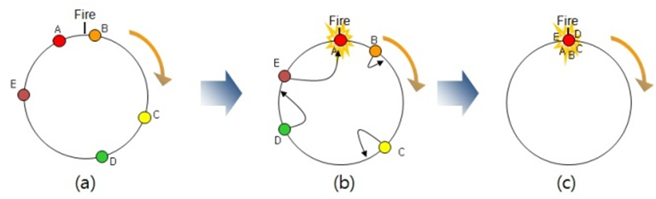

Figure 3. PCO Synchronization Steps

1. All nodes have oscillator with the same phase increment rate
2. One node fires, then other nodes adjust oscillator according to the predefined function without state other than it’s internal phase
3. Finally, all nodes converges to the same time base

The equation for phase adjustment is as follows:



To get synchrony, all nodes follow the same rule based on phase adjustment curve . The phase adjustment curve  is described by the non linear curve to represent mapping relation between the value  and the corresponding phase. The curve should be concave down for synchrony condition. The dissipation factor  has to be larger than zero. Using phase adjustment curve, adjusted phase value is calculated by following rule:



To provide fast convergence, selective update is adopted as following rule:

If  is met, the adjusted phase value is determined by the following rule:



If  is not met, there is no phase update.

To avoid ping-pong effect in scalable network environment, refractory period is decided during the time when the phase value has the following condition:



There is no phase update during refractory period.

### Synchronization procedure for operations in unlicensed band

The synchronization procedure with energy sensing is designed for operations in unlicensed band to coexist with different systems sharing the same band.

This procedure is enabled only in initial synchronization mode.

1. A PD senses energy level while doing operation for distributed synchronization.
2. If medium is busy, the PD pends synchronization operation. Else, the PD keeps synchronization operation.

If medium is not busy and SS is not detected during synchronization period, Superframe starts in Maintaining Synchronization mode.

## Discovery

PAC should support three discovery types of the following:

* Advertisement: In Advertisement type discovery, a PD broadcasts its own discovery information and does not expect responses.
* Publish/Subscribe: In Publish/Subscribe type discovery, a PD broadcasts its own discovery information and expects responses from PDs that have discovered the broadcast message.
* Query/Reply: In Query/Reply type discovery, a PD broadcasts the discovery information of the PD or PDs being queried and expects a response or responses from the PD or PDs, accordingly.

For the purpose of discovery of PDs, the discovery information may represent one or more of the following IDs such as Device ID, Device Group ID, Application type ID, Application-specific ID, Application-specific user ID, and Application-specific group ID.

The discovery procedure should support mechanisms to ensure privacy that a PD is not tracked.

The discovery procedure should support protection of identity from impersonation.

Discovery Information (DI) is driven from higher layer such as application layer or middleware.

Protocol stack for discovery procedure is described as following:



Supported discovery types are Advertisement, Publish/subscribe, Query/reply, SSF (Self Spatial Filtering) aka LnL (Look-and-Link), or Emergency messages.

Discovery slot is comprised of Discovery Indication Sub-slot and multiple Discovery Blocks (DB).



Discovery Indication Sub-slot supports sleep mode at Discovery Slot as follows:

* A PD with a discovery message to transmit
* Transmit discovery indication signal in the discovery indication sub-slot
* Transmit the discovery message in the discovery sub-slot
* A PD without a discovery message to transmit
* Listens to the discovery indication sub-slot. If carrier is sensed, listens to discovery sub-slot for discovery messages
* Listens to the discovery indication sub-slot. If no carrier is sensed, does not listen to the discovery sub-slot to reduce power consumption

Discovery Block is selected by PD based on congestion condition and/or hashed index from discovery information.

The procedure to select a Discovery Block is as follows:

1. A PD selects one Discovery Block.
2. The PD broadcasts Peer Discovery Message at the selected Discovery Block.
3. The PD monitors congestion level by energy sensing.
4. If congested, the PD selects different Discovery Block for next transmission.
5. If not congested, the PD keeps the current Discovery Block.

## Peering

Peering is the procedure to establish a link between a pair of PDs or links among multiple PDs discovered during the discovery procedure.

Re-peering is the procedure to re-establish a link between a pair of PDs or links among multiple PDs which peered previously. In the re-peering procedure, peering may be simplified.

De-peering is the procedure to disconnect the link established by peering.

A PD exchanges information such as device capability for setup a link, and determines link related parameters such as Link ID, QoS class, link range, or etc.

*Network protocol such as routing shall be operated only over connected links.*

**Peering Procedure**



Figure 6. Peering Procedure

The peering procedure is initiated by sending a peering request message including requested peering information. Responder may send a peering response message to requestor for indicating if the peering request is accepted or not. The response message may include peering information if the request is accepted.

**Re-peering procedure:**



Figure 7. Re-peering Procedure

Re-peering procedure is similar to peering procedure. The main differences are: 1) some of the previous peering information may not be included in request and response messages; 2) the PD receiving the request validates peering information before making a decision to accept the re-peering request.

**De-peering procedure:**



Figure 8. De-peering Procedure

De-peering procedure starts with a de-peering request, which is replied by a de-peering response message. De-peering response may be optional

Peering Slot is designed as similar as Discovery Slot. It comprises Peering Indication Sub-slot and Peering Sub-slot.



Peering Indication Sub-slot supports sleep mode for peering procedure as follows:

* A PD with a peering message to transmit
  + Transmit peering indication signal in the peering indication sub-slot
  + Transmit the peering message in the peering sub-slot
* A PD in sleep mode without a peering message to transmit
  + Listens to the peering indication sub-slot. If carrier is sensed, listens to peering sub-slot for peering messages
  + Listens to the peering indication sub-slot. If no carrier is sensed, do not listen to the peering sub-slot to reduce power consumption
* A PD not in sleep mode without a peering message to transmit
  + Listens to the peering indication sub-slot. If carrier is sensed, listens peering sub-slot for peering messages
  + Listens to the peering indication sub-slot. If no carrier is sensed, use peering sub-slot as a CAP (contention access period)

Peering, re-peering, and de-peering messages and their corresponding response messages are transmitted using random access scheme, which is identical to the random access scheme for data communication in the contention access period as described in Sub-clause 5.6.

## Communications

Data communication may be conducted as unicast between a pair of PDs, or as multicast within a group of PDs, or as broadcast to any PD.

### Unicast

Unicast is a one-to-one data communication between a pair of PDs. For reliable unicast transmission, ACK may be used for acknowledging a successful data transmission.

### Multicast

Multicast is a one-to-many data communication to a group or groups of PDs which may be addressed by multicast group ID(s). To support multicast, the following features are supported:

* Multicast group creation: A PD creates a multicast group.
* Joining multicast group: A PD joins a multicast group.
* Leaving multicast group: A PD leaves a multicast group.

### Broadcast

Broadcast is a one way data communication to any PDs within reachable range, or any PDs in a group or groups of PDs. A PD which received a broadcast message does not respond with acknowledgement.

### Contention Access Period

In CAP, unicast, multicast, or broadcast data packets are transmitted using CSMA/CA based random access, which is similar to the random access scheme used in the synchronization slot for distributed synchronization in Maintain Synchronization mode. The differences between the random access scheme in CAP and that in synchronization slot in Maintain Synchronization mode are as follows:

* + A PD increases it CW when it does not receive an ACK after transmitting a unicast packet, in addition to when it detects a collision.
  + It decreases its CW when a PD detects no collision for predetermined period of time Td.
  + The increase and decrease of CW follows EIED backoff algorithm. The increase factor and decrease factor for packet transmission is different from the factors for synchronization [TBD].

### Contention Free Period

*A PD shall determine Resource Slot based on the predetermined distributed scheduling algorithm.*

Data transmission is performed during Data frame which is accessed by only peered PDs. For unicast transmission, Link ID is determined via peering procedure.

*A PD shall determine one or multiple Resource Slot during Scheduling subframe as contention-free channel access scheme.*

Scheduling subframe is comprised of Scheduling Request subframe and Scheduling Response subframe.

Scheduling Request signal represents Link ID, Resource Slot Star Index, and Resource Slot Length.

**

Scheduling Response signal represents Link ID, Resource Slot Adjusted Index, and Resource Slot Length.



Both signal contains resource information relating to resource assignment and is broadcasted to nearby PDs.

The flowchart of operation for distributed scheduling is as follows:

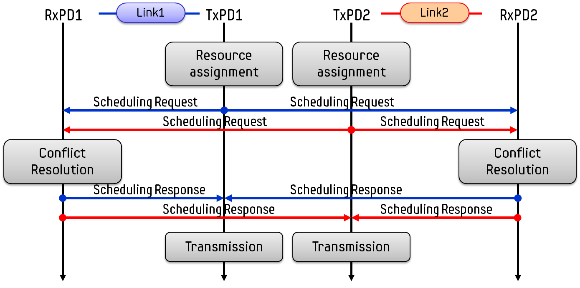

Link1 has a transmitter PD1(TxPD1) and a receiver PD1(RxPD1) and Link2 has a transmitter PD2(TxPD2) and a receiver PD2(RxPD2). Initially, TxPD1 and TxPD2 determine one or multiple RSs by initial configuration respectively. The candidate RS information is transmitted to the corresponding RxPD and neighboring RxPD as well. RxPD receives multiple Scheduling Request message and has resource information including RS Start Index and RS Length. RxPD modifies resource information to avoid resource assignment confliction based on RS Star Index information from neighbouring TxPDs. The modified resource information including RS Adjusted Index and RS Adjusted Length are transmitted by the RxPD to the corresponding TxPD and neighboring TxPDs. The TxPD determines the assigned RSs to transmit data packets on.

## MPDU structure

MPDU for data communication has a MPDU header and may have a variable length MPDU payload and a fixed length FCS. The MPDU payload is data information. FCS contains CRC check sequence for error detection.



Figure 9. PAC MPDU format

## Multiple access

Multiple access schemes allow multiple PDs to share a communication medium. Contention-based access as well as contention-free access schemes are considered.

In a contention-based multiple access scheme, multiple PDs compete for channel access.

Contention-free multiple access schemes try to guarantee channel access to PDs so that the PDs do not have to compete for channel access.

## Synchronization procedure

Key desired features of synchronization procedure are as follows:

* The purpose of synchronization is to find, at least, the time boundary either at the PHY or the MAC. The time boundary may be symbol, slot, frame, application frame, super frame, etc.
* Synchronization reference signal may be a sequence or a beacon.
* Any PD should be able to synchronize with a PD or PDs in at least the discovery radio range, i.e. synchronized with neighboring PDs.
* There is no specific and static synchronization reference PD operating in a centralized manner, i.e. there is no dedicated PD for sending synchronization reference signal like a coordinator in a centralized control system.
* Synchronization mechanism should support low duty cycling for discovery and peering, i.e. low overhead for discovery and peering.
* Synchronization mechanism should efficiently support PDs participating in one or multiple group communications.
* Synchronization mechanism should efficiently support multi-hop communications.

## Discovery procedure

Key desired features of peer discovery procedure:

* Peer discovery function is enabled or disabled triggered by upper layer.
* Peer discovery information is driven from upper layer.
* Peer discovery message contains at least peer discovery information.
* A PD may transmit peer discovery message periodically during peer discovery broadcasting.

## QoS

The MAC sublayer may provide differentiated operations according to traffic types.

## Interference management

Interference among multiple links is managed by the threshold level.

## Transmit power control

A PD may perform transmit power control based on channel measurement status.

## Multi-hop operation

To extend the coverage of a PD or group members, a PD or group members relay received data to the destination PD or group members.

## Relative positioning

A PD may measure the relative position of other PDs.

## Power management

A PD should support power management operation including low duty cycling, sleep mode, etc.

## Security

Security functions may provide PDs with privacy, authentication and authorization.

Multi-hop operation should not violate the security provision of PDs.

### Security modes

Security function provides different security modes on the basis of security requirements.

### Authentication

Authentication is the process of verifying peers and services.

#### Infrastructureless authentication

PAC is fully distributed, and no coordinator is expected to exist to serve as an AAA server. Authentication between PDs may be done using secret information shared between PDs, or certificates issued by a trusted authority.

One-way or mutual authentications may be supported.

#### Infrastructure authentication

When AAA server and a dynamic coordinator exist, a PD with intermittent connection to the AAA server, authentication between PDs may be achieved using symmetric master key, or certificate issued by the AAA server.

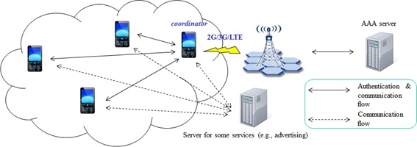

Figure 10. Infrastructure architecture

#### Authorization

Authorization is the process of deciding if a PD is allowed to access to a certain service provided by a peer.

Authorization always includes authentication, and grants access rights to PDs on the basis of their trust levels.

## Coexistence

PAC shall coexist with non-PAC devices operating in unlicensed bands.

## Upper layer interaction

A PD has at least an interface between the MAC and an upper layer.

# Physical layer

## Channelization

Frequency bands of operation for PAC are sub-GHz band, 2.4 GHz unlicensed band, and 5 GHz unlicensed bands, and UWB band under 11 GHz.

A channelization scheme divides frequency bands into channels, where each channel is characterized by its center frequency and bandwidth.

### Channelization for sub-GHz band, 2.4 GHz and 5 GHz unlicensed bands

Parameters of a channelization scheme include the center frequency of each channel, the number of channels, and the maximum allowed transmit power.

.

### Channelization for UWB band

|  |  |  |  |  |  |
| --- | --- | --- | --- | --- | --- |
| **Band plan** | | | | | |
| **Channel index** | **Lower band edge (MHz)** | **Upper band edge (MHz)** | **Region** | **Comment** | **Available mandatory frequencies** |
| 1 | 4200 | 4800 | China | Low band in China | a |
| 2 | 3100 | 4800 | Europe, Korea | Low band in Europe and Korea | a,b,c |
| 3 | 3400 | 4800 | Japan | Low band in Japan | a,b,c |
| 4 | 3100 | 5700 | USA | Low band in USA | a,b,c |
| 5 | 6000 | 9000 | Europe, China | High band in Europe and China | d,e,f,g |
| 6 | 7250 | 10250 | Japan | High band in Japan | e,f,g,h |
| 7 | 7200 | 10200 | Korea | High band in Korea | e,f,g,h |
| 8 | 6000 | 10600 | USA | High band in USA | d,e,f,g,h |
| 9 | 5925 | 7200 | USA | Wideband in USA | d |

|  |  |
| --- | --- |
| **Mandatory frequency\* allocation** | |
| **Index** | **Mandatory frequency (MHz)** |
| a | 3500 |
| b | 4000 |
| c | 4500 |
| d | 6500 |
| e | 7500 |
| f | 8000 |
| g | 8500 |
| h | 9000 |

\* Mandatory frequency is frequency at which PSD level is less than 6 dB below maximum.

## Duplex schemes

PAC uses TDD as a duplex scheme.

## Multiplexing schemes

Multiplexing schemes under consideration for PAC are time-division multiplexing and/or frequency-division multiplexing.

## PPDU structure

The transmitted RF signal is generated by modulating the complex baseband signal, which is composed of multifarious fields. The fields are delimited by timing boundaries. The general PHY frame format is shown in Fig. xxx.



Fig. xxx – General PPDU format

The Preamble field is composed of STF and LTF, and is a part of PPDU that is used for carrier sensing, AGC (automatic gain control), packet detection, time and frequency synchronization, and channel estimation. A detailed description of the Preamble field is in sub-clause 6.4.1.

The PHY Header field is used to describe the content in the MPDU as well as the protocol used to transfer it.

The MPDU consists of MAC header, payload, and FCS.

SSF (Self Spatial Filtering) uses a technique called beam jittering. The Beam Jitter field is transmitted at the end of SSF request frame. The presence of Beam Jitter field is indicated in the MAC header in the MPDU, and payload of MPDU includes IE that contains the threshold for the correlation level used in SSF which is defined in 6.2.2.

### Preamble format

The preamble consists of two fields named STF (Short Training Field) and LTF (Long Training Field). Figure xxx is a time-domain illustration of the preamble structure.



Fig. xxx – Preamble format

#### STF

The STF is used for carrier sensing, AGC, packet detection, partial fine time/frequency synchronization. The length of STF is equivalent to two OFDM symbols. What is transmitted is signaled using the STF pattern as shown below:

* Set (D,D,D,D,D) is configured in the beginning of the Preamble for each of synchronization slot, RTS, CTS, ACK, and discovery/peering indication sub-slot.
* Set (D,D,D,D,-D) is configured in the beginning of the Preamble for data packet.

To generate the periodic signal, the STF sequence in frequency domain is specified as shown in Fig. xxx. In this figure, base sequence bV(k) is

 for k=0,1,…,12,

and modified sequence mV(k) is

 for k=0,1,…,12.



Fig. xxx – STF format in frequency domain.

#### LTF

The LTF consists of two OFDM symbols. The LTF is used for refined timing/frequency synchronization and channel estimation.

To generate the periodic signal, the LTF sequence in frequency domain is specified as shown in Fig. xxx. In this figure, base sequence bV(k) is

 for k=0,1,…,25,

and modified sequence mV(k) is

 for k=0,1,…,25.



Fig. xxx – LTF format in frequency domain.

### Contention-window indication field

CWIF is based on tone-hopping. The code word (Z,Y,X,W) in the 1st symbol is mapped into a part of the TO IDs. Each of Z,Y,X, and W is in range of 0 to 12. The code word (Z’,Y’,X’,W’) in the 2nd symbol is mapped into the remaining part of the TO IDs. Each of Z’,Y’,X’, and W’ is in range of 0 to 12. The maximum number of code words is 138. When the total number of TO IDs needed is less than the maximum number, the 1st code words shall be selected such that the Hamming distance ≥ 3, and the 2nd code words shall be selected such that the Hamming distance ≥ 3.



Fig. xxx – CWIF format in frequency domain.

### Collision detection field

CDF is based on random 4-tone. A PD who wants to transmit data using Random Access selects four random subcarriers, one from each group of subcarriers. The PD transmits a busy tone in the selected subcarriers in the CDF. When a receiver sees more than one tone in any of the groups of subcarriers, collision occurs.



Fig. xxx – CDF format in frequency domain.

### Beam Jitter field

SSF request frame includes a Beam Jitter field. Beam Jitter field comprises of a single OFDM symbol. A sequence (TBD) is assigned to the sub-carriers of the OFDM symbol.

When a PD transmits an SSF request frame, the Beam Jitter field is transmitted using beam jittering described in 6.4.4.1.

When a PD is receiving an SSF request frame, the Beam Jitter field is received without channel equalization. On receiving an SSF request frame, a PD calculates the correlation coefficient defined as follows.



where $\vec{x}$ is a vector of the known sequence that is assigned to the sub-carriers of the OFDM symbol of Beam Jitter field, and $\vec{r}$ is a vector the OFDM sub-carriers of the received Beam Jitter field.

The cross-correlation coefficient $ρ$ is compared with the threshold found in the IE received in the SSF request frame. If $ρ$ is larger than the threshold, the PD transmits an SSF response frame to the transmitter of the SSF request frame with the calculated $ρ$.

Beam jittering can be implemented for single carrier systems with minor modification. The detailed structure of beam jittering for single carrier system is TBD.

#### Beam Jittering.

Beam jittering is an open-loop transmit beamforming technique that uses an array antenna, where each sub-carrier of an OFDM symbol is transmitted with a beam pattern independently selected from a set of *K* predefined beam patterns.

The predefined beam patterns are designed so that all the beam patterns have an identical array gain in the boresight direction of the array, while the array gains in other directions are random.

The number of predefined beam patterns (*K*), design of beam patterns, and beam selection pattern are implementation specific, and is outside of the scope of this document.

Fig. xxx and Table xxx show plots and array parameters of an example of a set of pre-defined beam patterns, respectively, where *K*=2. SSF with *K*=2 shows good performance when the beam patterns are well designed.

|  |  |
| --- | --- |
| M:\SkyDrive\802.15.8\20130714_Geneva\our_contributions\ssf\figures\beam_pattern_2_3_overlap.png  Amplitude of array response | M:\SkyDrive\802.15.8\20130714_Geneva\our_contributions\ssf\figures\phase_response_2_3_overlap.png  Phase of array response |

Figure xxx – An example of pre-defined beam patterns.

Table xxx – An example of array parameters for *K* pre-defined beam patterns.

|  |  |
| --- | --- |
| Antenna configuration | 4 antenna ULA |
| Antenna spacing | 0.5λ |
| *K* | 2 |
| Null locations | Beam L: $\sin^{-1}\left(\frac{2i-1}{4}\right), i=-1,1,2.$ |
| Beam R: $\sin^{-1}\left(\frac{2i-1}{4}\right), i=-1,0,2.$ |

## Modulation and coding scheme (MCS)

### Modulation

Modulation schemes under consideration for PAC include BPSK, QPSK, 16QAM, 64QAM, GFSK, Filtered FSK, Multi-carrier modulation, OOK, and BPM/BPSK.

#### Sub 1 GHz band

Modulation schemes under consideration for the sub-GHz band are GFSK, Multi-carrier modulation, and Filtered FSK.

#### 2.4 GHz and 5 GHz band

Modulation schemes for 2.4 GHz and 5 GHz unlicensed bands are SBPSK, BPSK/SQPSK, QPSK, 16QAM, 64QAM.

#### UWB band

Modulation schemes under consideration for UWB band are OOK and BPM/BPSK.

### Coding Scheme

PAC shall use channel coding to protect messages against channel noise or interference from other devices.

LDPC, convolution code and RS code are under consideration as a coding scheme.

## Multiple antennas

PAC may support multiple antenna technologies such as MIMO or beamforming to improve performance or provide specific functionalities. For example, MIMO technologies can be used to increase data rate or reduce packet error rate. Beamforming can be used to increase the SNR of the received signal, extend the coverage, or to aid discovery procedure by providing directivity of discovery signals. PAC may also support other array processing technologies to estimate the angle of arrival of incident signals to provide location based services.

## Bit interleaver

PAC supports bit interleaving to improve the performance of forward error correcting code.

## Scrambling

PAC shall have a scrambler, or a randomizer, which is used to shape the data spectrum and to reduce interferences.

## UWB Physical (PHY) layer

PAC may support reuse of parts of the UWB physical layer specification of IEEE 802.15.4a-2007.

PAC may also support OOK modulation scheme for UWB PHY.