IEEE P802.15
Wireless Personal Area Networks

Project | IEEE P802.15 Working Group for Wireless Personal Area Networks (WPANs)
Title | MAC Specification for Peer Aware Communications
Date Submitted | May 2, 2014 (r0)
Source | 802.15.8 MAC specification proposer:  Seong-Soon Joo (ETRI) | E-Mail:  [ssjoo@etri.re.kr]
Re:
Abstract | This is the draft version of 802.15.8 PAC MAC specification.
Purpose | This document provides the specification of the TG8 PAC MAC. The document provides an outline of each the functional blocks that will be a part of the final specification.
Notice | This document does not represent the agreed views of the IEEE 802.15 Working Group or IEEE 802.15.8 Task Group. It represents only the views of the participants listed in the “Source(s)” field above. It is offered as a basis for discussion and is not binding on the contributing individual(s) or organization(s). The material in this document is subject to change in form and content after further study. The contributor(s) reserve(s) the right to add, amend or withdraw material contained herein.
Release | The contributor acknowledges and accepts that this contribution becomes the property of IEEE and may be made publicly available by P802.15.
Patent Policy | The contributor is familiar with the IEEE-SA Patent Policy and Procedures:  <http://standards.ieee.org/guides/bylaws/sect6-7.html#6> and  <http://standards.ieee.org/guides/opman/sect6.html#6.3>.  Further information is located at <http://standards.ieee.org/board/pat/pat-material.html> and  <http://standards.ieee.org/board/pat>.

Overview

Definitions

Abbreviations and acronyms

General descriptions

  - Concepts and architecture

The peer aware communication (PAC) network is a peer-to-peer wireless proximity network of which a device can act as a client or a server or both for the other devices by allowing shared access to the various resources such as configuration or control information, location information, sensing data, advertisement, multi-media contents, social contents, etc.

The PAC enabled network consists of the PAC devices (PDs) which carry one of roles: peer network initiator, peer network participants, and peer network relay. The initiator defines a mission, configures the peer group, hosts peers, and authenticates peers. The peer network participants collaborate to perform a defined mission. The peer network relay provides one-hop frame relaying.

Topology

According to whether additional communication features except PAC are implemented on a PD, a PD may be a PAC PD or a PAC included PD. A PAC PD may form a PAC group or participate in multiple PAC groups, as illustrated in Figure 4.2: (a) single PAC group with only PAC PDs, (b) multiple PAC groups. A PAC included PD may form a PAC group or participate in multiple PAC groups with PAC included PD having same additional communication feature, as illustrated in Figure 4.2: (c) a PAC group which has PAC PDs and PAC included PDs connecting to an external network, (d) multiple PAC groups which have PAC included PDs connecting to an external network. PAC included PDs which have different additional communication features may form a PAC group or participate in multiple PAC groups, as illustrated in Figure 4.2: (e) a PAC group which has PAC PDs and PAC included PDs connecting to multiple network, (f) multiple PAC groups which have PAC included PDs connecting to multiple external networks.

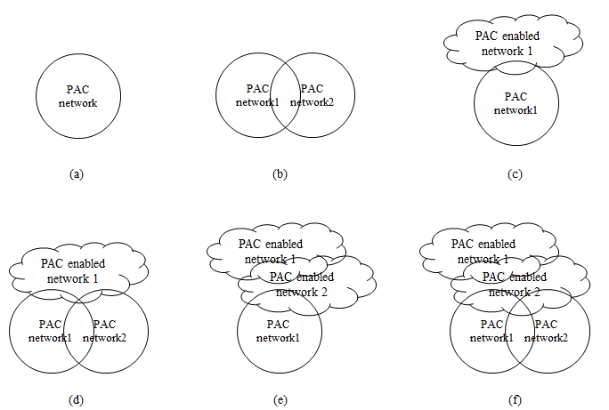
Figure 4.2- Possible PAC groups constructed with the PAC equipped devices

A PAC device may have connections to multiple peers in a peer group and may participate in multiple peer groups concurrently. A PAC device provides one-to-one communication and one-to-many communication in a peer group. A PAC device provides one-to-one communication to multiple peer groups and one-to-many communication to multiple peer groups.

Reference model

MAC layer

  - Overview

Frame Structure

To support various service requirements of multiple peer group concurrently, configurable multiple access of PDs is specified by allocating appearance sequence and length of time-slots of MAC superframe. The length of MAC superframe is multiple times of PHY synchronization interval. The MAC superframe consists of group slot, contention period slot, contention free period slot, relay slot, and idle slot. The appearance sequence and length of each slot are specified according to peer group service and phases of service. The life cycle of the peer group from forming to disbanding is specified by combining the phases: discovering, peering, data communication, and advertising phase. Any combinations phases are possible and a combination of the phases can be iterated except the de-peering phase. In each phase, the slotted resources are allocated to group, peers, relay, and inactive period. The MAC superframe may have any combinations of allocation order and a combination of the allocation order can be iterated.
The MAC superframe structure specification is provided in peer group information elements field or can be predefined. The combination of the phase and the combination of allocation order of each phase are designed prior to support a service which is specified with the technical attributes defined in application matrix of IEEE 802.15.8 (15-12-0684).

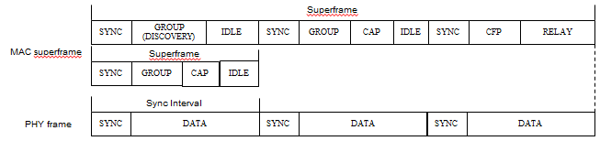
Figure 5.2- basic unit of MAC superframe and slot allocated to MAC superframe

Synchronization

Discovery

Peering

Communications

MPDU structure

The MPDU consist of MAC frame header, MAC frame information, MAC frame payload, and MAC frame tail. The MAC frame header contains frame control, peer group identifier, peer device addressing fields, and peer group authenticator. The MAC frame information contains peer group information elements.

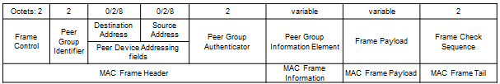

Figure 5.1- Structure of MAC frame MPDU

The peer group identifier consists of service class of peer group, peer group service type identifier, and local peer group identifier.

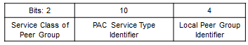

Figure 5.2- Structure of Peer Group Identifier

The peer device address consists of local device ID indicator and local PAC device identifier.

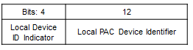
Figure 5.3- Structure of Peer Device Address

The peer group information element consists of peer group IE type and length, superframe offset, and supplementary information. The peer group IE is comes with discover, advertise, peer command frame, and data frame.

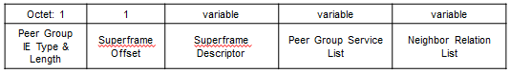
Figure 5.4- Structure of Peer Group Information Elements

Multiple access

The resource scheduling is followed the resource allocation configuration pre-determined by the peer group service. The unit resource slot of a peer group is n times of the base slotted resource. The unit resource slot size may be different from other peer groups to support the designated grade of service. The resources, which may be temporal or spectral or spatial, are slotted and allocated to the components of the peer group on the whole time frame from the start to the end of the peer network.
To avoid interference caused of unscheduled accesses from multiple peer groups, the MAC sublayer provides two interference avoidance capabilities. During peer group formation, the peer observes the frames from neighbour peer groups and gathers the resource allocation schedules. The peer adjusts the resource allocation configuration and selects the start time to cause low probability of interference. The peers who serve to multiple peer networks schedule the transmission by selecting time-slot to avoid contention among multiple peer networks. In case of contention, the peers select appropriate access control algorithm to the peer’s priority.

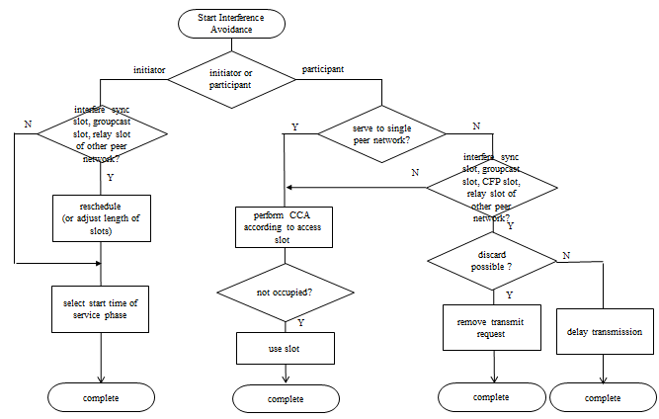
Figure 5.6- Proactive interference avoidance at a PD which serves to multiple peer groups

Synchronization procedure

Discovery procedure

QoS

Interference management

Transmit power control

Multi-hop operation

To extend the coverage of the peer group, peer group relay capable PDs provide hop-relaying. The hop-relaying is performed at the RELAY sublayer by transmitting the received frames not destined to the device to the other side neighbour PD. The allocation of resources for relaying frames and the relaying procedure can be adopted from the IEEE 802.15.4k Timeslot Relaying based Link Extension.

Relative positioning

The MAC sublayer provides geographical relation information among PDs which are resided within two hops from the device. The geographical relation presents relative angular distance among the neighbour devices. The relation matrix generated from the geographical relation information is advertised to the peer group according to the request.

Power management

Security

Coexistence

Upper layer interaction

