IEEE P802.15
Wireless Personal Area Networks

Project | IEEE P802.15 Working Group for Wireless Personal Area Networks
Title | Minutes Study Group SG4r Jan 2014
Date Submitted | 23 January 2014
Source | [Benjamin Rolfe]  [BCA]  [PO Box 798 Los Gatos CA 95031] | Voice: [+1-408-395-7207]  Fax: [ deprecated ]  E-mail: [ben.rolfe @ ieee.org]
Re: | Study Group meeting, January 2014 wireless interim.
Abstract | Meeting minutes for the Study Group meeting held Los Angeles, CA, USA
Purpose | Document meeting activity and action items.
Notice | This document has been prepared to assist the IEEE P802.15. It is offered as a basis for discussion and is not binding on the contributing individual(s) or organization(s). The material in this document is subject to change in form and content after further study. The contributor(s) reserve(s) the right to add, amend or withdraw material contained herein.
Release | The contributor acknowledges and accepts that this contribution becomes the property of IEEE and may be made publicly available by P802.15.
Minutes for IEEE 802.15 Study Group 4r
January 2014 Wireless Interim Meeting
Los Angeles, CA, USA
19-23 January 2014

Table of Contents
PM1 20 January 2014 2
AM1 23 January 2014 3
Attendance Record 4
List of Attendees, Monday January 20th 4
List of Attendees, Thursday January 23th 6

PM1 20 January 2014
Meeting called to order at 13:30 Local Time by Study Group Chair Dietmar Eggert.
Attendee list included at the end of the document
Dietmar presents Doc 15-13-0751-00-004r, meeting agenda. Leads discussion on the agenda.
Dietmar presents the IEEE IPR policy slides and meeting requirements. Dietmar provides call for essential patents and no responses are heard.
No changes are made to the agenda.
Motion to approve the agenda:
Moved by Ben Rolfe
Seconded by Kunal Shah
No discussion on the motion.
No objections heard, motion carries by unanimous consent.

Document 15-14-0044-00 is presented by Dietmar and discussed.
Document 15-14-0045-00 is presented by Ben Rolfe and Christina Siebert, and discussed.
Document 15-14-0019-00 is presented by Dietmar on behalf of Rainer Hatch and discussed.

Following discussion, Dietmar asks for an indication from attendees of interest to move forward developing the PAR. Interest is expressed. Following discussion of project scope, action is assigned to Kunal Shah, Ben Rolfe and Dietmar Eggert to develop a draft PAR and Standards Criteria Document for SG review on Thursday.

Meeting recessed until Thursday AM1.

AM1 23 January 2014
Meeting called to order at 0820 Local Time

Dietmar reminds attendee that IEEE rules still apply.

Ben leads review and discussion of PAR and CSD and Kunal Shah edits. Result is uploaded as revision 2 PAR draft and revision 2 of CSD.

Motion: request that the PAR and Five Criteria contained in documents 15-14-0075-02-004r-sg4r-draft-par.docx and 15-14-0076-02-004r-sg4r-draft-csd.docx be approved for submission to the WG for its approval and that the EC be requested to forward the PAR to NesCom.

Moved: Steve Jillings
Second; Goerge Flammer
No discussion. No Objections. Motion carries by unanimous consent.

Meeting recessed at Adjourned 0924 Local Time

Attendance Record

List of Attendees, Monday January 20th
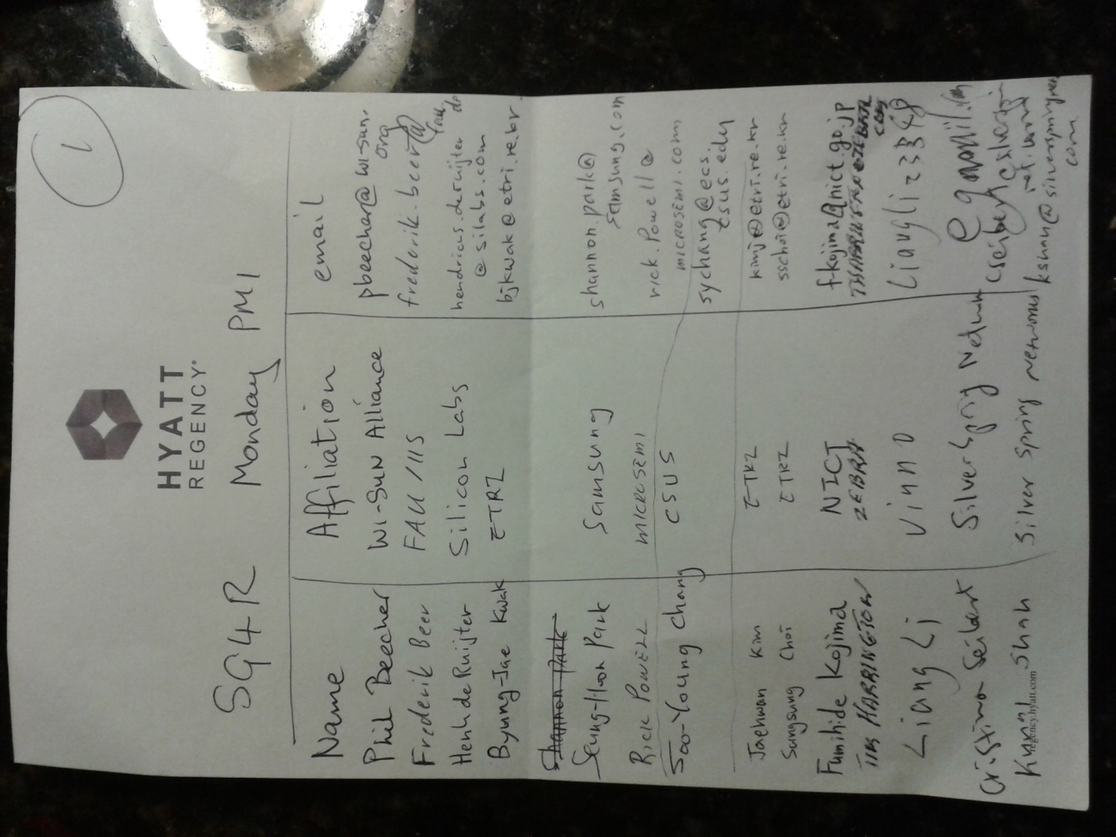

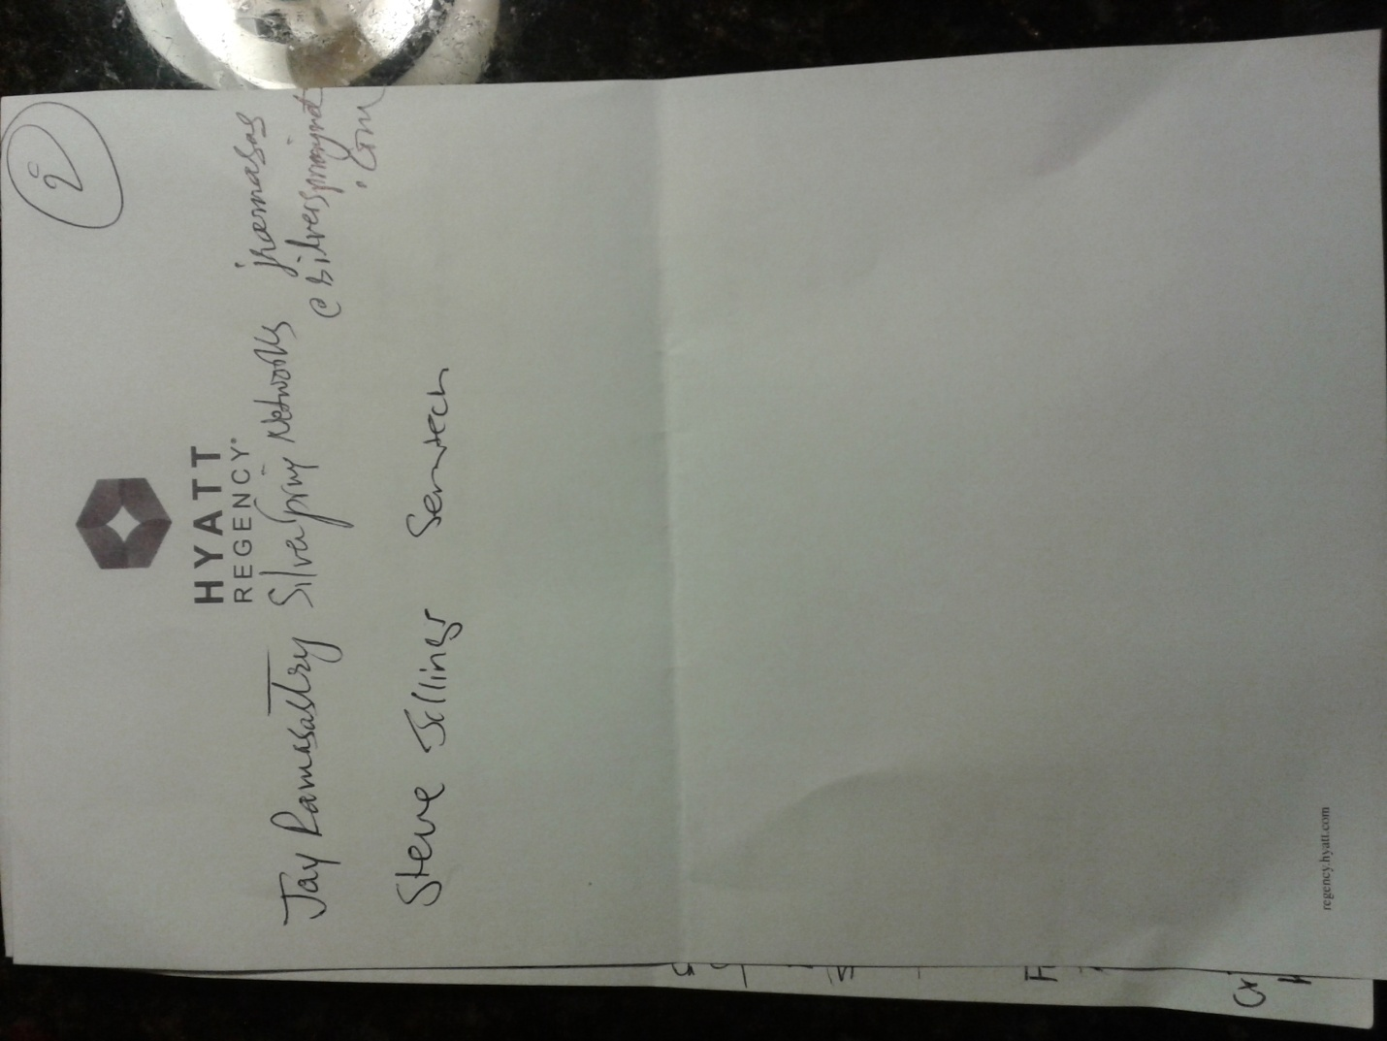

List of Attendees, Thursday January 23th
