IEEE P802.15
Wireless Personal Area Networks

Project | IEEE P802.15 Working Group for Wireless Personal Area Networks (WPANs)
Title | Resolution of the editorial comments on 13-368-r2 for the harmonized PFD
Date Submitted | Jan. 17, 2014 (r0)
Source | 802.15.8 MAC specification proposer:  Seong-Soon Joo (ETRI) | E-Mail:  [ssjoo@etri.re.kr]
Re:
Abstract | This is the resolution of the comments on IEEE802.15-13-368-02-008 submitted for PFD.
Purpose | This document provides the specification of the TG8 PAC link layer. The document provides an outline of each the functional blocks that will be a part of the final specification.
Notice | This document does not represent the agreed views of the IEEE 802.15 Working Group or IEEE 802.15.8 Task Group. It represents only the views of the participants listed in the “Source(s)” field above. It is offered as a basis for discussion and is not binding on the contributing individual(s) or organization(s). The material in this document is subject to change in form and content after further study. The contributor(s) reserve(s) the right to add, amend or withdraw material contained herein.
Release | The contributor acknowledges and accepts that this contribution becomes the property of IEEE and may be made publicly available by P802.15.
Patent Policy | The contributor is familiar with the IEEE-SA Patent Policy and Procedures:  <http://standards.ieee.org/guides/bylaws/sect6-7.html#6> and  <http://standards.ieee.org/guides/opman/sect6.html#6.3>.  Further information is located at <http://standards.ieee.org/board/pat/pat-material.html> and  <http://standards.ieee.org/board/pat>.

Overview

Definitions

Abbreviations and acronyms

General descriptions

Concepts and architecture

Editor’s note: Delete text enclosed by <368r2> </368r2>.The text describes a network architecture that is not agreed upon by TG8.The concept of client/server model is not in line with the fully distributed coordination mentioned in PAR.
IMPORTANT: Please comment. If no supporting comment is received (from other than SS Joo), this text will be marked ‘deleted.’

Resolution: The architecture in 368r2 describes the fully distributed network: in a peer-to-peer network, server is defined as a peer who provides information responding to any peer requests. The server is not the coordinator of the P2P network. The server may be a client, when requests some information to any peers in a peer group.

To exemplify possible configurations with the PAC equipped devices, insert the following text.

A PD may be a device which has PAC only as for the communication feature or has multiple communication features including PAC. With PAC PDs and PAC included PDs, the possible configured communication groups are illustrated in Fig. 2: (a) single PAC group with only PAC PDs, (b) multiple PAC groups, (c) a PAC group which has PAC PDs and PAC included PDs connecting to an external network, (d) a PAC group which has PAC PDs and PAC included PDs connecting to multiple networks, (e) multiple PAC groups which have PAC included PDs connecting to an external network, and (f) multiple PAC groups which have PAC included PDs connecting to multiple external networks.

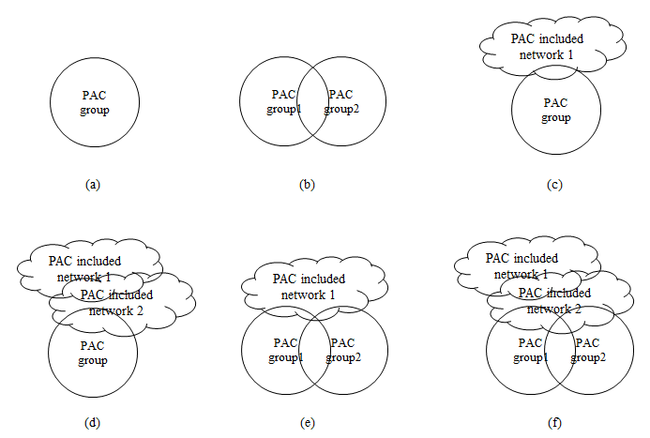
Figure 4.2- Possible PAC groups constructed with the PAC equipped devices

Topology

Reference model

Editor’s note: The texts enclosed by <368r2> and <395r1> below will be merged to generate a single text. <368r2> and <395r1> are very similar to each other, except that <368r2> has additional “MAC Relay Sublayer.”
Please comment if we want to have separate MAC Relay Sublayer in the reference model. I no supporting comment is received (from other than SS Joo), the merged text will NOT have a separate MAC Relay Sublayer.

Resolution: Proposer has an opinion that IEEE Std 802.2-1998 Logical Link Control (LLC) sublayer is not provide enough features to support the PAC, especially multi-hop relaying function. Proposer suggests resuming this discussion after having the detailed contributions.

MAC layer

  - Overview

Frame Structure

Synchronization

Discovery

Peering

Communications

Broadcast

Editor’s note: Probably we should re-word following text enclosed by <368r1>. Qing, can you volunteer?.

Resolution: provide following text for this sub clause.

Broadcast is a one way data communication to any PDs within reachable range, or any PDs in a group, or any selected PDs in a group. The PD received the broadcast message will not respond with acknowledgment.

MPDU structure

Multiple access

Editor will add text describing the general concept of contention based access and contention free access with the merits and demerits of each approach here.

Resolution: provide following text for this sub clause.

For PAC standard, multiple access schemes shall control the accesses from multiple PDs or groups and shall be operated in fully distributed structure.

Synchronization procedure

Discovery procedure

Editor: Shannon started an e-mail thread to discuss discovery procedure.
Shannon, please provided a high level description of the discovery procedure based on the discussion. Everybody else, please participate in the discussion if you want to be heard.

Resolution: provide following text for this sub clause.

The peer discovery is carrying out during discovery region by transmitting a peer discovery frame, which contains peer group identifier and QoS requirements of the group.

QoS

Interference management

Editor: The text below enclosed by <377r0> is general in nature, but needs some improvement.

Resolution: provide following text for this sub clause.

The interference caused of multiple accesses from multiple PDs or groups shall be managed in fully distributed manner. The number of concurrent link may be regulated upon identification of neighbour PDs.

Transmit power control

Multi-hop operation

Editor: The text below enclosed by <368r2> is proposal specific and will be deleted.
Dr. Joo, could you provide a general high level text for multi-hop operation, not specific to any proposal?

Resolution: provide following text for this sub clause.

To extent the coverage of a PD or group, a PD or PDs in a group relay received not destined data to the destination PD or group. To support multi-hop operation, a PD or group members maintain a routing table.

Relative positioning

Editor: Dr. Joo, could you provide an improved text for relative positioning, not specific to any proposal?

Resolution: provide following text for this sub clause.

A PD may measure the relative position to the neighbour PDs in a group. The relative positioning data may be used for discovering a PD, regulating tx power, and searching a path to a PD or group.

Power management

Security

Comment: Three sub clauses (5.16.2 Security parameters, 5.16.3 Key Derivation, and 5.16.4 Authentication) are specific for the PFD and are needed to be deleted.

Coexistence

Higher layer interaction

