IEEE P802.15
Wireless Personal Area Networks

Project | IEEE P802.15 Working Group for Wireless Personal Area Networks (WPANs)
Title | Simulation of Flat Fading Channel relevant for IEEE 802.15.4q
Date Submitted | 30 December 2013
Source | Jinesh P. Nair  Kiran Bynam  Youngsoo Kim  Chandrashekhar Thejaswi P.S  Frederik Beer | Voice: +918041819999  Fax: +918041819000  E-mail:  jinesh.p@samsung.com  kiran.bynam@samsung.com  kimyoungsoo@samsung.com  c.thejaswi@samsung.com  frederik.beer@fau.de
Re: | Task Group 15.4q Channel Models Recommended to evaluate Proposals
Abstract | TG4q – Simulation of Flat Ricean Fading Channel
Purpose | Flat fading Ricean channel models suitable for applications mentioned in IEEE 802.15.4q to serve as reference for fair comparison of proposals and system evaluation
Notice | This document has been prepared to assist the IEEE P802.15. It is offered as a basis for discussion and is not binding on the contributing individual(s) or organization(s). The material in this document is subject to change in form and content after further study. The contributor(s) reserve(s) the right to add, amend or withdraw material contained herein.
Release | The contributor acknowledges and accepts that this contribution becomes the property of IEEE and may be made publicly available by P802.15.

Simulation of Flat Ricean Fading Channel Model

Introduction

The document describes the simulation of a flat fading channel with a LOS component. This is a typical channel model encountered in many applications of interest to TG4q as explained in [1]. The simulator has been created in response to the demand from the TG4q group. The coefficients generated from the simulation may be multiplied with the incoming signals at the appropriate rate prior to noise addition.

1.1 Purpose

The purpose of the document is to create a reference flat fading channel simulator for TG4q for system evaluation and fair comparison of PHY proposals

- Description of the Simulation

The recommendation from the group is to specify a simulator for a flat fading channel with a Ricean factor of K= 0dB and a mobility of around 2 miles/hr. The code accepts the K factor in dB, the mobility in miles/hr, the center frequency and the channel sampling rate in Hz as inputs and outputs the channel coefficients at the specified channel sampling rate. The result of the code is to produce channel coefficients at an arbitrary (channel) sampling rate.

2.1 Generation of Ricean Fading Co-efficient

We use the method of filtered noise to generate channel coefficients with the specified distribution and spectral
power density. For each tap a set of complex zero-mean Gaussian distributed numbers is generated with a variance of 0.5 for the real and imaginary part, so that the total average power of this distribution is 1. This yields a normalized Rayleigh distribution (equivalent to Rice with K=0) for the magnitude of the complex coefficients. If a Ricean distribution (K>0 implied) is needed, a constant path component m has to be added to the Rayleigh set of coefficients. The ratio of powers between this constant part and the Rayleigh (variable) part is specified by the K-factor. For this general case, we show how to distribute the power correctly. The total power is assumed to be normalized to 1.
$$1= {\left|m\right|}^{2}+σ^{2} (1)$$
Where m is the constant and $σ^{2}$ the variance of the complex Gaussian set. The ratio of powers is
$$K= \frac{{\left|m\right|}^{2}}{σ^{2}} (2)$$
From these equations, we can find the power of the complex Gaussian and the power of the constant part as

$${\left|m\right|}^{2}=\frac{K}{K+1}, σ^{2}=\frac{1}{K+1} (3)$$

2.2 Doppler Spectrum

The complex Gaussian distributed numbers are filtered using Doppler filters with the power spectrum given by
$$S(f)=\frac{1}{πf_{d}\sqrt{1-{\left(\frac{f}{f_{d}}\right)}^{2}}}, \left|f\right|<f_{d}, f_{d}=\frac{vf_{c}}{c} (4)$$
Here $f_{d}, f_{c}, c,v$are the Doppler frequency, center frequency, the velocity of light and the pedestrian mobility considered here. Two sets of zero mean complex Gaussian numbers are arranged symmetrically and multiplied with the Doppler filter in the frequency domain. The symmetry ensures that real outputs are obtained, one each for the in-phase and quadrature arms respectively. The normalization of the power to adjust for the power in the spectral components and the NLOS components is then carried out.

- Matlab Simulation Code

function f = ChannSim4q()

clc;close all;clear all;

v = 3.6; % Km/hr equivalent to 2.23miles/hr;
fc = 2.4e9; % Center Frequency Hz
Kf = 0; % Ricean K factor in dB
fs = 1e6; % Channel Sampling Rate in Hz

h = FlatFad2(Kf, v, fc, fs);

figure;
semilogy([0:floor(length(h)/10)-1].*1./fs,abs(h(1:floor(length(h)/10))));
xlabel('Time (seconds)');
ylabel('Amplitude');
title('Ricean Flat Fading Channel')

end

function Str = FlatFad2(Kf, m, fc, BWsamp)

%--------------------Derived Parameters -----------------------------------
v = m*1e3/(3600); % Velocity in m/s
c = 3e8; % Velocity of light in m/s
fd = floor(v*fc/c); % Maximum Doppler Frequency in Hz
fsamp = 256; % Number of frequency smaples within Doppler Bandwidth
fdmax = 100; % Hz (BW = 2*fdmax)
K = 10^(0.1*Kf); % dB to linear scale conversion
s2 = 1./(K+1); % Calculate variance scaling for complex Gaussian process
m2 = K./(K+1); % Calculate constant power for specular component
randPhase = rand(1)*2*pi; % Random initial phase in the LOS component
freqOffset = 2*pi*randi(fd,1,1)/fdmax; % Frequency Offset limited by the maximum Doppler

%--------------------Doppler Filter----------------------------------------
ft = [-fd:2*fd/(fsamp):fd]; % Frequency axis of Doppler Filter
Sf = 1.5./(pi*fd*sqrt(1-(ft/fd).^2)); % Doppler Filter
Sf(1) = 1000; % limiting the infinite values
Sf(end) = Sf(1);
Sf = sqrt(Sf);

%-------------------Frequency axis for fdmax sampling ---------------------
fre = round((fdmax-fd)*fsamp/(2*fd));
lft = [ -fd-fre*2*fd/(fsamp):2*fd/(fsamp):-fd-2*fd/(fsamp)];
rft = [ fd + 2*fd/(fsamp):2*fd/(fsamp): fd + fre*2*fd/(fsamp)];
faxis = [lft ft rft];

%-------------------Generation of In-phase component-----------------------
I = randn(1,fsamp/2)+randn(1,fsamp/2)*1i; % Complex Gaussian Process
Im = [I 0 fliplr(conj(I))]; % Symmetrical Output
ISfiltBB = [Sf(1+fsamp/2:end).*Im(1+fsamp/2:end) zeros(1,2*fre)...
Sf(1:fsamp/2).*Im(1:fsamp/2)]; % Frequency Domain Filtering and
% Interpolation
In = ifft([ISfiltBB]); % Generation of In-phase component
In = 1./sqrt(2)*In./(sqrt(mean(In.^2))); % Normalization

%-------------------Generation of Quadrature component---------------------
Q = randn(1,fsamp/2)+i*randn(1,fsamp/2)*1i; % Complex Gaussian Process
Qm = [Q 0 fliplr(conj(Q))]; % Symmetrical Output
QSfiltBB = [Sf(1+fsamp/2:end).*Qm(1+fsamp/2:end) zeros(1,2*fre)...
Sf(1:fsamp/2).*Qm(1:fsamp/2)]; % Frequency Domain Filtering and
% Interpolation
Qn = ifft([QSfiltBB]); % Generation of Quadrature component
Qn = 1./sqrt(2)*Qn./(sqrt(mean(Qn.^2))); % Normalization

Sr = (In+Qn*1i); % Generation of the Rayleigh Fading Component
% St = sqrt(m2) + sqrt(s2).*Sr; % Generation of the Ricean Fading i.e. LOS and NLOS
St = sqrt(m2).*exp(1j*(randPhase + freqOffset.*(1:length(Sr)))) + sqrt(s2) .* Sr;
Str = resample(St(1:2000),BWsamp/1,(2*fdmax)); % Matching to Channel Sampling Rate
% 10 seconds simulation at 1MHz sampling
end

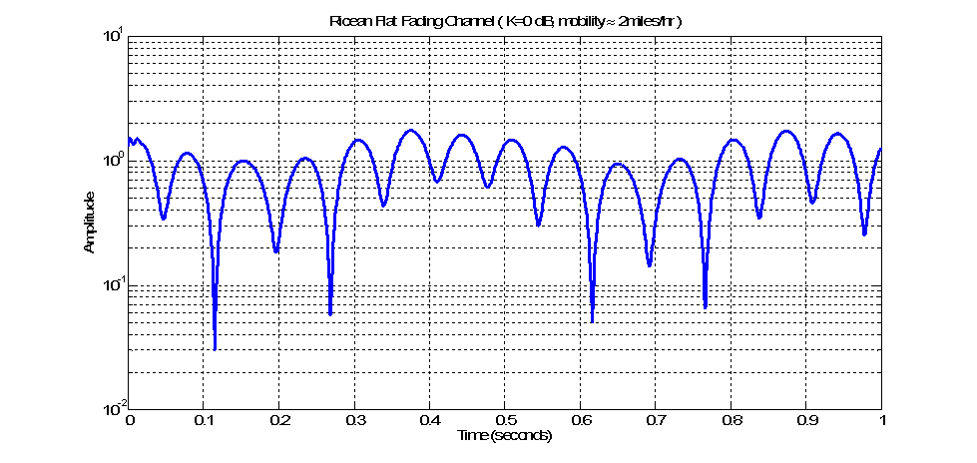
Fig: Exemplary Ricean fading channel amplitudes as a function of time

If simulation related errors are displayed due to the usage of a different version of Matlab, store the two functions in different files say “ChannSim4q.m” for the function ChannSim4q and “FlatFad2.m” for the function FlatFad2 in one folder and make this the working folder in Matlab. Comment “function f = ChannSim4q()” and “end” in ChannSim4q.m. To generate the co-efficient, run ChannSim4q.m.

References

- Jinesh Nair, Kiran Bynam and Youngsoo Kim, “Channel Models for IEEE 802.15.4q” IEEE P802.15 Working Group for Wireless Personal Area Networks (WPANs), DCN: 15-12-0329-00, May. 2013.

