IEEE P802.15
Wireless Personal Area Networks

Project | IEEE P802.15 Working Group for Wireless Personal Area Networks (WPANs)
Title | Distributed time synchronization for PAC
Date Submitted | Nov 13, 2013
Source | Chang-Sub Shin, Wun-Cheol Jeong, Hoyong Kang | E-Mail:  [shincs@etri.re.kr]
Re:
Abstract | This document proposes technical specification of Distributed time synchronization for 802.15.8 PAC.
Purpose | This document describes the functional behaviour and technical specification of Distributed time synchronization for PAC.
Notice | This document does not represent the agreed views of the IEEE 802.15 Working Group or IEEE 802.15.8 Task Group. It represents only the views of the participants listed in the “Source(s)” field above. It is offered as a basis for discussion and is not binding on the contributing individual(s) or organization(s). The material in this document is subject to change in form and content after further study. The contributor(s) reserve(s) the right to add, amend or withdraw material contained herein.
Release | The contributor acknowledges and accepts that this contribution becomes the property of IEEE and may be made publicly available by P802.15.
Patent Policy | The contributor is familiar with the IEEE-SA Patent Policy and Procedures:  <http://standards.ieee.org/guides/bylaws/sect6-7.html#6> and  <http://standards.ieee.org/guides/opman/sect6.html#6.3>.  Further information is located at <http://standards.ieee.org/board/pat/pat-material.html> and  <http://standards.ieee.org/board/pat>.

Distributed time synchronization for PAC

PDs in PAC network shall be synchronized by using distributed manners. When a new PD listens to neighbouring PD’s beacon frame, it will synchronize to PAC network. Synchronized PD shall keep synchronization with periodic beacon frame. Since the new PD tracks its time synchronization from beacon frame, it shall determine the next receiving time of beacon frame.

a) before transmitting beacon frame for synchronization, every PD in the PAC network have to initiate prioritized backoff algorithm to get a chance to transmit beacon frame.

b) beacon frame shall be transmitted periodically every beacon interval

c) all PDs which participated in PAC network shall keep time synchronization using timestamp value of beacon frame.

d) beacon frame shall set the timestamp value including transmitting PD’s local delay

e) PDs in the PAC network shall not be allowed to transmit a frame before receiving beacon frame.

f) a PD transmitting beacon frame can be selected sequentially among PDs in the PAC network.

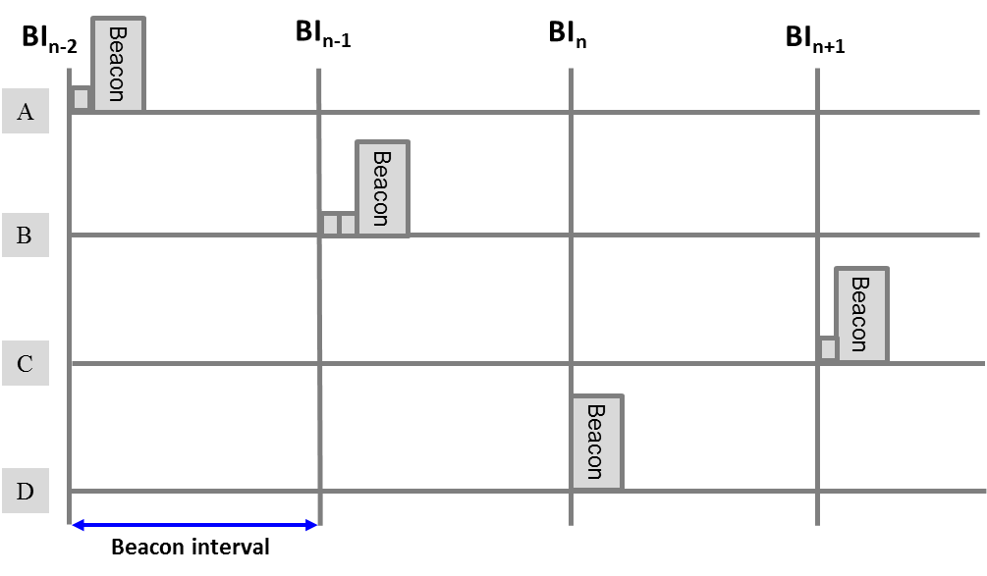
Figure-1 Distributed time synchronization

