IEEE P802.15
Wireless Personal Area Networks

Project | IEEE P802.15 Working Group for Wireless Personal Area Networks (WPANs)
Title | Samsung Proposal for PAC Framework Document (Doc.)
Date Submitted | July 7, 2013 (r0)
Source | Seung-Hoon Park, Kyungkyu Kim, Sungjin Lee, Sangkyu Baek, Youngbin Chang, Chiwoo Lim, Hyunseok Ryu, Daegyun Kim and Won-il Roh (Samsung) | E-Mail: [shannon.park@samsung.com]
Re:
Abstract | Description of PAC synchronous operations and frame structure with identified features for working consensus to work on PFD
Purpose | Corresponding to Call for Proposal
Notice | This document does not represent the agreed views of the IEEE 802.15 Working Group or IEEE 802.15.8 Task Group. It represents only the views of the participants listed in the “Source(s)” field above. It is offered as a basis for discussion and is not binding on the contributing individual(s) or organization(s). The material in this document is subject to change in form and content after further study. The contributor(s) reserve(s) the right to add, amend or withdraw material contained herein.
Release | The contributor acknowledges and accepts that this contribution becomes the property of IEEE and may be made publicly available by P802.15.
Patent Policy | The contributor is familiar with the IEEE-SA Patent Policy and Procedures:  <http://standards.ieee.org/guides/bylaws/sect6-7.html#6> and  <http://standards.ieee.org/guides/opman/sect6.html#6.3>.  Further information is located at <http://standards.ieee.org/board/pat/pat-material.html> and  <http://standards.ieee.org/board/pat>.

Table of Contents
1. Overview 3
2. Definitions 3
3. Abbreviations and acronyms 3
4. General descriptions 3
4.1. Concepts and architecture 3
4.2. Topology 3
4.3. Reference model 3
5. MAC layer 3
5.1. MPDU structure 3
5.2. Multiple access 3
5.3. Synchronization procedure 3
5.4. Discovery procedure 3
5.5. Peering procedure 3
5.6. Scheduling 3
5.7. QoS 3
5.8. Interference management 3
5.9. Transmit power control 3
5.10. Multicast 4
5.11. Broadcast 4
5.12. Multi-hop operation 4
5.13. Relative positioning 4
5.14. Power management 4
5.15. Security 4
5.16. Coexistence 4
5.17. Higher layer interaction 4
6. Physical layer 4
6.1. Channelization 4
6.1.1. Operating frequency bands 4
6.2. Duplex schemes 4
6.3. Multiplex schemes 4
6.4. Frame structure 4
6.4.1. Discovery frame structure 4
6.4.2. Data frame structure 4
6.5. Modulation and coding scheme (MCS) 4
6.5.1. Data rates 4
6.6. Multiple antennas 4

Overview
The 802.15.8 specification shall be developed according to the P802.15.8 Peer Aware Communication (PAC) project authorization request (PAR), document number 15-12-0063r2 and Five Criteria (5c), document number 15-12-0064r1, which were approved by the IEEE-SA in March of 2012.

Definitions

Abbreviations and acronyms
PD PAC Device

General descriptions
This clause provides the basic framework of PDs. The framework serves as a guideline in developing the functionalities of PDs and their interactions specified in detail in the subsequent clauses.

Concepts and architecture
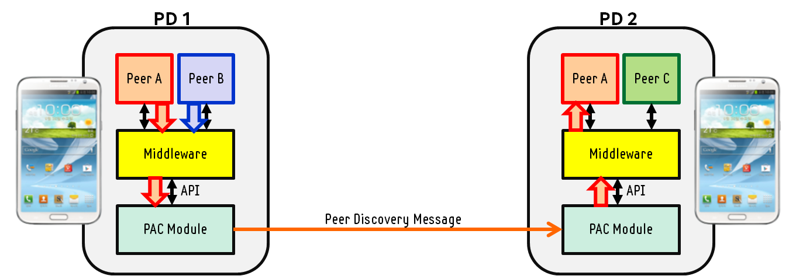
PAC application at PD1 requests application-specific discovery operation via PAC middleware. PAC middleware has a API to PAC module including PAC PHY and MAC layer, and requests to send Peer Discovery Identity (PDI) to PAC module. PAC MAC constructs Peer Discovery Message (PDM) including PDI from higher layer and transmits the PDM via Discovery Slot determined at PHY layer. PDM is received by PAC module at PD2. PAC module matched the received PDI to the pre-stored PDI and it delivered to PAC middleware if it meets the matching constraints.
Therfore, only PDs with same PDI shall be discovered each other.
PDI may be pre-installed or given from network to higher layer.
The content of PDM including application-specific ID, application-specific user ID or application-specific group ID is decided by higher layer.
Different peer discovery types such as “Advertise/Monitor”, “Search/Response or “Publish-Subscribe” may be supported.

Topology

Reference model

MAC layer

MPDU structure

Multiple access
e.g. Contention-based access, Contention-free access
IEEE802.15.8 PAC shall consist of several types of frames to serve different operations, based on contention-free channel-access scheme.
The several different frames constructs PAC superframe. IEEE802.15.8 PAC may have contention-based channel-access during a separated frame.

PAC Frame Structure
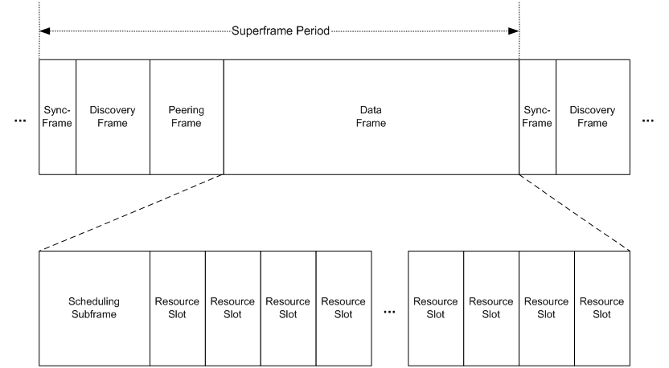
IEEE802.15.8 PAC superframe comprises of Sync frame, Discovery frame, Peering frame, and Data frame.

Synchronization procedure
IEEE802.15.8 PAC follows distributed synchronization procedure without any single master PD to get reference timing. The distributed synchronization is proper to flat and scalable network to be supported by PAC. Because two PDs not being discovered are not able to make connection, synchronization procedure shall be prior to peering (link establishment). Moreover, it is better to be prior to discovery procedure to enhance peer discovery performance. Obviously, it helps to get higher throughput by efficient signalling and data transmission as well.

A PD shall be in synchrony state prior to peer discovery procedure and peering procedure.
IEEE802.15.8 PAC has two synchronization mode including Initial Synchronization mode and Maintaining Synchronization mode.

PAC synchronization modes and procedure
Initial Synchronization mode:
- Start in Initial Synchronization mode.
- PD monitors Synchronization Signals (SSs) during synchronization period.
- If at least one SS is detected during synchronization period, perform according to distributed synchronization mechanism.
- Else, start PAC operations based on frame structure in Maintaining Synchronization mode.
Maintaining Synchronization mode:
- PD sends SS periodically, but checks synchrony state via Blank subframe sometimes without sending SS.
- If in-synchrony, PD adjusts oscillator for phase drift compensation.
- If out-of-synchrony, go to initial synchronization mode.

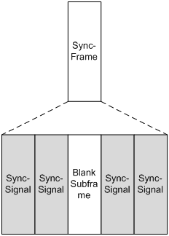
Figure 1. Synchronization Frame Structure
Synchronization frame consists of several redundant SSs to be robust to channel fading. Blank subframe is in the middle of several SSs.

The distributed synchronization mechanism is designed based on classical PCO (Pulse Coupled Oscillator) synchronization algorithm. According to PCO algorithm, a PD assumes to have an oscillator which can fasten the own phase when receiving pulse as Figure 1. This adjustment is controlled by the predefined function which has the own phase value as an input. If there is no other pulse detected, there is no change but normal phase increment according to time advance.
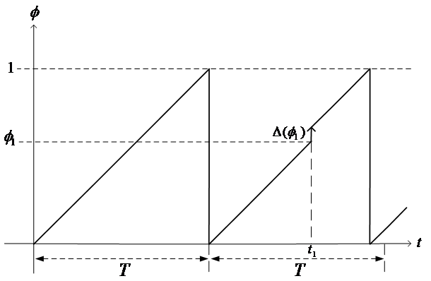
Figure 2. Oscillator Phase Transition
The overall PCO synchronization steps can be imagined from Figure 2. The phase value of each node is mapped to on the edge of circle. At first (a) phase, all nodes start randomly, so each node has a different phase value at a certain instant time. When node A increases the phase and reaches the maximum value (1 as normalized one), it fires Synchronization Signal (SS) to medium as the same role to pulse of original algorithm. Other nodes receiving the SS adjust the own oscillator to change the phase value according to predefined rule. Through these interactions with coupled oscillator, all nodes can achieve to reach the synchrony in a time as shown from Figure 2 (c).
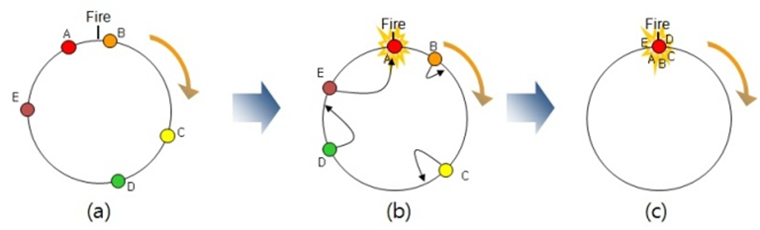
Figure 3. PCO Synchronization Steps
- All nodes have oscillator with the same phase increment rate
- One node fires, then other nodes adjust oscillator according to the predefined function without state other than it’s internal phase
- Finally, all nodes converges to the same time base

The equation for phase adjustment is as follows:

To get synchrony, all nodes follow the same rule based on phase adjustment curve . The phase adjustment curve is described by the non linear curve to represent mapping relation between the value and the corresponding phase. The curve should be concave down for synchrony condition. The dissipation factor has to be larger than zero. Using phase adjustment curve, adjusted phase value is calculated by following rule:
To provide fast convergence, selective update is adopted as following rule:
If is met, the adjusted phase value is determined by the following rule:
If is not met, there is no phase update.
To avoid ping-pong effect in scalable network environment, refractory period is decided during the time when the phase value has the following condition:
There is no phase update during refractory period.

Synchronization procedure for operations in unlicensed band
The synchronization procedure with energy sensing is designed for operations in unlicensed band to coexist with different systems sharing the same band.
This procedure is enabled only in initial synchronization mode.
- A PD senses energy level while doing operation for distributed synchronization.
- If medium is busy, the PD pends synchronization operation. Else, the PD keeps synchronization operation.
- If medium is not busy and SS is not detected during synchronization period, Superframe starts in Maintaining Synchronization mode.

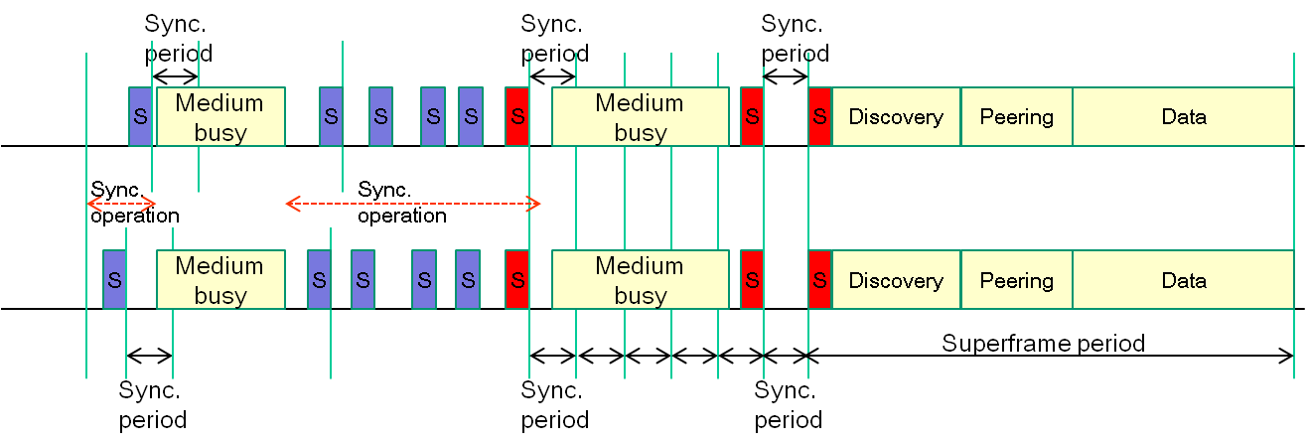
Figure 4. Synchronization Operation with Energy Sensing

Discovery procedure
IEEE802.15.8 PAC shall have a periodic Discovery frame per a superframe.
Discovery frame is comprised of multiple Discovery slots as Figure 5. A Discovery Slot delivers single Peer Discovery Message (PDM). A PDM contains a PDI(Peer Discovery Identity) and a PDI label to present the type or usage of PDI.
The procedure to select a Discovery Slot is as follows:
- A PD selects one Discovery Slot.
- The PD broadcasts Peer Discovery Message at the selected Discovery Slot.
- The PD monitors congestion level by energy sensing.
- If congested, the PD selects different Discovery Slot for next transmission.
- If not congested, the PD keeps the current Discovery Slot.

Peering procedure
Peering is the link establishment between the discovering PD and the discovered PD.
Peering Request message and Peering Response message shall be exchanged to establish a link.
A PD exchanges information such as device capability for setup a link, and determines link related parameters such as Link ID, QoS class, link range, or etc.
Network protocol such as routing shall be operated only over connected links.

Scheduling
A PD shall determine Resource Slot based on the predetermined distributed scheduling algorithm.
Data transmission is performed during Data frame which is accessed by only peered PDs. For unicast transmission, Link ID is determined via peering procedure.
A PD shall determine one or multiple Resource Slot during Scheduling subframe as contention-free channel access scheme.
Scheduling subframe is comprised of Scheduling Request subframe and Scheduling Response subframe.
Scheduling Request signal represents Link ID, Resource Slot Star Index, and Resource Slot Length.
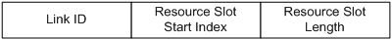
Scheduling Response signal represents Link ID, Resource Slot Adjusted Index, and Resource Slot Length.
Both signal contains resource information relating to resource assignment and is broadcasted to nearby PDs.
The flowchart of operation for distributed scheduling is as follows:
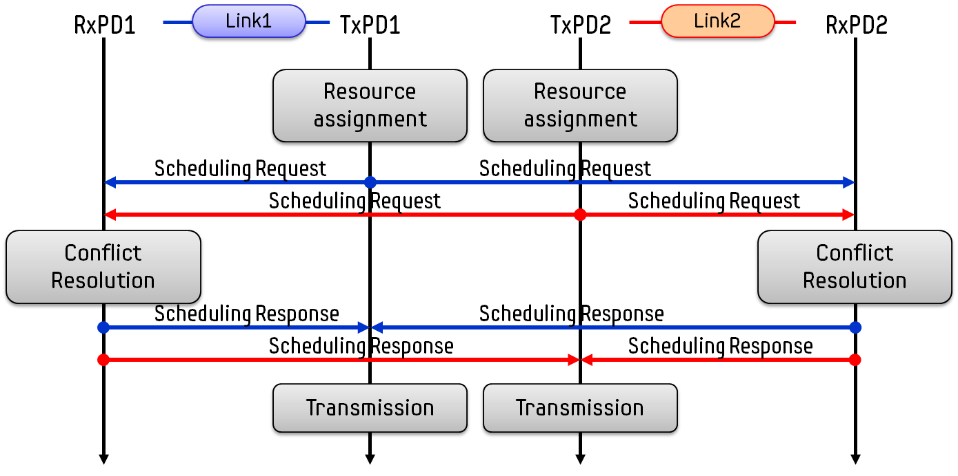
Link1 has a transmitter PD1(TxPD1) and a receiver PD1(RxPD1) and Link2 has a transmitter PD2(TxPD2) and a receiver PD2(RxPD2). Initially, TxPD1 and TxPD2 determine one or multiple RSs by initial configuration respectively. The candidate RS information is transmitted to the corresponding RxPD and neighboring RxPD as well. RxPD receives multiple Scheduling Request message and has resource information including RS Start Index and RS Length. RxPD modifies resource information to avoid resource assignment confliction based on RS Star Index information from neighbouring TxPDs. The modified resource information including RS Adjusted Index and RS Adjusted Length are transmitted by the RxPD to the corresponding TxPD and neighboring TxPDs. The TxPD determines the assigned RSs to transmit data packets on.

QoS

Interference management
Interference among multiple links is managed by threshold level which is used to identify neighbouring PDs. The number of concurrent link goes many as the threshold level goes low. Conversely, the number of concurrent link goes small as the threshold level goes high.

Transmit power control

Multicast

Broadcast

Multi-hop operation

Relative positioning

Power management

Security

Coexistence

Higher layer interaction

Physical layer

Channelization

Operating frequency bands

Duplex schemes

Multiplex schemes
(e.g. CDMA, OFDMA)
IEEE802.15.8 PAC shall use OFDM to support high efficient control and data transmission. Moreover, the error of synchronization among links is compensated by using long cyclic prefix.

Frame structure

Discovery frame structure
Discovery frame is comprised of multiple Discovery slots. A Discovery Slot delivers single Peer Discovery Message (PDM).
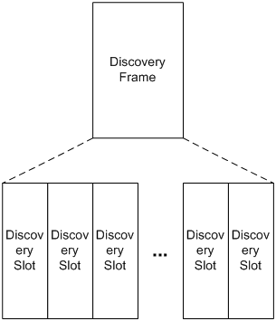
Figure 5. Discovery Frame Structure

Data frame structure
A Data frame is comprised of one or multiple scheduling subframe and the multiple resource slots (RSs) which are associated to one scheduling subframe.
A RS consists of Preamble Signal duration, Channel Feedback Signal duration, Data Packet duration, and ACK Signal duration.
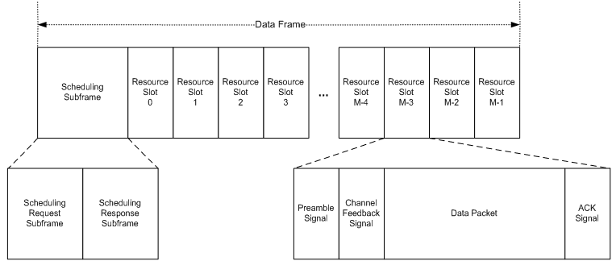

Modulation and coding scheme (MCS)

Data rates

Multiple antennas

