IEEE P802.15
Wireless Personal Area Networks

Project | IEEE P802.15 Working Group for Wireless Personal Area Networks (WPANs)
Title | NICT PHY Proposal text
Date Submitted | July 6th, 2013
Source | Marco Hernandez, Huan-Bang Li, Igor Dotlić, Ryu Miura (NICT)
Re: | In response to Technical Guidance Document contributions
Abstract | Channel models
Purpose | Reference channel models for proposals evaluation to TG8
Notice | This document has been prepared to assist the IEEE P802.15. It is offered as a basis for discussion and is not binding on the contributing individual(s) or organization(s). The material in this document is subject to change in form and content after further study. The contributor(s) reserve(s) the right to add, amend or withdraw material contained herein.
Release | The contributor acknowledges and accepts that this contribution becomes the property of IEEE and may be made publicly available by P802.15.

Contents
1 h 3

The enumeration is based on the PAC framework document DCN 328r4.
6
NICT PHY architecture

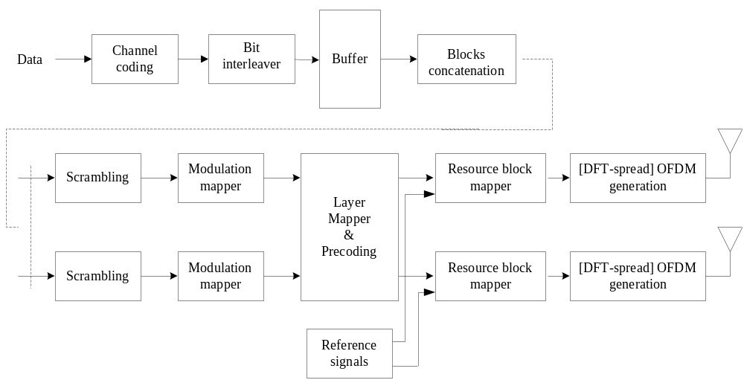

6.1 Channelization
Frequency bands of operation are: Sub-GHz, 2.4 GHz and 5.7 GHz bands.
- Channelization of 5.7 GHz band
  - Such frequency band ranges from 5.725 GHz to 5.875 GHz, which is divided into 14 channels of 10 MHz. By regulation, the maximum transmit power at the input antenna is 1 W. The central frequencies are given by
f_{c} = 5735 MHz + 10n for n = 0, 1, ..., 13
- Channelization of 2.4 GHz band
  - Such frequency band ranges from 2.4 GHz to 2.5 GHz, which is divided into 9 channels of 10 MHz. By regulation, the maximum transmit power at the input antenna is 1 W. The central frequencies are given by
f_{c} = 2410 MHz + 10n for n = 0, 1, ..., 8
  - The basic channelization by regulations in Japan is summarized in the following table:
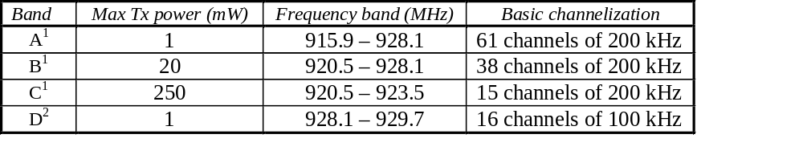

  - ¹bandwidth rule tolerance: 200 n kHz, where n=1,2,3,4,5.
  - ²bandwidth rule tolerance: 100 n kHz, where n=1,2,3,4,5.
- Proposed channelization
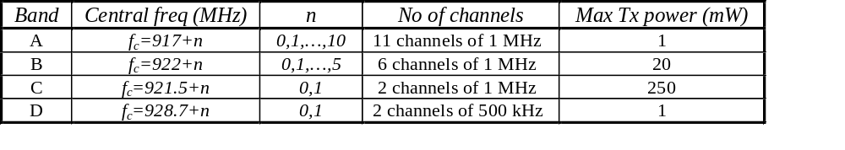

6.2 Duplex
- Frame structure in FDD mode
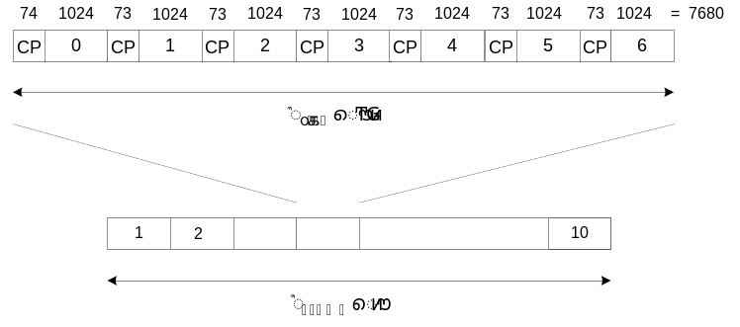

- One slot contains 7 DTF-S OFDM or OFDM symbols.
- T_{slot}=7680T_{s}=0.5 msec
- Frame structure in TDD mode
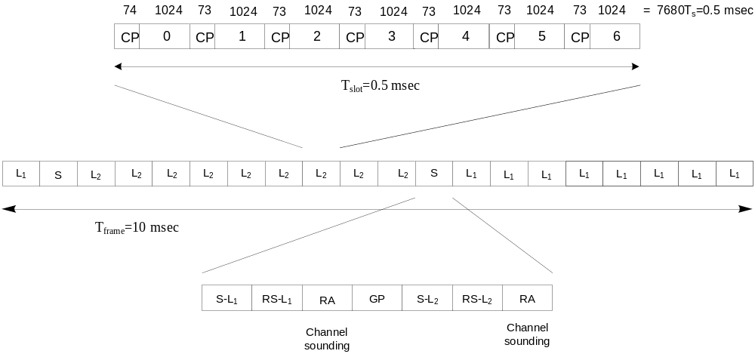

where L₁=PD₁ transmits and PD₂ receives, L₂=PD₂ transmits and PD₁ receives, S-L₁=synchronization for L₁, RS-L₁=reference signals for L₁, RA=random access or channel sounding for MIMO or beamforming, GP=guard period.

The GP is computed as GP=(73+1024)T_{s}=71.42 µsec and satisfies

T_{p}+T_{dec}+T_{sw}+T_{comp}+T_{p}=GP
  - T_{dec}=time to detect the last symbol
  - T_{sw}=time to switch from Rx to Tx or vice-versa
  - T_{comp}=compensation time to align to GP

where T_{p}=1 Km/3x10⁸m/s=3.3 µsec (worst case).

6.2 Multiplex scheme
The resource block for either OFDMA or SC-FDMA is given by

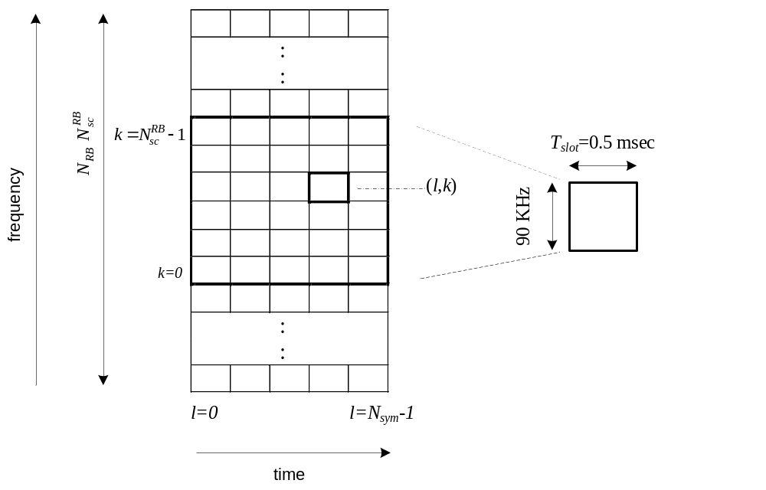

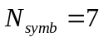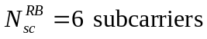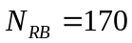where , , and
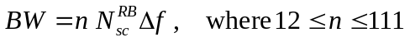BW is obtained by concatenating RBs:

Proposed bandwidths are given by
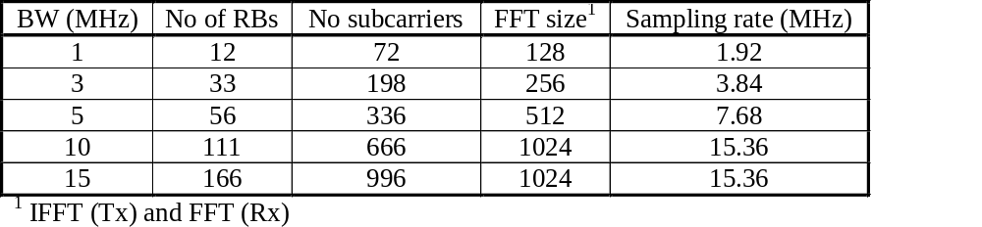

6.4.1 Frame structure for discovery

We propose to use a discovery preamble (DP) based on a ZC sequence and a discovery resource block (DRB) from a modified (DTF-S) OFDM signal.
  - The DP and DRB formed the Discovery Signal (DS).
Moreover, we propose to use one channel (from the proposed channelization for sub-GHz, 2.4 GHz and 5.7 GHz bands) for only discovery of devices.
  - PAC devices can either transmit or receive the DS in this unique channel asynchronously.
The discovery signal (DS) sent over a discovery shared channel (DSCH):

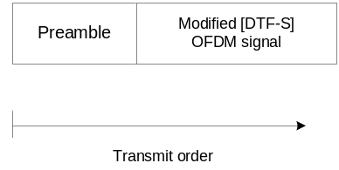

The DS consists of a preamble sequence plus a DRB formed by N_{fs} frequency slots and N_{ts} time slots.
Once synchronized, a receiver knows the location of the discovery resource block (DRS) to scan for possible peers or to pick time-frequency slots to transmit its DS.
The proposed ZC sequence for initial synchronization during discovery (or communication mode) is a ZC sequence with the following parameters:
  - Sequence length N = 63, relative prime r = 62 and q = 0.
Such ZC sequence is mapped onto 62 sub-carriers
  - The first subcarrier and the DC subcarrier are empty.
  - Of course, several repetitions may be transmitted.

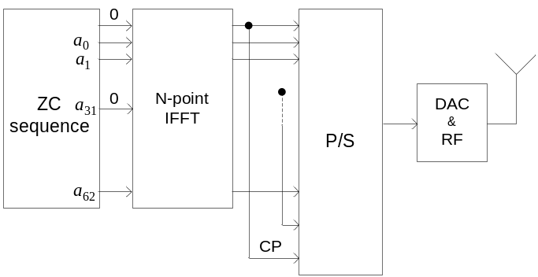

For discovery, the nth symbol transmitted over the kth subcarrier is given by
  - 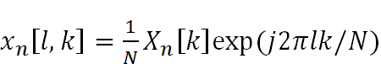
  - for l=-L+1,,…,0,1,…,N-1 and L the CP

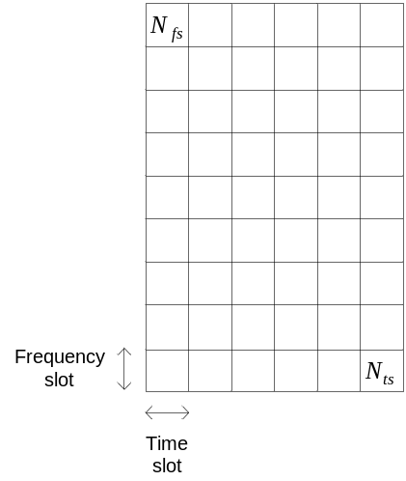

The DS is transmitted with a predefined duty-cycle. From upper layers, terminals pick time-frequency slots in the DRB to transmit the DS.
A set of 126 symbols are transmitted per time slot:
  - such frame contains information about a given peer (peer ID, service ID, application ID, etc.) and which channel is used for association (different from the SDCH).
The number of frequency slots N_{fs} =1024 (IFFT size) and the number of time slots N_{ts} is chosen as 20.
Consequently, the DRB can support up to N_{fs}xN_{ts}=20,480 users for discovery per Group.
The discovery data is formatted as illustrated

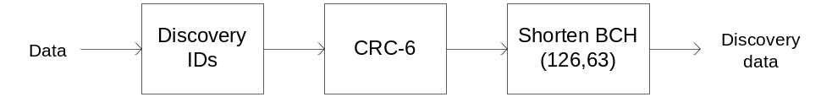

Append 57 bits for user ID, device ID, Group ID, etc.
Append 6 bits from CRC-6-ITU error detection code
Append 63 bits from shorten BCH(126,63) code

6.4.2 Data frame structure
The physical layer protocol data unit (PPDU) is formed by concatenating synchronization header (SHR), Discovery header (DIS), physical layer header (PHR) and physical layer service data unit (PSDU)
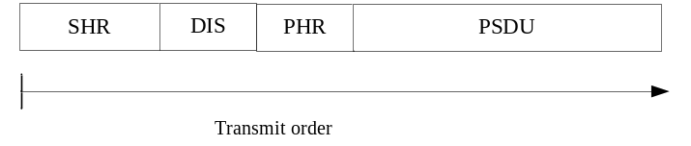

Reference signals for demodulation/equalization are embedded in the PSDU.
The MAC protocol data unit (MPDU) is passed to the PHY. Such data is encoded by QC-LDPC codes.

6.5 Modulation and coding scheme
QC-LDPC codes allows performance close to turbo codes, besides that encoder/decoder enable high throughput and low implementation complexity (efficient implementation in parallel architectures).
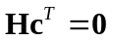Quasi-cyclic LDPC codes are systematic, linear codes satisfying

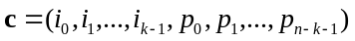Codeword , k information bits, n-k parity bits.
Parity check matrix
QC-LDPC codes are defined by a prototype matrix
H is constructed from H_{p} by replacing each entry [H_{p}]_{i,j} with either a cyclic shift matrix P_{c}, identity or null matrices of size ZxZ (final size of H is M_{p}ZxN_{p}Z).
If [H_{p}]_{i,j}=0 , replace it by I_{ZxZ}=P₀
If [H_{p}]_{i,j}=“-”, replace it by 0_{ZxZ}
If [H_{p}]_{i,j}=c , replace it by P_{c}

The cyclic-permutation matrix P_{c} is obtained by cyclically shifting the columns of P₀=I_{ZxZ} to the right c times.
Example:
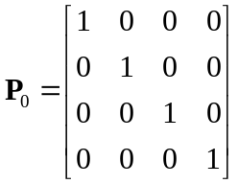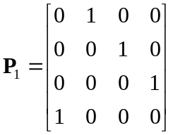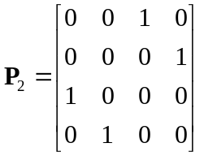

QC-LDPC parameters:

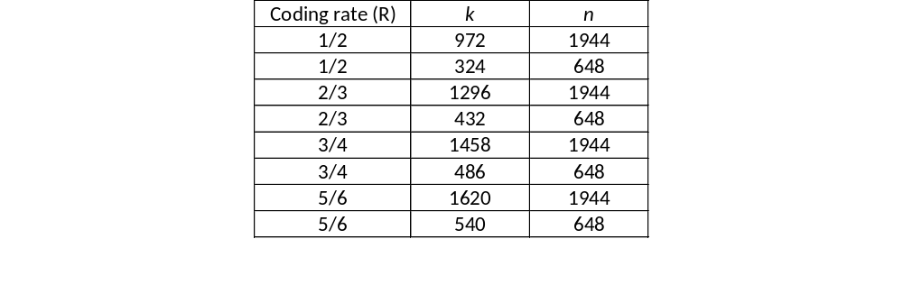

where k= number of information bits, n=number of coded bits, n-k=number of parity bits.

The matrix H_{p} for n=648, Z=27, R=1/2 is given by

0 | - | - | - | 0 | 0 | - | - | 0 | - | - | 0 | 1 | 0 | - | - | - | - | - | - | - | - | - | -
22 | 0 | - | - | 17 | - | 0 | 0 | 12 | - | - | - | - | 0 | 0 | - | - | - | - | - | - | - | - | -
6 | - | 0 | - | 10 | - | - | - | 24 | - | 0 | - | - | - | 0 | 0 | - | - | - | - | - | - | - | -
2 | - | - | 0 | 20 | - | - | - | 25 | 0 | - | - | - | - | - | 0 | 0 | - | - | - | - | - | - | -
23 | - | - | - | 3 | - | - | - | 0 | - | 9 | 11 | - | - | - | - | 0 | 0 | - | - | - | - | - | -
24 | - | 23 | 1 | 17 | - | 3 | - | 10 | - | - | - | - | - | - | - | - | 0 | 0 | - | - | - | - | -
25 | - | - | - | 8 | - | - | - | 7 | 18 | - | - | 0 | - | - | - | - | - | 0 | 0 | - | - | - | -
13 | 24 | - | - | 0 | - | 8 | - | 6 | - | - | - | - | - | - | - | - | - | - | 0 | 0 | - | - | -
7 | 20 | - | 16 | 22 | 10 | - | - | 23 | - | - | - | - | - | - | - | - | - | - | - | 0 | 0 | - | -
11 | - | - | - | 19 | - | - | - | 13 | - | 3 | 17 | - | - | - | - | - | - | - | - | - | 0 | 0 | -
25 | - | 8 | - | 23 | 18 | - | 14 | 9 | - | - | - | - | - | - | - | - | - | - | - | - | - | 0 | 0
3 | - | - | - | 16 | - | - | 2 | 25 | 5 | - | - | 1 | - | - | - | - | - | - | - | - | - | - | 0

The rest of values for matrix H_{p} can be found in 369r1.
In the modulation mapper, the scrambled coded bits for i=0,1,…,n-1 are modulated with either BSPK, QPSK or 16QAM modulations, resulting in the a block of complex modulation symbols d_{i} for i=0,1,…,N_{sym}-1, where d_{i}=I+jQ

BPSK mapping

b_{i} | I | Q
0 | 1/√2 | 1/√2
1 | -1/√2 | -1/√2

QPSK mapping
b_{i},b_{i+1} | I | Q
00 | 1/√2 | 1/√2
01 | 1/√2 | -1/√2
10 | -1/√2 | 1/√2
11 | -1/√2 | -1/√2

16QAM mapping
b_{i},b_{i+1},b_{i+2},b_{i+3} | I | Q
0000 | 1/√10 | 1/√10
0001 | 1/√10 | 3/√10
0010 | 3/√10 | 1/√10
0011 | 3/√10 | 3/√10
0100 | 1/√10 | -1/√10
0101 | 1/√10 | -3/√10
0110 | 3/√10 | -1/√10
0111 | 3/√10 | -3/√10
1000 | -1/√10 | 1/√10
1001 | -1/√10 | 3/√10
1010 | -3/√10 | 1/√10
1011 | -3/√10 | 3/√10
1100 | -1/√10 | -1/√10
1101 | -1/√10 | -3/√10
1110 | -3/√10 | -1/√10
1111 | -3/√10 | -3/√10

DFT-S OFDM or OFDM
The Parameters are given by
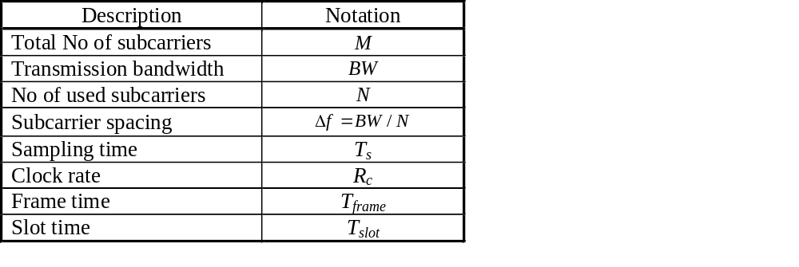

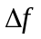is constant and equal to 15 KHz.
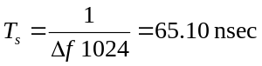Maximum FFT size M=1024
Sampling time
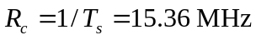Timing based on a common clock at

6.5.1 Optional GFSK modulation
An optional and very low power PHY based on CP-2FSK modulation is contemplated for the sub-GHz band.
No support for MIMO technologies, i.e., layer mapper and precoding are not necessary.
The proposed channel encoder, bit interleaver and scrambler are used as well. The modulation mapper is CP-2FSK.

CP-2FSK modulation is given by
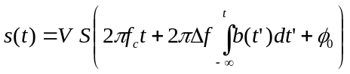

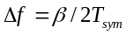where V is amplitude, S(t)=sin(2πf_{c}t) is the modulating-carrier signal, f_{c} is the carrier frequency, is the peak frequency deviation, β=1 is the modulation index, T_{sym} is the symbol time and φ₀ is the initial phase of the modulating-carrier signal

The information bearing signal is given by
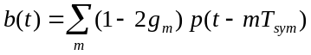

where g_{m} is information bit, p(t) is a Gaussian pulse shape of bandwidth-symbol duration product of 0.8

6.6 Multiple antennas

Layer mapping
Two MIMO technologies are supported: open loop spatial multiplexing and transmit diversity (SFBC) for 2 and 4 antennas.
The [complex] modulation symbols per codeword d_{i} for i=0,1,…,N_{sym}-1 are mapped into several layers
  - Layer=independent stream of symbols in a MIMO configuration.
  - Rank=number of layers transmitted.
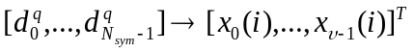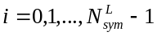As for
  - 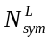where is the number of layers and is the number of symbols per layer for the qth codeword.
- Open loop spatial multiplexing (parallel data streams)
  - Here 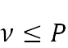, where P is the number of antennas.

No layers | No codewords | Mapping | Parameter
1 | 1 | 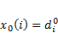 | 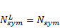
2 | 1 | 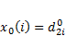  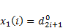 | 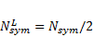
2 | 2 | 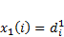
4 | 1 | 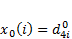  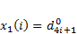  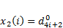  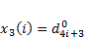 | 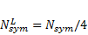
4 | 2 | 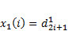  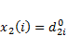  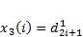

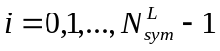where

- Transmit diversity (same information is Tx from multiple antennas)
  - 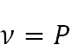

No layers | No codewords | Mapping | Parameter
2 | 1
4 | 1 |  | 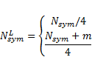

where and m null symbols at the end such that N_{sym}+m Mod4=0

Precoding allows to increase system performance and robustness by feeding back to the transmitter CSI.
Schematic diagram of MIMO support with precoding is given by

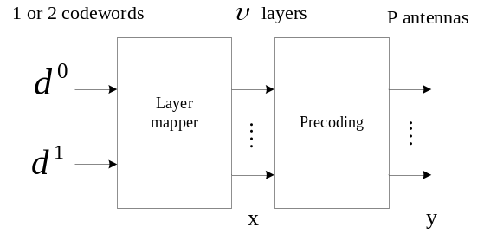

- Open loop spatial multiplexing increases robustness by feeding back the channel’s rank (RI=rank indicator)
  - Transmitter chooses a pre-fixed codeword according to RI
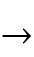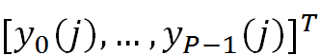
  - 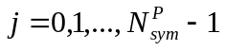 for and
  - 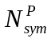where is the number of symbols transmitted per antenna.
Single antenna mapping is given by
  - 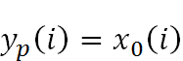
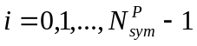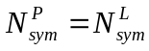where 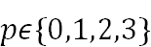, and

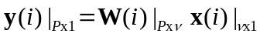Multiple antennas mapping
  - for and
- Transmitter chooses a codeword according to reported ν
- Codebook for 2 antennas is given by
index | 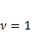 | 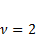
0 | 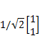 | 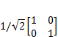
1 | 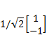 | 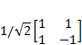
2 | 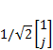 | 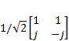
3 | 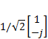

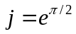where

Codebook for 4 antennas is given by

n | u_{n} |  |  | 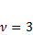 | 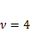
0 | 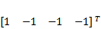 |  | 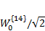 | 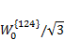 | 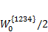
1 | 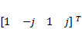 |  | 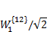 | 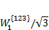 | 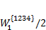
2 | 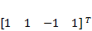 |  | 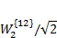 | 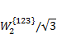 | 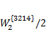
3 | 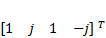 |  | 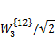 | 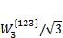 | 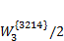
4 | 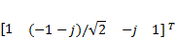 |  | 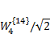 | 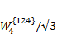 | 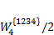
5 | 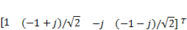 |  | 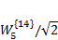 | 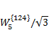 | 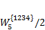
6 | 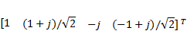 |  | 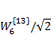 | 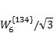 | 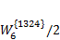
7 | 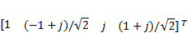 |  | 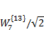 | 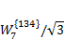 | 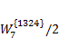
8 | 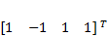 |  | 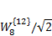 | 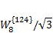 | 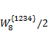
9 | 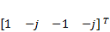 |  | 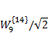 | 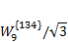 | 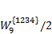
10 | 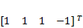 |  | 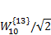 | 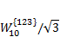 | 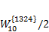
11 | 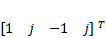 |  | 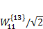 | 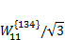 | 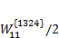
12 | 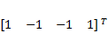 |  | 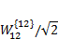 | 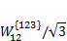 | 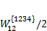
13 | 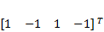 |  | 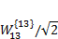 | 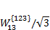 | 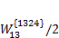
14 | 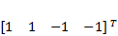 |  | 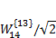 | 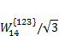 | 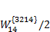
15 | 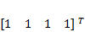 |  | 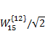 | 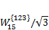 | 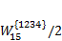

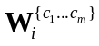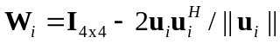where W is conformed from the codebook for 4 antennas table, denotes the matrix formed by the columns {c₁…c_{m}} of the matrix

Precoding for transmit diversity
Support for 2 or 4 antenna configurations and one data stream. Transmit diversity is aimed to increase robustness in scenarios with low SNR, low delay tolerance or no feedback to the transmitter is available or reliable.
Case of 2 antennas
  - STBC (Alamouti scheme) for DTF-Spread OFDM
  - SFBC (equivalent of STBC) for OFDM
SFBC for 2 antennas is given by
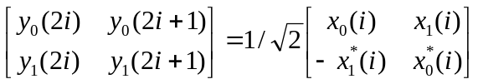

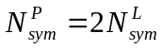for and

In case of 4 antennas a combination of SFBC (2 antennas) with frequency switch transmission diversity is given by

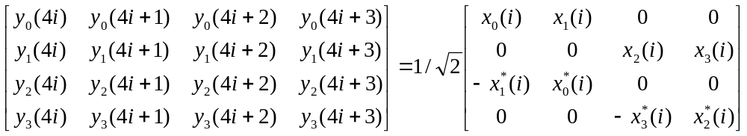

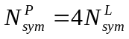for and

6.6 Bit interleaver
In order to minimize latency and integration on parallel architectures within the encoder/decoder implementation, an algebraic interleaver is proposed.
A maximum contention-free quadratic permutation interleaver is defined as
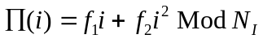

where i=0,1,…,N_{I}-1. N_{I} is interleaver’s length.
If N_{I} is even, f₁ is odd and relative prime to N_{I} and all prime factors of N_{I} are also factors of f₂.
Elements of codewords of length n (c_{i} for i=0,1,…,n-1) are interleaved in blocks of N_{I} bits as c_{∏(j)} for j=0,1,…,N_{I}-1
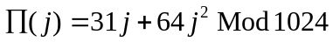Short length interleaver:

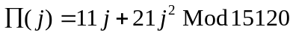Long length interleaver:

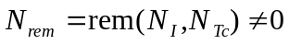If (N_{Tc} is the total number of coded bits in a packet), in the last codeword, insert N_{rem} bits stuffing.

6.7 Scrambling
A scrambler is used to shape the data spectrum and to randomize data across users in order to reduce interference.
We propose a Gold code generator of length 63 is proposed as scrambler
  - PN sequence with period 2⁶³ (truly random for long packets)
  - Different initialization seeds, enables a different Gold code per user with low correlation respect to other user using a different seed.
63 shift register initialization
  - User ID and group ID (already known during discovery phase)
  - Fast forward 100 times to reduce PAPR (OFDM)

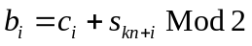The Gold code generator (with polynomials x⁶+x+1 and x⁶+x⁵+x²+x+1) outputs s_{i} for i=0,1,…,2⁶³-1, which is used to scramble the interleaved codeword bits c_{i} for i=0,1,…,n-1 prior to modulation as

It may include several codewords in a packet (k=0,1,…N_{CW}-1)
63 shift registers initialization at start of a packet is given by
  - User ID (1st register) and group ID (2nd register)
  - Fast forward both registers 100 times to reduce PAPR

6.8 Discovery procedure
We propose to use a discovery preamble (DP) based on a ZC sequence and a discovery resource block (DRB) from a modified (DTF-S) OFDM signal.
  - The DP and DRB formed the Discovery Signal (DS).
Moreover, we propose to use one channel (from the proposed channelization for sub-GHz, 2.4 GHz and 5.7 GHz bands) for only discovery of devices.
  - PAC devices can either transmit or receive the DS in this unique channel asynchronously.
Such unique channel for discovery is named Shared Discovery Channel (SDCH).
The discovery signal (DS) sent over a discovery shared channel (DSCH):

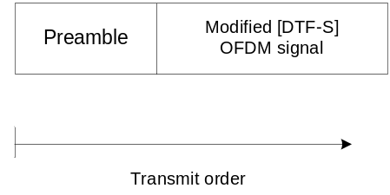

The DS consists of a preamble sequence plus a DRB formed by N_{fs} frequency slots and N_{ts} time slots.
Once synchronized, a receiver knows the location of the discovery resource block (DRS) to scan for possible peers or to pick time-frequency slots to transmit its DS.
The proposed ZC sequence for initial synchronization during discovery (or communication mode) is a ZC sequence with the following parameters:
  - Sequence length N = 63, relative prime r = 62 and q = 0.
  - The autocorrelation function is illustrated as
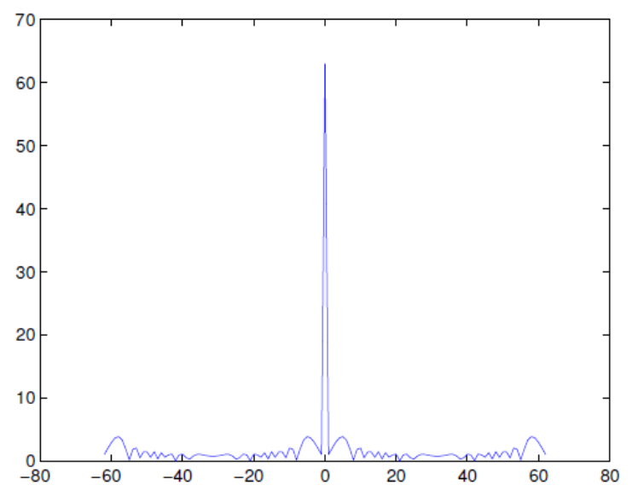

Such ZC sequence is mapped onto 62 sub-carriers
  - The first subcarrier and the DC subcarrier are empty.
Of course, several repetitions may be transmitted
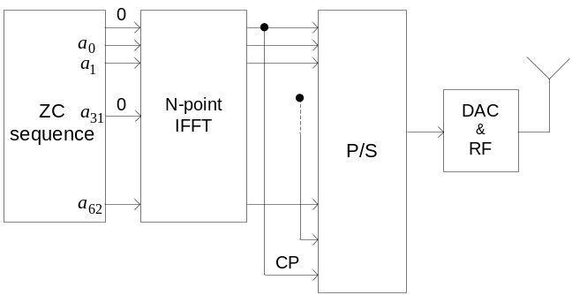

For discovery, the proposed PHY can be reused with some simplifications.
The discovery process is energy intensive. In order to minimize power consumption, in case of DTF-Spread OFDM, the M-point FFT is bypassed (this is not required for OFDM) and only one subcarrier of the N-point IFFT is used per user.
  - The PAPR is set to the minimum.
  - Across the frequency domain, users are orthogonal (OFDMA)
- For discovery, the nth symbol transmitted over the kth subcarrier is given by
  - for l=-L+1,,…,0,1,…,N-1 and L the CP

Contiguous subcarriers are orthogonal as illustrated in the figure:

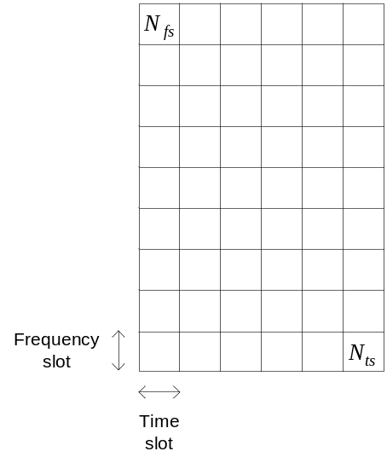

The DS is transmitted with a predefined duty-cycle (see NICT MAC pre-proposal).
From upper layers, terminals pick time-frequency slots in the DRB to transmit the DS.
A set of 126 symbols are transmitted per time slot:
  - such frame contains information about a given peer (peer ID, service ID, application ID, etc.) and which channel is used for association (different from the SDCH).
The number of frequency slots N_{fs} =1024 (IFFT size) and the number of time slots N_{ts} is chosen as 20.
Consequently, the DRB can support up to N_{fs}xN_{ts}=20,480 users for discovery per Group.
The discovery data is formatted as illustrated in the figure:
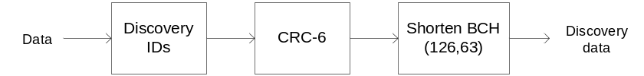

Append 57 bits for user ID, device ID, Group ID, etc.
Append 6 bits from CRC-6-ITU error detection code
Append 63 bits from shorten BCH(126,63) code

6.9 Peering procedure
Devices are in three possible states:
  - RDM –receiving discovery mode,
  - TDM –transmitting discovery mode,
  - Sleep -idle.
  - Also, devices are equipped with clear channel assessment (CCA).

  - 1) At start up or after idle or after command, a device enters into receiving discovery mode (RDM) and listens for a DS.
    - Synchronization subsystem detects the preamble (and hence the position of the DRB in time) and detection subsystem scans the DRB for DRB usage and detection of peer ID, service ID, etc. Go to Sleep mode.
  - 2) After command, a device enters into transmitting discovery mode (TDM)
    - Device chooses a free time-frequency slot to transmit its DS over the next DRB transmission. Go to Sleep mode.
Of course, there are intermediate steps like time-out for DRB scanning, miss detection, etc. Here, we present the core algorithm only.

An estimate of the distance range of peers is obtained from the link budget as
  - 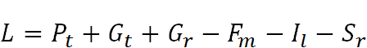
  - Receiver’s sensitivity: 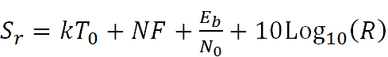
Once the value of path loss is known, an estimate of the transmission distance is obtained depending on a desired path loss law.

Once the value of path loss is known, an estimate of the transmission distance is obtained depending on a desired path loss law.

Example path loss parameters
  - 920 MHz band, option C.
  - The maximum transmit power at the input antenna: Pt = 250 mW.
  - Antenna gains are assumed as Gt = Gr = 0 dBi.
  - The fade margin: Fm = 6 dB.
  - Receiver’s implementation losses: Il = 3 dB.
  - Receiver’s noise figure: NF = 6 dB.
  - Through simulations: E_{b}/N₀ = 8 dB for BER= 10⁻⁷ (BPSK).
  - Data rate: 1 Mbps, 250 kbps.
The maximum allowed path losses are:
  - L₁ = 114:97 dB for 1 Mbps
  - L₂ = 120:98 dB for 250 kbps

Using the ITU outdoor path loss model with h_{b}=h_{m}=1.5 m, distances are:
  - 900 m for 1 Mbps
  - 1200 m for 250 kbps.
Using the indoor path loss model with n = 3.27 and 2 block walls, distances are:
  - 60 m for 1 Mbps
  - 80 m for 250 kbps.

Notice that the first terminal to start a discovery session, will set the discovery signal duty cycling for other terminals to follow, no matter if it stops transmitting afterwards. There is not central control.
Also, such terminal will set the channel for association (communication link) named Association Channel (ACH). Although, it may change afterwards.
For association, intended devices that want to establish a communication link, request that through a random access preamble transmitted in the ACH.

6.9.1 Peering through random access
The random access association preambles are named Random Access Preambles (RAPs).
Such RAPs are formed with ZC sequences as well.
Hence, a pool of orthogonal RAPs is formed
  - in order to reduce interference from competing terminals for random access.
A unique RAP is assigned to every device in a Group.
Such unique RAP is used for fine synchronization and control messages (how a communication link is granted).
The RAP signal is illustrated as

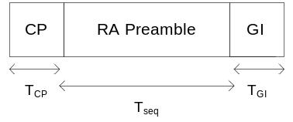

where GI is guard interval and RA preamble is set of orthogonal preambles.

6.9.1.1 RA preamble design
Maximum round-trip time
  - T_{seq} must allow round-trip estimation at the largest expected distance.
  - d=500 m (1 km round-trip)
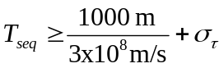

The RMS delay spread is estimated as
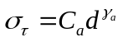

frequency
5.7 GHz | 339 nsec
2.4 GHz | 355 nsec
920 MHz | 2 µsec

Consequently an lower bound is given by

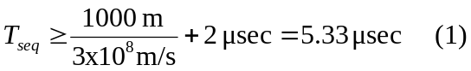

Coverage performance can be estimated from the link budget
It is possible to show that
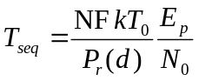

where E_{p} is the required preamble energy to meet a PFA of 10⁻³
Parameters
  - d=500m, f_{c}=2.4 GHz, P_{t}=1 W, G_{t}=G_{r}=5 dBi, NF=5 dB, kT₀=-204 dB, the path loss model in clause 2.2.6 of the channel model document, through simulations E_{p}/N₀=18 dB.
  - 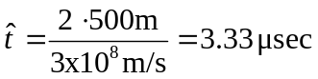T_{seq}=0.433 msec
The CP and GI lengths are given by

Thus, T_{seq} is upper bounded by

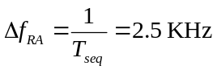From (1) and (2) T_{seq}=0.4 msec satisfies both inequalities.
  - Inter-carrier spacing

  - 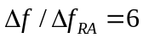Granularity increment

  - 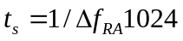Sampling time

  - 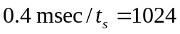Preamble sequence length is given by

Thus, a set of orthogonal preamble sequences of length 1024 can be generated from ZC sequences for random access, which satisfy maximum round-trip time and coverage performance for a maximum distance of 500m.

6.9.1.2 Random access procedure
Once initial synchronization and decoding of discovery RB are achieved by Terminal 2 over Terminal 1:
  - Terminal 2 requests association by a random access procedure based on an orthogonal RAP.

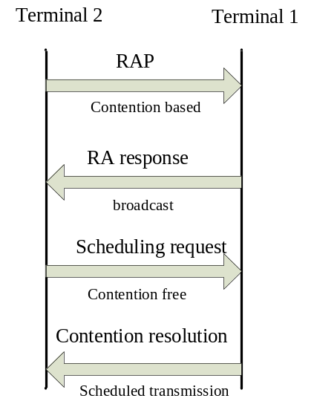

The process is initiated and control by upper layers.
1) Terminal 2 sends RAP over the ACH.
  - It is randomly selected from a pool of orthogonal ZC sequences.
  - It contains finer frequency granularity for Terminal 1 to acquire fine time and frequency synchronization of Terminal 2, plus information about the resources needed to transmit in 3).
2) Terminal 1 replies with RA response message.
  - It contains timing information (round-trip delay), RAP-ID, RB grant to transmit in 3), Group identifier, etc.
3) Scheduling request
  - It contains scheduling request information for transmission.
  - If this message is successfully detected in Terminal 1, still contention remains unsolved for other terminals. A quick resolution is needed.
- 4) Contention resolution
  - Terminal 1 echoes Terminal 2 ID contained in 3)
  - Terminal 2 detects its ID and sends ACK (RA terminated) a communication link is scheduled and established.
  - Terminal 2 detects another ID (RA terminated, starts a new one)
  - Terminal 2 fails to detect ID (RA terminated, starts a new one)

6.10 Reference signals

Reference signals are required to perform channel estimation in time and frequency for detection and equalization.
6.10.1 Channel time dispersion
Considering a maximum speed of v=100 Km/h (27.78 m/s)
The Doppler spread is given by f_{d}=f_{c} v/c
Min. sampling time to reconstruct the channel is T_{c}=1/2f_{d}


The slot time T_{slot}=0.5 msec. Then, one reference symbol per slot is needed in the time domain to estimate the channel correctly.

6.10.2 Channel frequency dispersion

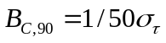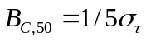Considering 90%, 50% coherence bandwidth as and
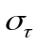where is the RMS delay spread.

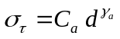The outdoor RMS delay spread is estimated as
For a distance d=500m, we have 90%, 50% coherence bandwidth given in the table
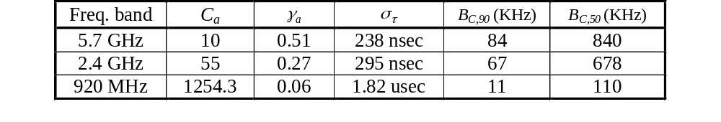

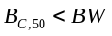If then frequency selective fading and frequency domain equalization is needed.
  - We propose that the spacing between 2 reference symbols in frequency in a RB is 30 KHz to resolve frequency variations.

6.10.2 ZC sequences
Preambles or beacons for synchronization and reference signals (RSs) are formed with Zadoff-Chu (ZC) sequences of length N.
  - Constant-amplitude zero-correlation (CAZAC) sequences
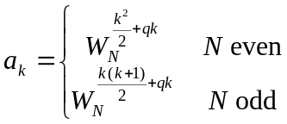

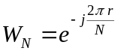where is a primitive nth root of unity, r is a relative prime to N, sequence index k = 0, 1, ...,N-1and q is any integer.

ZC sequences have constant amplitude and so its N-point DFT.
  - This limits the PAPR and simplifies implementation as only phases have to be generated and stored, besides of bypassing the FFT at transmitter for DFT-S OFDM.
ZC sequences have ideal cyclic autocorrelation, i.e., the correlation with its shifted version is a delta function
  - Thus, a [large] set of orthogonal preambles or reference signals is possible to generate.

