IEEE P802.15
Wireless Personal Area Networks

Project | IEEE P802.15 Working Group for Wireless Personal Area Networks (WPANs)
Title | Draft of TG8 PAC Link Layer Specification Document
Date Submitted | Nov. 12, 2013 (r2)
Source | 802.15.8 Link specification proposer:  Seong-Soon Joo (ETRI) | E-Mail:  [ssjoo@etri.re.kr]
Re:
Abstract | This is the draft version of 802.15.8 PAC Link Layer Specification Document.
Purpose | This document provides the specification of the TG8 PAC link layer. The document provides an outline of each the functional blocks that will be a part of the final specification.
Notice | This document does not represent the agreed views of the IEEE 802.15 Working Group or IEEE 802.15.8 Task Group. It represents only the views of the participants listed in the “Source(s)” field above. It is offered as a basis for discussion and is not binding on the contributing individual(s) or organization(s). The material in this document is subject to change in form and content after further study. The contributor(s) reserve(s) the right to add, amend or withdraw material contained herein.
Release | The contributor acknowledges and accepts that this contribution becomes the property of IEEE and may be made publicly available by P802.15.
Patent Policy | The contributor is familiar with the IEEE-SA Patent Policy and Procedures:  <http://standards.ieee.org/guides/bylaws/sect6-7.html#6> and  <http://standards.ieee.org/guides/opman/sect6.html#6.3>.  Further information is located at <http://standards.ieee.org/board/pat/pat-material.html> and  <http://standards.ieee.org/board/pat>.

Overview
The 802.15.8 specification shall be developed according to the P802.15.8 Peer Aware Communication (PAC) project authorization request (PAR), document number 15-12-0063r2 and Five Criteria (5c), document number 15-12-0064r1, which were approved by the IEEE-SA in March of 2012.

Definitions
peer aware communication (PAC) network : A peer-to-peer wireless proximity network of which a device can act as a client or a server for the other devices by allowing shared access to various resources such as configuration or control information, location information, sensing data, advertisement, multi-media contents, social contents, etc.

PAC enabled network: An external network of the devices on which the PAC features are equipped

peer network initiator: A PAC device which defines a mission, configures the peer group, hosts peers, and authenticates peers

Device ID: Unique PAC device address e.g. MAC address
Service type ID: Service category for PAC discovery [Appendix A]
Service group: The set of PDs which became peering each other
Discovering PD: PD which transmits the request signal to discover other PD(s)
Discovered PD: PD which transmits the response signal to discovering PD

Abbreviations and acronyms

PAC peer aware communication

General descriptions

Concepts and architecture
The peer aware communication (PAC) network is a peer-to-peer wireless proximity network of which a device can act as a client or a server for the other devices by allowing shared access to the various resources such as configuration or control information, location information, sensing data, advertisement, multi-media contents, social contents, etc.

The PAC enabled network consists of the PAC devices (PDs) which carry one of roles: peer network initiator, proxy peer network initiator, peer network peers, peer network relay, and peer network observer. The initiator defines a mission, configures the peer group, hosts peers, and authenticates peers. The peer network relay provides one-hop frame relaying. The peer network observer is a neighbor of the peer group, but is not a member of the peer group.

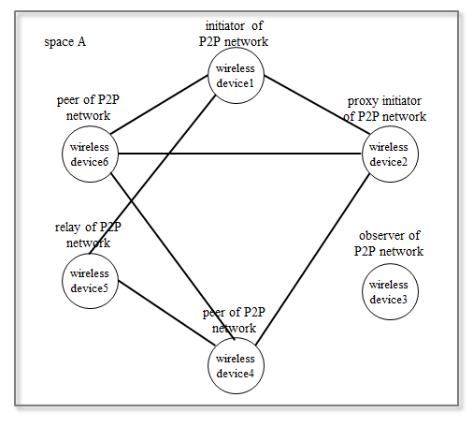

Figure 4.1- Components of the PAC enabled networks

The peer aware communications (PAC) features may be equipped on a PAC dedicated device or on external network equipment. The PAC network is composed of the PAC dedicated devices. The PAC enabled network is composed of the PAC enabled external network devices.

The PAC networks and the PAC enabled networks construct a peer group consisted of: single PAC group, multiple PAC groups, single PAC group and single PAC enabled network, single PAC group and multiple PAC enabled networks, multiple PAC groups and single PAC enabled network, and multiple PAC groups and multiple PAC enabled networks.

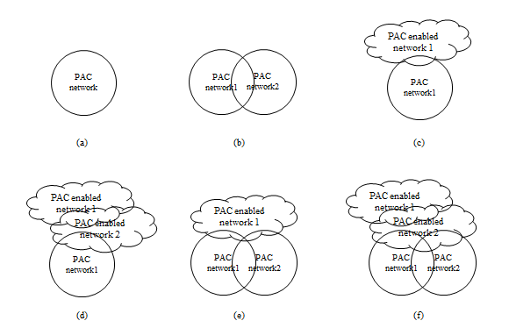
Figure 4.2- Possible peer groups constructed with the PAC equipped devices

Topology
A PAC device may have connections to multiple peers in a peer group and may participate in multiple peer groups concurrently. A PAC device provides one-to-one communication and one-to-many communication in a peer group. A PAC device provides one-to-one communication to multiple peer groups and one-to-many communication to multiple peer groups.

IEEE 802.15.8 shall support a PD having simultaneous communication sessions for same or different applications. IEEE 802.15.8 shall support a PD participation in at least two independent one-to-many communications with different peers at the same time.

A PAC device may have star topology to peers in a peer group or may have mesh topology to peers in a peer group. A PAC device provides at least two hops relay to peers in a peer group.
Figure 4.3. An example of concurrent communication

Reference model
In accordance with the ISO/OSI-IEEE Std 802-2001 reference model, all PDs are internally partitioned into a physical (PHY) layer, a medium access control (MAC) sublayer of the data link layer, and a MAC relaying sublayer (RELAY) resided below the Service Specific Convergence Sublayer (SSCS) of IEEE Std 802.2-1998 Logical Link Control (LLC). Direct communications between PDs are to transpire at the PHY layer and MAC sublayer as specified in this standard; Message security services are to occur at the MAC sublayer, and security operations are to take place inside and/or outside the MAC sublayer.

Within a PD, the RELAY provides its service to the higher layer through the RELAY service access point (SAP) located immediately above the RELAY sublayer, while the MAC provides its service to the RELAY through the MAC SAP located between them. On transmission, the higher layer passes MAC service data units (MSDUs) to the RELAY sublayer via the RELAY SAP and the RELAY sublayer passes MSDUs to the MAC sublayer via the MAC SAP, and the MAC sublayer passes MAC frames (also known as MAC protocol data units or MPDUs) to the PHY layer via the PHY SAP. On reception, the PHY layer passes MAC frames to the MAC sublayer via the PHY SAP, and the MAC sublayer passes MSDUs to the RELAY sublayer via the RELAY SAP, and the RELAY sublayer passes MSDUs to the higher layer via the RELAY SAP or relays MSDUs to the MAC sublayer via the MAC SAP.
MAC and PHY SAPs also pass control information between the layers.
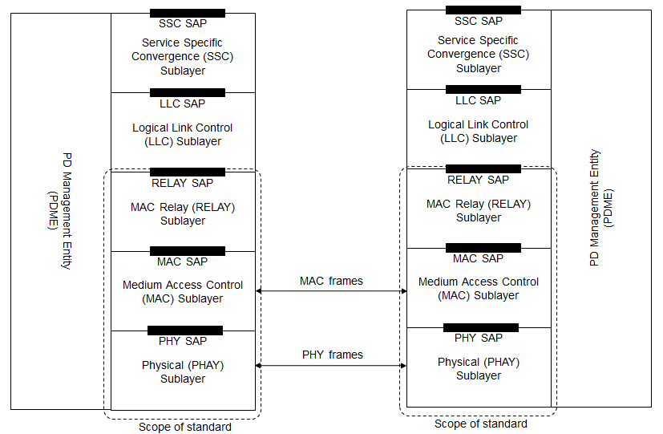

Figure 4.4. Reference model

There may be a logical PD management entity (PDME) that exchanges network management information with the PHY and MAC as well as with other layers or exchanges network management information with the external network management entity.

MAC layer

MPDU structure
The MPDU consist of MAC frame header, MAC frame information, MAC frame payload, and MAC frame tail. The MAC frame header contains frame control, peer network identifier, peer device addressing fields, and peer network authenticator. The MAC frame information contains peer network information elements.

The peer network identifier consists of service class of peer network, peer group service profile identifier, and local peer network identifier.

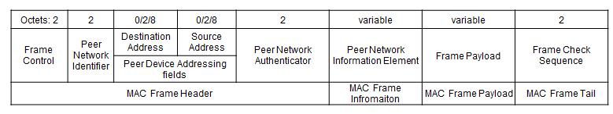
Figure 5.1- Structure of MAC frame MPDU

Multiple access
The PAC enabled network provides resource allocation configuration primitives to the next higher layer of the peer network initiator. The resources, which may be temporal or spectral or spatial, are slotted and allocated to the components of the peer group on the whole time frame from the start to the end of the peer network.

The life cycle of the peer group from forming to disbanding is specified by combining the phases: synchronization phase, discovering phase, peering phase, data phase, disbanding phase, and handshaking phase. Any combinations are possible and a combination of the phases can be iterated except the disbanding phase. In each phase, the slotted resources are allocated to initiator, proxy initiator, peers, relay, and inactive period. Any combinations of allocation order are possible and a combination of the allocation order can be iterated.

The combination of the phase and the combination of allocation order of each phase are designed prior to support a service which is specified with the technical attributes defined in application matrix of IEEE 802.15.8 (15-12-0684). According to the application matrix, the generic configurations of resource allocation are registered as peer group service profile identifiers. The peer group service profile identifier is contained in the peer network identifier and the observers of the peer network may listen and can recognize the schedule of resource allocation. By obtaining the neighbor peer groups’ resource allocation information with the implicit and distributed manner, the PAC enabled devices can perform the proactive interference avoidance.
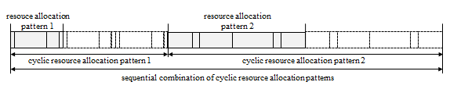

Figure 5.2- Combination of phase and the combination of resource allocation order

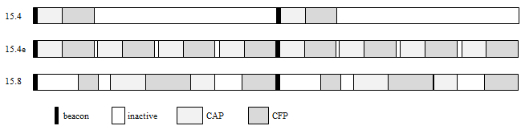

Figure 5.3- Comparison with IEEE 802.15.4 superframe and 15.4e multi-superframe

Synchronization procedure
The MAC sublayer provides a network synchronization procedure for peers to align to the current phase. In synchronization phase, initiator or the proxy initiator of the peer group transmits the peer group advertisement frame every T_{d} over minimum synchronization adjust interval. The peers receive the sequential advertisement frame and adjust the length of unit resource slot.
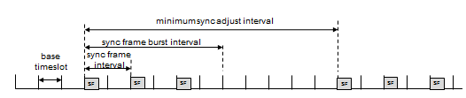

Figure 5.4- Synchronization for unit resource slot length adjustment

Discovery procedure
The peer discovery is carrying out during discovery phase by transmitting a peer discovery frame, which contains peer network identifier and peer network information elements. The peer group service profile is identified by the peer network identifier. The details on the combination of phase and allocation order are contained in peer network descriptor. The peer discovery frame is transmitted every T_{d} over minimum discovery interval.

Peering procedure

Scheduling
The resource scheduling is followed the resource allocation configuration pre-determined by the peer group service. The unit resource slot of a peer group is n times of the base slotted resource. The unit resource slot size may be different from other peer groups to support the designated grade of service.

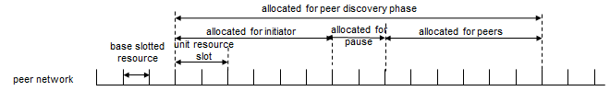

Figure 5.5- Base slotted resource and unit resource slot specified by each peer network

QoS

The MAC sublayer provides the resource allocation features and the data primitives for supporting multiple grades of service to the next higher layer. The grades of service are categorized with the technical attributes specified in the application matrix for IEEE 802.15.8 (15-12-0684-00-008).

Interference management
To avoid interference caused of unscheduled accesses from multiple peer groups, the MAC sublayer provides two interference avoidance capabilities. During peer group formation, the initiator observes the frames from neighbour peer groups and gathers the resource allocation schedules. The initiator adjusts the resource allocation configuration and selects the start time to cause low probability of interference. The peers who serve to multiple peer networks schedule the transmission by selecting time-slot to avoid contention among multiple peer networks. In case of contention, the peers select appropriate access control algorithm to the peer’s priority.

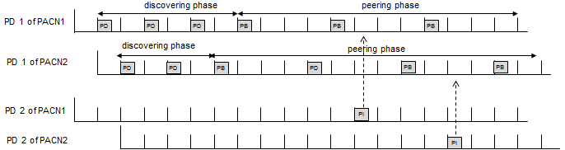
Figure 5.6- Proactive interference avoidance at a PD which serves to multiple peer groups

Transmit power control

Multicast

The part of devices in a peer group may establish a geo-group of the peer group. The MAC sublayer provides the geo-group of the peer group formation primitives and the geo-groupcast primitives to the next higher layer. The formation of a geo-group of the peer group is performed with the implicit inviting and the explicit grouping.

Broadcast

Multi-hop operation

To extend the coverage of the peer group, peer group relay capable PDs provide hop-relaying. The hop-relaying is performed at the RELAY sublayer by transmitting the received frames not destined to the device to the other side neighbour PD. The allocation of resources for relaying frames and the relaying procedure can be adopted from the IEEE 802.15.4k Timeslot Relaying based Link Extension.

Relative positioning

The MAC sublayer provides geographical relation information among PDs which are resided within two hops from the device. The geographical relation presents relative angular distance among the neighbour devices. The relation matrix generated from the geographical relation information is advertised to the peer group according to the request.

Power management

Security

Coexistence

Higher layer interaction

Physical layer

Channelization

Duplex schemes

Multiplex schemes

Frame structure

Modulation and coding scheme (MCS)

Multiple antennas

