IEEE P802.15
Wireless Personal Area Networks

Project | IEEE P802.15 Working Group for Wireless Personal Area Networks (WPANs)
Title | Draft of TG8 PAC Link Layer Specification Document
Date Submitted | Nov. 10, 2013 (r1)
Source | 802.15.8 Link specification proposer:  Seong-Soon Joo (ETRI) | E-Mail:  [ssjoo@etri.re.kr]
Re:
Abstract | This is the draft version of 802.15.8 PAC Link Layer Specification Document.
Purpose | This document provides the specification of the TG8 PAC link layer. The document provides an outline of each the functional blocks that will be a part of the final specification.
Notice | This document does not represent the agreed views of the IEEE 802.15 Working Group or IEEE 802.15.8 Task Group. It represents only the views of the participants listed in the “Source(s)” field above. It is offered as a basis for discussion and is not binding on the contributing individual(s) or organization(s). The material in this document is subject to change in form and content after further study. The contributor(s) reserve(s) the right to add, amend or withdraw material contained herein.
Release | The contributor acknowledges and accepts that this contribution becomes the property of IEEE and may be made publicly available by P802.15.
Patent Policy | The contributor is familiar with the IEEE-SA Patent Policy and Procedures:  <http://standards.ieee.org/guides/bylaws/sect6-7.html#6> and  <http://standards.ieee.org/guides/opman/sect6.html#6.3>.  Further information is located at <http://standards.ieee.org/board/pat/pat-material.html> and  <http://standards.ieee.org/board/pat>.

Table of Contents
1. Overview 3
2. Definitions 3
3. Abbreviations and acronyms 3
4. General descriptions 3
4.1. Concepts and architecture 3
4.2. Topology 3
4.3. Reference model 4
5. MAC layer 5
5.1. MPDU structure 5
5.2. Multiple access 5
5.3. Synchronization procedure 6
5.4. Discovery procedure 6
5.5. Peering procedure 6
5.6. Scheduling 6
5.7. QoS 7
5.8. Interference management 7
5.9. Transmit power control 7
5.10. Multicast 7
5.11. Broadcast 7
5.12. Multi-hop operation 7
5.13. Relative positioning 8
5.14. Power management 8
5.15. Security 8
5.16. Coexistence 8
5.17. Higher layer interaction 8
6. Physical layer 8
6.1. Channelization 8
6.2. Duplex schemes 8
6.3. Multiplex schemes 8
6.4. Frame structure 8
6.5. Modulation and coding scheme (MCS) 8
6.6. Multiple antennas 8

Overview

Definitions
PAC enabled X-network: A X-network of the devices on which the PAC features are equipped

PAC WPAN: The network of which a device can act as a client or a server for the other devices by allowing shared access to various resources such as configuration or control information, location information, sensing data, advertisement, multi-media contents, social contents, etc.

peer network initiator: A PAC device which defines a mission, configures the peer group, hosts peers, and authenticates peers

Abbreviations and acronyms

General descriptions
This clause provides the basic framework of PDs. The framework serves as a guideline in developing the functionalities of PDs and their interactions specified in detail in the subsequent clauses.

Concepts and architecture
The peer-to-peer wireless personal area network is a network of which a device can act as a client or a server for the other devices by allowing shared access to the various resources such as configuration or control information, location information, sensing data, advertisement, multi-media contents, social contents, etc.

The communication features of the peer-to-peer WPAN, peer aware communications (PAC), may be equipped on a dedicated device or on a device which is other network equipment. The network composed of the PAC devices is the PAC WPAN. The network composed of the PAC enabled on the devices of the X-network is the PAC enabled X-network. The hybrid PAC network is composed of the PAC devices and the PAC enabled devices.

There are possible cases to coexist the PAC WPAN and the PAC enabled X-network: single PAC WPAN, multiple PAC WPANs, single PAC WPAN & single PAC enabled X-network, single PAC WPAN & multiple PAC enabled X-networks, multiple PAC WPANs & single PAC enabled X-network, and multiple PAC WPANs & multiple PAC enabled X-networks.

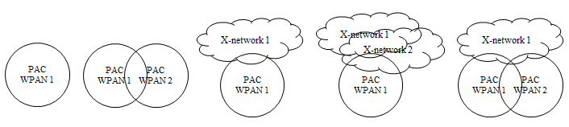
Figure 4.1- Possible network combinations with the PAC equipped devices

Topology
The PAC enabled network consists of the PAC devices (PDs) which carry one of roles: peer network initiator (proxy initiator), peer network peers, peer network relay, and peer network observer. The initiator defines a mission, configures the peer group, hosts peers, and authenticates peers. The peer network relay provides one-hop frame relaying. The peer network observer is a neighbor of the peer group, but is not a member of the peer group.

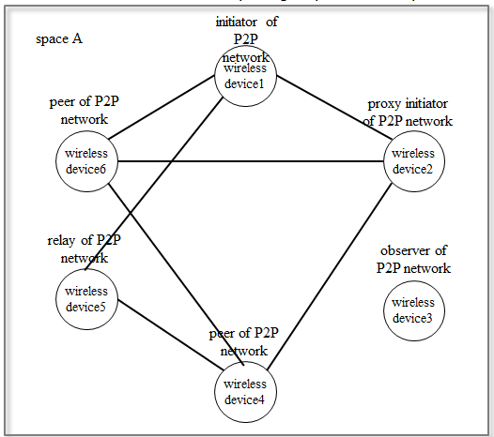

Figure 4.2- Components of the PAC enabled networks

Reference model
The reference model of the PAC enabled network consists of three link sub-layers and one management entity. The PD serves thorough two PD SAPs and two PAC enabled X-network device SAPs.
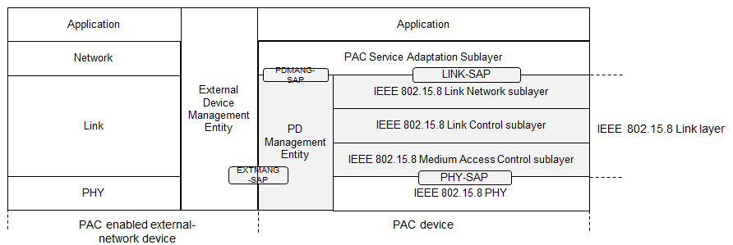

Figure 4.3- Reference model of the PAC enabled device

MAC layer

MPDU structure
The MPDU consist of link frame header, link frame information, link frame payload, and link frame tail. The link frame header contains frame control, peer network identifier, peer device addressing fields, and peer network authenticator. The link frame information contains peer network information elements.

The peer network identifier consists of service class of peer network, peer group service profile identifier, and local peer network identifier.

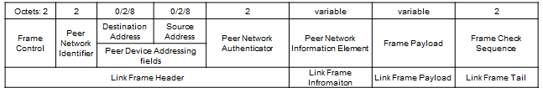
Figure 5.1- Structure of link frame MPDU

Multiple access
The PAC enabled network provides resource allocation configuration primitives to the next higher layer of the peer network initiator. The resources, which may be temporal or spectral or spatial, are slotted and allocated to the components of the peer group on the whole time frame from the start to the end of the peer network.

The life cycle of the peer group from forming to disbanding is specified by combining the phases: synchronization phase, discovering phase, peering phase, data phase, disbanding phase, and handshaking phase. Any combinations are possible and a combination of the phases can be iterated except the disbanding phase. In each phase, the slotted resources are allocated to initiator, proxy initiator, peers, relay, and inactive period. Any combinations of allocation order are possible and a combination of the allocation order can be iterated.

The combination of the phase and the combination of allocation order of each phase are designed prior to support a service which is specified with the technical attributes defined in application matrix of IEEE 802.15.8 (15-12-0684). According to the application matrix, the generic configurations of resource allocation are registered as peer group service profile identifiers. The peer group service profile identifier is contained in the peer network identifier and the observers of the peer network may listen and can recognize the schedule of resource allocation. By obtaining the neighbor peer groups’ resource allocation information with the implicit and distributed manner, the PAC enabled devices can perform the proactive interference avoidance.
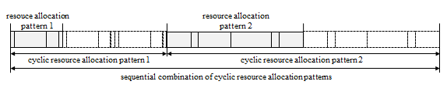

Figure 5.2- Combination of phase and the combination of resource allocation order

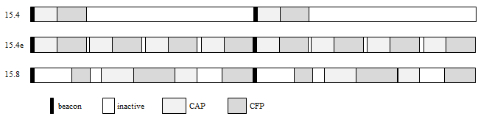

Figure 5.3- Comparison with IEEE 802.15.4 superframe and 15.4e multi-superframe

Synchronization procedure
The MAC sublayer provides a network synchronization procedure for peers to align to the current phase. In synchronization phase, initiator or the proxy initiator of the peer group transmits the peer group advertisement frame every T_{d} over minimum synchronization adjust interval. The peers receive the sequential advertisement frame and adjust the length of unit resource slot.
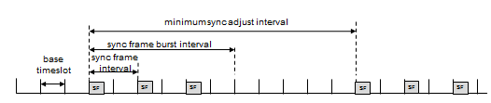

Figure 5.4- Synchronization for unit resource slot length adjustment

Discovery procedure
The peer discovery is carrying out during discovery phase by transmitting a peer discovery frame, which contains peer network identifier and peer network information elements. The peer group service profile is identified by the peer network identifier. The details on the combination of phase and allocation order are contained in peer network descriptor. The peer discovery frame is transmitted every T_{d} over minimum discovery interval.

Peering procedure

Scheduling
The resource scheduling is followed the resource allocation configuration pre-determined by the peer group service. The unit resource slot of a peer group is n times of the base slotted resource. The unit resource slot size may be different from other peer groups to support the designated grade of service.

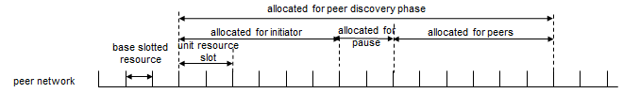

Figure 5.5- Base slotted resource and unit resource slot specified by each peer network

QoS

The MAC sublayer provides the resource allocation features and the data primitives for supporting multiple grades of service to the next higher layer. The grades of service are categorized with the technical attributes specified in the application matrix for IEEE 802.15.8 (15-12-0684-00-008).

Interference management
To avoid interference caused of unscheduled accesses from multiple peer groups, the MAC sublayer provides two interference avoidance capabilities. During peer group formation, the initiator observes the frames from neighbour peer groups and gathers the resource allocation schedules. The initiator adjusts the resource allocation configuration and selects the start time to cause low probability of interference. The peers who serve to multiple peer networks schedule the transmission by selecting time-slot to avoid contention among multiple peer networks. In case of contention, the peers select appropriate access control algorithm to the peer’s priority.

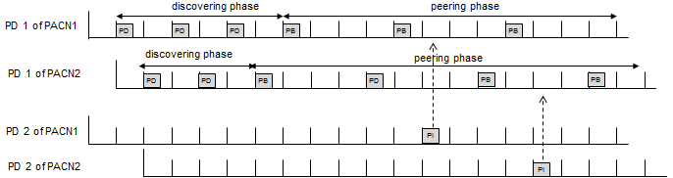
Figure 5.6- Proactive interference avoidance at a PD which serves to multiple peer groups

Transmit power control

Multicast

The part of devices in a peer group may establish a group of the peer group. The MAC sublayer provides the group of the peer group formation primitives and the group-cast primitives to the next higher layer. The formation of a group of the peer group is performed with the implicit inviting and the explicit grouping.

Broadcast

Multi-hop operation

To extend the coverage of the peer group, peer group relay capable PDs provide hop-relaying. The hop-relaying is performed at the MAC sublayer by transmitting the received frames not destined to the device to the other side neighbour PD. The allocation of resources for relaying frames and the relaying procedure can be adopted from the IEEE 802.15.4k Timeslot Relaying based Link Extension.

Relative positioning

The MAC sublayer provides geographical relation information among PDs which are resided within two hops from the device. The geographical relation presents relative angular distance among the neighbour devices. The relation matrix generated from the geographical relation information is advertised to the peer group according to the request.

Power management

Security

Coexistence

Higher layer interaction

Physical layer

Channelization

Duplex schemes

Multiplex schemes

Frame structure

Modulation and coding scheme (MCS)

Multiple antennas

