IEEE P802.15
Wireless Personal Area Networks

Project | IEEE P802.15 Working Group for Wireless Personal Area Networks (WPANs)
Title | Draft of TG8 PAC Link Layer Specification Document
Date Submitted | July 7, 2013 (r0)
Source | 802.15.8 Link specification proposer:  Seong-Soon Joo (ETRI) | E-Mail:  [ssjoo@etri.re.kr]
Re:
Abstract | This is the draft version of 802.15.8 PAC Link Layer Specification Document.
Purpose | This document provides the specification of the TG8 PAC link layer. The document provides an outline of each the functional blocks that will be a part of the final specification.
Notice | This document does not represent the agreed views of the IEEE 802.15 Working Group or IEEE 802.15.8 Task Group. It represents only the views of the participants listed in the “Source(s)” field above. It is offered as a basis for discussion and is not binding on the contributing individual(s) or organization(s). The material in this document is subject to change in form and content after further study. The contributor(s) reserve(s) the right to add, amend or withdraw material contained herein.
Release | The contributor acknowledges and accepts that this contribution becomes the property of IEEE and may be made publicly available by P802.15.
Patent Policy | The contributor is familiar with the IEEE-SA Patent Policy and Procedures:  <http://standards.ieee.org/guides/bylaws/sect6-7.html#6> and  <http://standards.ieee.org/guides/opman/sect6.html#6.3>.  Further information is located at <http://standards.ieee.org/board/pat/pat-material.html> and  <http://standards.ieee.org/board/pat>.

Table of Contents
1. Overview 3
2. Definitions 3
3. Abbreviations and acronyms 3
4. General descriptions 3
4.1. Concepts and architecture 3
4.2. Topology 3
4.3. Reference model 4
5. MAC layer 4
5.1. MPDU structure 4
5.2. Multiple access 5
5.3. Synchronization procedure 6
5.4. Discovery procedure 7
5.5. Peering procedure 7
5.6. Scheduling 7
5.7. QoS 7
5.8. Interference management 7
5.9. Transmit power control 7
5.10. Multicast 7
5.11. Broadcast 8
5.12. Multi-hop operation 8
5.13. Relative positioning 8
5.14. Power management 8
5.15. Security 8
5.16. Coexistence 8
5.17. Higher layer interaction 8
6. Physical layer 8
6.1. Channelization 8
6.1.1. Operating frequency bands 8
6.2. Duplex schemes 8
6.3. Multiplex schemes 8
6.4. Frame structure 8
6.4.1. Discovery frame structure 8
6.4.2. Data frame structure 8
6.5. Modulation and coding scheme (MCS) 8
6.5.1. Data rates 8
6.6. Multiple antennas 8

Overview

Definitions
PAC enabled X-network: A X-network of the devices which is equipped with the PAC device

PAC WPAN: The network in which a device can act as a client or server for the other device by allowing shared access various resources such as configuration or control information, location information, sensing data, advertisement, multi-media contents, social contents, etc.

peer network host: A PAC device which defines a mission, configures the peer group, hosts peers, and authenticates peers

Abbreviations and acronyms
PB peer network beacon

General descriptions
This clause provides the basic framework of PDs. The framework serves as a guideline in developing the functionalities of PDs and their interactions specified in detail in the subsequent clauses.

Concepts and architecture
The peer-to-peer wireless personal area network is a network in which a device can act as a client or server for the other device by allowing shared access various resources such as configuration or control information, location information, sensing data, advertisement, multi-media contents, social contents, etc.

The possible networks with the PAC enabled devices are the networks of the PAC enabled devices only (PAC WPAN), networks of the devices equipped with the PAC (PAC enabled X-network), and hybrid networks of the PAC WPAN and the PAC enabled X-networks (hybrid PAC network).

The possible network combinations with the PAC enabled networks are one PAC WPAN, multiple PAC WPAN, one PAC WPAN & one X-network, one PAC WPAN & multiple X-network, multiple PAC WPAN & one X-network, and multiple PAC WPAN & multiple X-network.

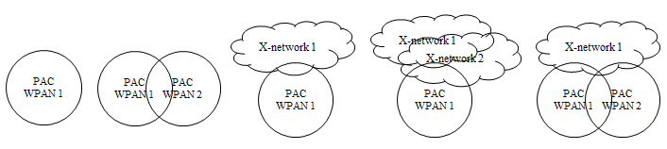
Figure 4.1- Possible network combinations with the PAC enabled networks

Topology
The PAC enabled network consists of peer network host (proxy host), peer network guest, peer network relay, and observer of the peer network.
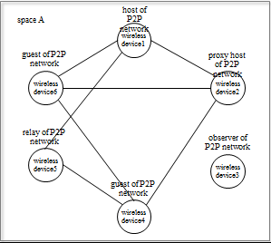
Figure 4.2- Components of the PAC enabled networks

Reference model
The reference model of the PAC enabled network consists of three link sub-layers and one management entity. The PD serves thorough two PD SAPs and two PAC enabled X-network device SAPs.
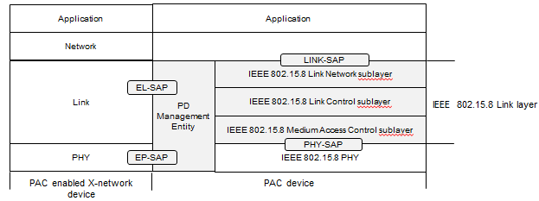
Figure 4.3- Reference model of the PAC enabled device

MAC layer

MPDU structure
The MPDU consist of link frame header, link frame information, link frame payload, and link frame tail.

- frame control
frame version (3 bits) :
frame type (3 bits) : peer-discover, peer-network management, peer-network data
frame length (10 bits) : up to 1024
control frame, data frame
- peer network identifier
peer network profile identifier (12bits): peer network profile
peer network number (6bits): identical number among peer networks of same service profile
- peer device address
two types of address : 64 bit address, 8 bit address assigned in a peer network
- peer network authenticator
PD’s 64bit address with pre-define key
- peer network information element
pre-network management information
    - peer discovery
      - hosting phase configuration
        - length of hosting phase number of time-slot (1byte)
        - sequence of resource allocation {p, h, g, r, gr} (1 byte)
        - length of pause, length of host, length of guest, length of relay, length of group number of time-slot (4bits each)
      - P2P phase configuration
      - handshaking phase configuration
    - peer link connection
after-network management information
    - peer beacon
    - peer groupcast
    - peer relaying
    - peer link release

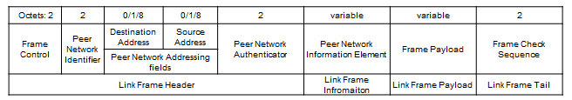
Figure 5.1- Structure of link frame MPDU

Multiple access
The link resource to be arbitrated is dependent on the number of links physically separated. To share a link among multiple PDs in a peer network or among PDs of multiple peer networks, it needs to allocate the resource in time domain. The unit of resource allocation is set to the length of time for transmitting the shortest frame which is the 10 bytes long link frame. A peer network specifies own time-slot length by selecting the consecutive number of resource unit.
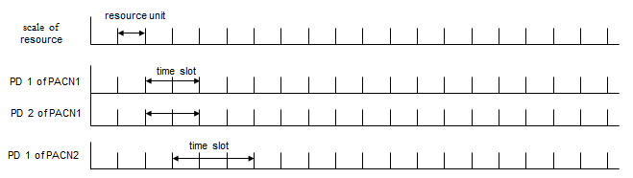
Figure 5.2- basic unit and time-slot specified by each peer network

To support various service requirements of multiple peer network concurrently, configurable multiple access of PDs is specified by selecting the access phase and by allocating time-slot for communications. The phases are hosting phase, P2P phase, and handshaking phase.
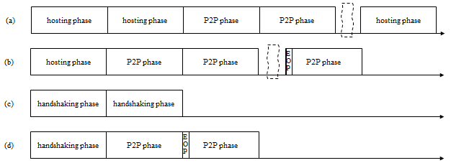
Figure 5.3- Example of composition of access phases

The link resource is allocated for communicating host, group, guest, relay, and to pause.

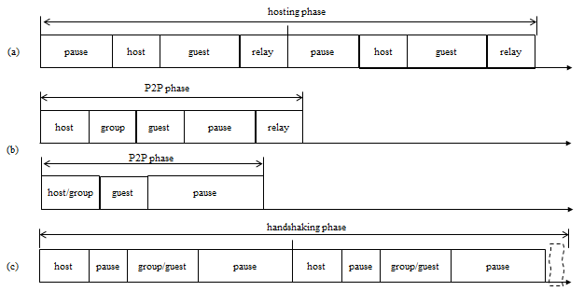
Figure 5.4- Example of resource allocation

Synchronization procedure
To align the access phase, PDs in a peer network are synchronized. The length of time-slot is adjusted by receiving the peer discovery frame periodically from the host. The peer discovery frame is transmitted every T_{d} over minimum synchronization adjust interval.
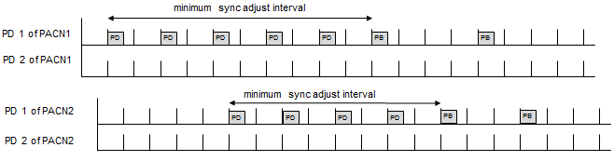
Figure 5.5- Synchronization of time-slot length adjustment

Discovery procedure
The peer discovery is carrying out during hosting phase by transmitting peer discovery frame, which contains peer network information elements. The peer network profile is identified by the peer network identifier and peer network descriptor element contains time slot length, configuration of hosting phase, P2P phase, and handshaking phase. The peer discovery frame is transmitted every T_{d} over minimum synchronization adjust interval.

Peering procedure

Scheduling

QoS

Interference management
To avoid interference by causing multiple access from multiple peer network, two capabilities are provided. During peer network formation, the host listens neighbour peer networks and adjusts P2P phase configuration enough to achieve low probability of interference. A PD which serves to multiple peer networks schedules the transmission by selecting time-slot to avoid contention among multiple peer networks.

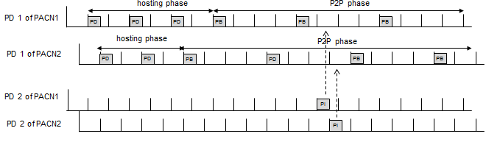
Figure 5.6- Interference avoidance at a PD which serves to multiple peer networks

Transmit power control

Multicast

Broadcast

Multi-hop operation

Relative positioning

Power management

Security

Coexistence

Higher layer interaction

Physical layer

Channelization

Operating frequency bands

Duplex schemes

Multiplex schemes
(e.g. CDMA, OFDMA)

Frame structure

Discovery frame structure

Data frame structure

Modulation and coding scheme (MCS)

Data rates

Multiple antennas

