IEEE P802.15
Wireless Personal Area Networks

Project | IEEE P802.15 Working Group for Wireless Personal Area Networks (WPANs)
Title | IEEE 802.15 SG L2R Waikoloa Meeting Minutes
Date Submitted | [16 May, 2013]
Source | [Clint Powell]  [PWC, LLC]  [1563 W Kaibab Dr.  Chandler, AZ 85248] | Voice: [+1 480-586-8457]  Fax: [ ]  E-mail: [cpowell@ieee.org]
Re: | [SG-L2R session minutes.]
Abstract | SG-L2R meeting minutes from the Waikoloa Interim.
Purpose | [SG-L2R session minutes.]
Notice | This document has been prepared to assist the IEEE P802.15. It is offered as a basis for discussion and is not binding on the contributing individual(s) or organization(s). The material in this document is subject to change in form and content after further study. The contributor(s) reserve(s) the right to add, amend or withdraw material contained herein.
Release | The contributor acknowledges and accepts that this contribution becomes the property of IEEE and may be made publicly available by P802.15.
Minutes for IEEE 802.15 L2R Study Group
Waikoloa Interim Meeting
13-17 May 2013
Chair - Clint Powell
Acting Secretaries – Tom Herbst (x3), Tim Godfrey,
Noriyuki Sato

Monday AM2 (5/13)
Chair calls the meeting to order at 10:30 AM

Noriyuki Sato moved to accept agenda (doc. # 15-13-0249-01).
Seconded – Fumihide Kojima
No objections

Call made for patents/patent claims.
No response

Kunal Shah moved to accept March SG-L2R Meeting minutes (doc. # 15-13-0213-00).
Second – Roberto Aiello
No objections

Chair reviewed Study Group activities.

Call for Liaison Rpts.
NTR
Some discussion on IETF and IEC activities occurred.

The group reviewed the draft PAR and 5c.

Revision to 5c doc. #232-rev1 posted as a result of changes.

The chair recesses the meeting until Tuesday PM1.

Tuesday PM1 (5/14)
Chair calls the meeting to order at 1:30 PM

Call made for patents/patent claims.
No response

The chair announces that the PAR will be submitted to the 802.15 closing plenary on Thursday, and from there go to the IEEE 802 ExCom for approval at the July Plenary meeting.

The current PAR being reviewed is document 15-13-0231-00-0l2r-l2r-working-draft-par.docx

This work will be a revision to 802.15.5, and would change 802.15.5 to make it a standard instead of the current recommended practice.

IEEE 802 will liaison with IETF and IEC regarding similar activities.

it was discussed by the group that, in light of the recent activities w.r.t. other SDO’s, it would be better if the effort included moving 802.15.5 to a standard instead of remaining a recommended practice, as it currently is, and there was no objection.

The chair will consult with the WG Chair, Vice Chair, and Technical editor regarding the proper way to indicate in the PAR that the intention is to change from a recommended practice to a standard, since those parts of the online PAR are not editable.

The group reviewed the Five Criteria, in document 15-13-0232-00-0l2r-l2r-working-draft-5c.docx

The 5C currently contains the text "An appropriate coexistence assurance document will be created. ", even though the standard does not define a PHY. The chair will check on whether that statement is necessary.

The edited version will be posted as 15-13-0232-01-0l2r-l2r-working-draft-5c.docx

Chair recesses the meeting until Wednesday PM1.

Wednesday PM1 (5/15)
Chair calls the meeting to order at 1:31 PM

Call made for patents/patent claims
No response
Changes on PAR, based on feedback and guidance from 802.15 leadership team, was introduced by the chair. Chair explained that this space is dynamically evolving and so the recommendation.
The major change was in going from a revision to the IEEE 802.15.5 recommended practice to a new IEEE 802.15.
Question & Comments
Q: Who made the direction on that dynamical change?
A: It was highly recommended by the 802.15 leadership team.
Q: Wasn’t a decision made to pursue an amendment to recommendation practice?
A: After March meeting, feedback from IETF was that they have interest in this activity. The group was reminded that:
- The PAR was originally written as an amendment to the recommended practice. Then it was also changed at the March meeting to a revision to the recommended practice and stated that the SG still needs to finalize whether or not it will recommend to the WG to pursue this project as a recommended practice or as a standard.
- During the Tues. session (5/14) it was discussed by the group that, in light of the recent activities w.r.t. other SDO’s, it would be better if the effort included moving 802.15.5 to a standard instead of remaining a recommended practice, as it currently is, for which there was no objection.
- The chair also took an action item in the same Tues. session (5/14) to consult with the WG Chair, Vice Chair, and Technical editor regarding the proper way to indicate in the PAR that the intention is to change from a recommended practice to a standard, since those parts of the online PAR entry are not editable. This consultation led to the feedback and guidance explained at the beginning of the session today.
The chair commented that the specification document should be a 'Standard' to be referred by the other SDOs outside of IEEE and vice versa.
Chair’s note: Chair later confirmed that this requirement is not necessary.
Chair proposed to recess in order to have time for everyone to consider if standard or recommendation is better. Participants were encouraged to review the modified PAR and 5c, which the chair uploaded to the mentor (PAR – doc. # 15-13-0231-01, 5c – doc. # 15-13-0232-02).
Chair arranges for SG L2R sessions to be added for Thurs. AM2 and PM1. The added sessions will be communicated to the 802.15 email reflector and on the schedule board.

Chair recesses the meeting until Thursday AM2.

Thursday AM2 (5/16)
Chair calls the meeting to order at 10:30 AM

Call made for patents/patent claims
No response

Pay Kinney moved to accept revision to agenda (doc. # 15-13-0249-02).
Seconded – Ben Rolfe
No objections

Group continues to work on drafting PAR and 5c drafts.
Straw polls were conducted on the direction the group would like to see the project go.
Straw Poll #1
- Recommended Practice – 14 in favor
- Standard - 10 in favor
Straw Poll #2
- Revision to 802.15.5 – 1 in favor
- Develop a new 802.15.10 recommended practice - 22 in favor
Chair recesses the meeting until Thursday PM1.

Thursday PM1 (5/16)
Chair calls the meeting to order at 1:33 PM

Call made for patents/patent claims
No response

Group continues to work on drafting PAR and 5c drafts.
Reviewed PAR Document 231 rev 2 and reviewed 5c – Document 232 rev 3.
Motion
Request that the PAR and Five Criteria contained in documents 15-13-0231-02 and 15-13-0232-03 respectively be approved by the IEEE 802.15 WG and that the EC be requested to forward the PAR to NesCom.
Moved – Ben Rolfe
Seconded – Tom Herbst
No objections

Motion will be submitted to the WG for a vote. Providing it passes it will be put on the EC agenda for the July mtg.
AoB – none

Chair adjourns at 1:49pm.

Mon. AM2 Attendance Sheet
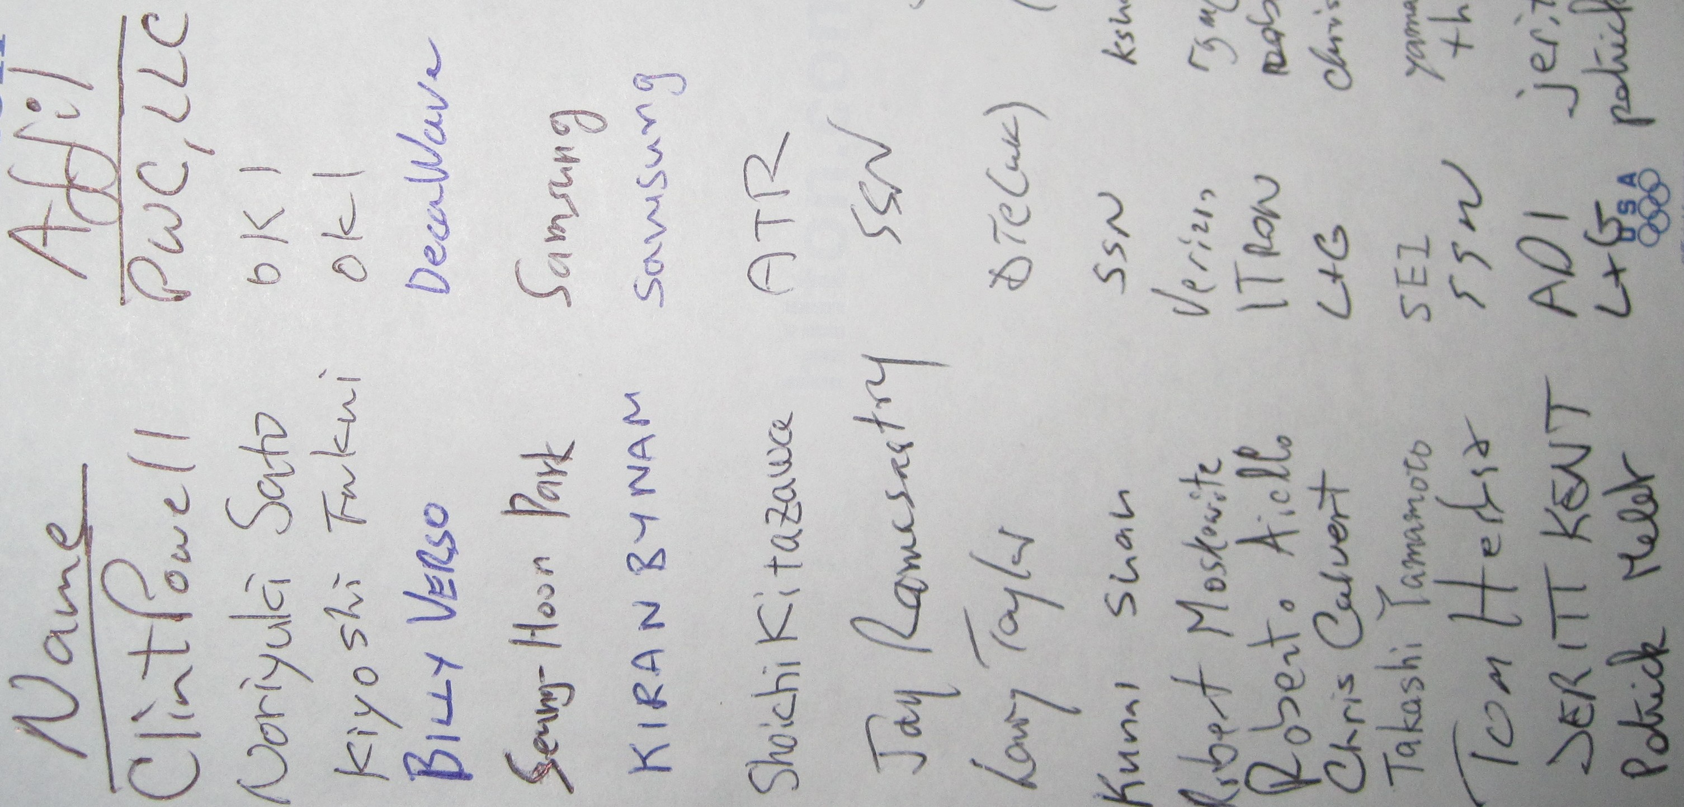
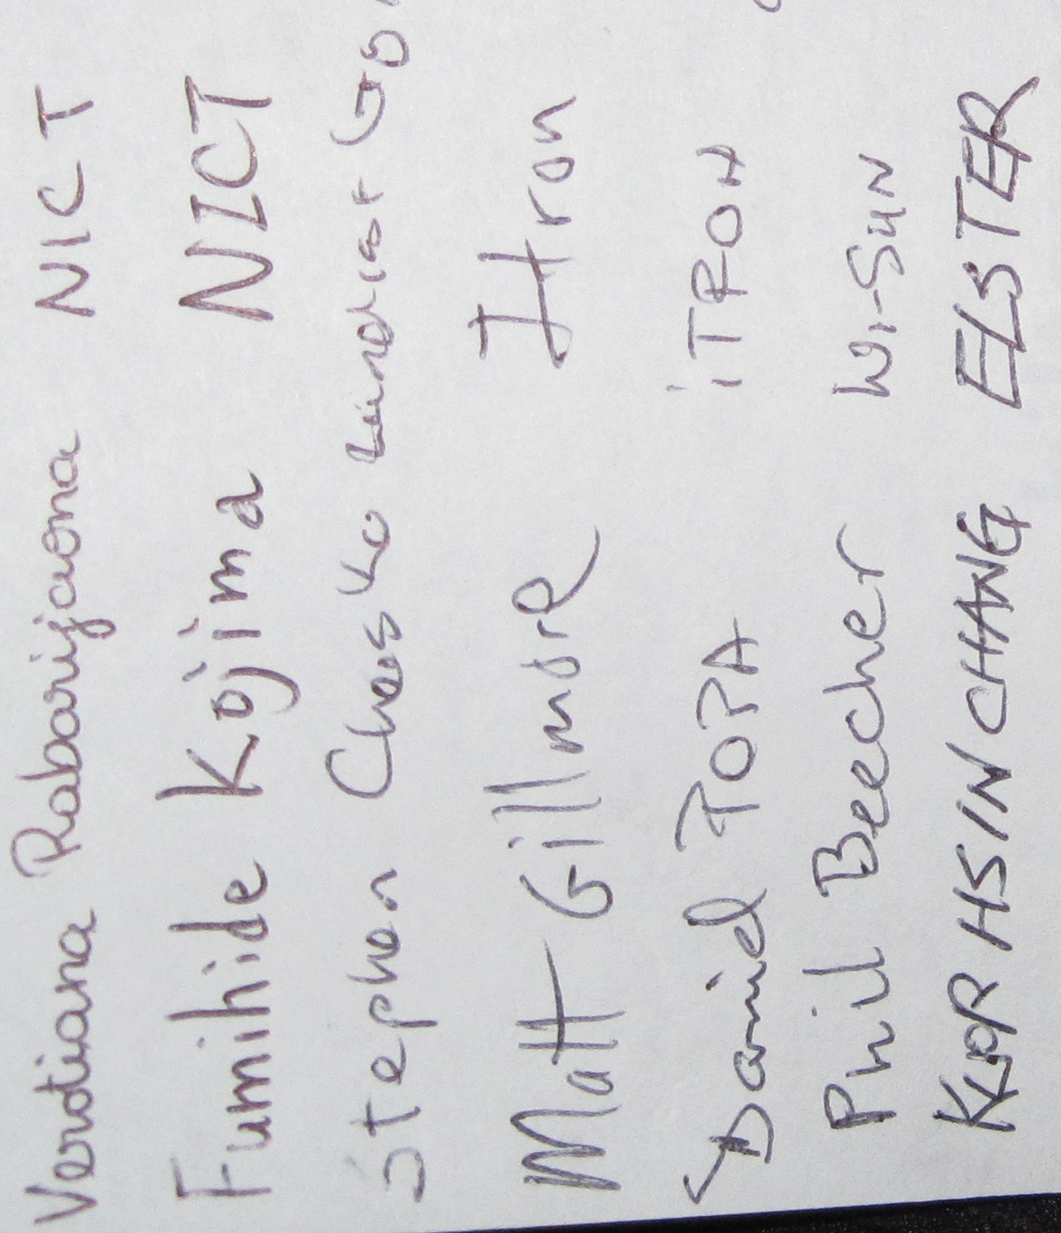
Tues. PM1 Attendance Sheet
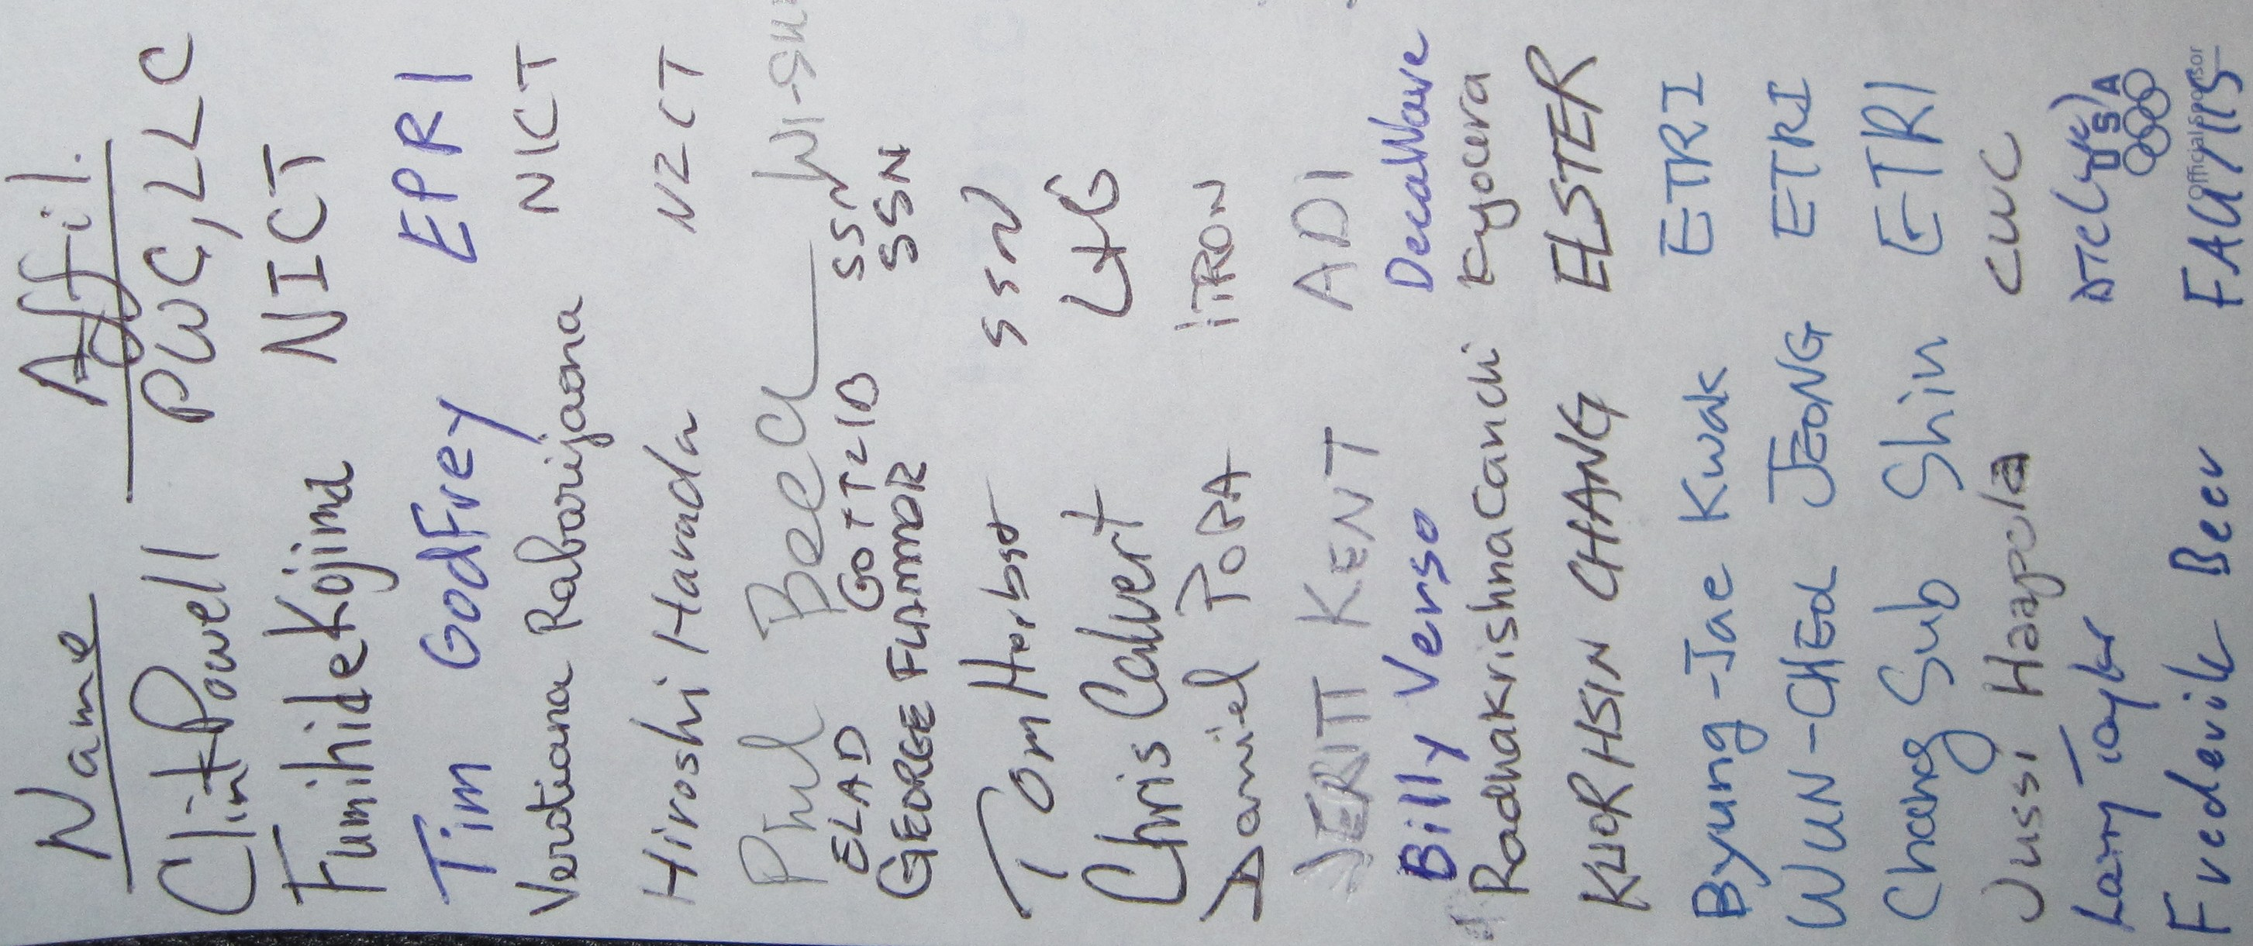
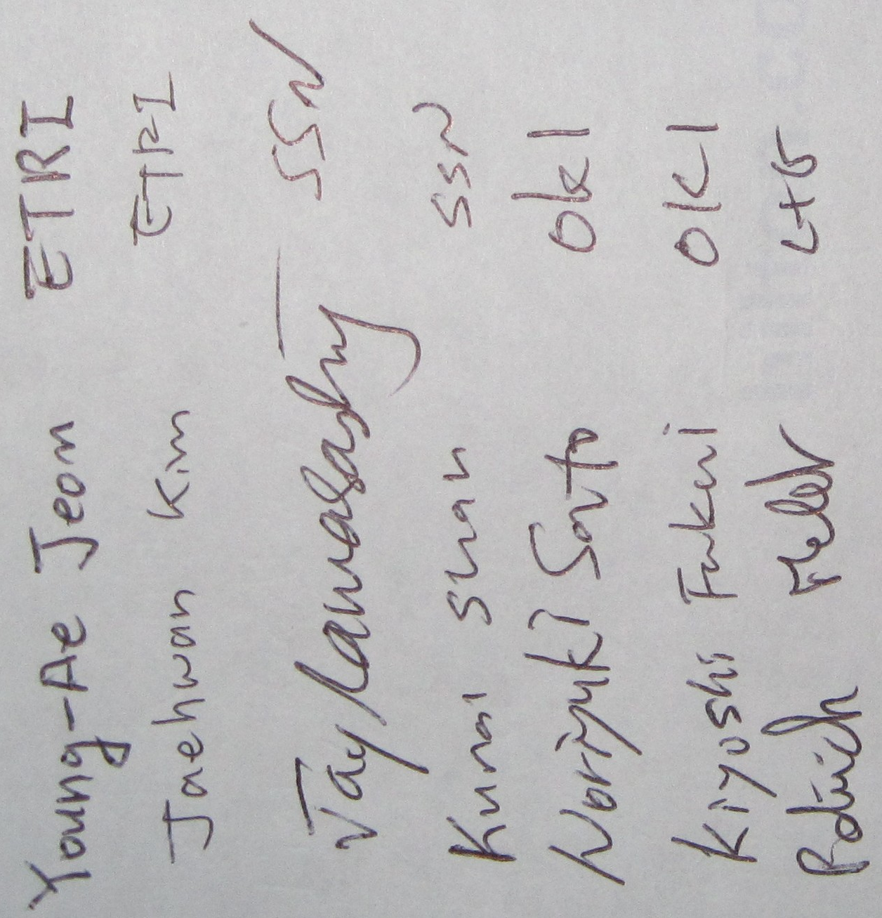
Wed. PM1 Attendance Sheet
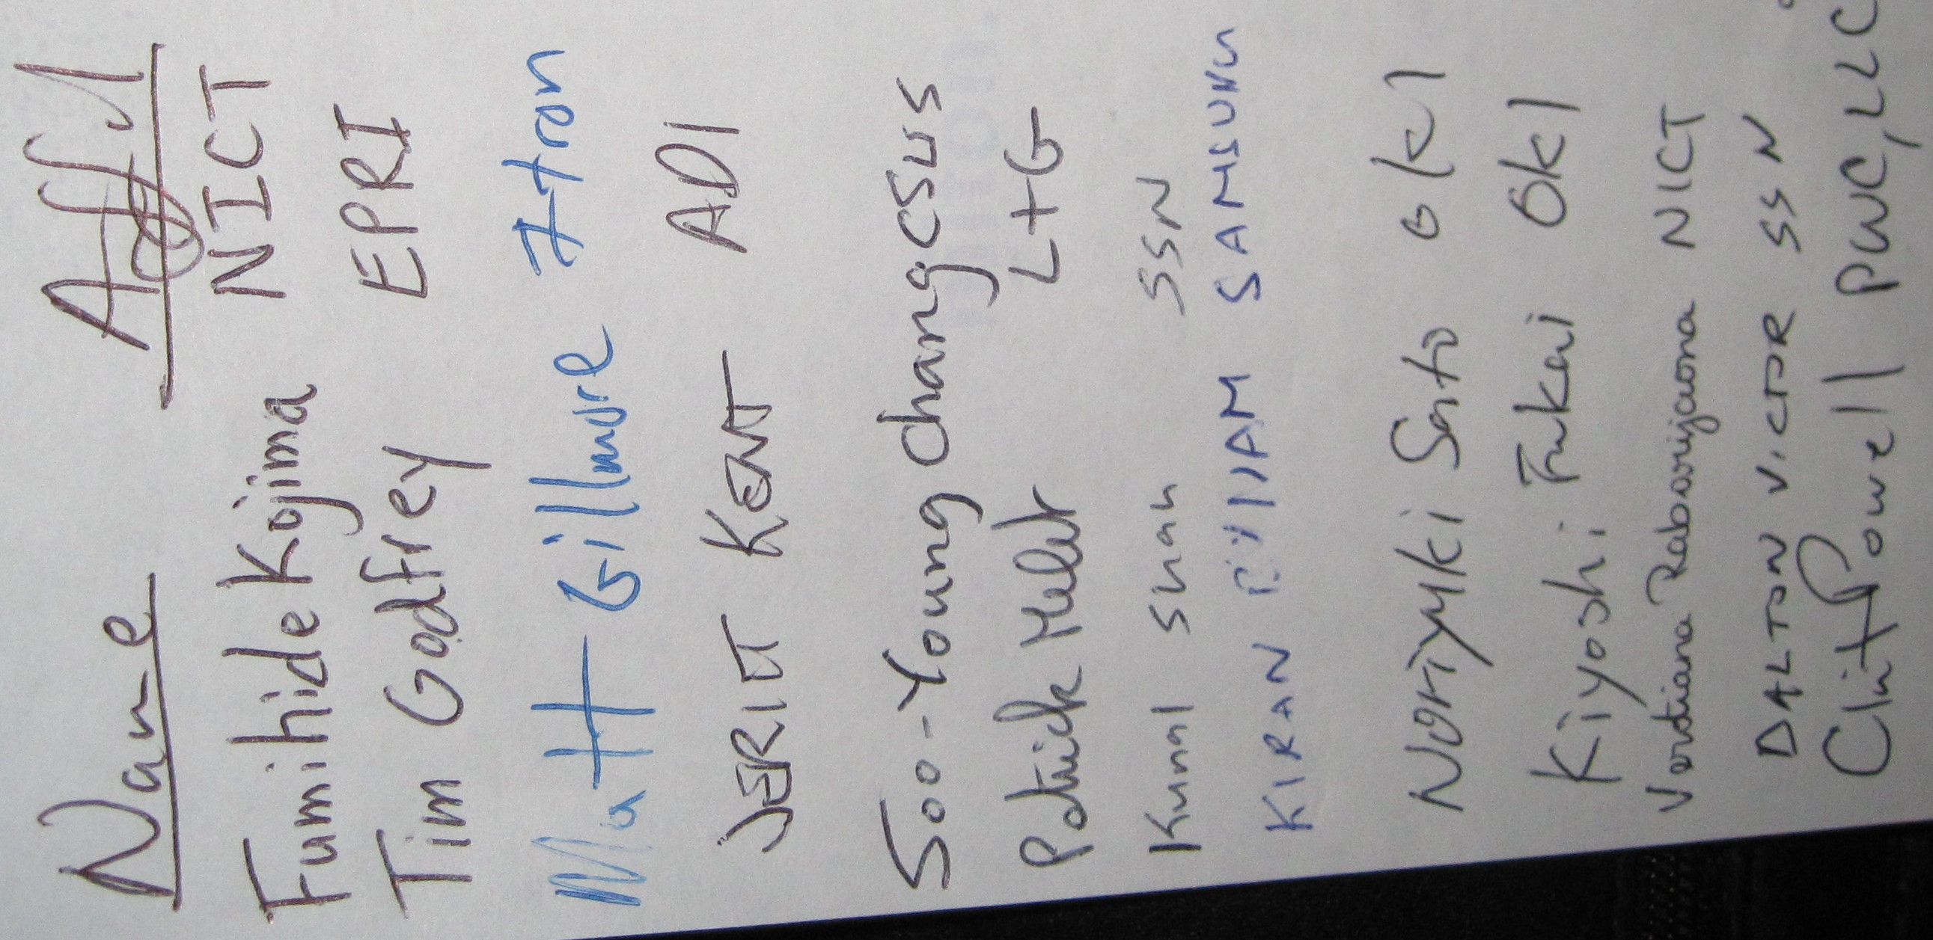

Thurs. AM2 Attendance Sheet
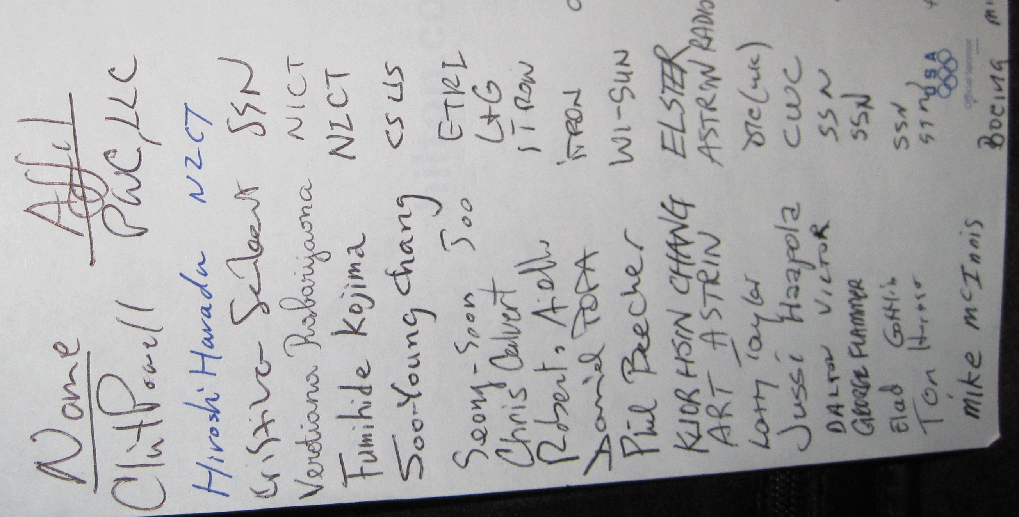
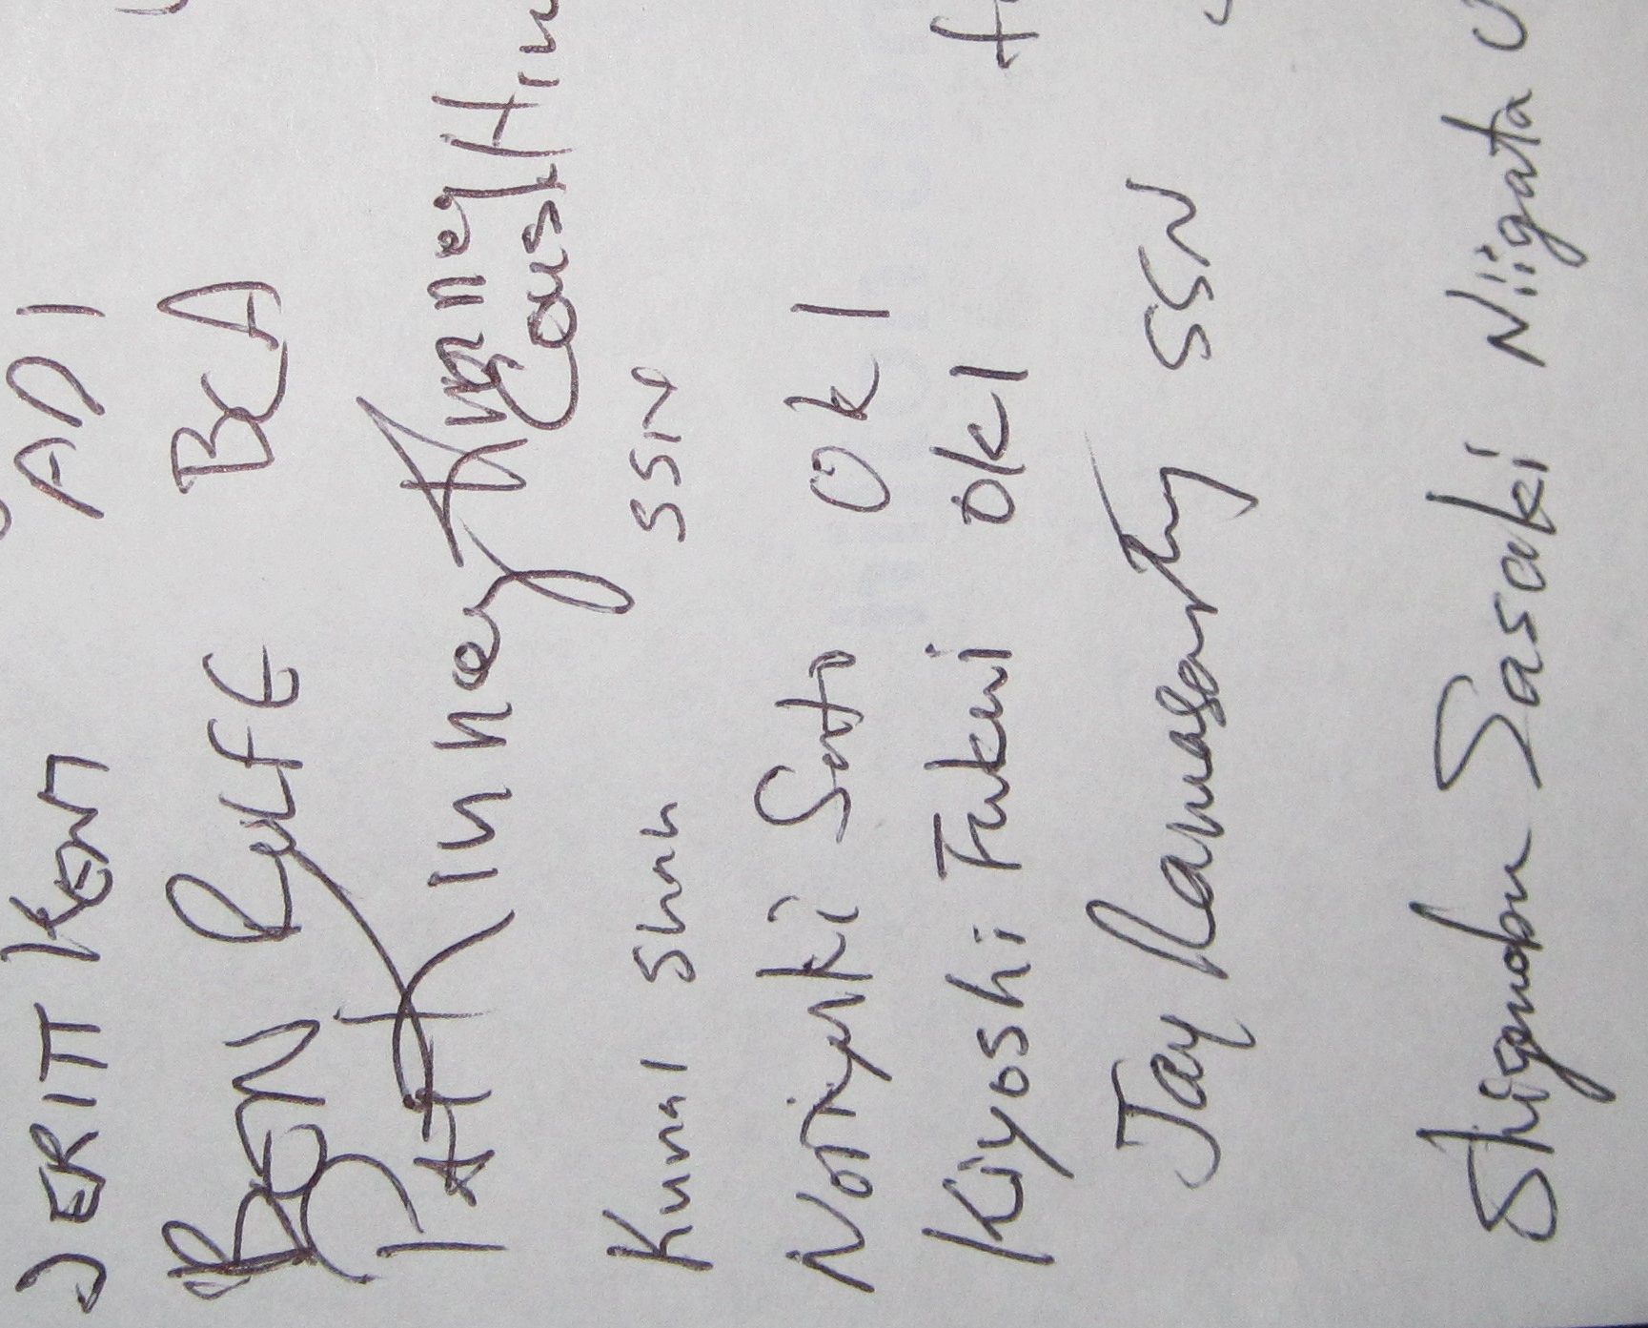
Thurs. PM1 Attendance Sheet
