IEEE P802.15
Wireless Personal Area Networks

Project | IEEE P802.15 Working Group for Wireless Personal Area Networks (WPANs)
Title | Ranging Support for 15.4n
Date Submitted | [The date the document is contributed, in the format “21 May, 1999”]
Source | [Dietmar Eggert]  [Atmel]  [Koenigsbruecker Str. 61,  01099 Dresden, Germany] | Voice: [ +49 351 6523 400]  Fax: [ +49 351 6523 199 ]  E-mail: [ dietmar.eggert@atmel.com ]
Re: | [If this is a proposed revision, cite the original document.]  [If this is a response to a Call for Contributions, cite the name and date of the Call for Contributions to which this document responds, as well as the relevant item number in the Call for Contributions.]  [Note: Contributions that are not responsive to this section of the template, and contributions which do not address the topic under which they are submitted, may be refused or consigned to the “General Contributions” area.]
Abstract | [Description of document contents.]
Purpose | [Contribution to TG15.4p]
Notice | This document has been prepared to assist the IEEE P802.15. It is offered as a basis for discussion and is not binding on the contributing individual(s) or organization(s). The material in this document is subject to change in form and content after further study. The contributor(s) reserve(s) the right to add, amend or withdraw material contained herein.
Release | The contributor acknowledges and accepts that this contribution becomes the property of IEEE and may be made publicly available by P802.15.
Atmel
Comments/Updates on document
‘pre-15-13-0097-02-004p_Preliminary document for TG4p 031813.pdf’

Comment 1) – 3. Definitions, acronyms, and abbreviations
Page | Section | Line | Comment
5 | 3.2 | 21 | add:  DCSS Discrete Chirp Spread Spectrum

Comment 2) – 5. MAC protocol
Insert before section 5.2 MAC frame formats:
5.1.9 DCSS Ranging using Phase Difference Measurement

DCSS Ranging using Phase Difference measurement is an optional feature.
The Phase Difference measurement supports two different types of ranging:
1. Local Phase Difference measurement between the ranging originator and a ranging recipient.
2. Remote Phase Difference measurement initiated by the ranging coordinator and performed between ranging nodes (ranging originator and a ranging recipient). A ranging coordinator itself must not necessarily support the DCSS PHY. Coordination tasks are limited to the communication channel using regular IEEE802.15.4 PHY capabilities.

5.1.9.1 Initialization of Local Phase Difference Measurement
In order to perform a local Phase Difference measurement between the ranging originator and the ranging recipient, the originator starts a frame exchange sequence between ranging nodes to negotiate the current ranging parameter set.

If the recipient does not accept the requested ranging parameters from the originator, or is currently not able to perform the requested Phase Difference measurement, it returns a frame including the rejection status of the current ranging request.

If the recipient accepts the requested ranging parameters from the originator, it returns the negotiated parameter set back to the originator. The originator then extracts the final ranging parameters set.

Once the involved nodes have agreed upon the ranging parameters set to be used, the actual, and possibly additional, Phase Difference measurement(s) is initiated by means of a dedicated start frame.

If any required response frame is not received from the ranging recipient, the MAC sublayer of the ranging originator notifies to the next higher layer about the timeout condition.

For any outgoing frame at the originator the source address is derived from the originator address information contained within the MLME-RANGING.request primitive. The destination address is derived from the recipient address information contained within the MLME-RANGING.request primitive.

5.1.9.2 Data exchange after a Local Phase Difference Measurement
After the end of the actual Phase Difference measurement, the originator requests the measured ranging data from the recipient, and the recipient forwards its measured data to the originator. This is performed by means of a frame exchange. Afterwards the MAC sublayer of the originator calculates the final result values and notifies to the next higher layer about the results of the requested ranging measurement.

5.1.9.3 Initialization of Remote Phase Difference Measurement
In order to perform a remote Phase Difference measurement, the ranging coordinator initiates a frame to the actual ranging originator. This frame payload contains the requested ranging recipient address (based on the recipient address information within the MLME-RANGING.request primitive). Additionally this frame contains the requested ranging parameter set.

If the requested ranging originator is not able to fulfill the requested ranging parameters from the ranging coordinator, or is currently not able to perform the requested Phase Difference measurement, it returns a frame including the rejection status of the current ranging request.

In case the requested ranging originator is currently involved in another Phase Difference measurement, it discards the received frame from the ranging coordinator. Therefore the ranging coordinator must maintain a timer to detect a timeout condition for the requested ranging procedure. In this case the MAC sublayer of the ranging coordinator notifies to the next higher layer about the timeout condition.

If the requested ranging originator is able to proceed the requested ranging measurement including the requested ranging parameter set, it follows the procedure as described for the local Phase Difference measurement initiation by means of the specific frame exchange.

For any outgoing frame at the coordinator the source address mode is derived from the coordinator address mode contained within the MLME-RANGING.request primitive. The destination address is derived from the originator address information contained within the MLME-RANGING.request primitive.

5.1.9.4 Data exchange after a Remote Phase Difference Measurement
Once the originator has received the measured ranging data from the recipient, it calculates the final result values. Afterwards the originator reports the calculated ranging result values back to the ranging coordinator using a dedicated frame. The MAC sublayer of the ranging coordinator notifies to the next higher layer about the received results of the requested ranging measurement.

In case the ranging coordinator does not receive a response from the requested originator within the Phase Difference measurement timeout, the MAC sublayer of the ranging coordinator notifies to the next higher layer about the timeout condition.

6.2 MAC management service
Append Table 8—Summary of the primitives accessed through the MLME-SAP:
Name | Request | Indication | Response | Confirm
MLME-RANGING | 6.2.18.1 |  |  | 6.2.18.2

Insert before section 6.3 MAC data service:
6.2.17.1 MLME-RANGING.request

The MLME-RANGING.request primitive allows the next higher layer to request a ranging measurement between an originator and a recipient node.

The semantics of this primitive are:

MLME-RANGING.request (
OrigAddrMode,
OrigPANId,
OrigAddr,
RecAddrMode,
RecPANId,
RecAddr,
CoordAddrMode,
RangingMode
)

The primitive parameters are defined in Table 44a.
Table 44a—MLME-RANGING.request parameters
Name | Type | Valid range | Description
OrigAddrMode | Enumeration | SHORT_ADDRESS,  EXTENDED_ADDRESS | The addressing mode of the requested ranging originator.
OrigPANId | Integer | 0x0000–0xffff | The PAN identifier of the requested ranging originator.
OrigAddr | Device  address | As specified by the  OrigAddrMode parameter | The individual device address of the requested ranging originator.
RecAddrMode | Enumeration | SHORT_ADDRESS,  EXTENDED_ADDRESS | The addressing mode of the ranging recipient.
RecPANId | Integer | 0x0000–0xffff | The PAN identifier of the ranging recipient.
RecAddr | Device  address | As specified by the  RecAddrMode parameter | The individual device address of the ranging recipient.
CoordAddrMode | Enumeration | NO_ADDRESS,  SHORT_ADDRESS,  EXTENDED_ADDRESS | The addressing mode of the ranging coordinator.
RangingMode | Enumeration | PM_RANGING | The actually requested ranging mode to be used during the ranging measurement. A value of PM_RANGING indicates Phase Difference Measurement.

On receipt of the MLME-RANGING.request primitive, the MAC sublayer entity initiates a ranging measurement procedure.
If the CoordAddrMode parameter specifies NO_ADDRESS, this node is the originator in a local ranging measurement procedure.

If the CoordAddrMode parameter specifies SHORT_ADDRESS or EXTENDED_ADDRESS, this node is the ranging coordinator node in a remote ranging measurement procedure. The ranging request is then forwarded to the intended ranging originator using the originator address information as destination address for any outgoing frame containing the recipient address information within the frame payload.

6.2.17.2 MLME-RANGING.confirm

The MLME-RANGING.confirm primitive allows the next higher layer to request a ranging measurement between an originator and a recipient node.

The semantics of the MLME-RANGING.confirm primitive are:

MLME-RANGING.confirm (
status,
Distance,
DistanceQuality
)

The primitive parameters are defined in Table 44b.

Table 44b—MLME-RANGING.confirm parameters
Name | Type | Valid range | Description
status | Enumeration | SUCCESS,  RANGING_REJECTED,  INVALID_ADDRESS,  CHANNEL_ACCESS_FAILURE,  NO_ACK,  INVALID_PARAMETER,  UNSUPPORTED_RANGING_METHOD,  RANGING_TIMEOUT | The status of the last ranging measurement.
Distance | Integer | 0x00000000–0xffffffff | The measured distance between originator and recipient in mm.
DistanceQuality | Integer | 0x00-0x64 | The confidence level of the ranging measurement in %.

The MLME-RANGING.confirm primitive is generated by the MAC sublayer entity in response to an MLME-RANGING.request primitive. The MLME-RANGING.confirm primitive returns a status of either SUCCESS, thus indicating that the request to transmit was successful, or the appropriate error code.

The parameters Distance and DistanceQuality are only valid if the returned status is SUCCESS.

If the OrigAddrMode or the RecAddrMode parameter is set to NO_ADDRESS in the MLME-RANGING.request primitive, the status shall be set to INVALID_ADDRESS.

If any ranging measurement relevant frame transmission uses CSMA-CA and the CSMA-CA algorithm failed due to adverse conditions on the channel, the status will be set to CHANNEL_ACCESS_FAILURE.

If the RangingMethod parameter in the MLME-RANGING.request primitive is set to any method not supported by any node involved in the ranging measurement, the status shall be set to UNSUPPORTED_RANGING_METHOD.

If any node involved in the ranging measurement is currently not able to perform the ranging measurement request, the status shall be RANGING_REJECTED.

6.4.2 MAC PIB attributes

Append Table 52—MAC PIB attributes:
Attribute | Type | Range | Description | Default
macPMRangingEnabled | Boolean | TRUE, FALSE | Indication of whether node is currently supporting Phase Difference measurement as ranging method. A value of TRUE indicates that Phase Difference measurement is permitted. | FALSE

9.3 PHY PIB attributes
Append Table 71—PHY PIB attributes:
Attribute | Type | Range | Description
phyPMSetupDuration | Integer |  | Setup duration required to synchronize the start of a new Phase Difference measurement procedure in us for the originator and recipient node
phyPMStartFreq | Integer | 0x0000-0xffff | Start frequency for Phase Difference measurement in 100 kHz
phyPMStopFreq | Integer | 0x0000-0xffff | Stop frequency for Phase Difference measurement in 100 kHz
phyPMStepFreq | Integer | 0x0000-0xffff | Frequency step for Phase Difference measurement in 100 kHz
phyPMShiftFreq | Integer | 0x00-0xff | Transmit frequency shift between phase 1 and phase 2 during a Phase Difference measurement in 100kHz; f_{Phase2} = f_{Phase1} + phyPMShiftFreq
phyPMFreqSettleDuration | Integer |  | Settle duration required for initializing a new frequency during a Phase Difference measurement in us
phyPMTxSetupDurationRec | Integer |  | Time required for transmitter settling of recipient node within Phase Difference measurement phase 1 in us
phyPMSamplingDurationOrig | Integer |  | Time required for actual phase measurement of originator node within Phase Difference measurement phase 1 in us
phyPMTxSetupDurationOrig | Integer |  | Time required for transmitter settling of originator node within Phase Difference measurement phase 2 in us
phyPMSamplingDurationRec | Integer |  | Time required for actual phase measurement of recipient node within Phase Difference measurement phase 2 in us
phyPMInnerLoopRepetitions | Integer | 0x00-0xff | Repetition count for inner Phase Difference measurement loop including  - phyPMTxSetupDurationOrig  - phyPMTxSetupDurationRec  - phyPMSamplingDurationOrig  - phyPMSamplingDurationRec
phyPMOuterLoopRepetitions | Integer | 0x00-0xff | Repetition count for outer Phase Difference measurement loop, including an entire Phase Difference measurement procedure consisting of ((phyPMStopFreq – phyPMStartFreq)/phyPMStepFreq + 1) individual cycles.  One cycle incorporates the following sequences:  - phyPMFreqSettleDuration  - phyPMTxSetupDurationOrig  - phyPMTxSetupDurationRec  - phyPMSamplingDurationOrig  - phyPMSamplingDurationRec

Comment 3) – 8. General PHY requirements
Page | Section | Line | Comment
15 | 8.1 | 6 | Insert the following item at the end of the first list in 8.1:  - Precision ranging for PHYs not supporting UWB
15 | 8.1 | 12 | Insert the following item at the end of the second list in 8.1:  - DCSS PHY: discrete chirp spread spectrum (DCSS) ranging PHY employing phase difference measurement techniques, operating in the 915 MHz and 2450 MHz band, as defined in Clause 22, communication channel uses alternative PHYs like O-QPSK or BPSK PHY
16 | 8.1.1 | 25 | add entries to Table 66:  Table 66 — Frequency bands and data rates  PHY (MHz) Frequency band (MHz) Modulation and bit rate  DCSS (optional) 450 - 470 as defined in Clause 22  863 - 870 as defined in Clause 22  870 - 876 as defined in Clause 22  902 – 928 as defined in Clause 22  928 – 960 as defined in Clause 22  2400 – 2483.5 as defined in Clause 22  4940 – 4990 as defined in Clause 22  5250 – 5350 as defined in Clause 22  5470 – 5725 as defined in Clause 22  5725 – 5850 as defined in Clause 22

Comment 4) – New Clause 22. DCSS PHY

Insert after section 21 RCC PHY
22. DCSS PHY
The DCSS PHY provides a method to determine the distance between an originator node and a recipient node. The general ranging procedure is shown in Figure 1.
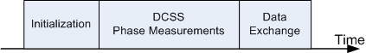
Figure 1—General Ranging Procedure

A ranging procedure is initiated by the originator node by sending a ranging request frame containing initialization data to the recipient node. The recipient node responds with a data frame and acknowledges or declines the ranging request depending on its abilities. During the ranging period both nodes transmit and receive signals based on a Discrete Chirp Spread Spectrum modulation (DCSS) and perform phase measurements. At the end of this ranging procedure, the recipient sends a data frame containing its phase measurement results to the originator node. Along with its own phase measurement results the originator node is able to calculate the distance between both nodes.

22.1 DCSS Ranging Method
To start a ranging sequence the originator transmits a start frame to the recipient. Based on this frame, both nodes wait the phyPMSetupDuration to synchronize their activities, so that TX mode and phase measurement always overlap. The originator sets its PLL at the phyPMStartFreq frequency while the recipient sets its PLL to the phyPMStartFreq + phyPMShiftFreq frequency. This frequency offset relates to the intermediate frequency of a low-IF receiver, where the originator receiver operates on an inverse IF position.
At first the recipient transmits a signal and the originator performs a phase measurement. The phase measurement duration at the originator is specified by the phyPMSamplingDurationOrig. While both PLLs are running continuously, both devices switch their RX/TX direction and the recipient performs phase measurements on the signal transmitted by the originator.
As shown in Figure 2 the inner loop is surrounded by an outer loop, while the frequencies of each PLL is stepped by phyPMStepFreq from phyPMStartFreq to phyPMStopFreq on the originator and with an offset of phyPMShiftFreq on the recipient.

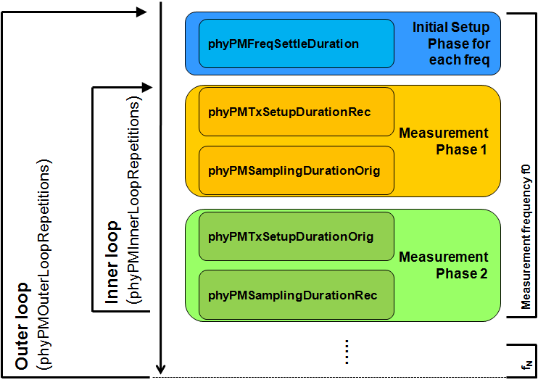
Figure 2--Inner and Outer Loop of Ranging Sequence
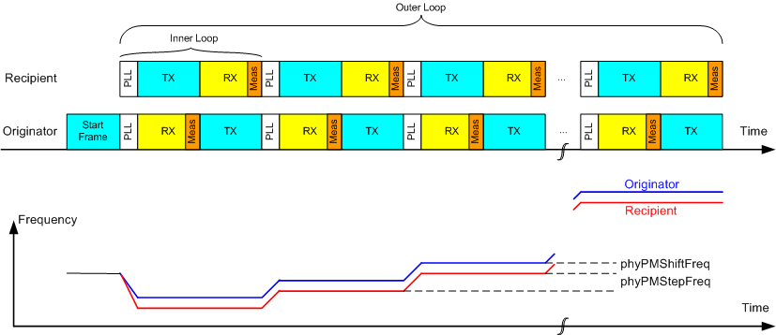
Figure 3--Ranging Sequence
Figure 3 shows the receive and transmit activities of both nodes over time and the corresponding carrier frequencies. The start frame activates the ranging procedure in both nodes according to the PIB attributes that are exchanged previously. Both nodes set its PLLs to the carrier frequency and activate RX and TX mode accordingly and wait phyPMFreqSettleDurationOrig/Rec. After the setup time of phyPMTxSetupDurationOrig/Rec the receiver performs the phase measurement. Than both nodes exchange their roles regarding TX and RX. This sequence of transmitting once in both directions is donated as inner loop and is repeated for each frequency defined by phyPMStartFreq, phyPMStopFreq, and phyPMStepFreq.

22.2 Phase Measurement
Phase measurement is performed on the received carrier signal relative to a reference clock signal derived from the crystal oscillator having the same frequency as specified by phyPMShiftFreq. Therefore, the phase measurement represents the phase shift of two signals with nominal the same frequency.

Comment 5) – Annex D
Page | Section | Line | Comment
35 | D.7.1 | 45 | add entries to Table D.1:  Table D.1 — Functional device types  Item Number Item description Reference Status Support  N/A Yes No  FD11 DCSS PHY 8.1 O.4  O.4: At least one of these features is supported.
36 | D.7.2.2 | 41 | add entries to Table D.3:  Table D.3 — Radio frequency (RF)  Item Number Item description Reference Status Support  N/A Yes No  RF22 DCSS PHY  RF22.1 At least one of the bands given in Table 66 8.1 FD11:M  RF22.2 <DCSS> Clause 22 FD11:M

