IEEE P802.15
Wireless Personal Area Networks

Project | IEEE P802.15 Working Group for Wireless Personal Area Networks (WPANs)
Title | IEEE 802.15 SG L2R Orlando Meeting Minutes
Date Submitted | [21 March, 2013]
Source | [Clint Powell]  [PWC, LLC]  [1563 W Kaibab Dr.  Chandler, AZ 85248] | Voice: [+1 480-586-8457]  Fax: [ ]  E-mail: [cpowell@ieee.org]
Re: | [SG-L2R session minutes.]
Abstract | SG-L2R meeting minutes from the Orlando Plenary.
Purpose | [SG-L2R session minutes.]
Notice | This document has been prepared to assist the IEEE P802.15. It is offered as a basis for discussion and is not binding on the contributing individual(s) or organization(s). The material in this document is subject to change in form and content after further study. The contributor(s) reserve(s) the right to add, amend or withdraw material contained herein.
Release | The contributor acknowledges and accepts that this contribution becomes the property of IEEE and may be made publicly available by P802.15.
Minutes for IEEE 802.15 L2R Study Group
Orlando Plenary Meeting
18-22 March 2013
Chair - Clint Powell
Acting Secretaries – Kiyoshi Fukui, Clint Powell

Monday PM1 (3/18)
Chair calls the meeting to order at 1:35 PM

Roberto Aielo moved to accept agenda (doc. # 0111-00).
Seconded - Khurram Waheed
No objections

Call made for patents/patent claims.
No response

Noriyuki Sato moved to accept Jan. IG-D2R Meeting minutes (doc. # 0061-00).
Second - Khurram Waheed
No objections

Chair reviewed Study Group activities.

The group reviewed the preliminary PAR and 5c.

The group started to make an initial PAR draft from newest par (15.4q) and 15.5 PAR.

The chair called for volunteers to complete the initial PAR draft.

The chair recessed until Wednesday AM1.

Wednesday AM1 (3/20)
Chair calls the meeting to order at 8:20 AM

Call made for patents/patent claims.
No response

The chair suggested that the group discuss the scope and purpose (what to be standardized) before discussing how and where (ex. Std. vs. Recommended Practice).

The chair reviewed the initial PAR draft which was drafted in Monday PM1 meeting.

The question was raised by Kunal:
Q: Is the PAR already applied in the template?
A: Since the template is often changed, it should be applied after completion.

The chair called for volunteers to help draft an initial 5c draft.

Chair recesses until Thursday PM1.

Thursday PM1 (3/21)
Chair calls the meeting to order at 1:31 PM

Call made for patents/patent claims
No response

Group continues to work on drafting PAR and 5c drafts.

802.15 VC advises the SG, that after consulting with WG Tech. Editor, that the SG should be targeting a revision to 802.15.5. The SG still needs to finalize whether or not it will recommend to the WG to pursue this project as a recommended practice or as a standard.

Group completes work on drafting PAR and 5c drafts.
Preliminary Draft PAR posted as - doc. #15-13-0231-00
Preliminary Draft 5c posted as - doc. #15-13-0232-00

PM2 session was cancelled and notification was sent to mtg. coordinator and network support.

Chair adjourns at 3:20pm.
Mon. PM1 Attendance Sheet
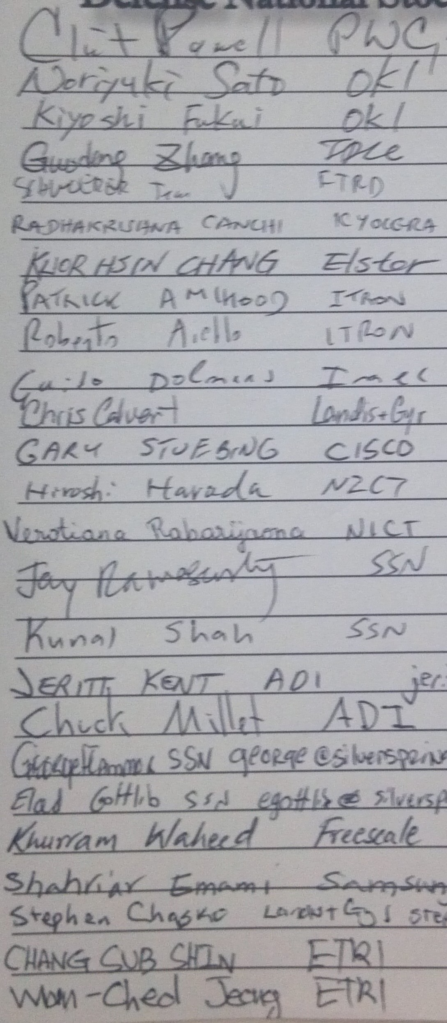

Wednesday AM1 Attendance Sheet
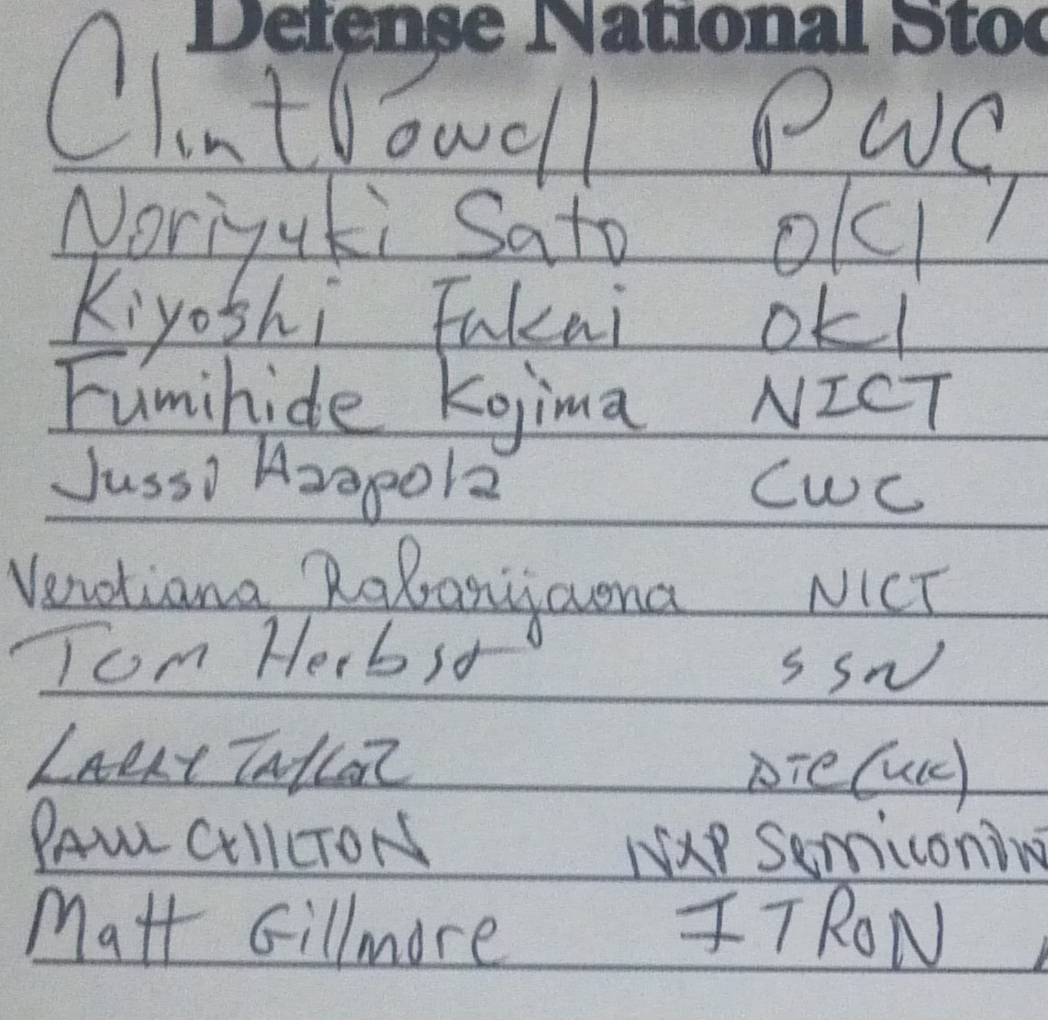

Thurs. PM1 Attendance Sheet
