IEEE P802.15
Wireless Personal Area Networks

Project | IEEE P802.15 Working Group for Wireless Personal Area Networks (WPANs)
Title | Text for TWWS-OFDM RF Requirements (Subclause 20.2.4)
Date Submitted | March 19, 2013
Source | Soo-Young Chang (SYCA), Cheolho Shin (ETRI), and Sangsung Choi (ETRI) | E-Mail: [sychang@ecs.csus.edu]
Re: | To provide the text for TWWS-OFDM RF Requirements (Subclause 20.2.4)
Abstract | [TG4m – To provide the text for TWWS-OFDM RF Requirements (Subclause 20.2.4) to satisfy a comment, CID416, of LB#87.]
Purpose | [Working document for the PAR and 5C to the P802.15 Working Group.]
Notice | This document has been prepared to assist the IEEE P802.15. It is offered as a basis for discussion and is not binding on the contributing individual(s) or organization(s). The material in this document is subject to change in form and content after further study. The contributor(s) reserve(s) the right to add, amend or withdraw material contained herein.
Release | The contributor acknowledges and accepts that this contribution becomes the property of IEEE and may be made publicly available by P802.15.

This document is prepared to provide a text for TVWS OFDM PHY RF requirements per a comment, CID 416, of LB#87.

CID 416

- Comment
  - TVWS-OFDM PHY has an incomplete specification of RF requirements.

- Proposed Change
  - One can assume that these requirements would be worked into the draft over time. Please include a list of the specifications that would be specified by the standard. Include RF requirements that are known.

The following text is prepared for the resolution of the comment, CID 416:

20.2.4 TVWS-OFDM RF requirements

20.2.4.1 Operating frequency range
The TVWS-OFDM PHY operates in the bands indicated in Table 4ic.

20.2.4.2 Transmit power spectral density (PSD) mask
The TVWS-OFDM PHY transmit PSD mask shall conform with local regulations.

20.2.4.3 Receiver sensitivity
The sensitivity requirements, as described in 8.1.7, for every Option and MCS mode are shown in Table x.
Table x—Sensitivity requirements for MCS modes
MCS Mode | Sensitivity
0 | -97 dBm
1 | -94 dBm
2 | -91dBm
3 | -103 dBm
4 | -100 dBm
5 | -97 dBm

20.2.4.4 Tx-to-Rx turnaround time
The Tx-to-Rx turnaround time shall be as given in 8.2.1.

20.2.4.5 Rx-to-Tx turnaround time
The Rx-to-Tx turnaround time shall be as given in 8.2.2.

20.2.4.6 Error-vector magnitude (EVM) definition
The relative constellation RMS error averaged over subcarriers, symbols, and packets shall not exceed the values shown in Table y.

Table y—EVM requirements for TVWS-NB-OFDM PHY
MCS Mode | RMS error
0 | -10 dB
1 | -10 dB
2 | -10 dB
3 | -12 dB
4 | -14 dB
5 | -17 dB

The transmit modulation accuracy test shall be performed by instrumentation capable of converting the transmitted signal into a stream of complex samples. The sampled signal shall be processed in a manner similar to an actual receiver, according to the following steps, or an equivalent procedure:
a) Detect the start of packet.
b) Detect the transition from STF to LTF, and establish fine timing (with one sample resolution).
c) Estimate the coarse and fine frequency offsets.
d) De-rotate the packet according to estimated frequency offset.
e) Estimate the complex channel response coefficients for each of the subcarriers.
f) For each data OFDM symbol, transform the symbol into subcarrier received values and divide each subcarrier value with the estimated channel response coefficient.
g) For each data-carrying subcarrier, find the closest constellation point and compute the squared Euclidean distance from it.
h) Compute the RMS average of all errors in a packet. It is given by
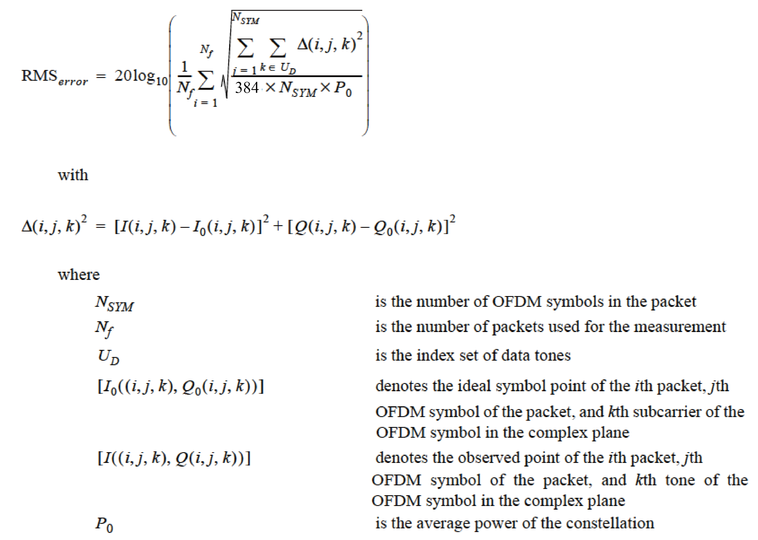
The test shall be performed over at least N_{f} = 20 packets. The payload of the packets under test shall contain N_{SYM} = 16 OFDM symbols. Random data shall be used for the payload.

20.3.5.7 Transmit center frequency and symbol tolerance
The transmit center frequency tolerance shall be ±20 ppm maximum. The symbol clock frequency tolerance shall also be ±20 ppm maximum. The transmit center frequency and the symbol clock frequency shall be derived from the same reference oscillator.

