IEEE P802.15
Wireless Personal Area Networks

Project | IEEE P802.15 Working Group for Wireless Personal Area Networks (WPANs)
Title | IEEE 802.15 SG L2R Vancouver Meeting Minutes
Date Submitted | [16 January, 2012]
Source | [Clint Powell]  [PWC, LLC]  [1563 W Kaibab Dr.  Chandler, AZ 85248] | Voice: [+1 480-586-8457]  Fax: [ ]  E-mail: [cpowell@ieee.org]
Re: | [SG-L2R session minutes.]
Abstract | SG-L2R meeting minutes from the Vancouver Interim.
Purpose | [SG-L2R session minutes.]
Notice | This document has been prepared to assist the IEEE P802.15. It is offered as a basis for discussion and is not binding on the contributing individual(s) or organization(s). The material in this document is subject to change in form and content after further study. The contributor(s) reserve(s) the right to add, amend or withdraw material contained herein.
Release | The contributor acknowledges and accepts that this contribution becomes the property of IEEE and may be made publicly available by P802.15.
Minutes for IEEE 802.15 L2R Study Group
Vancouver Interim Meeting
14-18 Jan. 2013
Chair - Clint Powell
Acting Secretaries - Tom Herbst, Kunal Shah, Clint Powell

Monday AM2 (1/14)
Chair calls the meeting to order at 8:00 AM

Call for IP Made
No response

Jon Adams moved to accept agenda (doc. # 0688-01)
Seconded - Shariar Emami
No objections

Call made for patents/patent claims
No response

Mike McInnis moved to accept Nov. IG-L2R Meeting minutes (doc. # 0672-00)
Second - Jon Adams
No objections

Reviewed Study Group Activities

Call for leaders to own sections of SG Activities (see back of doc.)

How does L2R differ from RPL – Tom Herbst

How 1901.2 adapts IETF – Mike McInnis

Intra .15 or intra 802 – Norm Finn
802.3 bridging, use of ethertype or not – Norm Finn

Does an amendment to 802.15.5 look possible (check scope and purpose of 802.15.5 against preliminary scope and purpose) – Noriyuki Sato

Extended discussion of potential scope and approaches for moving forward

Chair recesses until Tuesday AM1

Tuesday AM1 (1/15)
Chair calls the meeting to order at 8:05 AM

Call made for patents/patent claims
No response

Norm Finn presents doc#47r0
There is comment that the coordinator can be a gateway.

Tom Herbst presents doc#49r0
There is comment that IETF RPL is for layer3 and the challenges are to move to layer 2 routing.
The response was to have a detailed presentation in the next meeting that explains the RPL and challenges to address by layer 2 meshing.
There is a comment that the issues are with layer 3 meshing or specific to RPL.
The response was it is related to RPL.

Clint goes through the scope and purpose of 15.5 and provides the similarities and differences with preliminary L2R scope.
There is comment that the scalability is the network is not dynamic, so 15.5 can be extended to accommodate.

Chair recesses until Tuesday AM2

Tuesday AM2 (1/15)
Chair calls the meeting to order at 10:31 AM

Call made for patents/patent claims
No response

Straw poll on where interest lies w.r.t. applying/developing L2R for different parts of 802.15
802.15.3 - 0
802.15.4 - 16
802.15.6 - 0
Overwhelming interest of attendees in applying/developing L2R (route under mesh) for 802.15.4

Generated preliminary working title, scope, and purpose (see end of doc.) based on problem statement, potential features needed and interest for 802.15.4 (see end of doc.)

Chair adjourns at 12:15pm

Mon. AM2 Attendance Sheet
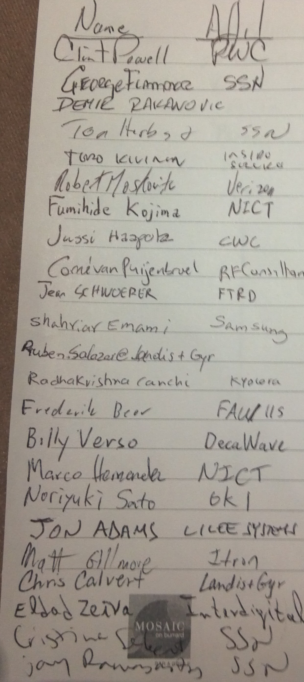
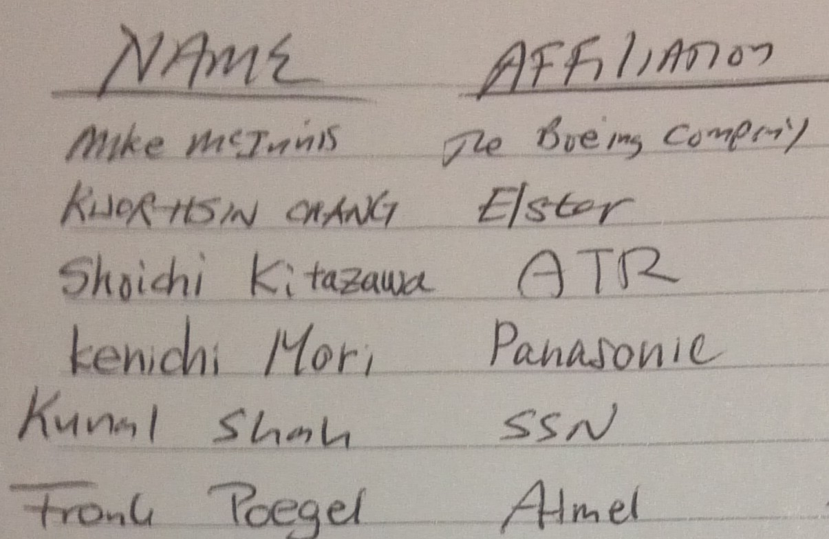
Tues. AM1 Attendance Sheet
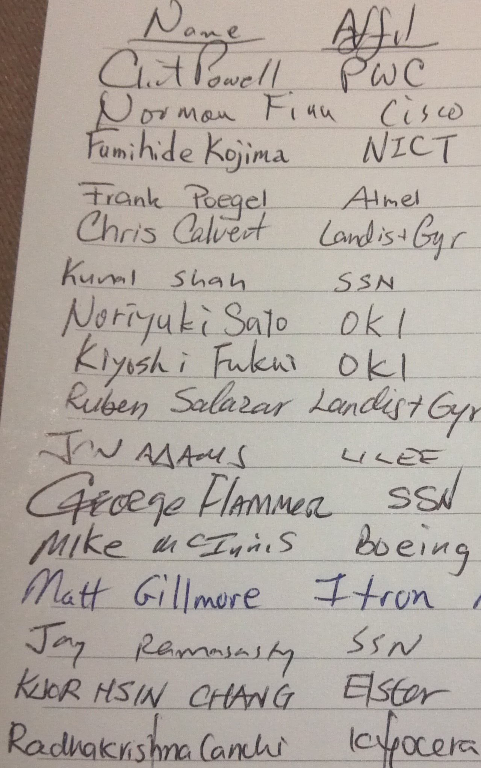

Tues. AM2 Attendance Sheet
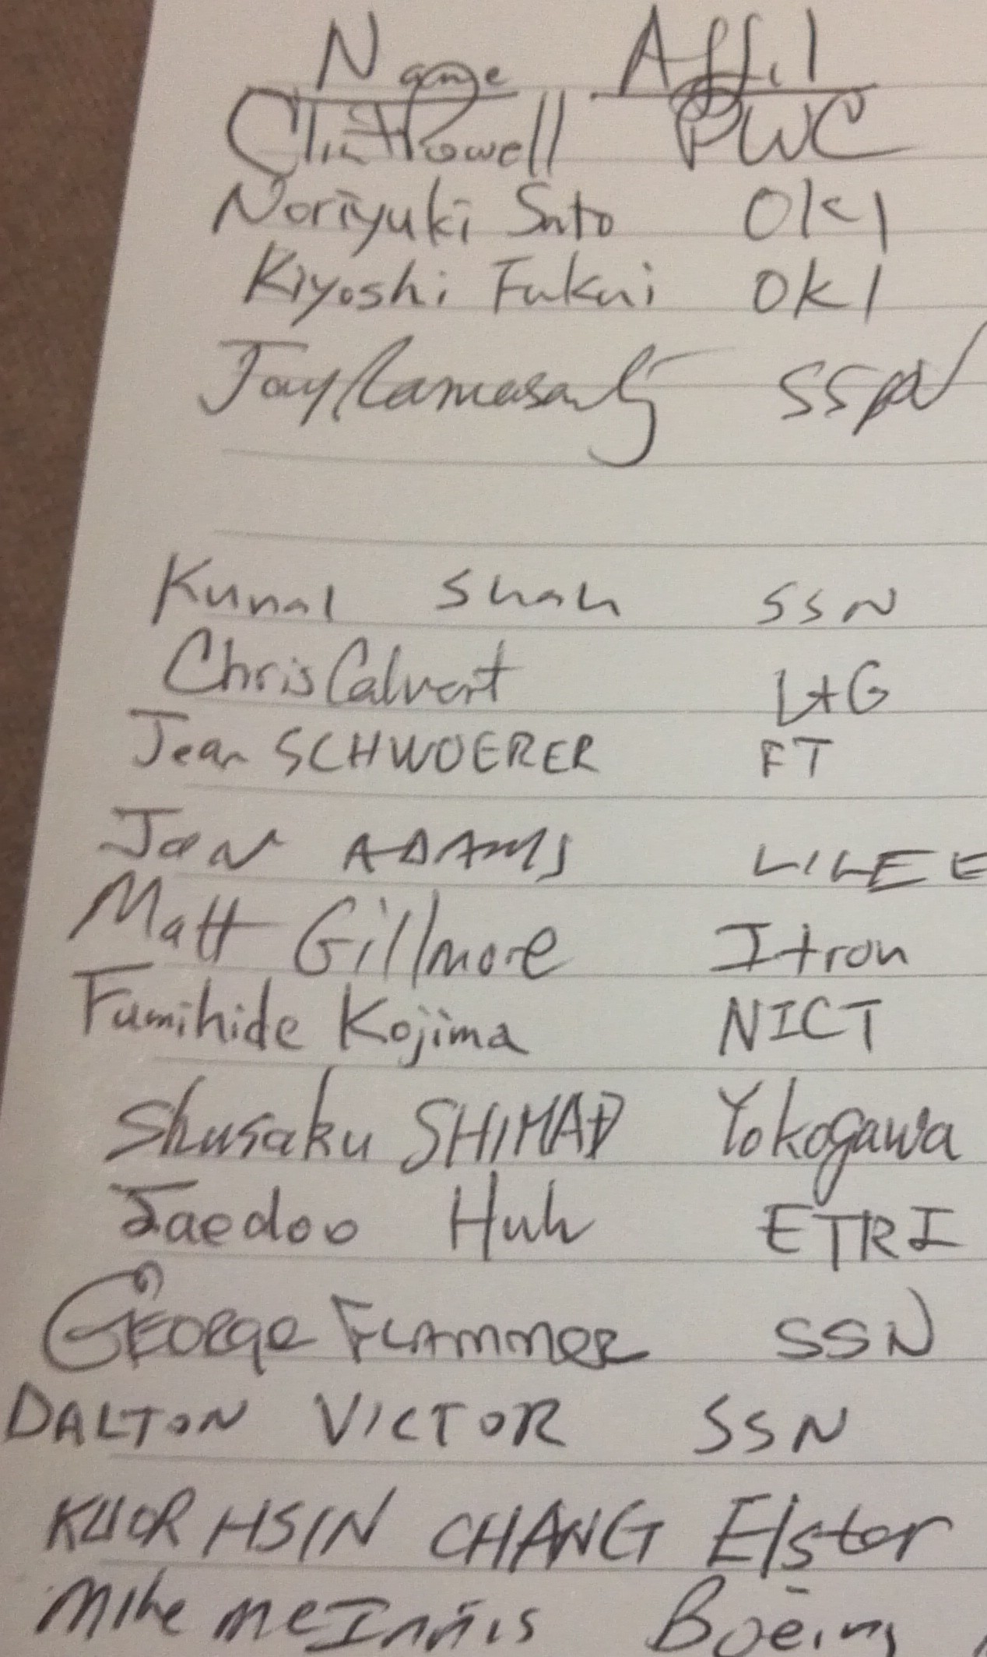

Study Group Activities
(worked on during L2R sessions)

Problem Statement
Define a (efficient - to be defined later) protocol that routes packets in a dynamically changing network (changes on the order of a minute time frame), with minimal impact to route handling.
Specifically to be able to automatically handle:
- Route establishment
- Discovery and addition of new nodes
- Breaking of established routes
- Loss and recurrence of routes
- Real time gathering of link status
- Allowing for 1 hop appearance at the networking layer (not breaking standard L3 mechanisms)
- Support of broadcast
- Support of multicast
- Effective frame forwarding

SG Activities
Topic A
Encouraged to do a brainstorming in SG of areas to attack
Need to review how it differs from RPL, etc.
Is a different problem being solved?
Is the same problem being solved differently?
Look at how 1901.2 does adaptation of IETF
Topic B
Should it be Intra 15 or Intra 802?
For instance - 802.11.glk-sg, moved to AK-TG,
See par 11-12-1207-00-0glk and 5c 11-12-1208-00-0glk
Look at what would be needed for an 802.3 Multimedia bridging
i.e. local scope 48 bit address
Is ether type support needed and if so what
Path(s) Forward
Look specifically at if/how 802.15.5 could be extended

Determine scope of capabilities to be provided and issues that will be addressed/solved
Determine scope of applications

Final steps of SG
Determine whether a standard or recc. practice
Determine whether an amendment or new
Draft PAR and 5C

In Development

Preliminary Working Title
Part 15.5: Mesh Topology Capability in Wireless Personal Area Networks (WPANs)
Amendment 1: Amendment to Low-Rate WPAN Mesh Topologies

Preliminary Working Scope
To amend the recommended practice in 802.15.5 to extend wireless mesh topologies by providing a (efficient - to be defined later) protocol that routes packets in a dynamically changing network (changes on the order of a minute time frame), with minimal impact to route handling.

Preliminary Working Purpose
This project facilitates enhancement of IEEE 802.15.5 for IEEE 802.15.4 WPAN mesh topologies. Specifically it provides the capabilities for automatic handling of:
- Route establishment
- Dynamic route reconfiguration
  - Discovery and addition of new nodes
  - Breaking of established routes
  - Loss and recurrence of routes
- Real time gathering of link status
- Allowing for 1 hop appearance at the networking layer (not breaking standard L3 mechanisms)
- Support of broadcast
- Support of multicast
- Effective frame forwarding

