**IEEE P802.15**

**Wireless Personal Area Networks**

|  |  |  |
| --- | --- | --- |
| Project | IEEE P802.15 Working Group for Wireless Personal Area Networks (WPANs) | |
| Title | Network formation using TVWS multichannel cluster tree PAN (TMCTP) | |
| Date Submitted | [Dec. 6 2012] | |
| Source | [Youngae Jeon, Sangjae Lee, and Sangsung Choi] [ETRI]  [Soo-Young Chang][SYCA] | Voice: [ ] Fax: [ ] E-mail: [yajeon@etri.re.kr] |
| Re: | [If this is a proposed revision, cite the original document.]  [If this is a response to a Call for Contributions, cite the name and date of the Call for Contributions to which this document responds, as well as the relevant item number in the Call for Contributions.]  [Note: Contributions that are not responsive to this section of the template, and contributions which do not address the topic under which they are submitted, may be refused or consigned to the “General Contributions” area.] | |
| Abstract | [Description of document contents.] | |
| Purpose | [Description of what the author wants P802.15 to do with the information in the document.] | |
| Notice | This document has been prepared to assist the IEEE P802.15. It is offered as a basis for discussion and is not binding on the contributing individual(s) or organization(s). The material in this document is subject to change in form and content after further study. The contributor(s) reserve(s) the right to add, amend or withdraw material contained herein. | |
| Release | The contributor acknowledges and accepts that this contribution becomes the property of IEEE and may be made publicly available by P802.15. | |

# TVWS multichannel cluster tree PAN (TMCTP)

# TMCTP overview

A TVWS multichannel cluster tree PAN (TMCTP) is a form of a cluster tree network where the SPC is the overall PAN coordinator providing synchronization services to other PAN coordinators in the cluster and has access to the geolocation database (GDB) server to provide TVWS channel availability information to the other PAN coordinators. Each PAN coordinator uses a different channel allocated by the SPC. An example is shown in Figure 1. The use of TMCTP can increase the coverage area with controlled message latency and reduced collisions between coordinators, and allows independent operations of each cluster simultaneously. Each TMCTP-parent PAN coordinator including the SPC may communicate with its TMCTP-child PAN coordinators during the active portion of the TMCTP-parent PAN coordinator and receives beacon frames of TMCTP-child PAN coordinators on a dedicated channel during the dedicated beacon slots (DBS) assigned to them in the beacon only period (BOP), as shown with an asterisk (*) in Figure 1.

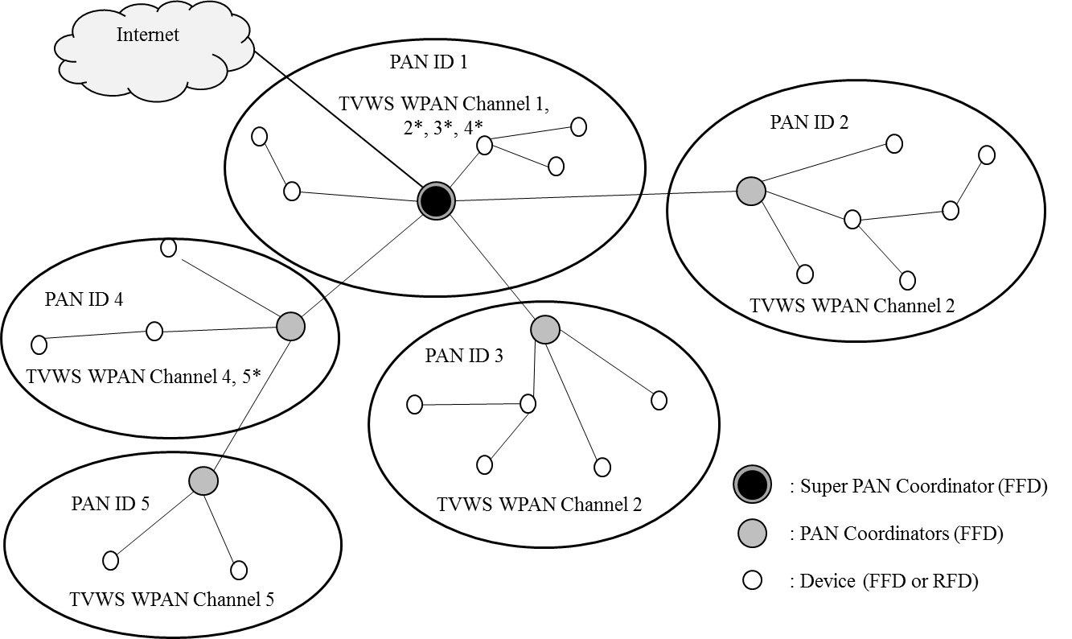

Figure : Example of TVWS multichannel cluster tree PAN

# TMCTP superframe structure

This standard allows the optional use of a superframe structure in a TVWS multichannel cluster tree PAN (TMCTP) that is extended by the addition of a beacon only period (BOP) to the active portion of the superframe. The format of the TMCTP superframe is defined by the SPC. The TMCTP superframe is bounded by network beacons sent by the SPC. The active portion of the TMCTP superframe is composed of a beacon, a CAP, a CFP and a BOP. An example of a TMCTP superframe including the BOP is illustrated in Figure 2. The BOP is composed of one or more DBSs. A DBS is used to communicate beacons between the TMCTP-parent PAN coordinator and the TMCTP-child PAN coordinator.

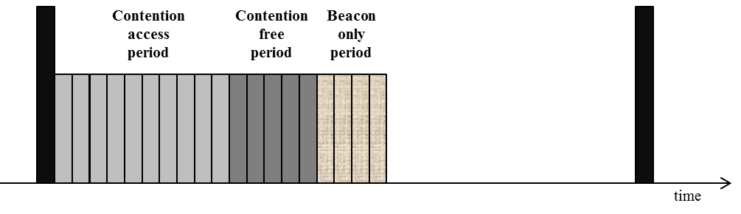

Figure : TMCTP superframe extension

## Beacon Only Period (BOP)

When present, the BOP shall follow the CAP and CFP, if the CFP is present. The CAP and CFP comprise the first 16 slots of the superframe, and the BOP shall commence on the slot boundary immediately following. The BOP shall complete before the end of the active portion of the superframe. The BOP duration depends on the number of DBSs allocated to each TMCTP-child PAN coordinator. All DBSs shall be located within the BOP and occupy contiguous slots. The BOP therefore grows and/or shrinks depending on the total length of all of the combined DBSs. BOP slots are allocated to a DBS according to the length of beacon sent by the lower coordinator which will occupy the DBS.

No beacon transmissions within the BOP shall use a CSMA-CA mechanism to access the dedicated channel. A TMCTP-child PAN coordinator transmitting in the BOP shall ensure that its beacon transmission is complete one IFS period, before the end of its DBS.

## Superframe use for TMCTP operation

The TMCTP superframe is an extension of the basic superframe. The active portion of the TMCTP superframe is composed of four parts, which is illustrated in Figure 3.

* The beacon, which is used to set the timing allocations and to communicate management information for the PAN.
* The contention access period (CAP), which is used to communicate command frames and/or data.
* The contention free period (CFP), which is composed of guaranteed time slots (GTSs). No transmissions within the CFP shall use a CSMA-CA mechanism to access the channel.
* The beacon only period (BOP), which is composed of one or more DBSs. A DBS is used to communicate beacons between the TMCTP-parent PAN coordinator (including the SPC) and the TMCTP-child PAN coordinator in a TMCTP.

The MAC PIB attribute *macTMCTPExtendedOrder* describes the extended length of the active portion of the superframe. The value of *macTMCTPExtendedOrder*, and the extended duration, ED, are related as follows:

*ED = aBaseSuperframeDuration × 2macTMCTPExtendedOrder*

*= aBaseSlotDuration × ( aNumSuprframeSlots × 2macTMCTPExtendedOrder* *)*

for

*0 ≤ macTMCTPExtendedOrder ≤ (macBeaconOrder- macSuperframeOrder)≤ macBeaconOrder ≤ 14*

The ED of each TMCTP superframe shall be divided into *aNumSuprframeSlots × 2macTMCTPExtendedOrder* equally spaced slots of duration *aBaseSlotDuration* and is composed of beacon only period (BOP). The BOP consists of DBSs. Each DBS is composed of one or more base slots, which are *aBaseSlotDuration* in length. The extended duration of the active portion of each TMCTP superframe includes the base superframe duration, *SD*, and the extended duration for the BOP, *ED*:

*ESD* = *SD* + *ED*.

An example of a TMCTP superframe structure is shown in Figure 3, according to the macBeaconOrder, the macsuperframeOrder and the macTMCTPExtendedOrder as shown in Figure 3.





Figure : An example of the TMCTP superframe structure

# Network formation using TMCTP

Figure 4 shows an example with a suggested message sequence for TMCTP formation between the SPC, which is the TMCTP-parent PAN coordinator, and a TMCTP-child PAN Coordinator. The example is explained as follows:

In Step A, the SPC obtains the list of available TVWS channels from the geolocation database (GDB) through the internet. The protocol used to access the GDB over the internet is outside the scope of this standard. Alternately, the SPC may obtain the list of available TVWS channels from another device (Fixed, Mode II, or Mode I Device). The SPC maps the TVWS channels to corresponding PHY channels and selects one of the available PHY channels, and transmits its beacon through that channel. The TMCTP-child PAN coordinator completes the scan procedure over all PHY channels.

In Step B, the SPC transmits an enhanced beacon containing a TMCTP Extended Superframe Specification IE. Upon successful reception of the beacon from the SPC, the TMCTP-child PAN coordinator may request a DBS allocation sending a DBS request, to the SPC. Upon receiving the DBS request, the SPC will allocate a DBS slot and channel, and generate a DBS response to report the slot and channel allocated (the request is successful in this example).

In Step C, of the example, the SPC indicates pending data for the TMCTP-child PAN coordinator in its beacon. The TMCTP-child PAN coordinator sends the data request command frame. Upon receiving the data request, the SPC replies with the DBS response generated in Step B.

In Step D, the SPC sends its own beacon frame. The SPC switches into the channel allocated to the PAN coordinator and receives the beacon frame from the PAN coordinator.

In Step E, upon receiving the beacon frame during the slot allocated to the TMCTP-child PAN coordinator on the channel allocated to the TMCTP-child PAN coordinator, the SPC switches into its own dedicated channel.

During the CAP of the SPC, each PAN coordinator sends a DBS request to the SPC and receives a DBS response from the SPC. The SPC switches into the allocated channel before the DBS slot time allocated to the PAN coordinator. Each PAN coordinator forms an independent PAN by transmitting its beacon during the allocated DBS slot.

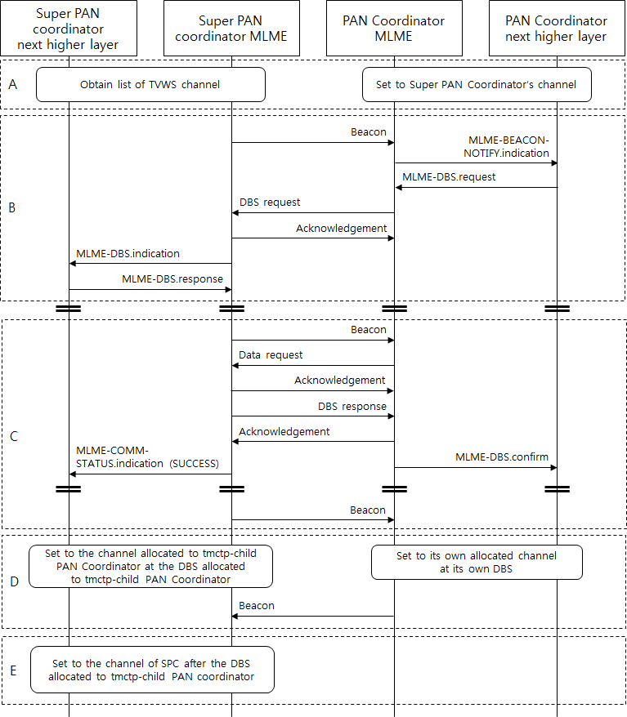**Figure 4 - Example message sequence between the SPC and the TMCTP-child PAN coordinator**

Figure 5 provides another example for TMCTP formation between two PAN coordinators, where one is the TMCTP-parent PAN coordinator and the other is the TMCTP-child PAN Coordinator.

In Step A, the TMCTP-child PAN coordinator performs a scan procedure and is waiting for the beacon of the TMCTP-parent PAN coordinator.

In Step B, the TMCTP-parent PAN coordinator sends an enhanced beacon containing a TMCTP Specification IE. Upon successful reception of the beacon from the TMCTP-parent PAN coordinator, the TMCTP-child PAN coordinator requests a channel and a slot by using the DBS request sent to the TMCTP-parent PAN coordinator. Upon receiving the DBS request, the TMCTP-parent PAN coordinator directly generates the DBS response frame reporting the slot and a channel allocated, or it or sends the DBS request command frame to the SPC and then receives the DBS response command frame from the SPC.

In Step C, the TMCTP-parent PAN coordinator sends a beacon. The TMCTP-parent PAN coordinator switches into the channel allocated to the TMCTP-child PAN coordinator and receives the beacon frame from the TMCTP-child PAN coordinator.

In Step D, upon receiving the beacon frame during the slot allocated to the TMCTP-child PAN coordinator on the channel allocated to the TMCTP-child PAN coordinator, the TMCTP-parent PAN coordinator switches into its own dedicated channel.

During CAP of the TMCTP-parent PAN coordinator, which has a relay capability or a channel allocation capability, each TMCTP-child PAN coordinator sends a DBS request to the TMCTP-parent PAN coordinator and receives the DBS response from the TMCTP-parent PAN coordinator. The TMCTP-parent PAN coordinator switches into the channel allocated to the TMCTP-child PAN coordinator during the DBS slot allocated to each TMCTP-child PAN coordinator. Each TMCTP-child PAN coordinator manages its own WPAN by transmitting a beacon during the allocated DBS slot time.

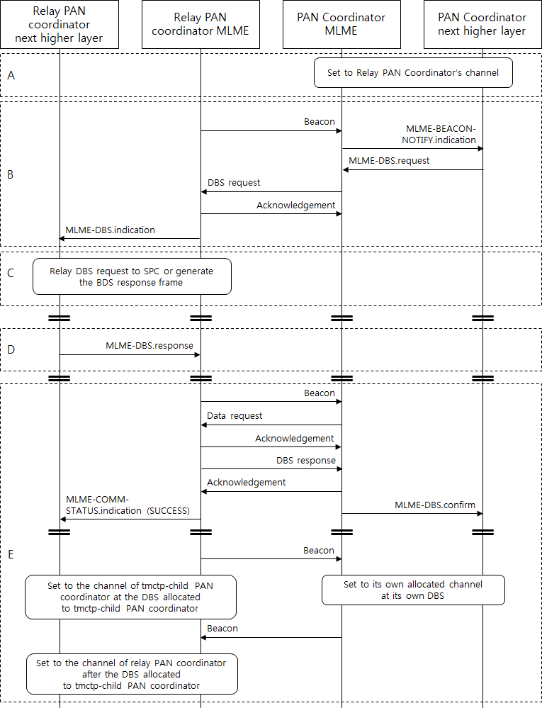

Figure - Example message sequence between TMCTP PAN Coordinators

Figure 6 shows an example of the multichannel allocation for the network topology as presented in Figure 1. In this case, the super PAN coordinator operates on the dedicated channel, which is Channel 1 in this figure, and switches into the dedicated channels of the TMCTP-child PAN coordinators 2, 3, and 4 during their DBSs. Similarly the PAN coordinator 4 operates on the dedicated channel, which is Channel 4, and switches into the dedicated channel of the TMCTP-child PAN coordinator 5 during its DBS.



Figure - Example TMCTP BOP allocation

# TMCTP DBS command frames

## TMCTP Specification IE

The TMCTP Specification IE shall be formatted as illustrated in Figure 7.

|  |  |  |  |  |  |  |  |
| --- | --- | --- | --- | --- | --- | --- | --- |
| Bits: 0-3 | 4 | 5 | 6 | 7 | 8-15 | 16-23 | variable |
| Beacon Only Period Order | TMCTP Frame Pending | Dedicated Beacon Slot Allocation Capability | Channel Allocation Capability | Channel Allocation Relay Capability | Hop Count to SPC | Number of PAN ID Pending | PAN ID List |

Figure : Format of the TMCTP Specification IE

The Beacon Only Period Order field specifies the length of the extended duration.

The TMCTP Frame Pending field shall be set to one if the TMCTP-parent PAN coordinator has more frames for the TMCTP-child PAN coordinator. Otherwise, this field shall be set to zero. The Dedicated Beacon Slot Allocation Capability field shall be set to one if the device is capable of allocating the DBS to the TMCTP-child PAN coordinator, it shall be set to zero otherwise.

The Channel Allocation Capability field shall be set to one if the device is capable of allocating the dedicated channel to the TMCTP-child PAN coordinator, it shall be set to zero otherwise.

The Channel Allocation Relay Capability field shall be set to one if the device is capable of relaying the DBS request of the TMCTP-child PAN coordinator, it shall be set to zero otherwise.

The Hop Count to SPC field indicates the number of hops to reach the SPC.

The Number of PAN ID Pending field indicates the number of PAN IDs contained in the PAN ID List field of the beacon frame.

The size of the PAN ID List field is determined by the values specified in the Number of PAN IDs Pending field of the beacon frame and contains the list of PAN IDs of the TMCTP-child PAN coordinators that currently have messages pending with the upper coordinator.

## DBS request command frame

The DBS request command is used in a TMCTP enabled PAN to request allocation of a DBS and a channel. The DBS request command shall be formatted as shown in Figure 8.

|  |  |  |
| --- | --- | --- |
| Octets: 11-25 | 1 | 4 |
| MHR Fields | Command Frame Identifier | DBS Request Information |

Figure - TMCTP DBS Request Command Frame

* + 1. MHR Fields

The Destination Addressing Mode field and Source Addressing Mode field shall be set to indicate short addressing.

The Frame Pending field, the AR field, and the Frame Version field shall be set to zero, one, and (TBD) respectively.

The Destination PAN Identifier field shall contain the PAN identifier of the SPC, and the Destination Address field shall contain the address of the SPC. The Source PAN Identifier field shall contain the value of macPANId. Each PAN coordinator shall have a unique PAN identifier in a SPC domain and the 16-bit short address for its Source Address field shall contain the value of macShortAddress.

* + 1. DBS Request Information field

The DBS Request information field shall be encoded as shown in Figure 9.

|  |  |  |  |  |
| --- | --- | --- | --- | --- |
| Bits: 0:15 | 16:19 | 20:22 | 23 | 24:31 |
| Requester Short Address | DBS Length | Reserved | Characteristics Type | Number of the Descendant |

Figure - DBS Request information field encoding

The Requester Short Address field contains the short address of the coordinator requesting a DBS and shall be set to macShortAddress upon transmission.

The DBS Length field shall contain the number of *aBaseSlotDuration* being requested for a DBS.

The Characteristics Type field shall be set to one if the characteristics refer to a DBS allocation or zero if the characteristics refer to a DBS deallocation.

The Number of the Descendant field indicates the actual or expected number of descendant PAN coordinators. It may be set to zero if the PAN coordinator is not clear about how many descendants it will have.

## DBS response command frame

The DBS response command is used in a TMCTP PAN to report the results of a DBS allocation request. The DBS response command shall be formatted as shown in Figure 32.

|  |  |  |
| --- | --- | --- |
| Octets: 11-25 | 1 | 8 |
| MHR Fields | Command Frame Identifier | DBS Response Information |

Figure - TTMCTP DBS response command format

* + 1. MHR Fields

The Destination Addressing Mode field and Source Addressing Mode field shall be set to indicate the short addressing.

The Frame Pending field, the AR field shall, and the Frame Version field shall set to zero, one, and (TBD) respectively.

The Destination PAN Identifier field shall contain the source PAN identifier from the DBS request frame, and the Destination Address field shall contain the source address from the DBS request frame. The Source PAN Identifier field shall contain the value of macPANId, and the Source Address field shall contain the value of macShortAddress.

* + 1. DBS Response Information field

|  |  |  |  |  |  |  |
| --- | --- | --- | --- | --- | --- | --- |
| Octets:2 | 1 | 1 | 1 | 1 | 1 | 1 |
| Requester Short Address | Allocated DBS Starting Slot | Allocated DBS Length | Allocated PHY Channel ID | Allocated PHY Channel Page | Starting PHY Channel ID | Ending PHY Channel ID |

The Requester Short Address field contains the short address of the coordinator requesting a DBS and shall be set to *macShortAddress* upon transmission.

The Allocated DBS Starting Slot field shall contain the first slot of the allocated DBS in the BOP. The unit is the *aBaseSlotDuration*, as described in Table 51.

The Allocated DBS Length field shall contain the length of the allocated DBS.

The Allocated PHY Channel Number field shall contain the channel number that the coordinator intends to use for all future communications.

The Allocated PHY Channel Page field, if present, shall contain the channel page that the coordinator intends to use for all future communications. This field may be omitted if the new channel page is the same as the previous channel page.

The Starting PHY Channel Number field shall contain the lowest channel number, which is assigned by the upperPAN coordinator, including the SPC.

The Ending PHY Channel Number field shall contain the highest channel number, which is assigned by the upperPAN coordinator, including the SPC.

# TMCTP DBS primitives

These primitives are used in a TMCTP enabled PAN to allocate the DBS between the TMCTP-parent PAN coordinator and the TMCTP-child PAN coordinator.

## MLME-DBS.request

The MLME-DBS.request primitive is used when a TMCTP-child PAN coordinator requests the allocation of a DBS and a channel to a TMCTP-parent PAN coordinator including a super PAN coordinator.

The semantics of this primitive are:

MLME-DBS.request (

RequesterCoordAddr,

RequestType,

DBSLength,

NumberOfDescendents,

SecurityLevel,

KeyIdMode,

KeySource,

KeyIndex

)

The primitive parameters are defined in Table 1.

On receipt of the MLME-DBS.request primitive, the MLME generates a DBS request command, with the DBS characteristics field set to 1 (request allocation).

The SecurityLevel parameter specifies the level of security to be applied to the DBS request command frame. Typically, the DBS request command should not be implemented using security. However, if the TMCTP-child PAN coordinator requesting DBS allocation shares a key with the TMCTP-parent PAN coordinator, then security may be specified.

Table - MLME-DBS.request Parameters

|  |  |  |  |
| --- | --- | --- | --- |
| Name | Type | Valid range | Description |
| RequesterCoordAddr | Device Short  address | 0x0000-0xffff | The short device address of the (original) source requester PAN coordinator. |
| RequestType | Enumeration | ALLOCATION, DEALLOCATION | If the request is for allocation or deallocation of TMCTP DBS. |
| DBSLength | Integer | 0x00-0xff | Number of BOP slots being requested for the DBS. |
| NumberOfDescendents | Integer | 0x00-0xff | The actual or expected number of descendant PAN coordinators. Set as zero if the PAN coordinator is not clear about how many descendants it will have. |
| SecurityLevel | Integer | As defined in Table 46 of IEEE Std 802.15.4™‐2011 | As defined in Table 46 of IEEE Std 802.15.4™‐2011 |
| KeyIdMode | Integer | As defined in Table 46 of IEEE Std 802.15.4™‐2011 | As defined in Table 46 of IEEE Std 802.15.4™‐2011 |
| KeySource | Set of octets | As defined in Table 46 of IEEE Std 802.15.4™‐2011 | As defined in Table 46 of IEEE Std 802.15.4™‐2011 |
| KeyIndex | Integer | As defined in Table 46 of IEEE Std 802.15.4™‐2011 | As defined in Table 46 of IEEE Std 802.15.4™‐2011 |

## MLME-DBS.indication

The MLME-DBS.indication primitive is generated to indicate the reception of a DBS request command.

The semantics of this primitive are:

MLME-DBS.indication (

CoordAddress,

RequesterCoordAddr,

RequestType,DBSLength,

NumberOfDescendents,

SecurityLevel,

KeyIdMode,

KeySource,

KeyIndex

)

The primitive parameters are defined in Table 2.

Table - MLME-DBS.indication Parameters

|  |  |  |  |
| --- | --- | --- | --- |
| Name | Type | Valid range | Description |
| CoordAddress | Device Short  address | 0x0000-0xffff | The short address of the Coordinator that sent TMCTP DBS Request |
| RequesterCoordAddr | Device Short  address | 0x0000-0xffff | The short device address of the (original) source requester PAN coordinator. |
| RequestType | Enumeration | ALLOCATION, DEALLOCATION | Indicates if the received request is for an allocation or deallocation of TMCTP DBS. |
| DBSLength | Integer | 0x00-0xff | The value of the DBSLength field of the received TMCTP DBS Request |
| NumberOfDescendents | Integer | 0x00-0xff | The desired number of descendant PAN coordinators. Set as zero if the PAN coordinator is not clear about how many descendants it will have. |
| SecurityLevel | Integer | As defined in Table 46 of IEEE Std 802.15.4™‐2011 | As defined in Table 46 of IEEE Std 802.15.4™‐2011 |
| KeyIdMode | Integer | As defined in Table 46 of IEEE Std 802.15.4™‐2011 | As defined in Table 46 of IEEE Std 802.15.4™‐2011 |
| KeySource | Set of octets | As defined in Table 46 of IEEE Std 802.15.4™‐2011 | As defined in Table 46 of IEEE Std 802.15.4™‐2011 |
| KeyIndex | Integer | As defined in Table 46 of IEEE Std 802.15.4™‐2011 | As defined in Table 46 of IEEE Std 802.15.4™‐2011 |

When the next higher layer of a TMCTP-parent PAN coordinator receives the MLME-DBS.indication primitive, the TMCTP-parent PAN coordinator determines whether to accept or reject the DBS allocation request using an algorithm outside the scope of this standard.

## MLME-DBS.response

The MLME-DBS.response primitive is used to initiate a response to an MLME-DBS.indication primitive.

The semantics of this primitive are:

MLME-DBS.response (

CoordAddress,

RequesterCoordAddr,

DBSStartingSlot,

DBSLength,

ChannelNumber,

ChannelPage,

StartingChNum,

EndingChNum,

SecurityLevel,

KeyIdMode,

KeySource,

KeyIndex

)

The primitive parameters are defined in Table 3.

Table : MLME-DBS.response Parameters

|  |  |  |  |
| --- | --- | --- | --- |
| Name | Type | Valid range | Description |
| CoordAddress | Device Short  address | 0x0000–0xffff | The short address of the Coordinator that sent TMCTP DBS Request |
| RequesterCoordAddr | Device Short  address | 0x0000–0xffff | The short device address of the (original) source requester PAN coordinator. |
| DBSStartingSlot | Integer | 0x0000‐0xffff | The first slot of the allocated DBS in the BOP |
| DBSLength | Integer | 0x00‐0xff | The size, in BOP slots, of the allocated DBS. |
| ChannelNumber | PHY Channel ID | See 8.1.2 of IEEE Std 802.15.4™‐2011 | The channel number that the coordinator intends to use for all future communications |
| ChannelPage | Integer | See 8.1.2 of IEEE Std 802.15.4™‐2011 | The channel page that the coordinator intends to use for all future communications. |
| StartingChNum | PHY Channel ID | See 8.1.2 of IEEE Std 802.15.4™‐2011 | The lowest channel number, which is assigned by the TMCTP-parent PAN coordinator |
| EndingChNum | PHY Channel ID | See 8.1.2 of IEEE Std 802.15.4™‐2011 | The highest channel number, which is assigned by the TMCTP-parent PAN coordinator |
| SecurityLevel | Integer | As defined in Table 46 of IEEE Std 802.15.4™‐2011 | As defined in Table 46 of IEEE Std 802.15.4™‐2011 |
| KeyIdMode | Integer | As defined in Table 46 of IEEE Std 802.15.4™‐2011 | As defined in Table 46 of IEEE Std 802.15.4™‐2011 |
| KeySource | Set of octets | As defined in Table 46 of IEEE Std 802.15.4™‐2011 | As defined in Table 46 of IEEE Std 802.15.4™‐2011 |
| KeyIndex | Integer | As defined in Table 46 of IEEE Std 802.15.4™‐2011 | As defined in Table 46 of IEEE Std 802.15.4™‐2011 |

When the MLME of a TMCTP-parent PAN coordinator receives the MLME-DBS.response primitive, it generates a DBS response command, and attempts to send it to the TMCTP-child PAN coordinator requesting the allocation of a DBS and a channel.

## MLME-DBS.confirm

The MLME-DBS.confirm primitive is used to inform the next higher layer of the initiating device whether its request for the allocation of a DBS and a channel was successful or unsuccessful.

The semantics of this primitive are:

MLME-DBS.confirm (

RequesterCoordAddr,

DBSStartingSlot,

DBSLength,

ChannelNumber,

ChannelPage,

StartingChNum,

EndingChNum,

status

)

The primitive parameters are defined in Table 4.

Table : MLME-DBS.confirm parameters

|  |  |  |  |
| --- | --- | --- | --- |
| Name | Type | Valid range | Description |
| RequesterCoordAddr | Integer | 0x0000-0xffff | The short device address of the (original) source requester PAN coordinator. |
| DBSStartingSlot | Integer | 0x0000‐0xffff | The first slot of the allocated DBS in the BOP |
| ChannelNumber | PHY Channel ID | See 8.1.2 of IEEE Std 802.15.4™‐2011 | The channel number that the coordinator intends to use for all future communications |
| ChannelPage | Integer | See 8.1.2 of IEEE Std 802.15.4™‐2011 | The channel page that the coordinator intends to use for all future communications. |
| StartingfChNum | PHY Channel ID | See 8.1.2 of IEEE Std 802.15.4™‐2011 | The lowest channel number, which is assigned by the TMCTP-parent PAN coordinator |
| EndingChNum | PHY Channel ID | See 8.1.2 of IEEE Std 802.15.4™‐2011 | The highest channel number, which is assigned by the TMCTP-parent PAN coordinator |
| Status | Enumeration | SUCCESS,  NO_ACK,  DENIED,  UNAVAILABLE_KEY,  UNSUPPORTED_SECURITY,  INVALID_PARAMETER | The status of the attempt of the allocation of a DBS and a channel. |

If the DBS allocation request was successful, then the status parameter will be set to SUCCESS. Otherwise, the status parameter will be set to indicate the type of failure.