IEEE P802.15
Wireless Personal Area Networks

Project | IEEE P802.15 Working Group for Wireless Personal Area Networks (WPANs)
Title | IEEE 802.15 IG L2R San Antonio Meeting Minutes
Date Submitted | [15 November, 2012]
Source | [Clint Powell]  [PWC, LLC]  [1563 W Kaibab Dr.  Chandler, AZ 85248] | Voice: [+1 480-586-8457]  Fax: [ ]  E-mail: [cpowell@ieee.org]
Re: | [IG-L2R session minutes.]
Abstract | IG-L2R meeting minutes from the San Antonio Plenary.
Purpose | [IG-L2R session minutes.]
Notice | This document has been prepared to assist the IEEE P802.15. It is offered as a basis for discussion and is not binding on the contributing individual(s) or organization(s). The material in this document is subject to change in form and content after further study. The contributor(s) reserve(s) the right to add, amend or withdraw material contained herein.
Release | The contributor acknowledges and accepts that this contribution becomes the property of IEEE and may be made publicly available by P802.15.
Minutes for IEEE 802.15 L2R Interest Group
San Antonio Plenary Meeting
11-16 Nov. 2012
Clint Powell, chair, acting secretary

Monday PM2 (11/12)

Meeting called to order

Agenda Approval
Bob M.
Mike M.
Approved Unanimously

Call for IP Made
No response

Approval of Sept. IG-L2R Mins.
Doc. # 536-00
No objections - accepted by acclamation

Paul ran through tutorial presentation

Chair recesses until Tuesday AM1

Tuesday AM1 (11/13)

Meeting called to order

Agenda Rvw.

Call for IP Made
No response

Recap. of Tutorial and Attendance

Recap. of Attendance at prior. IG-L2R sessions

Official Liaisons w.r.t. IG-L2R activity
Ralph Droms IETF / Clint Powell IEEE

Straw Poll
Unanimous to reccom. to WG to move activity to SG

Paul gave a recap. of latest IETF mtg.

Initial Activities for SG to Undertake
Encouraged to do a brainstorming in SG of areas to attack
Need to review how it differs from RPL, etc.
Is a different problem being solved?
Is the same problem being solved differently?

Should it be Intra 15 or Intra 802?
For instance - 802.11.glk-sg, moved to AK-TG,
See par 11-12-1207-00-0glk
And 5c 11-12-1208-00-0glk

Look at how 1901.2 does adaptation of IETF

Chair recesses until Thursday PM1

Thursday PM2 (11/15)

Meeting called to order

Agenda Rvw.

Call for IP Made
No response

Additional activities for SG to undertake
Look at what would be needed for an 802.3 Multimedia bridging
i.e. local scope 48 bit address
Is ether type support needed and if so what

Look specifically at if/how 802.15.5 could be extended

SG needs to determine scope of capabilities to be provided and issues that will be addressed/solved
Determine scope of applications

Final steps of SG
Determine whether a standard or recc. practice
Determine whether an amendment or new
Draft PAR and 5C

Worked on supporting slides for EC mtg. - included as backup material in closing report.

Motion to Adjourn
Khurram Waheed
Bob Moskowitz

Chair adjourns

Mon. PM2 Attendance Sheet
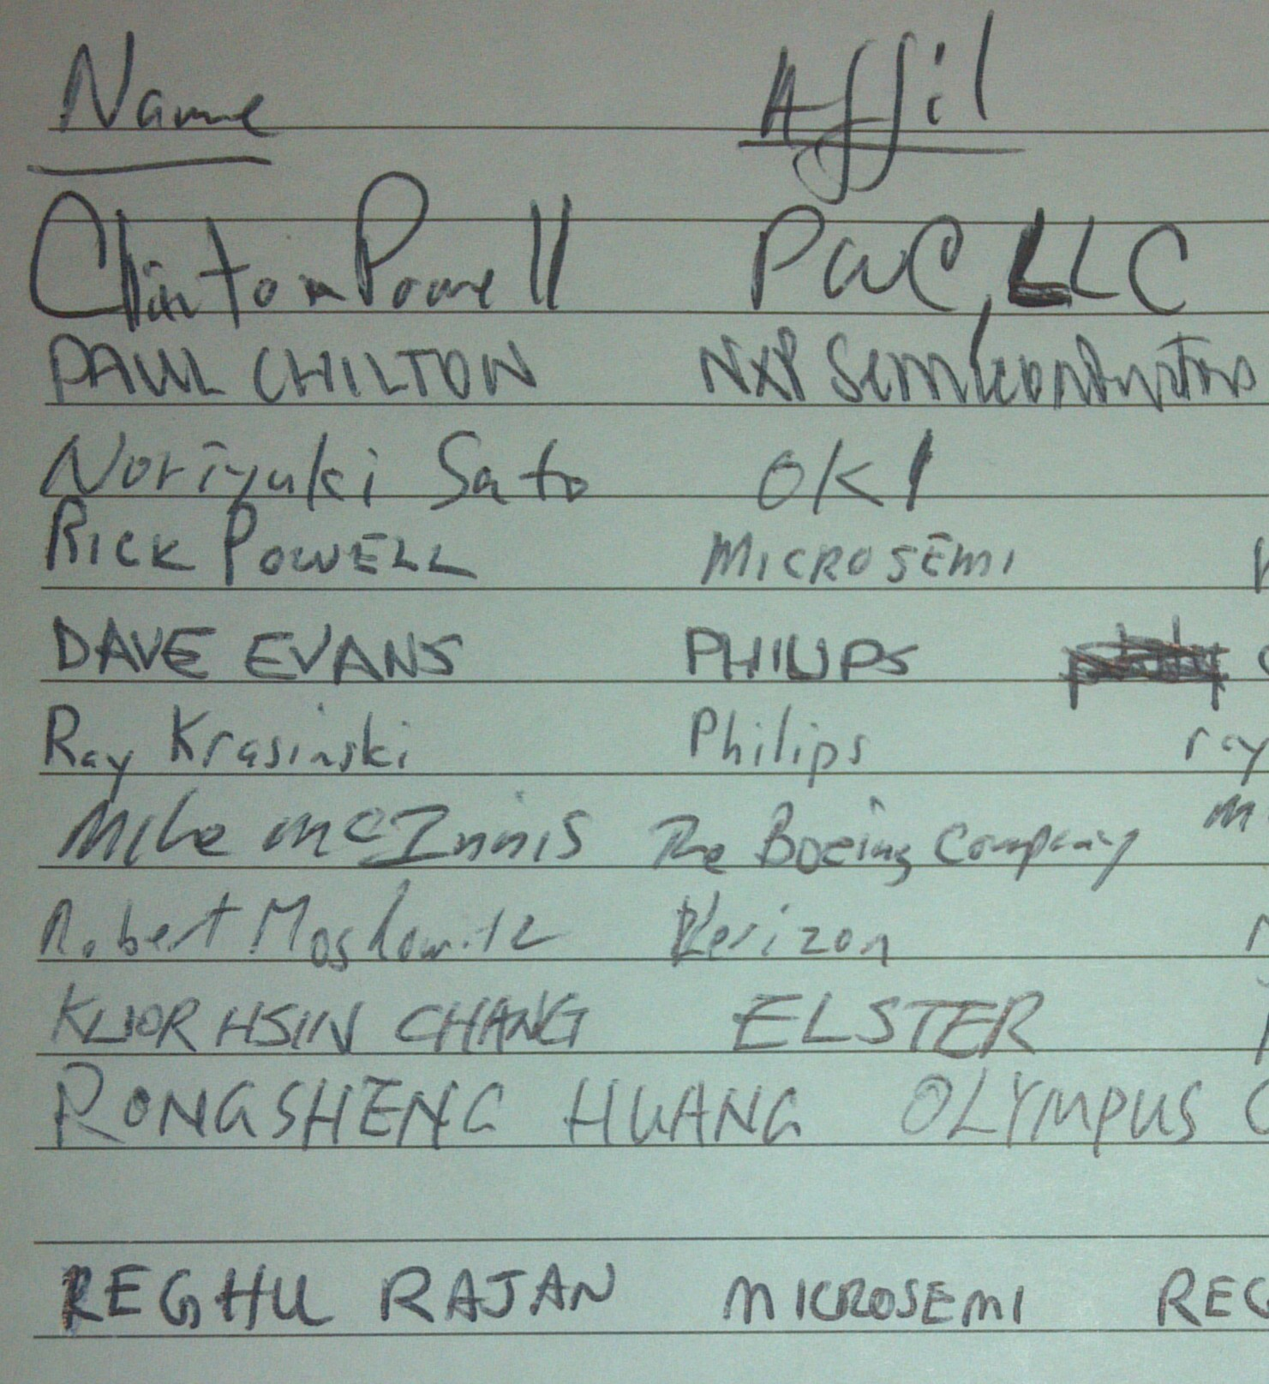

Tues. AM1 Attendance Sheet
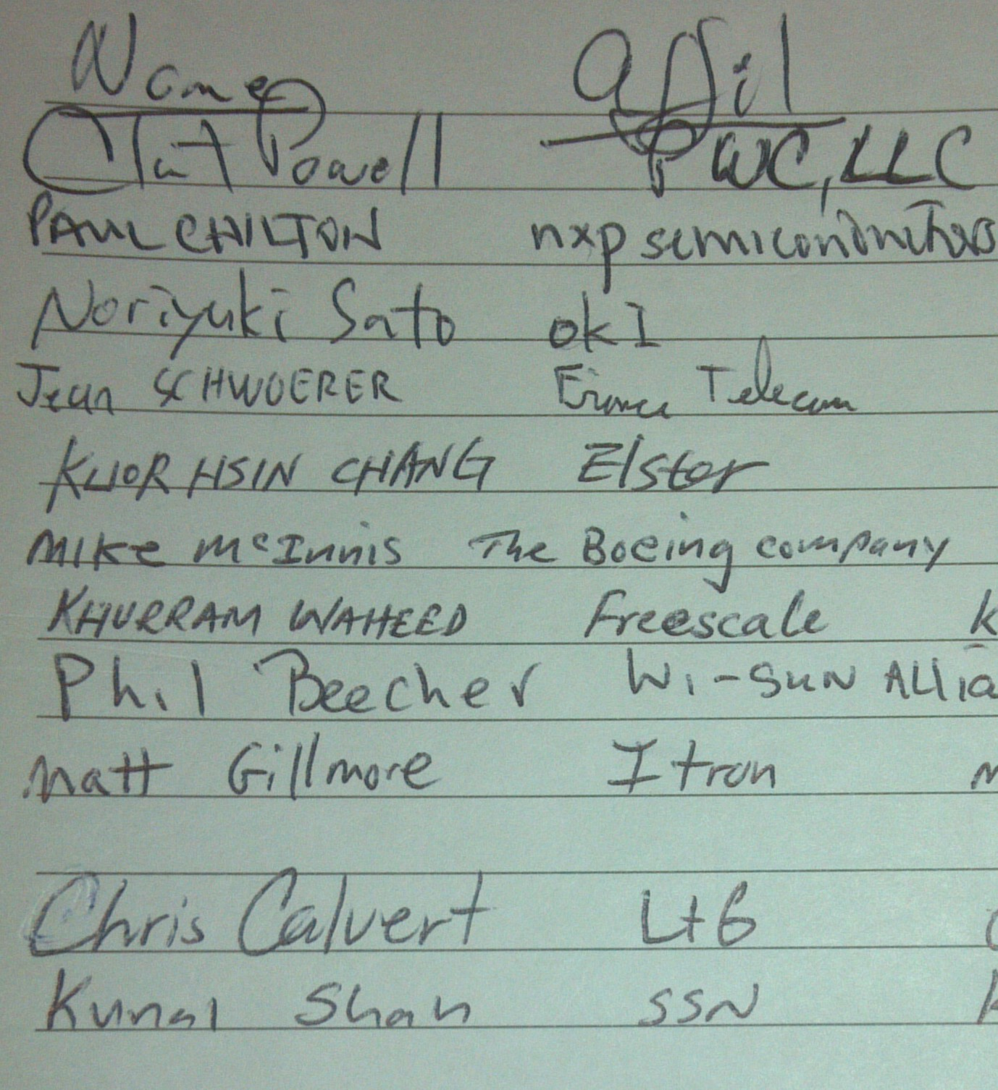

Thurs. PM1 Attendance Sheet
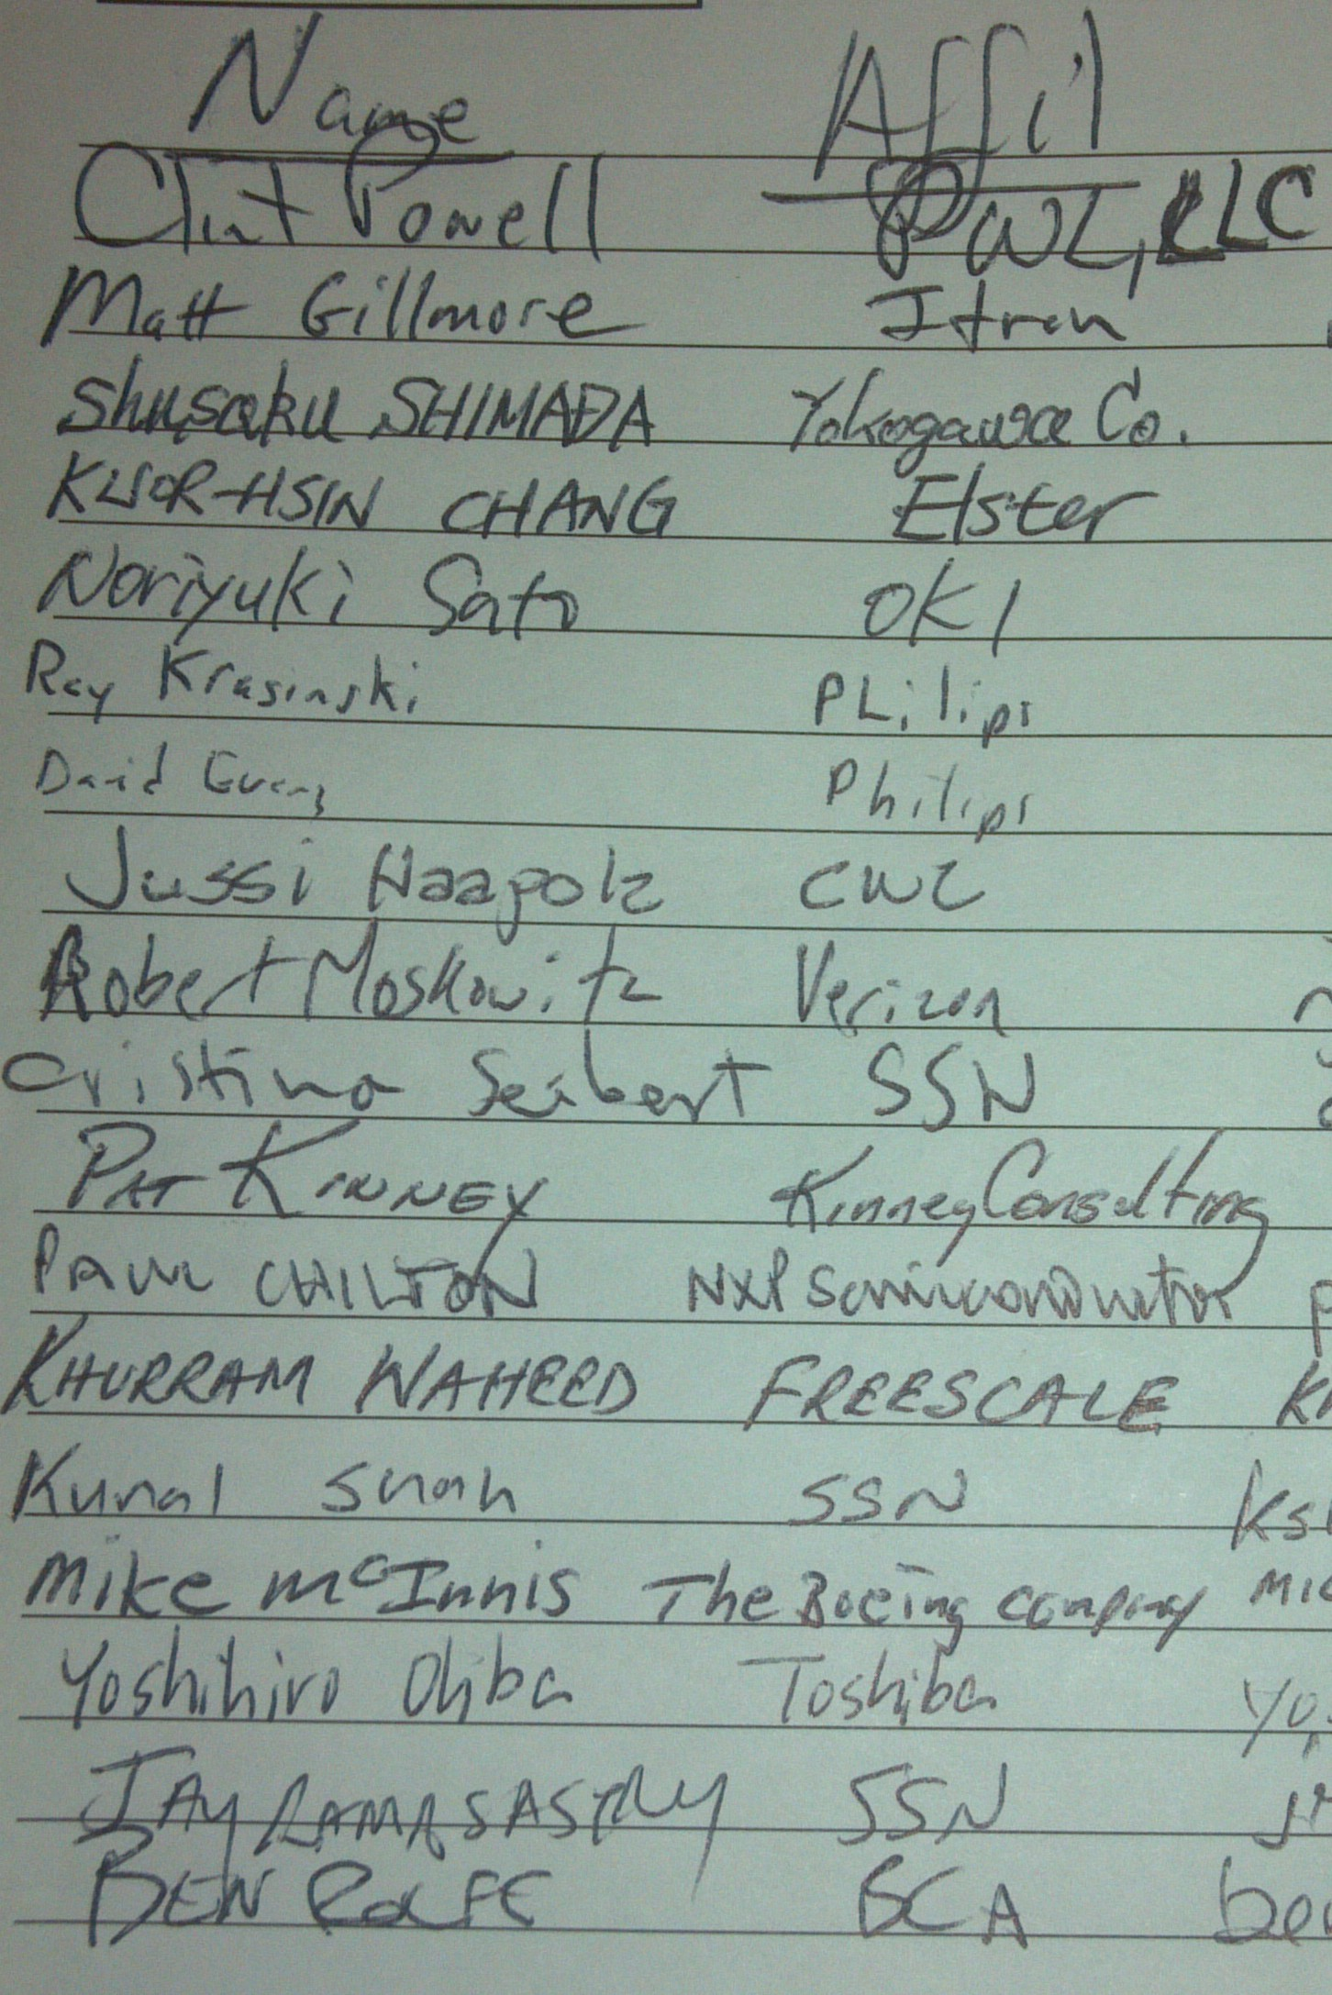

Recommended Activities for Study Group

Initial activities for SG to undertake
Encouraged to do a brainstorming in SG of areas to attack
Need to review how it differs from RPL, etc.
Is a different problem being solved?
Is the same problem being solved differently?

Should it be Intra 15 or Intra 802?
For instance - 802.11.glk-sg, moved to AK-TG,
See par 11-12-1207-00-0glk
And 5c 11-12-1208-00-0glk

Look at how 1901.2 does adaptation of IETF

Look at what would be needed for an 802.3 Multimedia bridging
i.e. local scope 48 bit address
Is ether type support needed and if so what

Look specifically at if/how 802.15.5 could be extended

SG needs to determine scope of capabilities to be provided and issues that will be addressed/solved
Determine scope of applications

Final steps of SG
Determine whether a standard or recc. practice
Determine whether an amendment or new
Draft PAR and 5C

