IEEE P802.15
Wireless Personal Area Networks

Project | IEEE P802.15 Working Group for Wireless Personal Area Networks (WPANs)
Title | Channel models for TG8
Date Submitted | September 2012
Source | Marco Hernandez, Huan-Bang Li, Igor Dotlić, Ryu Miura (NICT)
Re: | In response to Technical Guidance Document contributions
Abstract | Channel models
Purpose | Reference channel models for proposals evaluation to TG8
Notice | This document has been prepared to assist the IEEE P802.15. It is offered as a basis for discussion and is not binding on the contributing individual(s) or organization(s). The material in this document is subject to change in form and content after further study. The contributor(s) reserve(s) the right to add, amend or withdraw material contained herein.
Release | The contributor acknowledges and accepts that this contribution becomes the property of IEEE and may be made publicly available by P802.15.

Contents
1 Introduction 3
2 Large-Scale Path Loss 4
2.1 Outdoor Path Loss 4
2.1.1 Propagation situations 4
2.1.2 Line-of-sight (LoS) paths 4
2.1.3 Propagation over rooftops, non-line-of-sight (NLoS1) 5
2.1.4 Propagation along street canyons, non-line-of-sight (NLoS2) 6
2.2 Path Loss for sub-1 GHz, 2.4 GHz and 5 GHz bands 6
2.2.1 LoS in street canyons 6
2.2.2 NoLoS over roof-tops for urban area 7
2.2.3 NoLoS over roof-tops for suburban area 10
2.2.4 NoLoS in street canyons for sub-1 GHz band 12
2.2.5 NoLoS in street canyons for 2.4 GHz and 5 GHz bands 12
2.3 Outdoor Path Loss for UWB band 13
2.4 Indoor Path Loss 13
2.4.1 Attenuation Factor Model for 900 MHz band 13
2.4.2 Indoor Path Loss for 2.4 GHz and 5 GHz bands 16
2.4.3 Indoor Path Loss for UWB band 17
3 Small-Scale Fading 19
3.1 SISO ITU models 19
3.2 MatLab™ code 21
3.3 SISO ITU extended models 22
3.4 MatLab™ code 23
3.5 SISO ETSI BRAN 5 GHz channel model 24
3.6 MatLab™ code 28
3.7 UWB Channel model 29
4 MIMO channel models 30
5 Bibliography 31
6 Annex A – Matlab code for IEEE802.15.4a UWB channel model 32

Introduction

There are numerous contributions to path loss propagation in the literature for the target frequency bands of TG8 indicated in the PAR. Namely, sub-1 GHz, 2.4 GHz, 5 GHz and high band of UWB.
We present the most accepted contributions to be used for a fair comparison of PHY and MAC proposals.

Large-Scale Path Loss

Outdoor Path Loss

Outdoor path loss is based on ITU-R P.1411-6 “Propagation data and prediction methods for the planning of short-range outdoor radio communication systems and radio local area networks in the frequency range 300 MHz to 100 GHz”.
It provides an up to date recommendation for propagation over paths of length less than 1 Km, which is affected primarily by buildings and trees. The effect of buildings is predominant, since most short-path radio links are found in urban and suburban areas. The mobile terminal is most likely to be held by a pedestrian or located in a vehicle.
The type of propagation mechanism that dominates depends also on the height of the base station antenna relative to the surrounding buildings. Table 1 lists the typical cell types relevant for outdoor short-path propagation.

Cell type | Cell radius | Typical position of base  station antenna
Micro-cell | 0.05 to 1 km | Outdoor; mounted above average roof-top level, heights of some surrounding buildings may be above base station antenna height
Dense urban micro-cell | 0.05 to 0.5 km | Outdoor; mounted below average roof-top level
Pico-cell | Up to 50 m | Indoor or outdoor (mounted below roof-top level)
Table 1 Definition of cell types.

Propagation situations
Four situations of base station (BS) and mobile station (MS) geometries are depicted in Figure 1. Base station BS₁ is mounted above roof-top level. The corresponding cell is a micro-cell. Propagation from this BS is mainly over the roof-tops. Base station BS₂ is mounted below roof-top level and defines a dense urban micro- or pico-cellular environment. In these cell types, propagation is mainly within street canyons. For mobile-to-mobile links, both ends of the link can be assumed to be below roof-top level, and the models relating to BS₂ may be used.

Line-of-sight (LoS) paths
The paths BS₁-MS₂ and BS₂-MS₄ illustrated in Figure 1 are examples of LoS situations. The same models can be applied for both types of LoS path.

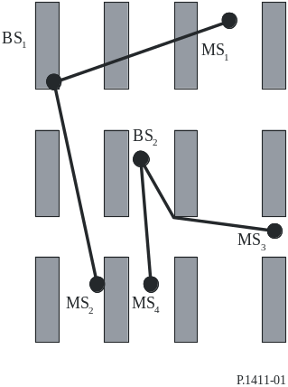
Figure 1 Typical propagation situation in urban areas.

Propagation over rooftops, non-line-of-sight (NLoS1)
The typical NLoS case (link BS₁-MS₁ in Figure 1) is described in Figure 2.

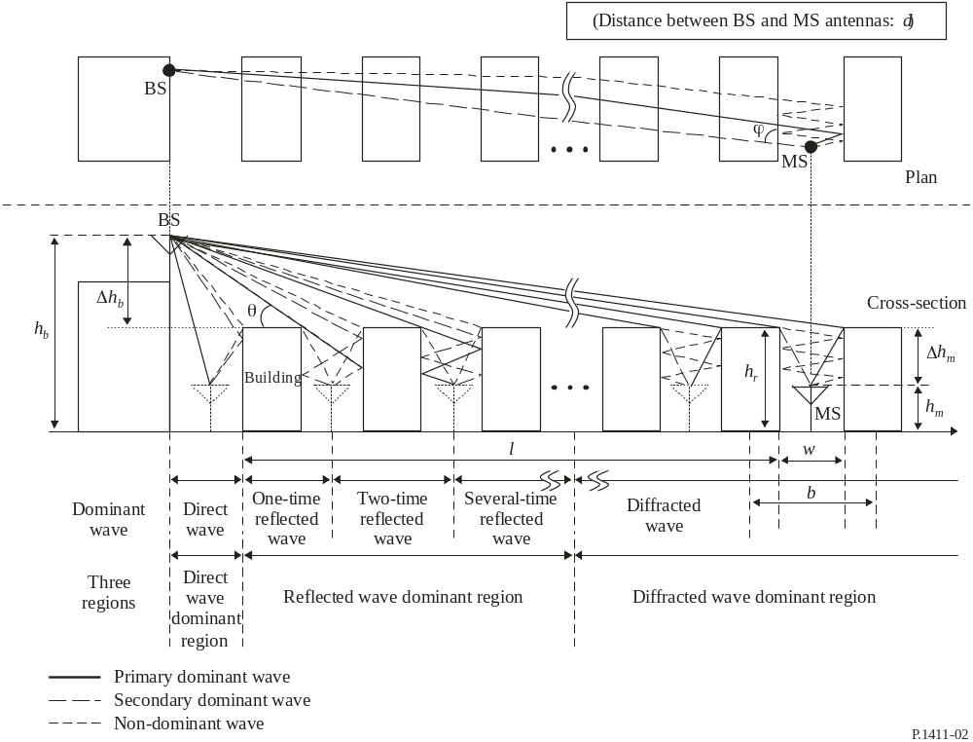
Figure 2 Parameters for the NoLoS1 case.
The relevant parameters are given by
hr : average height of buildings (m)
w : street width (m)
b : average building separation (m)
 : street orientation with respect to the direct path (degrees)
h_{b} : BS antenna height (m)
h_{m} : MS antenna height (m)
l : length of the path covered by buildings (m)
d : distance from BS to MS.

Propagation along street canyons, non-line-of-sight (NLoS2)
Figure 3 shows the situation for a typical dense urban micro-cellular NLoS case, link BS₂-MS₃ in Figure 1.
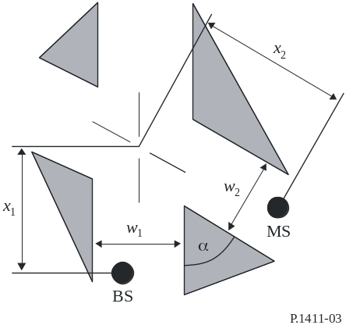
Figure 3 Parameters for the NoLoS2 case.
The relevant parameters are given by
w₁ : street width at the position of the BS (m)
w₂ : street width at the position of the MS (m)
x₁ : distance BS to street crossing (m)
x₂ : distance MS to street crossing (m)
 : is the corner angle (rad).

Path Loss for sub-1 GHz, 2.4 GHz and 5 GHz bands

LoS in street canyons
The path loss is characterized by two slopes and a breakpoint. An upper and lower bounds are provided. However, we propose to use the median value that is given by

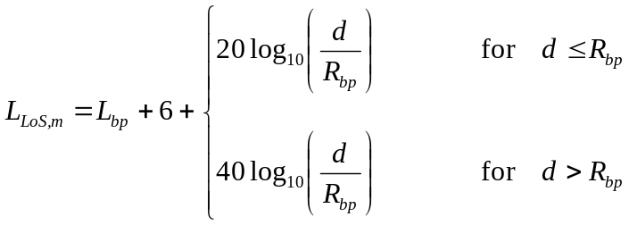 Equation 1
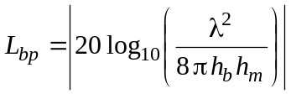 , 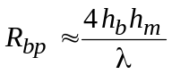, 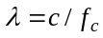.
where L_{bp} is transmission loss at break point, R_{bp} is the breakpoint distance and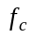is the central frequency.

NoLoS over roof-tops for urban area
The recommendation presents values for which the models are valid. However, for the purposes of comparison of proposals, such values can be relaxed a bit. Models are defined for the two situations described in 2.1.1. The models are valid for:
h_{b}: 4 to 50 m
h_{m}: 1 to 3 m
f: 800 to 5 000 MHz
2 to 16 GHz for h_{b} < h_{r} and w₂ < 10 m (or sidewalk)
d: 20 to 1000 m.
In the model for transmission loss in NLoS for roof-tops of similar height, the loss between isotropic antennas is expressed as the sum of free-space loss, L_{bf}, the diffraction loss from roof-top to street L_{rts} and the reduction due to multiple screen diffraction past rows of buildings, L_{msd}. In this model L_{bf} and L_{rts} are independent of the BS antenna height, while L_{msd} is dependent on whether the base station antenna is at, below or above building heights.

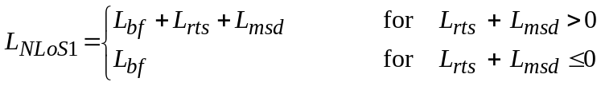 Equation 2
where d is path length, f is frequency (MHz), L_{rts} describes the coupling of the wave propagating along the multiple-screen path into the street where the mobile station is located and given by

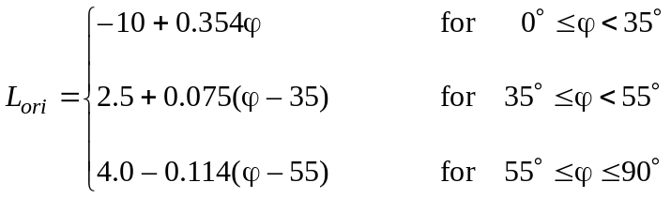
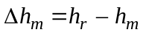
L_{ori} is the street orientation correction factor, which takes into account the effect of roof-top-to-street diffraction into streets that are not perpendicular to the direction of propagation (see Figure 2).
The multiple screen diffraction loss from the BS due to propagation past rows of buildings depends on the BS antenna height relative to the building heights and on the incidence angle. A criterion for grazing incidence is the “settled field distance”, d_{s}:

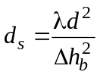 , 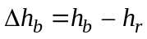
Finally, for the calculation of L_{msd}, d_{s} is compared to the distance l over which the buildings extend:
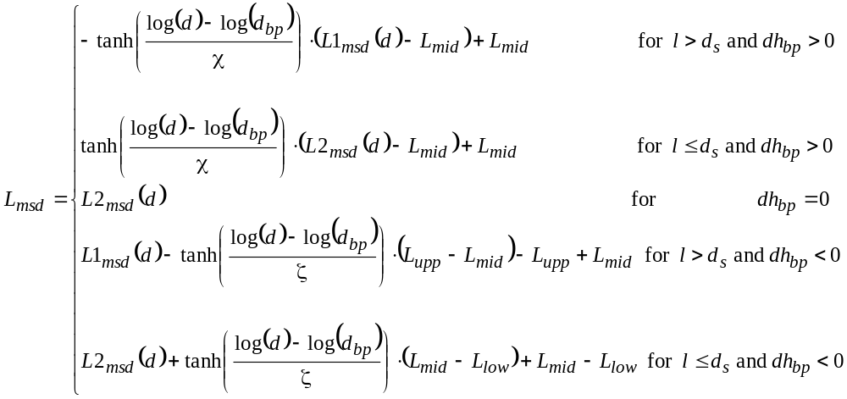
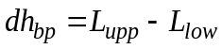

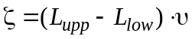

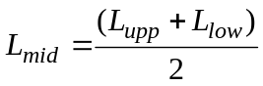

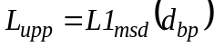

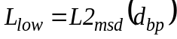
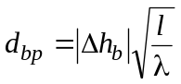
υ = 0.0417
χ = 0.1

Calculation of L1_{msd} for l > d

where:
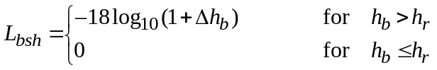

is a loss term that depends on the BS height:

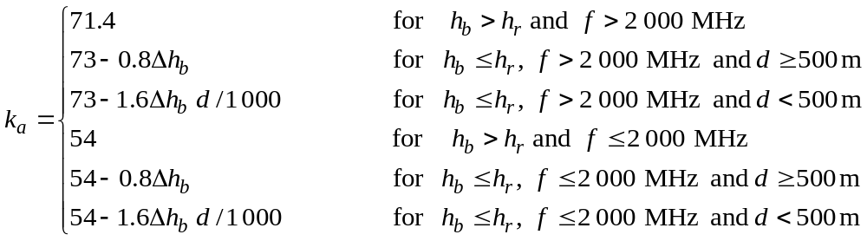

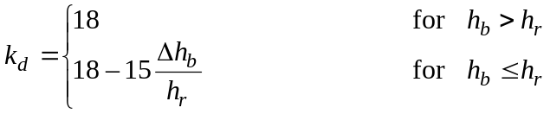
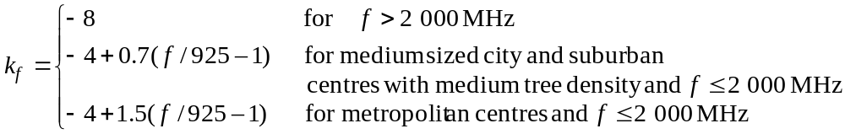

Calculation of L2_{msd} for l < d_{s}

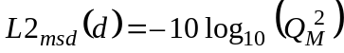

where:

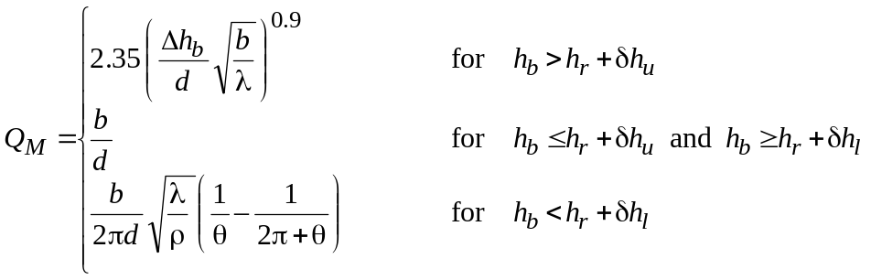

and

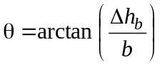

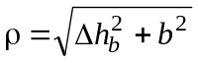

and 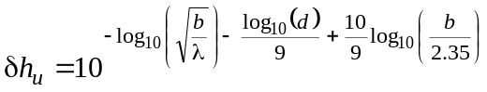

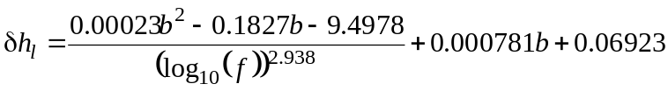

NoLoS over roof-tops for suburban area
The recommendation presents values for which the models are valid. However, for the purposes of comparison of proposals, such values can be relaxed a bit. Model is defined for the situation of h_{b} > h_{r} described in 2.1.1. The model is valid for
h_{r}: any height m
Δh_{b}: 1 to 100 m
Δh_{m}: 4 to 10 (less than h_{r}) m
h_{b}: h_{r} + Δh_{b} m
h_{m}: h_{r} − Δh_{m} m
f: 0.8 to 20 GHz
w: 10 to 25 m
d: 10 to 1 000 m
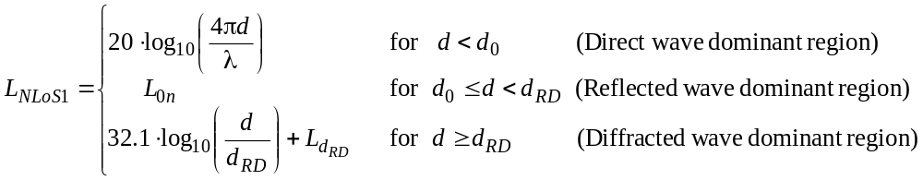 Equation 3
where:

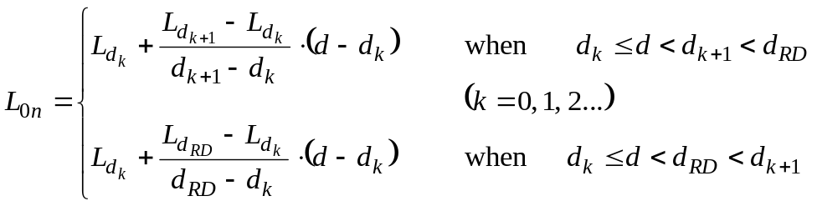

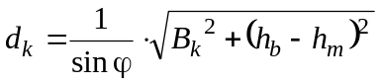

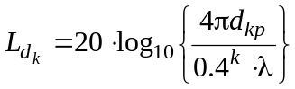

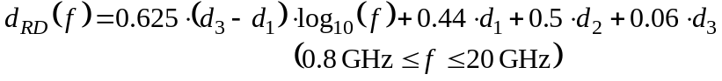

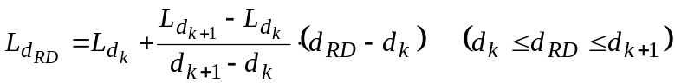

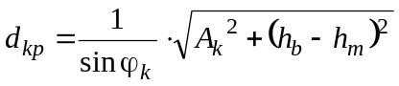

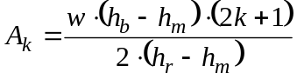
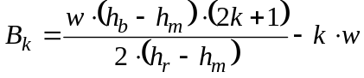

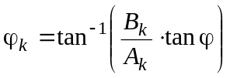

NoLoS in street canyons for sub-1 GHz band
For this NLoS situation both antennas are below roof-top level (see Figure 3 for reference).

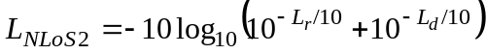 Equation 4

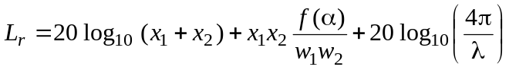
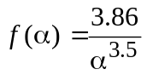 , 0.6 < α < π.

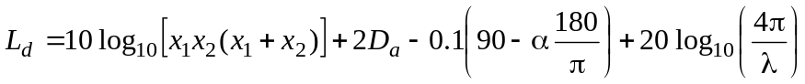

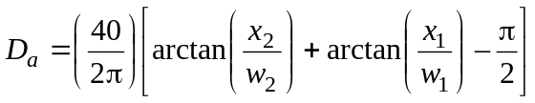

NoLoS in street canyons for 2.4 GHz and 5 GHz bands
This NLoS propagation model is described in 2.1.4 with the corner angle α = π/2. Such model assumes h_{b} < h_{r} and w₂ is up to 10 m (or sidewalk). Using x₁, x₂, and w_{1,} as shown in Figure 3, the overall path loss (L_{NLoS2}) beyond the corner region (x₂ > w₁/2 + 1) is given by
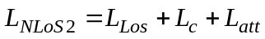 Equation 5

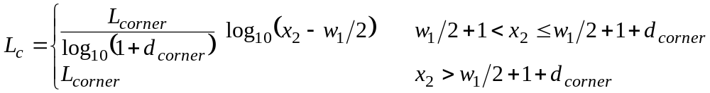

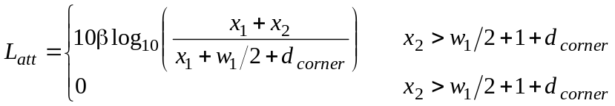
where L_{LoS} is the path loss in the LoS street for x₁ (> 20 m) is given in Equation 5. L_{corner} is given as 20 dB in an urban environment and 30 dB in a residential environment. d_{corner} is 30 m and β is 6 in both environments.

Outdoor Path Loss for UWB band
The outdoor path loss model for UWB band is based in the final report for UWB channel models document of former IEEE802.15.4a TG, as the propagation situations are the same for IEEE802.15.8 TG.
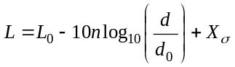 Equation 6
where d₀=1m is the reference distance, L₀ is path loss at the reference distance and n is path loss exponent.
L₀= -45.6 (LOS) , -73.0 (NLOS).
n= 1.76 (LOS) , 2.5 (NLOS).
=1.9 (LOS), =3.9 (NLOS)
d is valid up to 17m.

Indoor Path Loss

Attenuation Factor Model for 900 MHz band
An indoor propagation model that includes the effect of the building type and variations caused by obstacles is describe by Sei92b. This model is flexible and more accurate than the conventional log distance path loss model. The path loss is given by
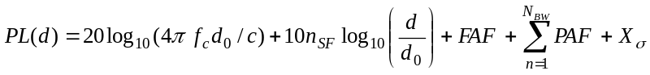 Equation 7
where d₀ is a reference distance, c is the speed of light, n_{SF} is the exponent of the same floor measurement. FAF is the floor attenuation factor for a specified number of building floors, PAF represents the partition attenuation factor for a specific obstruction encountered by a ray drawn between transmitter and receiver. X_{σ} represents a normal random variable in dB having a standard deviation of σ dB.
Alternatively, FAF may be replaced by n_{MF}, an exponent that considers the effects of multiple floor separation.
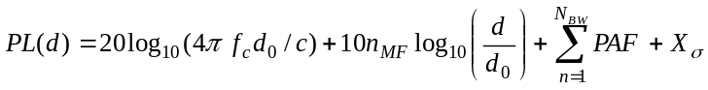 Equation 8

Example: An estimate of the path loss from a distance of 30m, through 3 floors of office building 1. Assume that 2 concrete block walls are between transmitter and receiver on the intermediate floors.
The mean path loss exponent for the same floor measurements in a building is n=3.27 (see Table 3). The mean path loss exponent for the three-floor measurements in a building is n=5.22 (see Table 3). The average floor attenuation factor for 3 floors is FAF=24.4 dB (see Table 2). The average attenuation for concrete block wall is PAF=13 dB (see Table 4) and N_{BW}=2. The reference distance is d₀=1m and f_{c}=900 MHz.
The mean path loss (without shadowing) using Equation 7 is given by
PL(30m)=31.5266+10*3.27log₁₀(30)+24.4+2*13=130.2 dB
The mean path loss (without shadowing) using Equation 8 is given by
PL(30m)=31.5266+10*5.22log₁₀(30)+2*13=134.6 dB

Table 2 Average floor attenuation factor in two office buildings
Building | FAF (dB) | σ (dB)
Office building 1
Through 1 floor | 12.9 | 7.0
Through 2 floor | 18.7 | 2.8
Through 3 floor | 24.4 | 1.7
Through 4 floor | 27.0 | 1.5
Office building 2
Through 1 floor | 16.2 | 2.9
Through 2 floor | 27.5 | 5.4
Through 3 floor | 31.6 | 7.2

Table 3 Path loss exponent for various types of buildings
Building | n | σ (dB)
All buildings
All locations | 3.14 | 16.3
Same floor | 2.76 | 12.9
Through 1 floor | 4.19 | 5.1
Through 2 floor | 5.04 | 6.5
Through 3 floor | 5.22 | 6.7
Grocery store | 1.81 | 5.2
Retail store | 2.18 | 8.7
Office building 1
Entire building | 3.54 | 12.8
Same floor | 3.27 | 11.2
West wing 5th floor | 2.68 | 8.1
Central Wing 5th floor | 4.01 | 4.3
West wing 4th floor | 3.18 | 4.4
Office building 2
Entire building | 4.33 | 13.3
Same floor | 3.25 | 5.2

Table 4 Average signal loss measurements for radio paths obstructed by common building materials
Material type | Loss (dB) | Frequency (MHz)
All metal | 26 | 815
Aluminum siding | 20.4 | 815
Foil insulation | 3.9 | 815
Concrete block wall | 13 | 1300
Metallic inventory | 4 - 7 | 1300
Loss from 1 floor | 20 - 30 | 1300
Ceiling duct | 1 - 8 | 1300

Indoor Path Loss for 2.4 GHz and 5 GHz bands
The site-specific model of Recommendation ITU-R P.1238-7 propagation and prediction methods for the planning of indoor radio communication systems and radio local area networks in the frequency range 900 MHz to 100 GHz is employed. Such propagation model would have the option of explicitly accounting for the loss due to each wall instead of including it in the distance model.

Ltotal = 20 log10 f + n log10 d + Lf (n) – 28 Equation 9
where:
n : distance power loss coefficient;
f : frequency (MHz);
d : separation distance (m) between the base station and portable terminal (where d > 1 m);
L_{f} : floor penetration loss factor (dB);
n : number of floors between base station and portable terminal (n ≥ 1).
Typical parameters are given in Table 5 and Table 6.

Table 5 Power loss coefficient, n.
Frequency | Residential | Office | Commercial
1.8-2 GHz | 28 | 30 | 22
2.4 GHz | 28 | 30
3.5 GHz |  | 27
4 GHz | – | 28 | 22
5.2 GHz | 30 (apartment)  28 (house) ⁽²⁾ | 31 | –
5.8 GHz |  | 24
²Apartment: Single or double storey dwellings for several households. In general most walls separating rooms are concrete walls.
House: Single or double storey dwellings for a household. In general most walls separating rooms are wooden walls.

Table 6 Floor penetration factor, L_{f}, with n being the number of floors penetrated.
Frequency | Residential | Office | Commercial
1.8-2 GHz | 4 n | 15 + 4 (n – 1) | 6 + 3 (n – 1)
2.4 GHz | 10⁽¹⁾ (apartment)  5 (house) | 14
3.5 GHz |  | 18 (1 floor)  26 (2 floors)
5.2 GHz | 13⁽¹⁾ (apartment)  7⁽²⁾ (house) | 16 (1 floor) | –
5.8 GHz |  | 22 (1 floor)  28 (2 floors)
⁽¹⁾ Per concrete wall.
⁽²⁾ Wooden mortar.

Indoor Path Loss for UWB band
The outdoor path loss model for UWB band is based in the final report for UWB channel models document of former IEEE802.15.4a TG, as the propagation situations are the same for IEEE802.15.8 TG.
Equation 10
where d₀=1m is the reference distance, L₀ is path loss at the reference distance, n is path loss exponent and 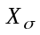is a normal random variable in dB with standard deviation in dB.
Residential:
L₀= -43.9 (LOS) , -48.7 (NLOS).
n= 1.79 (LOS) , 4.58 (NLOS).
is not specified.
d is valid up to 20m.
Indoor Office:
L₀= -35.4 (LOS) , -59.9 (NLOS).
n= 1.63 (LOS) , 3.07 (NLOS).
=1.9 (LOS), =3.9 (NLOS)
d is valid up to 28m.

Small-Scale Fading

SISO ITU models
For the frequency bands and bandwidths targeted by TG8, extensive measurement datasets for SISO (single-input single-output) channel modeling were performed throughout the 1980s and 1990s, like projects COST207, COST231, COST259, etc. Most of these channel models form a basis for the ITU models, which were largely applied in the development of the third generation wireless communication systems.

The ITU profiles model the temporal dispersion of the time-variant wireless channel 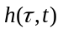, as a discrete tapped-delay-line with K taps given by

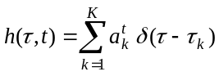 Equation 11
The tapped-delay-line model represents a wide sense stationary uncorrelated scattering (WSSUS) channel as long as the time-variant tap coefficients 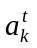 are uncorrelated Gaussian random processes with a Doppler power spectrum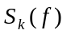. Such power spectrum could be either the classic (Jakes) Doppler spectrum or flat Doppler spectrum.

The classic Doppler spectrum is given by
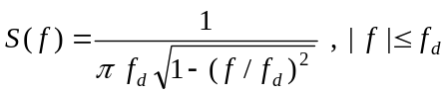

The flat Doppler spectrum is given by
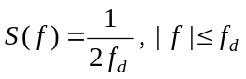
where 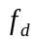is the maximum Doppler shift or Doppler spread:
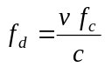
v is the relative velocity, f_{c} is the carrier frequency and c is the speed of light.

Table 7 ITU Indoor office
Tap | Relative delay (ns) | Average power (dB) | Doppler spectrum
1 | 0 | 0 | flat
2 | 50 | -3 | flat
3 | 110 | -10 | flat
4 | 170 | -18 | flat
5 | 290 | -26 | flat
6 | 310 | -32 | flat

Table 8 ITU outdoor to indoor and pedestrian
Tap | Relative delay (ns) | Average power (dB) | Doppler spectrum
1 | 0 | 0 | classic
2 | 110 | -9.7 | classic
3 | 190 | -19.2 | classic
4 | 410 | -22.8 | classic

Table 9 ITU vehicular (high antenna)
Tap | Relative delay (ns) | Average power (dB) | Doppler spectrum
1 | 0 | 0 | classic
2 | 310 | -1 | classic
3 | 710 | -9 | classic
4 | 1090 | -10 | classic
5 | 1730 | -15 | classic
6 | 2510 | -20 | classic

MatLab™ code
The following scripts were written in MatLabR2011 and the Communications Toolbox.

% %
% function [h] = ITUchannel(model,fd,Ts) %
% %
% Return object for FIR channel taps of ITU channel models %
% %
% INPUT PARAMETERS: %
% model = ITU channel model %
% fd = Maximum Doppler shift %
% Ts = Simulation sampling time %
% %
% OUTPUT VALUE: %
% h = complex channel taps %
% %
% Author: Marco Hernandez, v1.0 %
% ***************************************************************** %

function [h] = ITUchannel(model,fd,Ts)

switch model
case 'office'
% vector of path delays in sec
tau=[0 50 110 170 290 310]*1e-9;
% vector of average path power gains in dB
pdb=[0 -3 -10 -18 -26 -32];
case 'pedestrian'
tau=[0 110 190 410]*1e-9;
pdb=[0 -9.7 -19.2 -22.8];
case 'vehicular'
tau=[0 310 710 1090 1730 2510]*1e-9;
pdb=[0 -1 -9 -10 -15 -20];
otherwise
error('Model not implemented.');
end

% Object for Rayleigh channel with classic Doppler spectrum
h = rayleighchan(Ts,fd,tau,pdb);

% Choose flat Doppler spectrum for office scenario.
if strcmp(model,'office');
h.DopplerSpectrum=doppler.flat;
end

% The state of the channel object is not reset between calls.
% Hence, preserving continuity of the fading process across frames.
h.ResetBeforeFiltering=0;

end

SISO ITU extended models
The previous channel models were extended to include bandwidths in the order of 20 MHz to reflect the fact that the characteristics of the radio channel frequency response are connected to the delay resolution. Also, such extended channel models are applied with Doppler shift of 5 Hz, 70 Hz and 300 Hz, which at a carrier frequency of 2.5 GHz, correspond to mobile velocities of 2 km/h, 30 km/h and 130 km/h respectively.

Table 10 Extended ITU outdoor to indoor and pedestrian
Tap | Relative delay (ns) | Average power (dB) | Doppler spectrum
1 | 0 | 0 | classic
2 | 30 | -1 | classic
3 | 70 | -2 | classic
4 | 80 | -3 | classic
5 | 110 | -8 | classic
6 | 190 | -17.2 | classic
7 | 410 | -20.8 | classic

Table 11 Extended ITU vehicular
Tap | Relative delay (ns) | Average power (dB) | Doppler spectrum
1 | 0 | 0 | classic
2 | 30 | -1.5 | classic
3 | 150 | -1.4 | classic
4 | 310 | -3.6 | classic
5 | 370 | -0.6 | classic
6 | 710 | -9.1 | classic
7 | 1090 | -7 | classic
8 | 1730 | -12 | classic
9 | 2510 | -16.9 | classic

Table 12 Extended ITU typical urban
Tap | Relative delay (ns) | Average power (dB) | Doppler spectrum
1 | 0 | -1 | classic
2 | 50 | -1 | classic
3 | 120 | -1 | classic
4 | 200 | 0 | classic
5 | 230 | 0 | classic
6 | 500 | 0 | classic
7 | 1600 | -3 | classic
8 | 2300 | -5 | classic
9 | 5000 | -7 | classic

MatLab™ code
The following scripts were written in MatLabR2011 and the Communications Toolbox.

% %
% function [h] = ExtendedITUchannel(model,fd,Ts) %
% %
% Return object for FIR channel taps of Extended ITU channel models %
% %
% INPUT PARAMETERS: %
% model = Extended ITU channel model %
% fd = Maximum Doppler shift %
% Ts = Simulation sampling time %
% %
% OUTPUT VALUE: %
% h = complex channel taps %
% %
% Author: Marco Hernandez, v1.0 %
% ***************************************************************** %

function [h] = ExtendedITUchannel(model,fd,Ts)

switch model
case 'pedestrian'
% vector of path delays in sec
tau = [0 30 70 80 110 190 410]*1e-9;
% vector of average path power gains in dB
pdb = [0 -1 -2 -3 -8 -17.2 -20.8];
case 'vehicular'
tau=[0 30 150 310 370 710 1090 1730 2510]*1e-9;
pdb=[0 -1.5 -1.4 -3.6 -0.6 -9.1 -7 -12 -16.9];
case 'urban'
tau=[0 50 120 200 230 500 1600 2300 5000]*1e-9;
pdb=[-1 -1 -1 0 0 0 -3 -5 -7];
otherwise
error('Model not implemented.');
end

% Object for Rayleigh channel with classic Doppler spectrum
h = rayleighchan(Ts,fd,tau,pdb);

% The state of the channel object is not reset between calls.
% Hence, preserving continuity of the fading process across frames.
h.ResetBeforeFiltering=0;

end

Example of use:

Ts = 1e-6; % simulation sampling time: 1usec
fd = 100; % maximum Doppler shift: 100 Hz
model='vehicular';

% Create an instance of object ExtendedITUchannel
h=ExtendedITUchannel(model,fd,Ts);

% How to use "h" in Monte Carlo simulation
Nframes = 1000;
Nsamp = 1000;
for i = 1:Nframes
input = ones(1,Nsamp);
y = filter(h,input);
end

SISO ETSI BRAN 5 GHz channel model
For the development of the standard HiperLAN2, the ETSI BRAN Group worked out channel models in the 5 GHz band. There are five scenarios:

Table 13 5 GHz HiperLAN2 channel models
Model | RMS delay spread (ns) | Rice factor 1st tap (dB) | Scenario
A | 50 | 0 | Office
B | 100 | 0 | Open space NLOS/ office large delay spread
C | 150 | 0 | Large open space indoor/outdoor large delay spread
D | 140 | 10 | Large open space indoor LOS/outdoor
E | 250 | 0 | Large open space indoor/outdoor large delay spread

Table 14 Model A – office scenario NLOS and 50ns average rms delay spread.
Tap | Relative delay (ns) | Average power (dB) | Rice factor | Doppler spectrum
1 | 0 | 0 | 0 | classic
2 | 10 | -0.9 | 0 | classic
3 | 20 | -1.7 | 0 | classic
4 | 30 | -2.6 | 0 | classic
5 | 40 | -3.5 | 0 | classic
6 | 50 | -4.3 | 0 | classic
7 | 60 | -5.2 | 0 | classic
8 | 70 | -6.1 | 0 | classic
9 | 80 | -6.9 | 0 | classic
10 | 90 | -7.8 | 0 | classic
11 | 110 | -4.7 | 0 | classic
12 | 140 | -7.3 | 0 | classic
13 | 170 | -9.9 | 0 | classic
14 | 200 | -12.5 | 0 | classic
15 | 240 | -13.7 | 0 | classic
16 | 290 | -18 | 0 | classic
17 | 340 | -22.4 | 0 | classic
18 | 390 | -26.7 | 0 | classic

Table 15 Model B -large open space and office NLOS and 100ns average rms delay spread
Tap | Relative delay (ns) | Average power (dB) | Rice factor | Doppler spectrum
1 | 0 | -2.6 | 0 | classic
2 | 10 | -3 | 0 | classic
3 | 20 | -3.5 | 0 | classic
4 | 30 | -3.9 | 0 | classic
5 | 50 | 0 | 0 | classic
6 | 80 | -1.3 | 0 | classic
7 | 110 | -2.6 | 0 | classic
8 | 140 | -3.9 | 0 | classic
9 | 180 | -3.4 | 0 | classic
10 | 230 | -5.6 | 0 | classic
11 | 280 | -7.7 | 0 | classic
12 | 330 | -9.9 | 0 | classic
13 | 380 | -12.1 | 0 | classic
14 | 430 | -14.3 | 0 | classic
15 | 490 | -15.4 | 0 | classic
16 | 560 | -18.4 | 0 | classic
17 | 640 | -20.7 | 0 | classic
18 | 730 | -24.6 | 0 | classic

Table 16 Model C –large open space NLOS and 150 ns rms delay spread
Tap | Relative delay (ns) | Average power (dB) | Rice factor | Doppler spectrum
1 | 0 | -3.3 | 0 | classic
2 | 10 | -3.6 | 0 | classic
3 | 20 | -3.9 | 0 | classic
4 | 30 | -4.2 | 0 | classic
5 | 50 | 0 | 0 | classic
6 | 80 | -0.9 | 0 | classic
7 | 110 | -1.7 | 0 | classic
8 | 140 | -2.6 | 0 | classic
9 | 180 | -1.5 | 0 | classic
10 | 230 | -3 | 0 | classic
11 | 280 | -4.4 | 0 | classic
12 | 330 | -5.9 | 0 | classic
13 | 400 | -5.3 | 0 | classic
14 | 490 | -7.9 | 0 | classic
15 | 600 | -9.4 | 0 | classic
16 | 730 | -13.2 | 0 | classic
17 | 880 | -16.3 | 0 | classic
18 | 1050 | -21.2 | 0 | classic

Table 17 Model D –same as Model C but LOS
Tap | Relative delay (ns) | Average power (dB) | Rice factor | Doppler spectrum
1 | 0 | 0 | 10 | classic
2 | 10 | -10 | 0 | classic
3 | 20 | -10.3 | 0 | classic
4 | 30 | -10.6 | 0 | classic
5 | 50 | -6.4 | 0 | classic
6 | 80 | -7.2 | 0 | classic
7 | 110 | -8.1 | 0 | classic
8 | 140 | -9 | 0 | classic
9 | 180 | -7.9 | 0 | classic
10 | 230 | -9.4 | 0 | classic
11 | 280 | -10.8 | 0 | classic
12 | 330 | -12.3 | 0 | classic
13 | 400 | -11.7 | 0 | classic
14 | 490 | -14.3 | 0 | classic
15 | 600 | -15.8 | 0 | classic
16 | 730 | -19.6 | 0 | classic
17 | 880 | -22.7 | 0 | classic
18 | 1050 | -27.6 | 0 | classic
Table 18 Model E –large open space NLOS and 250 ns rms delay spread
Tap | Relative delay (ns) | Average power (dB) | Rice factor | Doppler spectrum
1 | 0 | -4.9 | 0 | classic
2 | 10 | -5.1 | 0 | classic
3 | 20 | -5.2 | 0 | classic
4 | 40 | -0.8 | 0 | classic
5 | 70 | -1.3 | 0 | classic
6 | 100 | -1.9 | 0 | classic
7 | 140 | -0.3 | 0 | classic
8 | 190 | -1.2 | 0 | classic
9 | 240 | -2.1 | 0 | classic
10 | 320 | 0 | 0 | classic
11 | 430 | -1.9 | 0 | classic
12 | 560 | -2.8 | 0 | classic
13 | 710 | -5.4 | 0 | classic
14 | 880 | -7.3 | 0 | classic
15 | 1070 | -10.6 | 0 | classic
16 | 1280 | -13.4 | 0 | classic
17 | 1510 | -17.4 | 0 | classic
18 | 1760 | -20.9 | 0 | classic

MatLab™ code
The following scripts are written in MatLabR2011 and the Communications Toolbox.
% %
% function [h] = ETSIchannel(model,fd,Ts) %
% %
% Return object for FIR channel taps of ETSI channel models %
% %
% INPUT PARAMETERS: %
% model = ETSI channel model %
% fd = Maximum Doppler shift %
% Ts = Simulation sampling time %
% %
% OUTPUT VALUE: %
% h = complex channel taps %
% %
% Author: Marco Hernandez, v1.0 %
% ***************************************************************** %

function [h] = ETSIchannel(model,fd,Ts)

switch model
case 'A'
% vector of path delays in sec
tau=[0 10 20 30 40 50 60 70 80 90 110 140 170 200 240 290 340 390]*1e-9;
% vector of average path power gains in dB
pdb=[0 -0.9 -1.7 -2.6 -3.5 -4.3 -5.2 -6.1 -6.9 -7.8 -4.7 -7.3 -9.9 -12.5 -13.7 -18 -22.4 -26.7];
% K factor of Rician model per path
kFactor=zeros(1,18);
case 'B'
tau=[0 10 20 30 50 80 110 140 180 230 280 330 380 430 490 560 640 730]*1e-9;
pdb=[-2.6 -3 -3.5 -3.9 0 -1.3 -2.6 -3.9 -3.4 -5.6 -7.7 -9.9 -12.1 -14.3 -15.4 -18.4 -20.7 -24.6];
kFactor=zeros(1,18);
case 'C'
tau=[0 10 20 30 50 80 110 140 180 230 280 330 400 490 600 730 880 1050]*1e-9;
pdb=[-3.3 -3.6 -3.9 -4.2 0 -0.9 -1.7 -2.6 -1.5 -3 -4.4 -5.9 -5.3 -7.9 -9.4 -13.2 -16.3 -21.2];
kFactor=zeros(1,18);
case 'D'
tau=[0 10 20 30 50 80 110 140 180 230 280 330 400 490 600 730 880 1050]*1e-9;
pdb=[0 -10 -10.3 -10.6 -6.4 -7.2 -8.1 -9 -7.9 -9.4 -10.8 -12.3 -11.7 -14.3 -15.8 -19.6 -22.7 -27.6];
kFactor=zeros(1,18); kFactor(1)=10;
case 'E'
tau=[0 10 20 40 70 100 140 190 240 320 430 560 710 880 1070 1280 1510 1760]*1e-9;
pdb=[-4.9 -5.1 -5.2 -0.8 -1.3 -1.9 -0.3 -1.2 -2.1 0 -1.9 -2.8 -5.4 -7.3 -0.6 -13.4 -17.4 -20.9];
kFactor=zeros(1,18);
otherwise
error('Model not implemented.');
end

% Object for Rician channel with classic Doppler spectrum
h = ricianchan(Ts,fd,kFactor,tau,pdb);

% The state of the channel object is not reset between calls.
% Hence, preserving continuity of the fading process across frames.
h.ResetBeforeFiltering=0;

end

UWB Channel model
The UWB channel impulse responses are taken from the channel models document of former IEEE802.15.4a TG. Scenarios, bandwidths and central frequencies are similar to the ones targeted for IEEE802.15.8 TG. The MatLab code is attach in Annex A.

MIMO channel models
TBD

Bibliography
[1] Recommendation ITU-R P.1411-6 Propagation data and prediction methods for the planning of short-range outdoor radio communication systems and radio local area networks in the frequency range 300 MHz to 100 GHz.
[2] Seidel S., Rappaport T., “914 MHz Path Loss Prediction Models for Indoor Wireless Communications in Multifloor Buildings”, IEEE Transactions on Antennas and Propagation, Vol 40, No 2, February 1992, pp207-217.
[3] Recommendation ITU-R P.1238-7 Propagation data and prediction methods for the planning of indoor radio communication systems and radio local area networks in the frequency range 900 MHz to 100 GHz.
[4] IEEE802.15-04-0662-04-004a-channel-model-final-report-r1
[5] Recommendation ITU-R M. 1225 Guidelines for evaluation of radio transmission technologies for IMT-2000.
[6] T.B. Sørensen, P.E. Mogensen, and F. Frederiksen, “Extension of the ITU Channel Models for Wideband (OFDM) Systems”, in Proc. IEEE Vehicular Technology Conf., Dallas, USA, Sept. 2005.
[7] ETSI BRAN, 3ER1085B, Channel models for HiperLAN2

Annex A – Matlab code for IEEE802.15.4a UWB channel model

% modified S-V channel model evaluation
%%Written by Sun Xu, Kim Chee Wee, B. Kannan & Francois Chin on 22/02/2005
clear;
no_output_files = 1; % non-zero: avoids writing output files of continuous-time responses
num_channels = 100; % number of channel impulse responses to generate
randn(’state’,12); % initialize state of function for repeatability
rand(’state’,12); % initialize state of function for repeatability
cm_num = 6; % channel model number from 1 to 8
% get channel model params based on this channel model number
[Lam,Lmean,lambda_mode,lambda_1,lambda_2,beta,Gam,gamma_0,Kgamma, ...
sigma_cluster,nlos,gamma_rise,gamma_1,chi,m0,Km,sigma_m0,sigma_Km, ...
sfading_mode,m0_sp,std_shdw,kappa,fc,fs] = uwb_sv_params_15_4a( cm_num );
fprintf(1,[’Model Parameters\n’ ...
’ Lam = %.4f, Lmean = %.4f, lambda_mode(FLAG) = %d\n’ ...
’ lambda_1 = %.4f, lambda_2 = %.4f, beta = %.4f\n’ ...
’ Gam = %.4f, gamma0 = %.4f, Kgamma = %.4f, sigma_cluster = %.4f\n’ ...
’ nlos(FLAG) = %d, gamma_rise = %.4f, gamma_1 = %.4f, chi = %.4f\n’ ...
’ m0 = %.4f, Km = %.4f, sigma_m0 = %.4f, sigma_Km = %.4f\n’ ...
’ sfading_mode(FLAG) = %d, m0_sp = %.4f, std_shdw = %.4f\n’, ...
’ kappa = %.4f, fc = %.4fGHz, fs = %.4fGHz\n’], ...
Lam,Lmean,lambda_mode,lambda_1,lambda_2,beta,Gam,gamma_0,Kgamma, ...
sigma_cluster,nlos,gamma_rise,gamma_1,chi,m0,Km,sigma_m0,sigma_Km,...
sfading_mode,m0_sp,std_shdw,kappa,fc,fs);
ts = 1/fs; % sampling frequency
% get a bunch of realizations (impulse responses)
[h_ct,t_ct,t0,np] = uwb_sv_model_ct_15_4a(Lam,Lmean,lambda_mode,lambda_1, ...
lambda_2,beta,Gam,gamma_0,Kgamma,sigma_cluster,nlos,gamma_rise,gamma_1, ...
chi,m0,Km,sigma_m0,sigma_Km,sfading_mode,m0_sp,std_shdw,num_channels,ts);
% change to complex baseband channel
h_ct_len = size(h_ct, 1);
phi = zeros(h_ct_len, 1);
for k = 1:num_channels
phi = rand(h_ct_len, 1).*(2*pi);
h_ct(:,k) = h_ct(:,k) .* exp(phi .* i);
end
% now reduce continuous-time result to a discrete-time result
[hN,N] = uwb_sv_cnvrt_ct_15_4a( h_ct, t_ct, np, num_channels, ts );
if N > 1,
h = resample(hN, 1, N); % decimate the columns of hN by factor N
else
h = hN;
end
% add the frequency dependency
[h]= uwb_sv_freq_depend_ct_15_4a(h,fc,fs,num_channels,kappa);
%********************************************************************
% Testing and ploting
%********************************************************************
% channel energy
channel_energy = sum(abs(h).^2);
h_len = length(h(:,1));
t = [0:(h_len-1)] * ts; % for use in computing excess & RMS delays
excess_delay = zeros(1,num_channels);
RMS_delay = zeros(1,num_channels);
num_sig_paths = zeros(1,num_channels);
num_sig_e_paths = zeros(1,num_channels);
for k=1:num_channels
% determine excess delay and RMS delay
sq_h = abs(h(:,k)).^2 / channel_energy(k);
t_norm = t - t0(k); % remove the randomized arrival time of first cluster
excess_delay(k) = t_norm * sq_h;
RMS_delay(k) = sqrt( ((t_norm-excess_delay(k)).^2) * sq_h );
% determine number of significant paths (paths within 10 dB from peak)
threshold_dB = -10; % dB
temp_h = abs(h(:,k));
temp_thresh = 10^(threshold_dB/20) * max(temp_h);
num_sig_paths(k) = sum(temp_h > temp_thresh);
% determine number of sig. paths (captures x % of energy in channel)
x = 0.85;
temp_sort = sort(temp_h.^2); % sorted in ascending order of energy
cum_energy = cumsum(temp_sort(end:-1:1)); % cumulative energy
index_e = min(find(cum_energy >= x * cum_energy(end)));
num_sig_e_paths(k) = index_e;
end
energy_mean = mean(10*log10(channel_energy));
energy_stddev = std(10*log10(channel_energy));
mean_excess_delay = mean(excess_delay);
mean_RMS_delay = mean(RMS_delay);
mean_sig_paths = mean(num_sig_paths);
mean_sig_e_paths = mean(num_sig_e_paths);
fprintf(1,’Model Characteristics\n’);
fprintf(1,’ Mean delays: excess (tau_m) = %.1f ns, RMS (tau_rms) = %1.f\n’, ...
mean_excess_delay, mean_RMS_delay);
fprintf(1,’ # paths: NP_10dB = %.1f, NP_85%% = %.1f\n’, ...
mean_sig_paths, mean_sig_e_paths);
fprintf(1,’ Channel energy: mean = %.1f dB, std deviation = %.1f dB\n’, ...
energy_mean, energy_stddev);
figure(1); clf; plot(t, abs(h)); grid on
title(’Impulse response realizations’)
xlabel(’Time (nS)’)
figure(2); clf; plot([1:num_channels], excess_delay, ’b-’, ...
[1 num_channels], mean_excess_delay*[1 1], ’r–’ );
grid on
title(’Excess delay (nS)’)
xlabel(’Channel number’)
figure(3); clf; plot([1:num_channels], RMS_delay, ’b-’, ...
[1 num_channels], mean_RMS_delay*[1 1], ’r–’ );
grid on
title(’RMS delay (nS)’)
xlabel(’Channel number’)
figure(4); clf; plot([1:num_channels], num_sig_paths, ’b-’, ...
[1 num_channels], mean_sig_paths*[1 1], ’r–’);
grid on
title(’Number of significant paths within 10 dB of peak’)
xlabel(’Channel number’)
figure(5); clf; plot([1:num_channels], num_sig_e_paths, ’b-’, ...
[1 num_channels], mean_sig_e_paths*[1 1], ’r–’);
grid on
title(’Number of significant paths capturing > 85% energy’)
xlabel(’Channel number’)
temp_average_power = sum((abs(h))’.*(abs(h))’, 1)/num_channels;
temp_average_power = temp_average_power/max(temp_average_power);
average_decay_profile_dB = 10*log10(temp_average_power);
threshold_dB = -40;
above_threshold = find(average_decay_profile_dB > threshold_dB);
ave_t = t(above_threshold);
apdf_dB = average_decay_profile_dB(above_threshold);
figure(6); clf; plot(ave_t, apdf_dB); grid on
title(’Average Power Decay Profile’)
xlabel(’Delay (nsec)’)
ylabel(’Average power (dB)’)
if no_output_files,
return
end
%**************************************************************************
%Savinge the data
%**************************************************************************
%%% save continuous-time (time,value) pairs to files
save_fn = sprintf(’cm%d_imr’, cm_num);
% A complete self-contained file for Matlab users
save([save_fn ’.mat’], ’t’, ’h’,’t_ct’, ’h_ct’, ’t0’, ’np’, ’num_channels’, ’cm_num’);
% Three comma-delimited text files for non-Matlab users:
% File #1: cmX_imr_np.csv lists the number of paths in each realization
dlmwrite([save_fn ’_np.csv’], np, ’,’); % number of paths
% File #2: cmX_imr_ct.csv can open with Excel
% n’th pair of columns contains the (time,value) pairs for the n’th realization
% save continous time data
th_ct = zeros(size(t_ct,1),3*size(t_ct,2));
th_ct(:,1:3:end) = t_ct; % time
th_ct(:,2:3:end) = abs(h_ct); % magnitude
th_ct(:,3:3:end) = angle(h_ct); % phase (radians)
fid = fopen([save_fn ’_ct.csv’], ’w’);
if fid < 0,
error(’unable to write .csv file for impulse response, file may be open in another application’);
end
for k = 1:size(th_ct,1)
fprintf(fid,’%.4f,%.6f,’, th_ct(k,1:end-2));
fprintf(fid,’%.4f,%.6f\r\n’, th_ct(k,end-1:end)); % \r\n for Windoze end-of-line
end
fclose(fid);
% File #3: cmX_imr_dt.csv can open with Excel
% discrete channel impulse response magnitude and phase pair realization.
% the first column is time. phase is in radians
% save discrete time data
th = zeros(size(h,1),2*size(h,2)+1);
th(:,1) = t’; % the first column is time scale
th(:,2:2:end) = abs(h); % even columns are magnitude
th(:,3:2:end) = angle(h); % odd columns are phase
fid = fopen([save_fn ’_dt.csv’], ’w’);
if fid < 0,
error(’unable to write .csv file for impulse response, file may be open in another application’);
end
for k = 1:size(th,1)
fprintf(fid,’%.4f,%.6f,’, th(k,1:end-2));
fprintf(fid,’%.4f,%.6f\r\n’, th(k,end-1:end)); % \r\n for Windoze end-of-line
end
fclose(fid);
return; % end of program
function [Lam,Lmean,lambda_mode,lambda_1,lambda_2,beta,Gam,gamma_0,Kgamma, ...
sigma_cluster,nlos,gamma_rise,gamma_1,chi,m0,Km,sigma_m0,sigma_Km, ...
sfading_mode,m0_sp,std_shdw,kappa,fc,fs] = uwb_sv_params_15_4a( cm_num )
% Written by Sun Xu, Kim Chee Wee, B. Kannan & Francois Chin on 22/02/2004
% Return modified S-V model parameters for standard UWB channel models
%————————————————————————–
% Lam Cluster arrival rate (clusters per nsec)
% Lmean Mean number of Clusters
% lambda_mode Flag for Mixture of poission processes for ray arrival times
% 1 -> Mixture of poission processes for the ray arrival times
% 2 -> tapped delay line model
% lambda_1 Ray arrival rate for Mixture of poisson processes (rays per nsec)
% lambda_2 Ray arrival rate for Mixture of poisson processes (rays per nsec)
% beta Mixture probability
%————————————————————————–
% Gam Cluster decay factor (time constant, nsec)
% gamma0 Ray decay factor (time constant, nsec)
% Kgamma Time dependence of ray decay factor
% sigma_cluster Standard deviation of normally distributed variable for cluster energy
% nlos Flag for non line of sight channel
% 0 -> LOS
% 1 -> NLOS with first arrival path starting at t ~= 0
% 2 -> NLOS with first arrival path starting at t = 0 and diffused first cluster
% gamma_rise Ray decay factor of diffused first cluster (time constant, nsec)
% gamma_1 Ray decay factor of diffused first cluster (time constant, nsec)
% chi Diffuse weight of diffused first cluster
%————————————————————————–
% m0 Mean of log-normal distributed nakagami-m factor
% Km Time dependence of m0
% sigma_m0 Standard deviation of log-normal distributed nakagami-m factor
% sigma_Km Time dependence of sigma_m0
% sfading_mode Flag for small-scale fading
% 0 -> All paths have same m-factor distribution
% 1 -> LOS first path has a deterministic large m-factor
% 2 -> LOS first path of each cluster has a deterministic
% large m-factor
% m0_sp Deterministic large m-factor
%————————————————————————–
% std_shdw Standard deviation of log-normal shadowing of entire impulse response
%————————————————————————–
% kappa Frequency dependency of the channel
%————————————————————————–
% fc Center Frequency
% fs Frequency Range
%%
modified by I2R
if cm_num == 1, % Residential LOS
% MPC arrival
Lam = 0.047; Lmean = 3;
lambda_mode = 1;
lambda_1 = 1.54; lambda_2 = 0.15; beta = 0.095;
%MPC decay
Gam = 22.61; gamma_0 = 12.53; Kgamma = 0; sigma_cluster = 2.75;
nlos = 0;
gamma_rise = NaN; gamma_1 = NaN; chi = NaN; % dummy in this scenario
% Small-scale Fading
m0 = 0.67; Km = 0; sigma_m0 = 0.28; sigma_Km = 0;
sfading_mode = 0; m0_sp = NaN;
% Large-scale Fading – Shadowing
std_shdw = 2.22;
% Frequency Dependence
kappa = 1.12;
fc = 6; % GHz
fs = 8; % 2 - 10 GHz
elseif cm_num == 2, % Residential NLOS
% MPC arrival
Lam = 0.12; Lmean = 3.5;
lambda_mode = 1;
lambda_1 = 1.77; lambda_2 = 0.15; beta = 0.045;
%MPC decay
Gam = 26.27; gamma_0 = 17.5; Kgamma = 0; sigma_cluster = 2.93;
nlos = 1;
gamma_rise = NaN; gamma_1 = NaN; chi = NaN; % dummy in this scenario
% Small-scale Fading
m0 = 0.69; Km = 0; sigma_m0 = 0.32; sigma_Km = 0;
sfading_mode = 0; m0_sp = NaN;
% Large-scale Fading – Shadowing
std_shdw = 3.51;
% Frequency Dependence
kappa = 1.53;
fc = 6; % GHz
fs = 8; % 2 - 10 GHz
elseif cm_num == 3, % Office LOS
% MPC arrival
Lam = 0.016; Lmean = 5.4;
lambda_mode = 1;
lambda_1 = 0.19; lambda_2 = 2.97; beta = 0.0184;
%MPC decay
Gam = 14.6; gamma_0 = 6.4; Kgamma = 0; sigma_cluster = 3; % assumption
nlos = 0;
gamma_rise = NaN; gamma_1 = NaN; chi = NaN; % dummy in this scenario
% Small-scale Fading
m0 = 0.42; Km = 0; sigma_m0 = 0.31; sigma_Km = 0;
sfading_mode = 2; m0_sp = 3; % assumption
% Large-scale Fading – Shadowing
std_shdw = 0; %1.9;
% Frequency Dependence
kappa = 0.03;
fc = 6; % GHz
fs = 8; % 3 - 6 GHz
elseif cm_num == 4, % Office NLOS
% MPC arrival
Lam = 0.19; Lmean = 3.1;
lambda_mode = 1;
lambda_1 = 0.11; lambda_2 = 2.09; beta = 0.0096;
%MPC decay
Gam = 19.8; gamma_0 = 11.2; Kgamma = 0; sigma_cluster = 3; % assumption
nlos = 2;
gamma_rise = 15.21; gamma_1 = 11.84; chi = 0.78;
% Small-scale Fading
m0 = 0.5; Km = 0; sigma_m0 = 0.25; sigma_Km = 0;
sfading_mode = 0; m0_sp = NaN; % assumption
% Large-scale Fading – Shadowing
std_shdw = 3.9;
% Frequency Dependence
kappa =0.71;
fc = 6; % GHz
fs = 8; % 3 - 6 GHz
elseif cm_num == 5, % Outdoor LOS
% MPC arrival
Lam = 0.0448; Lmean = 13.6;
lambda_mode = 1;
lambda_1 = 0.13; lambda_2 = 2.41; beta = 0.0078;
%MPC decay
Gam = 31.7; gamma_0 = 3.7; Kgamma = 0; sigma_cluster = 3; % assumption
nlos = 0;
gamma_rise = NaN; gamma_1 = NaN; chi = NaN; % dummy in this scenario
% Small-scale Fading
m0 = 0.77; Km = 0; sigma_m0 = 0.78; sigma_Km = 0;
sfading_mode = 2; m0_sp = 3; % assumption
% Large-scale Fading – Shadowing
std_shdw = 0.83;
% Frequency Dependence
kappa = 0.12;
fc = 6; % GHz
fs = 8; % 3 - 6 GHz
elseif cm_num == 6, % Outdoor NLOS
% MPC arrival
Lam = 0.0243; Lmean = 10.5;
lambda_mode = 1;
lambda_1 = 0.15; lambda_2 = 1.13; beta = 0.062;
%MPC decay
Gam = 104.7; gamma_0 = 9.3; Kgamma = 0; sigma_cluster = 3; % assumption
nlos = 1;
gamma_rise = NaN; gamma_1 = NaN; chi = NaN; % dummy in this scenario
% Small-scale Fading
m0 = 0.56; Km = 0; sigma_m0 = 0.25; sigma_Km = 0;
sfading_mode = 0; m0_sp = NaN; % assumption
% Large-scale Fading – Shadowing
std_shdw = 2; % assumption
% Frequency Dependence
kappa = 0.13;
fc =6; % GHz
fs = 8; % 3 - 6 GHz
elseif cm_num == 7, % Industrial LOS
% MPC arrival
Lam = 0.0709; Lmean = 4.75;
lambda_mode = 2;
lambda_1 = 1; lambda_2 = 1; beta = 1; % dummy in this scenario
%MPC decay
Gam = 13.47; gamma_0 = 0.615; Kgamma = 0.926; sigma_cluster = 4.32;
nlos = 0;
gamma_rise = NaN; gamma_1 = NaN; chi = NaN; % dummy in this scenario
% Small-scale Fading
m0 = 0.36; Km = 0; sigma_m0 = 1.13; sigma_Km = 0;
sfading_mode = 1; m0_sp = 12.99;
% Large-scale Fading – Shadowing
std_shdw = 6;
% Frequency Dependence
kappa = -1.103;
fc = 6; % GHz
fs = 8; % 2 - 8 GHz
elseif cm_num == 8, % Industrial NLOS
% MPC arrival
Lam = 0.089; Lmean = 1;
lambda_mode = 2;
lambda_1 = 1; lambda_2 = 1; beta = 1; % dummy in this scenario
%MPC decay
Gam = 5.83; gamma_0 = 0.3; Kgamma = 0.44; sigma_cluster = 2.88;
nlos = 2;
gamma_rise = 47.23; gamma_1 = 84.15; chi = 0.99;
% Small-scale Fading
m0 = 0.3; Km = 0; sigma_m0 = 1.15; sigma_Km = 0;
sfading_mode = 0; m0_sp = NaN; % m0_sp is assumption
% Large-scale Fading – Shadowing
std_shdw = 6;
% Frequency Dependence
kappa = -1.427;
fc = 6; % GHz
fs = 8; % 2 - 8 GHz
elseif cm_num == 9, % Open Outdoor Environment NLOS (Fram, Snow-Covered Open Area)
% MPC arrival
Lam = 0.0305; Lmean = 3.31;
lambda_mode = 1;
lambda_1 = 0.0225; lambda_2 = 1; beta = 1;
%MPC decay
Gam = 56; gamma_0 = 0.92; Kgamma = 0; sigma_cluster = 3; % sigma_cluster is assumption
nlos = 1;
gamma_rise = NaN; gamma_1 = NaN; chi = NaN;
% Small-scale Fading
m0 = 4.1; Km = 0; sigma_m0 = 2.5; sigma_Km = 0;
sfading_mode = 0; m0_sp = NaN; % m0_sp is assumption
% Large-scale Fading – Shadowing
std_shdw = 3.96;
% Frequency Dependence
kappa = -1; % Kappa is assumption
fc = 6; % GHz
fs = 8; % 2 - 8 GHz
else
error(’cm_num is wrong!!’)
end
return
function [h]= uwb_sv_freq_depend_ct_15_4a(h,fc,fs,num_channels,kappa)
% This function is used to include the frequency dependency
f0 = 5; % GHz
h_len = length(h(:,1));
f = [fc-fs/2 : fs/h_len/2 : fc+fs/2]./f0;
f = f.^(-2*(kappa));
f = [f(h_len : 2*h_len), f(1 : h_len-1)]’;
i = (-1)^(1/2); % complex i
for c = 1:num_channels
% add the frequency dependency
h2 = zeros(2*h_len, 1);
h2(1 : h_len) = h(:,c); % zero padding
fh2 = fft(h2);
fh2 = fh2 .* f;
h2 = ifft(fh2);
h(:,c) = h2(1:h_len);
% Normalize the channel energy to 1
h(:,c) = h(:,c)/sqrt(h(:,c)’ * h(:,c) );
end
return
function [h,t,t0,np] = uwb_sv_model_ct_15_4a(Lam,Lmean,lambda_mode,lambda_1, ...
lambda_2,beta,Gam,gamma_0,Kgamma,sigma_cluster,nlos,gamma_rise,gamma_1, ...
chi,m0,Km,sigma_m0,sigma_Km,sfading_mode,m0_sp,std_shdw,num_channels,ts)
% Written by Sun Xu, Kim Chee Wee, B. Kannan & Francois Chin on 22/02/2005
% IEEE 802.15.4a UWB channel model for PHY proposal evaluation
% continuous-time realization of modified S-V channel model
% Input parameters:
% detailed introduction of input parameters is at uwb_sv_params.m
% num_channels number of random realizations to generate
% Outputs
% h is returned as a matrix with num_channels columns, each column
% holding a random realization of the channel model (an impulse response)
% t is organized as h, but holds the time instances (in nsec) of the paths whose
% signed amplitudes are stored in h
% t0 is the arrival time of the first cluster for each realization
% np is the number of paths for each realization.
% Thus, the k’th realization of the channel impulse response is the sequence
% of (time,value) pairs given by (t(1:np(k),k), h(1:np(k),k))
%%
modified by I2R
% initialize and precompute some things
std_L = 1/sqrt(2*Lam); % std dev (nsec) of cluster arrival spacing
std_lam_1 = 1/sqrt(2*lambda_1);
std_lam_2 = 1/sqrt(2*lambda_2);
% std_lam = 1/sqrt(2*lambda); % std dev (nsec) of ray arrival spacing
h_len = 1000; % there must be a better estimate of # of paths than this
ngrow = 1000; % amount to grow data structure if more paths are needed
h = zeros(h_len,num_channels);
t = zeros(h_len,num_channels);
t0 = zeros(1,num_channels);
np = zeros(1,num_channels);
for k = 1:num_channels % loop over number of channels
tmp_h = zeros(size(h,1),1);
tmp_t = zeros(size(h,1),1);
if nlos == 1,
Tc = (std_L*randn)^2 + (std_L*randn)^2; % First cluster random arrival
else
Tc = 0; % First cluster arrival occurs at time 0
end
t0(k) = Tc;
if nlos == 2 & lambda_mode == 2
L = 1; % for industrial NLOS environment
else
L = max(1, poissrnd(Lmean)); % number of clusters
end
%%%%%%%%%%%%%%%%%%%%%%%%%%%%%%%%%%%%%%%%%%%%%%%%%
if Kgamma ~= 0 & nlos == 0
Tcval = []; Tc_cluster= [];
Tc_cluster(1,1)=Tc;
for i_Tc=2:L+1
Tc_cluster(1,i_Tc)= Tc_cluster(1,i_Tc-1)+(std_L*randn)^2 + (std_L*randn)^2;
end
end
%%%%%%%%%%%%%%%%%%%%%%%%%%%%%%%%%%%%%%%%%%%%%%%%%
cluster_index = zeros(1,L);
path_ix = 0;
nak_m = [];
for ncluster = 1:L
% Determine Ray arrivals for each cluster
Tr = 0; % first ray arrival defined to be time 0 relative to cluster
cluster_index(ncluster) = path_ix+1; % remember the cluster location
gamma = Kgamma*Tc + gamma_0; % delay dependent cluster decay time
if nlos == 2 & ncluster == 1
gamma = gamma_1;
end
Mcluster = sigma_cluster*randn;
Pcluster = 10*log10(exp(-1*Tc/Gam))+Mcluster; % total cluster power
Pcluster = 10^(Pcluster*0.1);
%%%%%%%%%%%%%%%%%%%%%%%%%%%%%%%%%%%%%%%%
if Kgamma ~= 0 & nlos == 0
Tr_len=Tc_cluster(1,ncluster+1)-Tc_cluster(1,ncluster);
else
Tr_len = 10*gamma;
end
%%%%%%%%%%%%%%%%%%%%%%%%%%%%%%%%%%%%%%%
while (Tr < Tr_len),
t_val = (Tc+Tr); % time of arrival of this ray
if nlos == 2 & ncluster == 1
% equation (22)
h_val = Pcluster*(1-chi*exp(-Tr/gamma_rise))*exp(-Tr/gamma_1) ...
*(gamma+gamma_rise)/gamma/(gamma+gamma_rise*(1-chi));
else
% equation (19)
h_val = Pcluster/gamma*exp(-Tr/gamma)/(beta*lambda_1+(1-beta)*lambda_2+1);
end
path_ix = path_ix + 1; % row index of this ray
if path_ix > h_len,
% grow the output structures to handle more paths as needed
tmp_h = [tmp_h; zeros(ngrow,1)];
tmp_t = [tmp_t; zeros(ngrow,1)];
h = [h; zeros(ngrow,num_channels)];
t = [t; zeros(ngrow,num_channels)];
h_len = h_len + ngrow;
end
tmp_h(path_ix) = h_val;
tmp_t(path_ix) = t_val;
% if lambda_mode == 0
% Tr = Tr + (std_lam*randn)^2 + (std_lam*randn)^2;
if lambda_mode == 1
if rand < beta
Tr = Tr + (std_lam_1*randn)^2 + (std_lam_1*randn)^2;
else
Tr = Tr + (std_lam_2*randn)^2 + (std_lam_2*randn)^2;
end
elseif lambda_mode == 2
Tr = Tr + ts;
else
error(’lambda mode is wrong!’)
end
% generate log-normal distributed nakagami m-factor
m_mu = m0 - Km*t_val;
m_std = sigma_m0 - sigma_Km*t_val;
nak_m = [nak_m, lognrnd(m_mu, m_std)];
end
Tc = Tc + (std_L*randn)^2 + (std_L*randn)^2;
%%%%%%%%%%%%%%%%%%%%%%%%%%%%%%%%%%%%%%%%%%%%%
if Kgamma ~= 0 & nlos == 0
Tc = Tc_cluster(1,ncluster+1);
end
%%%%%%%%%%%%%%%%%%%%%%%%%%%%%%%%%%%%%%%%%%%%%
end
% change m value of the first multipath to be the deterministic value
if sfading_mode == 1
nak_ms(cluster_index(1)) = m0_sp;
elseif sfading_mode == 2
nak_ms(cluster_index) = m0_sp;
end
% apply nakagami
for path = 1:path_ix
h_val = (gamrnd(nak_m(path), tmp_h(path)/nak_m(path))).^(1/2);
tmp_h(path) = h_val;
end
np(k) = path_ix; % number of rays (or paths) for this realization
[sort_tmp_t,sort_ix] = sort(tmp_t(1:np(k))); % sort in ascending time order
t(1:np(k),k) = sort_tmp_t;
h(1:np(k),k) = tmp_h(sort_ix(1:np(k)));
% now impose a log-normal shadowing on this realization
% fac = 10^(std_shdw*randn/20) / sqrt( h(1:np(k),k)’ * h(1:np(k),k) );
% h(1:np(k),k) = h(1:np(k),k) * fac;
end
return
function [hN,N] = uwb_sv_cnvrt_ct_15_4a( h_ct, t, np, num_channels, ts )
% convert continuous-time channel model h_ct to N-times oversampled discrete-time samples
% h_ct, t, np, and num_channels are as specified in uwb_sv_model
% ts is the desired time resolution
%%hN will be produced with time resolution ts /
N.
% It is up to the user to then apply any filtering and/or complex downconversion and then
% decimate by N to finally obtain an impulse response at time resolution ts.
min_Nfs = 100; % GHz
N = max( 1, ceil(min_Nfs*ts) ); % N*fs = N/ts is the intermediate sampling frequency before decimation
N = 2^nextpow2(N); % make N a power of 2 to facilitate efficient multi-stage decimation
Nfs = N / ts;
t_max = max(t(:)); % maximum time value across all channels
h_len = 1 + floor(t_max * Nfs); % number of time samples at resolution ts / N
hN = zeros(h_len,num_channels);
for k = 1:num_channels
np_k = np(k); % number of paths in this channel
t_Nfs = 1 + floor(t(1:np_k,k) * Nfs); % vector of quantized time indices for this channel
for n = 1:np_k
hN(t_Nfs(n),k) = hN(t_Nfs(n),k) + h_ct(n,k);
end
end

