IEEE P802.15
Wireless Personal Area Networks

Project | IEEE P802.15 Working Group for Wireless Personal Area Networks (WPANs)
Title | Time-slot Relaying based Link Extension (TRLE) draft for TG4k
Date Submitted | [27 July 2012]
Source | Seong-Soon Joo [ETRI]  Ben Rolfe [Blind Creek Associates]  Pat Kinney [Kinney Consulting] | Voice: [ +82.42.860.6333 ]  E-mail: [ ssjoo @ etri.re.kr ]  Voice: [+1.408.395.7207]  E-Mail: [ben @ blindcreek.com]  Voice: [+1.847.960.3715]  E-Mail: [pat.kinney@ieee.org]
Re: | [TG4k LECIM PHY development, MAC support]
Abstract | Time-slot Relaying based Link Extension draft for supporting range extension with LECIM PHYs
Purpose | Draft standard development
Notice | This document has been prepared to assist the IEEE P802.15. It is offered as a basis for discussion and is not binding on the contributing individual(s) or organization(s). The material in this document is subject to change in form and content after further study. The contributor(s) reserve(s) the right to add, amend or withdraw material contained herein.
Release | The contributor acknowledges and accepts that this contribution becomes the property of IEEE and may be made publicly available by P802.15.

IEEE 802.15.4k MAC Working Draft version: 2012-07-27
Insert after Annex O the following new annex (Annex P):

Annex P
(informative)
Low Energy, Critical Infrastructure Monitoring Systems

P.1 Introduction
P.2 Functionality added

P.3 Range extension with Time-slot Relaying based Link Extension (TRLE)

P.3.1 General
LECIM network deployments will typically use a star topology that provides a direct connection between the PAN coordinator acting as the concentrator and an endpoint. In a star topology, the range of the network is limited by the transmission and reception range of the devices forming a link. Even with the extended range possible with the LECIM PHYs, there are occasions when a further range extension of the LECIM network may be required. An example would be when supporting a very sparse dispersion of devices beyond the radio range of a PAN coordinator to endpoint. Another example may arise when maintaining connection with an endpoint where the RF environment degrades as a result of geographic change after the initial deployment.
To provide connectivity between the PAN coordinator and an endpoint beyond the PAN coordinator’s transmission and/or reception range is to use either routers or repeaters to extend the range the network.
In a beacon-enabled PAN, the endpoint associates with the PAN coordinator. In a router-enabled network the connection between the PAN coordinator and endpoint that is outside the radio range of the concentrator would associate with the coordinator acting as a router, and the path to the PAN coordinator becomes a routed connection of multiple links. Using a coordinator acting as router to extend the range of an LECIM network may require the installation mains-powered routers.
In a beacon-enabled PAN that uses routers for extending a link, the routers would get one or more GTS allocations from the PAN coordinator. The router may transmit to/from the PAN coordinator, or it may transmit to any other device in the assigned GTS. An endpoint(s) may request GTS allocation(s) from the router, and when allocated, use the GTS(s) to communicate with the router. If the router receives a frame that has as the destination the PAN coordinator with which it is associated, it will forward the frame inward to the PAN coordinator in the appropriate GTS. Likewise if receives a frame from the PAN coordinator directed at one of its associated endpoints, it will forward the frame outward to the device.
In a LECIM network, a repeater may be used for extending the network’s range. The repeater is transparent to the PAN coordinator and an endpoint. The repeater retransmits a frame, which it receives with the destination address of a device that is associated with the repeater, at an appropriate time so as to not interfere with neighboring devices.
The TRLE repeater extends the network range by relaying frames. The TRLE repeater will relay frames after the third-level filtering and checking the destination address. In this way data may flow from endpoints associated with the repeater inward to the PAN coordinator, which the repeater is associated with, and from the PAN coordinator outward to endpoints.

P.3.2 Features of the TRLE repeater
The TRLE repeater may be used in several beacon enabled PAN configurations, as shown in Figure P.1:
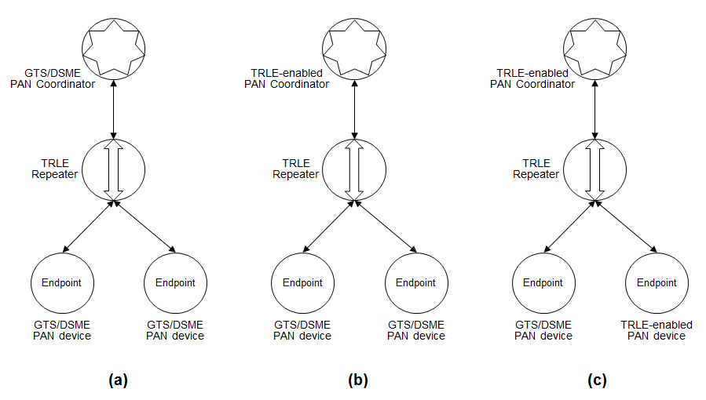
Figure P.1-The usage of a TRLE repeater
The TRLE repeater provides the following features:
- Relaying a frame, destined for the PAN coordinator or an endpoint, in a synchronous manner
- Sharing the cyclic-superframe among the TRLE-enabled devices
- TRLE path management

For star topologies, the features provided by a TRLE repeater are different depending upon the capabilities of devices within the network. For networks without a TRLE-enabled PAN coordinator, a TRLE repeater is limited to relaying frames. For networks with a TRLE-enabled PAN coordinator and beacon-enabled endpoint(s), sharing the cyclic-superframe and TRLE path management are performed additionally on the TRLE PAN coordinator and TRLE repeaters.

P.3.2.1 Relaying frames
The TRLE repeater will relay frames outward from the PAN coordinator to the endpoint and inward from the endpoint to the PAN coordinator.
One or more repeaters may exist between the PAN coordinator and an end device. For any given repeater a neighboring repeater closer to the PAN coordinator is called an inner repeater and a repeater closer to the endpoint is called an outer repeater. Beacon frames from the PAN coordinator received by repeaters within the transmission range of the PAN coordinator form tier 1 of the TRLE-enabled PAN. The repeaters that are within a transmission range of the tier 1 repeaters, but not within PAN coordinator range, form tier 2 of the TRLE-enabled PAN, and so on, as illustrated in Figure P.2.
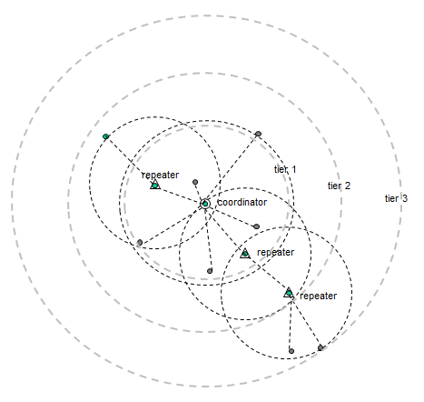
Figure P.2-Hierarchy of relaying in the TRLE-enabled PAN
The TRLE repeater can identify the transmission direction of a received frame and retransmit the frame at a time slot that is delayed by a multiple of superframe durations, but aligned synchronously to the PAN coordinator, as shown in Figure P.3.
The beacon generated by the PAN coordinator is relayed outward after a unique repeater delay to avoid interfering with other beacons from neighboring repeaters. The frames received in a CAP or a CFP from inner repeaters are relayed in the CAP and the CFP, respectively, of the outward superframe that contains an outward beacon time slot. For a GTS network, the delay duration for relaying is determined by the repeater. When a repeater associates with a TRLE-enabled PAN coordinator, the delay is assigned by the TRLE PAN coordinator.
In order to relay frames to endpoints, the TRLE repeater performs repeater-mode frame filtering: the TRLE repeater performs the third-level filtering requirements with the exception of destination address matching. The destination address is used to determine the direction of relaying.
A frame to be relayed outward is retransmitted in the allocated time slot of the superframe generated by the repeater. The time slot is selected to minimize interference with neighboring devices. The repeated frame is delayed for the number of superframe and timeslot durations separating the received time slot and the retransmission timeslot. An example is shown in Figure P.3. The actual delay depends on the superframe configuration at each tier.
Frames that are received in the CAP in the superframe from a higher tier are retransmitted in the CAP of the superframe generated by the repeater. Frames received from a lower tier in the CAP of the superframe generated by the repeater are retransmitted in the CAP of the superframe generated by the higher tier.

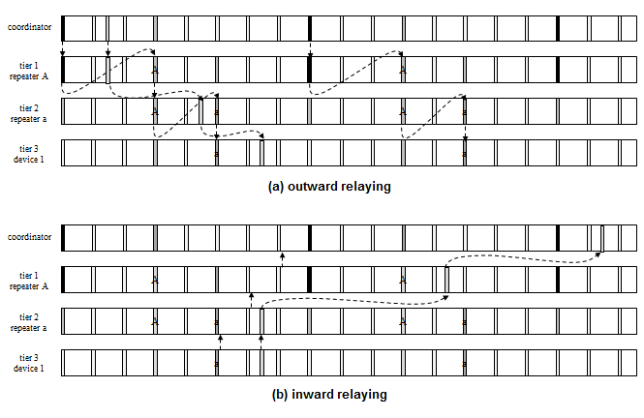
Figure P.3-Synchronous frame relaying (a) outward relaying (b) inward relaying

P.3.2.2 Cyclic-superframe and synchronous relaying
In a DSME enabled PAN, the TRLE-enabled PAN uses the multi-superframe structure of the DSME without the CAP reduction. In a TRLE-enabled PAN, time slots of the multi-superframe are used, as illustrated in Figure P.4.
The CAP is divided into time slots for transmitting a frame to the PAN coordinator (i.e. the prioritized device time slot) and time slots for transmitting a frame to endpoint devices (i.e. the coordinator time slot). The prioritized device time slot starts after the beacon and continues for a preset number of time slots. The coordinator time slot starts after the prioritized device time slot and continues for a number of time slots. The DSME-GTS allocation to a device is used for bidirectional transmission and is referred to as the bidirectional time slot.
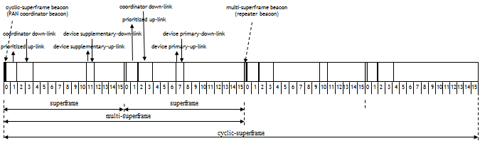
Figure P.4-Relay time slots in a TRLE cyclic-superframe
The time slots in a superframe used to connect TRLE-enabled devices are referred to as relay time slots. The relay time slots in a beacon interval are available to the devices periodically and form a cyclic-superframe. The TRLE-enabled devices are able to share the cyclic-superframe. The time slots of cyclic-superframe act like as write-and-read memory to switch frames from one TRLE-enabled device to the other TRLE-enabled device, as illustrated in Figure P.5.
At a TRLE repeater, a cyclic-superframe is relayed either outward or inward as described in P.3.2.1. The coordinator time slots and bidirectional time slots are relayed outward synchronously to the PAN coordinator beacon. The prioritized device time slots and bidirectional time slots are relayed inward synchronously to the PAN coordinator beacon.
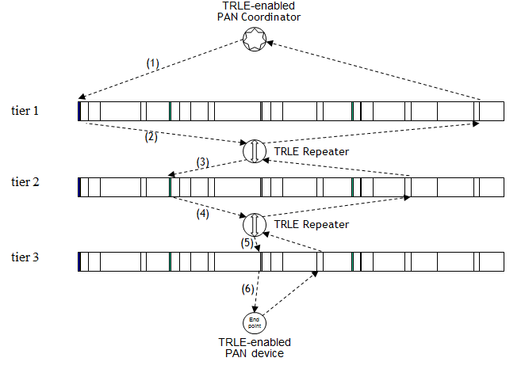
Figure P.5- Cyclic-superframe, tiers of a TRLE-enabled PAN, and Synchronous Relaying
In a TRLE-enabled PAN, to accommodate various quality of service requirements for relaying frames between the PAN coordinator and a device, three grades of synchronous access are provided: grade 0 for transmitting delay sensitive data, grade 1 for the reliable transmission of data, and grade 2 for the best effort data transmission.
For grade 0 link access, a device first searches the earliest prioritized device time slot. If the device fails to transmit the data in the prioritized device time slot, the device will continue trying to transmit the data in either a bidirectional time slot or in another prioritized device time slot, whichever comes first. Figure P.6 illustrates the steps of the grade 0 link access.
A device using grade 1 link access waits for the primary bidirectional time slot in the cyclic-superframe and transmits the data. If the device fails to transmit the data in the primary bidirectional time slot, the device will keep searching supplementary bidirectional time slots for the duration of the cyclic-superframe or will search the coming cyclic-superframe for an opportunity to transmit the data.
A device using grade 2 link access waits for the primary bidirectional time slot in the cyclic-superframe and transmits the data without requiring an acknowledgment.
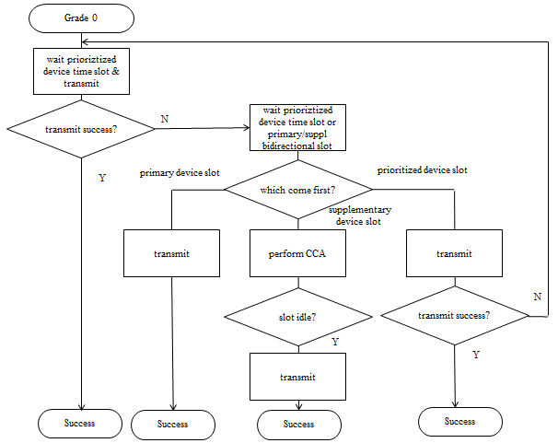
Figure P.6- Grade 0 link access algorithm

P.3.2.3 TRLE Path management
The repeaters and endpoints are able to compensate for the clock drift based on the statistical variance of the difference in the real start time of a given time slot and the expected start time. The selection of a time slot to be measured for collecting statistical data depends on the frame type carrying the time synchronization specification and the grade of link access.
After starting a TRLE-enabled PAN, the PAN coordinator may check the status of an endpoint, collect information on the configuration of repeaters on the TRLE relaying paths, and control the transmission power of a device with the TRLE management procedure.

P.3.3 Usage of the TRLE repeater
When a TRLE repeater resides between a PAN coordinator and an endpoint, the TRLE repeater performs the following procedure to support the extension of a link:
- The TRLE repeater scans the channels and extracts information from the beacon frames sent from neighboring coordinators
- The TRLE repeater selects the coordinator to which it will connect and synchronizes to the beacon of that coordinator
- Acting upon the information from the beacon frame, the TRLE repeater chooses the time slot to relay the inner coordinator’s beacon and uses the time slot as the reference point for starting beacon interval of the repeater
- The TRLE repeater starts relaying frames received in a time slot from inner coordinator to the time slot aligned synchronously with the reference point of the repeater
- The TRLE repeater filters received frames, frames not destined to that repeater will be relayed

If the PAN coordinator is TRLE-enabled, a TRLE repeater cooperates with the TRLE PAN coordinator and neighbor TRLE repeaters as follows:
- The TRLE repeater scans the channels and extracts information on beacon frames from a neighboring TRLE PAN coordinator or TRLE repeater(s)
- The TRLE repeater selects the TRLE PAN coordinator or an inner TRLE repeater which is closer to the TRLE PAN coordinator, and synchronizes to the beacon of TRLE PAN coordinator or the inner TRLE repeater as appropriate
- The TRLE repeater requests to associate with the TRLE PAN coordinator and is notified the reference point for the starting beacon interval of the repeater
- The TRLE repeater starts to share the inward cyclic-superframe with its inner repeater and, if an outer repeater exists, shares the outward cyclic-superframe.
- The following information is transferred along the path from the outermost TRLE-enabled repeater to the TRLE PAN coordinator: TRLE PAN descriptor, relaying descriptor, and TRLE path management
- At the outermost TRLE repeater, the relaying descriptor is either inserted in an inward frame or dropped out from the outward frame
If the endpoint is TRLE-enabled, it may choose the grade of the link connections to the TRLE PAN coordinator as follows:
- Upon associating to the TRLE PAN coordinator, the TRLE-enabled endpoint will be assigned a bidirectional time slot
- The TRLE-enabled device can use inward prioritized device time slots and outward coordinator time slots
- The path to the TRLE-enabled device will be managed by the TRLE PAN coordinator

