IEEE P802.15
Wireless Personal Area Networks

Project | IEEE P802.15 Working Group for Wireless Personal Area Networks (WPANs)
Title | Proposed resolutions for CIDs 34, 423 and Figure 34sa, 34sd
Date Submitted | [26 July 2012]
Source | [Yang Yang, Xiang Wang] | Voice: [ +86 15921697670 ]  Fax: [ ]  E-mail: [youcyyang@gmail.com]
Re: | [TG4k LECIM MAC support]
Abstract | Proposed resolutions for CIDs 34, 423 and Figure 34sa, 34sd.
Purpose | Draft standard development
Notice | This document has been prepared to assist the IEEE P802.15. It is offered as a basis for discussion and is not binding on the contributing individual(s) or organization(s). The material in this document is subject to change in form and content after further study. The contributor(s) reserve(s) the right to add, amend or withdraw material contained herein.
Release | The contributor acknowledges and accepts that this contribution becomes the property of IEEE and may be made publicly available by P802.15.

- Resolution for CID 34, CID 423
Modify the following contents in Table 52j of subclause 6.4.3.7
Attribute | Type | Range | Description | Default
macHWSLWakeupInterval | Integer | macMaxFrameTotalWaitTime - 65535 | Specifies the interval between two successive HWSL wakeup frames in an HWSL wakeup sequence, in units of symbols. | macMaxFrameTotalWaitTime

- Modification of Figure 34sa

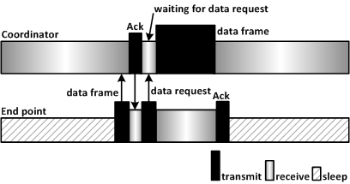

- Modification of Figure 34sd

