IEEE P802.15
Wireless Personal Area Networks

Project | IEEE P802.15 Working Group for Wireless Personal Area Networks (WPANs)
Title | Relayed Slot-Link Network (RSLN) draft for TG4k
Date Submitted | [18 July 2012]
Source | [Seong-Soon Joo]  [ETRI]  [] | Voice: [ +82.42.860.6333 ]  Fax: [ ]  E-mail: [ ssjoo @ etri.re.kr ]
Re: | [TG4k LECIM PHY development, MAC support]
Abstract | Relayed Slot-Link Network draft for MAC additions necessary to support the LECIM PHYs
Purpose | Draft standard development
Notice | This document has been prepared to assist the IEEE P802.15. It is offered as a basis for discussion and is not binding on the contributing individual(s) or organization(s). The material in this document is subject to change in form and content after further study. The contributor(s) reserve(s) the right to add, amend or withdraw material contained herein.
Release | The contributor acknowledges and accepts that this contribution becomes the property of IEEE and may be made publicly available by P802.15.

IEEE 802.15.4k MAC Working Draft version: 2012-07-18
- Overview
  - General
  - Scope
  - Purpose

- Normative references

- Definitions, Acronyms and Abbreviations
  - Definitions

Insert the following definitions alphabetically into 3.1:
repeater: A coordinator in a relayed slot-link network that relays IEEE Std 802.15.4 MAC frames either in the direction of the PAN coordinator or in the direction of a device.

slot-link: The pairwise assignment of a directed communication between the PAN coordinator and a device(s) in a given time slot.

  - Acronyms

Insert the following acronyms alphabetically into 3.2:
RSLN relayed slot-link network

- General Description
  - General
  - Components of the WPAN
  - Network topologies
    - Star network formation

Insert before 4.3.2 the following paragraph:
For extending networking coverage, a star network may include repeaters that relay MAC frames synchronously inward to the PAN coordinator or outward to a device, to form a relayed slot-link network (RSLN) operating in a star topology.

    - Peer to peer network formation
  - Architecture
    - PHY layer (PHY)
    - MAC Sub-layer (General Characteristics)
  - Functional Overview
    - Superframe Structure
      - General

    - Data transfer model
      - Data transfer to a coordinator
      - Data transfer from a coordinator

      - Peer-to-peer data transfers
    - Frame Structure
    - Improving probability of successful delivery
      - CSMA-CA mechanism
      - ALOHA mechanism
      - Frame acknowledge
      - Data verification
      - Asynchronous multi-channel adaptation

    - Power consumption considerations
      - General
      - Low-energy mechanisms

Insert the following new subclause (4.5.5.3) after 4.5.5.2:
      - Low energy extension of networking coverage by synchronous relaying
In a star network, the coverage of networking is limited by the transmission range of the device. To increase the device's battery life, low energy devices may use low transmit power. Compared to the energy-constrained end point device, the abundantly powered coordinator can have greater responsibility to extend the coverage of the network while preserving the star topology with no burden to the end device. In an RSLN-enabled PAN, a repeater provides synchronous relaying of the frames to inward or outward between the PAN coordinator and a device, in order to extend the coverage of a star network.

    - Security
  - Concept of primitives

- MAC protocol
  - MAC functional description

    - Channel access
      - Superframe structure
      - Incoming and outgoing superframe timing
      - Interframe spacing (IFS)
      - CSMA-CA Algorithm
      - TSCH-Slotframe structure
      - LLDN Superframe structure
      - LE-Functional description
    - Synchronization
      - Synchronization with beacons
      - Synchronization without beacons
      - Orphaned device realignment
      - LECIM Synchronization

    - Transaction handling
    - Transmission, reception, and acknowledgment
      - Transmission
      - Reception and rejection
      - Extracting pending data from a coordinator
      - Use of acknowledgments and retransmissions
        - No acknowledgment
        - a Incremental fragment acknowledgment
        - a Incremental fragment retransmission
      - Promiscuous mode
      - Transmission scenarios
    - GTS allocation and management
    - Ranging
    - LLDN Transmission states
    - Deterministic and synchronous multi-channel extension (DSME)
    - LE-transmission, reception and acknowledgment
      - Coordinated sampled listening (CSL)
      - Receiver initiated transmission (RIT)
      - LECIM Alternate/Hybrid LE scheme
    - Asynchronous multi-channel adaptation (AMCA)

Insert the following new subclauses (5.1.13) after 5.1.12.5:
    - Relayed Slot-Link Network (RSLN)
The macRSLNenabled PAN coordinator may form an RSLN-enabled PAN. In an RSLN-enabled PAN, a link between the PAN coordinator and end device in a star topology shall be alternated with the limited number of links and repeaters. A macRSLNcapable FFD may associate an RSLN-enabled PAN as a repeater. A repeater in an RSLN-enabled PAN shall maintain synchronization with the PAN coordinator and relay a frame from the PAN coordinator to an end device or vice versa.
The RSLN-enabled PAN shall use the multi-superframe structure of the DSME without the CAP reduction. In an RSLN-enabled PAN, time slots of the multi-superframe are differently used. The CAP is divided into the time slots for transmitting frame to the PAN coordinator (i.e. the prioritized device slot) and the time slots for transmitting frame to a device(s) (i.e. the coordinator slot). The prioritized device slot starts after the beacon and continues for macNumPrioritizedDeviceSlot time slots. The coordinator slot starts after the prioritized device slot and continues for macNumCoordSlot time slots. The DSME-GTS allocated to a device shall be used for bidirectional transmission and called the bidirectional device slot.
A time slot assigned between the PAN coordinator and an end device shall be relayed at a repeater in direction to a device (i.e. outward relaying) or in direction to the PAN coordinator (i.e. inward relaying). One more repeaters may exist between the PAN coordinator and an end device, and at a certain repeater the neighbor repeater closer to the PAN coordinator is called as inner repeater and the repeater of the other side is called as outer repeater. The time slot relayed from the PAN coordinator to a device or vice versa may form a slot link.
The beacon generated at the PAN coordinator shall be relayed outward and at each repeater the location of time slot in multi-superframes to be relayed shall be assigned by the PAN coordinator. The coordinator slots and bidirectional device slots shall be relayed outward synchronously to the PAN coordinator beacon relayed at a repeater. The prioritized device slots and bidirectional device slots shall be relayed inward synchronously to the PAN coordinator beacon of the inner repeater. The multi-superframes in a beacon interval received at a repeater shall be relayed synchronously to the outer repeater or to the inner repeater and the multi-superframes in a beacon interval may form a cyclic-superframe, as shown in Figure xx.
A cyclic-superframe from the PAN coordinator shall be appeared at the repeaters within a transmission range of the PAN coordinator and these repeaters may form the tier 1 of the RSLN-enabled PAN. The grouped repeaters which are within a transmission range of the tier1 repeaters may form the tier 2 of the RSLN-enabled PAN, and so on.
The next higher layer of the macRSLNenabled PAN coordinator shall start an RSLN-enabled PAN through the use of the MLME-START.request primitive (6.2.12.1). The macRSLNenabled PAN coordinator shall generate a beacon conveying the RSLN-enabled PAN Descriptor IE (5.2.4.24) and provide the information on the structure of the cyclic-superframe (5.2.4.24.1), the global clock timestamp in units of microseconds (5.2.4.24.2), the information on relaying tier (5.2.4.25), and the beacon map to indicate the beacon slot occupied superframes in a cyclic-superframe.
The next higher layer may let the macRSLNenabled FFD associate the RSLN-enabled PAN as a repeater through the use of the MLME-ASSOCIATE.request primitive (6.2.2.1). A repeater shall generate or modify the RSLN Relaying Specification IE (5.2.4.25) when relaying data frame, acknowledgement frame, and MAC command frames.
Only the last outer repeater may accommodate end devices. The last outer repeater shall insert the RSLN Relaying Specification IE in the frame from the end device or remove the RSLN Relaying Specification IE from the frame transmitted to the end device. An end device may join the RSLN-enabled PAN by requesting DSME-GTS allocation.
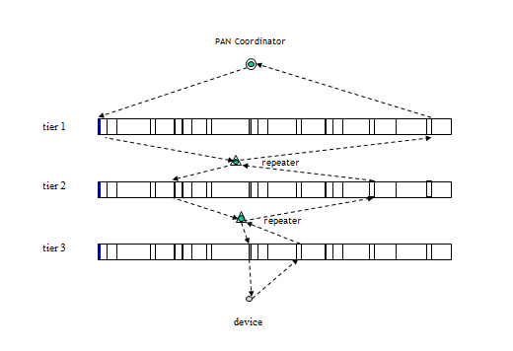
Figure xx- Cyclic-superframe and tiers of RSLN-enabled PAN, and Synchronous Relaying

  - MAC frame formats
    - Format of individual frame types
      - Beacon frame format
        - Information Elements fields

Insert the following new row at the end of Table 3b:
Table 3b-EBR IEs per enabled attribute
Attribute Request Identifier | PIB attribute | IE type | IEs to include
5 | macRSLNenabled | Header | RSLN-enabled PAN Descriptor (5.2.4.24), RSLN Relaying Specification (5.2.4.25), RSLN ACK Descriptor (5.2.4.26)

    - Information element
      - General
      - Header Information Elements

Insert the following new rows in Table 4b:
Table 4b-Element IDs, Header IEs
Element ID | Content length | Name | Description
TBD | Variable | RSLN-enabled PAN Descriptor | As defined in 5.2.4.24
TBD | 2 | RSLN Relaying Specification | As defined in 5.2.4.25
TBD | Variable | RSLN ACK Descriptor | As defined in 5.2.4.26

Insert the following new subclauses (5.2.4.24-5.2.4.26) after 5.2.4.23:

      - RSLN-enabled PAN descriptor IE
The RSLN-enabled PAN descriptor IE shall be included in enhanced beacons that are sent in a RSLN-enabled PAN.
The RSLN-enabled PAN descriptor IE shall be formatted as illustrated in Figure 48ns.

Octets: 2 | Octets: 6 | Variable
Cyclic-superframe Specification | Time Synchronization Specification | Synchronous Relaying Specification

Figure 48ns- RSLN-enabled PAN Descriptor IE

        - Cyclic-superframe Specification field
The cyclic-superframe Specification field shall be formatted as illustrated in Figure 48nt.
Bits: 0-3 | 4-7 | 8-11 | 12-13 | 14-15
Beacon Order | Superframe Order | Multi-superframe Order | Number of Prioritized device slot | Number of Coordinator slot

Figure 48nt-Cyclic-superframe Specification field format

The Beacon Order field is described in 5.2.2.1.2.
The Superframe Order field is described in 5.2.2.1.2.
The Mulit-superframe Order field is described in 5.2.4.9.1.
The Number of Prioritized Device Slot field shall specify the number of time slots in a superframe assigned to the devices for prioritized inward transmission as described in 5.1.13.
The Number of Coordinator Slot field shall specify the number of time slots in a superframe assigned to the coordinator for outward transmission as described in 5.1.13.

        - Time Synchronization Specification field
The Time Synchronization Specification field is the timestamp in units of microseconds. It shall specify the start time of the slot in which the frame is transmitted.

        - Synchronous Relaying Specification field
The Synchronous Relaying Specification field shall be formatted as illustrated in Figure 48nu.
Octets: 2 | 1/2/4/8/16/32/64
Relaying Specification | Beacon Bitmap

Figure 48nu- Synchronous Relaying Specification field format
The Relaying Specification field has the same format as the content of the RSLN Relaying Specification IE described in 5.2.4.25.
The Beacon Bitmap field contains the bitmap indicating the beacon slot of the superframe reserved for transmitting a beacon from neighboring devices. Each corresponding bit in the bitmap shall be set to one if the beacon slot of the superframe is occupied, otherwise it is set to zero. The length of beacon bitmap will be 2(macBeaconOrder – macSuperframeOrder – 3)) bits and is limited to 64 Octets (i.e. (macBeaconOrder – macSuperframeOrder)≤ 9).

      - RSLN Relaying specification IE
The RSLN Relaying specification IE shall be included in data, acknowledgment, and MAC command frames that are sent in an RSLN-enabled PAN.
The RSLN Relaying specification IE shall be formatted as illustrated in Figure 48nw.
Bits: 0-2 | 3 | 4-5 | 6 | 7-15
Relaying Tier Identifier | RSLN Device Type | Grade of Link access | Reference of Relaying Sync Indicator | Superframe Index

Figure 48nw- RSLN Relaying specification IE
The Relaying Tier Identifier field contains the number of relaying tier that generated a frame. A value of zero shall indicate the PAN coordinator.
The RSLN Device Type field shall be set to one if the device generating this IE is the repeater, otherwise it is set to zero.
The Grade of Link access field is defined in Table 46.
The Reference of Relaying Sync Indicator field shall be set to one if a superframe is the first slotted-superaframe of a cyclic-superframe, otherwise it shall be set to zero.
The Superframe Index field contains the index of the superframe transmitting a frame. The index of the first superframe in a cyclic-superframe of the PAN coordinator shall be set to zero.

      - RSLN ACK descriptor IE
The RSLN ACK descriptor IE shall be included in acknowledgment frames that are sent in an RSLN-enabled PAN.
The RSLN ACK descriptor IE shall be formatted as illustrated in Figure 48nx.

Octets: 1 | 6 | Variable
ACK Control Specification | Time Synchronization Specification  (refer to 5.2.4.24.2) | List of DSN of the acknowledged frame

Figure 48nx- RSLN ACK Descriptor IE

The ACK Control Specification field shall be formatted as illustrated in Figure 48ny.
Bits: 0-1 | 2-5 | 6-7
ACK Type | Number of Group ACK frames | Reserved

Figure 48ny- ACK Control Specification field format
The ACK Type, shown in Table xx, identifies the acknowledgment modes for relaying frames.
Table xx- Values of the ACK Type field
ACK Type value  b₁ b₀ | Description
00 | End-to-end ACK
01 | Slot-link ACK
10 | Group end-to-end ACK
11 | Reserved

The Number of Group ACK frames field contains an integer that represents the number of group acknowledged frames.
The List of DSN of the acknowledged frame field shall contain the sequence number of the frame acknowledged in Group end-to-end acknowledgment mode.

  - MAC command frames

Insert the following new rows in Table 5:
Table 5-MAC Command frames
Command frame idnetifier | Command name | RFD |  | Subclause
 |  | Tx | Rx
TBD | RSLN-Association request |  |  | 5.3.15.1
TBD | RSLN-Association response |  |  | 5.3.15.2
TBD | RSLN-Management request | X | X | 5.3.15.3
TBD | RSLN-Management response | X | X | 5.3.15.4

Insert the following subclause (5.3.15) after 5.3.14:

    - RSLN commands
A macRSLNcapable FFD device in a RSLN-enabled PAN shall be capable of transmitting and receiving all command frame types defined in 5.3.15.1 and 5.3.15.2.

      - RSLN-Association request command
The RSLN-Association request command allows a device to request association with an RSLN-enabled PAN as a repeater through the PAN coordinator or an inward coordinator.
The RSLN-Association request command shall be formatted as illustrated in Figure 59dda.

Octets: variable | 1 | 1 | Bits:0-2 | 3-6 | 7-15
MHR fields  (5.2.2.4.1) | Command Frame Identifier  (Table 1) | Capability Information  (5.3.1.2) | Relaying Tier Identifier  (5.2.4.25) | Reserved | Superframe Index  (5.2.4.25)

Figure 59dda-RSLN-Association request command format

      - RSLN-Association response command
The RSLN-Association response command allows the PAN coordinator or an inward coordinator to communicate the results of an association attempt back to the device requesting association.
The RSLN-Association response command shall be formatted as illustrated in Figure 59di.

Octets: variable | 1 | 2 | 1 | Bits:0-2 | 3-6 | 7-15 | variable
MHR fields  (refer to 5.2.2.4.1) | Command Frame Identifier  (Table 1) | Short Address  (5.3.2.2) | Association Status  (5.3.2.3) | Relaying Tier Identifier  (5.2.4.25) | Reserved | Superframe Index  (5.2.4.25) | Beacon Bitmap  (5.2.4.24.3)

Figure 59ddb-RSLN-Association response command format

      - RSLN-Management request command
The RSLN-Management request command request is used by a device or the PAN coordinator to request the information on the clock time, the device configuration, and the relaying path configuration, or to control the transmission power of a device.
The RSLN-Management request command shall be formatted as illustrated in Figure xx.

Octets: variable | 1 | 1
MHR fields  (5.2.2.4.1) | Command Frame Identifier  (Table 1) | Management Type

Figure 59ddc-RSLN-Management request command format
The Management Type field shall be set one of the values listed in Table xx.
Table 7c- Values of the Management Type field
Management Type value | Description
0x00 | Hello
0x01 | Time
0x02 | Device configuration
0x03 | Relaying path configuration
0x04 | Link power configuration
0x05 | Link power control
0x06~0xff | Reserved

      - RSLN-Management response command
The RSLN-Management response command is used by the PAN coordinator or a device to announce the result of a request to inform the clock time, the device configuration, and the relaying path configuration, or a request to control the transmission power of a device.
The RSLN-Management response command shall be formatted as illustrated in Figure xx.

Octets: variable | 1 | 1 | 1 | 0/6 | 0/variable | 0/variable | 0/variable
MHR fields  (refer to 5.2.2.4.1) | Command Frame Identifier  (defined in Table 5) | Management Type  (refer to 5.3.15.3) | Management Status | Time Synchronization Specification  (refer to 5.2.4.24.2) | Device Descriptor | Relaying Path Descriptor | Power Management Descriptor

Figure 59ddd-RSLN-Management response command format

        - Management Status field
The Management Status field shall be set as defined in Table xx.
Table 7d- Values of the Management Status field
Management Status value | Description
0x00 | Management request successful.
0x01 | Management request denied.
0x02 | Management request not reached.
0x03-0x7f | Reserved
0x80~0xff | Reserved for MAC primitive enumeration values.

        - Device Descriptor field
The Device Descriptor field shall be formatted as illustrated in Figure xx.
Octets: 1 | variable
Device Descriptor Count | Device List

Figure 59dde- RSLN Device Descriptor field format
The Device Descriptor Count field specifies the number of the Device Descriptors in the Device List field.
The Device Descriptor shall be formatted as illustrated in Figure xx.
Octets: 2 | 2 | 2 | 2
Relaying Specification  (5.2.4.25) | Primary Bidirectional Device Slot Index  (5.2.4.24.4) | Inward Repeater Short Address | Inward Repeater Link Status

Figure 59ddf- RSLN Device Descriptor format
The Superframe Index of the Relaying Specification field contains the index of the superframe designated as the reference of synchronous relaying. (i.e., macRelayingSyncReference)
The Inward Repeater Short Address field contains the short address of the repeater connected to the device in the direction of the PAN coordinator.
The Inward Repeater Link Status field shall be formatted as illustrated in Figure xx.
Octets: 1 | 1
Channel | avgLQI

Figure 59ddg- Inward Repeater Link Status format
The Channel field specifies the channel index reported by the device. The avgLQI field contains the average received LQI of the channel specified in Channel field within macLinkStatusStatisticPeriod symbols, as described in Table 52h..
        - Relaying Path Descriptor field
The Relaying Path Descriptor field shall be formatted as illustrated in Figure xx.
Octets: 1 | variable
Repeater Descriptor Count | Repeater List

Figure 59ddh- RSLN Relaying Path Descriptor field format
The Repeater Descriptor Count field specifies the number of the Repeater Descriptors in the Repeater List field.
The Repeater Descriptor shall be formatted as illustrated in Figure xx.
Octets: 2 | 2
Repeater Short Address | Relaying Specification  (5.2.4.25)

Figure 59ddi- Repeater Descriptor field format
The Superframe Index of the Relaying Specification field contains index of the superframe designated as the reference of synchronous relaying. (i.e., macRelayingSyncReference)

        - Power Management Descriptor field
The Power Management Descriptor field shall be formatted as illustrated in Figure xx.
Octets: 1 | 1 | variable
PHY TX Power  (Table 71) | RX Link Status Descriptor Count | RX Link Status List

Figure 59ddj- RSLN Power Descriptor format
The PHY TX Power field specifies the transmit power of the device in dBm.
The RX Link Status Descriptor Count field specifies the number of the RX Link Status Descriptors in the RX Link Status List field.
The RX Link Status Descriptor field shall be formatted as illustrated in Figure xx.
Octets: 2 | 1 | variable
Repeater Short Address | Repeater Link Count | Repeater Link Status List  (5.3.15.4.2)

Figure 59ddk- RSLN RX Link Descriptor format
The Repeater Short Address field contains the short address of the repeater neighbored to the device inward or outward.
The Repeater Link Count field specifies the number of channels activated in the neighbored repeater.

  - MPDU Fragmentation
    - MPDU PHY adaptation, fragmentation and reassembly
    - Fragment cell formats

- MAC services
  - Overview
  - MAC management service

Table 8— Summary of the primitives accessed through the MLME-SAP
Name | Request | Indication | Response | Confirm
MLME-RSLN-MANAGEMENT | 6.2.23.1 | 6.2.23.2 | 6.2.23.3 | 6.2.23.4

    - Association primitives
      - MLME-ASSOCIATE.request

Insert the following new parameter at the end of the list in 6.2.2.1 (before the closing parenthesis):
RelayingTierIdentifier,
IndexSuperframe

Insert the following new row at the end of Table 9:
Table 9—MLME-ASSOCIATE.request parameters
Name | Type | Valid range | Description
RelayingTierIdentifier | Integer | 0x00-07 | Tier of RSLN-enabled PAN of the device requesting association.
IndexSuperframe | Integer | 0x0000-0x0fff | Specifies the preferred superframe in which to start the cyclic-superframe of the device requesting association.

The RelayingTierIdentifier specifies the location of the repeater requesting association in an RSLN-enabled PAN.
The IndexSuperframe specifies the preferred superframe index in which the repeater requesting association starts the cyclic-superframe.

      - MLME-ASSOCIATE.indication

Insert the following new parameter at the end of the list in 6.2.2.2 (before the closing parenthesis):
RelayingTierIdentifier,
IndexSuperframe

Insert the following new row at the end of Table 9:
Table 10—MLME-ASSOCIATE.indication parameters
Name | Type | Valid range | Description
RelayingTierIdentifier | Integer | 0x00-07 | Tier of RSLN-enabled PAN of the device requesting association.
IndexSuperframe | Integer | 0x0000-0x0fff | Specifies the preferred superframe in which to start the cyclic-superframe of the device requesting association.

The RelayingTierIdentifier specifies the location of the repeater requesting association in an RSLN-enabled PAN.
The IndexSuperframe specifies the preferred superframe index in which the repeater requesting association starts the cyclic-superframe.

      - MLME-ASSOCIATE.response

Insert the following new parameters at the end of the list in 6.2.2.3 (before the closing parenthesis):
IndexSuperframe,
BeaconBitmap

Insert the following new rows at the end of Table 11:
Table 11—MLME-ASSOCIATE.response parameters
Name | Type | Valid range | Description
IndexSuperframe | Integer | 0x0000-0x0fff | Specifies the assigned superframe in which to start the cyclic-superframe of the device requesting association.
BeaconBitmap | Beacon bitmap | As specified by 5.2.4.24.3 | Indicates the superframes reserved for transmitting a beacon from the neighboring devices around the inward coordinator.

The IndexSuperframe specifies the assigned superframe index in which the repeater requesting association starts the cyclic-superframe.
The Beacon Bitmap field contains the bitmap indicating the beacon slot of the superframe reserved for transmitting a beacon from neighboring devices. Each corresponding bit in the bitmap shall be set to one if the beacon slot of the superframe is occupied, otherwise it is set to zero.

      - MLME-ASSOCIATE.confirm

Insert the following new parameters at the end of the list in 6.2.2.4 (before the closing parenthesis):
IndexSuperframe,
BeaconBitmap

Insert the following new rows at the end of Table 12:
Table 12—MLME-ASSOCIATE.confirm parameters
Name | Type | Valid range | Description
IndexSuperframe | Integer | 0x0000-0x0fff | Specifies the assigned superframe in which to start the cyclic-superframe of the device requesting association.
BeaconBitmap | Beacon bitmap | As specified by 5.2.4.24.3 | Indicates the superframes reserved for transmitting a beacon from the neighboring devices around the inward coordinator.

The IndexSuperframe specifies the assigned superframe index in which the repeater requesting association starts the cyclic-superframe.
The Beacon Bitmap field contains the bitmap indicating the beacon slot of the superframe reserved for transmitting a beacon from neighboring devices. Each corresponding bit in the bitmap shall be set to one if the beacon slot of the superframe is occupied, otherwise it is set to zero.

    - Primitives for updating the superframe configuration
      - MLME-START.request

Insert the following new parameter at the end of the list in 6.2.12.1 (before the closing parenthesis):
RSLNSpecification

Insert the following new row at the end of Table 34:
Table 34-MLME-START.request parameters
Name | Type | Valid range | Description
RSLNSpecification | Cyclic-superframe-Specification | As specified by 5.2.4.24.1 | Specifies the cyclic-superframe in the RSLN-enabled PAN, as defined in 5.2.4.24.1.

The RSLNSpecification parameter consists of the Beacon Order (5.2.2.1.2), the Superframe Order (5.2.2.1.2), the Mulit-superframe Order (5.2.4.9.1), the Number of Prioritized Device Slot, and the Number of Coordinator Slot.

    - MAC management service

Insert the following new subclause (6.2.23) after 6.2.22:
    - Primitives for RSLN management
      - MLME-RSLN-MANGEMENT.request
This primitive allows a RSLN-enabled device to request the device status, clock time, slot-link information, relaying path information, and control of the transmission power of a peer device.
The semantics of this primitive are:
MLME-RSLN-MANAGEMENT.request (
ManagementType,
DstAddrMode,
DstAddr,
TxGrade

)
The primitive parameters are defined in Table 44za
Table 44dd- MLME-RSLN-MANAGEMENT.request parameters
Name | Type | Valid range | Description
ManagementType | Enumeration | HELLO, TIME, DEVICE, PATH, POWER CONFIG, POWER CNTL | The type of management for this primitive, as described in 5.3.15.3.
DstAddrMode | Enumeration | NO_ADDRESS,  SHORT_ADDRESS,  EXTENDED_ADDRESS | The destination addressing mode for this primitive.
DstAddr | Device  address | As specified by the  DstAddrMode parameter | The individual device address of the device for which the frame was intended.
TxGrade | Enumeration | GRADE_0,  GRADE_1,  GRADE_2 | The grade of link access to be used

The MLME-RSLN-MANAGEMENT.request primitive is generated by the higher layer of a device and issued to its MLME to request the device status, clock time, slot-link information, relaying path information, and control of the transmission power of a device.
On receipt of the MLME-RSLN-MANAGEMENT.request primitive, the MLME shall send a RSLN Management request command frame as described in 5.3.15.3 to the DstAddr. The Management Type field of the RLSN Management Request command shall be set to the value of the ManagementType parameter. The RSLN Management request command frame is relayed to the DstAddr with the grade of link access specified in TxGrade.

      - MLME-RSLN-MANAGEMENT.indication
The MLME-RSLN-MANAGEMENT.indication is used to indicate the reception of an RSLN Management Request command.
The semantics of this primitive are:
MLME-RSLN-MANAGEMENT.indication (
ManagementType,
SrcAddrMode,
SrcAddr,
TxGrade

)

The primitive parameters are defined in Table 44ee.
Table 44ee- MLME-RSLN-MANAGEMENT.indication parameters
Name | Type | Valid range | Description
managementType | Enumeration | HELLO, TIME, DEVICE, PATH, POWER CONFIG, POWER CNTL | The contents of the Management Type field of the received RSLN Management Request command [5.3.14.3]
SrcAddrMode | Enumeration | NO_ADDRESS,  SHORT_ADDRESS,  EXTENDED_ADDRESS | The source addressing mode for this primitive
SrcAddr | Device  address | As specified by the  SrcAddrMode parameter | The individual device address of the device for which the frame was generated.
TxGrade | Enumeration | GRADE_0,  GRADE_1,  GRADE_2 | The grade of link access to be used

This primitive is generated by the MLME of a device and issued to its next higher layer upon the reception of a RSLN Management request command frame.
On receipt of the MLME-RSLN-MANAGEMENT.indication primitive, the higher layer is notified of the reception of an RSLN Management request command frame.

      - MLME-RSLN-MANGEMENT.response
This primitive allows the next higher layer of a device to respond to the MLME-RSLN-MANAGEMENT.indication primitive.
The semantics of this primitive are:
MLME-RSLN-MANAGEMENT.response (
ManagementType,
DstAddrMode,
DstAddr,
TxGrade,
status,
TimeSync,
DeviceDescriptor,
PathDescriptor,
PowerMangDescriptor

)
The primitive parameters are defined in Table xx
Table 44ff- MLME-RSLN-MANAGEMENT.response parameters
Name | Type | Valid range | Description
ManagementType | Enumeration | HELLO, TIME, DEVICE, PATH, POWER CONFIG, POWER CNTL | The type of management for this primitive, as described in 5.3.15.3.
DstAddrMode | Enumeration | NO_ADDRESS,  SHORT_ADDRESS,  EXTENDED_ADDRESS | The destination addressing mode for this primitive
DstAddr | Device  address | As specified by the  DstAddrMode parameter | The individual device address of the device for which the frame was intended.
TxGrade | Enumeration | GRADE_0,  GRADE_1,  GRADE_2 | The grade of link access to be used
status | Enumeration | As defined in 5.3.15.4 | The status of the management attempt
TimeSync | Time Synchronization Specification | As defined in 5.2.4.24.2 | The start time of the slot in which the frame is transmitted.
DeviceDescriptor | Device Descriptor | As defined in 5.3.15.4.2 | The device configuration
PathDescriptor | Relaying Path Descriptor | As defined in 5.3.15.4.3 | The relaying path configuration
PowerMangDescriptor | Power Management Specification | As defined in 5.3.15.4.4 | The TX power configuration and RX link status

On receipt of the MLME-RSLN-MANAGEMENT.response primitive, the MLME of the device shall generate a RSLN Management response command frame as described in 5.3.15.4. The ManagementType, Status, TimeSync, DeviceDescriptor, PathDescriptor, PowerMangDescriptor shall be contained in the Management Type field, Management Status field, Time Synchronization Specification field, Device Descriptor field, Relaying Path Descriptor field, and Power Management Descriptor field of the RSLN-Management response command frame.

      - MLME-RSLN-MANGEMENT.confirm
The MLME-RSLN-MANAGEMENT.confirm primitive reports the result of the RSLN management request.
The semantics of this primitive are:
MLME-RSLN-MANAGEMENT.confirm (

ManagementType,
SrcAddrMode,
SrcAddr,
status,
TimeSync,
DeviceDescriptor,
PathDescriptor,
PowerMangDescriptor

)
The primitive parameters are defined in Table xx
Table 44gg- MLME-RSLN-MANAGEMENT.confirm parameters
Name | Type | Valid range | Description
managementType | Enumeration | HELLO, TIME, DEVICE, PATH, POWER CONFIG, POWER CNTL | The type of management for this primitive, as described in 5.3.15.3.
SrcAddrMode | Enumeration | NO_ADDRESS,  SHORT_ADDRESS,  EXTENDED_ADDRESS | The source addressing mode for this primitive
SrcAddr | Device  address | As specified by the  SrcAddrMode parameter | The individual device address of the device for which the frame was generated.
status | Enumeration | As defined in 5.3.15.4 | The status of the management attempt
TimeSync | Time Synchronization Specification | As defined in 5.2.4.24.2 | The start time of the slot in which the frame is transmitted.
DeviceDescriptor | Device Descriptor | As defined in 5.3.15.4.2 | The device configuration
PathDescriptor | Relaying Path Descriptor | As defined in 5.3.15.4.3 | The relaying path configuration
PowerMangDescriptor | Power Management Specification | As defined in 5.3.15.4.4 | The TX power configuration and RX link status

On receipt of the MLME-RSLN-MANAGEMENT.confirm primitive, the higher layer is notified of the reception of an RSLN Management response command frame.

  - MAC data service
    - MCPS-DATA.request

Insert the following new parameter at the end of the list in 6.3.1 (before the closing parenthesis):
TxGrade

Insert the following new row at the end of Table 46:
Table 46-MCPS-DATA.request parameters
Name | Type | Valid range | Description
TxGrade | Enumeration | GRADE_0,  GRADE_1,  GRADE_2 | The grade of link access to be used

Insert the following paragraph at the end of 6.3.1:
When the RSLN is enabled and the TxGrade parameter is within the valid range, the multiple grades of link access feature are enabled.

  - MAC constants and PIB attributes
    - MAC constants

    - MAC PIB attributes

    - Calculating PHY dependent MAC PIB values
      - General
      - General MAC PIB attributes for functional organization

Add the following rows to Table 52a:
Attribute macRSLNcapable and macRSLNenabled are read-only and set by the implementer.
Table 52a-General MAC PIB attributes for functional organization
Attribute | Type | Range | Description | Default
macRSLNcapable | Boolean | TRUE, FALSE | A value of TRUE indicates that the device is capable of functionality specific to RSLN. A value FALSE indicates that it is not capable of RSLN functionality. | FALSE
macRSLNenabled | Boolean | TRUE, FALSE | A value of TRUE indicates that the device is using functionality specific to RSLN. A value of FALSE indicates that it is not using RSLN functionality. | FALSE

Insert the following new subclause after 6.4.3.11:
      - RSLN specific MAC PIB attributes

Subclause 6.4.3.1 applies and additional attributes are required, as presented in Table 52o.
Table 52o-RSLN specific MAC PIB attributes
Attribute | Type | Range | Description | Default
macNumPrioritizedDeviceSlot | Integer | 1-3 | The number of time slots in a superframe assigned as the prioritized device slots. | 1
macNumCoordSlot | Integer | 1-3 | The number of time slots in a superframe assigned as the coordinator slots. | 1
macNumBidirDeviceSlot | Integer | 1-7 | The number of time slots in a cyclic-superframe assigned as the bidirectional device slots. | 2
macRelayingTier | Integer | 0-7 | The identifier of the relaying tier in which a device is placed. The relaying tier of the PAN coordinator is zero. | 0
macRelayingSyncReference | Integer | See 5.2.4.24.3 | The index of the superframe starting to transmit a cyclic-superframe. The reference of relaying synchronization of the PAN coordinator is zero. | Implementation specific

- Security
- General PHY requirements
- PHY services
- O-QPSK PHY
- Binary phase-shift keying (BPSK) PHY
- Amplitude shift keying (ASK) PHY
- Chirp spread spectrum (CSS) PHY
- UWB PHY
- GFSK PHY
- SUN PHYs
- MSK PHY
- LRP UWB PHY
- LECIM PHYs

Insert after Annex O the following new annex (Annex P):

Annex P
(informative)
Low Energy, Critical Infrastructure Monitoring Systems

P.1 Introduction
P.2 Functionality added

P.3 Operation of the RSLN-enabled PAN

P.3.1 RSLN Slot-Link Structure

P.3.1.1 General
The RSLN-enabled PAN provides slot-links between the PAN coordinator and each device in the network by generating a sequence of time slots (i.e., the superframe) periodically. Time slots in a superframe may be a 1-to-1 link (e.g., a link between PAN coordinator and a single device) or a 1-to-n link (e.g., a link between the PAN coordinator and n devices). To increase the number of identified slot-links in an RSLN-enabled PAN, 2^{(MO-SO)} superframes may form a multi-superframe and 2^{(BO-SO)} superframes may form a cyclic-superframe.
A slot-link is specified with the owner of the slot, slot access method, and slot relaying operation, as illustrated in Figure 11i. A superframe contains a beacon slot-link, prioritized device slot-links, coordinator slot-links, and bidirectional device slot-links.
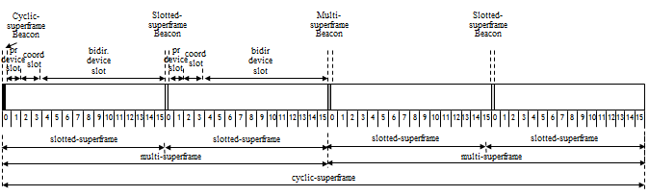
Figure 11i-Slot-links in an RSLN cyclic-superframe

P.3.1.2 Beacon slots
The beacon slot provides a link for transmitting a beacon from the PAN coordinator to devices. The cyclic-superframe beacon slot is reserved for the RSLN-enabled PAN coordinator. The beacon from the PAN coordinator is relayed by the repeater in its cyclic-superframe beacon slot. The beacon generated at the repeater is transmitted in the multi-superframe beacon slots, which are free from interference caused by the transmission of beacons from neighboring repeaters.
The start slot of the cyclic-superframe at each repeater is assigned when the repeater joins to the RSLN-enabled PAN, as described in P.3.2.1.

P.3.1.3 Prioritized device slot
The prioritized device slot provides a link for transmitting delay sensitive data or command frames from a device to the PAN coordinator. The prioritized device slot starts after the beacon and continues for macNumPrioritizedDeviceSlot time slots. The prioritized device slot is reserved in every superframe in a cyclic-superframe. At an RSLN repeater, the frame received in the prioritized device slot-link is relayed in the next available prioritized device slot.
The frame requesting grade 0 link access is transmitted in the prioritized device slot-link. The slotted ALOHA mechanism is applied to access the prioritized device slot-link.

P.3.1.4 Coordinator slot
The coordinator slot provides a link for transmitting command, acknowledgment, or data frames from the PAN coordinator to a device(s). The coordinator slot starts after the prioritized device slot and continues for macNumCoordSlot time slots. The coordinator slot is reserved in every superframe in a cyclic-superframe. At an RSLN repeater, the frame received in the inner coordinator slot-link is relayed to the coordinator slot of the superframe aligned synchronously to the inner coordinator, as described in P.3.2.1.
The command frame to be broadcasted is transmitted in the coordinator slot. The slotted ALOHA mechanism is applied to access the coordinator slot-link.

P.3.1.5 Bidirectional device slot
Each bidirectional device slot provides a link for transmitting data or command frames either from a device to the PAN coordinator or from the PAN coordinator to a device. One primary bidirectional device slot and (macNumBidirDeviceSlot - 1) supplementary bidirectional device slots are allocated to each device in an RSLN-enabled PAN. The supplementary bidirectional device slot is also used for retransmitting a frame which failed to transmit in the primary bidirectional device slot. The number of the bidirectional device slots within a cyclic-superframe is defined as macNumBidirDeviceSlot. If the number of bidirectional device slots in a cyclic-superframe is larger than the number of devices in the RSLN-enabled PAN, a dedicated primary bidirectional device slot-link is assigned for each device.
At an RSLN repeater, the frame received in a bidirectional device slot-link is relayed to the bidirectional device slot of the superframe aligned synchronously to the sender, as described in P.3.2.1.2.
The command frame to a certain device, or the frame requesting grade 1 or grade 2 link access, is transmitted on the bidirectional device slot. The link access mechanism of a bidirectional slot-link depends upon the direction of transmission and the bidirectional device slot type. The slotted ALOHA mechanism is applied by a device to access a primary bidirectional device slot-link.
A device shall use a slotted CSMA-CA mechanism when accessing a supplementary bidirectional device slot-link. The PAN coordinator shall use a slotted ALOHA mechanism when accessing a primary bidirectional device slot-link.

P.3.2 RSLN-enabled PAN formation and maintenance

P.3.2.1 Starting an RSLN-enabled PAN
A macRSLNenabed FFD is instructed to begin operating an RSLN-enabled PAN through the use of the MLME-START.request primitive, as described in 6.2.12.1, with the PANCoordinator parameter set to TRUE and the CoordRealignment parameter set to FALSE. The MAC sublayer shall update the cyclic-superframe configuration and channel parameters, and shall issue the MLME-START.confirm primitive, as described in 6.2.12.2, with a status of SUCCESS.
An RSLN-enabled PAN is formed when the PAN coordinator advertises the presence of the network by sending enhanced beacons in the cyclic-superframe beacon slot. The enhanced beacon contains the RSLN-enabled PAN descriptor IE:
- Cyclic-superframe specification, as defined in 5.2.4.24.1
- Time synchronization specification , as defined in 5.2.4.24.2
- Synchronous relaying information, as defined in 5.2.4.24.3
- Indirect data transmission information, as defined in 5.2.4.24.4

P3.2.2 Forming a relaying path
A device wishing to join the network as a repeater begins passively or actively scanning for the network as a result of receiving an MLME-SCAN.request primitive from its next higher layer. The device selects the PAN coordinator or a suitable inward repeater (e.g., repeater that is closest to the PAN coordinator) from the list of RSLN-enabled PAN descriptors returned from the channel scan. The next higher layer should request through the MLME-ASSOCIATE.request primitive, as described in 6.2.2.1, that the MLME configure the following PHY and MAC PIB attributes to the values for association and then generate an RSLN association request command, as described in 5.3.15.1.
- RSLN-enabled PAN information (phyCurrentChannel, phyCurrentPage, macPANId)
- Inward coordinator information (macCoordExtendedAddress or macCoordShortAddress)
- Synchronous relaying information (macRelayingTier, macRelayingSyncReference)

The inward coordinator indicates the reception of an RSLN-Association request command through the MLME-ASSOCIATE.indication primitive, as described in 6.2.2.2. The next higher layer of the inward coordinator determines whether to accept or reject the device as a repeater and initiates a response using an MLME-ASSOCIATE.response primitive. The next higher layer of the inward coordinator selects the superframe starting to transmit a cyclic-superframe beacon of the device requesting association and provides a bitmap on occupied superframes in a cyclic-superframe for transmitting a beacon from the neighboring devices around the inward coordinator. When the MLME of the inward coordinator receives the MLME-ASSOCIATE.response primitive, it generates an RSLN-Association response command, as described in 5.3.15.2, and attempts to send command to the device requesting association.
The device requesting association informs the next higher layer of the association response by using an MLME-ASSOCIATE.confirm primitive. The device successfully associating with the RSLN-enabled PAN starts to relay the MAC frames.
The structure of RSLN relaying tiers and an allocation of the beacon slots of the repeaters on the relaying tiers are illustrated in Figure 19j. The devices that are one hop away from the PAN coordinator form relaying tier 1 of the RSLN-enabled PAN. Devices that select the devices on relaying tier 1 as their inward repeater form relaying tier 2 of the RSLN-enabled PAN. The relaying of an RSLN-enabled PAN is limited to seven tiers. The superframes of the relaying tiers are synchronously indexed to the cyclic-superframe of the PAN coordinator. The Beacon Bitmap field of the enhanced beacon specifies beacon slots in a cyclic-superframe occupied by the repeaters on the peer relaying tier, the repeaters on the one-hop inward relaying tier, and the repeaters on the one-hop outward relaying tier.

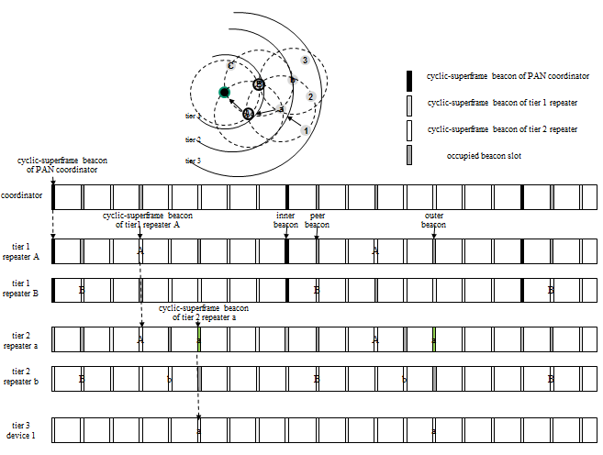
Figure 19j- RSLN-enabled PAN and beacon allocation on relaying tiers

P.3.2.3 Joining an RSLN-enabled PAN
A device wishing to join the network as an end point begins passively or actively scanning for the network as the result of receiving an MLME-SCAN.request from its next higher layer. The device selects the PAN coordinator or a suitable inward repeater from the list of RSLN-enabled PAN descriptors returned from the channel scan and shall be able to respond to the RSLN link management request command
After joining, the device may use the prioritized device slot and the bidirectional device slots assigned to the device.
The primary bidirectional device slot and multiple supplementary bidirectional device slots for an end point or a repeater should be assigned at the starting phase. The algorithm for selecting bidirectional device slots is outside the scope of this standard.

P.3.2.4 Maintaining an RSLN-enabled PAN
The repeaters and end points in an RSLN-enabled PAN are synchronized with the clock time of the PAN coordinator. The clock time of the RSLN-enabled PAN is advertised outward to the repeaters and end points via the Time Synchronization Specification field of the RSLN-enabled PAN descriptor IE in beacon frame (5.2.4.24), the RSLN acknowledgment descriptor IE in acknowledgment frame (5.2.4.26), and the RSLN-Management response command (5.3.15.4).
The repeaters and end points compensate for the clock drift based on the statistical variance of the difference in the real start time of a given slot and the expected start time. The selection of a slot to be measured for collecting statistical data depends on the frame type carrying the time synchronization specification and the grade of link access. In the beacon frame, the Time Synchronization Specification field contains the start time of the beacon slot. In the acknowledgment frame and the RSLN-Management response command frame with grade 0 link access, the Time Synchronization Specification field contains the start time of the coordinator slot. In the acknowledgment frame and the RSLN-Management response command frame with grade 1 link access, the Time Synchronization Specification field contains the start time of the primary bidirectional device slot.
After starting an RSLN-enabled PAN, the PAN coordinator may check the status of a device, collect information on the configuration of repeaters on the RSLN relaying paths, and control the transmission power of a device with the RSLN management procedure.
To search activated devices on the relaying path, the PAN coordinator uses the HELLO type of MLME-RSLN-MANAGEMENT primitives, as described in 6.2.23. The HELLO type of RSLN management command is relayed to the destination device. The destination device reports the current configuration of all the devices on the relaying path beyond the destination device, as defined in 5.3.15.4.2.
To get information on the device configuration, the coordinator uses the DEVICE type of MLME-RSLN-MANAGEMENT primitives. The destination device reports the current configuration, as defined in 5.3.15.4.2.
To get information on the relaying path configuration, the coordinator uses the PATH type of MLME-RSLN-MANAGEMENT primitives. The destination device reports the relaying path configuration identified at the device, as defined in 5.3.15.4.3.
To get information on the transmission power of a device, the coordinator uses the POWER_CONFIG type of MLME-RSLN-MANAGEMENT primitives. To control the transmission power of a device, the coordinator uses the POWER_CNTL type of MLME-RSLN-MANAGEMENT primitives. The requested transmission power is sent in PHY TX Power field of the Power Management Descriptor field, as defined in 5.3.15.4.4.

P.3.3 Synchronous relaying

P.3.3.1 Transmission
In an RSLN-enabled PAN, the next higher layer begins data transmission by issuing the MCPS-DATA.request primitive with the RSLN Relaying specification IE ID and the grade of link access, as described in 6.3.1. On receipt of the MCPS-DATA.request primitive, the MAC sublayer entity transmits data frames.
For grade 0 link access, a device first searches the earliest prioritized device slot. If the device fails to transmit the data in the prioritized device slot, the device will continue trying to transmit the data in either a bidirectional device slot or in another prioritized device slot, whichever comes first.
A device using grade 1 link access waits for the primary bidirectional device slot in the cyclic-superframe and transmits the data. If the device fails to transmit the data in the primary bidirectional device slot, the device will keep searching supplementary bidirectional device slots for the duration of the cyclic-superframe or will search the coming cyclic-superframe for an opportunity to transmit the data.
A device using grade 2 link access waits for the primary bidirectional device slot in the cyclic-superframe and transmits the data without requiring an acknowledgment.
When a device or the PAN coordinator generates an RSLN acknowledgment frame or RSLN MAC command frame, a device or the PAN coordinator specifies the grade of link access applied to relaying of the frame.

P.3.3.2 Relaying slot-link
The repeater receives data frames and command frames generated from the PAN coordinator, the inward repeater, the outward repeater, and end points. If received frames satisfy third-level filtering requirements as described in 5.1.6.2 except the destination address matching, data frames are relayed by the MCPS entity, and command frames are relayed by the MLME. The selection of the relaying slot-link depends on the relaying direction and the type of slot-link receiving a frame.
The cyclic-superframe beacon received from an inward repeater or the PAN coordinator shall be relayed outward by transmitting in the cyclic-superframe beacon slot of the repeater. The distance between the cyclic-superframe beacon slot of the inward coordinator and the cyclic-superframe beacon slot of the repeater shall be applied synchronously for relaying the frames received in the coordinator slot and the bidirectional slots, as shown in Figure 29a.
When relaying the cyclic-superframe beacon, the repeater updates the Synchronous Relaying Specification field of the RSLN-enabled PAN descriptor IE. When relaying the multi-superframe beacon, the repeater changes the source address field with the repeater’s address and updates the Time Synchronization Specification field and the Synchronous Relaying Specification field of the RSLN-enabled PAN descriptor IE.
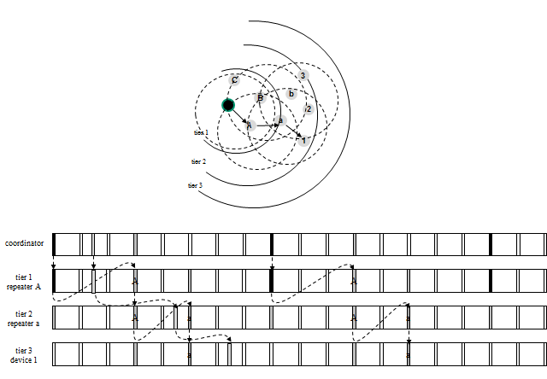
Figure 29a- Outward synchronous relaying in an RSLN-enabled PAN

The prioritized device slot and the bidirectional device slots are relayed inward, as illustrated in Figure 29b. The prioritized device slot of the outer coordinator or end point is relayed to the next available prioritized device slot.
The frames received in the bidirectional device slot of the outer coordinator or the end point are relayed to the bidirectional device slot of the inner coordinator. The distance between the slot-link relaying to the inner coordinator and the cyclic-superframe beacon slot of the inner coordinator is the same as the distance between the cyclic-superframe beacon slot of the outer coordinator and the received bidirectional device slot.
When relaying a frame inward, the repeater updates the relaying specification field of the frame.
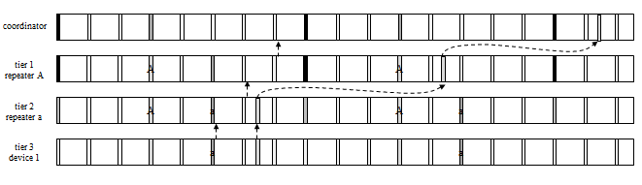
Figure 29b- Inward synchronous relaying in an RSLN-enabled PAN

P.3.3.3 Acknowledgment and retransmission
In an RSLN-enabled PAN, the relayed data frame shall be acknowledged either via an end-to-end or via a slot-link acknowledgment. If an end-to-end acknowledgment is used, the acknowledgment frame generated in the PAN coordinator is relayed by the repeaters on the RSLN path along to the end device or vice versa. If a slot-link acknowledgment is used, the frame received successfully from a relayed slot-link is acknowledged to the repeater by transmitting the slot-link acknowledgment frame.
The slot-link acknowledgment frame is sent within the same time slot in which the frame is received, if there is enough time to complete transmission of the slot-link acknowledgment frame before the end of the time slot. Otherwise, the slot-link acknowledgment frame sent in the coordinator slot of the following superframe. The end-to-end acknowledgment frame from the PAN coordinator is sent in the coordinator slot of the superframe to which the primary bidirectional device slot of the source device is assigned. The end-to-end acknowledgment frame from a device is sent in the primary bidirectional device slot of the device.
According to the grade of link access for transmitting a data frame, the RSLN acknowledgment procedure selects one of three modes: GRADE0_ACK, GRADE1_ACK, or GRADE2_ACK.
In the GRADE0_ACK mode, the repeater along the RSLN path to the destination generates the slot-link acknowledgment frame to the sender, and the destination device generates the end-to-end acknowledgment frame to the source device when the frame is successfully received at the destination, as illustrated in Figure 29c.
If a slot-link acknowledgment is not received within macAckWaitDuration or a slot-link acknowledgment is received containing a DSN that is not the same as that of the original transmission, the repeater shall conclude that the single transmission attempt has failed. If a single transmission attempt has failed, the repeater shall retransmit the frame in an alternative slot and wait for the slot-link acknowledgment, up to a maximum of macMaxFrameRetries times, as illustrated in Figure 29d.

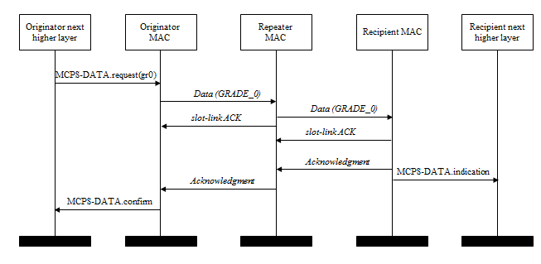
Figure 29c- Successful GRADE_0 data transmission in an RSLN-enabled PAN
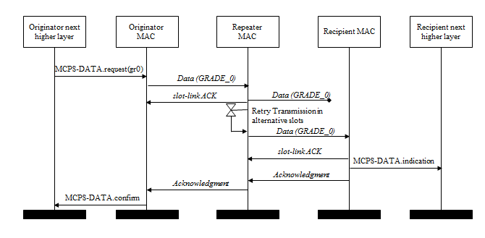
Figure 29d- Retransmission of the lost GRADE_0 data frame in an RSLN-enabled PAN

In the GRADE1_ACK mode, when the frame is received successfully at the destination, the destination generates the end-to-end acknowledgment frame. The end-to-end acknowledgment frame is relayed to the source device, as illustrated in Figure 29e.
If an end-to-end acknowledgment is not received within BI ｘ macRelayingTier or an end-to-end acknowledgment is received containing a DSN that was not the same as that in the original transmission, the device shall conclude that the single transmission attempt has failed. If a single transmission attempt has failed, the device shall retransmit the frame in an alternative slot and wait for the end-to-end acknowledgment, up to a maximum of macMaxFrameRetries times, as illustrated in Figure 29f.

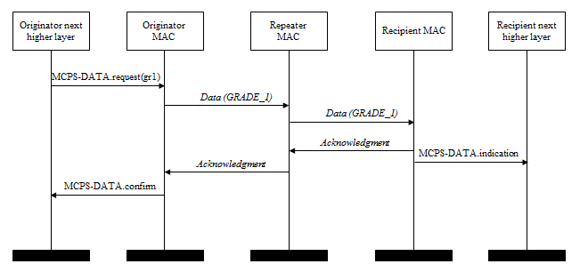
Figure 29e- Successful GRADE_1 data transmission in an RSLN-enabled PAN
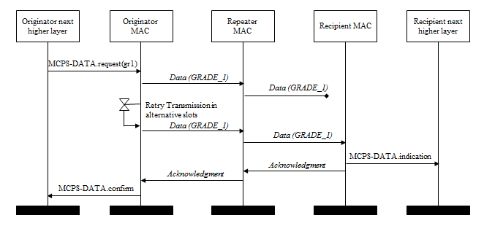
Figure 29f- Retransmission of the lost GRADE_1 data frame in an RSLN-enabled PAN

In the GRADE2_ACK mode, the received frame shall not be acknowledged by its intended recipient.

