IEEE P802.15
Wireless Personal Area Networks

Project | IEEE P802.15 Working Group for Wireless Personal Area Networks (WPANs)
Title | Relayed Slot-Link Network (RSLN) working draft contribution for TG4k
Date Submitted | [17 January 2012]
Source | [Seong-Soon Joo]  [ETRI]  [] | Voice: [ +82.42.860.6333 ]  Fax: [ ]  E-mail: [ ssjoo @ etri.re.kr ]
Re: | [TG4k LECIM PHY development, MAC support]
Abstract | Relayed Slot-Link Network working draft for MAC additions necessary to support the LECIM PHYs
Purpose | Draft standard development
Notice | This document has been prepared to assist the IEEE P802.15. It is offered as a basis for discussion and is not binding on the contributing individual(s) or organization(s). The material in this document is subject to change in form and content after further study. The contributor(s) reserve(s) the right to add, amend or withdraw material contained herein.
Release | The contributor acknowledges and accepts that this contribution becomes the property of IEEE and may be made publicly available by P802.15.

IEEE 802.15.4k MAC Working Draft version: 2012-01-17
WARNING: Incomplete Work Product
WORKING DRAFT ONLY: Contribution to TASK GROUP Draft Development Process.
DO NOT USE FOR ANY OTHER PURPOSE

Contents
Contents
1. Overview 1
1.1 General 1
1.2 Scope 1
1.3 Purpose 1
2. Normative references 1
3. Definitions, Acronyms and Abbreviations 2
3.1 Definitions 2
3.2 Acronyms 2
4. General Description 2
4.1 General 2
4.2 Components of the WPAN 2
4.3 Network topologies 2
4.3.1 Star network formation 2
4.3.2 Peer to peer network formation 2
4.4 Architecture 2
4.4.1 PHY layer (PHY) 2
4.4.2 MAC Sub-layer (General Characteristics) 2
4.5 Functional Overview 2
4.5.1 Superframe Structure 2
4.5.2 Data transfer model 3
4.5.3 Frame Structure 4
4.5.4 Improving probability of successful delivery 4
4.5.5 Power consumption considerations 4
4.5.6 Security 5
4.6 Concept of primitives 5
5. MAC protocol 5
5.1 MAC functional description 5
5.1.1 Channel Access 5
5.1.2 Starting and maintaining PANs 7
5.1.3 Association and disassociation 8
5.1.4 Synchronization 9
5.1.5 Transaction handling 10
5.1.6 Transmission, reception, and acknowledgment 10
5.1.7 GTS allocation and management 12
5.1.8 Ranging 12
5.1.9 LLDN Transmission states 12
5.1.10 Deterministic and synchronous multi-channel extension (DSME) 12
5.1.11 LE-transmission, reception and acknowledgment 12
5.1.12 Asynchronous multi-channel adaptation (AMCA) 12
5.1.13 Relayed slot-link network (RSLN) 12
5.2 MAC frame formats 12
5.3 MAC command frames 12
5.3.14 RSLN-commands 12
5.4 MPDU Fragmentation 13
5.4.1 MPDU PHY adaptation, fragmentation and reaassembly 13
5.4.2 Fragment cell formats 13
6. MAC services 13
6.1 Overview 13
6.2 MAC management service 13
6.2.22 MAC management service 13
6.2.23 Primitives for RSLN 13
6.3 MAC data service 14
6.3.5 MAC data service 14
6.3.6 Primitives for RSLN 14
7. Security 14
8. General PHY requirements 15
9. PHY services 15
10. O-QPSK PHY 15
11. Binary phase-shift keying (BPSK) PHY 15
12. Amplitude shift keying (ASK) PHY 15
13. Chirp spread spectrum (CSS) PHY 15
14. UWB PHY 15
15. GFSK PHY 15
16. SUN PHYs 15
17. MSK PHY 15
18. LRP UWB PHY 15
19. LECIM PHYs 15

Draft<opt_Trial-Use><Gde./Rec. Prac./Std.> for <Complete Title Matching PAR>
NOTE: When preparing a draft amendment, the editors will include only the section headings where changes to the base standard are made. Amendments, when completed, will not contain any empty sub-clauses. In this outline all of the clauses and sub-clauses of the base standard are included for preliminary draft development (and because it is easier in Word). If there is no annotation in a section it is likely the amendment would not have contents for that section.
This outline is based on P8021.15.4-2011 taking into account (nearly) approved amendments 15.4e, 15.4f and 15.4g. By the time LECM balloting begins these will be completed approved amendments.
This is a working draft outline so it excludes the IEEE Boilerplate that will be added to the draft prior to balloting.
No additions Clause 1 are expected.
- Overview
  - General
  - Scope
  - Purpose

- Normative references
No changes expected.
- Definitions, Acronyms and Abbreviations
  - Definitions
  - Acronyms

Insert the following text:
RSLN relayed slot-link network

- General Description
  - General
  - Components of the WPAN
  - Network topologies
    - Star network formation

Insert before 4.3.2 the following paragraph:
For extending networking coverage, a star network can use FFDs, which may relay MAC frames synchronously inward to the PAN coordinator or outward to a device, to form a relayed link network operating as a virtual star network.

    - Peer to peer network formation
  - Architecture
    - PHY layer (PHY)
    - MAC Sub-layer (General Characteristics)
  - Functional Overview
    - Superframe Structure
      - General

      - Use of superframe structure for LECIM

Insert before 4.5.2 the following paragraph:
In a relayed slot-link network (RSLN) PAN, the PAN coordinator generates a cyclic-superframe that periodically transmits slotted-superframes, which can be combined into multi-superframes. The slotted-superframe contains a beacon slot, prioritized device slots, coordinator slots, and bidirectional device slots as shown in Figure xx. The prioritized device slot shall start immediately following the beacon and provide an up-link to the coordinator for transmitting delay sensitive data from devices. The coordinator slot shall provide a down-link to devices for broadcasting frames. The bidirectional device slots in a cyclic-superframe shall be assigned to each device in a RSLN and provide a bidirectional link between a certain device and the PAN coordinator.
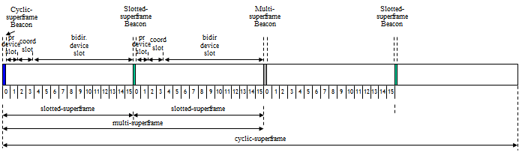
Figure xx-An example of the cyclic-superframe structure

    - Data transfer model
      - Data transfer to a coordinator

Insert before 4.5.2.2 the following paragraph:
In a RSLN PAN, two types of data transfer link to a coordinator exist. When a device wishes to transfer delay sensitive data to a coordinator, the device shall transmit the data frame on the earliest prioritized device slot of a slotted-superframe. If a device failed to transfer on a prioritized device slot and wishes to transfer data to a coordinator, the data frame shall be transmitted on the bidirectional device slot, which is allocated exclusively for the device in a RSLN.

      - Data transfer from a coordinator

Insert before 4.5.2.3 the following paragraph:
In a RSLN PAN, two types of data transfer link to a device exist. When the coordinator wants to broadcast data to devices in a RSLN, the coordinator may use the coordinator slot. When the coordinator wishes to transfer data to a device without notifying, the coordinator may transmit the data frame continuously on the bidirectional device slot assigned to the device of a cyclic-superframe until the device acknowledges the successful reception of the data.

      - Peer-to-peer data transfers
    - Frame Structure
    - Improving probability of successful delivery
      - CSMA-CA mechanism
      - ALOHA mechanism
      - Frame acknowledge
      - Data verification
      - Asynchronous multi-channel adaptation

Insert before 4.5.5 the following subclause:
      - Multiple grades of synchronous channel access
The times of occurrence of events are often crucial for the observer and maintaining synchronous channels can support an accurate time-stamping of measuring events. The synchronous channel access helps distributing the data transfers in time scale and can provide multiple grades of channel access. In a RSLN PAN, three grades of synchronous channel access are provided: the grade 0 for transmitting a delay sensitive data, the grade 1 for the reliable transmission of data, and the grade 2 for the best efforts on transmitting data.
As for the grade 0 channel access, a device searches the earliest prioritized device slot firstly. If fails to transmit the data on the prioritized device slot, a device keeps finding a chance to transmit the data on the bidirectional device slot or prioritized device slot which will come next. A device with the grade 1 channel access waits for the primary bidirectional device slot in the cyclic-superframe and transmits the data. If fails to transmit the data, a device keeps searching supplementary bidirectional device slots from the rest of duration of cyclic-superframe or from the coming cyclic-superframe for transmitting the data.

    - Power consumption considerations
      - General
      - Low-energy mechanisms

Insert before 4.5.6 the following subclause:
      - Low energy extension of networking coverage by synchronous relaying
In a star network, the coverage of networking will be limited by the transmission range of a device, which must be operated in low power as possible as for increasing a life span in the network. Compared to the energy critical device, the power sourced coordinator may have more responsibility to extend the coverage of the star network with no burden to a device and preserving the topology. In a RSLN PAN, a cyclic-superframe repeater provides synchronous relaying of the frames to inward or outward between the PAN coordinator and a device to extend the coverage of a star network.

    - Security
  - Concept of primitives

- MAC protocol
  - MAC functional description

Insert the following text after the second paragraph in 5.1:
- Relaying the slot-links

    - Channel Access
      - Superframe structure

Insert the following paragraph before 5.1.1.1.1:
For RSLN applications an additional superframe structure is required, as described in 5.1.1.8.

      - Incoming and outgoing superframe timing
      - Interframe spacing (IFS)
      - CSMA-CA Algorithm
      - TSCH-Slotframe structure
      - LLDN Superframe structure
      - LE-Functional description

Insert before 5.1.2 the following subclause:
      - RSLN slot-link structure
        - General
The relayed slot-link network has slot-links between the PAN coordinator and each device in the network. A slot-link is the pairwise assignment of a directed communication between the PAN coordinator and a device in a given timeslot. The PAN coordinator generates a sequence of timeslots and repeats the sequences, the cyclic-superframe. Timeslots in a cyclic-superframe are the link for PAN coordinator to a device, 1-to-1 link, or the link for the PAN coordinator to n devices, 1-to-n link.
The cyclic-superframe provides slot-links to devices, the slotted-superframe, in time scale. The slotted-superframe is consists of a beacon slot, prioritized device slot, coordinator slot, and bidirectional device slot.
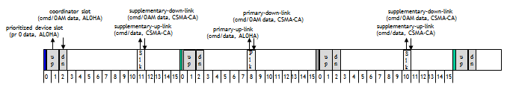
Figure xx-An example of slot-links in a cyclic-superframe

        - Beacon slot
The beacon slot provides a link for transmitting a beacon from the PAN coordinator to devices. The beacon slot is reserved for the RSLN PAN coordinator to indicate the start of every slotted-superframe with the transmission of a beacon.
The beacon provides the RSLN PAN information such as structure of cyclic-superframe and global time information.

        - Prioritized device slot
The prioritized device slot provides a link for transmitting delay sensitive data from a device to the PAN coordinator. The number of the prioritized device slot is defined as macNumPrioritizedDeviceSlot.
A device shall use slotted ALOHA mechanism to access the prioritized device slot-link.

        - Coordinator slot
The coordinator slot provides a link for transmitting data from the PAN coordinator to devices. The number of the coordinator slot is defined as macNumCoordSlot.
The PAN coordinator shall use slotted ALOHA mechanism to access the coordinator slot-link.

        - Bidirectional device slot
The bidirectional device slot provides a link for transmitting data from a device to the PAN coordinator or from the PAN coordinator to a device. The bidirectional device slot-link is assigned to all the devices in a RSLN PAN. If the number of bidirectional device slots in a cyclic-superframe is larger than the number of devices in a RSLN PAN, each device has a preemptive bidirectional device slot-link. Otherwise, some devices might share the bidirectional device slot-link to the PAN coordinator.
The channel access mechanism of a bidirectional slot-link depends upon the direction of transmission. On the access of the bidirectional device slot-link, the device gives priority in use. A device transmits without sensing the medium at the start of the assigned bidirectional device slot. Each time the PAN coordinator wishes to transmit data on the bidirectional device slot-link assigned to a certain device, it waits for a random number of backoff periods at the start of the assigned bidirectional device slot. If the slot-link is found to be idle, the PAN coordinator begins transmitting.
One primary bidirectional device slot and multiple supplementary bidirectional device slots are allocated to each device in a RSLN PAN. The supplementary bidirectional device slot provides additional slots for the transmission or is used for retransmitting the frame which was failed to transmit in the primary bidirectional device slot. On the access of the supplementary bidirectional device slot-link, the device shall use a slotted CSMA-CA mechanism.

    - Starting and maintaining PANs

Insert before 5.1.3 the following subclause:
      - RSLN PAN formation
A RSLN PAN is formed when the PAN coordinator is instructed to begin operating through the use of the MLME-RSLN-START.request primitive, as defined in 6.2.x.x, with the RSLN PAN configuration and starts to send Enhanced Beacon on every beacon slots of a cyclic-superframe. The Enhanced Beacons contain:
- Cyclic-superframe specification (BO, SO, MO, number of prioritized device slot, number of coordinator slot)
- Time synchronization specification (global clock timestamp, slotted-superframe ID)
- Synchronous relaying specification (current depth of relaying, beacon information about neighbor tiers’ repeaters)
- Indirect data transmission information

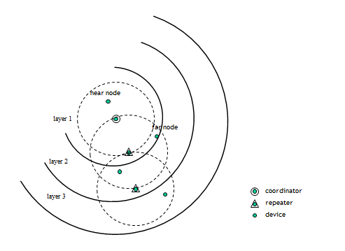
Figure xx- Relayed slot-link network PAN

    - Association and disassociation

Insert before 5.1.4 the following subclause:
      - RSLN repeater association
The next higher layer shall attempt to associate as a repeater after having completed channel scan. The result of channel scan would have been used to choose a repeater closer to the PAN coordinator or the PAN coordinator from the list of the RSLN PAN descriptors.
Following the selection of an inner coordinator to associate, the next higher layers shall request through the MLME-RSLN-ASSOCIATE.request primitive, as described in 6.2.x.x, that the MLME configures the following the values for repeater association to the RSLN PAN:
- RSLN PAN information (phyCurrentChannel, phyCurrentPage, macPANId)
- inner coordinator information (macCoordExtendedAddress or macCoordShortAddress)
- repeater information (current depth of relaying, slotted-superframe ID)

The PAN coordinator shall allow association only if relayed beacon slot is available.
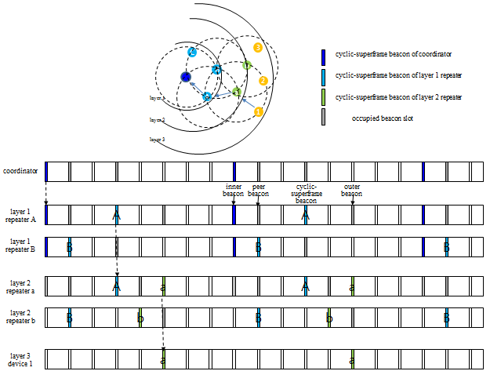
Figure xx- Synchronous relaying of cyclic-superframe in a RSLN PAN

    - Synchronization
      - Synchronization with beacons
      - Synchronization without beacons
      - Orphaned device realignment
      - LECIM Synchronization

Insert before 5.1.5 the following subclause:
        - RSLN Synchronization
TBD
    - Transaction handling
    - Transmission, reception, and acknowledgment
      - Transmission
      - Reception and rejection
      - Extracting pending data from a coordinator
      - Use of acknowledgments and retransmissions
        - No acknowledgment
        - a Incremental fragment acknowledgement
        - a Incremental fragment retransmission

Insert before 5.1.5 the following subclause:
        - RSLN acknowledgement
TBD

      - Promiscuous mode
      - Transmission scenarios

Insert before 5.1.7 the following subclause:
      - Synchronous relaying
Each repeater relays the slot-link outward or inward. The selection of relayed slot-link depends on the direction of relaying and the type of the slot-link.
Only the beacon received on the beacon slot of an inner repeater or the PAN coordinator shall be relayed to the outward beacon slot of the inner repeater or the PAN coordinator. The relaying of the cyclic-superframe beacon slot-link of the PAN coordinator to the cyclic-superframe beacon slot-link of the repeater is synchronized by letting a cyclic-superframe beacon of the PAN coordinator relayed on the cyclic-superframe beacon slot of the repeater. The outward relaying beacon slot of the inner repeater is determined by relative beacon slot distance between the cyclic-superframe beacon slot of the repeater and the inner repeater.
Outward relaying of the coordinator slot is synchronized with the relaying of the cyclic-superframe beacon slot.
The frames received on the bidirectional device slot of the inner repeater are relayed to the bidirectional device slot of the next cyclic-superframe.
When relaying the beacon or command frames outward, the repeater updates the time synchronization specification and the synchronous relaying specification in the frames, if applicable.
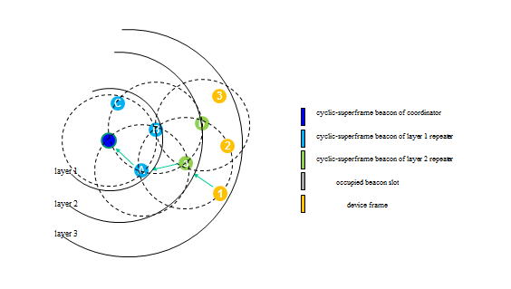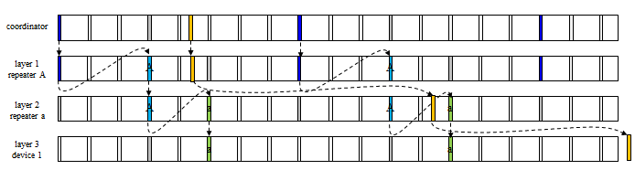
Figure xx- Outward synchronous relaying in a RSLN PAN

The prioritized device slot of the outer repeater is relayed to the earliest available prioritized device slot of coming slotted-superframe.
The frames received on the bidirectional device slot of the outer repeater are relayed to the bidirectional device slot of the next cyclic-superframe.
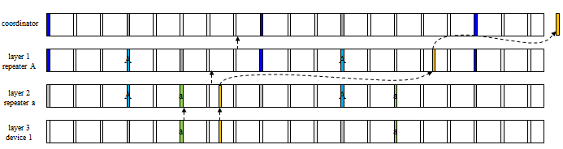
Figure xx- Inward synchronous relaying in a RSLN PAN

    - GTS allocation and management
    - Ranging
    - LLDN Transmission states
    - Deterministic and synchronous multi-channel extension (DSME)
    - LE-transmission, reception and acknowledgment
      - Coordinated sampled listening (CSL)
      - Receiver initiated transmission (RIT)
      - LECIM Alternate/Hybrid LE scheme
    - Asynchronous multi-channel adaptation (AMCA)

Insert before 5.2 the following subclause:
    - Relayed slot-link network (RSLN)
TBD

  - MAC frame formats

  - MAC command frames

Insert before 6 the following subclause:
    - RSLN-commands
TBD

  - MPDU Fragmentation
    - MPDU PHY adaptation, fragmentation and reaassembly
    - Fragment cell formats

- MAC services
  - Overview
  - MAC management service
    - MAC management service

Insert before 6.3 the following subclauses:
    - Primitives for RSLN
      - Primitives for RSLN network formation
        - MLME-RSLN-START.request
TBD
        - MLME-RSLN-START.confirm
TBD

      - Primitives for RSLN repeater association
        - MLME-RSLN-ASSOCIATE.request
TBD
        - MLME-RSLN-ASSOCIATE.indication
TBD
        - MLME-RSLN-ASSOCIATE.response
TBD
        - MLME-RSLN-ASSOCIATE.confirm
TBD

      - Primitives for RSLN link management
        - MLME-RSLN-LINK.request
TBD
        - MLME-RSLN-LINK.indication
TBD
        - MLME-RSLN-LINK.confirm
TBD

  - MAC data service
    - MAC data service

Insert before 6.3 the following subclauses:
    - Primitives for RSLN
      - MCPS-RSLN-DATA.request
TBD
      - MCPS-RSLN-DATA.confirm
TBD
      - MCPS-RSLN-DATA.indication
TBD

- Security
Very few changes I hope!
- General PHY requirements
- PHY services
- O-QPSK PHY
- Binary phase-shift keying (BPSK) PHY
- Amplitude shift keying (ASK) PHY
- Chirp spread spectrum (CSS) PHY
- UWB PHY
- GFSK PHY
- SUN PHYs
Added by 15.4g TG.
- MSK PHY
Added by 15.4f RFID TG.
- LRP UWB PHY
Added by 15.4f RFID TG.
- LECIM PHYs

