**IEEE P802.15**

**Wireless Personal Area Networks**

|  |  |  |
| --- | --- | --- |
| Project | IEEE P802.15 Working Group for Wireless Personal Area Networks (WPANs) | |
| Title |  | |
| Date Submitted | March 14, 2012 | |
| Source | Soo-Young Chang [CSUS], Mi-Kyung Oh, Cheolho Shin, Sangsung Choi [ETRI], Liru Lu, Chin Sean Sum, Hiroshi Harada, Fumihide Kojima, Ming-Tuo Zhou [NICT], Kunal Shah, Jay Ramasastry, Cristina Seibert, George Flammer, Steve Shearer [Silver Spring Networks], Nancy Bravin [Self] | E-Mail: [sychang@ecs.csus.edu] |
| Re: | Task Group 15.4m Technical Guidance for Proposals | |
| Abstract | [TG4m - technical guidance for PHY proposals.] | |
| Purpose | [Working document for the PAR to the P802.15 Working Group.] | |
| Notice | This document has been prepared to assist the IEEE P802.15. It is offered as a basis for discussion and is not binding on the contributing individual(s) or organization(s). The material in this document is subject to change in form and content after further study. The contributor(s) reserve(s) the right to add, amend or withdraw material contained herein. | |
| Release | The contributor acknowledges and accepts that this contribution becomes the property of IEEE and may be made publicly available by P802.15. | |

**Table of Contents**

1. Introduction

Purpose

Methodology

# Requirements Discussion

Summary of PAR

## High Level Requirements Overview

Application Requirements Matrix

## White Space Related Regulations

## Summary of Regulations

Regulatory Requirements

Coexistence

Interoperability

## Complexity and Cost Considerations

1. Channel Characteristics

Path Loss Propagation Models

Line-of-Sight (LOS) Progationl Model

Non-Line-of-Sight (NLOS) Propagation Model

Channel Impulse Response Model

1. Definitions

References

Annex A: Non-Line-of-Sight (NLOS) Propagation Models

Annex B: Multipath Delay Spread Models

**Abbreviations**

The following abbreviations are used in this document.

ATSC Advanced Television Systems Committee

CEPT European Conference of Postal and Telecommunications Administrations

CRTC Canadian Radio-Television and Telecommunications Commission

dB Decibels

DVB-T Digital Video Broadcasting — Terrestrial

ECC Electronic Communications Committee in Europe

EIRP Equivalent Isotropically Radiated Power

ERC European Radiocommunications Committee in Europe

ERP Effective Radiated Power

FCC Us Federal Communications Commission

FD Fixed Device

GDB Geo-Location Database

GSM Global System for Mobile Communications, originally Groupe Spécial Mobile

GHz Gigahertz (1 GHz = 109 Hertz or a frequency of one billion cycles per second)

IDA Info-Communications Development Authority in Singapore

ITU International Telecommunication Union

LOS Line-Of-Sight

M2M Machine To Machine

MAC Media Access Control Layer

MHz Megahertz (1 MHz = 106 Hertz or a frequency of one million cycles per second)

NLOS Non-Line-Of-Sight

NTSC National Television System Committee

PAR Project Authorization Request

PDP Power Delay Profile

PHY Physical Layer

PICS Protocol Implementation Conformance Statement

PPD Personal/Portable Device

TG4m Ieee802 Working Group 15 Task Group m

TGD Technical Guidance Document

TVBD TV Band Device

TVWS TV White Space

UHF Ultra High Frequency

VHF Very High Frequency

WPAN Wireless Personal Area Network

WPAN-WS Wireless Personal Area Network – White Space

WSD White Spaces Device

TG4m Technical Guidance Document (TGD)

1. **Introduction**

**Purpose**

This document provides technical guidance by summarizing parametrically the key PHY characteristics and any necessary MAC changes identified in consideration of WPAN-WS (WPAN white space) application and regulatory requirements. The technical summary on PHY and MAC parameters are intended to provide guidelines to the proposals for Task Group 802.15.4m. It should be noted that the main objective of this document is to provide technical recommendations for designing and evaluating potential proposals, and should not be understood as mandatory requirements for the system design.

The intent of the task group is to use a flexible and efficient process that provides sufficient descriptions of the technical requirements to enable relevant responses, with efficiency of effort while meeting the critical need for a timely standard. The TG4m task group will use this document to help qualify MAC and PHY protocol proposals.

The responsibility of the TG4m is to produce a quality and timely standard specification. To achieve this goal, TG4m will consider the technical recommendations in this document to assist the preparation and evaluation of technical proposals.

## Methodology

The methodology provides recommendations to defining a minimal set of features, characteristics, performance and constraints to be considered. This document provides:

* A functional view of the PHY characteristics, in the form of specific parameters which define externally verifiable performance and interoperability characteristics; and
* Application/performance description~~s~~ that characterizes the types of WPAN-WS applications and the derived performance characteristics.

In preparing proposals, this can be used as a framework to produce a concise summary of the characteristics of each given proposal, and will allow the group to see the similarities and differences in submitted proposals.

# Requirements Discussion

## Summary of PAR

**2.1 Title:**

IEEE Standard for Local and Metropolitan Area Networks Part 15.4: Low Rate Wireless Personal Area Networks (LR-WPANs) Amendment: TV White Space between 54 MHz and 862 MHz Physical Layer

**5.2 Scope:**

This amendment specifies a physical layer for 802.15.4 meeting TV white space regulatory requirements in as many regulatory domains as practical and also any necessary Media Access Control (MAC) changes needed to support this physical layer. The amendment enables operation in the VHF/UHF TV broadcast bands between 54 MHz and 862 MHz, supporting typical data rates in the 40 kbits per second to 2000 kbits per second range, to realize optimal and power efficientdevice command and control applications.

**5.5 Need for the Project:**

There are many instances in large area device command and control applications where infrastructure requirements need to be minimized for effective deployment. These needs are effectively served by the ability to operate 802.15.4 class networks in the TV white space spectrum.

The PAR can be found on the IEEE802 web site: (https://mentor.ieee.org/802.15/dcn/11/15-11-0643-00-004m-tg4m-par.pdf).

## High Level Requirements Overview

From the PAR and general procedural rules, key overall goals and requirements of this project can be summaried as follows:

* The amendment shall specify operations meeting at least one, and as many as practical, TV White Space regulatory requirements.
* The amendment shall specify operations in TV white space frequency bands under regulatory constraints that can be identified.
* The amendment shall provide operation modes that support PHY data rate of typically 40kbps to 2000kbps. Proposers are encouraged to provide optional operation modes that support PHY data rates of ~10Mbps.
* The amendment shall achieve operating range of at least 1km.
* The amendment shall provide at least one operation mode that supports up to at least 1000 direct neighboring devices.
* The amendment should provide a means for frequency band and channel switching for radios with multi-band capability.
* The amendment shall provide mechanism to enable coexistence with users (*e.g.* TV broadcasting) protected by regulations.
* The amendment should support coexistence with other 802 systems operating in the TV white space fulfilling the requirements of providing the Coexistence Assurance Document.
* The amendment complies with the P802.15.4m PAR and 5 Criteria.
* The amendment will include a PICS proforma.
* The amendment should provide technical mechanisms to enable direct device-to-device communications in both star and peer-to-peer networks.

**Application Requirements Matrix**

|  |  |  |  |
| --- | --- | --- | --- |
| **Application** | **Description** | **Key Parameters** | **Reference** |
| Smart utility networks (SUN) | TV White space application is a good candidate for SUN   * + There is no special interference source except TV signal.   + Use the similar TV Channel frequencies all over the world | - Environment: Indoor/outdoor, Urban/suburban/rural  -  Operating range: up to several km  -  Up to several thousands of nodes in the network  -  Mobility (Device type): fixed  -  Security features: required  -  Reliability: high  -  Device category: as regulations applied to all applications | 15-09-0275-02  15-11-0171-00 |
| Intelligent Transportation System | TV bands make signal travel longer distance and less vulnerable in rural areas, which can enable multiple applications between car and fixed node.   * Information delivery * Traffic management * Logistics tracking/Vehicle location | * Environment: Outdoor * Data rate: Generally <1Mbps, Up to 10Mbps * Operating range: One controller covers up to 1 square km * Data flow: two-way, 100 end devices (mobile) to 1 controller (fixed) * Transmission power: Obey regulations all over the world * Power type: Mains powered or powered by car engine | 15-11-0194-00  15-11-0279-01 |
| Surveillance, control and monitoring network | Larger coverage areas due to excellent propagation characteristics, which make it attractive for surveillance, control and monitoring networks | - Environment: Indoor/outdoor  - Data rate: up to 2Mbps  - Operating range: up to 1 Km  - Mobility: support (e.g., up to 10Km/h) | 15-11-0215-02 |
| Infrastructure moditoring network | Larger coverage areas due to excellent propagation characteristics, which make it attractive for infrastructure monitoring | - Environment: outdoor  - Data rate: less than 100Kbps  - Operating range: up to several Km  - Reliability: high  - Mobility: fixed  - Energy efficiency: high | 15-11-0215-02 |
| Local network in machine-to-machine (M2M) | Larger coverage areas due to excellent propagation characteristics, which make it attractive for local networks in M2M | - Environment: Indoor/outdoor  - Data rate: depends on M2M applications (40Kbps~2Mbps)  - Operating range: depends on M2M applications (up to several Km)  - Mobility: depends on M2M applications (up to 20~30Km/h) | 15-11-0215-02 |
| Digital Signage System | Larger coverage areas due to excellent propagation characteristics, which make it attractive for the proposed system | - Environment: Indoor/outdoor  - Data rate: 2Mbps typical, up to 10Mbps  - Operating range: up to several Km  - Mobility: fixed  - Frame rate: ≥15fps  - Power type: mains powered | 15-12-0060-00 |

## White Space Related Regulations

## Summary of Regulations

|  |  |  |  |  |  |
| --- | --- | --- | --- | --- | --- |
| **Region**  **/Country** | **TVWS Channel Band** | **Device Type** | **Transmitted Power Requirements** | **GDB * Requirements** | **Sensing Requirement** |
| **US (FCC)**  Related document: FCC 10-174  Final order: almost finalized | 6MHz channel allocation  FD only: TV channel 2 (54-60MHz); TV channel 5 to 20 (76-512MHz)  FD and PPD: TV channel 21 to 35 (512 to 602MHz) and TV channel 39 to 52(620-704MHz) | Fixed Device (FD): capable of geolocation and TV bands database access  Personal/Portable Device (PPD): Mode I: list of available channels through fixed or Mode II devices; Mode II: capable of geolocation and TV bands database access;  Sensing-only PPD: with no geolocation and TV bands database access. | FD: 30dBm (1W) delivered to antenna, 4W EIRP;  Mode I and II PPD: 20dBm (100mW) EIRP if the adjacent channel separation requirement is met;  16dBm (40mW) EIRP if the adjacent channel separation requirement is not met;  Sensing-only PPD:  17dBm (50mW) EIRP Transmit power control required | Must be supported in both Fixed and PPD Mode II devices. | Optional for Fixed and PPD Mode I and II devices,  Mandatory for sensing-only PPDs |
| **UK (Ofcom)**  Related document: 9 Nov 2010 Consultation  Final rules pending | 8MHz channel allocation  Possibly 470-550 and 614-790MHz and FM radio bands and other bands to be identified | Master device: direct connect to database;  Slave device: no need to contacct database, managed by master device | Determined by the database;  Transmit power control required | Must be supported in Master devices. | Not to be used in the UK but included to aid  international harmonisation |
| **Europe (CEPT (ECC))**  Related document: ECC Report 159  Still in progress | 8MHz channel allocation  470-790 MHz | Not defined as devices with specific roles/features. | Determined by the database;  Transmit power control required | Must be supported. | Optional |
| **Canada (Industry Canada(CRTC))**  Related document: SMSE-012-11  Still in progress | 6MHz channel allocation  54-72, 76-88, 174-216, 470-608, 614-698MHz, | Fixed;  Mobile:  Mode I: slave device- no direct access to database);  Mode II: master device- direct access to database | Fixed: Max EIRP 6dBW;  Mobile:  Mode I: Max 16dBm EIRP; 20dBm;  Mode II: Max 16dBm EIRP; | Must be supported in both Fixed and Mode II devices. | To be considered in the future when technology is mature. |
| **Singapore (IDA)**  Related document: IDA White Space Technology Information Package, 7 April 2010  Still in progress | VHF 7MHz and UHF 8MHz channel allocation  VHF: between 174 to 230 MHz and UHF: between 494 to 790 MHz | Will be developed in future | Sensing only devices: 100mW per channel; 4dBm with adjacent channeloperated by incumbent;  17dBm with N+2 channel operated by incumbent;  Device with only geolocation: 100mW per channel | Required | Mandatory for both analogue and digital broadcast services;  optional for both analogue and digital wireless microphones |

GDB - Geolocation Database

## Regulatory Requirements

There are several regulatory bodies including the Federal Communications Commission (FCC) in the U. S, Electronic Communications Committee (ECC) under the European Conference of Postal and Telecommunications Administrations (CEPT) in EU, Ofcom in the U. K., and Industry Canada in Canada. Based on the rules from the FCC (refer to FCC 10-174, Second Memorandum Opinion and Order, September 2010) and ECC (refer to ECC Report 159, January 2011), a set of regulatory requirements for white space communications is identified. Therefore whenever new rules are established or future changes of rules from any regulatory bodies are made, they should be considered for the proposals.

***Requirements identified from FCC rules***

A set of common regulatory requirements for white space communications from the rules of FCC are listed as follows:

Frequency bands:

* Devices shall be operatied in any of the regionally available TV white space frequency bands on a license-exempt basis.

Types of white space devices:

* Fixed device
  + This type of device is operated at a fixed location and is capable of geolocation and TV bands database access.
* Mode II Personal/portable device
  + This type of deive does not have a fixed location while operating and is a device which has geolocation and database access features.
* Mode I Personal/portable device
  + This type of device is a device which does not have geolocation and database access features.
* Sensing-only Personal/portable device
  + This type of device is a device which relys only on sensing to protect incumbent users.

Transmit power:

* Fixed devices:
  + Maximum 4W EIRP while the maximum power delivered to transmit antenna is 1W regardless of the number of TV channels on which the device operates and the maximum height of their directional antennas is 30 m above ground.
* Mode I and Mode II Personal/portable devices
  + Maximum 100mW EIRP with permanently attached transmit and receive antennas.
* Sensing-only Personal/portable devices
  + Maximum 50mW EIRP

Transmit power related requirements:

* All devices shall incoporate transmit power control to limit their operating power to the minimum necessary for successful communication.
* In the TV channels immediately adjacent to the channel in which a device is operating, emissions from the device shall be at least 72.8 dB below the highest average power in the TV channel in which the device is operating.
* At frequencies beyond the television channels immediately adjacent to the channel in which the device is operating, the radiated emissions from devices shall meet the following limit requirements:
  + 54-88MHz: 100 μV/m @ 3 m;
  + 88-174MHz: 150 μV/m @ 3 m;
  + 174-216MHz: 1500 μV/m @ 3 m;
  + 216-470MHz, 512-566 MHz, 608-614 MHz, 806-862 MHz : 200 μV/m @ 3 m;
  + 470-512MHz, 566-608 MHz, 614-806 MHz: 5000 μV/m @ 3 m.

Geolocation requirements:

* Fixed devices
  + The geographic coordinates shall be generated with an accuracy of +/- 50 meters by either an incorporated geo-location capability or a professional installer.
  + If the fixed device is moved to another location or if its stored coordinates become altered, the operator shall re-establish the device’s geographic location either
    - by means of the device’s incorporated geo-location capability or
    - through the services of a professional installer;

and store this information in the device and re-register with the database based on the device’s new coordinates.

* Mode II personal/portable devices
  + Accuracy of a geo-location capability to determine its geographic coordinates is +/- 50 meters.
  + Re-establishment of its position by using its geo-location capability shall be performed:
    - each time it is activated from a power-off condition, and
    - at least once every 60 seconds while in operation, except while in sleep mode, i.e., in a modein which the device is inactive but is not powered-down.

TV bands database access and frequency bands operated:

* Fixed devices only
  + Prior to their initial service transmission at a given location, a Fixed device shall access a TV bands database over the Internet to determine the TV channels that are available at its geographic coordinates, taking into consideration its antenna height.
* Mode II devices only
  + Mode II personal/portable devices must access a TV bands database over the Internet to determine the TV channels that are available at their geographic coordinates prior to their initial service transmission at a given location.
  + A Mode II device shall access the database:
    - each time it is activated from a power-off condition and re-check its location, and
    - if it changes location during operation by more than 100 meters from the location at which it last accessed the database.
  + A Mode II device that has been in a powered state shall re-check its location and access the database daily to verify that the operating channel(s) continue to be available.
  + Mode II devices must adjust their use of channels in accordance with channel availability schedule information provided by their database for the 48 hour period beginning at the time of the device last accessed the database for a list of available channels.
  + A Mode II device may load channel availability information for multiple locations around, *i.e.*, in the vicinity of, its current location and use that information in its operation. A Mode II TVBD may use such available channel information to define a geographic area within which it can operate on the same available channels at all locations, for example a Mode II TVBD could calculate a bounded area in which a channel or channels are available at all locations within the area and operate on a mobile basis within that area. A Mode II TVBD using such channel availability information for multiple locations must contact the database again if/when it moves beyond the boundary of the area where the channel availability data is valid, and must access the database daily even if it has not moved beyond that range to verify that the operating channel(s) continue to be available.
* Common to Fixed and Mode II devices
  + Fixed and Mode II devices shall access the database at least once a day to verify that the operating channels continue to remain available.
  + Operation is permitted only on channels that are indicated in the database as being available for the device.
  + Fixed and Mode II devices must adjust their use of channels in accordance with channel availability schedule information provided by their database for the 48 hour period beginning at the time of the device last accessed the database for a list of available channels.
  + If a fixed or Mode II personal/portable TVBD fails to successfully contact the TV bands database during any given day, it may continue to operate until 11:59 PM of the following day at which time it must cease operations until it re-establishes contact with the TV bands database and re-verifies its list of available channels.
* Mode I devices
  + A Mode I device may only transmit upon receiving a list of available channels from a fixed or Mode II device that has contacted a database and verified that the Device Identifier (ID) of the Mode I device is valid. The list of channels provided to the Mode I device must be the same as the list of channels that are available to the fixed or Mode II device, except that a Mode I device may operate only on channels that are permissible for its use.
  + A fixed device may also obtain from a database a separate list of available channels that includes adjacent channels that would be available to a Mode I personal/portable device and provide that list to the Mode I device. A fixed or Mode II device may provide a Mode I device with a list of available channels only after it contacts its database, provides the database the Device Identifier (ID) of the Mode I device requesting available channels, and receives verification that the Device Identifier (ID) is valid for operation.
  + To initiate contact with a fixed or Mode II device, a Mode I device may transmit on an available channel used by the fixed or Mode II device or on a channel the fixed or Mode II device indicates is available for use by a Mode I device on a signal seeking such contacts.
  + At least once every 60 seconds, except when in sleep mode, a Mode I device must either receive a contact verification signalfrom the Mode II or fixed device that provided its current list of available channels or contact a Mode II or fixed device to re-verify/re-establish channel availability.
  + A fixed or Mode II device shall provide the information needed by a Mode I device to decode the contact verification signal. At the same time it provides the list of available channels.
  + A Mode I device may respond only to a contact verification signal from the fixed or Mode II device that provided the list of available channels on which it operates.
  + A Mode I device must cease operation immediately if it does not receive a contact verification signal or is not able to re-establish a list of available channels through contact with a fixed or Mode II device on this schedule. In addition, a Mode II device must re-check/reestablish contact with a fixed or Mode II device to obtain a list of available channels if they lose power. Collaterally, if a Mode II device loses power and obtains a new channel list, it must signal all Mode I devices it is serving to acquire new channel list.
* Fixed devices without a direct connection to the internet.
  + If a fixed device does not have a direct connection to the Internet and has not yet been initialized and registered with the TV bands database, but can receive the transmissions of another fixed device, the fixed device needing initialization and registration without a direct connection to the internet may transmit to another fixed device on either a channel that that other device has transmitted on or on a channel which that other device indicates is available for use to access the database to register its location and receive a list of channels that are available for its own use. Subsequently, the newly registered device must only use the television channels that the database indicates are available for it to use. A fixed device may not obtain lists of available channels from another fixed device as provided by a TV bands database for such other device, *i.e.*, a fixed device may not simply operate on the list of available channels provided by a TV bands database for another fixed device with which it communicates but must contact a database to obtain a list of available channels on which it may operate.

Security:

* TV band devices shall incorporate adequate security measures
  + to ensure that they are capable of communicating for purposes of obtaining lists of available channels only with databases operated by administrators, and
  + to ensure that communications between TV band devices and databases and between TV band devices are secure to prevent corruption or unauthorized interception of data.
* This requirement includes implementing security for communications between Mode I devices and fixed or Mode II devices for purposes of providing lists of available channels. However, it is not necessary for devices to apply security coding to channel availability anchannel access information where they are not the originating or terminating device and that they simply pass through.When a Mode I device makes a request to a fixed or Mode II device for a list of available channels the receiving device shall check with TV bands database that the Mode I device has a valid Device Identifier (ID) before providing a list of available channels. Contact verification signals transmitted for Mode I devices are to be encoded with encryption to secure the identity of the transmitting device. Mode I devices using contact verification signals shall accept as valid for authorization only the signals of the device from which they obtained their list of available channels.

Sensing requirements for sensing only devices:

* Detection threshold: referenced to an omnidirectional receive antenna with a gain of 0 dBi
  + ATSC digital TV signals: -114 dBm, averaged over a 6 MHz bandwidth;
  + NTSC analog TV signals: -114 dBm, averaged over a 100 kHz bandwidth;
  + Low power auxiliary, including wireless microphone, signals: -107 dBm, averaged over a 200 kHz bandwidth.
* Channel availability check time
  + A TVBD may start operating on a TV channel if no TV, wireless microphone or other low power auxiliary device signals above the detection threshold are detected within a minimum time interval of 30 seconds.
* In-service monitoring
  + In-service monitoring of an operating channel shall be performed at least once every 60 seconds.
* Channel move time
  + After a TV, wireless microphone or other low power auxiliary device signal is detected on a channel that a device is operating, all transmissions by the device must cease within 2 seconds.

***Requirements from ECC rules not identified in or different from the rules of FCC***

Electronic Communications Committee (ECC), under the European Conference of Postal and Telecommunications Administrations (CEPT), issued a most recent report in January 2011, ECC Report 159. This report sets technical and operational requirements for using TVWS by cognitive radios in EU which are not much different from those of the FCC listed in the above. However, some of the requirements included in the above related to FCC are different from European rules and regulations specified in this report, which should also be considered for TG4m guidance. These requirements are as follows:

TVBDs’ transmission:

* The TVBD (also known as Wide Space Device (WSD) by ECC) shall stop transmitting on a channel within the TV white space band (such as 470-790 MHz band) immediately if
* it cannot re-consult the database by the end of the validity period of the received frequency information,
* it fails to monitor its location with the required accuracy, and
* it moves outside the determined area, for which the frequency information received from the database is valid.

Master/Slave TVBD configuration (determined by the database):

* In the case of a master/slave TVBD configuration, it can be envisaged that the master would be responsible for the query of the database and that associated slaves would be controlled by the master and would receive information on their operational parameters (channels, powers, etc) directly from the master without querying the database themselves. In order to do so while protecting the incumbent primary users, a TVBD master shall be able to fulfil the above requirements, and in addition also be capable of,
* Communicating with the associated slave TVBDs.
* Deriving the location, with associated accuracy, of a slave TVBD.
* Act as a proxy for geo-location database queries towards the slave TVBDs.
* Control the operation of the slave TVBDs in terms of which channels, bandwidths and what maximum transmit power they are allowed to use.
* A master TVBD shall stop transmitting and stop allowing the associated slave TVBDs to transmit on a channel within the TV white space band (such as 470-790 MHz band) immediately if it fails to repeat the database query within the frequency validity period.
* A slave TVBD shall be capable of,
* Communicating with an associated master (e.g. Receipt, Acknowledge).
* Receiving, at a minimum, instructions on frequency allocation and the allowed maximum transmit power for each allocated frequency from the master.
* A slave TVBD shall optionally also be able to communicate to the master TVBD, information on its location, its location accuracy, device type (including device identifier), etc.
* A slave TVBD unit shall not transmit within the TV white space band (such as 470-790 MHz band) unless instructed to do so by the TVBD master.

Information communicated by the TVBD to the geo-location database:

* The following information is provided by TVBDs
  + Location (minimum requirement): The location is the current position of the TVBD expressed in terms of geographical coordinates as determined by means of a geo-location method.
  + Location accuracy (minimum requirement): The location accuracy is the absolute accuracy, with which the geographical position of the TVBD is determined. It is expressed in terms of an uncertainty radius around the location. Location accuracy could be taken into account by the database in providing information on available frequencies.
  + Device type (minimum requirement): Providing information about the type of device, such as the device class will allow information to be returned according to device capabilities and interference characteristics. The database could then take into account its known transmission parameters in returning appropriate frequencies and allowed maximum transmission power.
* In the case of a master/slave TVBD configuration, the above information will be obtained by the TVBD master by requesting it from its associated slaves or deriving it by other reliable means (e.g., by network positioning methods for the position and accuracy and lookups of internally stored device type lists associated with the currently associated slaves).

Management of geo-location database:

* It is possible to have one or more databases and they could be provided by the regulator or third parties authorized by the regulator. If there are multiple databases they all need to provide the same minimum information about the available frequencies to the TVBDs.
* Single open database: One option is to have a single database for the entire country or for the whole of Europe. All TVBDs consult this database using a pre-defined and standardised message format. The database would be open to all users.
* Multiple open databases: A second option is to have multiple databases. In this case, TVBDs could select their preferred database but there would be no difference between them in the information related to the allowed frequencies. If some of the databases are operated by third parties, they could offer also other information and value-added services to the TVBDs, in addition to the mandatory interference protection related information.
* ‘Clearinghouse’ model: The ‘clearing house’ model partitions the process of providing information on available channels to TVBDs, in order to facilitate the development of multiple database service providers.

**Coexistence**

The amendment should provide mechanisms to fulfil the requirements mandated in different regulatory domains, particularly in addressing the coexistence with users protected by the regulations.

Coexistence among systems within the same band should be addressed fulfilling the requirements of the coexistence assurance document.

The importance of successful coexistence between 802 wireless systems has been an increasingly important concern within (and between) 802 wireless working groups. Future 802.15.4m devices must successfully operate in proximity to other wireless devices. Coexistence may be viewed from two aspects - tolerance to other systems in the same space and impact on other systems in the same space, including transmitters which might intentionally share the band and unintentionally impact the band. These evaluations and recommendations may be included as a part of the coexistence assurance document.

**Interoperability**

Proposals should discuss levels of interoperability. Support for previously deployed systems is not a consideration.

As guidance to the drafters of the standard, the standard should be written such that there may be behavior that will facilitate interoperability and coexistence with existing devices in the field. The drafters should make a reasonable attempt to include the majority of currently deployed systems.

## Complexity and Cost considerations

The PHY(s) defined by TG4m should be realizable by low complexity implementations to minimize cost and to enable mass adoption of the standard. The cost considerations are not only for low capital expenditure, but also low operational expenditure. One of this proposed amendment’s objectives includes low cost installation with minimal to no operator intervention.

Cost effective communication and simple modulation techniques are potential mechanisms that help meet the low complexity, low cost requirements.

## Channel Characteristics

To evaluate the proposed systems, channel models are needed which represent target environments given for applications considered for TG4m. Two types of models are considered – channel models for calculation of path losses and ones for multipath delay profiles which consist of delayed taps.

In this section, one path loss calculation model and one multipath delay profile model are selected from the models listed in Annexes A and B as references. The recommended path loss and delay profile models may be employed as a reference for performance evaluation if necessary. These recommended models may serve as a common platform if any proposers wish to evaluate their proposals.

**Path Los Channel Models** (for link budget calculation)

1. *Line-of-Sight (LOS) Propagation Model*

Friis free space equation is applied for the line-of-sight propagation model for path loss calculations:



where , and *c* is the speed of light. Additionally, *d*, *f*, *G*B and *G*T specify the transmitter-receiver-distance in meters, the frequency in Hertz and the base and terminal station antenna gain values in dBi, respectively. This model does not take the contributions from additional reflected and scattered signal paths into account.

***b.*** *Non-Line-of-Sight (NLOS) Propagation Model*

To select the NLOS propagation model for this project, three models were considered – Okumura-Hata model, a modified Hata model from ERC Report 68, and a model from ITU-R P.1546-1. These three models are explained and compared in detail in Annex A.

Through technical examination and consideration of the TG4m applications, it is determined that the modified Hata model from ERC Report 68 will be used for comparison of all TG4m proposals although these three models have almost the same results without significant differences in calculation results for the ranges of parameters of interest including frequency bands and distances. Thus this model is adopted for the NLOS model for this project. However, a proposer can use any of the models listed in Annex A according to his/her discretion or judgement to verify the technology in his/her own proposal.

**Modified Hata Model for Propagation Prediction Used for ERC Report 68**

The modified Hata model adopted in ERC Report 68 is available for outdoor-outdoor path loss calculations. The total path loss is

where:

*L* = median propagation loss (in dB)

*f* = frequency (in MHz)

*h1* = antenna height of the transmitter antenna (in m)

*h2* = antenna height of the receiver antenna (in m)

*d* = distance (in km), preferably less than 100 km

*env* = parameter for the environments of the transmitter and receiver: (outdoor/indoor), (rural, urban or suburban), (propagation above or below roof)

This model can be extended to indoor-outdoor applications and indoor-indoor applications by modifying the above equation as explained in Annex A.

The detailed procedures and equations includingcalculation of the median path loss *L*, assessment of the standard deviation for the lognormal distribution and extension of this model to indoor-outdoor and indoor-indoor applicationsare explained in Annex A.

**Channel Impulse Response Model** (for PHY simulations)

Several channel impulse response models for multipath channel evaluation from various technology groups such as 802.15g, 802.16, 802.22, and Cost 207 Project are listed in Annex B. Each model was devised for its own environment which is slightly different from those of others. From these models, some models which fit best to TG4m environments are selected as following for indoor and ourdoor environments.

This section provides guidelines for the procedure to be used in evaluating proposals for their corresponding environments. These environments, defined herein, are chosen to simulate closely the more stringent radio operating environments. The evaluation procedure is designed in such a way that the impact of the candidate technologies on the overall performance may be fairly and equally assessed on a technical basis. It ensures that the overall scope and purposes of TG4m PAR are met.

The model provides, for proposers, the common bases for the submission and evaluation of their proposals and for evaluation of system aspects impacting the radio performance.

1. For indoor scenarios

|  |  |  |  |  |  |  |
| --- | --- | --- | --- | --- | --- | --- |
|  | Path 1 | Path 2 | Path 3 | Path 4 | Path 5 | Path 6 |
| Indoor-B as defined in ITU-R M.1225 | | | | | | |
| Path Delay (us) | 0 | 0.1 | 0.2 | 0.3 | 0.5 | 0.7 |
| Avg Path Gain | 0 | -3.6 | -7.2 | -10.8 | -18.0 | -25.2 |

1. For Outdoor scenarios

|  |  |  |  |  |  |  |
| --- | --- | --- | --- | --- | --- | --- |
|  | Path 1 | Path 2 | Path 3 | Path 4 | Path 5 | Path 6 |
| d=1.5 km Profile A | | | | | | |
| Path Delay (us) | 0 | 0.7 | 1.2 | 3.2 | 5.5 | 6.8 |
| Avg Path Gain | 0 | -34.9 | -25.9 | -22.7 | -24.8 | -34.6 |
| d=2.7 km Profile B | | | | | | |
| Path Delay | 0 | 0.9 | 1.7 | 3.1 | 3.8 | 7.5 |
| Avg Path Gain | 0 | -18.2 | -20.6 | -25 | -26.5 | -19.6 |
| d=6.1 km Profile C | | | | | | |
| Path Delay | 0 | 0.6 | 5.3 | 6.2 | 7.5 | 19.5 |
| Avg Path Gain | 0 | -12.1 | -25.2 | -22.2 | -18.5 | -21.8 |
| COST 207 Profile D | | | | | | |
| Path Delay | 0 | 0.2 | 0.5 | 1.6 | 2.3 | 5 |
| Avg Path Gain | -3 | 0 | -2 | -6 | -8 | -10 |

All channel impulse response models are quasi-static channels where the I and Q components of each tap are chosen from independent normal distributions at the start of each packet.

# Definitions

The following provides definition of specific terms in the context of discussion with respect to TG4m applications and PHY proposals**.**

Available Channel:

A TV channel which is not being used by an authorized service at or near the same geographic location as the TVBD is and is acceptable for use by an unlicensed device.

Fixed device:

A TVBD that transmits and/or receives radio-communication signals at a specified fixed location. A fixed TVBD may select channels for operation itself from a list of available channels provided by a TV bands database, initiate and operate a network by sending enabling signals to one or more fixed TVBDs and/or personal/portable TVBDs.

Geo-location capability:

The capability of a TVBD to determine its geographic coordinates within the level of accuracy. This capability is used with a TV bands database approved by the regulation (e.g. FCC) to determine the availability of TV channels at a TVBD’s location.

Mode I personal/portable device:

A personal/portable TVBD that does not use an internal geo-location capability and access to a TV bands database to obtain a list of available channels. A Mode I device must obtain a list of available channels on which it may operate from either a fixed TVBD or Mode II personal/portable TVBD.

Mode II personal/portable device:

A personal/portable TVBD that uses an internal geo-location capability and accesses to a TV bands database, either through a direct connection to the Internet or through an indirect connection to the Internet by way of fixed TVBD or another Mode II TVBD, to obtain a list of available channels.

Personal/portable device:

A TVBD that transmits and/or receives radio-communication signals at unspecified locations that may change. In U.S. personal/portable devices may only transmit on available channels in the frequency bands 512-608 MHz (TV channels 21-36) and 614-698 MHz (TV channels 38- 51).

Sensing (also known as detection):

Devices that monitor frequencies for any radio transmissions. If the devices do not detect any radio transmission, assume that the channel is free and can be used.

Television band device (TVBD):

Intentional radiator that operates on an unlicensed basis on available channels in the broadcast television frequency bands, for example, in U.S. at 54-60 MHz (TV channel 2), 76-88 MHz (TV channels 5 and 6), 174-216 MHz (TV channels 7-13), 470-608 MHz (TV channels 14-36) and 614-698 MHz (TV channels 38-51). It is also known as Wide Space Device (WSD) by ECC.

TV bands database:

A database system that maintains records of all authorized services in the TV frequency bands, is capable of determining the available channels as a specific geographic location and provides lists of available channels to TVBDs.

White space:

Unused radio spectrum locally available which has either never been used, or is becoming free as a result of technical changes. In particular, the switchover to digital television frees up large areas between about 50 MHz and 800 MHz. The TV spectra that can be accessed by unlicensed wireless systems temporarily and locally in the absence of primary services protected by the regulations are referred to as TV white space (TVWS).

# References

1. 15-11-0039-00-04tv-introduction-of-tv-white-space
2. 15-09-0275-02-004g-phy-proposal-for-802-15-4g-based-on-ofdm-technology-using-tv-white-space
3. 15-11-0000-00-04tv-possible-PHYs-for-upcoming-TG4m
4. 15-11-0394-00-04tv-tv-white-space-operation-for-wpan
5. 15-11-0171-00-04tv-usage-model-and-system-design-considerations-for-low-rate-wpan-operating-in-tv-white-space
6. 15-11-0194-00-04tv-tv-white-space-used-for-intelligent-transportation-system
7. 15-11-0215-02-04tv-wpan-applications-operating-in-tv-white-space
8. 15-11-0279-01-04tv-tv-white-space-for-vehicle-application
9. 15-11-0543-00-04tv-possible-phys-for-upcoming-tg4m
10. 15-11-0546-00-04tv-TV-white-space-issues-for-15.4
11. ITU Recommendation, ITU-R P.1546-1
12. 15-12-0037-00-004m-white-space-channel-models
13. ERC Report 68 “MONTE-CARLO SIMULATION METHODOLOGY FOR THE USE IN SHARING AND COMPATIBILITY STUDIES BETWEEN DIFFERENT RADIO SERVICES OR SYSTEMS”dated Feb. 2000 and lastly revised in June 2002
14. RECOMMENDATION ITU-R M.1225, GUIDELINES FOR EVALUATION OF RADIO TRANSMISSION TECHNOLOGIES FOR IMT-2000, 1997

**Annex A**

**Non-Line-of-Sight (NLOS) Propagation Models**

In this annex, three non-line-of-sight (NLOS) propagation models are introduced – Okumura-Hata mode, a modified Hata model adopted in ERC Report 68,l and ITU-R P.1546-1 model - to explain how path losses can be calculated through these models. These three models are compared in detail and some calculation results are suggested for a specific scenario for comparison.

1. **Okumura-Hata Model**

In NLOS scenarios an additional path loss results from scattering, diffraction and reflection effects. This is modelled by the term *L*excess, i.e.,

[dB]



Besides of the frequency and the transmitter-receiver separation the excess path loss depends on the base and terminal station antenna heights denoted by *h*B and *h*T, respectively, in meters. For frequencies within 150-1500 MHz and distances from one up to 20 kilometres, Hata’s model may be employed for the excess path loss prediction. The model is based on extensive measurements in Tokyo and makes a distinction between small/medium and large cities as well as between urban, suburban and open rural areas. For *f*0 = 1 GHz, the excess path loss according to Hata’s model can be expressed by



.

The applicable coefficients *L*HATA and *μ*HATA for different *h*B and *h*T are summarised in the following tables for small/medium cities, for large cities and for suburban and open areas. These tables provide the coefficients *L*HATA and *μ*HATA for the excess path loss calculation based on *f*0 = 1 GHz. for different *h*B and *h*T according to Hata’s model.

**Table A1: Hata's model excess path loss coefficients for small/medium cities at *f*0 = 1 GHz.**

|  |  |  |  |  |
| --- | --- | --- | --- | --- |
|  | *h*T = 1 m | *h*T = 4 m | *h*T = 7 m | *h*T = 10 m |
| *h*B = 30 m | *L*HATA = -9.22  *μ*HATA = 15.22 | *L*HATA = -17.02  *μ*HATA = 15.22 | *L*HATA = -24.82  *μ*HATA = 15.22 | *L*HATA = -32.62  *μ*HATA = 15.22 |
| *h*B = 50 m | *L*HATA = -7.93  *μ*HATA = 13.77 | *L*HATA = -15.73  *μ*HATA = 13.77 | *L*HATA = -23.53  *μ*HATA = 13.77 | *L*HATA = -31.33  *μ*HATA = 13.77 |
| *h*B = 100 m | *L*HATA = -6.17  *μ*HATA = 11.80 | *L*HATA = -13.97  *μ*HATA = 11.80 | *L*HATA = -21.77  *μ*HATA = 11.80 | *L*HATA = -29.57  *μ*HATA = 11.80 |
| *h*B = 200 m | *L*HATA = -4.42  *μ*HATA = 9.83 | *L*HATA = -12.22  *μ*HATA = 9.83 | *L*HATA = -20.02  *μ*HATA = 9.83 | *L*HATA = -27.82  *μ*HATA = 9.83 |

**Table A2: Hata's model excess path loss coefficients for large cities at *f*0 = 1 GHz.**

|  |  |  |  |  |
| --- | --- | --- | --- | --- |
|  | *h*T = 1 m | *h*T = 4 m | *h*T = 7 m | *h*T = 10 m |
| *h*B = 30 m | *L*HATA = -9.22  *μ*HATA = 15.22 | *L*HATA = -17.02  *μ*HATA = 15.22 | *L*HATA = -24.82  *μ*HATA = 15.22 | *L*HATA = -32.62  *μ*HATA = 15.22 |
| *h*B = 50 m | *L*HATA = -7.93  *μ*HATA = 13.77 | *L*HATA = -15.73  *μ*HATA = 13.77 | *L*HATA = -23.53  *μ*HATA = 13.77 | *L*HATA = -31.33  *μ*HATA = 13.77 |
| *h*B = 100 m | *L*HATA = -6.17  *μ*HATA = 11.80 | *L*HATA = -13.97  *μ*HATA = 11.80 | *L*HATA = -21.77  *μ*HATA = 11.80 | *L*HATA = -29.57  *μ*HATA = 11.80 |
| *h*B = 200 m | *L*HATA = -4.42  *μ*HATA = 9.83 | *L*HATA = -12.22  *μ*HATA = 9.83 | *L*HATA = -20.02  *μ*HATA = 9.83 | *L*HATA = -27.82  *μ*HATA = 9.83 |

**Table A3: Hata's model excess path loss coefficients for suburban and open areas at *f*0 = 1 GHz.**

|  |  |  |
| --- | --- | --- |
|  | Suburban areas | Open areas |
| *h*B = 30 m | *L*HATA = -20.72  *μ*HATA = 15.22 | *L*HATA = -39.47  *μ*HATA = 15.22 |
| *h*B = 50 m | *L*HATA = -19.43  *μ*HATA = 13.77 | *L*HATA = -38.18  *μ*HATA = 13.77 |
| *h*B = 100 m | *L*HATA = -17.67  *μ*HATA = 11.80 | *L*HATA = -36.42  *μ*HATA = 11.80 |
| *h*B = 200 m | *L*HATA = -15.92  *μ*HATA = 9.83 | *L*HATA = -34.67  *μ*HATA = 9.83 |

**Frequency Dependency of the Excess Path Loss**

As the above calculations are based on a radio frequency of 1 GHz they are not directly applicable to the TG4m system. Clearly, the excess path loss is frequency dependent as at least the diffraction losses increase with *f*. Reliable investigations on the frequency dependency of the path loss based on measurements are rare since most channel sounders operate within a very limited band only. A model was proposed based on experiments at 0.45, 0.9, and 3.7 GHz. An excess path loss exponent of 0.6 was found appropriate for the modelling of the frequency dependency. With this extrapolation, the excess path loss in the above equation can be predicted according to



where *μ*excess = 6.

**Location Variability**

The large-scale path loss values depend on a great number of environmental factors. When the terminal or base stations move around in space, the received signal strength varies since the situation changes in terms of shadowing, number of reflected paths etc. It has turned out that the signal strength variations are quite well described by a lognormal distribution. Hence, *L*excess provides the mean excess path loss in dB while *σL* is the standard deviation of the normal distributed signal strength in dB, known as the location variability. In fact, *σL* depends on the frequency and the environment. *σL* is modelled according to



with *S*E = 5.2 for urban and *S*E = 6.6 for suburban environments, respectively.

Since the TG4m systems are supposed to be fixed located, this equation will in fact not be exercised.

1. **Modified Hata Model for Propagation Prediction Used for ERC Report 68**

The modified Hata model adopted in ERC Report 68 is available for outdoor-outdoor path loss calculations. The total path loss is

where:

*L* = median propagation loss (in dB)

*f* = frequency (in MHz)

*h1* = antenna height of the transmitter antenna (in m)

*h2* = antenna height of the receiver antenna (in m)

*Hm* = min{$h_{1}, h_{2}$}

*Hb* = max{$h_{1}, h_{2}$}

*d* = distance (in km), preferably less than 100 km.

*env* = parameter for the environments of the transmitter and receiver: (outdoor/indoor), (rural, urban or suburban), (propagation above or below roof)

If *Hm* and/or *Hb* are below 1 m, a value of 1 m should be used instead. Antenna heights above 200 m might also lead to significant errors. Propagation below roof means that both *Hm* and *Hb* are below the height of roofs. Propagation is above roof in other cases (*Hb* is above the height of roofs).

**Calculation of the median path loss *L***

Case 1: *d* ≤ 0.04 km

The median path loss *L* is

$L=32.4+20\log\left(f\right)+10 log(d^{2}+{{(H}_{b}-H_{m})}^{2}/{10}^{6})$

Case 2: *d* ≥ 0.1 km

Let *a*(*Hm*), *a*(*Hm*),and *α* be defined first and the median path loss *L* is equated for each case of urban, suburban and open areas as defined in three subcases in the below.

$$a\left(H_{m}\right)=\left(1.1\log\left(f\right)-0.7\right)\min\left\{10,H_{m}\right\}-\left(1.56\log\left(f\right)-0.8\right)+max\left\{0,{20log⁡(H}_{m}/10)\right\}$$

$$b\left(H_{b}\right)=\min\left\{0,{20log⁡(H}_{b}/30)\right\}$$

Note that for short range devices in the case of low base station antenna height, *Hb* , is replaced with

$$b\left(H_{b}\right)=\left(1.1\log\left(f\right)-0.7\right)\min\left\{10,H_{b}\right\}-\left(1.56\log\left(f\right)-0.8\right)+max\left\{0,{20log⁡(H}_{b}/10)\right\}$$

and

$$α=\left\{\begin{aligned}1 d≤20km \\ 1+\left(0.14+0.000187f+0.00107H_{b}\right){(log\frac{d}{20})}^{0.8} 20km≤d≤100km\end{aligned}\right.$$

*Sub-case 1: Urban*

• 30 MHz ≤ *f* ≤ 150 MHz

$$L=69.6+26.2\log\left(150\right)-20\log\left(\frac{150}{f}\right)-13.82\log\left(\max\left\{30,H_{b}\right\}\right)+\left[44.9-6.55\log\left(\max\left\{30,H_{b}\right\}\right)\right]{(log⁡(d))}^{α}-a\left(H_{m}\right)-b\left(H_{b}\right)$$

• 150 MHz ≤ *f* ≤ 1500 MHz

$$L=69.6+26.2\log\left(f\right)-13.82\log\left(\max\left\{30,H_{b}\right\}\right)+\left[44.9-6.55\log\left(\max\left\{30,H_{b}\right\}\right)\right]{(log⁡(d))}^{α}-a\left(H_{m}\right)-b\left(H_{b}\right)$$

*Sub-case 2: Suburban*

$$L=L\left(urban\right)-2{\{log⁡[min⁡\{max⁡\{150,f\},2000\}/28]\}}^{2}-5.4$$

*Sub-case 3: Open area*

$$L=L\left(urban\right)-4.78{\{log⁡[min⁡\{max⁡\{150,f\},2000\}]\}}^{2}+18.33log⁡[min⁡\{max⁡\{150,f\},2000\}]-40.94$$

Case 3: 0.04 km ≤ *d* ≤ 0.1 km

Using the values from the above two cases, the median path loss is for this case,

$L=L\left(0.04\right)+\frac{[\log\left(d\right)-\log\left(0.04\right)]}{[\log\left(0.1\right)-\log\left(0.04\right)]}[L\left(0.1\right)-L\left(0.04\right)]$.

When *L* is below the free space attenuation for the same distance, the free space attenuation should be used instead.

**Combined indoor-outdoor propagation models**

Most of the propagation models published in the open literature are derived either for outdoor or indoor application. But in the "real world" a combination of both types is required.

The path loss *LNLOS* consists of median path loss *L*:

$L_{NLOS}=f_{propag}\left(f,h_{1}, h_{2}, d, env\right)=L$*.*

For outdoor-outdoor applications, the equations defined in the above sections can be used. For combined outdoor-indoor models, the following two cases can be considered:

Case 1: Indoor-outdoor or outdoor-indoor

Median path loss:

*L*(indoor -outdoor) = *L* (outdoor-outdoor) + *Lwe*

where *Lwe* is the attenuation due to external walls (*default value = 10 dB*).

Case 2: Indoor-indoor

There are two different scenarios possible: The transmitter and receiver are in the same or in different buildings.

*i) Selection of the scenario*

The first step is to determine whether the indoor-indoor scenario corresponds to transmitter and receiver in the same building or not.

*ii) Indoor-indoor, different buildings*

Median path loss:

*L*(indoor -indoor) = *L* (outdoor-outdoor) + 2*Lwe*

It is noticealbe that the loss due to 2 external walls is to add.

*iii) Indoor-indoor, same building*

Median path loss:

$L\left(indoor-indoor\right)=-27.6+20\log\left(1000d\right)+20\log\left(f\right)+fix\left(\frac{1000d}{d_{room}}\right)L_{wi}+{k_{f}}^{[\frac{k_{f}+2}{k_{f}+1}-b]}L_{f}$

with $k_{f}=fix(\frac{\left|h_{2}-h_{1}\right|}{h_{floor}})$

*Lwi*  = loss of internal wall (in dB) (*default value = 5 dB*)

*Lf* = loss between adjacent floor (in dB) (*default value = 18.3 dB*)

*b* = empirical parameter (*default value = 0.46*)

*droom* = size of the room (in m) (*default value = 4 m*)

*hfloor* = height of each floor (in m) (*default value = 3 m*).

where the fix function returns the integer portion of a number.

1. **ITU-R P.1546-1 Propagation Prediction Model**

The propagation prediction model contained in ITU-R Recommendation P.1546-1 has been developed over the years for the point-to-area prediction of field-strength for the broadcasting, land mobile, maritime mobile and certain fixed services (e.g., those employing point-to-multipoint systems) in the frequency range of 30 MHz to 3 000 MHz and for the distances range 1 km to 1000 km.

This model consists of a set of propagation curves that represent field-strength values for 1 kW effective radiated power (e.r.p.) at nominal frequencies of 100, 600 and 2 000 MHz, respectively, as a function of various parameters. The model includes the methods to interpolate and extrapolate field-strength values from these three nominal frequencies. These propagation curves were derived from the original “F-curves” still in use by the FCC in the USA for prediction broadcasting coverage.

This ITU-R P.1546-1 provides the procedure to calculate path losses applying this Recommendation step by step. It has annexes which can be used for calculation of path losses for various environments for this project as follows:

* + Annex 1: Introduction
  + Annex 2: Frequency range 30 MHz to 300 MHz
  + Annex 3: Frequency range 300 MHz to 1000 MHz
  + Annex 5: Additional information and methods for implementing the prediction method
  + Annex 6: Procedure for the application of this Recommendation
  + Annex 7: Comparison with the Okumura-Hata method
  + Annex 8: Additional information and methods to calculate the field strength of any point contained within the envelope of the land family of curves
  + Annex 9: Adjustment for different climatic regions

The model also includes the method to obtain the effective height of the transmitting/base antenna above terrain height averaged between distances of 3 to 15 km in the direction of the receiving antenna. For paths shorter than 15 km, the method can take account of the height of the transmitting/base antenna above the height of a representative clutter around its location. The curves are produced for a receive antenna height corresponding to the representative height of the ground cover surrounding the receiving antenna location, i.e., 30m for dense urban area, 20 m for urban area and 10 m for suburban, rural and sea paths. A correction method is provided if receiving antennas at different heights.

The model includes curves for 1%, 10% and 50% time availability and a method is given to interpolate for time availability in the range from 1% to 99%. It also includes prediction over mixed land and sea propagation paths. The propagation curves represent the field strength value exceeded at 50% of locations within any area of typically 200 m by 200 m. A method is given for a correction for different percentages of location based on a standard deviation of 5.5 dB for wideband digital broadcasting.

The following figure shows an example of these curves found in this recommendation for this model.

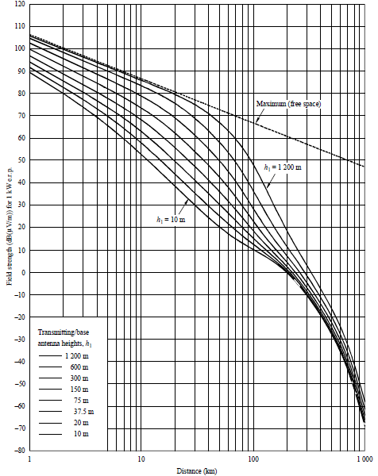

**Figure A1. An example curve of field strength vs distance**

**for 100 MHz, land path, 50% time**

1. **Comparison of three models**

**Comparison between Original Okumura-Hata and Modified Hata models**

The original Okumura-Hata model was published in 1980 by Masaharu Hata. Hata took the information in the field strength curves produced by Yoshihisa Okumura and produced a set of equations for path loss. Okumura carried out a number of propagation studies in and around Tokyo City and produced a set of curves of field strength against distance. Two of the limitations of the Hata model are that it has a limited path length and a limited frequency range. A number of modified models have been produced to extend the path length and frequency range. One of them is the modified Hata model adopted in ERC Report 68 which is recommended as the non-line-of-sight (NLOS) propagation loss model in the main body of this document. These modified models vary slightly from each other and some of these models more closely match the Okumura curves than others do.

Various modified Hata models including the model adopted in ERC Report 68 are compared against the Okumura field strength curves from which the original Hata model was derived. The models are compared for different frequencies and base transmitter heights for only distances larger than 20 km because for less than 20 km these models have almost the same results. The terminal/mobile antenna height in all cases was assumed to be 1.5m and the field strength values are calculated for a 1 kW ERP transmitter.

In the below, Figures A2 to A5 compare the results of two modified Hata models - the ITU-R P.529-3 and the ERC Report 68 models - against the Okumura curves. These models give similar results at low frequencies but at high frequencies the ERC68 model starts to drop well below Okumura's curves. At lower frequencies in some cases the ERC68 model comes closer to the Okumura curve than the ITU-R P.529-3 model. Overall though, the ITUR P.529-3 model is a better match to the Okumura data than the ERC68 model. However, since for most TG4m target applications, the distances less than 20 km and lower frequency bands less than 1GHz are considered, in this document the model from ERC 68 is recommended for TG4m purposes.

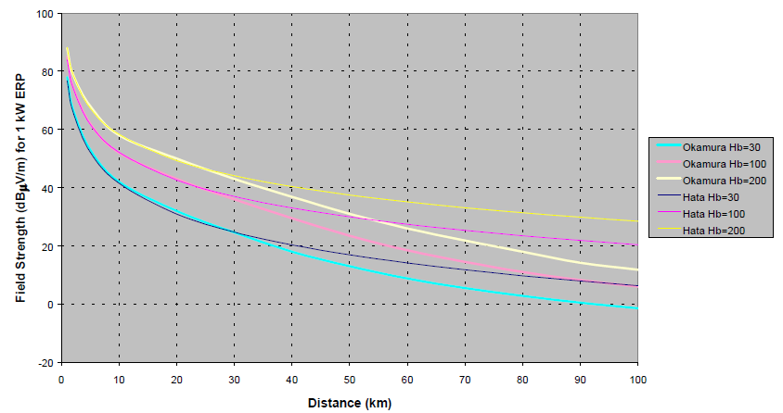

**Figure A2 Compares the Hata Model Field Strength Curves against the Okumura**

**Field Strength Curves for urban areas (150 MHz).**

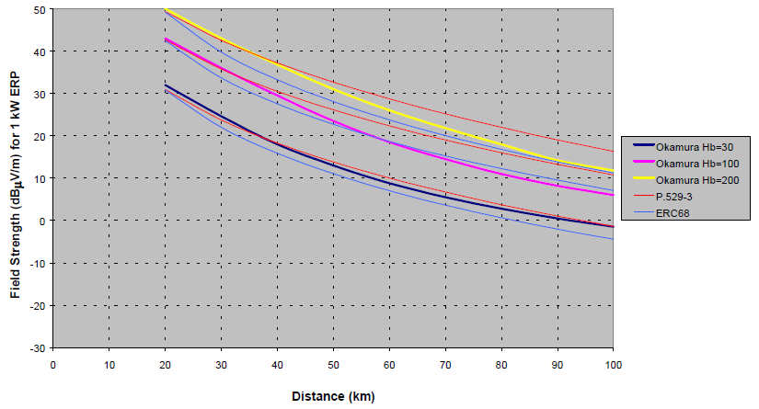

**Figure A3 Compares Modified Hata Models from ITU-R P.529-3 and ERC68**

**Field Strength Curves against the Okumura Field Strength Curves (150 MHz).**

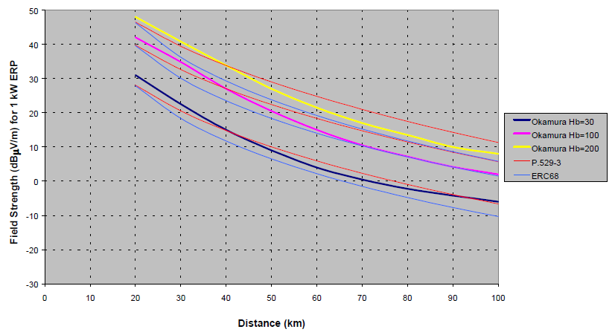

**Figure A4 Compares Modified Hata Models from ITU-R P.529-3 and ERC68**

**Field Strength Curves against the Okumura Field Strength Curves (450 MHz).**

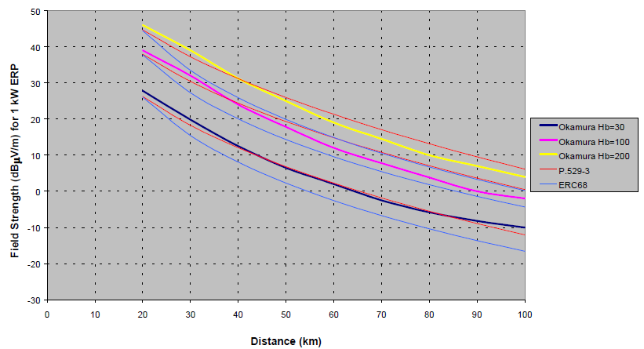

**Figure A5 Compares Modified Hata Models from ITU-R P.529-3 and ERC68**

**Field Strength Curves against the Okumura Field Strength Curves (900 MHz).**

The original Hata model and modified Hata models have almost the same performance in the distance and frequrency ranges of interest for our purposes. Therefore the modified Hata model from ERC Report 68 should be an appropriate model for TG4m applications.

**Comparison between Okumura-Hata and ITU-R P.1546-1 models**

In Annex 7 of the ITU-R P.1546-1 Recommendation this ITU model gives results compatible with the Okumura-Hata model in the condition of mobile services in an urban environment for receive antenna height of 1.5 m, clutter height of 15 m and distances up to 10 km. However, a comparison was made with the two models at 600 MHz, 10 m receive antenna height, and for 50% location availability in open rural areas and the results indicate that the Okumura-Hata model predicts higher received field-strengths than the P.1546-1 model. Table A4 gives the results of this comparison.

Here are some further comparative notes on the two models:

* + - The Hata model covers the range of base antenna height of 30 m to 200 m whereas the P.1546-1 covers a range of 10 m to 1200 m;
    - The Hata model covers the range of user terminal antenna heights from 1 m to 10 m whereas the P-1546-1 model assumes that the antenna is at the same height as the local clutter or ground cover (i.e., 30 m in dense urban, 20 m in urban and 10 m elsewhere) with a correction factor depending on the path length for different antenna height;
    - The Hata model predict up to a range of 20 km whereas the P-1546-1 model goes up to 1 000 km;
    - The frequency range of the Hata model is from 150 MHz to 2 000 MHz whereas the P-1546-1 allows interpolation and extrapolation from 30 MHz to 3 000 MHz based on three nominal frequencies (100, 600 and 2 000 MHz);
    - The excess path loss increases by 6 dB per decade in the Hata model whereas it is distance independent in the P-1546-1 model.
    - The standard deviation for the location variability is frequency dependent and found to be 8 dB at 600 MHz whereas it is equal to 5.5 dB for wideband digital broadcast signals and frequency independent in the P.1546-1 model;
    - The Hata model does not allow for a variation of time availability;
    - The Hata model does not include prediction over sea paths.

**Table A4: Field-strength prediction difference between the Okumura-Hata model and ITU-R P.1546-1 model expressed in dB and in % (for 50% and 50%)** (Positive values indicate larger excess path loss predicted by P.1546-1.)



From the result of these above two comparisons, the modified Hata model from ERC Report 68 is adopted for TG4m channel evaluation.

**Annex B**

**Multipath Delay Spread Models**

**Bandwidth Related Channel Models**

Bandwidth related channel models can be considered to model small-scale fading. Additional variations of the signal attenuation are led by multipath wave propagation with rapid changes when moving the antenna positions locally or there are moving objects between a transmitter and a receiver.

Dispersion in the time domain and in a frequency selectivity of the channel is caused by dispersion led by multipath for broadband transmission. The dispersion of the transmitted signal induced by the channel is modelled by a convolution with the channel impulse response. For this impulse response, statistical models can be defined.

**Discrete Time Multipath Channel Model**

The discrete-time impulse response model suitable for baseband Monte Carlo simulations is given by



,

where *t*Δ is the sampling interval. The complex-valued coefficients *h*0, *h*1, … for the tapped-delay-line model are randomly generated. It is reasonable to assume uncorrelated scattering, i.e., E[*hk (hl)\**] = 0 for *k* ≠ *l*. Also, a zero-mean complex Gaussian distribution is assumed for each coefficient with the variance given by



,



, *k* = 1, 2,….

The complex Gaussian distribution of all tap coefficients leads to a Rayleigh fading characteristic in the absence of a direct path (i.e. *c*0 = 0), whereas otherwise a Rician fading results. Taking the location variability into account, the parameters *c*0 and *c*1 are also random variables having a log-normal distribution.

**Power Delay Profile (PDP)**

PDP provides statistical a-priori information about the impulse response. PDP provides the expected signal energy arriving at a specific delay from the transmission of a Dirac impulse. The earliest arriving contribution is assigned delay zero and normally originates from the signal part travelling in a direct transmitter-receiver path, resulting in a peak in the PDP. The energies in the indirect, reflected or scattered signal parts typically decay exponentially in the mean. This leads to the common *spike-plus-exponential* shape of the PDP, given by



, *τ* ≥ 0,

where δ(·) is the Dirac delta function. *c*0 and *c*1 determine the mean energies in the direct and indirect signal parts, respectively, and *τ*1 specifies the exponential decay in the indirect components. The mean total signal energy returning from a transmitted unit energy pulse equals *c*0+*c*1.

PDP provides statistical a-priori information about the impulse response. For LOS scenarios



where *LLOS* is the direct path propagation loss. For NLOS scenarios and wide angle terminal station antennas



where *LNLOS* is the total propagation loss from direct and indirect paths. The ratio ***c*0/*c*1** is referred to as the K-factor *K*0, providing information about the presence and strength of the direct propagation path. The root mean square (RMS) delay spread ***τ*RMS** of the PDP defined in the previous equation



.

So K-factor is defined as a power ratio between the direct path component and scattered multipath components. Both the delay spread and the K-factor heavily depend on the environment and the antenna types. In LOS scenarios the K-factor is much larger than for NLOS scenarios even with omnidirectional antennas. In NLOS scenarios, *K*0 is determined by the presence and strength of a dominant signal path. If the area between the transmitter and the receiver is totally obstructed, *K*0 is close to zero. Clearly, the K-factor also increases when narrowing the terminal station antenna beamwidth because of increased fading of reflected signal parts arriving from “blind” angles.

**Multipath versus Frequency**

There is unquestionably asignificant frequency dependence in terms of propagation losses. The attenuation resulting from diffraction around objects or penetration through them almost invariably increases with frequency. The delay spread is independent of the operating frequency at frequencies above 30 MHz. As the wavelength increases, the energy scattered off a given object tends to decrease (more absorption and diffraction), which would decrease the amplitude of the multipath reflections. On the other hand, path loss decreases with increasing wavelength (i.e., the effective aperture of the isotropic antenna at that frequency). These two effects tend to balance each other, making delay spread roughly independent of frequency. Thus most of the important statistical parameters are relatively constant across the VHF and UHF bands.

**Effect Of Pre-Echoes**

It is possible that the main signal is received at a lower power level than the reflected signals. In such a case, the receiver will have to work in presence of pre-echoes and still synchronize, and either equalize it or discard it. Because of the geometry involved in these signal reflection, attenuation and blockage, the extend of such pre-echoes is typically less than the post-echoes but they should not be neglected. A typical range for these pre-echoes is typically found to be around 5 μsec. This type of echoes should be considered in the TG4m multipath models after taking the practical measurements, but may not be important for our models except for the models for relatively larger distances than 5 km.

Thus three types of echoes need to be considered for the TG4m models: Echoes with medium excess delays in the range between about 1 μsec and 10 μsec, echoes with small excess delay produced by the RF signal being reflected by structures close to the receiver or the transmitter which are most important, and pre-echoes.

**Various Multipath Profiles**

Various multipath delay spread models adopted or considerd for other technologies are listed in this section to help TG4m proposers to select a model for their proposal evaluation:

***802.15.4g***

Channel models from 15-09-0279-01-004g-channel-characterization-for-sun

|  |  |  |  |  |
| --- | --- | --- | --- | --- |
| **Channel Models taken from ETSI EN 300 392-2 V3.2.1 (2007-09) for phase modulation** | | | | |
| Propagation Model | Tap Number | Relative Delay (us) | Average Relative Power (dB) | Tap gain process |
| Rural Area (Rax) | 1 | 0 | 0 | Rice |
| Typical Urban (Tux) | 1 | 0 | 0 | Class |
| 2 | 5 | -22.3 | Class |
| Bad Urban (Bux) | 1 | 0 | 0 | Class |
| 2 | 5 | -3 | Class |
| Hilly Terrain (HTx) | 1 | 0 | 0 | Class |
| 2 | 15 | -8.6 | Class |

Channel models from 15-09-0263-01-004g-channel-characteristics-4g

***1.Dense City Deployment:*** typical of dense apartment complexes where dozens of end points might be located in a narrow utility alley or across the street in another alley

|  |  |  |  |  |  |
| --- | --- | --- | --- | --- | --- |
| **Dense City Deployment 100m** | | | | | |
| Path | Distance of reflector to LOS bore | Path length difference | Multipath delay | Multipath amplitude relative to 1’st path | Fading rate |
| 1 | 0 | 0 | 0 | 0dB | 40mph |
| 2 | 100m | 40m | .13us | 0dB | 40mph |

***2.Residential / Industrial:*** where the end points are either within, or around, the home or business park

|  |  |  |  |  |  |
| --- | --- | --- | --- | --- | --- |
| **Residential / Industrial 500m** | | | | | |
| Path | Distance of reflector to LOS bore | Path length difference | Multipath delay | Multipath amplitude relative to 1’st path | Fading rate |
| 1 | 0 | 0 | 0 | 0dB | Quasi static |
| 2 | 100m | 40m | .13us | 0dB | Quasi static |
| 3 | 100m | 40m | .13us | -6dB | Equivalent to 75mph |

***3.Medium Range:*** the link from the meter to a utility pole

|  |  |  |  |  |  |
| --- | --- | --- | --- | --- | --- |
| **Medium Range 2km** | | | | | |
| Path | Distance of reflector to LOS bore | Path length difference | Multipath delay | Multipath amplitude relative to LOS | Fading rate |
| 1 | 0 | 0 | 0 | 0dB | Quasi static |
| 2 | 400m | 150m | .52us | 0dB | Quasi static |
| 3 | 400m | 150m | .52us | -6dB | Equivalent to 75mph |

***4.Long Range:*** a link from a utility pole to a number of houses in a rural setting

|  |  |  |  |  |  |
| --- | --- | --- | --- | --- | --- |
| **Medium Range LOS 20km** | | | | | |
| Path | Distance of reflector to LOS bore | Path length difference | Multipath delay | Multipath amplitude relative to LOS | Fading rate |
| 1 | 0 | 0 | 0 | 0dB | Quasi static |
| 2 | 4km | 1.5km | 5us | 0dB | Quasi static |

***802.16***

***1. Minimum path loss category: mostly flat terrain with light tree densities with low delay spread***

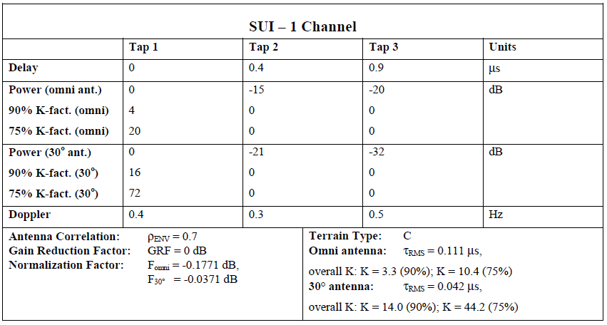

***2. Minimum path loss category: mostly flat terrain with light tree densities***

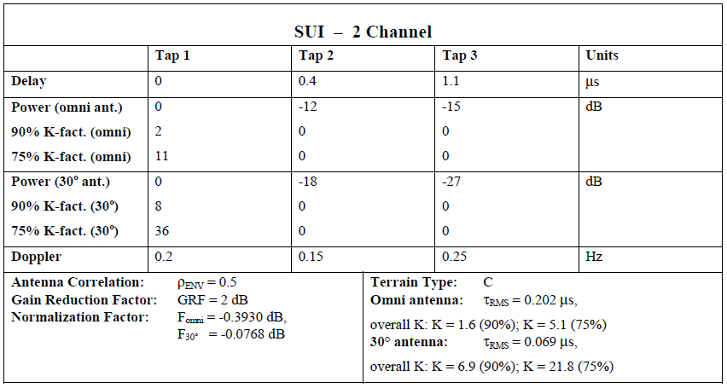

***3. Intermediate path loss category with low delay spread***

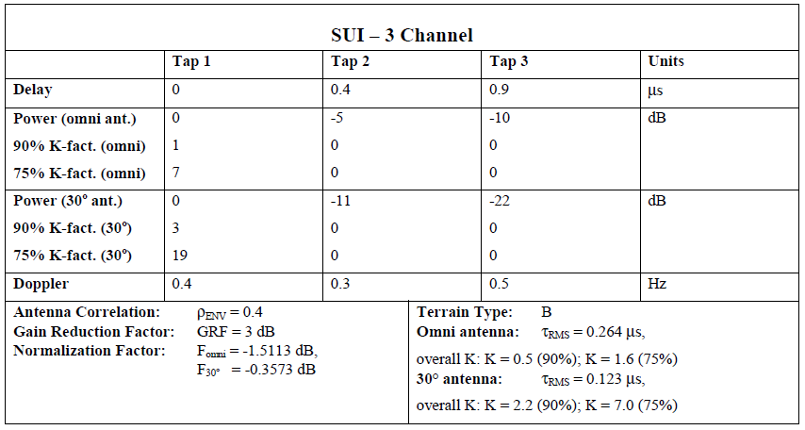

***4. Intermediate path loss category with moderate delay spread***

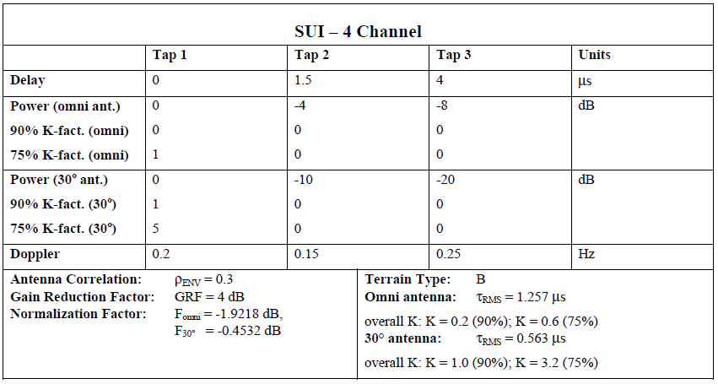

***5. Maximum path loss category: Hilly terrain with moderate-to-heavy tree densities***

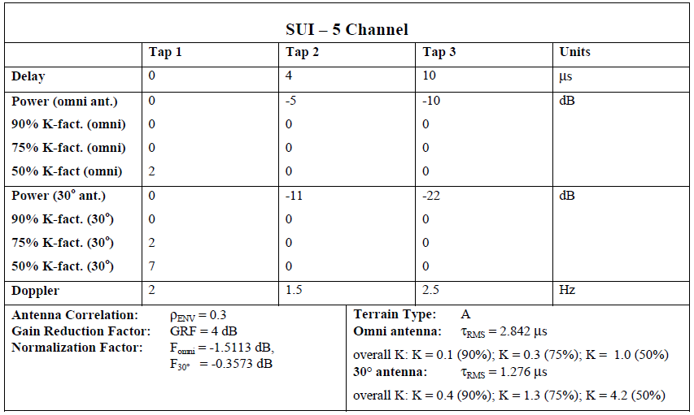

***6. Maximum path loss category: Hilly terrain with moderate-to-heavy tree densities with high delay spread***

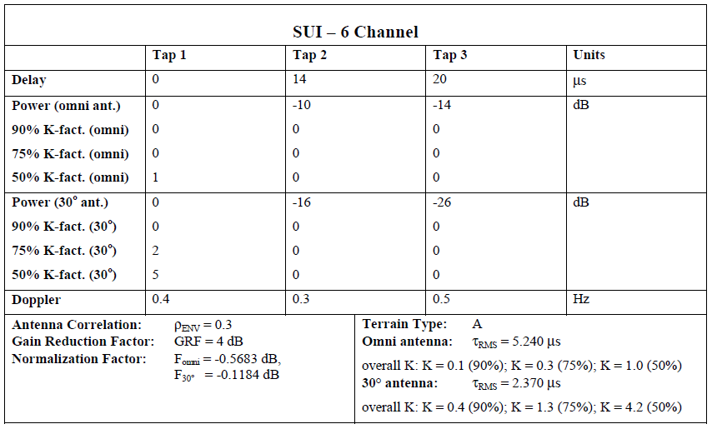

***802.22***

|  |  |  |  |  |  |  |
| --- | --- | --- | --- | --- | --- | --- |
| Profile A | Path 1 | Path 2 | Path 3 | Path 4 | Path 5 | Path 6 |
| *Excess delay* | 0 | 3 μsec | 8 μsec | 11 μsec | 13 μsec | 21 μsec |
| Relative amplitude | 0 | -7 dB | -15 dB | -22 dB | -24 dB | -19 dB |
| Doppler frequency | 0 | 0.10 Hz | 2.5 Hz | 0.13 Hz | 0.17 Hz | 0.37 Hz |
| Profile B | Path 1 | Path 2 | Path 3 | Path 4 | Path 5 | Path 6 |
| Excess delay | -3 μsec | 0 | 2 μsec | 4 μsec | 7 μsec | 11 μsec |
| Relative amplitude | -6 dB | 0 | -7 dB | -22 dB | -16 dB | -20 dB |
| Doppler frequency | 0.1 Hz | 0 | 0.13 Hz | 2.5 Hz | 0.17 Hz | 0.37 Hz |
| Profile C | Path 1 | Path 2 | Path 3 | Path 4 | Path 5 | Path 6 |
| Excess delay | -2 μsec | 0 | 5 μsec | 16 μsec | 24 μsec | 33 μsec |
| Relative amplitude | -9 dB | 0 | -19 dB | -14 dB | -24 dB | -16 dB |
| Doppler frequency | 0.13 Hz | 0 | 0.17 Hz | 2.5 Hz | 0.23 Hz | 0.10 Hz |
| Profile D | Path 1 | Path 2 | Path 3 | Path 4 | Path 5 | Path 6 |
| Excess delay | -2 μsec | 0 | 5 μsec | 16 μsec | 22 μsec | 0 to 60 μsec |
| Relative amplitude | -10 dB | 0 | -22 dB | -18 dB | -21 dB | -30 to +10 dB |
| Doppler frequency | 0.23 Hz | 0 | 0.1 Hz | 2.5 Hz | 0.17 Hz | 0.13 Hz |

***COST 207 MODELS***

The main reference is the work done in Europe as part of the development of the GSM mobile radio system in the UHF range. Although this work was done for mobile communication, some useful information could be extracted for fixed point-to-point operation by considering the somewhat limited directivity of the user terminal antennas (typically 60º in low UHF). Four mobile channel models, each representative of a different geographical environment, were developed by the COST 207 committee on Digital Land Mobile Radio Communications.

|  |  |  |
| --- | --- | --- |
| Urban, non-hilly: | exp(-t/1us) |  |
| Rural, non-hilly: | exp(-9.2 t/1us) |  |
| Bad urban, hilly: | exp(-t/1us)   0.5 exp(5-t/1us) | for 0 < t < 5us  for 5 < t < 10us |
| Hilly: | exp(-3.5 t/1us)   0.1 exp(15-t/1us) | for 0 < t < 2us  for 15 < t < 20us |

COST 207 describes typical channel characteristics for over transmit bandwidths of 10 to 20 MHz around 900MHz for GSM. COST 207 profiles were adapted to mobile DVB-T reception in the EU Motivate project.

**Typical urban reception (TU6)**

As an example of COST 207 models, TU-6 models the terrestrial propagation in an urban area.

Tap number Delay (us) Power (dB) Fading model

1 0.0 -3 Rayleigh

2 0.2 0 Rayleigh

3 0.5 -2 Rayleigh

4 1.6 -6 Rayleigh

5 2.3 -8 Rayleigh

6 5.0 -10 Rayleigh

***ITU-R M.1225 Model***

Another commonly used set of empirical channel models is that specified in ITU-R recommendation M.1225. The recommendation specifies three different test environments: Indoor office, outdoor-to-indoor pedestrian, and vehicular with high antenna. Since the delay spread can vary significantly, this recommendation specifies two different delay spreads for each test environment: low delay spread (A), and medium delay spread (B). In all there are 6 cases. For each of these cases, a multipath tap delay profile is specified. The number of multipath components in each model is different. The following three tables list the specified parameters.

***1. ITU Channel Model for Indoor Office***

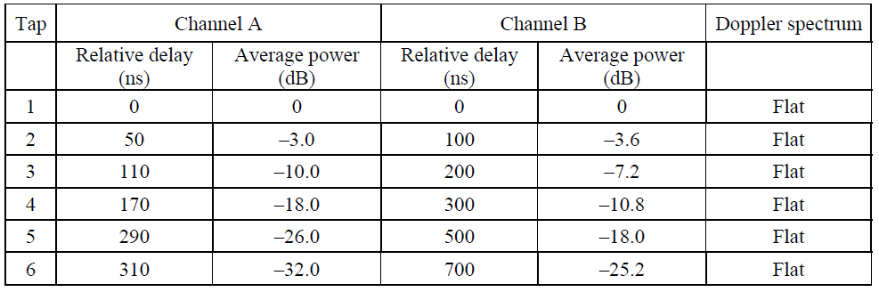

***2. ITU Channel Model for Outdoor to Indoor and Pedestrian Test Environment***

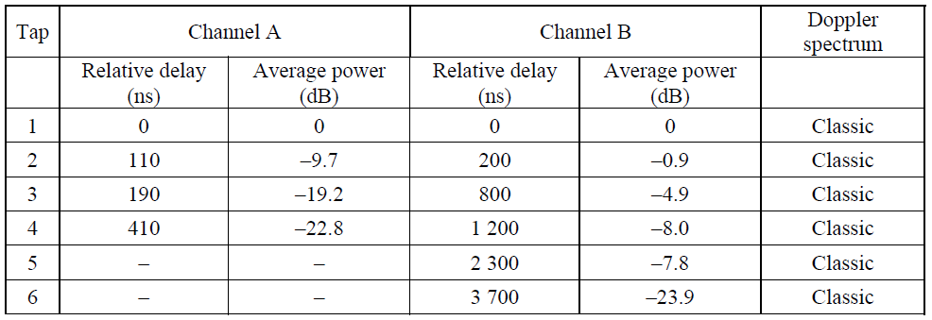

***3. ITU Channel Model for Vehicular Test Environment***

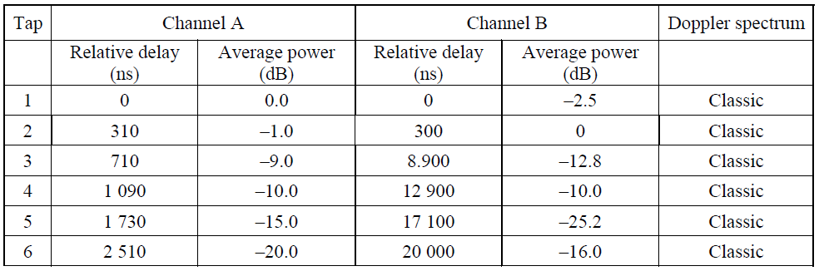

The term classic is used to identify the Doppler spectrum as

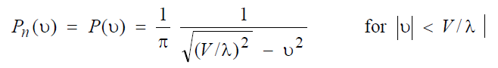

while the term flat is used to identify the Doppler spectrum as

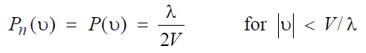

where *V* is the velocity of the mobile and λ is the wavelength at the carrier frequency. [14]

***Channel Models Initially Proposed for the First Version of TGD Draft***

***1. For indoor scenarios***

|  |  |  |  |  |  |  |
| --- | --- | --- | --- | --- | --- | --- |
|  | Path 1 | Path 2 | Path 3 | Path 4 | Path 5 | Path 6 |
| Indoor-B as defined in ITU-R M.1225 | | | | | | |
| Path Delay (us) | 0 | 0.1 | 0.2 | 0.3 | 0.5 | 0.7 |
| Avg Path Gain | 0 | -3.6 | -7.2 | -10.8 | -18.0 | -25.2 |

***2. For Outdoor scenarios***

|  |  |  |  |  |  |  |
| --- | --- | --- | --- | --- | --- | --- |
|  | Path 1 | Path 2 | Path 3 | Path 4 | Path 5 | Path 6 |
| d=1.5 km Profile A | | | | | | |
| Path Delay (us) | 0 | 0.7 | 1.2 | 3.2 | 5.5 | 6.8 |
| Avg Path Gain | 0 | -34.9 | -25.9 | -22.7 | -24.8 | -34.6 |
| d=2.7 km Profile B | | | | | | |
| Path Delay | 0 | 0.9 | 1.7 | 3.1 | 3.8 | 7.5 |
| Avg Path Gain | 0 | -18.2 | -20.6 | -25 | -26.5 | -19.6 |
| d=6.1 km Profile C | | | | | | |
| Path Delay | 0 | 0.6 | 5.3 | 6.2 | 7.5 | 19.5 |
| Avg Path Gain | 0 | -12.1 | -25.2 | -22.2 | -18.5 | -21.8 |
| COST 207 Profile D | | | | | | |
| Path Delay | 0 | 0.2 | 0.5 | 1.6 | 2.3 | 5 |
| Avg Path Gain | -3 | 0 | -2 | -6 | -8 | -10 |