IEEE P802.15
Wireless Personal Area Networks

Project | IEEE P802.15 Working Group for Wireless Personal Area Networks (WPANs)
Title | Comment Resolution for Letter Ballot 70, CID 39
Date Submitted | 11 May 2011
Source | [Steve Shearer, Cristina Seibert]  [Silver Spring Networks] | Voice: [ +1.408.997.0576]  Fax: [ ]  E-mail:[ sshearer@silverspringnet.com ]
Re: | Task Group 15.4g
Abstract | Comment Resolution for Letter Ballot 70, CID 39
Purpose | Comment Resolution
Notice | This document has been prepared to assist the IEEE P802.15. It is offered as a basis for discussion and is not binding on the contributing individual(s) or organization(s). The material in this document is subject to change in form and content after further study. The contributor(s) reserve(s) the right to add, amend or withdraw material contained herein.
Release | The contributor acknowledges and accepts that this contribution becomes the property of IEEE and may be made publicly available by P802.15.

Proposal for simplifying Clause 16.1.2.5 Code-symbol interleaving

CID 39.
The interleaver description is too complicated. | Simplify to a concise description of a write-in-rown/read-in-column interleaver.

Proposal
Accept in principle. Replace the entire sub-clause 16.1.2.5 with the following text:

<< Start of text >>
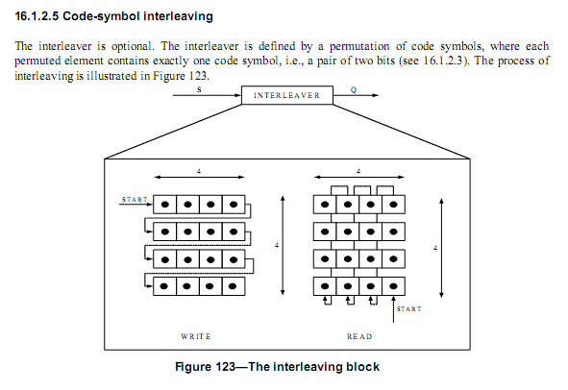
Coded symbols are written into an array of $N_{r}$ rows and $N_{c}$ columns. Coded symbols are written into the array row-wise, and read out column-wise. For this interleaver, $N_{c}= N_{r}=4,$ $N_{interleave}= N_{c} × N_{r}=16$

The sequence of output coded symbols $q(i)$ is generated from the input sequence $s(k)$

$$q\left(i\right)= s\left(k\right)$$
where
$$k=N_{interleave}- mod\left(i*N_{c},N_{interleave}\right)- mod\left(floor\left(\frac{i}{N_{r}}\right)N_{c}\right)+ floor\left(\frac{i}{N_{interleave}}\right)N_{interleave}-1$$
and
$$i=\left[0..N-1\right]$$
$$where N is the length of the sequence, and is a non-zero integer multiple of N_{interleave} (see Equation (5)).$$

<< End of Text >>

Verification using a Matlab Script

S=[]
Nr=4
Nc=4
Ninter=Nr*Nc

N=16* 1
for i=0:N-1

S=[S ( Ninter - mod(i*Nc,Ninter)-mod(floor(i/Nr),Nc) ...
+ floor(i/Ninter)*Ninter-1 ) ];

end
S
num2str(S)

N=16
for i=0..N-1,
k= 15 11 7 3 14 10 6 2 13 9 5 1 12 8 4 0

N=32
for i=0..N-1,
k= 15 11 7 3 14 10 6 2 13 9 5 1 12 8 4 0
31 27 23 19 30 26 22 18 29 25 21 17 28 24 20 16

N=48
for i=0..N-1,
K= 15 11 7 3 14 10 6 2 13 9 5 1 12 8 4 0
31 27 23 19 30 26 22 18 29 25 21 17 28 24 20 16
47 43 39 35 46 42 38 34 45 41 37 33 44 40 36 32

