**IEEE P802.15**

**Wireless Personal Area Networks**

|  |  |  |
| --- | --- | --- |
| Project | IEEE P802.15 Working Group for Wireless Personal Area Networks (WPANs) | |
| Title | Updated text based on 6.6.11.1 and 6.6.11.2 | |
| Date Submitted | [16 September, 2010] | |
| Source | [Jaeseung Son, Taehan Bae, Sridhar Rajagopal] [Samsung Electronics] [Suwon, Korea] | Voice:[82-31-279-7293] Fax: [ ] E-mail:[js1007.son@samsung.com , [taehan.bae@samsung.com](mailto:taehan.bae@samsung.com), [srajagop@sta.samsung.com](mailto:srajagop@sta.samsung.com) ] |
| Re: | [] | |
| Abstract | [Update of 6.6.11.1 and 6.6.11.2] | |
| Purpose | [Comment resolution] | |
| Notice | This document has been prepared to assist the IEEE P802.15. It is offered as a basis for discussion and is not binding on the contributing individual(s) or organization(s). The material in this document is subject to change in form and content after further study. The contributor(s) reserve(s) the right to add, amend or withdraw material contained herein. | |
| Release | The contributor acknowledges and accepts that this contribution becomes the property of IEEE and may be made publicly available by P802.15. | |

(Current D2)









(Comment)

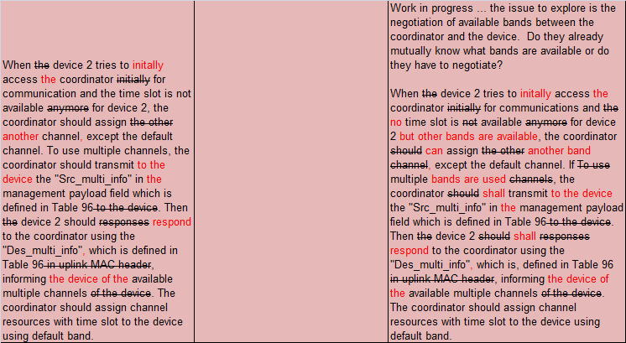

Instruction to editor: Replace 6.6.11.1 with next edited document.

(Updated document)

**6.6.11.1 Multiple bands information**

When the coordinator does not have time slot resources to assign for new user, the coordinator should extend the resource by using multiple bands. Figure 130 shows the one example of multiple bands usage. Figure 131 describes the procedure of multiple band usage when multiple band function is needed. When device 2 tries to initially access the coordinator for communication and no time slot is available but other bands are available for device 2, the coordinator can assign another band except the default band. Capability exchange should occur for all bi-directional communication during device discovery (see 6.6.2.2). If multiple bands are used, the coordinator should transmit to the device the "Src_multi_info" in the MAC command payload field which is defined in Table 96 to the device. Then the device 2 shall respond to the coordinator using the "Des_multi_info" which is defined in Table 96 informing the device of available multiple bands of the device.

If the coordinator does not support the multiple bands, because the coordinator has the single bands light source, or does not want to use multiple bands, the coordinator should transmit Src_multi_info with set code '0000000' which is defined in Annex F.

If the device also cannot support multiple bands due to the hardware limitation, like single bands light source or interference situation, or does not want to use multiple bands, the device should response the Des_multi_info with set code '0000000' which is defined in Annex F.





**Figure 131—MSC for Multi-bands information**

**Table 96 - MAC command frame payload for multiple bands**



(Current D2)



(Comment)

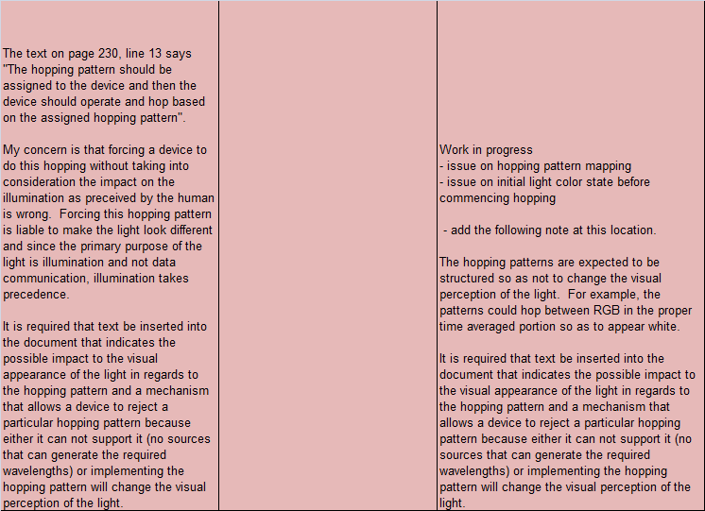

Instruction to editor: Delete subclause 6.3.16 Channel hopping command and replace 6.6.11.2 with next edited document.

(Updated document)

**6.6.11.2 Band hopping for interference avoidance**

A sin­gle coordinator can coordinate multiple cells.

If interference is being experienced from an adjacent light then hopping can be used to mitigate it. When spatial reuse due to direction optics is not present, and when the VLC communications system uses the same time slot between the adjacent light sources or cells with multiple band communication, and when multi­ple bandss are supported by the PHY, bands hopping can be used. In order to avoid interference and increase system capacity, pre-assigned hopping patterns should be adopted.

The hopping pattern should be assigned to the device and then the device should operate and hop based on the assigned hopping pattern.

If the VLC system does not use the multiple bands (Src_multi_info is set code '0000000')then the hopping function does not be supported. The hopping patterns shall be structured so as not to change the visual perception of the light. For example, the patterns could hop between RGB in the proper time averaged portion so as to appear white.