**IEEE P802.15**

**Wireless Personal Area Networks**

|  |  |  |
| --- | --- | --- |
| Project | IEEE P802.15 Working Group for Wireless Personal Area Networks (WPANs) | |
| Title | Editing CSK constellation description | |
| Date Submitted | [11 Sep, 2010] | |
| Source | [Atsuya Yokoi, Jaeseung Son, Sridhar Rajagopal, Samsung Electronics] | E-mail:[atsuya.yokoi@samsung.com, [js1007.son@samsung.com](mailto:js1007.son@samsung.com), srajagop@sta.samsung.com] |
| Re: |  | |
| Abstract | Full description about CSK constellation | |
| Purpose | [TG 7 received about CSK constellation comment in recirculation. This document is the response about CSK constellation comments] | |
| Notice | This document has been prepared to assist the IEEE P802.15. It is offered as a basis for discussion and is not binding on the contributing individual(s) or organization(s). The material in this document is subject to change in form and content after further study. The contributor(s) reserve(s) the right to add, amend or withdraw material contained herein. | |
| Release | The contributor acknowledges and accepts that this contribution becomes the property of IEEE and may be made publicly available by P802.15. | |

Resolution for A-CID: 1

Resolution for T-CID: 100, 103

Instruction to Editor :

Add 15-10-0724-00-0007-CSK-constellation-description to list of references and replace in [xx] in 3 places below

**5.8.4 CSK constellation overview**

The CSK signal is generated by using 3 color light sources out of the 7 color bands that are defined in 5.1.1. The 3 vertices of CSK constellation triangle are decided by the center wave length of the 3 color bands on *xy* color coordinates. It is possible that some of the optical sources would have a spectral peak at a different frequency than the center of the bandplan. It is also possible that the spectrum of the optical source would be distributed among over multiple frequency bands. Implementers of CSK systems can select the color band based on the center wave length of the actual optical source. Table 29 shows the *xy* color coordinates values assuming the optical source is chosen with the spectral peak occurring at the center of each of the 7 color bands. The color calibration function in 5.8.5 can compensate color coordinate errors caused by the optical source characteristics and cancel any interference between the 3 colors.

Figure 38 shows the center of color bands of Table 29 on *xy* color coordinates.

5.8.4.1. CSK constellation design rules

5.8.4.1.1 Design rule for 4-CSK

4-CSK symbol points are defined by the design rule in Figure 39. Points I, J and K show the center of the 3 color bands on *xy* color coordinates in Table 29. In figure 39, x-axis and y-axis are the relative value. S0 to S3 are 4 symbol points of 4-CSK. S1, S2 and S3 are 3 vertices of the triangle IJK. S0 is the centroid of the triangle IJK. The absolute values for 4-CSK for multiple combinations of the optical sources assuming the spectral peak of the optical source is at the center of the bandplan can be obtained in [xx].

figureNumNew-x-figureNumOld-x-Symbol points allocation design rule for 4CSK.tif

Figure 39 Symbol points allocation design rule for 4-CSK

5.8.4.1.2 Design rule for 8-CSK

8-CSK symbol points are defined by the design rule in Figure 40. Points I, J and K show the center of the 3 color bands on *xy* color coordinates in Table 29. S0 to S7 are 8 symbol points of 8-CSK. S0, S4 and S7 are 3 vertices of the triangle IJK. S1 and S2 are points that divide side JK and side JI in the ratio 1:2. Point B and C are midpoints of the line JI and line JK. S6 is a midpoint of the line KI. Point A is the centroid of the triangle B-S6-I. Point D is the centroid of the triangle C-K-S6. S3 is a point that divides line AB in the ratio 1:2. S5 is a point that divides line DC in the ratio 1:2. The absolute values for 8-CSK for multiple combinations of the optical sources assuming the spectral peak of the optical source is at the center of the bandplan can be obtained in [xx].

figureNumNew-x-figureNumOld-x-Symbol points allocation design rule for 8CSK.tif

Figure 40 Symbol points allocation design rule for 8-CSK

5.8.4.1.3 Design rule for 16-CSK

16-CSK symbol points are defined by the design rule in Figure 41. Points I,J and K show the center of the 3 color bands on *xy* color coordinates in Table 29. S0 to S15 are 16 symbol points of 16-CSK. S5, S10 and S15 are 3 vertices of the triangle IJK. S2 and S8 are points that divide side JK in one third. S3 and S12 are points that divide side JI in one third. S11 and S14 are points that divide side KI in one third. S0 is the centroid of the triangle IJK. S1, S4, S6, S7, S9 and S13 are the centroids of each of the smaller triangles. The absolute values for 16-CSK for multiple combinations of the optical sources assuming the spectral peak of the optical source is at the center of the bandplan can be obtained in [xx].

figureNumNew-x-figureNumOld-x-Symbol points allocation design rule for 16CSK.tif

Figure 41 Symbol points allocation design rule for 16-CSK

5.8.4.2. Data mapping for CSK

4-CSK data mapping is shown in Figure 42. Two bits are assigned per one symbol.

figureNumNew-x-figureNumOld-x-Data allocation for 4CSK.tif

Figure 42 Data mapping for 4-CSK

8-CSK data mapping is shown in Figure 43. Three bits are assigned per one symbol.

figureNumNew-x-figureNumOld-x-Data allocation for 8CSK.tif

Figure 43 Data mapping for 8-CSK

16-CSK data mapping is shown in Figure 44. Four bits are assigned per one symbol.

figureNumNew-x-figureNumOld-x-Data allocation for 16CSK.tif

Figure 44 Data mapping for 16-CSK

5.8.4.3. Valid color band combinations

CSK constellation is decided by the combination of the 3 color bands. Certain combinations which cannot make a triangle on the *xy* color coordinates are excluded, such as (110-101-100) or (100-011-010). Table 30 shows valid color band combinations that can make triangles for CSK constellations.

Table 30 Valid color band combinations for CSK

|  |  |  |  |
| --- | --- | --- | --- |
| No. | Valid color codes for Color band combinations | | |
| Band i | Band j | Band k |
| 1 | 110 | 011 | 001 |
| 2 | 110 | 011 | 000 |
| 3 | 110 | 010 | 001 |
| 4 | 110 | 010 | 000 |
| 5 | 101 | 011 | 001 |
| 6 | 101 | 011 | 000 |
| 7 | 101 | 010 | 001 |
| 8 | 101 | 010 | 000 |
| 9 | 100 | 011 | 001 |
| 10 | 100 | 011 | 000 |
| 11 | 100 | 010 | 001 |
| 12 | 100 | 010 | 000 |
| 13 | 011 | 010 | 001 |
| 14 | 011 | 010 | 000 |

Figure 45 shows an example of the CSK constellation triangle when color codes (110, 010, 000) are used.

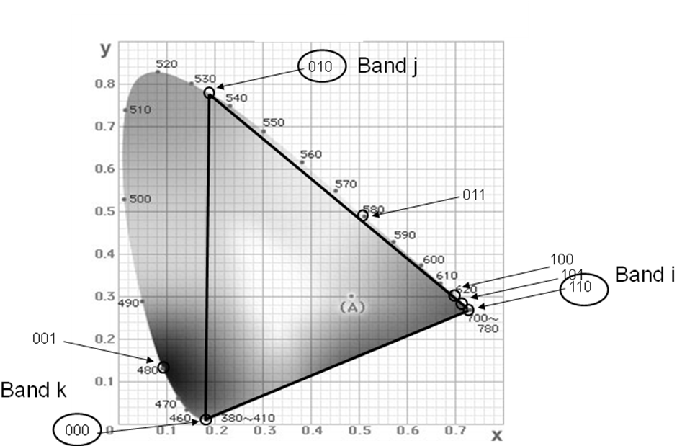

Figure 45 Valid CSK constellation triangle example for 110, 010, 000

Table 31 Color band combination example for 110, 010, 000

|  |  |  |  |  |
| --- | --- | --- | --- | --- |
| **Color band combination** | | ***xy* coordinates values of symbols** | | |
| Color codes | Center of band  (x,y) | 4 CSK  [data] – (xp,yp) | 8 CSK  [data] – (xp,yp) | 16 CSK  [data] – (xp,yp) |
| 110  010  000 | (0.730 0.270)  (0.190 0.780)  (0.180 0.010) | [0 0] - (0.190 0.780)  [0 1] - (0.367 0.353)  [1 0] - (0.180 0.010)  [1 1] - (0.730 0.270) | [0 0 0] - (0.190 0.780)  [0 0 1] - (0.187 0.523)  [0 1 0] - (0.370 0.610)  [0 1 1] - (0.519 0.383)  [1 0 0] - (0.180 0.010)  [1 0 1] - (0.244 0.253)  [1 1 0] - (0.455 0.140)  [1 1 1] - (0.730 0.270) | [0 0 0 0] - (0.190 0.780)  [0 0 0 1] - (0.249 0.638)  [0 0 1 0] - (0.187 0.523)  [0 0 1 1] - (0.370 0.610)  [0 1 0 0] - (0.246 0.381)  [0 1 0 1] - (0.367 0.353)  [0 1 1 0] - (0.429 0.468)  [0 1 1 1] - (0.426 0.211)  [1 0 0 0] - (0.183 0.267)  [1 0 0 1] - (0.242 0.124)  [1 0 1 0] - (0.180 0.010)  [1 0 1 1] - (0.363 0.097)  [1 1 0 0] - (0.550 0.440)  [1 1 0 1] - (0.609 0.298)  [1 1 1 0] - (0.547 0.183)  [1 1 1 1] - (0.730 0.270) |

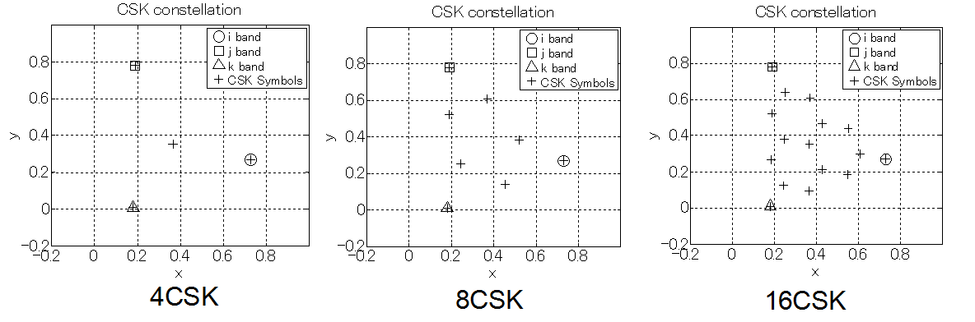

Figure 46 CSK constellations made by color band combination