DCN 15-10-0618-01-0006
Source: (Seung-Hoon Park, Jahngsun Park, Sangyeun Hwang, Sungjun Song, Hyeon-guk Choi)¹, (Junghwan Hwang, Hyong-pil Park)²
Affiliation : Samsung Electronics¹, ETRI²

These following figures and tables are provided as the result of comment resolution. More details will be provided later to meet resolution result.

New table to describe the relation among the center frequency, Data rate and BW.
 |  | fc = 21MHz |  | fc = 32Mhz
 |  | Data rate | BW | Data rate | BW
Data field | 000 | 164 kbps | 0.65625 MHz | 250 kbps | 1 MHz
 | 001 | 328 kbps | 1.3125 MHz | 500 kbps | 2 MHz
 | 010 | 656 kbps | 2.625 MHz | 1 Mbps | 4 MHz
 | 011 | 1.3125 Mbps | 5.25 MHz | 2 Mbps | 8 MHz
 | 100
 | 101

Table 67 FSC Bit Mapping for Preamble
Gold code value | FSC bit mapping result (Preamble output)
0 | [0 1 0 1 0 1 0 1]
1 | [1 0 1 0 1 0 1 0]

Table 69 Code Set for SFD
Bit | 0 | 1 | 2 | 3 | 4 | 5 | 6 | 7 | 8 | 9 | 10 | 11 | 12 | 13 | 14 | 15
Code | 0 | 1 | 0 | 1 | 0 | 1 | 1 | 0 | 0 | 1 | 0 | 1 | 1 | 1 | 0 | 1
Bit | 16 | 17 | 18 | 19 | 20 | 21 | 22 | 23 | 24 | 25 | 26 | 27 | 28 | 29 | 30 | 31
Code | 1 | 1 | 0 | 1 | 1 | 0 | 1 | 1 | 1 | 1 | 0 | 0 | 1 | 0 | 1 | 0
Bit | 32 | 33 | 34 | 35 | 36 | 37 | 38 | 39 | 40 | 41 | 42 | 43 | 44 | 45 | 46 | 47
Code | 0 | 1 | 0 | 1 | 1 | 0 | 0 | 0 | 0 | 0 | 1 | 0 | 0 | 1 | 1 | 0
Bit | 48 | 49 | 50 | 51 | 52 | 53 | 54 | 55 | 56 | 57 | 58 | 59 | 60 | 61 | 62 | 63
Code | 0 | 1 | 1 | 1 | 1 | 0 | 1 | 0 | 1 | 1 | 0 | 0 | 1 | 1 | 0 | 1

Table 70 FSC Bit Mapping for SFD
Gold code value | FSC bit mapping result (SFD output)
0 | [0 1 0 1 0 1 0 1]
1 | [1 0 1 0 1 0 1 0]

Figure 149-1 – Transmit Spectrum Mask (for fc = 21MHz)
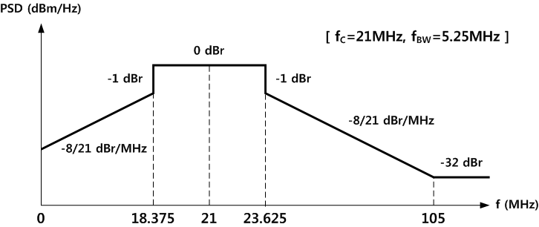

Figure 149-2 – Transmit Spectrum Mask (for fc = 32MHz)
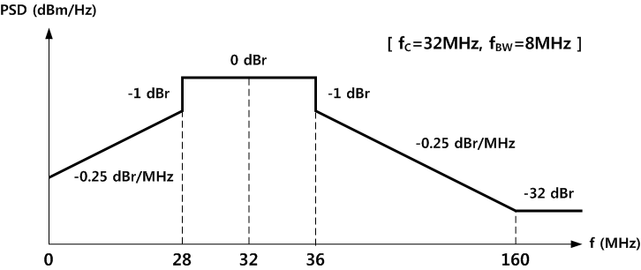

Table 79. Minimum Receiver Sensitivity Level
Center Frequency (MHz) | Data Rate (kbps) | Minimum Receiver Sensitivity (dBm)
21 | 164.1 | -110.8
 | 328.1 | -104.8
 | 656.3 | -98.8
 | 1312.5 | -92.8
32 | 250 | -106
 | 500 | -100
 | 1000 | -94
 | 2000 | -88

