IEEE P802.15
Wireless Personal Area Networks

Project | IEEE P802.15 Working Group for Wireless Personal Area Networks (WPANs)
Title | LB50 Annex Comment Resolutions
Date Submitted | July 2010
Source | [Roberts, Richard D]  [Intel Labs]  [address] | Voice: [ ]  Fax: [ ]  E-mail: [ ]
Re:
Abstract
Purpose
Notice | This document has been prepared to assist the IEEE P802.15. It is offered as a basis for discussion and is not binding on the contributing individual(s) or organization(s). The material in this document is subject to change in form and content after further study. The contributor(s) reserve(s) the right to add, amend or withdraw material contained herein.
Release | The contributor acknowledges and accepts that this contribution becomes the property of IEEE and may be made publicly available by P802.15.

This contribution addresses T-CIDs 842, 845, 846, 847, 849, 850, 851, 852, 853, 854, 856, 859, 860, 861, 862, 863, and 864. All these comments were in regards to text in the Annexes.
CID 842

Clause: Annex B, page 275, line 1

Comment: 2009 IEEE Standards Style Manual 10.7.1

Suggested Remedy: Reorder annexes accordingly

Recommended Resolution: Accept

10.7 Annexes

10.7.1 Ordering annexes
Normative and informative annexes shall be referred to as such [e.g., Annex A (normative), Annex B (informative)] in their titles and in the table of contents. Annexes should be referenced in the text by the word Annex and its letter only (e.g., “see Annex A”). Annexes should appear in the order in which they are referenced in the body of the standard (e.g., the first annex mentioned should be Annex A, the second Annex B, and so on). Note that this rule means that normative and informative annexes might be intermixed. An exception to this rule is the bibliography. The bibliography should be either the first or last annex of the standard (in instances where an index exists, all annexes would precede the index). If a glossary exists, it should either be the last annex or it should immediately precede the bibliography (if the bibliography is the last annex).

Action Required: The TE needs to read through the draft and reorder the annexes in the order in which they first referenced. This will be done prior to the printing of the book.

CID 845

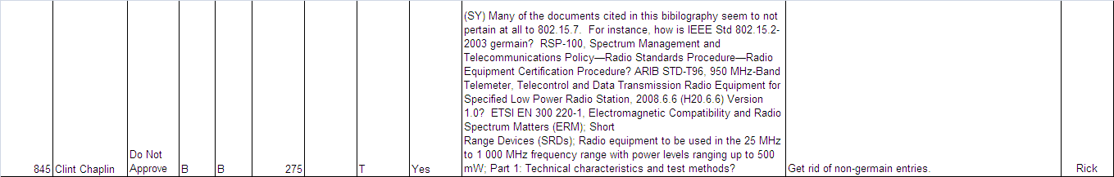

Clause: Annex B, page 275, line 1

Comment: Many of the documents cited in this bibilography seem to not pertain at all to 802.15.7. For instance, how is IEEE Std 802.15.2-2003 germain? RSP-100, Spectrum Management and Telecommunications Policy—Radio Standards Procedure—Radio Equipment Certification Procedure? ARIB STD-T96, 950 MHz-Band Telemeter, Telecontrol and Data Transmission Radio Equipment for Specified Low Power Radio Station, 2008.6.6 (H20.6.6) Version 1.0? ETSI EN 300 220-1, Electromagnetic Compatibility and Radio Spectrum Matters (ERM); Short
Range Devices (SRDs); Radio equipment to be used in the 25 MHz to 1 000 MHz frequency range with power levels ranging up to 500 mW; Part 1: Technical characteristics and test methods?

Suggested Remedy: Get rid of non-germain entries.

Recommended Resolution: Accept – the TE will read through the document to ascertain the relevance of the bibliography references and remove non-germain entries.

CID 846 and 847

Clause: Annex B.1, lines 9 and 42

Comment: Move reference from here to Clause 2

Suggested Remedy: Move reference from here to Clause 2

[B1] ANSI X9.63-2001, Public Key Cryptography for the Financial Services Industry—Key Agreement and
Key Transport Using Elliptic Curve Cryptography.6

[B9] IEEE Std 802.15.1-2002, IEEE Standard for Information technology—Telecommunications and
information exchange between systems—Local and metropolitan area networks—Specific requirements—
Part 15.1: Wireless medium access control (MAC) and physical layer (PHY) specifications for wireless
personal area networks (WPANs).

Recommended Resolution: Accept in principle. According to the style guide, clause 2 should contain references needed to implement the standard. The bibliography contains references generic to the standard. All references to both these clauses will be review to comply with the style guide.

CID 849, 850, 853, 854 and 856

Clause: Annex C.1, page 279, line 11; Annex C.1, page 279, line 12; C.4.3, page 283, line 50; C.4.3, page 283, line 51; C.4.3, page 284, line 28

Comment: B35 is not ANSI X9.63-2001; there is no B51; there is no B48; there is no B49; reference B45 is not 802.15.3-2003

Suggested Remedy: Remove B35 and add the actual standard to Clause 2; Remove B51 and add the actual standard to Clause 2; add missing references; delete B45 reference

Recommended Resolution: Accepted – there are several problems here.
_________________________________________________________________________________

First, the references in clause Annex C.1 and C.4.3 are not hot linked, which means that they were imported directly from 15.4 and never updated for 15.7. So the TE needs to hot link these references.

Secondly, in Annex C change B35 B1; B51B17; B48B14; B49B15; B52B18; B45B11.

CID 849, 850, 853, 854 and 856 (continued)

These changes are required on the following pages and text lines (there are more than indicated by the commenter):
- page 279, lines 11 and 12
- page 283, lines 39, 50 and 51
- page 284, lines 6, 21 and 28

CID 851, 852

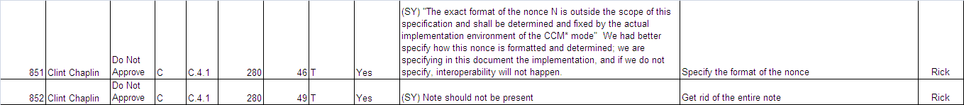

Clause: Annex C.4.1

Comment: “The exact format of the nonce N is outside the scope of this specification and shall be determined and fixed by the actual implementation environment of the CCM* mode" We had better specify how this nonce is formatted and determined; we are specifying in this document the implementation, and if we do not specify, interoperability will not happen; note should not be present.;

Suggested Remedy: Specify the format of the nonce; get rid of the entire note

Recommended Resolution: TBD (I think the comment is probably correct, but I need to research this a bit more)

CID 859, 860

Clause: Annex D.5, page 285, line 44

Comment: Annex A.4 does not provide the information. Wrong reference.; Annex A.4

Suggested Remedy: Unknown; Table D.1

Recommended Resolution: Accept solution from T-CID 860. Reference should be to Table D.1, but the TE is having trouble with the FrameMaker tool, so currently the table title is Table A.4.

CID 861

Clause: Annex D

Comment: The discussion of the VLC applications and how they relate to the topologies of clause 5.3 is not discussed sufficiently in annex D.

Suggested Remedy: Extend discussion in Annex D, how network topologies relate to VLC applications.

Recommended Resolution: Accept in principle, but no text modification was submitted with the comment, so there is not text change at this time.

CID 862

Clause: Annex D, page 287

Comment: Delete Annex E

Suggested Remedy: While this annex is interesting, it is irrelevant to the standard and is more an implementation issue, which the standard does not specifically address; hence, we should delete this annex.

Recommended Resolution: Reject – keep annex E.

CID 863, 864

Clause: Annex E, page 287, lines 6 and 10

Comment: 2009 IEEE Standards Style Manual 16.2

Suggested Remedy: Renumber figures (A.1) and properly cross reference them; Renumber figures (D3) and properly cross reference them.

Recommended Resolution: Accept – the commenter is correct but the TE cannot get the FrameMaker tool to properly issue the figure and table numbers in the annexes. This should be an automatic process and the tool is doing it incorrectly. I need help from the WG technical editor to fix this problem.

