**IEEE P802.15**

**Wireless Personal Area Networks**

|  |  |  |
| --- | --- | --- |
| Project | IEEE P802.15 Working Group for Wireless Personal Area Networks (WPANs) | |
| Title | CSK constellation description | |
| Date Submitted | [30 July, 2010] | |
| Source | [Atsuya Yokoi, Jaeseung Son, Sridhar Rajagopal, Samsung Electronics] | E-mail:[atsuya.yokoi@samsung.com, [js1007.son@samsung.com](mailto:js1007.son@samsung.com), srajagop@sta.samsung.com] |
| Re: |  | |
| Abstract | Full description about CSK constellation | |
| Purpose | [TG 7 received about CSK constellation comment in LB. This document is the response about CSK constellation comments] | |
| Notice | This document has been prepared to assist the IEEE P802.15. It is offered as a basis for discussion and is not binding on the contributing individual(s) or organization(s). The material in this document is subject to change in form and content after further study. The contributor(s) reserve(s) the right to add, amend or withdraw material contained herein. | |
| Release | The contributor acknowledges and accepts that this contribution becomes the property of IEEE and may be made publicly available by P802.15. | |

6.8.5. CSK constellation overview

The CSK signal is generated by using 3 color light sources out of the 7 color bands that are defined in 6.1.2. The 3 vertices of CSK constellation triangle are decided by the center wave length of the 3 color bands on *xy* color coordinates. Table 29 shows the *xy* color coordinates values for the 7 color bands.

Table 29 *xy* color coordinates values of 7 color bands

|  |  |  |  |
| --- | --- | --- | --- |
| **Band (nm)** | **Code** | **Center (nm)** | **(x , y)** |
| 380-450 | 000 | 415 | (0.18, 0.01) |
| 450-510 | 001 | 480 | (0.09, 0.13) |
| 510-560 | 010 | 535 | (0.19, 0.78) |
| 560-600 | 011 | 580 | (0.51, 0.49) |
| 600-650 | 100 | 625 | (0.70, 0.30) |
| 650-710 | 101 | 680 | (0.72, 0.28) |
| 710-780 | 110 | 745 | (0.73, 0.27) |

Figure 39 shows the center of color bands in table 29 on *xy* color coordinates.



Figure 39 Center of color bands on xy color coordinates

6.8.5.1. CSK constellation rule

6.8.5.1.1 Rule for 4 CSK

4 CSK symbol points are defined by the design rule in Figure 40. In Figure 40, Points I,J and K show the center of the 3 color bands on *xy* color coordinates. P0 to P3 are 4 symbol points of 4-CSK. P1, P2 and P3 are 3 vertices of the triangle IJK. P0 is the centroid of the triangle IJK.

Figure 40 Symbol points allocation design rule for 4CSK

6.8.5.1.2 Rule for 8 CSK

8 CSK symbol points are defined by the design rule in Figure 41. In Figure 41, Points I,J and K show the center of the 3 color bands on *xy* color coordinates. P0 to P7 are 8 symbol points of 8 CSK. P0, P4 and P7 are 3 verticess of the triangle IJK. P1 and P2 are points that divide side JK and side JI in the ratio 1:2. Point c and b are midpoints of the side JK and side JI. Line ba and line cd meet at right angles with line KI. P3 is a point that divides line ba in the ratio 1:2. P5 is a point that divides line cd in the ratio 1:2. P6 is a midpoint of the line KI.

Figure 41 Symbol points allocation design rule for 8CSK

6.8.5.1.3 Rule for 16 CSK

16 CSK symbol points are defined by the design rule in Figure 42. In Figure 42, Points I,J and K show the center of the 3 color bands on *xy* color coordinates. P0 to P15 are 16 symbol points of 16 CSK. P5, P10 and P15 are 3 vertices of the triangle IJK. P2 and P8 are points that divide side JK in one third. P3 and P12 are points that divide side JI in one third. P11 and P14 are points that divide side KI in one third. P0 is a centroid of the triangle IJK. P1, P4, P6, P7, P9 and P13 are the centroids of each of the smaller triangles.

Figure 42 Symbol points allocation design rule for 16CSK

6.8.5.2. Data mapping

6.8.5.2.1 Data mapping for 4 CSK

4 CSK data mapping is shown in Figure 43. 2 bits are assigned per one symbol.

Figure 43 Data mapping for 4CSK

6.8.5.2.2 8 Data mapping for CSK

8 CSK data mapping is shown in Figure 44. 3 bits are assigned per one symbol.

Figure 44 Data mapping for 8CSK

6.8.5.2.3 Data mapping for 16 CSK

16 CSK data mapping is shown in Figure 45. 4 bits are assigned per one symbol.

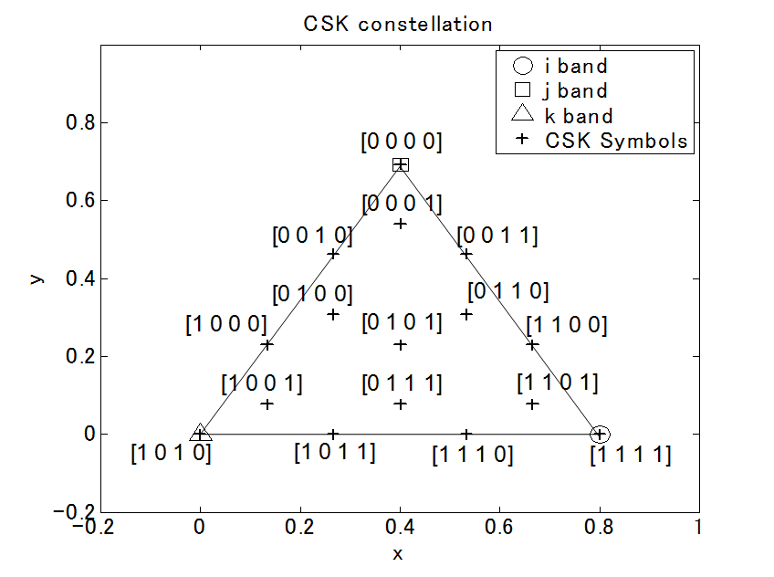

Figure 45 Data mapping for 16CSK

6.8.5.3.. Color band combinations

CSK constellation is decided by the combination of the 3 color bands. Certain combinations which cannot make a triangle on the *xy* color coordinates are excluded, such as (110-101-100) or (100-011-010). Table 30 shows color band combinations that can make triangles for CSK constellations.

Table 30 Invalid color band combinations for CSK

|  |  |  |  |
| --- | --- | --- | --- |
| No. | Valid color codes for Color band combinations | | |
| Band i | Band j | Band k |
| 1 | 110 | 011 | 001 |
| 2 | 110 | 011 | 000 |
| 3 | 110 | 010 | 001 |
| 4 | 110 | 010 | 000 |
| 5 | 101 | 011 | 001 |
| 6 | 101 | 011 | 000 |
| 7 | 101 | 010 | 001 |
| 8 | 101 | 010 | 000 |
| 9 | 100 | 011 | 001 |
| 10 | 100 | 011 | 000 |
| 11 | 100 | 010 | 001 |
| 12 | 100 | 010 | 000 |
| 13 | 011 | 010 | 001 |
| 14 | 011 | 010 | 000 |

Figure xx shows the CSK constellation triangle when color codes 110, 010, 000 are used. Table 31 shows color band combination and their *xy* coordinates’ values when color codes 110, 010, 000 are used. Figure 46 shows constellation when color codes 110, 010, 000 are used.

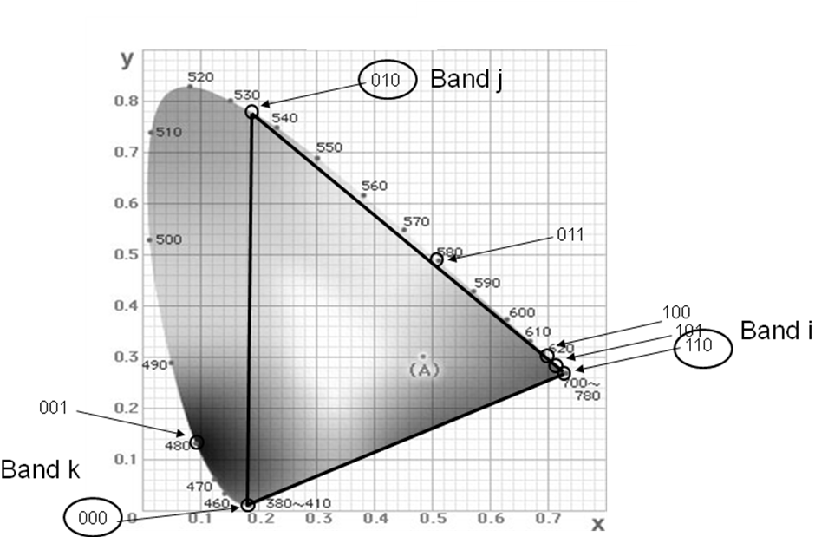

Figure xx Valid CSK constellation triangle example for 110, 010, 000

Table 31 Color band combination example for 110, 010, 000

|  |  |  |  |  |
| --- | --- | --- | --- | --- |
| **Color band combination** | | ***xy* coordinates values of symbols** | | |
| Color codes | Center of band  (x,y) | 4 CSK  [data] – (xp,yp) | 8 CSK  [data] – (xp,yp) | 16 CSK  [data] – (xp,yp) |
| 110  010  000 | (0.730 0.270)  (0.190 0.780)  (0.180 0.010) | [0 0] - (0.190 0.780)  [0 1] - (0.367 0.353)  [1 0] - (0.180 0.010)  [1 1] - (0.730 0.270) | [0 0 0] - (0.190 0.780)  [0 0 1] - (0.187 0.523)  [0 1 0] - (0.370 0.610)  [0 1 1] - (0.519 0.383)  [1 0 0] - (0.180 0.010)  [1 0 1] - (0.244 0.253)  [1 1 0] - (0.455 0.140)  [1 1 1] - (0.730 0.270) | [0 0 0 0] - (0.190 0.780)  [0 0 0 1] - (0.249 0.638)  [0 0 1 0] - (0.187 0.523)  [0 0 1 1] - (0.370 0.610)  [0 1 0 0] - (0.246 0.381)  [0 1 0 1] - (0.367 0.353)  [0 1 1 0] - (0.429 0.468)  [0 1 1 1] - (0.426 0.211)  [1 0 0 0] - (0.183 0.267)  [1 0 0 1] - (0.242 0.124)  [1 0 1 0] - (0.180 0.010)  [1 0 1 1] - (0.363 0.097)  [1 1 0 0] - (0.550 0.440)  [1 1 0 1] - (0.609 0.298)  [1 1 1 0] - (0.547 0.183)  [1 1 1 1] - (0.730 0.270) |

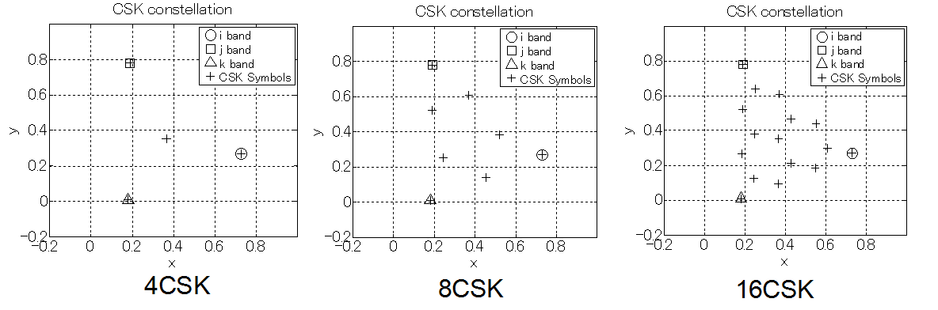

Figure 46 CSK constellations made by color band combination