**IEEE P802.15**

**Wireless Personal Area Networks**

|  |  |  |
| --- | --- | --- |
| Project | IEEE P802.15 Working Group for Wireless Personal Area Networks (WPANs) | |
| Title | CSK constellation description | |
| Date Submitted | [28 June, 2010] | |
| Source | [Atsuya Yokoi, Jaeseung Son, Samsung Electronics] | E-mail:[atsuya.yokoi@samsung.com, js1007.son@samsung.com] |
| Re: |  | |
| Abstract | Full description about CSK constellation | |
| Purpose | [TG 7 received about CSK constellation comment in LB. This document is the response about CSK constellation comments] | |
| Notice | This document has been prepared to assist the IEEE P802.15. It is offered as a basis for discussion and is not binding on the contributing individual(s) or organization(s). The material in this document is subject to change in form and content after further study. The contributor(s) reserve(s) the right to add, amend or withdraw material contained herein. | |
| Release | The contributor acknowledges and accepts that this contribution becomes the property of IEEE and may be made publicly available by P802.15. | |

6.8.5. CSK constellation Overview

CSK signal is generated by 3 color light sources in 7 color bands that are defined in 6.1.2 Operating frequency range and channel assignments. The 3 tops of CSK constellation triangle are decided by the center wave length of the 3 color bands on xy color coordinates. Table 29 shows the xy color coordinates values of those 7 color bands. Figure 39 shows the center of color bands on xy color coordinates.

Table 29 xy color coordinates values of 7 color bands

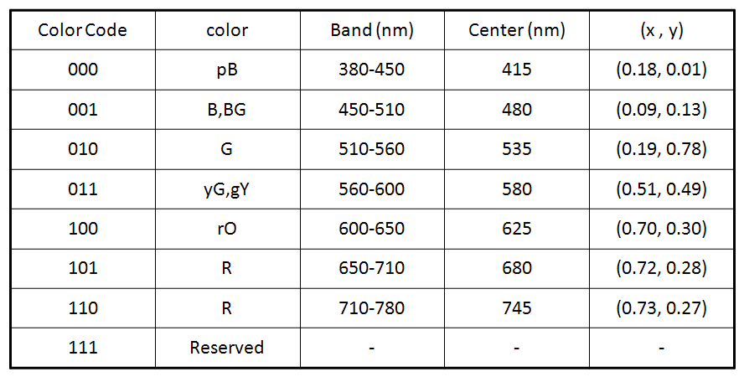

Figure 39 Center of color bands on xy color coordinates

6.8.5.1. CSK constellation rule

6.8.5.1.1 4 CSK

4 CSK symbol points are defined by the design rule in Figure 40. In Figure 40, Points I,J and K show the center of the 3 color bands on xy color coordinates. P0 to P3 are 4 symbol points of 4CSK. P0, P2 and P3 are 3 tops of the triangle IJK. P1 is a gravity center of the triangle IJK.



Figure 40 Symbol points allocation design rule for 4CSK

6.8.5.1.2 8 CSK

8 CSK symbol points are defined by the design rule in Figure 41. In Figure 41, Points I,J and K show the center of the 3 color bands on xy color coordinates. P0 to P7 are 8 symbol points of 8CSK. P0,P4 and P7 are 3 tops of the triangle IJK. P1 and P2 are points that divide side JK and side JI in the ratio 1:2. Point c and b are midpoints of the side JK and side JI. Line ba and line cd meet at right angles with line KI. P3 is a point that divides line ba in the ratio 1:2. P5 is a point that divides line cd in the ratio 1:2. P6 is a midpoint of the line KI.



Figure 41 Symbol points allocation design rule for 8CSK

6.8.5.1.3 16 CSK

16CSK symbol points are defined by the design rule in Figure 42. In Figure 42, Points I,J and K show the center of the 3 color bands on xy color coordinates. P0 to P15 are 16 symbol points of 16CSK. P0, P10 and P15 are 3 tops of the triangle IJK. P2 and P8 are points that divide side JK in one third. P3 and P12 are points that divide side JI in one third. P11 and P14 are points that divide side KI in one third. P5 is a gravity center of the triangle IJK. P1, P4, P6, P7, P9 and P13 are gravity centers of small triangles.



Figure 42 Symbol points allocation design rule for 16CSK

6.8.5.2. Data allocation

6.8.5.2.1 4 CSK

4 CSK data allocation is shown in Figure 43.



Figure 43 Data allocation for 4CSK

6.8.5.2.2 8 CSK

8 CSK data allocation is shown in Figure 44.



Figure 44 Data allocation for 8CSK

6.8.5.2.3 16 CSK

16 CSK data allocation is shown in Figure 45.



Figure 45 Data allocation for 16CSK

6.8.5.3.. Color band combinations

CSK constellation is decided by the combination of the 3 color bands. The system cannot select the combination which cannot make a triangle on the xy color coordinates, like as (110-101-100) or (100-011-010). Because, in those example combinations, the center points of 3 color bands are on a line in xy color coordinates in Figure 39. Table 30 shows color band combinations that can make triangles for CSK constellations.

Table 30 Color band combinations for CSK



Some of the color band combinations and their xy coordinates’ values are shown in Table 31,32 and 33.And their constellations are shown in Figure 46,47 and 48.

Table 31 Color band combination (No.4)



Figure 46 CSK constellations made by color band combination (No.4)

Table 32 Color band combination (No.11)



Figure 47 CSK constellations made by color band combination (No.11)

Table 33 Color band combination (No.13)



Figure 48 CSK constellations made by color band combination (No.13)