**IEEE P802.15**

**Wireless Personal Area Networks**

|  |  |  |
| --- | --- | --- |
| Project | IEEE P802.15 Working Group for Wireless Personal Area Networks (WPANs) | |
| Title | Baseline Mode for SUN | |
| Date Submitted | Sep 2010 | |
| Source | Mark Wilbur | Voice: 01 440 528 7471 Fax: 01 440 528 7199  E-mail: mwilbur@aclara.com |
| Re: |  | |
| Abstract | IEEE 802.15 Task Group TG4g Comment Resolution | |
| Purpose | Define Baseline Mode for SUN | |
| Notice | This document has been prepared to assist the IEEE P802.15. It is offered as a basis for discussion and is not binding on the contributing individual(s) or organization(s). The material in this document is subject to change in form and content after further study. The contributor(s) reserve(s) the right to add, amend or withdraw material contained herein. | |
| Release | The contributor acknowledges and accepts that this contribution becomes the property of IEEE and may be made publicly available by P802.15. | |

**Goal: is to enhance coexistence in general (see Appendix) and possibly enable interoperability**

**Comment Topic Grouping:**

1. Transition from RTJ/RTJR to EB/EB
2. Device Class Removal (one CSM is better than 3 CSMs!)
3. Common Signaling Mode
4. Transition from RTJ/RTJR to EB/EB

D. Raychaudhuri and Xiangpeng Jing WINLAB, Rutgers University 73 Brett Road Piscataway, NJ 08854, USAEmail: *f*ray, xjing*g*@winlab.rutgers.edu

**The first 15.4G draft defined “NEW” beacons and beacon responses named “request to join” or RTJ and “request to join response” or RTJR. Through the diligent efforts of the 15.4E work group the legacy 15.4 Beacon and Beacon Request commands have been modified to fully support the RTJ and RTJR functionality. It is therefore suggested that the RTJ and RTJR references be replaced with the newly defined Enhanced Beacon and Enhanced Beacon request in the next revision of the 15.4G draft**

*Informative text outlineing the modifications made to the existing Beacon and Beacon requests*

*Editorial note: add the 5.3.9b text below*

**5.5.3.1b Beacon Request - Enhanced (EBR)**

The EBR defined in 7.3.7a is an information request transmission initiated by a device attempting to communicate with neighboring devices. The EBR includes a response filter defined in 7.3.7a that may be used to limit the beacon response to only units meeting the response filter criteria.

**Refer to 7.3.13.1 EBR-Enhanced Beacon request command for more detailed information**

*Editorial note: add the5.3.9a text below*

**5.5.3.1a Beacon – Enhanced (EB)**

The EB defined in 7.2.2.1a may be transmitted by a device in response to a received EBR. A device may chose to not send a beacon should it determine that the EBR response criteria defined in 7.3.7awere not met. The device may use the information contained within the EB payload to perform actions such as, avoidance of incompatible neighboring networks or the facilitation of the network association process. The use of a pseudorandom EB transmission delays may be utilized to limit the number of simultaneous responses from neighboring devices.

**Refer to 7.2.x.1 Enhanced Beacon for more detailed information**

|  |  |  |
| --- | --- | --- |
| Comment # | Comment | Resolution |
| 1595 | Is support for the newly defined commands RTJ/RTJR mandatory in SUN networks? The text implies that a) all new devices join via RTJ-RTJR exchanges prior to association requests and b) devices in SUN networks need to periodically listen for RTJ commands sent by new devices trying to join. This adds overhead to SUN networks and is in contradiction to section 6.1 that states SUN networks can simply operate using optional modes. | AP  RTJ/RTJR commands replaced with the modified beacon and beacon request mechanism |
| 1596 | “Request to Join” and “Request to Join Response” are a confusing name with MLME-JOIN for existing TSCH-MAC implementation, and these primitives may tend to be a bit ambiguous mechanism if they are working without appropriate NHL and application layer services. | AP  RTJ/RTJR commands replaced with the modified beacon and beacon request mechanism |
| 1597 | Table 123 contains novel command frames of RTJ and RTJR which seem to replicate these existing functions inclusively, e.g. beacon_request, association_request and response, and radio resource information request and response. So, RTJ and RTJR may not be atomic. | AP  RTJ/RTJR commands replaced with the modified beacon and beacon request mechanism |
| 1598 | Are RTJ commands only sent using the CSM? If so, this needs to be stated in these sections. If not, the device would already have to know the PHY mode used for the network and a RTJ command is not required | AP  The enhanced beacon request may be sent on the CSM or other PHY Modes |

|  |  |  |
| --- | --- | --- |
| Comment # | Comment | Resolution |
| 1599 | The RTJ command cannot be mandatory since existing devices do not implement it. | AP  The use of the enhanced beacon request is not mandatory |
| 1602 | "This command shall be sent by an unassociated device that wishes to discover and associate with a PAN." I don't think the word "shall" should be used here. A device may also send a beacon request command. | AP  A device receiving a beacon request may reply with a enhanced beacon |
| 1603 | Text says, "unassociated device that wishes to discover and associate with a PAN."I don't think the text should say "associate," since association is not accomplished using this command. | AP  A device may transmit a beacon request in an attempt identify the phy mode in use by its neighbors |
| 1604 | Clause 7.3 is out of scope of the 15.4g PAR. The RTJ / RTJR MAC commands are not necessary for the implementation of the 15.4g PHY amendment. The only information that is transmitted with this exchange is the value of the PIB attribute phyCurrentSUNPageEntry, which "corresponds to the PHY operating mode currently in use by the existing network". The reality is, if you don't know the PHY operating mode currently in use by the existing network, the sender will be neither able to send the RTJ to the other device nor to receive the RTJR. That is, the value of the PHY operating mode currently in use by the existing network is already know to the receiver of the RTJR that would only transmit this value, superfluously. | AP  RTJ/RTJR commands replaced with the modified beacon and beacon request mechanism  Any device may transmit the enhanced beacon that may include the current network phy mode in response to a enhanced beacon request using the defined CSM or other PHY mode |

|  |  |  |
| --- | --- | --- |
| Comment # | Comment | Resolution |
| 1605-1609 | Are RTJ commands only sent using the CSM? If so, this needs to be stated in these sections. If not, the device would already have to know the PHY mode used for the network and a RTJ command is not required | AP  The enhanced beacon request may be sent on the CSM or other PHY modes |
| 1612-1617 | It looks like the only purpose of RTJ and RTJR is to exchange phyCurrentSUNPageEntry once an unassociated device establishes the communications with an existing device in a PAN. This can be easily done in NHL when an initial communication is established. | AP  The NHL my not have the ability to communicate nor detect the neighboring nodes |
| 1619 | Text says, "is issued by a device." What type of device(s)? I guess the transmitting device must be either a PAN coordinator or a coordinator? | AP  The Enhanced Beacon request and Enhanced Beacon may be sent by any device |
| 1624 | This comment refers to lines 30-31. | AP  Need more detail to provide response |
| 1762-1763 | the command payload of RTJR will be copied from *phyCurrentSUNPageEntry*, maybe give the clear format of this field will be better. | AP  RTJ/RTJR commands replaced with the modified beacon and beacon request mechanism |

1. Device Class Removal (one CSM is better than 3 CSMs!)

**The first 15.4G draft defined 3 unique device classes in order to establish classifications of smart utility devices. Each classification utilized different** **spectrum access management communications** **channels in order to reduce the technical complexity of all SUN devices.**

**It has been suggested by several commenter’s that 3 unique classes of devices lacking a common communication capability may represent an unacceptable network management burden. The proposed comment resolutions below suggest we remove the reference to device classification and establish a single unified spectrum access management communications channel.**

|  |  |  |
| --- | --- | --- |
| Comment # | Comment | Resolution |
| 80 | Device classes are introduced in this section but not used in the rest of the document. Also, is the intention the branding of SUN devices as to their compliance with such classes - if so, it seems the mapping to mandatory modes is unclear. Furthermore, the supported frequency band needs also be taken into account. | AP  Remove Device Classes Text |
| 82 | Lines 6-25. The device class information adds no real value to the PHYs that are added as part of 802.15.4g. Devices classes are mentioned, but there is nothing else in 4g or 4e to describe the importance or significance of device classes. | AP  Remove Device Classes Text |
| 83 | There seems to be no further mention of Device Classes in the draft. | AP  Remove Device Classes Text |
| 88 | Clarify if the volume of data defining the classes includes routing data or only data originated from the node itself. | AP  Remove Device Classes Text |
| 90 | It is not clear what the reason to define device classes is and what the consequence of it is on standard devices. | AP  Remove Device classes Text |

|  |  |  |
| --- | --- | --- |
| Comment # | Comment | Resolution |
| 92 | Not clear what parameter average is given over | AP  Remove Device Classes Text |
| 93 | Not clear how much information is in one "symbol" | AP  Device Classes Text Removed |
| 94 | Using "… a class of devices …" as the definition for a device class is circular | AP  Device Classes Text Removed |
| 98 | Not clear what parameter average is given over | AP  Device Classes Text Removed |
| 99 | Not clear how much information is in one "symbol" | AP  Device Classes Text Removed |
| 100 | Using "… a class of devices …" as the definition for a device class is circular | AP  Device Classes Text Removed |
| 101 | Not clear what parameter average is given over | AP  Device Classes Text Removed |
| 102 | Not clear how much information is in one "symbol" | AP  Device Classes Text Removed |
| 131 | The classification in this clause depends on characteristics that are application specific and outside the scope of this standard. Furthermore, this classification is never used. | AP  Device Classes Text Removed |
| 132 | 5.2a, p. 6, l. 14-24: The classification given seems to assume stable operational traffic and does not seem to take into account sudden bursts of communications that may arise, e.g., due to failure recovery (i.e., after recovery from a partial network failure), | AP  Device Classes Text Removed |

|  |  |  |
| --- | --- | --- |
| Comment # | Comment | Resolution |
| 134 | How are the throughput numbers generated? The data rate and duty cycle assumptions if any are unclear. | AP  Device Classes Text Removed |
| 146-149 | The device class information adds no real value to the PHYs that are added as part of 802.15.4g. Devices classes are mentioned, but there is nothing else in 4g or 4e to describe the importance or significance of device classes. | AP  Device Classes Text Removed |
| 150 | The 4g Amendment defines three classes of devices and establishes quite strict boundaries on the expected volume of data the devices within a class will exchange, but fails in providing some references to state-of-art analyzing this issue. | AP  Device Classes Text Removed |
| 152 | What is the definition of symbols in this context? Note that symbol time is very different among the SUN PHYs, and even not defined for the MR-O-QPSK PHY. | AP  Device Classes Text Removed |
| 254-255 | in different PHY, one symbol means different bits, it's not good to use symbols as the unit of data throughout | AP  Device Classes Text Removed |
| 257 | Are the throughput bounds of each device class arbitrary or based on real application needs? | AP  Device Classes Text Removed |

1. Common Signaling Mode
   1. Use of CSM channel is optional
   2. Use of EB/EBR is optional
   3. Need for FSK modulation in Phy is mandatory
      1. Bandwidth Requirement Illustration added for background
      2. New Message Sequence Diagram added for clarity

*Editorial note: replace existing 5.2a with text below*

**5.2a Baseline Common Signaling Mode**

Several incompatible PHY’s have been defined within this standard that will potentially operate within the same spectrum. The baseline common signaling mode may be used to support communications between these devices in order to facilitate network association, network avoidance, and frequency hopping network association. Should the next higher layer determine the primary baseline common signaling mode is currently unreliable the alternate baseline modes defined in 6.2a may be utilized.

*Editorial note: Replace Existing 6.2a text and table 6.2a*

**6.2a Baseline Modes**

All smart utility network (SUN) devices operating in license exempt bands shall be capable of communications using the baseline mode definedin table 6.2a. The baseline modes may be used for network traffic in bands where bandwidth is limited. Monitoring the baseline mode is optional

|  |  |  |  |  |  |
| --- | --- | --- | --- | --- | --- |
| **Baseline** | **Modulation** | **Modulation Index / Rate** | **Channel Spacing (kHz)** | **Data Rate (kbps)** | **Channel**  **Number** |
| Primary  Alt-1  Alt-2 | FSK  FSK  FSK | 1  1  1 | 200  200  200 | 50  50  50 | floor (TCB*0.75)  floor (TCB*0.25)  floor (TCB*0.50) |

**Table 6.2a**

TCB=Total number of Channels defined for the Band of operation

The floor(*x*) function takes a floating point number, *x*, and returns the first integer which is less than or equal to that number.

**This group of comments references the original draft text defining the common signaling mode**

|  |  |  |
| --- | --- | --- |
| Comment # | Comment | Resolution |
| 1670 | The CSM in this sub clause is not specified anywhere. | AP  Updated text with reference |
| 1671 | The sentence is confusing | AP  Updated text to clarify |
| 1672-73  1676-78 | There is not a mandatory mode for OFDM defined in 6.12b, so it is not clear what will be the common signaling mode for OFDM. | AP  The defined CSM may be used by all device types |
| 1675 | “The CSM is defined as the mandatory mode for a given band defined in 6.1.1, 6.12a, 6.12b, and 6.12c. The CSM mode will be used to communicate the RTJ and RTJR commands defined in 7.3.9a and 7.3.9b.” may not be effective to coordinate coexisting systems with inappropriate NHL and application layer services, rather may disturb overall coordination using different means | AP  The CSM may be used to augment existing collision avoidance mechanisms |
| 1679 | Lines 8-9. Is the purpose of CSM only to facilitate communication between coordinators or any devices? If only for coordinators, "SUN devices will periodically…" should be rewritten as "SUN coordinators will periodically…" | AP  All devices may use the CSM |
| 1680-85 | Is the purpose of CSM only to facilitate communication between coordinators or any devices? If only for coordinators, "SUN devices will periodically…" should be rewritten as "SUN coordinators will periodically…" | AP  All devices may use the CSM |
| 1686  1688  1690  1692  1694  1696  1698 | For devices using the new 802.15.4g PHY modes where frequency hopping spreading is required to meet regulatory requirements, it is not clear how a device joins a network and communicates with the network coordinator. For a useful standard, these mechanisms need to be defined. | AP  The CSM may be used by frequency hopping devices  (it is the responsibility of the implementer to comply with all local regulatory domain requirements ie 1/25 duty cycle) |

|  |  |  |
| --- | --- | --- |
| Comment # | Comment | Resolution |
| 1687  1689  1691  1693  1695  1697  1699 | It is not clear how a device using an FSK mode where frequency hopping is required would monitor for a RTJ message using CSM. A device that would be scanning for RTJ messages would be hopping across channels listening for a message. How does the initiating device (the device sending the RTJ) know which channel to use at any particular point in time. | AP  The CSM may be used in frequency hopping networks  (it is the responsibility of the implementer to comply with all local regulatory domain requirements ie 1/25 duty cycle) |
| 1700 | Lines 1-43. The channel scan times ignore how this would work when a PHY mode requiring frequency hopping is employed. How does the device sending the RTJ know which channel to use for a transmission? How does a device scanning know which channel to use to receive a RTJ command? | AP  The CSM may be used to transmit the enhanced beacon request or transmit the enhanced beacon |
| 1759 | What is "low energy discovery"? How does not qualify as "low energy"? | AP  Scan duration and transmission count could be significantly reduced by using the predetermined CSM |
| 1760-1761 | There didn't indicate whether RFD shall be capable of sending or receiving the new added MAC command frames. | AP  All devices may use the CSM |

*Editorial note: remove sections 7.5.8a and 7.5.8b*

In response to several comments received on the system bandwidth requirements illustration the new illustration was drafted to replace the original

|  |  |  |
| --- | --- | --- |
| Comment # | Comment | Resolution |
| 1701 | In the example of calculation, a result of “676.67” seems to be strange. In addition, two periods of RTJ interval and Scan interval may require to be (nearly) co-prime each other for synchronous coexisting systems. | AP  CSM Scan example updated |
| 1718-23 | The channel scan times ignore how this would work when a PHY mode requiring frequency hopping is employed. How does the device sending the RTJ know which channel to use for a transmission? How does a device scanning know which channel to use to receive a RTJ command? | AP  Frequency hoppers may use the CSM at the regulatory domain defined duty cycle  ie 1/25 |
| 1769-1770 | as description before, devices will periodically monitor the CSM for RTJ during periods of inactivity, but in this picture, Beacon Period is 1000ms, Scan Period is 1015ms, then after some periods, the scan slot will be confict with the activity period. | AP  The NHL may omit scan slots when they coincide with activity periods |

*Editorial note: replace existing figure 103a&b with figures below*

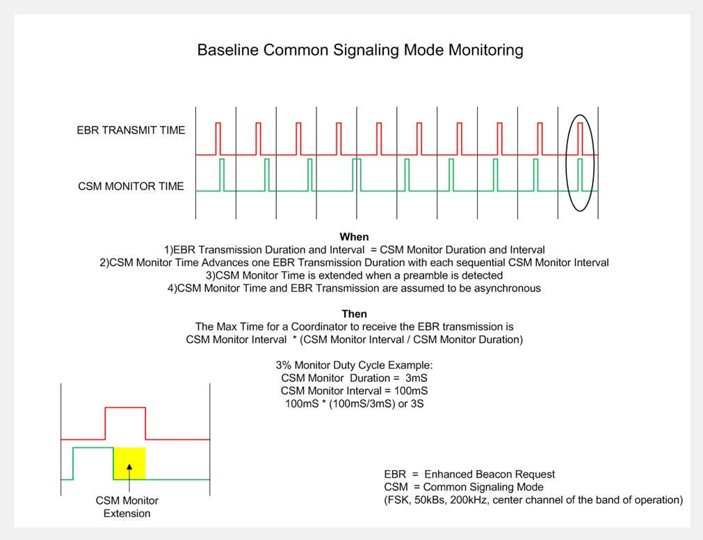

**Figure 103a** **system bandwidth calculation**

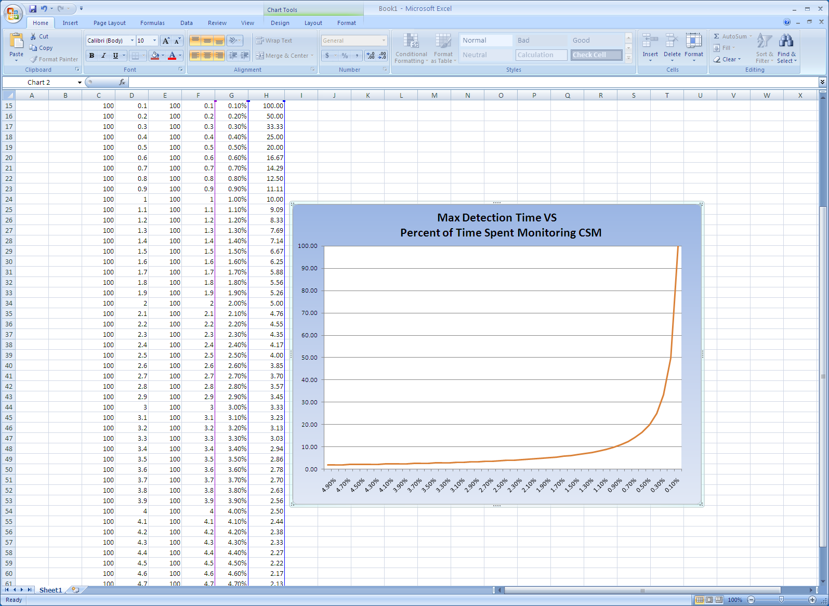

**Figure 103b detection time vs system bandwidth allocation**

In response to several comments received on the original packet sequence illustration the new illustration was drafted to replace the original

|  |  |  |
| --- | --- | --- |
| Comment # | Comment | Resolution |
| 1629 | Figure uses terminology not defined here. For example, "network PHY data" and "network data." | AP  Chart updated to remove reference to network PHY and data |
| 1630-1636 | In Figure 103c, the message sequences do not appear to line up with normal 802.15.4 messaging. How does a given device (i.e. Device B) know when to listen for a new device? What channel (or channel sequences) are used for these communications when the PHY CSM is one which requires frequency hopping? | AP  Devices may use a common duty cycle and duration to minimize scan times  Frequency hoppers may use the CSM at the regulatory domain defined duty cycle  ie 1/25 |
| 1764-1765 | the RTJ/RTJR packet sequence is not clear enough. | AP  Chart updated |

*Editorial note: replace existing figure 103c with figure below*

**Figure 103c example of EBR/EB sequence**

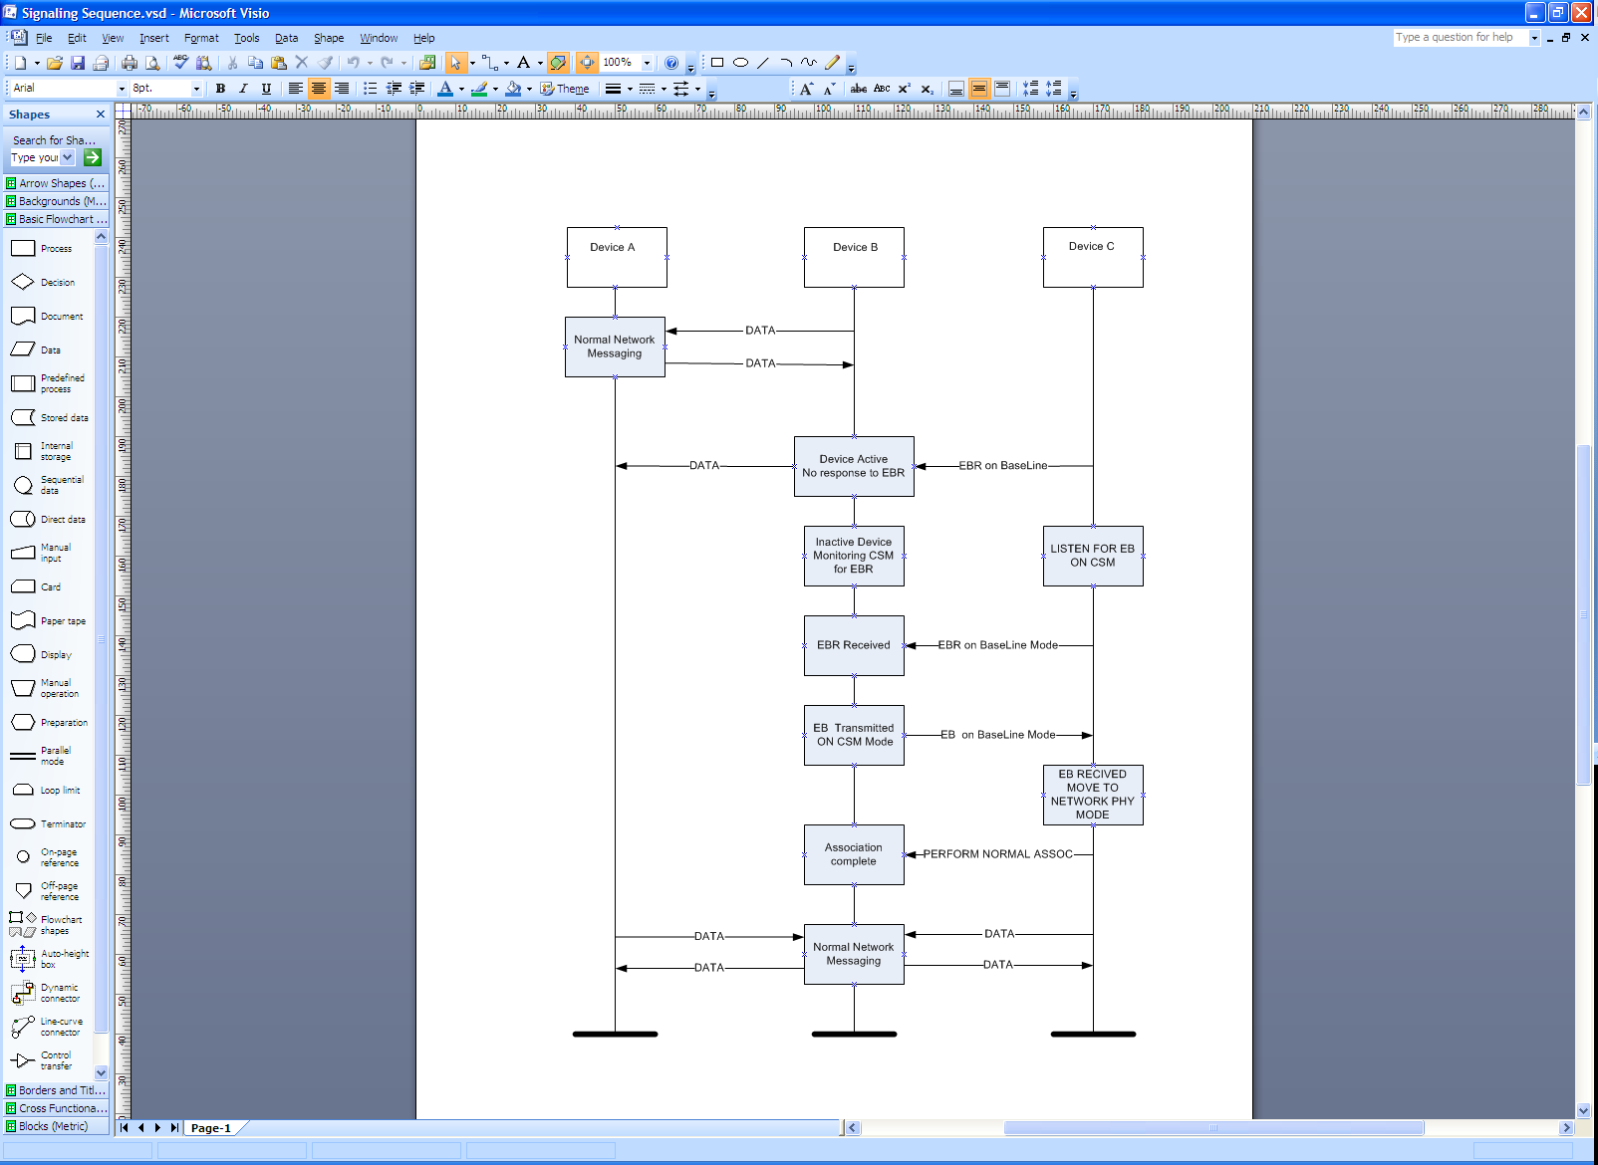

**Appendix**

**The Need for improved coexistence IS real:**

*NIST and EPRI are watching what the experts (this group) are proposing:*

**Report to NIST on the Smart Grid Interoperability Standards Roadmap*****June 17, 2009***

**NIST should commission a group of experts to study the issue of communications interference in unlicensed radio spectrums for smart grid applications**.

The American Recovery and Investment Act includes $11 billion in investments to “jump start the transformation to a bigger, better, smarter grid.”1 These investments and associated actions to modernize the nation’s electricity grid will result, for example, in more than 3,000 miles of new or modernized transmission lines **and 40 million “smart meters” in American homes**.

**6.1.5 Communications Interference in Unlicensed Radio Spectrums**

The Smart Grid provides mission-critical capabilities to the US economy and infrastructure. Communications is a key aspect of ensuring interoperability and increased efficiencies. Yet wireless **Smart Grid device manufacturers and system integrators struggle with communication interference issues** with other devices in unlicensed radio spectrums. Usage is not uniform across states further complicating the interoperability of networks.

**The risk of doing nothing is very well documented**

**Spectrum Sharing Without Licenses: Opportunities and Dangers**

Durga P. Satapathy2 and Jon M. Peha3 Carnegie Mellon University

Department of Electrical and Computer Engineering

In all wireless systems, design decisions are **exclusively based on the self-interest of the users** of the device

being designed. The design of the access strategy involves a trade-off between competing goals and interests. One goal is to conserve spectrum; others might be to reduce equipment and operating costs, or to optimize some measure of performance like access delay or reception quality. Thus, in unlicensed spectrum, it is more likely that the **best design decision from the selfish perspective of** **the designer** of a given device is also a *greedy* approach, where the more a device is designed to waste shared spectrum unnecessarily in favor of its own goals, the more we consider it to be greedy. Devices may therefore **be designed to transmit longer just to avoid the access delay** whenever they have a message to transmit again

**The Idea of a “Common Signaling Channel” is not new :**

A Spectrum Etiquette Protocol for Efficient

Coordination of Radio Devices in Unlicensed Bands D. Raychaudhuri and Xiangpeng Jing WINLAB, Rutgers University

*Abstract*—This paper presents a spectrum etiquette protocol for efficient coordination of radio communication devices in unlicensed (e.g. 2.4 GHz ISM and 5 GHz U-NII) frequency bands. The proposed etiquette method enables spectrum coordination between multiple wireless devices using different radio technologies such as IEEE 802.11.x, 802.15.x, Bluetooth, Hiperlan ,etc. The basic idea is to standardize a simple common protocol for announcement of radio and service parameters, called the “**common spectrum coordination channel** (CSCC)”. The CSCC mechanism is based on the low bit-rate mode of the 802.11bphysical layer, along with a periodic broadcast protocol at the MAC layer. The CSCC protocol is “policy neutral” in the sense that it provides a general mechanism which can accommodate a wide range of specific spectrum sharing rules. One possible CSCC protocol implementation is described in terms of the packet formats used and related channel access rules. Proof-of-concept experimental results from a CSCC prototype are presented for an example scenario in which nearby 802.11b and Bluetooth devices contend for 2.4 GHz ISM band access. Results showing file transfer delay with and without CSCC etiquette are given for comparison purposes.

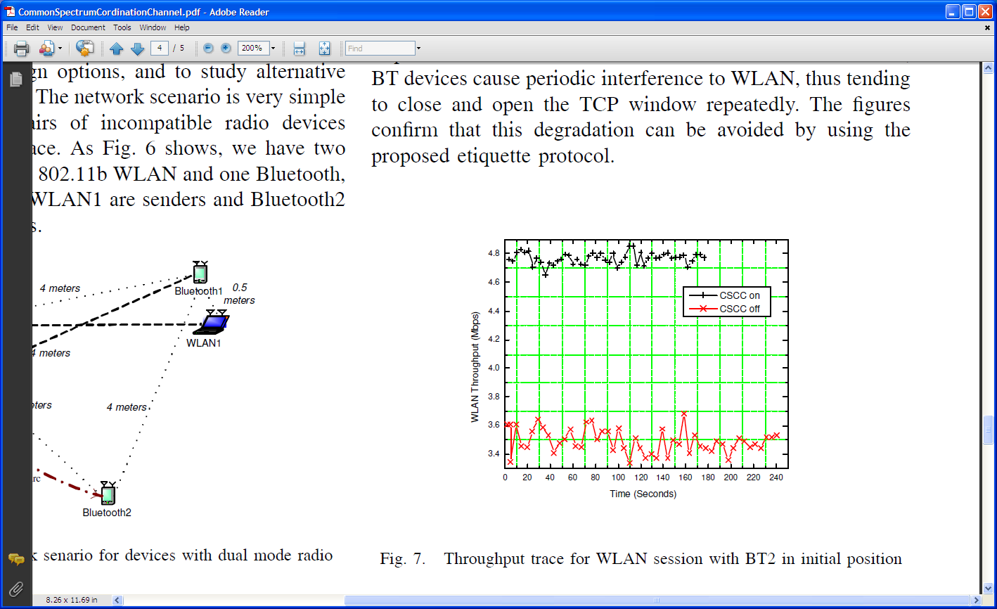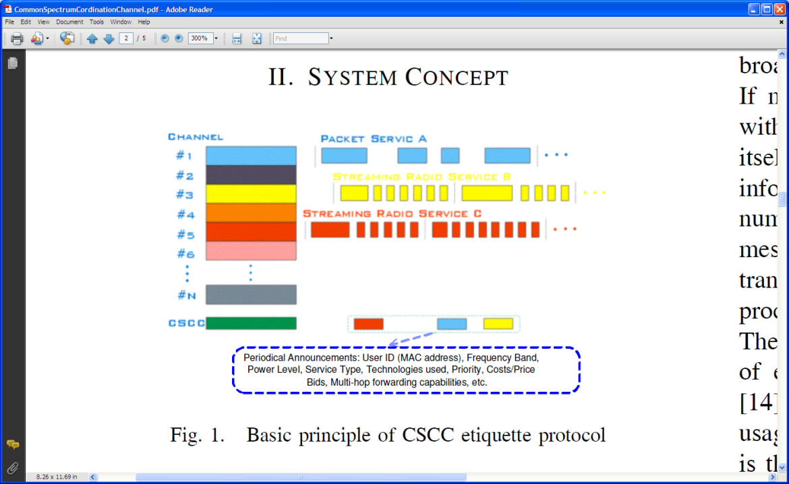

**An Analysis of Licensed Channel Avoidance Strategies for Unlicensed Devices**

Timothy X BrownInterdisciplinary Telecommunication ProgramElectrical and Computer Engineering DepartmentUniversity of Colorado Boulder, CO 80309-0530

A more distributed option is to **set aside a small frequency band for unlicensed devices** to exchange information about licensed transmitters. It would provide a known open channel that the unlicensed devices could use to signal each other about the presence of licensed and unlicensed services in the area. Like the area beacons, the format could be standardized as an etiquette protocol that would enable disparate devices to communicate with each other. This would be used to augment any of the other methods in this paper and enable new methods. For instance, unlicensed users might set up dedicated monitoring devices at prominent locations to identify and locate licensed transmitters.

**Interference Aware Medium Access for Dynamic Spectrum Sharing**

Gunther Auer DoCoMo Euro-Labs, Landsberger Straße 312, 80687 Munich, Germany

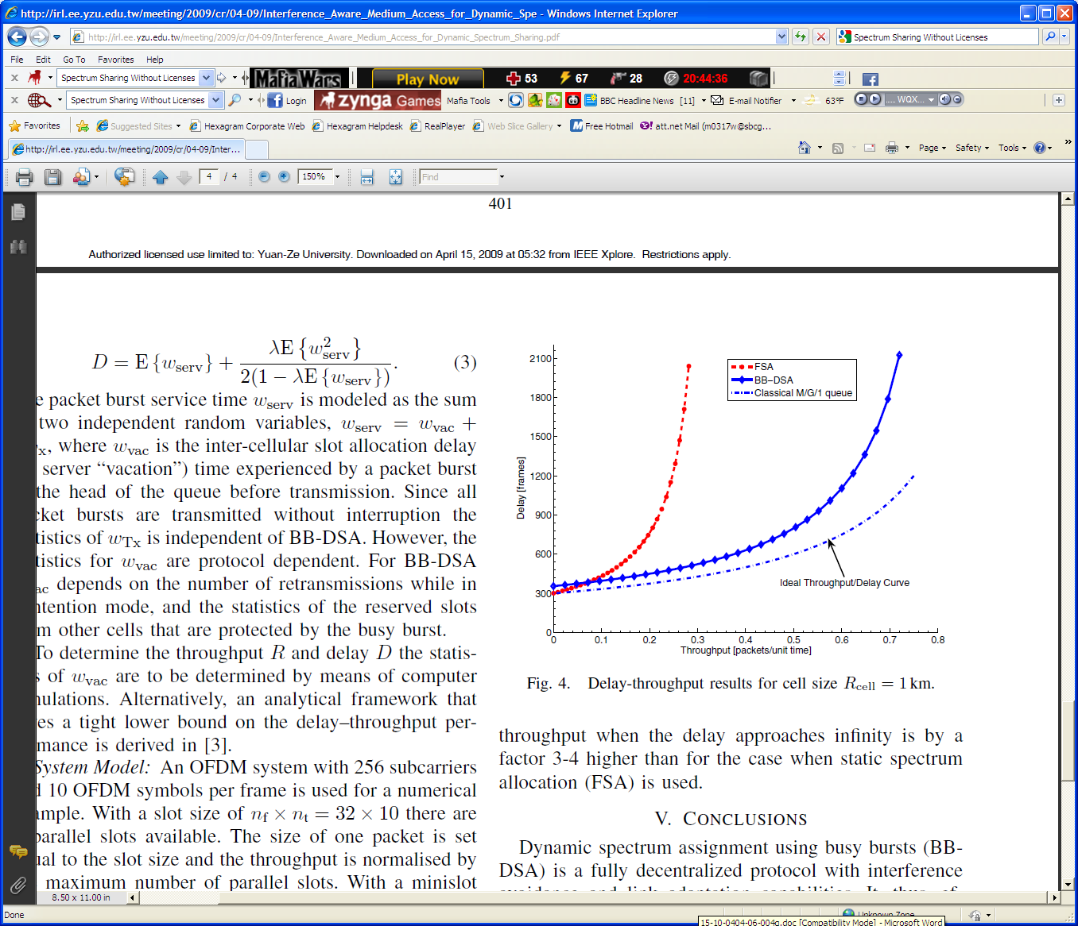

REFERENCES

[1] D. P. Satapathy and J. M. Peha, “Spectrum Sharing Without Licenses: Opportunities and Dangers,” in “Interconnection and the Internet,” book of Selected Papers From The 1996 Telecommunications Policy Research Conference, G. Rosston and D. Waterman (Eds.), Mahwah, NJ.

[2] U.S. Federal Communications Communication, “Operation of Unlicensed NII Devices in the 5 GHz Range,” ET Docket 96-102, Jan. 1997.

[3] D. P. Satapathy and J. M. Peha, “Performance of Unlicensed Devices With a Spectrum Etiquette,” in Proceedings of IEEE Globecom, Nov. 1997.

[4] Durga P. Satapathy and Jon M. Peha, “Etiquette Modification for Unlicensed Spectrum: Approach and Impact,” in Proceedings of the IEEE Vehicular Technology Conference, vol. 1, May 1998.

[5] D. Raychaudhuri, “Considerations for FCC’s 5 GHz NII/Supernet NPRM,” ATM Forum/96-8058/WATM, June 1996.

[6] D. Raychaudhuri, “Wireless ATM and the U-NII Spectrum,” Winlab FOCUS’ 98 Workshop on the Unlicensed National Information Infrastructure, June 22-23, Long Beach, NJ.

[7] A Kamerman, “Coexistence between Bluetooth and IEEE 802.11 CCK Solutions to Avoid Mutual Interference,” presentation to Lucent Technologies Bell Laboratories, Murray Hill, NJ, Jan. 1999.

[8] Marko Hnnikinen, Tapio Rantanen and Jani Ruotsalainen, et al., “Coexistence of Bluetooth and Wireless LANs,” in the 8th edition of IEEE ICT, 2001.

[9] G. Ennis, “Impact of Bluetooth on 802.11 Direct Sequence,” in IEEE P802.11 Working Group Contribution, IEEE P802.11-98/319, Sept. 1998.

[10] C.F. Chiasserini, R. Rao, “Performance of IEEE 802.11 WLANs in a Bluetooth Environment,” in IEEE Wireless Communications and Networking Conference, WCNC 2000, Chicago, IL, Sept. 2000.

[11] N. Glomie, R. E. Van Dyck, A. Soltanian, “Interference of Bluetooth and IEEE 802.11: Simulation Modeling and Performance Evaluation,” in Proceedings of the Fourth ACM International Workshop on Modeling, Analysis and Simulation of Wireless and Mobile Systems, MSWIM’01, Rome, Italy, July 2001.

[12] B. Treister, A. Batra, K.C. Chen, O. Eliezer, “Adapative Frequency Hopping: A Non-Collaborative Coexistence Mechanism,” in IEEE P802.15 Working Group Contribution, IEEE P802.15-01/252r0, Orlando, FL, May 2001.

[13] J. Lansford, R. Nevo, E. Zehavi, “MEHTA: A Method for coexistence between co-located 802.11b and Bluetooth Systems,” in IEEE P802.15 Working Group Contribution, IEEE P802.15-00/360r0, Nov. 2000.

[14] Cengiz Evci, Bernard Fino, “Spectrum Management, Pricing, and Efficiency Control in Broad-Band Wireless Communications,” in Proceedings of the IEEE, vol. 89, No. 1, Jan. 2001.

[15] A Spectrum Etiquette Protocol for Efficient Coordination of Radio Devices in Unlicensed Bands