**IEEE P802.15**

**Wireless Personal Area Networks**

|  |  |  |
| --- | --- | --- |
| Project | IEEE P802.15 Working Group for Wireless Personal Area Networks (WPANs) | |
| Title | Baseline Mode for SUN | |
| Date Submitted | July 2010 | |
| Source | Mark Wilbur | Voice: 01 440 528 7471 Fax: 01 440 528 7199  E-mail: mwilbur@aclara.com |
| Re: |  | |
| Abstract | IEEE 802.15 Task Group TG4g Comment Resolution | |
| Purpose | Define Baseline Mode for SUN | |
| Notice | This document has been prepared to assist the IEEE P802.15. It is offered as a basis for discussion and is not binding on the contributing individual(s) or organization(s). The material in this document is subject to change in form and content after further study. The contributor(s) reserve(s) the right to add, amend or withdraw material contained herein. | |
| Release | The contributor acknowledges and accepts that this contribution becomes the property of IEEE and may be made publicly available by P802.15. | |

The document provides resolution for the following comments:

**80, 82, 83, 88, 90-94, 98-102, 115, 131-134, 146-150, 152, 254, 255, 257**

**1595-1617, 1618-1626, 1628-1636, 1759, 1760-1765**

*Editorial note: replace existing 5.2a with text below*

**5.2a Baseline Common Signaling Mode**

**5.2a Baseline Common Signaling Mode**

Several incompatible PHY’s have been defined within this standard that will potentially operate within the same spectrum. The baseline common signaling mode is used to support communications between these devices. The baseline common signaling

mode may be used to facilitate network association, network avoidance, and frequency hopping network association. Should the next higher layer determine the primary baseline common signaling mode is currently unreliable the alternate baseline modes defined in 6.2a may be utilized

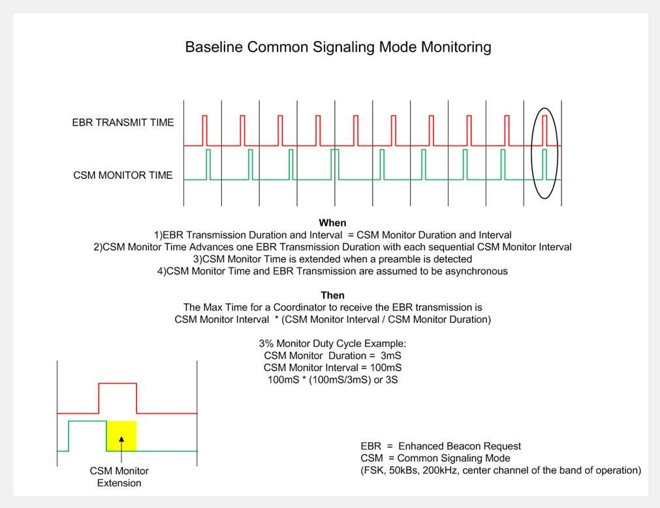

*Editorial note: add the 5.3.9b text below*

**5.5.3.1b Enhanced Beacon Request (EBR)**

The EBR defined in 7.3.7a provides a discovery mechanism that may be used by an unassociated device to make itself known to all devices actively monitoring the baseline common signaling mode. The EBR is an information request transmitted by an unassociated device in order to communicate with a neighboring network associated devices.

*Editorial note: add the5.3.9a text below*

**5.5.3.1a Enhanced Beacon (EB)**

The EB defined in 7.2.2.1a may be transmitted by a network associated device when the EBR response criteria defined in 7.3.7ahas been met. The device could use the information contained within the EB payload to perform any number of actions such as, avoidance of orthogonal networks sharing the spectrum, or facilitation of the network association process for frequency hopping devices. The use of a pseudorandom EB transmission delays may be utilized to limit the number of simultaneous responses from neighboring devices.

*Editorial note: add the text and table 6.2a text below*

**6.2a Baseline Modes**

**6.2a Baseline Modes**

All smart utility network (SUN) devices operating outside of the dedicated spectrum bands shall be capable of communications using the baseline mode definedin table 6.2a. The baseline modes may be used for network traffic in bands where bandwidth is limited. Monitoring the baseline mode is optional

|  |  |  |  |  |  |
| --- | --- | --- | --- | --- | --- |
| **Baseline** | **Modulation** | **Modulation Index / Rate** | **Channel Spacing (kHz)** | **Data Rate (kbps)** | **Channel**  **Number** |
| Primary  Alt-1  Alt-2 | FSK  FSK  FSK | 1  1  1 | 200  200  200 | 50  50  50 | floor (TCB*0.75)  floor (TCB*0.25)  floor (TCB*0.50) |

**Table 6.2a**

TCB=Total number of Channels defined for the Band of operation

The floor(*x*) function takes a floating point number, *x*, and returns the first integer which is less than or equal to that number.

*Editorial note: remove entire sections 7.5.8a and 7.5.8b*

**7.3 MAC command frames**

Editorial note: *Change Table 123 (the entire table is not shown) as indicated:*

*Change the second paragraph of 7.3 as indicated*

Ed. Note: Define MLME for EBR based on existing BR, add to BR boolean ExtendedBeacon, phyCurrentChannel, phyChannelPage, etc. and xref where they are defined.

*Editorial note: replace existing 7.3.9a with text below*

**7.3.7a Enhanced Beacon Request (EBR) command**

The EBR command shall be formatted as illustrated in Figure 103a.

|  |  |  |
| --- | --- | --- |
| octets: (see 7.2.2.4) | 1 | 1 |
| MHR fields | Command  Frame Identifier  (123) | Response Filter |

**Figure 103a—EBR command format**

**7.3.7a.1 MHR fields**

The source addressing mode subfield of the frame control field shall be set to three ( 64-bit extended addressing). The destination addressing mode subfield of the frame control field shall be set to two (i.e.,16-bit short addressing).The frame pending subfield of the frame control field shall be set to zero on transmission and ignored upon reception. The acknowledgment request subfield and security enabled subfield shall be set to zero. The destination PAN identifier field shall contain the broadcast PAN identifier (i.e., 0xffff). The destination address field shall contain the broadcast short address (i.e., 0xffff). The Source Address field shall contain the value of *aExtendedAddress*

**7.3.7a.2 Response Filter**

**The response filter identifies the coordinators whose response is requested. Valid values are:**

0=ALL Coordinators respond

1=Only SUN Coordinators respond

2=Only Frequency Hopping Coordinators respond

**3-255 -> Reserved.**

*Editorial note: replace existing 7.3.9b with text below*

**7.2.2.1a Enhanced Beacon (EB)**

The EB command is formatted as illustrated in Figure 103b.

|  |  |  |  |  |
| --- | --- | --- | --- | --- |
| **octets:**  **(see 7.2.2.4)** | 1 | 4 | 2 | *Variable |
| MHR fields | Command  Frame Identifier  (see Table 123) | *phyCurrentSUNPageEntry*  (see Tab. 3. 31) | *phyCurrentChannel*  (see Tab. 3. 31) | *Necessary*  *FreqHopping*  *parameters* |

**Figure 103b—EB command format**

*Frequency hopping parameters are only included in the beacon when responding to a EBR with the response filter set to (Only Frequency Hopping Coordinators respond)

**7.2.2.1a MHR fields**

The source addressing mode and destination addressing mode subfields of the frame control field shall both be set to three (i.e., 64-bit extended addressing).The frame pending subfield of the frame control field shall be set to zero and ignored upon reception. The acknowledgment request subfield and security enabled subfield shall be set to zero.. The PAN ID compression subfield of the frame control field shall be set to 1 and the Destination PAN shall contain the broadcast PAN ID (0xFFFF). The destination address field shall contain an extended address equal to the source address of the received EB command. The Source Address field shall contain the value of *aExtendedAddress*.

*Editorial note: replace existing figure 103c with figure below*

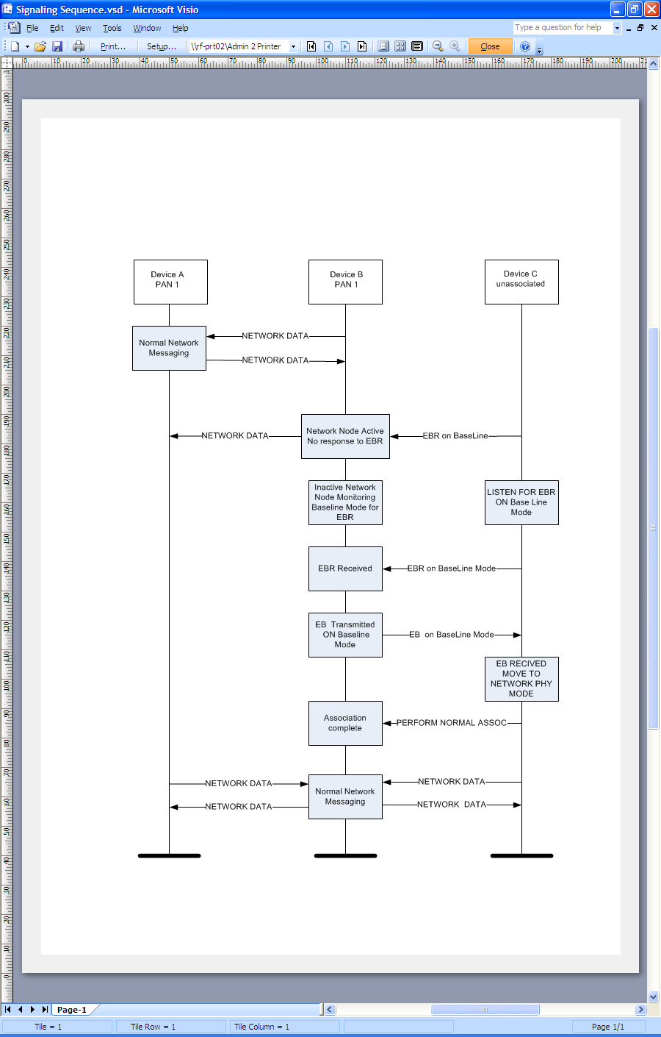

**Figure 103c example of EBR/EB sequence**