IEEE P802.15
Wireless Personal Area Networks

Project | IEEE P802.15 Working Group for Wireless Personal Area Networks (WPANs)
Title | 433 MHz PHY Draft Text
Date Submitted | June 23, 2010
Source | Dalibor Pokrajac  Guard RFID Solutions | Voice: 604-282-7584  E-mail: dalibor.pokrajac@guardrfid.com
Re: | Draft of 802.15.4f
Abstract | Draft text for 433 MHz PHY for inclusion in 802.15.4f standard
Purpose | Contribution to draft text
Notice | This document has been prepared to assist the IEEE P802.15. It is offered as a basis for discussion and is not binding on the contributing individual(s) or organization(s). The material in this document is subject to change in form and content after further study. The contributor(s) reserve(s) the right to add, amend or withdraw material contained herein.
Release | The contributor acknowledges and accepts that this contribution becomes the property of IEEE and may be made publicly available by P802.15.
4f changes to IEEE 802.15.4 (2006) taking into account changes made with IEEE 802.15.4a (2007) spec.
Text below is relevant to 433 MHz PHY Only:

General Description

Introduction
Change the following items in the dashed list of 5.1 as shown:
- Carrier sense multiple access with collision avoidance (CSMA-CA) or ALOHA [ultra-wide band (UWB) and 433 MHz] channel access
- 16 channels in the 2450 MHz band, 30 channels in the 915 MHz band, 3 channels in the 868 MHz band, 14 overlapping chirp spread spectrum (CSS) channels in the 2450 MHz band, 16 channels in three UWB bands (500 MHz and 3.1 GHz to 10.6 GHz) and 1 channel in 433 MHz band.

Physical Layer

Physical Layer (PHY)
Change the third paragraph in 5.4.1 as shown:
The features of the PHY are activation and deactivation of the radio transceiver, energy detection (ED), link quality indication (LQI), channel selection, clear channel assessment (CCA), and transmitting as well as receiving packets across the physical medium. The optional UWB PHY also has the optional feature of precision ranging. The radio operates at one or more of the following unlicensed bands:
- 868–868.6 MHz (e.g., Europe)
- 902–928 MHz (e.g., North America)
- 2400–2483.5 MHz (worldwide)
- 3100–10 600 MHz (UWB varies by region)
- 433.05 – 434.79 MHz (worldwide, varies by region)

Insert after 5.4.1.3 the following new subclause:

Advantages of 433 MHz PHY
433 MHz PHY intended and optimized primarily (but not restricted) for active RFID type applications within LR-WPAN space. 433 MHz PHY provides extended communication range when compared to higher frequency channels due to reduced signal attenuation, primarily in NLOS environment. Widespread availably of mature sub-gigahertz technology as well as global acceptability of 433 MHz frequency makes this PHY attractive for devices which move frequently from one location to another worldwide, as it is the case with active RFID devices.
One of critical advantages of 433 MHz PHY is its independence from any other 802 PHY allowing full coexistence and non-interference. This is important for active RFID systems where number of devices can be very high in very limited physical space.

PHY Specification

General Requirements and Definitions
Insert the following item at the end of the dashed list in 6.1:
- An 433 MHz MHz PHY employing minimum phase-shift keying (MSK) modulation

Insert the following item at the end of the 6.1:

In further additions to the rates supported in IEEE Std 802.15.4-2006 and IEEE Std 802.15.4a - 2007, additional, 433 MHz PHY has been added.

Operating Frequency Range
Insert the following row in “Table 1 – Frequency Bands and Data Rates”:

PHY (MHz) | Frequency band (MHz) | Chip Rate (kchp/s) | Modulation | Bit Rate (kb/s | Symbol Rate (ksymbol/s) | Symbols
433 | 433.63 – 434.21 |  | MSK | 250 | 250

Insert the following rows at the end of 6.1.1:

Japan:
- Document ARIB STD T92

United States:
- Document: FCC CFR47 Section 15.231(e)

Canada:
- Document: IC RSS210

Channel Assignments

Channel Numbering
?????? Can unused Channels in existing Channel Pages 0,1 and 2 be used for 433 MHz channel. Currently channels 27-31 are unused in these 3 Channel Pages ??????

Channel Pages
Same as for 6.1.2.1

Minimum long interframe spacing (LIFS) and short interframe spacing (SIFS) periods
Insert the following new rows at the beginning of Table 3:
Table 7—PD-DATA.confirm parameters
Channel Page (decimal) | macMinLIFSPeriod | macMinSIFSPeriod | Units
433.63 – 434.21 MHz MSK | 40 | 12 | Symbols

PHY Service Specifications

PD-DATA.Indication

Semantics of Service Primitive
Insert the following new parameters at the end of the list in 6.2.1.3.1 (before the closing parenthesis):
ppduRSSI
Insert the following new rows at the end of Table 8:
Table 8—PD-DATA.indication parameters
Name | Type | Valid Range | Description
ppduRSSI | Integer | 0x00 - 0xFF | Received Signal Strength measured during reception of PPDU (see x.x.x)

Sections from 6.2.2 to 6.3 not completed

PPDU Format

Preamble Field
Insert the following new rows at the beginning of Table 19:
Table 19 — Preamble field length
PHY | Length |  | Duration (us)
433.63 – 434.21 MHz MSK | 4 octets | 32 symbols | 128 us

SFD Field
Insert the following new rows at the beginning of Table 20:
Table 20 — SFD field length
PHY | Length
433.63 – 434.21 MHz MSK | 2 octets | 16 symbols

Insert the following text after Table 17:
433 MHz PHY (MSK modulation) has the following SFD:
1111 0111 0011 0001

433 MHz PHY Specification
Note: This Chapter should probably be numbered 6.8b in order to preserve continuity of 4 /4f numbering.

433 MHz Data Rate
The data rate of 433MHz MSK PHY shall be 250 kbps.

Modulation and Spreading
433 MHz PHY employs Minimum Shift Keying. This is special case of frequency shift keying where the transition between two bits occurs when the phase of frequencies is either 0° or 180° in order to minimize undesirable effects of phase discontinuation during frequency switching. This is also known as continuous phase frequency shift keying.

Reference Modulator Diagram
Data pulse shape is sinusoidal.
MSK Transmitter:
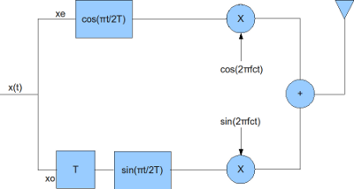
Figure 1 Block Diagram of MSK Transmitter

MSK Receiver
The receiver for the MSK transmission can be constructed as follows:
a) Down convert the RF signal to I and Q arms by I/Q down conversion
b) Multiply the I and Q arms by and respectively
c) Integrate over the a period of
d) On I arm, perform hard decision decoding on the integrator output at every to get the even bits
e) On Q arm, delay by time , perform hard decision decoding on the integrator output at every to get the odd bits
The block diagram is shown below:
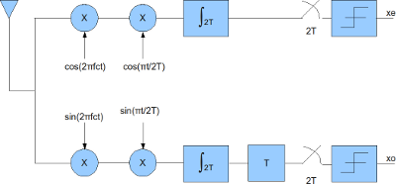

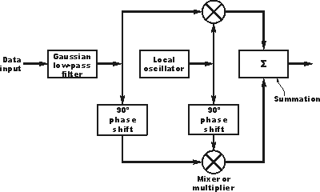
Figure 2 GMSK modulator

Bit-To-Symbol Mapping
Bit rate and symbol rate are equal.

Symbol-To-Chip Mapping
n/a

MSK Modulation
Minimum Shift Keying (MSK) is a special type of continuous phase frequency shift keying (CPFSK) with modulation index h = 0.5. This modulation index corresponds to minimum frequency spacing that allows two FSK signals to be coherently orthogonal. As a result, there are no phase discontinuities because the frequency changes occur at the carrier zero crossing points.
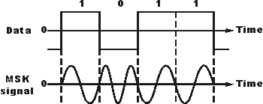
Figure 3 Signal Using MSK Modulation
MSK has two possible frequencies over any symbol interval, which differ in half bit rate:
fo – f1 = 1 / 2Tb
This is the smallest frequency difference which allows two signals to be orthogonal.

Pulse Shape
To be added

Chip Transmission Order
n/a

Definitions
As of June 2009, please use the following introductory paragraph. Also, there is no longer a requirement to number definitions per the 2009 IEEE Standards Style Manual. Refer to the 2009 IEEE Standards Style Manual for updates.
For the purposes of this document, the following terms and definitions apply. The IEEE Standards Dictionary: Glossary of Terms & Definitions should be referenced for terms not defined in this clause.

(informative)
Bibliography

The IEEE Standards Dictionary: Glossary of Terms & Definitions is available at http://shop.ieee.org/.

