IEEE P802.15
Wireless Personal Area Networks
Project | IEEE P802.15 Working Group for Wireless Personal Area Networks (WPANs)
Title | <Modified Text clauses from 7.9.1 to 7.9.5 >
Date Submitted | [11 February, 2010]
Source | [Taehan Bae, Doyoung Kim, Jaeseung Son, Sridhar Rajagopal, E.T. Won]  [Samsung Electronics]  [Suwon, Korea] | Voice:[82-31-279-7293]  Fax: [ ]  E-mail:[taehan.bae@samsung.com]
Re: | []
Abstract | [modified text clauses from 7.9.1 to 7.9.5]
Purpose | [Description of what the authors wants P802.15 to do with the information in the document.]
Notice | This document has been prepared to assist the IEEE P802.15. It is offered as a basis for discussion and is not binding on the contributing individual(s) or organization(s). The material in this document is subject to change in form and content after further study. The contributor(s) reserve(s) the right to add, amend or withdraw material contained herein.
Release | The contributor acknowledges and accepts that this contribution becomes the property of IEEE and may be made publicly available by P802.15.

7.9.1 Mobility using boundary information
The cell is defined as an aggregate or a group of light sources that should be covered by a coordinator. In order to support multi user communication and high system capacity, a cell configuration should be applied in VLC system. A single coordinator should coordinate multiple cells. Also each device in the cell should use different time slot that is assigned by the coordinator. By using different time slot assignment, user interference can be avoided. Figure 128 shows one of the VLC system cell configurations.

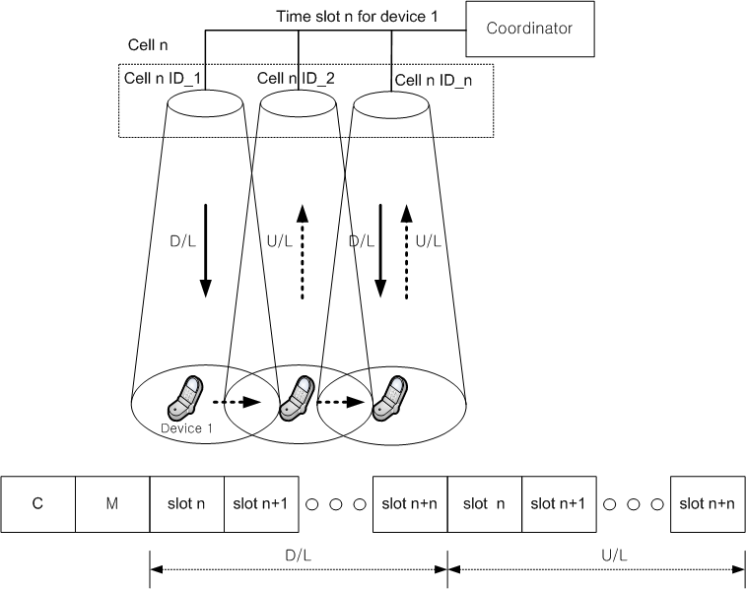
Figure 128-cell configuration for VLC mobility

In multi-user service based on TDD/TDMA communication VLC system, large cell size can give us relatively easy mobility to the device, but decrease system capacity with less complexity. While small cell size in VLC system can give us increasing system capacity with complexity like a lot of resource assignment and resource change (like as cell hand off) etc. A cell size in VLC needs to be considered as aspect of system capacity.

Each cell can be designed as optical source grouping and each optical source in a cell has each cell ID like as Figure 128. A cell ID is used as one of information of ‘Cell_info’ which is defined in table 85.

Table 85, Management payload field for mobility

Management payload  Filed | Bit | Usage / Description | Down/Up Link
Cell_info | 15 | Cell ID (D/L),  Coordinator ID (D/L)  Optical Source ID (D/L) : Cell n_ID_n,  PID (U/L) | D/L, U/L
MS_ID | 10 | Device ID | D/L, U/L
B_info | 2 | Cell boundary information | D/L
Fractional_Src | 1 | Using fractional resource assignment  Set 1: yes (fractional resource assignment)  Set 0 : no (general resource assignment) | D/L
G_cell_ID | 10 | Granular cell size | D/L
Spatial_mobility | 1 | Using Spatial mobility  Set 1: yes (Spatial mobility)  Set 0 : no (No spatial mobility) | D/L
S_info | 5 | Time slot assignment and response (D/L)  Request (U/L) | D/L, U/L
Reserved | 12
Total | 56

To distinguish devices, each device should have own unique ID number (MS_ID). MS_ID which is defined in table 85 should be exchanged between the device and the coordinator. For supporting the mobility of the device, two time slots should be used simultaneously in the boundary cell area. When the device is in boundary cell area, the coordinator should assign another time slot to the device using S_info.

In Figure 128, a cell n consists of optical sources, like Cell n ID_n. If Device 1 moves to next optical source area from Cell n ID_1 to Cell n ID_2 with time slot n assigned by coordinator, the device 1 and the coordinator can communicate through D/L(downlink) and U/L(uplink). The coordinator can detect the position of the device 1 in that Cell n using an optical Cell n ID_n because the device transmits U/L signal (like as data ACK or response) to PID.

Figure 129 shows the mobility and resource assignment procedure of the device 1 from cell j to cell k by using boundary alarm information. In cell j, the device 1 has a time slot n and in cell k, the device 2 has a time slot n+1. A cell boundary is defined as each cell edge area and called ‘cell boundary’.
When the device 1 moves into in cell 1 boundary, the coordinator can detect the device 1 uplink signal at cell j boundary. The coordinator should transmit boundary information, ‘B_info’ which is defined in table 85 to device 1 through boundary area optical sources like Cell j ID-4, 8 and 12. Then, optical sources of cell j boundary area assign time slot n+2 to the device 1 using S_info which is defined in table 85. In boundary area, device 1 transmits and receives data and control through time slot n and n+2.
If device 1 continues to move into cell k boundary area, then device 1 can detect cell k boundary information in cell k boundary area. In this case, device 1 should return previous time slot n, because time slot n was assigned in cell j. At first, the device 1 requests to return time slot n to the coordinator, the coordinator responses to the device 1.
After completing return time slot process, device 1 communicates with the coordinator using time slot n+2 only.
Even if device 1 cannot receive the cell k boundary information in cell k edge area, device 1 can return the time slot n. Because the device 1 still can detect the cell k ID, if the device 1 finds out the changed cell ID, device 1 decides to return the previous time slot n to the coordinator and use time slot n+2 only.

Fig. 129. Mobility using boundary information

Figure 130 shows another case. The device 1 moves back to previous cell j after device 1 has 2 time slot like time slot n and n+2.
At first, the device 1 follows the same procedure in figure 129 until device 1 is assigned time slot n and n+2.
When the device 1 moves back from cell j boundary area to cell j area, the device 1 cannot detect cell j boundary information anymore. In this case, the device 1 should return time slot n to the coordinator. The device 1 requests to return time slot n to the coordinator, the coordinator responses to device 1. After completing return time slot process, device 1 communicates with the coordinator using time slot n+2 only.

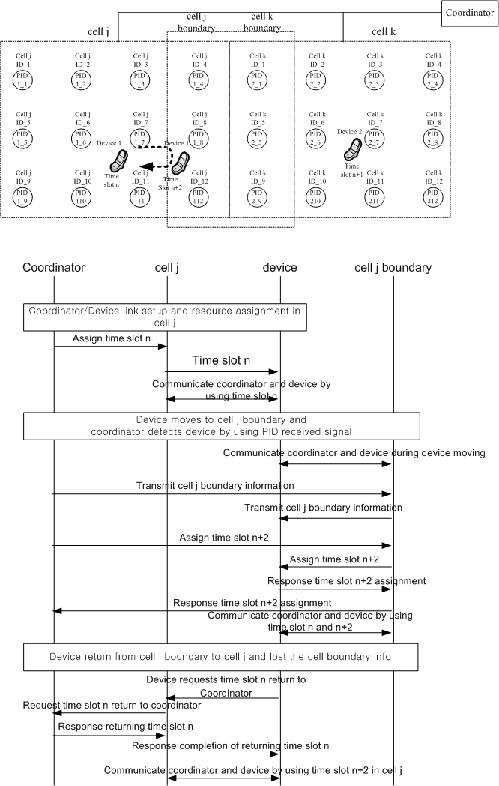
Fig. 130. Mobility using boundary information

Figure 131 shows using boundary information in multi-cell environment. When the device 1 moves from cell 3 to cell 2, the device needs to pass the overlapped area of cell 1, cell 2 and cell 4. If the device 1 moves into multi cell boundary, the device 1 receives the boundary information in multi cell boundary. To pass the overlapped area without interference, multi boundary optical sources should assign new time slot, like time slot n+9 to device 1. The coordinator assigns time slot n+9 that is not used in Cell 1, Cell 2, Cell 3 and Cell 4.

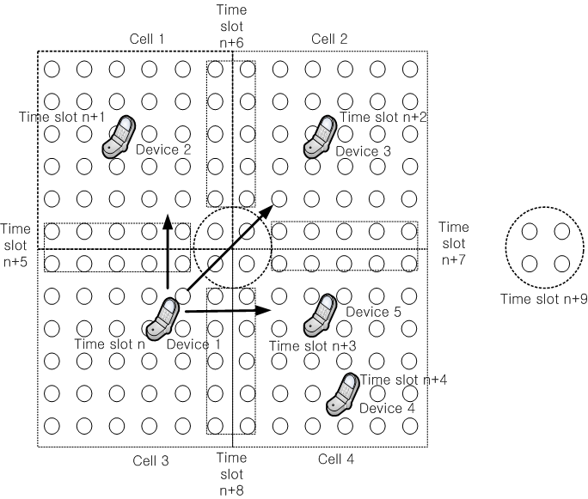
Fig. 131. Mobility using boundary information in multi-cell overlapped.

7.9.2 Same optical source ID assignment in a cell
In figure 132, shows that each optical source has assigned the same optical source ID inside each cell except the boundary area. Boundary area between 2 cells should be assigned the other cell ID for supporting the mobility of the device. Because of the same optical source ID in one cell, the coordinator cannot detect the movement of the device in that cell area. However, when the device 1 moves from cell j to cell k, the optical source of the cell i can detect the device 1 movement and should assign time slot n+1 to the device 1.

Figure 132-Same optical source ID assignment

7.9.3 Granular cell configuration
When the cell is defined as a group of light source, the dimension or size of the cell should be fixed or variable. When we want to use variable size of cell, the group of light sources should be assigned granularly and we can call it as a granular cell configuration. A cell size should be configured by using G_cell_ID which is defined in table 85. The G_cell_ID should be the specific number and the cell size is formed around the position of the device as the G_cell_ID number. Figure 133 (a) and figure 133 (b) show two examples of G_cell_ID, set as 00000 00001 and 00000 00010, respectively. If the G_cell_ID is set as 00000 00000, the granular cell configuration does not used.

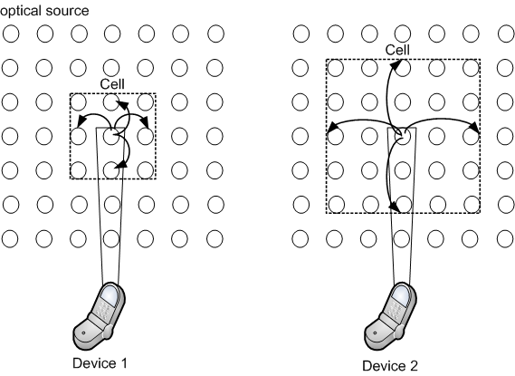
(a) (b)
Figure 133-Cell configuration by using G_cell_ID

7.9.4 Fractional resource assignment
When we want to use only some parts of the light sources in VLC system, that group of light sources should be assigned fractionally, and we can call it as a fractional resource assignment.
In that case, the position of the cell should not be fixed and the figure 134 shows one example of fractional resource assignment. To use fractional resource assignment, the coordinator should transmit the ‘Fractional_Src’ which is defined in table 83 with set code ‘1’. If the ‘Fractional_Src’ is set as ‘0’, the fractional resource assignment is not supported.
When the device 1 transmits initial access signal to the coordinator, the photo-detector of the coordinator should measure the power of the initial access signal from the device 1. As a result of the measured power, the coordinator should configure the cell based on the position of the measured optical signal power. In second method, the device 1 measure the signal power form the coordinator, for example a channel quality, and send that measured signal power to the coordinator. The coordinator should configure the cell based on the measured signal power received from the device 1. In that cell area, the coordinator should assign time slot n to the device 1. Likewise, the device 2 should be assigned another time slot like in figure 134. It helps to increase system efficiency and avoid interference.

Fig. 134. Fractional resource assignment

7.9.5 Granular cell & fractional resource assignment for mobility
This is one example of the logical mobility in non-fixed cell environment. Granular cell configuration and fractional resource assignment should be used for mobility.
In figure 135, the device 1 moves to the other place, the coordinator can detect the position of the device 1 using the photo detector and then configure the cell 1 based on the new position of the device 1. The cell configuration is defined in subclause 7.9.3.
It is possible to have overlapped area between cell 1 and cell 2 due to devices movement. In that case, the coordinator should change the cell size based on G_cell_ID to avoid the interference between two devices 1 and 2.

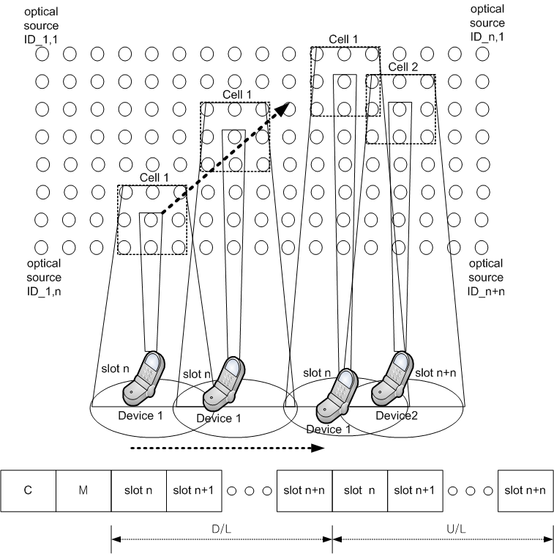
Figure 135-Granular cell & fractional resource assignment for mobility

7.9.6 Spatial mobility
Spatial mobility is one example of the logical mobility in non-fixed cell environment. ACK and NACK frame should be used for spatial mobility.
When the device moved out from a certain cell area that the device belong to like figure 136 (a), the device should transmit the NACK frame. When the coordinator receives the NACK frames, it should extend active cell area (b). Active area is the cell which provides data to the specific user. The coordinator should decide whether ACK frame is received from device within the extended active area. Extend active area means increasing light sources which transmits data. Extend active area should be restricted by pre assigned NACK signal numbers. If ACK frame is received, the coordinator should correct the active area size based on the place where ACK frame received. Active area size should be the predetermined light source numbers and variable depending on moving device direction and speed.
To use spatial mobility, the coordinator should transmit the ‘Spatial_mobility’ which is defined in table 83 with set code ‘1’. If the ‘Spatial_mobility’ is set as ‘0’, the spatial mobility is not supported.
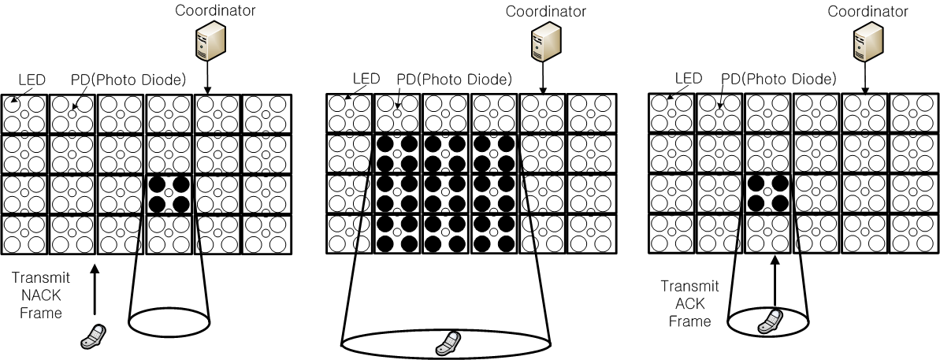
(a) (b) (c)
Fig. 136. Spatial mobility using ACK, NACK frame.

