IEEE P802.15
Wireless Personal Area Networks
Project | IEEE P802.15 Working Group for Wireless Personal Area Networks (WPANs)
Title | <Modified Text clauses 7.8>
Date Submitted | [11 February, 2010]
Source | [Jaeseung Son, Taehan Bae , Sridhar Rajagopal, E.T. Won]  [Samsung Electronics]  [Suwon, Korea] | Voice:[82-31-279-7293]  Fax: [ ]  E-mail:[taehan.bae@samsung.com]
Re: | []
Abstract | [Modified text clauses 7.8]
Purpose | [Description of what the authors wants P802.15 to do with the information in the document.]
Notice | This document has been prepared to assist the IEEE P802.15. It is offered as a basis for discussion and is not binding on the contributing individual(s) or organization(s). The material in this document is subject to change in form and content after further study. The contributor(s) reserve(s) the right to add, amend or withdraw material contained herein.
Release | The contributor acknowledges and accepts that this contribution becomes the property of IEEE and may be made publicly available by P802.15.

7.8 Multiple channel resource assignment
7.8.1 Multiple channel information
When the coordinator doesn’t have time slot resources to assign for new user, the coordinator should extend the resource by using multiple channel. Figure 124 shows the one example of multiple channel usage and Figure 127 describes the procedure of multiple channel usage in Figure 124. In figure 127, the device 1 initially accesses to the coordinator for communication by using the default band. The default band is used to initial access band between the coordinator and the devices and should be one or any bands from 7 bands in table 1. The coordinator assign time slot n to device 1 in control signal by using default band.
When the device 2 try to access coordinator initially for communication and the time slot is not available anymore for device 2, the coordinator should assign the other channel except the default channel. To use multiple channels, the coordinator should transmit the “Src_multi_info” in management payload field which is defined in table 83 to the device. Then the device 2 should responses to the coordinator using the “Des_multi_info” which is defined in table 83 in uplink MAC header, informing available multiple channels of the device. The coordinator should assign channel resources with time slot to the device using default band.

If the coordinator does not support the multiple channel, because the coordinator has the single channel light source, or does not want to use multiple channel, the coordinator should transmit Src_multi_info with set code ‘0000000’ which is defined in table 001 in Annex.
If the device also cannot support multiple channel due to the hardware limitation, like single channel light source or interference situation, or does not want to use multiple channel, the device should response the Des_multi_info with set code ‘0000000’ which is defined in table 001 in Annex.

Figure 124-Example of multiple channel usage

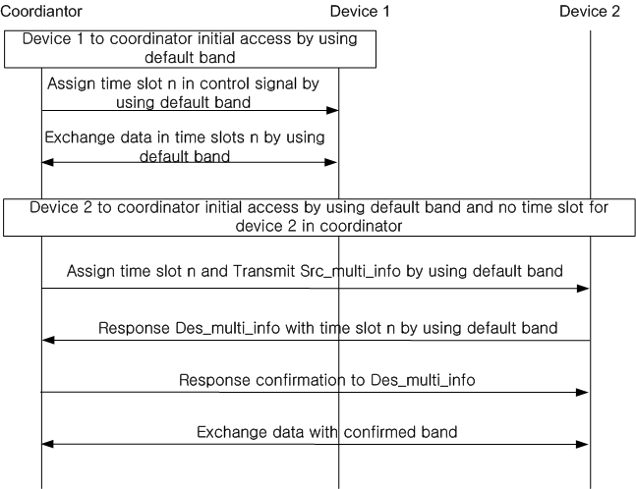

Fig. 127. Multi-channel information.

Table 83 - Management payload field for multiple channel

Management payload  filed | Bit | Usage / Description | Down/Up Link
Src_multi_info | 7 | Available channels information in Coordinator (Access Point)  ex: 0000000: No multiple channel mode  ex: 0000001: using channel “Band 7”  ex: 0000101: using channel “Band 5” and “Band 7” | D/L
Des_multi_info | 7 | Available channels information in mobile device  ex: 0000000: No multiple channel mode  ex: 0000001: using channel “Band 7”  ex: 0000101: using channel “Band 5” and “Band 7” | U/L

7.8.2 Channel hopping for interference avoidance
The cell is defined as an aggregate or group of light sources that should be covered by a coordinator. A single coordinator can coordinate multiple cells.
When the VLC communication system uses the same time slot between the adjacent light sources or cells with multiple channel communication, the channel hopping should be used. In order to avoid interference and increase system capacity, pre assigned hopping pattern should be adopted.
To use the channel hopping, the coordinator should transmit the ‘H_pattern’ in management payload field which is defined in table 84 to the device. The hopping pattern should be assigned to the device and then the device should operate and hop based on the assigned hopping pattern.
If the VLC system does not use the multiple channel (Src_multi_info is set code ‘0000000’), the hopping pattern does not supported.

Table 84, Management payload field for channel hopping
Management payload filed | Bit | Usage / Description | Down/Up Link
H_pattern | 5 | Channels hopping information | D/L
Annex X.

1. Channel assignment

Table 001. – Multiple channel assignment table
Bit | Band 1 | Band 2 | Band 3 | Band 4 | Band 5 | Band 6 | Band 7
0000000 | No multiple channel mode
0000001 | X | X | X | X | X | X | O
0000010 | X | X | X | X | X | O | X
0000011 | X | X | X | X | X | O | O
0000100 | X | X | X | X | O | X | X
0000101 | X | X | X | X | O | X | O
0000110 | X | X | X | X | O | O | X
0000111 | X | X | X | X | O | O | O
0001000 | X | X | X | O | X | X | X
0001001 | X | X | X | O | X | X | O
0001010 | X | X | X | O | X | O | X
0001011 | X | X | X | O | X | O | O
0001100 | X | X | X | O | O | X | X
0001101 | X | X | X | O | O | X | O
0001110 | X | X | X | O | O | O | X
0001111 | X | X | X | O | O | O | O
0010000 | X | X | O | X | X | X | X
0010001 | X | X | O | X | X | X | O
0010010 | X | X | O | X | X | O | X
0010011 | X | X | O | X | X | O | O
0010100 | X | X | O | X | O | X | X
0010101 | X | X | O | X | O | X | O
0010110 | X | X | O | X | O | O | X
0010111 | X | X | O | X | O | O | O
0011000 | X | X | O | O | X | X | X
0011001 | X | X | O | O | X | X | O
0011010 | X | X | O | O | X | O | X
0011011 | X | X | O | O | X | O | O
0011100 | X | X | O | O | O | X | X
0011101 | X | X | O | O | O | X | O
0011110 | X | X | O | O | O | O | X
0011111 | X | X | O | O | O | O | O
0100000 | X | O | X | X | X | X | X
0100001 | X | O | X | X | X | X | O
0100010 | X | O | X | X | X | O | X
0100011 | X | O | X | X | X | O | O
0100100 | X | O | X | X | O | X | X
0100101 | X | O | X | X | O | X | O
0100110 | X | O | X | X | O | O | X
0100111 | X | O | X | X | O | O | O
0101000 | X | O | X | O | X | X | X
0101001 | X | O | X | O | X | X | O
0101010 | X | O | X | O | X | O | X
0101011 | X | O | X | O | X | O | O
0101100 | X | O | X | O | O | X | X
0101101 | X | O | X | O | O | X | O
0101110 | X | O | X | O | O | X | O
0101111 | X | O | X | O | O | O | X
0110000 | X | O | O | X | X | X | X
0110001 | X | O | O | X | X | X | O
0110010 | X | O | O | X | X | O | X
0110011 | X | O | O | X | X | O | O
0110100 | X | O | O | X | O | X | X
0110101 | X | O | O | X | O | X | O
0110110 | X | O | O | X | O | O | X
0110111 | X | O | O | X | O | O | O
0111000 | X | O | O | O | X | X | X
0111001 | X | O | O | O | X | X | X
0111010 | X | O | O | O | X | X | X
0111011 | X | O | O | O | X | X | X
0111100 | X | O | O | O | O | X | X
0111101 | X | O | O | O | O | X | X
0111110 | X | O | O | O | O | O | X
0111111 | X | O | O | O | O | O | O
1000000 | O | X | X | X | X | X | X
1000001 | O | X | X | X | X | X | O
1000010 | O | X | X | X | X | O | X
1000011 | O | X | X | X | X | O | O
1000100 | O | X | X | X | O | X | X
1000101 | O | X | X | X | O | X | O
1000110 | O | X | X | X | O | O | X
1000111 | O | X | X | X | O | O | O
1001000 | O | X | X | O | X | X | X
1001001 | O | X | X | O | X | X | O
1001010 | O | X | X | O | X | O | X
1001011 | O | X | X | O | X | O | O
1001100 | O | X | X | O | O | X | X
1001101 | O | X | X | O | O | X | O
1001110 | O | X | X | O | O | O | X
1001111 | O | X | X | O | O | O | O
1010000 | O | X | O | X | X | X | X
1010001 | O | X | O | X | X | X | O
1010010 | O | X | O | X | X | O | X
1010011 | O | X | O | X | X | O | O
1010100 | O | X | O | X | O | X | X
1010101 | O | X | O | X | O | X | O
1010110 | O | X | O | X | O | O | X
1010111 | O | X | O | X | O | O | O
1011000 | O | X | O | O | X | X | X
1011001 | O | X | O | O | X | X | O
1011010 | O | X | O | O | X | O | X
1011011 | O | X | O | O | X | O | O
1011100 | O | X | O | O | O | X | X
1011101 | O | X | O | O | O | X | O
1011110 | O | X | O | O | O | O | X
1011111 | O | X | O | O | O | O | O
1100000 | O | O | X | X | X | X | X
1100001 | O | O | X | X | X | X | O
1100010 | O | O | X | X | X | O | X
1100011 | O | O | X | X | X | O | O
1100100 | O | O | X | X | O | X | X
1100101 | O | O | X | X | O | X | O
1100110 | O | O | X | X | O | O | X
1100111 | O | O | X | X | O | O | O
1101000 | O | O | X | O | X | X | X
1101001 | O | O | X | O | X | X | O
1101010 | O | O | X | O | X | O | X
1101011 | O | O | X | O | X | O | O
1101100 | O | O | X | O | O | X | X
1101101 | O | O | X | O | O | X | O
1101110 | O | O | X | O | O | O | X
1101111 | O | O | X | O | O | O | O
1110000 | O | O | O | X | X | X | X
1110001 | O | O | O | X | X | X | O
1110010 | O | O | O | X | X | O | X
1110011 | O | O | O | X | X | O | O
1110100 | O | O | O | X | O | X | X
1110101 | O | O | O | X | O | X | O
1110110 | O | O | O | X | O | O | X
1110111 | O | O | O | X | O | O | O
1111000 | O | O | O | O | X | X | X
1111001 | O | O | O | O | X | X | O
1111010 | O | O | O | O | X | O | X
1111011 | O | O | O | O | X | O | O
1111100 | O | O | O | O | O | X | X
1111101 | O | O | O | O | O | X | O
1111110 | O | O | O | O | O | O | X
1111111 | O | O | O | O | O | O | O

2. Channel hopping information
In Figure xxx, if a certain optical source uses HP1 (00001) and other optical source in adjacent cell uses HP2 (00011), then hopping pattern application in adjacent cell is that HP1 operates R in first frame or time slot, B in second frame or time slot, G in third frame or time slot, but HP2 is operating at G in first frame or time slot, G and R in second frame or time slot, R and B in third frame or time slot. This mechanism can avoid interference between optical sources each other. Also hopping pattern application does not limit one frame or one time slot. Many frame or time slot based is fine for application and more than R/G/B is fine to hopping pattern.

Table 002 expressed hopping pattern example for applicable to VLC. If coordinator assign pattern '00001' to MS by using H_pattern, then MS's frame or time slot moves according to hopping pattern. Also one hopping pattern can be assign to one user and multiple hopping patterns can be assigned to one user.

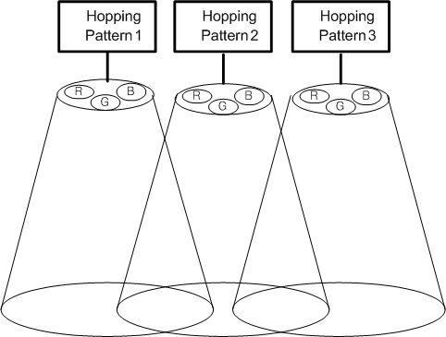

Figure 002- Hopping pattern assignment

Pattern | 00001 | 00011 | 00101
Frame/time slot | HP1 | HP2 | HP3
1 | R | G | B
2 | B | G/R | B
3 | G | R/B | G
4 | G/R | B | G/R
5 | G/R | R | G/B
6 | R/B | G | R/B
7 | G | B | R
8 | B | R | G
9 | R | G/B | R

Table 002-Example of hopping pattern assignment

